**Practice Activity2 - JavaScript**

1. Display the message as shown below when the page is loaded.

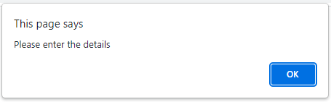

1. Design the **FORM** as shown below:

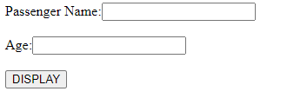

1. Using **JavaScript** create a **Function (**assign **any name**)
   1. Inside this function, declare **2** variables and assign any names.
   2. Get the values from the text box (passenger name and age) and assign to the declared variables.
   3. Use “conditional statement” to check the eligibility for license.
      1. If the age is greater than or equal to 18, display as “Ali-you are eligible for driving license”
      2. If the age is less than 18, display as “Ali-you are not eligible “
      3. “Ali” must be the value entered in the form.
   4. When the submit button is clicked, display the **output** as shown below:

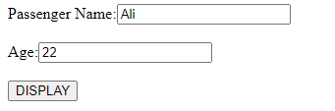

**OUTPUT**