**Practice Activity - JavaScript**

**General Instructions:**

* Download the folder and extract the file.

Open the file **“activity1_template.html**” and do the following:

1. Declare a **variable** and assign “any name”.
2. Assign the value **Higher College** to the variable.
3. Get the value ”Higher College” from the variable and display the output in the **alert box** as shown below:

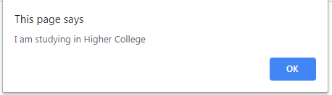

1. Display a **prompt box** that prompts the user to enter the input as shown below**:**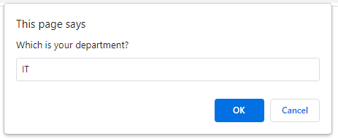

When the “OK” button is clicked, display the output as shown below:

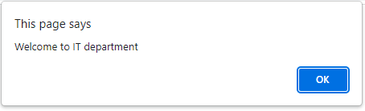

Open the file **“conditional_statement.html**” and do the following:

6.Declare **2 variables** and name it as **“a”** and “b”.

* 1. Assign the values **6** and **Semester1** to the variables a and b.
  2. Use **conditional statement** to check whether the student is a regular or probation student.
* If the number of courses are 5 or above, then display the message in the HTML document as “You are a regular student in Semester1”
* If the number of courses are below 5, then display the message in the HTML document as “You are a probation student in Semester1”.
* Get the value “Semester1” from the variable and display the output in the **HTML document** as shown below:

Output



**.**