
LJ UNIVERSITY OF COMPUTER APPLICATION
LJ Campus, Nr. Sanand Cross Road, S G Road, Ahmedabad, Gujarat, India
MCA Semester – 3
WEB-BASED PROJECT REPORT
On
TESTIFY
Online Examination Platform
— : Developed By : —
Sheikh Aafridi A. (25004401110038) A-45
Gajjar Ayush R. (25004401110089) A-17
Dhaduk Sanket J. (25004401110021) A-13
Dept. of Master Computer Application
Website: www.ljku.edu.in
Internal Guide: Prof. Gadhiya Aksha

Table of Contents
1. Problem Definition 3
2. Objective of the New System 4
3. Core Components 5
4. Project Profile 7
5. Need of the New System 8
6. Scope of the New System 9
7. Advantages and Limitations of the Proposed System 11
8. Proposed Timeline Chart 12
9. Targeted Users 13
10. Requirement Determination and Analysis 14
11. Requirement Determination 16
Non-Functional Requirements 16
12. Requirement Specification 17
13. System Design 18
13.1 Use Case Diagram 18

1. Problem Definition
Traditional examination systems require considerable manual effort for creating examinations, managing users and students, conducting tests, evaluating answers, and preparing results. As the number of students and examinations increases, these activities become time-consuming and difficult to manage. Manual processes can also lead to errors in maintaining student records, examination management, result calculation, and tracking examination activities. Therefore, there is a need for a centralized online platform that can reduce manual work and organize the examination process efficiently.
TESTIFY — Online Examination Platform is proposed as a digital solution to simplify and organize the examination process. The system provides separate access for Admin, Teacher, Student, and User, with different responsibilities for each role. The Admin can manage users, teachers, students, classes, examinations, questions, notifications, and overall platform activities. The Teacher can manage classes and student enrollment, including uploading a CSV file containing student details, and perform examination-related activities. The User can access the platform according to the permissions provided by the system, while student and enrollment information is maintained in the database for examination management.
Existing platforms such as Google Forms, Moodle, Class Marker, ProProfs Quiz Maker, and Testmoz provide online testing facilities, but they may have limitations such as complex interfaces, limited customization, paid advanced features, or workflows that do not exactly match the required class, student enrollment, and examination management process.
TESTIFY is designed to provide a simple and centralized platform with role-based access, CSV-based student enrollment, examination management, MCQ question management, and online examination functionality, reducing manual effort and making the examination process more organized and efficient.

2. Objective of the New System
The main objective of TESTIFY — Online Examination Platform is to provide a simple, organized, and efficient platform for conducting and managing MCQ-based online examinations. The objectives are:

2.1 Online Examination
- To conduct MCQ-based examinations online.
- To provide a timer for examinations.

2.2 User & Student Management
- To provide secure login for users and students.
- To manage student enrollment through CSV files.

2.3 Teacher Management
- To allow teachers to manage classes and enrolled students.
- To conduct examinations available to them.

2.4 Examination Management
- To manage examinations and MCQ questions.
- To make Admin-provided examinations available to teachers and students.

2.5 Result Management
- To automatically generate examination results.
- To maintain examination records.

3. Core Components
The major components of TESTIFY — Online Examination Platform are:

3.1 User Management
- Manages user registration, login, and account information.
- Provides role-based access for Admin, Teacher, Student, and User.

3.2 Examination Management
- Manages examinations provided by the Admin.
- Controls examination availability and access.

3.3 Question Bank
- Manages MCQ questions and their options.
- Stores questions required for conducting examinations.

3.4 Online Examination
- Provides the student examination interface.
- Includes questions, options, timer, navigation, and answer submission.

3.5 Enrollment Management
- Allows teachers to enroll students in classes.
- Supports student enrollment through CSV file upload.

3.6 Result Management
- Processes submitted examination answers.
- Generates and maintains examination results.

3.7 Teacher Management
- Allows teachers to manage classes and enrolled students.
- Provides examination-related management and result viewing features.

3.8 Admin Management
- Allows Admin to manage users, teachers, students, classes, examinations, questions, and notifications.
- Provides centralized control over the platform.

3.9 Student Management
- Maintains student information and enrollment records.
- Provides students with access to their available examinations through the Exam Dashboard.

4. Project Profile
Group No | 07
Project Name | TESTIFY
Project Title | Online Examination Platform
Project Type | Web-Based Application
Domain | Education / Online Examination
Frontend | HTML5, CSS3, JavaScript
Backend | Django
Database | MySQL
Platform | Web Browser
Team Members | Sheikh Aafridi A. (25004401110038)  Gajjar Ayush R. (25004401110089)  Dhaduk Sanket J. (25004401110021)
Stream | MCA Sem - 3
Project Guide | Prof. Gadhiya Aksha
Submitted To | LJ University

5. Need of the New System
There is a need for an online examination system that can simplify and organize the process of conducting MCQ-based examinations. TESTIFY is needed because:
- Online Examination: Reduces dependence on manual examination processes.
- Easy Access: Users and students can access the examination system through a web browser.
- Student Exam Flow: Students can log in, enroll in available examinations, attempt the exam, submit answers, and log out.
- Teacher Management: Teachers can manage classes, student enrollment, and examination activities.
- Admin Control: Admin can manage users, teachers, students, examinations, questions, and other system activities.
- CSV Enrollment: Teachers can enroll students efficiently using CSV files.
- Time Management: A timer helps conduct time-limited examinations.
- Result Generation: The system generates examination results after submission.
- Leaderboard: Users can view rankings based on examination performance.
- Role-Based Access: Separate permissions for Admin, Teacher, User, and Student make the system easier to manage.
- Centralized Platform: Combines user management, student enrollment, question management, examinations, results, and leaderboard functionality in one system.

6. Scope of the New System
The scope of TESTIFY — Online Examination Platform covers the frontend, backend, database, user management, examination management, student enrollment, and online examination process. The system provides separate functionality for User, Student, Teacher, and Admin according to their responsibilities.

User Scope
Users can:
- Log in to the system.
- Access the User dashboard.
- View available examination information.
- View examination results and performance information.
- View the leaderboard.
- Manage their profile.
- Log out from the system.

Student Scope
Students have a limited examination-focused scope. They can:
- Log in to the Student portal.
- Access the Exam Dashboard after login.
- View available examinations.
- Enroll in an available examination.
- Attend MCQ-based examinations.
- Use the examination timer.
- Navigate between questions.
- Submit the examination.
- Log out after completing the examination.

Teacher Scope
Teachers can:
- Log in to the Teacher portal.
- Manage classes.
- Add student information through a CSV file and manage enrolled students.
- View enrolled students.
- Manage examination-related activities.
- Manage MCQ questions.
- Create and make examinations available for Students.
- View examination participants and results.

Admin Scope
Administrators can:
- Manage users, teachers, and students.
- Manage classes and platform activities.
- Manage MCQ questions and examinations.
- Create and make examinations available for Users.
- View examination information and results.
- Manage notifications.
- Monitor the overall examination platform.

7. Advantages and Limitations of the Proposed System

Advantages
- Role-Based Access: Provides separate functions and access for User, Student, Teacher, and Admin.
- Time-Saving: Reduces manual work involved in conducting examinations and evaluating MCQ answers.
- CSV Enrollment: Allows teachers to add student information through a CSV file.
- Centralized Data Storage: Stores examination and user-related information in the database.
- Automatic Evaluation: Automatically evaluates submitted MCQ answers and generates results.
- Leaderboard: Provides performance-based ranking for Users.

Limitations
- Internet Dependency: The system requires a stable internet or network connection for online examination activities.
- Server Dependency: System performance may be affected by server capacity when many users attempt examinations simultaneously.
- Limited Proctoring: Advanced anti-cheating and real-time examination monitoring may not be fully implemented.
- Security Limitations: Additional advanced security mechanisms may be required for large-scale deployment.
- External Services: Features such as email, SMS, or third-party authentication may require additional API integration.

8. Proposed Timeline Chart
Activity | Aug W1-2 | Aug W3-4 | Sep W1-2 | Sep W3-4 | Oct W1-2 | Oct W3-4 | Nov W1-2 | Nov W3-4
Requirement Analysis | ✓
Existing System Study | ✓ | ✓
System Design |  |  | ✓
UI Design |  |  | ✓ | ✓
User Module Development |  |  |  | ✓
Teacher Module Development |  |  |  | ✓ | ✓
Admin Module Development |  |  |  |  | ✓
Examination Module |  |  |  |  | ✓
Testing |  |  |  |  |  |  | ✓
Documentation | ✓ | ✓ | ✓ | ✓ | ✓ | ✓ | ✓ | ✓
Final Presentation |  | ✓

9. Targeted Users
TESTIFY — Online Examination Platform is designed for four main types of users: User, Student, Teacher, and Admin. Each role has separate access and responsibilities according to the requirements of the system.

9.1 User
The User is a registered candidate who can access examinations made available by the Admin. The User can log in to the system, access the User Dashboard, view available examinations, attempt MCQ-based examinations, submit answers, and access the features provided according to their permissions.

9.2 Student
The Student is a learner who participates in examinations made available by the Teacher. Students can log in to the Student portal and are redirected to the Exam Dashboard after successful login. From the Exam Dashboard, they can view available examinations and attempt the assigned MCQ examinations within the specified time limit.
Student information can be managed by the Teacher, including adding student details through a CSV file for enrollment and examination management.

9.3 Teacher
The Teacher is responsible for managing students and conducting examinations for them. Teachers can manage classes, add student information through a CSV file, view enrolled students, manage MCQ questions, create examinations, make examinations available to Students, and manage examination-related activities.

10. Requirement Determination and Analysis
Requirement determination is the process of identifying and analyzing the functions and features required for TESTIFY — Online Examination Platform. The requirements were determined by studying the online examination process and identifying the activities required by Users, Students, Teachers, and Administrators.

The main requirements identified for the system are:
- User Registration & Login: Users can register and log in.
- Teacher & Admin Login: Teachers and Admins can access their dashboards.
- Exam Listing: Users and Students can view available exams.
- Exam Details: Displays exam information.
- Exam Enrollment: Eligible users can access exams.
- MCQ Exam: Candidates can attempt MCQ questions.
- Exam Timer: Displays remaining time.
- Question Navigation: Allows movement between questions.
- Mark for Review: Candidates can mark questions for review.
- Exam Submission: Candidates can submit exams.
- Result: Displays exam results.
- Answer Review: Candidates can review submitted answers.
- Exam History: Stores previous exam records.
- Leaderboard: Displays performance rankings.
- Teacher Management: Teachers can create and manage exams.
- Admin Management: Admin can manage users, teachers, students, questions, and exams.
- Reports: Authorized users can view reports and performance.

Public Platform Requirements
- Home: Provides an overview of TESTIFY.
- Exams: Displays available exams.
- Exam Details: Shows exam information.
- Leaderboard: Displays rankings.
- About Us: Provides platform information.
- Contact Us: Provides contact information.
- Login: Allows registered users to access their dashboards.
- Register: Allows visitors to create a User account.
The requirement analysis therefore focuses on providing role-based access, examination management, student management, CSV-based student enrollment, MCQ examination functionality, and centralized administration. The system separates the User, Student, Teacher, and Admin workflows so that each role can access the functions relevant to its responsibilities.

11. Requirement Determination

Functional Requirements
- Registration and Login
- View Examinations and Details
- Examination Enrollment
- MCQ Examination
- Timer and Question Navigation
- Mark for Review
- Examination Submission
- Result and Answer Review
- Examination History and Leaderboard
- Teacher Examination and Question Management
- Student Enrollment Management
- Admin Management
- Reports and Settings

Non-Functional Requirements
- Usability: Simple and user-friendly interface.
- Performance: Fast and efficient system response.
- Responsiveness: Works properly on desktop, tablet, and mobile.
- Accessibility: Clear and easy-to-use controls.
- Maintainability: Well-organized frontend and Django backend.
- Consistency: Consistent design and navigation.
- Security: Secure authentication, authorization, and data management.

12. Requirement Specification
Requirement Type | Short Specification
User Registration | User can create an account.
Authentication | Separate login for User, Student, Teacher, and Admin.
Exam Management | Teachers and Admin can manage exams.
Question Management | Teachers and Admin can manage MCQ questions.
Enrollment | Teachers can manage students and upload CSV data.
Exam Access | Users and Students can access available exams.
Online Exam | Users and Students can attempt MCQ exams.
Timer | Displays remaining exam time.
Navigation | Allows navigation between questions.
Review | Users can mark questions for review.
Submission | Users can submit exams with confirmation.
Result | Displays score, percentage, and answer details.
History | Users can view previous exam history.
Leaderboard | Users can view performance rankings.
Reports | Admin can view system and exam reports.
Responsive Design | Supports desktop, tablet, and mobile screens.
Theme | Supports light and dark themes.

13. System Design

13.1 Use Case Diagram
This section presents the use case diagrams of TESTIFY for each actor: Visitor, User, Student, Teacher and Admin.

13.1.1 Use Case Diagram — Visitor

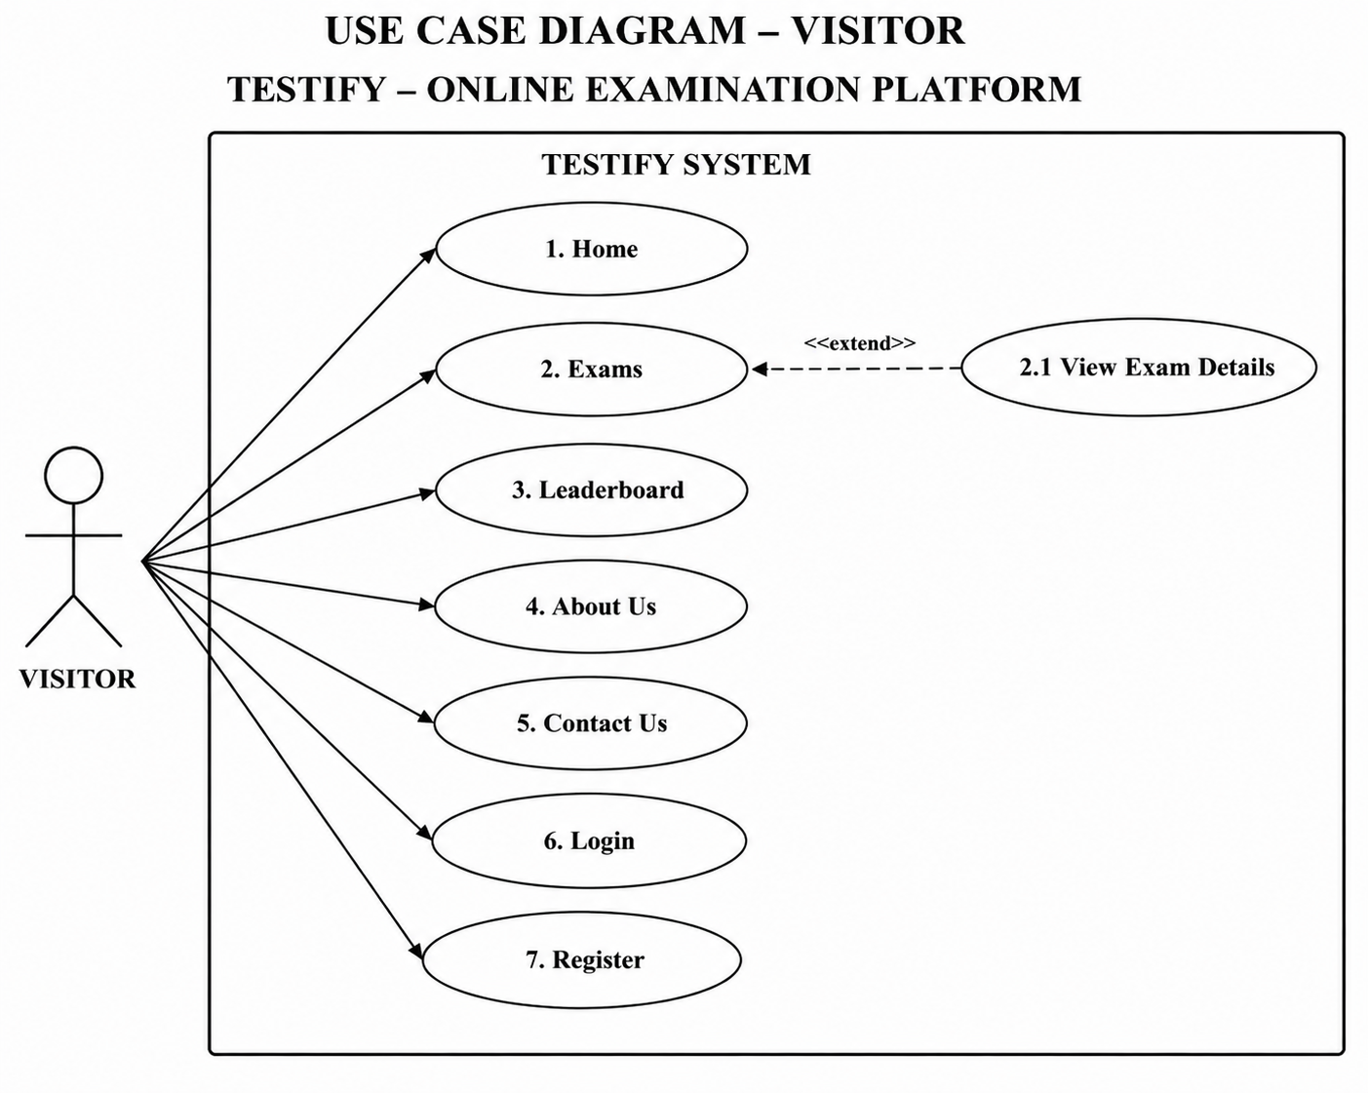

Figure 13.1 — Use Case Diagram: Visitor

13.1.2 Use Case Diagram — User

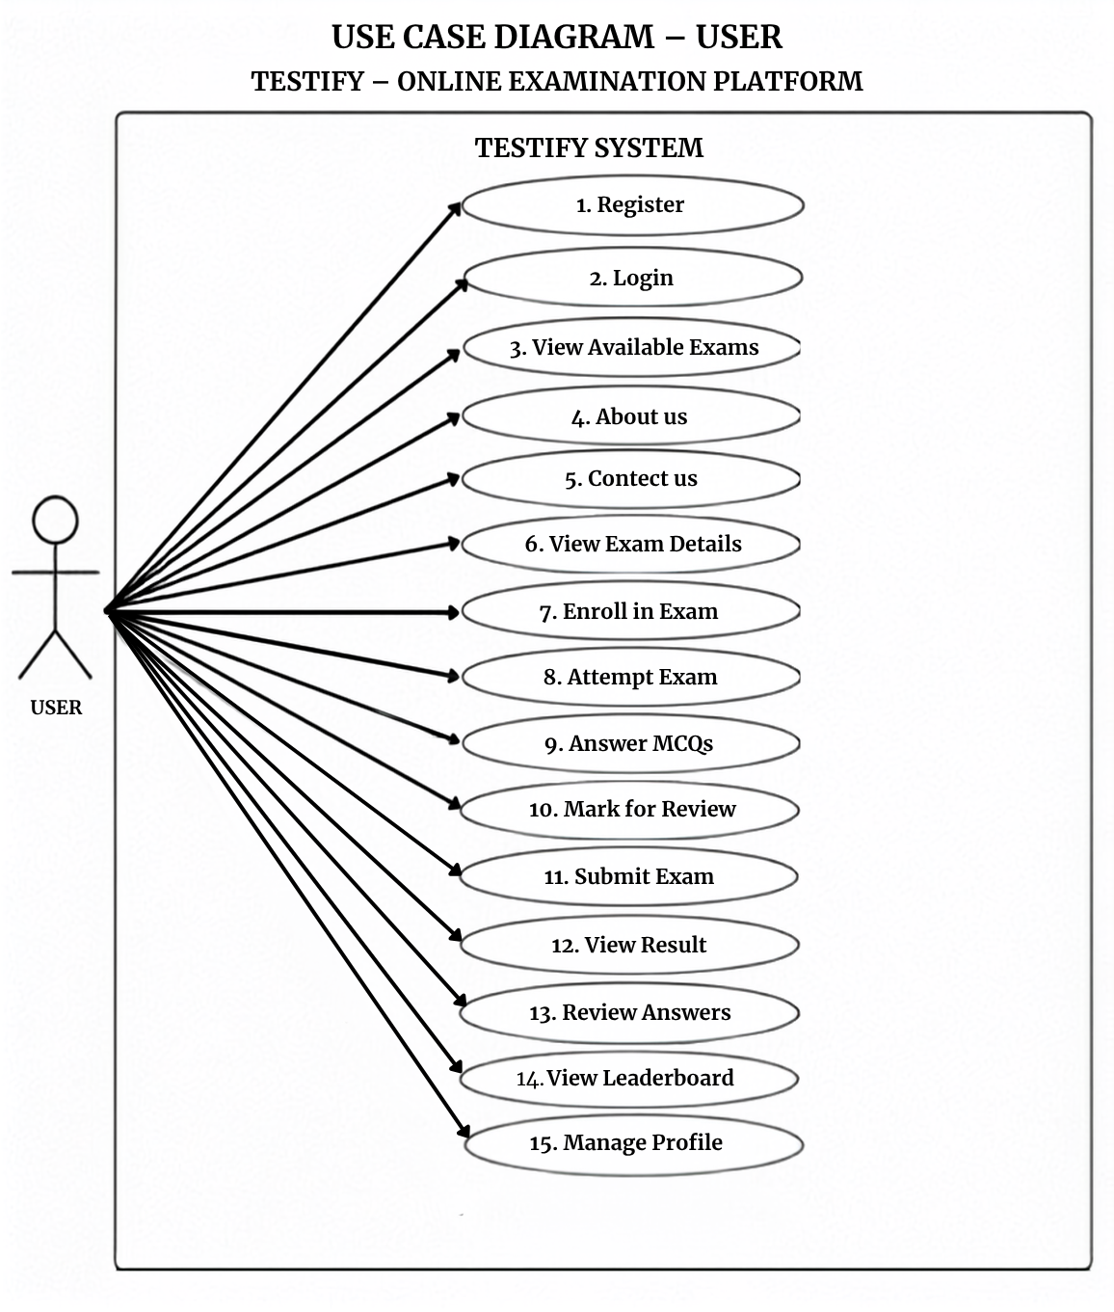

Figure 13.2 — Use Case Diagram: User

13.1.3 Use Case Diagram — Student

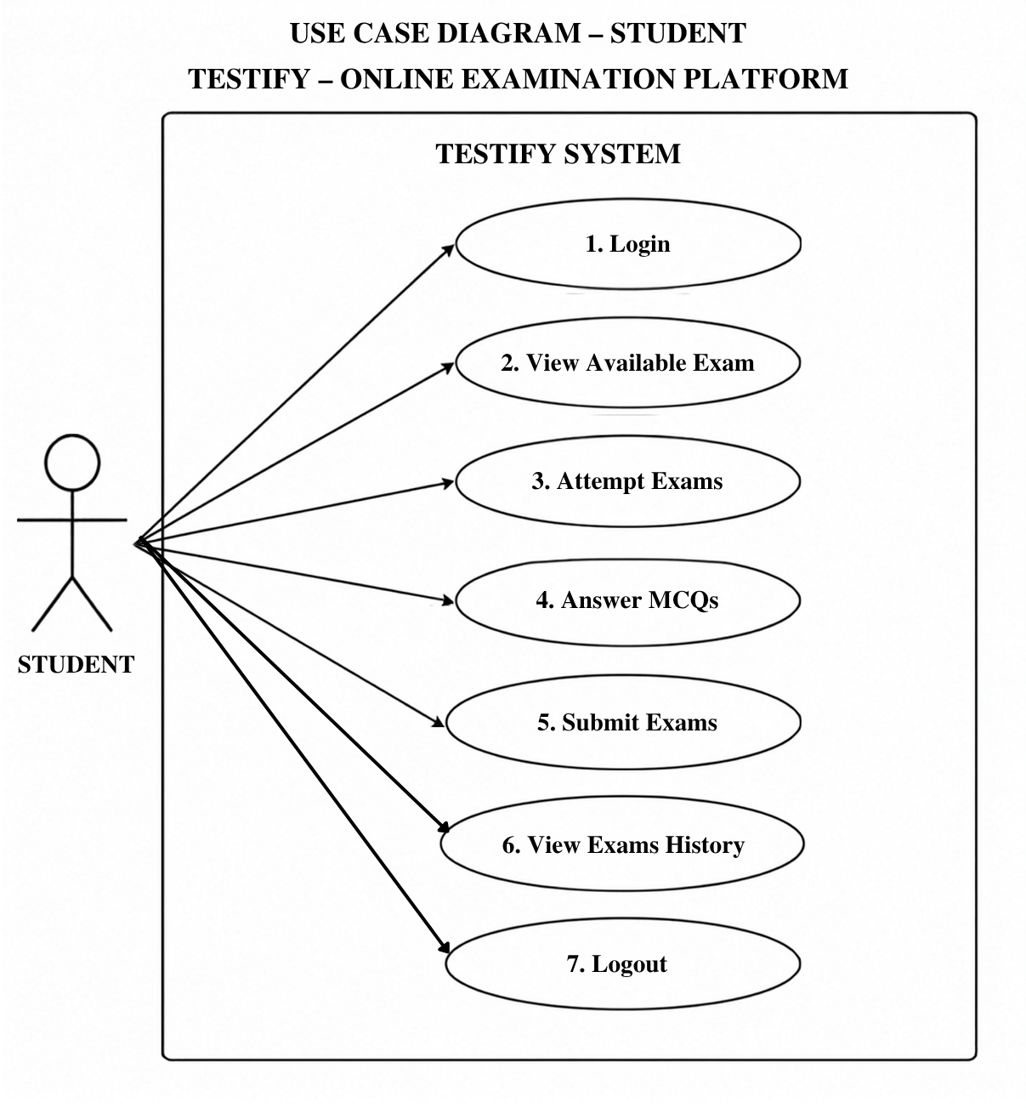

Figure 13.3 — Use Case Diagram: Student

13.1.4 Use Case Diagram — Teacher

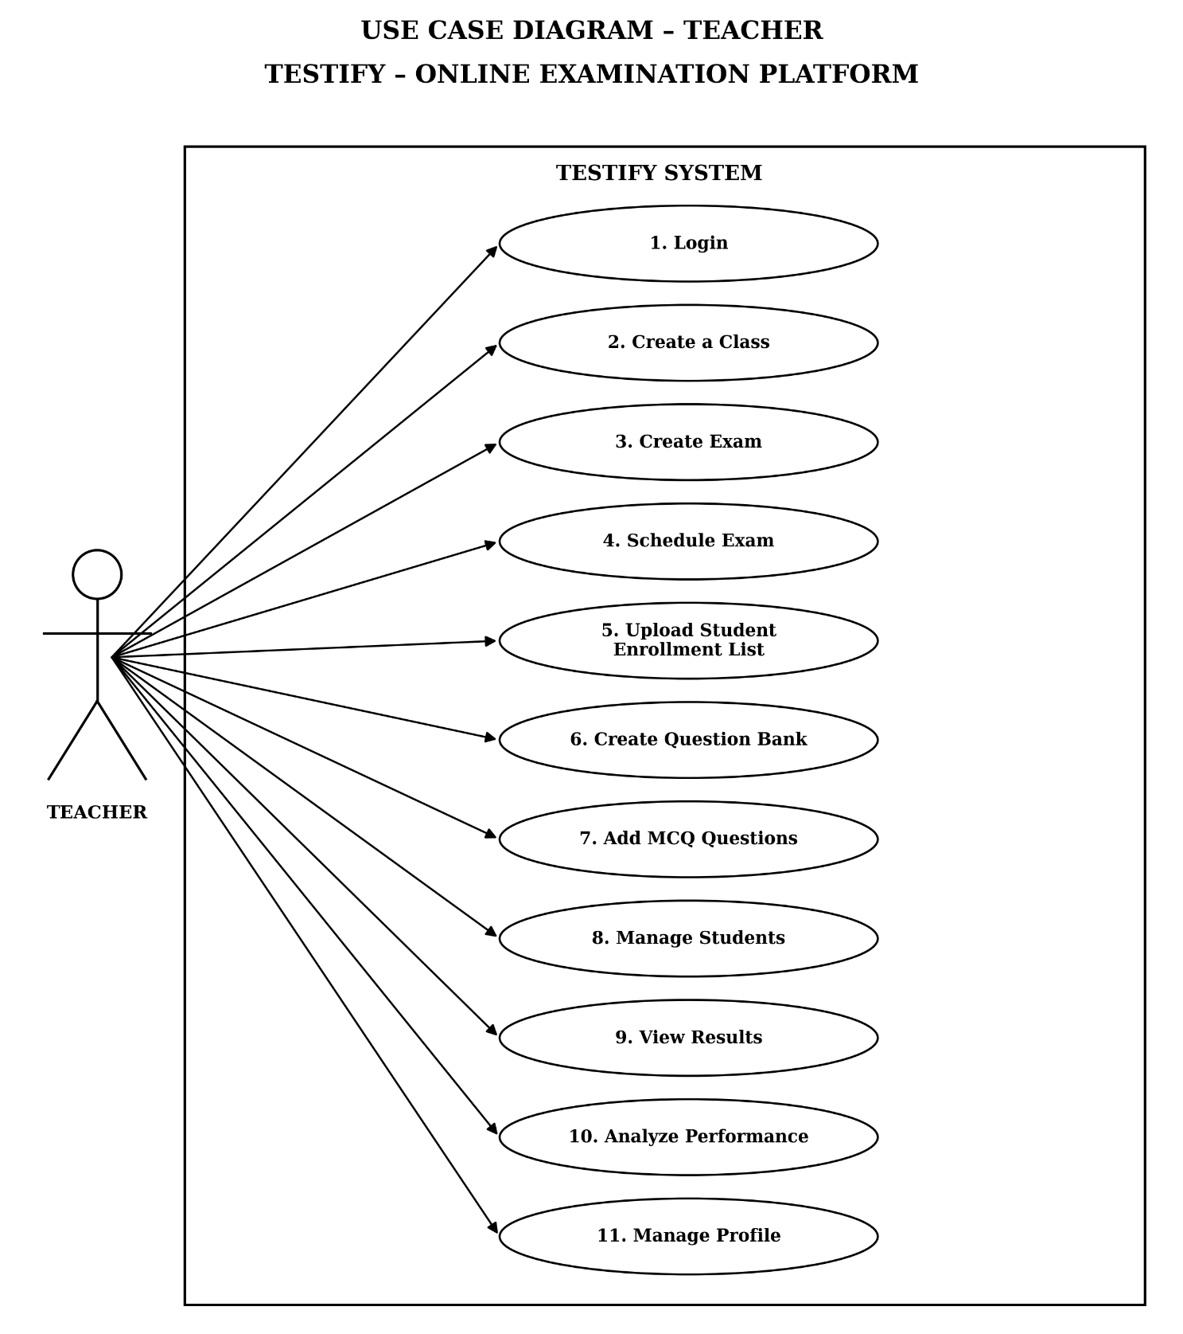

Figure 13.4 — Use Case Diagram: Teacher

13.1.5 Use Case Diagram — Admin

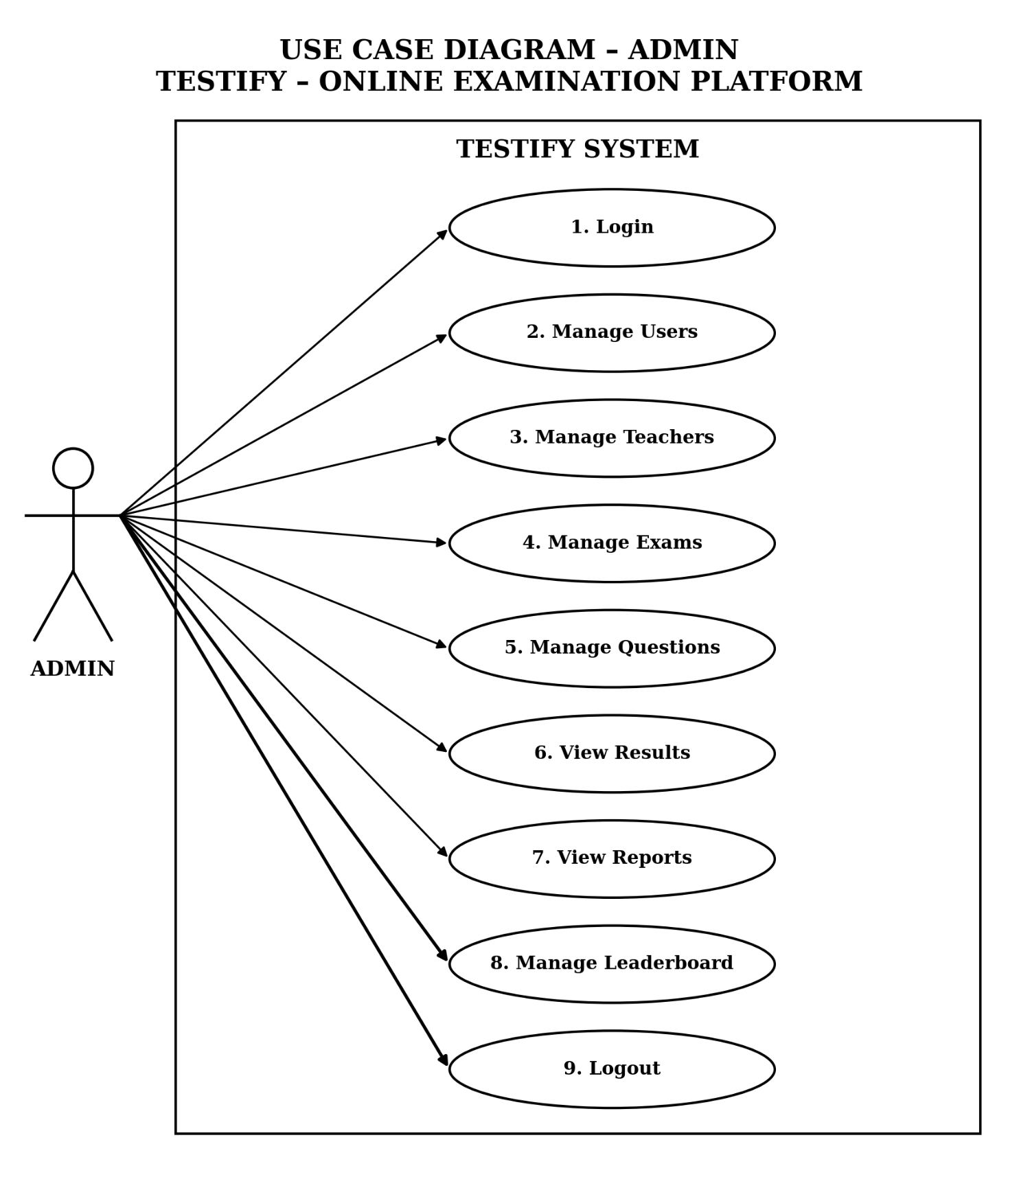

Figure 13.5 — Use Case Diagram: Admin

