AI/ML Trainee Assessment – Accuknox
Name: Adnan Shaikh
Position: AI/ML Trainee
Date: 4 October 2026

- Assignment 1 – Python, API, CSV and Database

  - API Data Retrieval and Storage

Objective: Retrieve book information from an external REST API, store it in SQLite, and display the retrieved data.
Assumption: The problem statement did not provide a specific books API endpoint, so I selected the Open Library Search API as the external REST API.
Approach: Open Library API -> HTTP GET request -> JSON response -> Extract title / author / publication year -> SQLite -> SELECT -> Display records
Technologies: Python, Requests, SQLite, REST API, JSON
Implementation:
problem_1_1_api_sqlite.py code:
import requests
import sqlite3

API_URL = "https://openlibrary.org/search.json?q=python&limit=5"

# 1. Fetch data from API
response = requests.get(API_URL, timeout=10)
response.raise_for_status()

data = response.json()
books = data["docs"]

# 2. Connect to SQLite
connection = sqlite3.connect("books.db")
cursor = connection.cursor()

# 3. Create table
cursor.execute("""
CREATE TABLE IF NOT EXISTS books (
id INTEGER PRIMARY KEY AUTOINCREMENT,
title TEXT NOT NULL,
author TEXT,
publication_year INTEGER
)
""")

# 4. Insert books
for book in books:
title = book.get("title")
authors = ", ".join(book.get("author_name", []))
publication_year = book.get("first_publish_year")

cursor.execute("""
INSERT INTO books (title, author, publication_year)
VALUES (?, ?, ?)
""", (title, authors, publication_year))

# 5. Save changes
connection.commit()

# 6. Retrieve and display data
cursor.execute("""
SELECT title, author, publication_year
FROM books
""")

rows = cursor.fetchall()

for row in rows:
print(row)

# 7. Close database connection
connection.close()

Output:
('Learning Python', 'Mark Lutz, David Ascher', 1999)
('Python For Data Analysis', 'Wes McKinney', 2012)
('Fluent Python', 'Luciano Ramalho', 2015)
('Black Hat Python', 'Justin Seitz, Tim Arnold', 2014)
('Python Cookbook', 'Alex Martelli, David Ascher, David M. Beazley, Brian K. Jones', 2002)

I learned how a REST API works with Python. I used the requests library to get JSON data from an API, extract details like the title, author, and year, and store the data in SQLite. I also learned about HTTP status checking, error handling, duplicate handling, and displaying the selected records. First Python sends a GET request to the REST API. The API returns JSON data, then I extract the required fields and store them in SQLite, and finally I query the database and display the results.

  - Data Preprocessing and Visualization

Objective: Retrieve student test scores from an API, calculate averages, and create a bar chart.
Assumption: The problem statement did not specify whether the average should be calculated per student or per subject, so I calculated the average score for each subject across the available students.
Approach: Student Scores API -> JSON data -> Extract subject scores -> Calculate subject-wise averages -> Matplotlib -> Bar chart
Average Results:
Math: 83.45
History: 80.33
Physics: 81.34
Chemistry: 80.00
Biology: 79.58
English: 81.28
Geography: 80.89

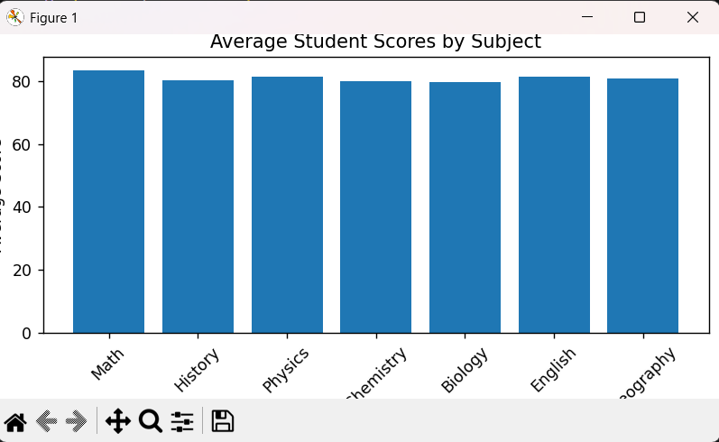

Implementation:
problem_1_2_scores.py code:
import requests
import matplotlib.pyplot as plt

API_URL = "https://api.slingacademy.com/v1/sample-data/files/student-scores.json"

# 1. Fetch student data
response = requests.get(API_URL, timeout=10)
response.raise_for_status()

students = response.json()

# 2. Subjects to analyze
subjects = {
"Math": "math_score",
"History": "history_score",
"Physics": "physics_score",
"Chemistry": "chemistry_score",
"Biology": "biology_score",
"English": "english_score",
"Geography": "geography_score"
}

# 3. Calculate average score for each subject
average_scores = {}

for subject, field in subjects.items():
total = sum(student[field] for student in students)
average = total / len(students)
average_scores[subject] = average

# 4. Display averages
print("Average Scores:")

for subject, average in average_scores.items():
print(f"{subject}: {average:.2f}")

# 5. Create bar chart
plt.figure(figsize=(10, 6))

plt.bar(
average_scores.keys(),
average_scores.values()
)

plt.xlabel("Subjects")
plt.ylabel("Average Score")
plt.title("Average Student Scores by Subject")
plt.xticks(rotation=45)
plt.tight_layout()

plt.show()

  - CSV Data Import to SQLite
Objective: Python script that reads user name/email data from CSV and inserts it into SQLite.
Approach: users.csv -> csv.DictReader -> SQLite INSERT -> users table -> SELECT -> Display records

Input:
name,email
Adnan Shaikh,adnan@example.com
Rahul Kumar,rahul@example.com
Priya Sharma,priya@example.com
Ayesha Khan,ayesha@example.com

Output:
Users stored in database:
(5, 'Adnan Shaikh', 'adnan@example.com')
(6, 'Rahul Kumar', 'rahul@example.com')
(7, 'Priya Sharma', 'priya@example.com')
(8, 'Ayesha Khan', 'ayesha@example.com')

Implementation:
import csv
import sqlite3

# Connect to SQLite database
connection = sqlite3.connect("users.db")
cursor = connection.cursor()

# Create table
cursor.execute("""
CREATE TABLE IF NOT EXISTS users (
id INTEGER PRIMARY KEY AUTOINCREMENT,
name TEXT NOT NULL,
email TEXT NOT NULL
)
""")

# Read CSV and insert users
with open("data/users.csv", "r", newline="", encoding="utf-8") as file:
reader = csv.DictReader(file)

for row in reader:
cursor.execute("""
INSERT INTO users (name, email)
VALUES (?, ?)
""", (row["name"], row["email"]))

# Save changes
connection.commit()

# Retrieve inserted data
cursor.execute("SELECT id, name, email FROM users")

users = cursor.fetchall()

print("Users stored in database:")

for user in users:
print(user)

# Close database connection
connection.close()

Q4 Most Complex Python Code
https://github.com/shaikhadnan0123/airbnb-price-prediction
I built an NYC Airbnb Price Predictor that estimates the nightly price of a listing based on factors like location, room type, reviews, and availability. I trained and compared machine learning models and used an Extra Trees Regressor for the final prediction system. I also built a Flask API and React interface and deployed the project so it can be tested through a live web application.

Q5 Most Complex Database Code: CSV Data Import to SQLite
Repository link: shaikhadnan0123/Accuknox-AIML-Assessment

Assignment 2-Self Assessment
Machine Learning [A]
I am comfortable with the basic ML workflow, from collecting and cleaning data to preprocessing, training, testing, prediction, and evaluation. I can independently work with models like Linear Regression and tree-based models and understand metrics such as MAE, RMSE, and R².
Deep Learning [B]
I understand the basics of neural networks, layers, activation functions, loss functions, and backpropagation. I have also learned about concepts like GANs and autoencoders, but I am still improving my practical experience.
AI [A]
I understand how AI includes areas like machine learning, deep learning, and generative AI. I have worked with concepts such as embeddings, RAG, computer vision, and prediction or classification tasks.
LLM [B]
I have learned the basic concepts of LLMs and how they can be used with applications like RAG. I am currently improving my understanding of prompting, embeddings, retrieval, and how LLM applications work in practice.

LLM Chatbot Architecture
Objective: Key architectural components and a high-level approach.
User / UI -> Backend / API -> Conversation History -> Prompt Builder -> LLM -> Response Handling User

I learned how an LLM chatbot works as a complete pipeline. The user sends a message through the interface, the backend handles it, the prompt builder prepares the context, and the LLM generates the response, which is then sent back to the user. The interface is where the user interacts with the chatbot, the backend manages the request, and the prompt builder prepares the information for the LLM. The LLM generates the answer, and the response handler sends it back to the user.
I understood that an LLM application is not just the model itself. There are different components like the user interface, API/backend, conversation history, prompt building, the LLM, and response handling that work together.

Vector Database
I learned that a vector database stores data as numerical vectors called embeddings. It can compare the similarity between a user’s query and stored documents and retrieve the most relevant information. n a RAG system, the document is first converted into embeddings and stored in a vector database. When the user asks a question, the system searches for similar chunks, retrieves the relevant information, and gives it to the LLM to generate a grounded answer. A normal SQL database is mainly used for structured data and exact queries, while a vector database is useful when we need similarity search. It is especially useful for RAG applications where we need to find relevant information from documents.
For my RAG projects, I chose ChromaDB because it is simple to use with Python and works well for storing and searching embeddings. It is also convenient for building and testing RAG applications locally.
While doing this assignment, I learned how to handle REST API responses, extract JSON data, and store and query data using SQLite. I also practiced CSV processing, SQL queries, LLM architecture, and vector similarity with RAG, which helped me understand how these parts are used in a real application.

