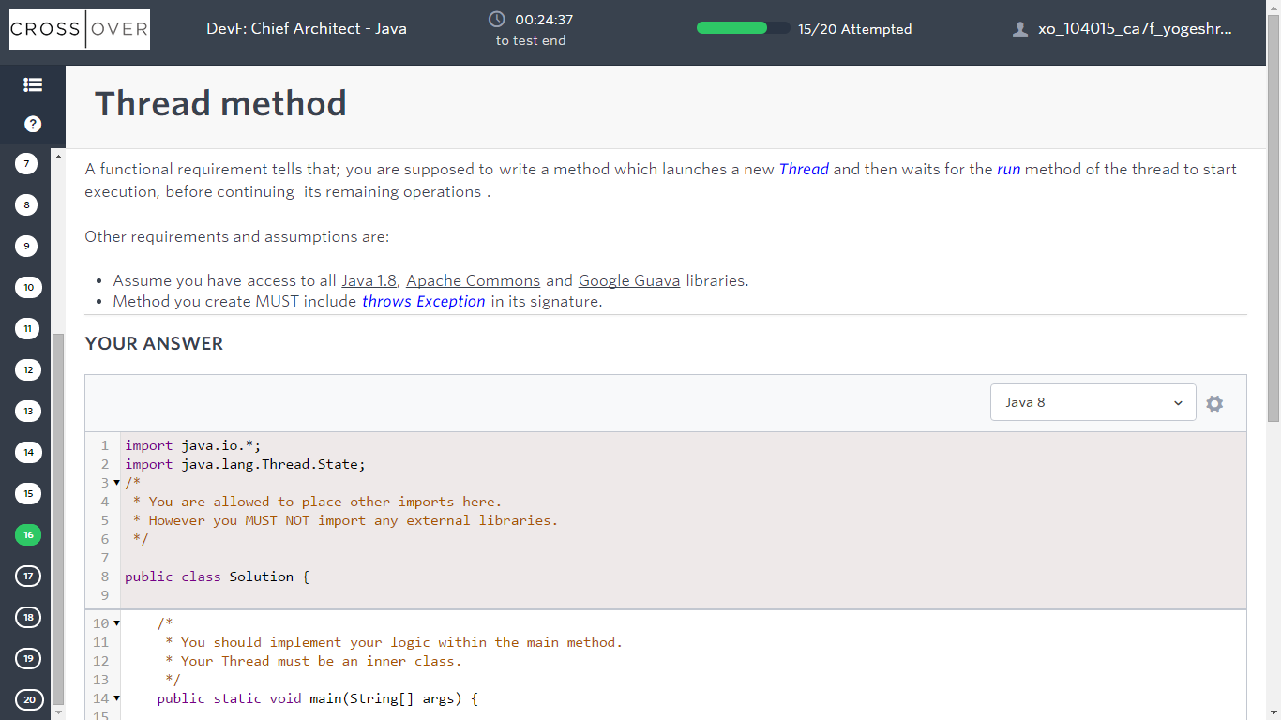

|  |
| --- |
| import java.io.*;  import java.lang.Thread.State;  /*  * You are allowed to place other imports here.  * However you MUST NOT import any external libraries.  */  public class Solution {  /*  * You should implement your logic within the main method.  * Your Thread must be an inner class.  */  public static void main(String[] args) {      }  /*  * Your implementation MUST call this method in order to print the state of the Thread.  */  private static void printState(State threadState){  System.out.println(threadState.toString());  }  } |

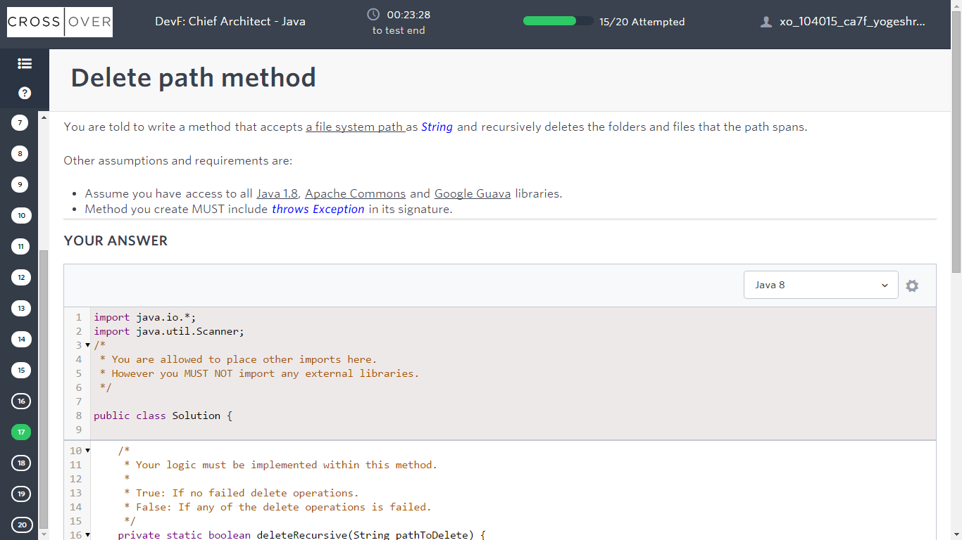

|  |
| --- |
| import java.io.*;  import java.util.Scanner;  /*  * You are allowed to place other imports here.  * However you MUST NOT import any external libraries.  */  public class Solution {    /*  * Your logic must be implemented within this method.  *  * True: If no failed delete operations.  * False: If any of the delete operations is failed.  */  private static boolean deleteRecursive(String pathToDelete) {    return false; // Please replace with your own code.    }  /*  * This main() method is pre-written in order to help you to focus on the requested business logic only.  * Please do not waste time by modifying this method.  */  public static void main(String[] args) throws IOException{    System.out.println("Please enter the path to be deleted : ");  Scanner scanner = new Scanner(System.in);  String pathToDelete =scanner.nextLine();  System.out.println(pathToDelete);    // Your method is called here!  boolean result = deleteRecursive(pathToDelete);    System.out.println(result);    scanner.close();  }  } |

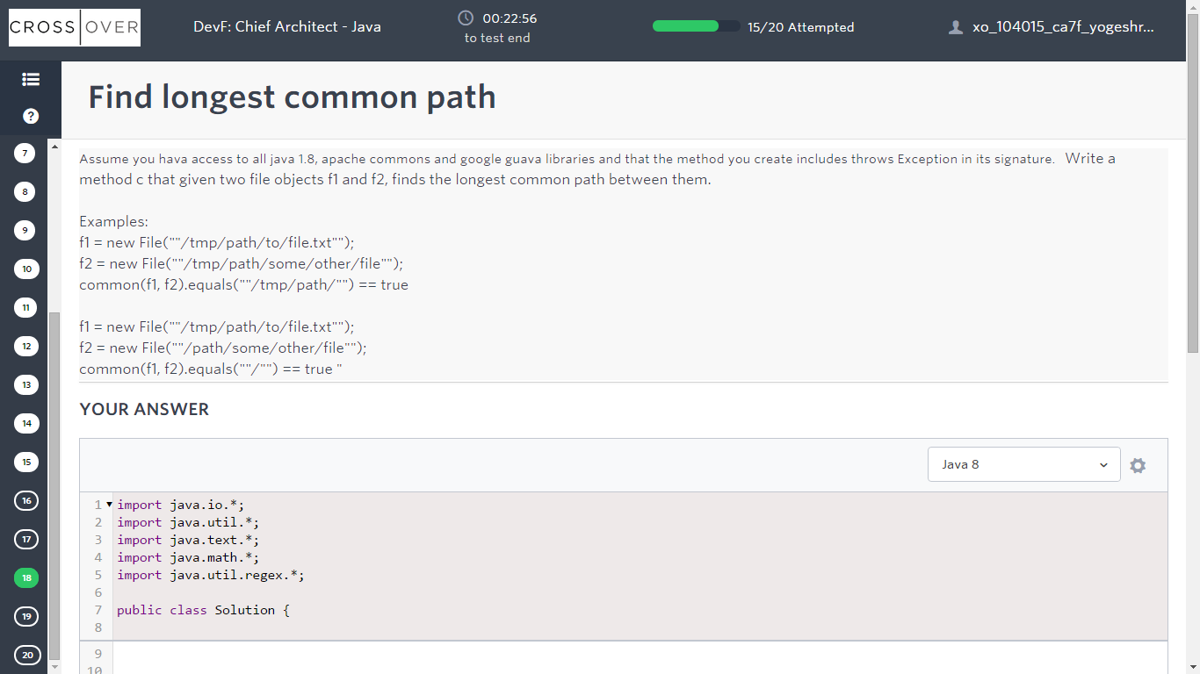

|  |
| --- |
| import java.io.*;  import java.util.*;  import java.text.*;  import java.math.*;  import java.util.regex.*;  public class Solution {    static int c() {  }  public static void main(String[] args) throws IOException{  Scanner in = new Scanner(System.in);  final String fileName = System.getenv("OUTPUT_PATH");  BufferedWriter bw = new BufferedWriter(new FileWriter(fileName));  int res;  res = c();  bw.write(String.valueOf(res));  bw.newLine();    bw.close();  }  } |

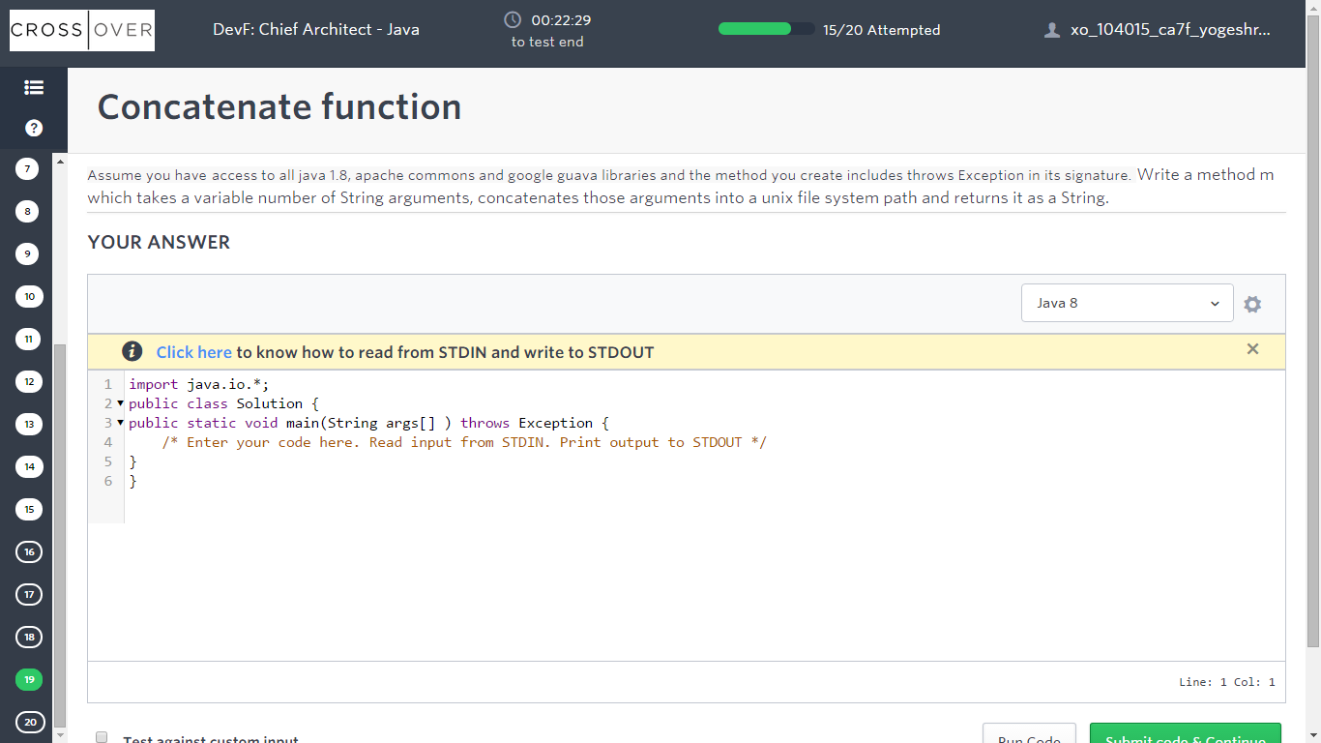

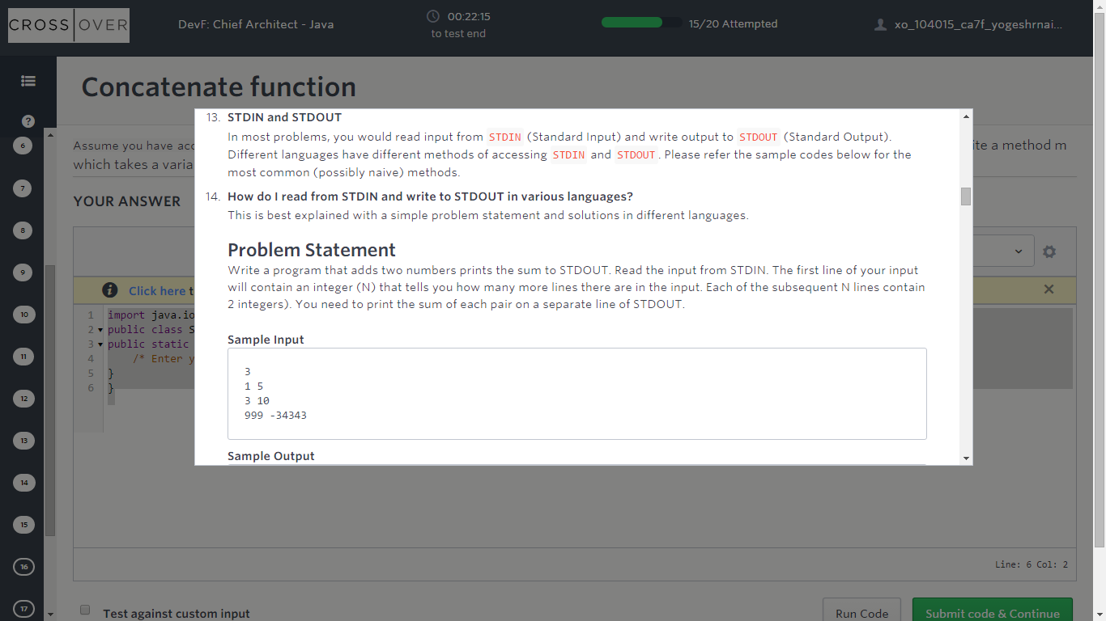

|  |
| --- |
| import java.io.*;  public class Solution {  public static void main(String args[] ) throws Exception {  /* Enter your code here. Read input from STDIN. Print output to STDOUT */  }  } |

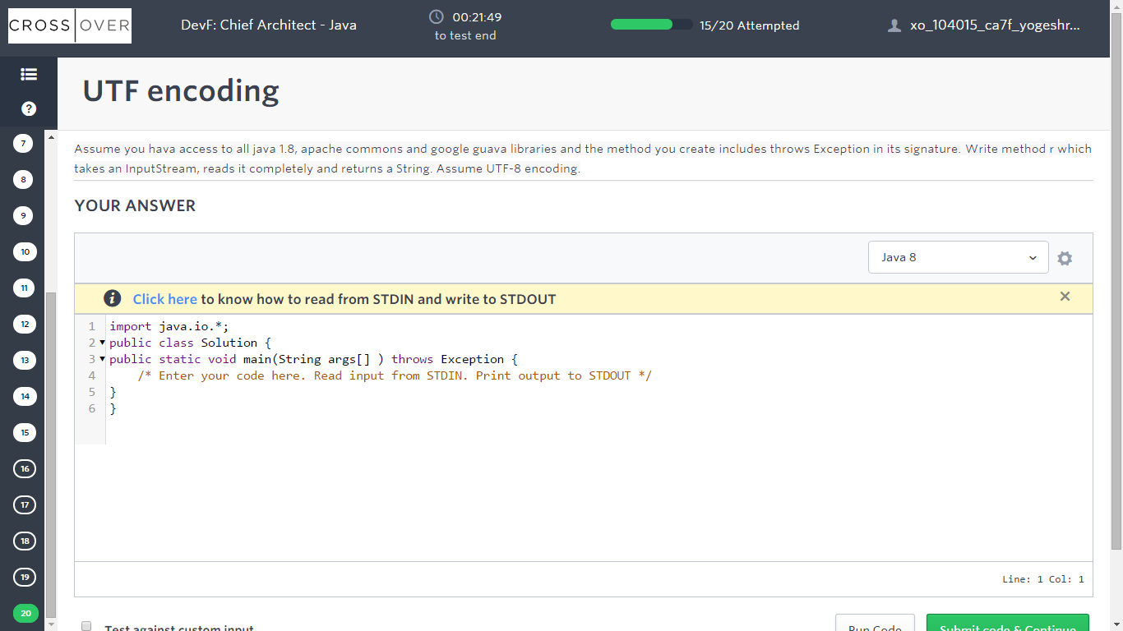

|  |
| --- |
| import java.io.*;  public class Solution {  public static void main(String args[] ) throws Exception {  /* Enter your code here. Read input from STDIN. Print output to STDOUT */  }  } |