Title: Face Attendance System Form No: IQAC-112
SRN.No. | 31240250
Name: | Shaikh Mohammed Anas

VISHWAKARMA UNIVERSITY, PUNE
University Grants Commission (UGC) Approved State Private University

Examination: Project-1
Academic Year | 2025-2026 | Pattern | 2025-2026
Faculty | Commerce | Course Name | DevOps
Department | Management | Course Code | MCA24403
Programme | MCA | Semester | IV
Division | A | Course Teacher (s) | Dr. Bharati Kawade
Maximum Marks | 25 | Total No. of Pages | 6
Project Start Date | 15/03/2026 | Project End Date | 18/04/2026
Instructions to Candidates: -
- Students need to strictly adhere to the project deadlines
- Project content should be unique and plagiarism is strictly prohibited.
- Submission of project report in a prescribed format is mandatory.

Project Title: FACE RECOGNITION BASED ATTENDANCE SYSTEM

Project Objective:
The Face Recognition Based Attendance System automates student attendance using real-time face recognition. The system uses OpenCV's Haar Cascade algorithm for face detection and the LBPH (Local Binary Pattern Histograms) algorithm for recognition. Students are registered by capturing 100 face images, a model is trained using these images, and attendance is marked automatically when a registered face is detected by the camera. The project is containerized using Docker and the Docker image is deployed to AWS ECR (Elastic Container Registry) demonstrating a complete DevOps pipeline.
Project Outcome:
- Students can register their face by entering ID and Name and clicking Take Images — 100 grayscale face photos are captured and saved automatically.
- The LBPH model is trained on all registered face images by clicking Save Profile — the trained model is saved as Trainner.yml.
- Attendance is marked automatically when a registered face is recognised by the camera with confidence score below 50.
- Daily attendance records are saved as CSV files with student ID, name, date and timestamp.
- The project is containerized using Docker and the image is pushed to AWS ECR for cloud deployment.

Project Description
1. | Problem Definition / Identification  Traditional attendance systems rely on manual roll calls which are time-consuming, error-prone, and vulnerable to proxy attendance. There is no reliable way to verify student identity automatically. This project addresses this problem by implementing a face recognition based system that automatically identifies registered students and marks their attendance in real time without any manual intervention. The system also demonstrates DevOps practices including version control with GitHub, containerization with Docker, and cloud deployment with AWS ECR.
2. | Methodology  Stage 1 — Face Registration: Student enters ID and Name. Camera opens and Haar Cascade detects face in each frame. 100 grayscale images saved to TrainingImage/ folder. Student details saved to StudentDetails.csv.  Stage 2 — Model Training: LBPH algorithm reads all saved face images. Extracts texture fingerprint (Local Binary Pattern Histograms) from each image. Trained model saved as TrainingImageLabel/Trainner.yml.  Stage 3 — Attendance Marking: Camera opens and loads trained model. Haar Cascade detects face. recognizer.predict() returns serial number and confidence score. If confidence < 50, attendance marked with timestamp in daily CSV file.  DevOps Pipeline: Code pushed to GitHub for version control. Dockerfile created for containerization. Docker image built on AWS CloudShell. Image tagged and pushed to AWS ECR private registry.
3. | Implementation  Algorithms Used:  Haar Cascade — Pre-trained XML model by Viola-Jones. Scans every video frame at multiple scales for face-shaped light/shadow patterns. Used for face detection in both registration and attendance stages.  LBPH (Local Binary Pattern Histograms) — For each pixel, compares brightness to 8 neighbours and writes binary code. Creates texture fingerprint histogram. Matches live face against stored fingerprints using confidence score (lower = better match, threshold = 50).  Key Functions:  Function Description  TakeImages() Opens camera, captures 100 face images, saves to TrainingImage/, updates StudentDetails.csv  TrainImages() Loads all face images, trains LBPH model, saves Trainner.yml  TrackImages() Opens camera in background thread, recognises faces, marks attendance, updates GUI table  fix_student_details() Auto-removes duplicate CSV entries and reassigns clean serial numbers on startup  refresh_table() Updates attendance treeview table using pandas after camera closes  DevOps Implementation:  Step Tool / Command Result  Version Control git init, git push → GitHub github.com/shaikhanas78/face-attendance-system  Containerization Dockerfile + requirements.txt Docker image defined  Build Image docker build -t face-attendance-system . Built in 138 seconds on AWS  Cloud Login aws ecr get-login-password | docker login Login Succeeded  Tag Image docker tag face-attendance-system:latest ... Image tagged with ECR URI  Push to Cloud docker push .../face-attendance-system:latest Image live on AWS ECR
4. | Output & Evidence:  1. Face Registration — Student enters ID and Name. Camera opens and captures 100 face images. StudentDetails.csv updated with serial number, ID and name.  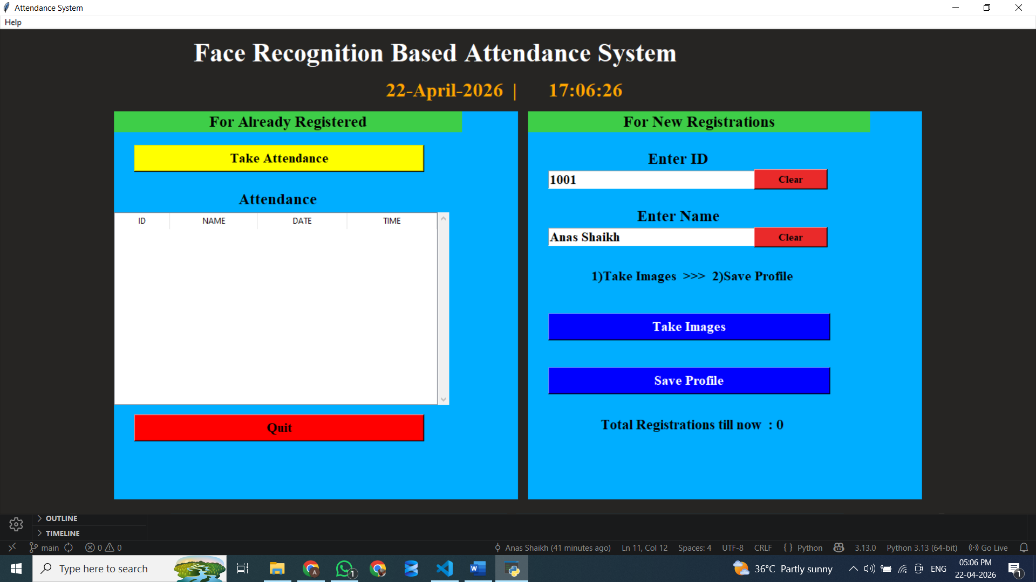  2. Model Training — Click Save Profile, enter password. LBPH model trained on all face images. Message displays 'Profile Saved Successfully' and Trainner.yml is created in TrainingImageLabel/ folder.  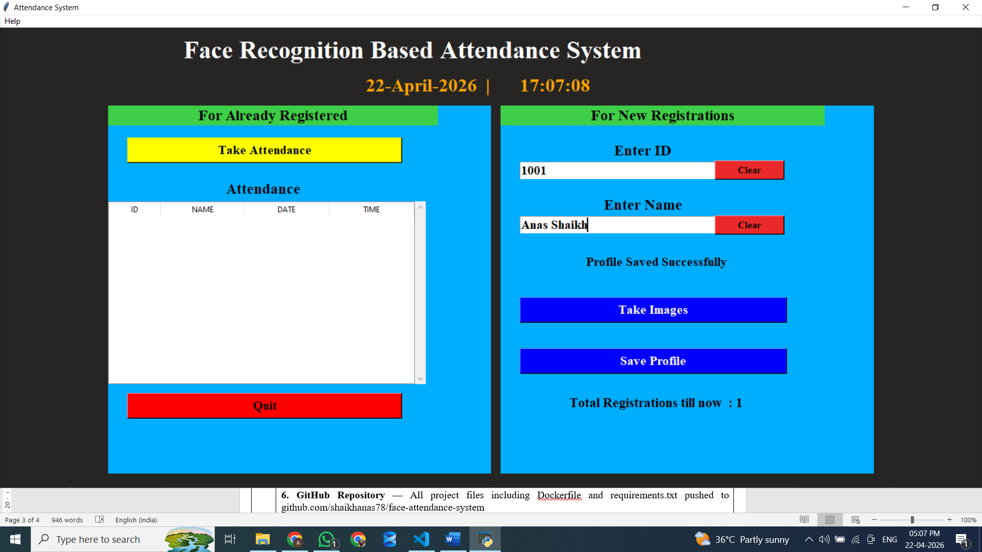  3. Attendance Marking — Camera opens, detects face in real time with blue rectangle. Recognised name displayed on screen. Press Q to close camera.  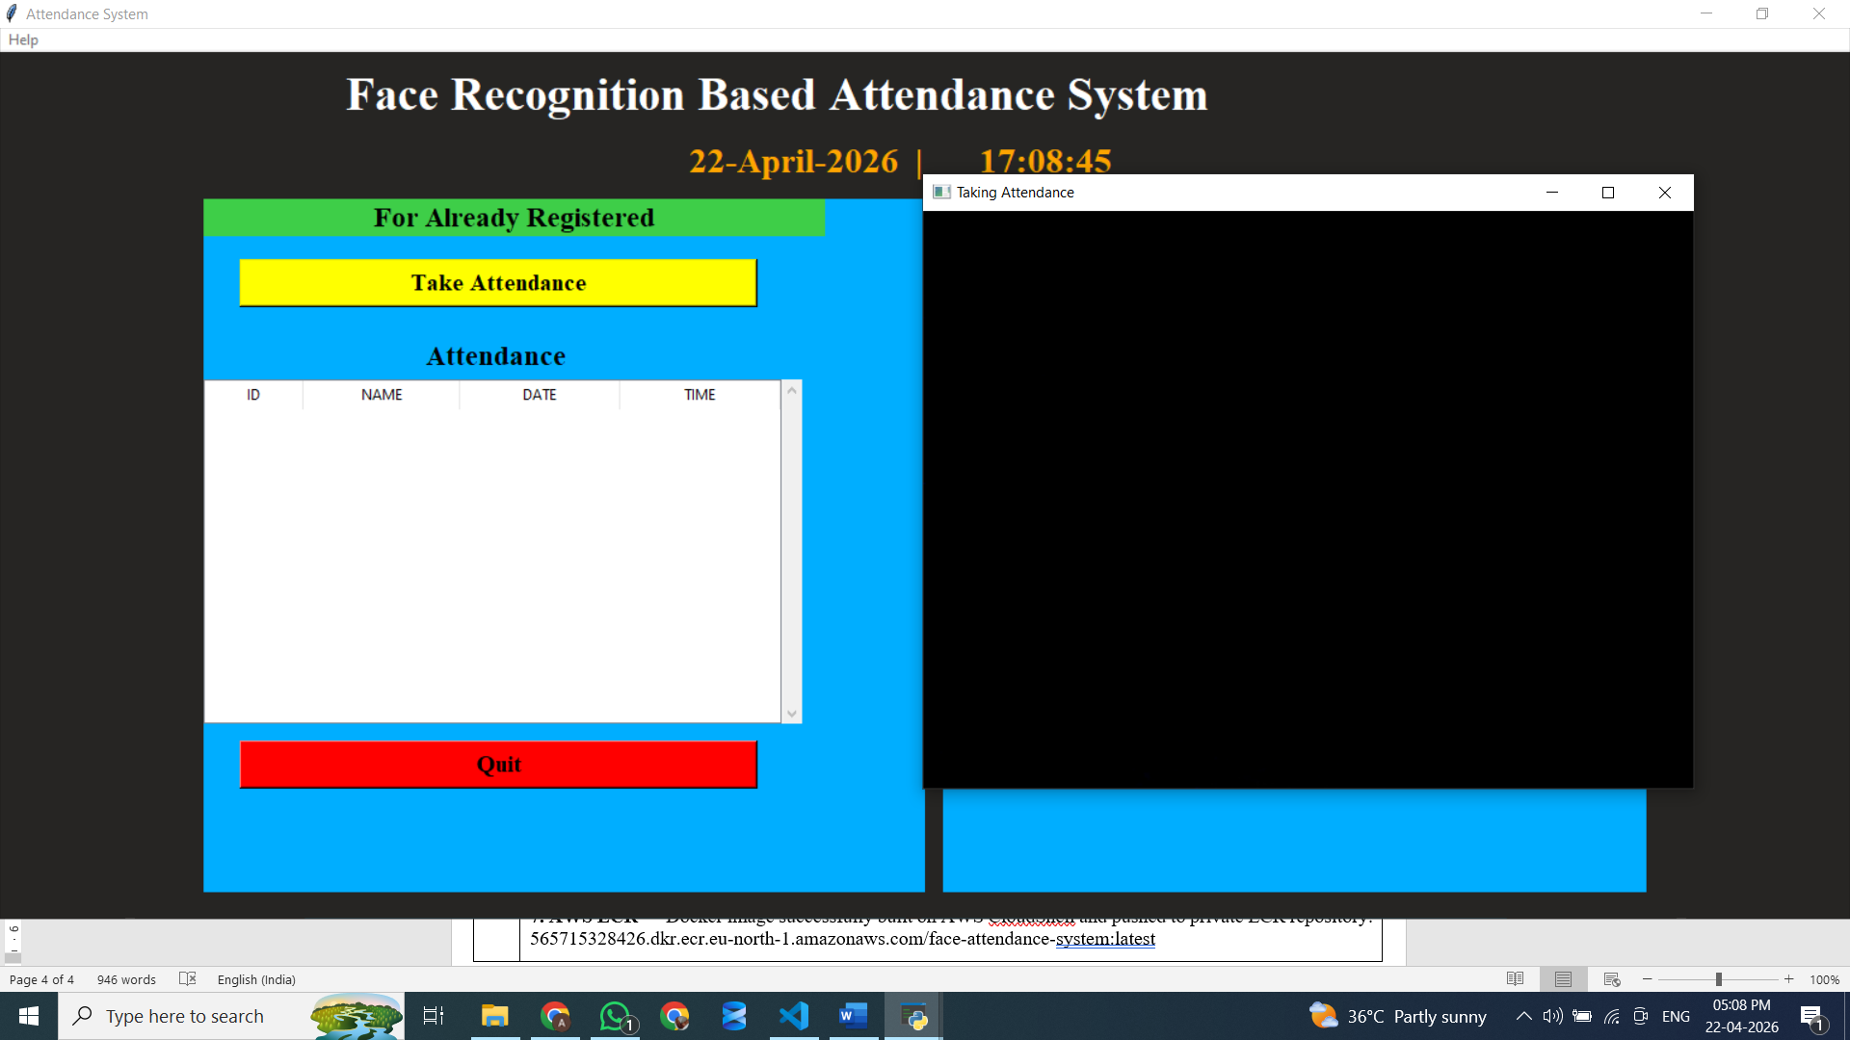  4. Attendance Table — After pressing Q, attendance table in GUI updates automatically showing ID, Name, Date and Time for each recognised student.  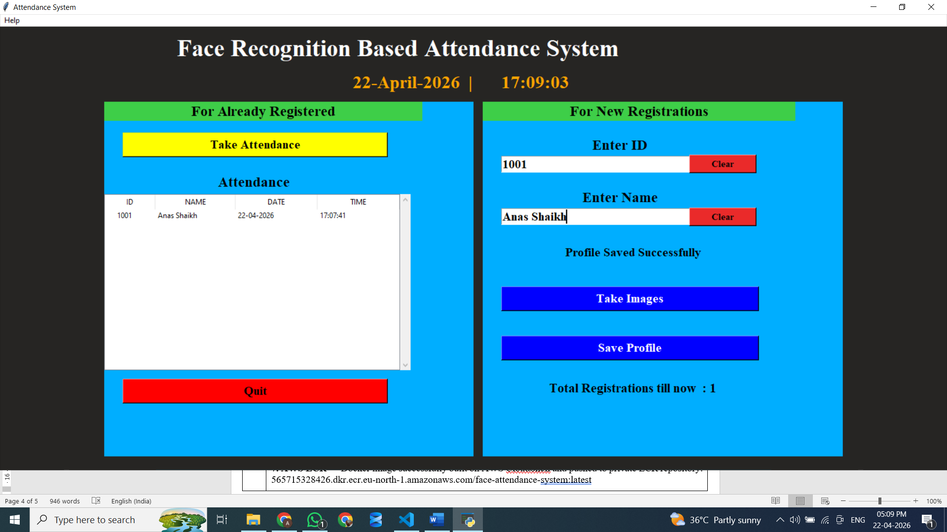  5. CSV Output — Attendance_DD-MM-YYYY.csv created in Attendance/ folder with columns: Id, Name, Date, Time for every session.    6. GitHub Repository — All project files including Dockerfile and requirements.txt pushed to github.com/shaikhanas78/face-attendance-system  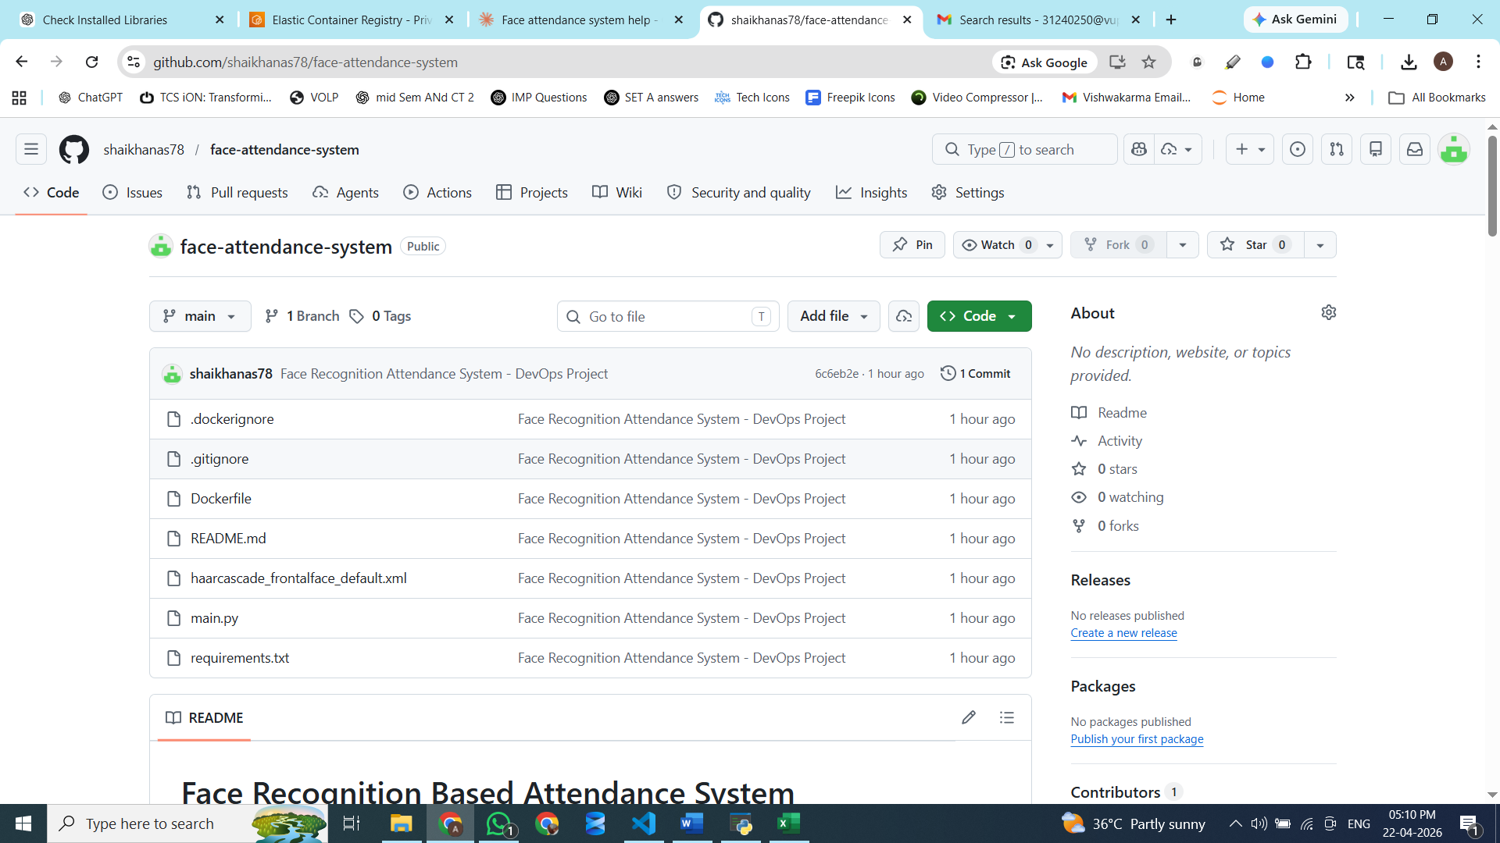  7. AWS ECR — Docker image successfully built on AWS CloudShell and pushed to private ECR repository: 565715328426.dkr.ecr.eu-north-1.amazonaws.com/face-attendance-system:latest  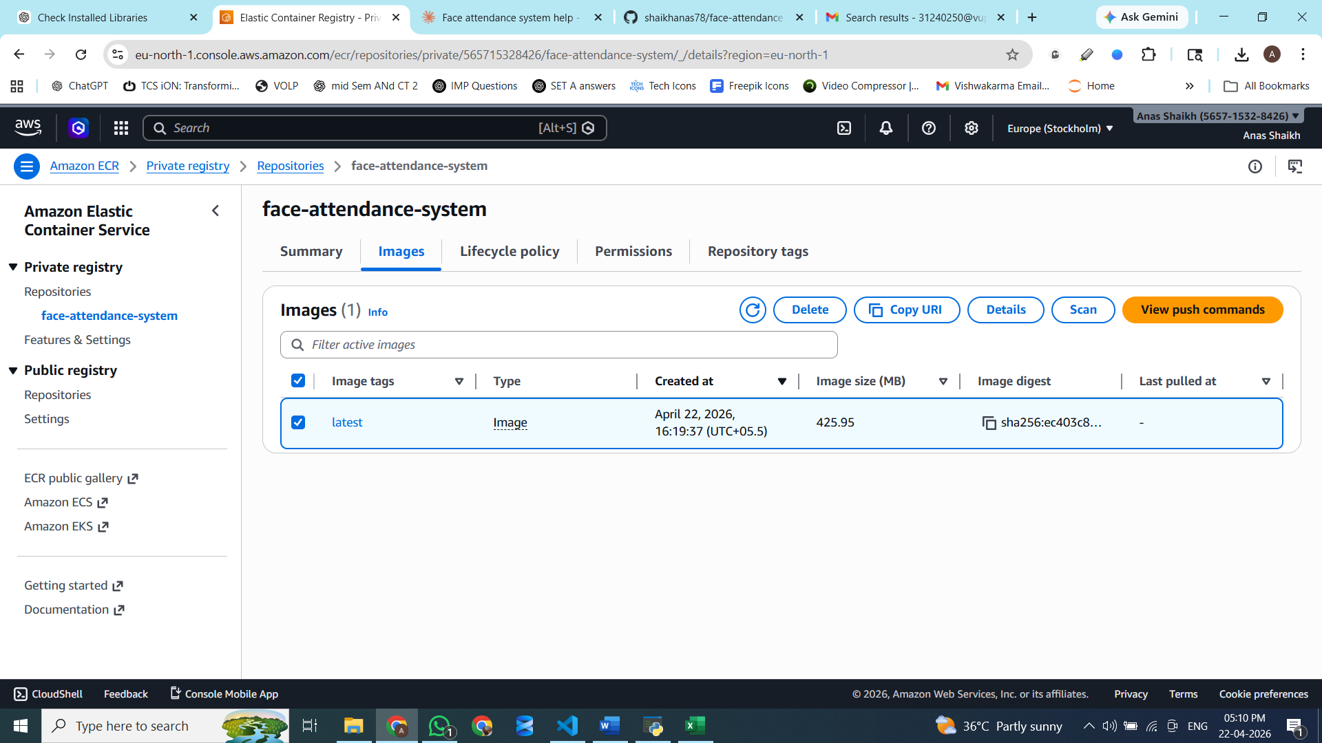

CO: Course Outcome, BTL: Bloom's Taxonomy Level
Course Outcomes
CO No. | Statement
CO1 | Understand DevOps concepts and containerization principles (Understand)
CO2 | Apply version control using Git and GitHub (Apply)
CO3 | Implement Docker containerization for Python applications (Apply)
CO4 | Deploy Docker images to AWS cloud services (Apply)
CO5 | Demonstrate a complete DevOps pipeline from code to cloud (Create)

Bloom's Taxonomy Level (BTL)
BTL No. | BTL | Statement
1 | Remember | Recall facts and basic concepts
2 | Understand | Explain ideas or concepts
3 | Apply | Use information in new situations
4 | Analyze | Draw connections among ideas
5 | Evaluate | Justify a stand or decision
6 | Create | Produce new or original work

