SZABIST UNIVERSITY
(Shaheed Zulfikar Ali Bhutto Institute of Science and Technology)

DATABASE MANAGEMENT SYSTEM (DBMS)
PROJECT REPORT

Online Shopping Management System
A Relational Database Design & Implementation Project

Submitted By
Nadia Shaikh (24108120)
Anzal Shaikh (24108106)
Instructor
Sir Sikandar

Submission Date
1 May 2024

1. Introduction

1.1 Introduction to the Online Shopping Management System
The Online Shopping Management System is a relational database project designed to model the backend data operations of a fashion and clothing e-commerce store. The system is built using MySQL and managed through phpMyAdmin on a XAMPP server environment. It captures the complete data lifecycle of an online store, covering customers, product catalogues, shopping carts, wishlists, orders, payments, shipments, and product reviews within a single, structured relational database named online shopping management system.

1.2 Purpose of the Project
The purpose of this project is to design and implement a normalized relational database capable of efficiently managing an online fashion store end-to-end. It aims to demonstrate practical database design skills, including entity identification, relationship modeling, key constraints, and SQL query writing, by building a real, working schema populated with sample data.

1.3 Problem Statement
Fashion retail businesses moving online often lack a centralized system to manage their operations. Specifically, the project addresses the following problems identified during requirement analysis:
- No centralized system exists to track products, stock levels, and suppliers together.
- Managing customer accounts, addresses, and order history becomes difficult without a structured schema.
- There is no proper mechanism to track shopping carts and wishlists for users.
- Manual handling of payments, shipments, and coupon codes is error-prone.
- There is no structured way to collect and view product reviews and ratings.

1.4 Objectives
- To design a normalized relational database schema for an online fashion store.
- To correctly model one-to-one, one-to-many relationships between entities using primary and foreign keys.
- To implement the schema in MySQL using phpMyAdmin on a XAMPP server.
- To populate the database with realistic sample data for testing.
- To write and demonstrate SQL queries involving joins, grouping, and aggregate functions.

1.5 Scope of the System
The scope of the system, as implemented, covers 16 interlinked tables spanning user management (users, addresses), product management (products, categories, suppliers, inventory), shopping (carts, cart_items, wishlists, wishlist_items), order processing (orders, order_items, coupons), fulfilment (payments, shipments), and customer feedback (reviews). The system focuses on the fashion and clothing domain, covering Women, Men, Kids, Accessories, and Sale categories. The project scope is limited to database design, implementation, and query demonstration; a front-end application layer was not part of the delivered database and is discussed under Future Enhancements.

2. System Overview

2.1 How the Online Shopping Database Works
The database is centered around the users table, which stores customer account information. From this central entity, the system branches into several functional areas. Each user can have multiple saved addresses, a cart, and a wishlist. Users place orders, which reference a shipping address, a billing address, and optionally a coupon. Each order is broken down into individual order_items, each pointing to a specific product. Products are organized under categories and stocked through suppliers via the inventory table. Once an order is placed, it generates a corresponding payment record and, subsequently, a shipment record for delivery tracking. Users may also leave reviews for products they have purchased.

2.2 How Users, Products, Orders, Payments, Shipments, and Reviews Are Connected
The relationships in the schema flow as follows: a user (users) can own multiple addresses (addresses), place multiple orders (orders), maintain one cart (carts) and one wishlist (wishlists), and write multiple reviews (reviews). Each order is linked to the user who placed it and to two address records (shipping and billing), and optionally to a coupon (coupons) for discounts. An order is composed of multiple order_items, each referencing a product (products). Products belong to a category (categories) and are supplied and stocked through the inventory table, which links products to suppliers (suppliers). Once an order is confirmed, a payments record captures the transaction, and a shipments record tracks delivery. Reviews connect a user and a product, allowing feedback to be tied back to both the customer and the item purchased.

2.3 Why a Relational Database Is Suitable for This System
A relational database is well suited to this system because the domain is inherently made up of distinct, interrelated entities — customers, products, orders, payments — that must remain consistent with one another. Foreign key constraints enforce referential integrity, for example ensuring that an order_items row cannot reference a product that does not exist, or that a payments row cannot exist without a valid order_id. The tabular, normalized structure avoids data duplication (for instance, product details are stored once in products and referenced by product_id everywhere else), and SQL provides a powerful and standardized way to query, join, and aggregate this interconnected data, which is essential for reporting on orders, revenue, inventory, and customer behaviour.

3. Technologies Used
The project was implemented using the following technology stack:
Technology | Purpose
MySQL | The relational database management system (RDBMS) used to create, store, and query the 16-table database schema, including all tables, primary/foreign key constraints, and sample data.
phpMyAdmin | A web-based administration tool used to design, build, and manage the MySQL database — including creating tables, defining relationships, running SQL queries, and viewing the database structure through the Designer tab (used for the ER diagram).
XAMPP | A local server stack (Apache, MySQL/MariaDB, PHP, Perl) used to host the MySQL/MariaDB server and phpMyAdmin locally for development and testing of the database.

The database dump indicates the project was generated using phpMyAdmin version 5.2.1, running on a MariaDB 10.4.32 server (MySQL-compatible), with PHP version 8.2.12 — consistent with a standard XAMPP local development environment.

4. Database Design

4.1 Database Structure
The database is named online shopping management system and consists of 16 tables, organized into five functional groups:
Functional Group | Tables
User Management | users, addresses
Product & Supply Management | products, categories, suppliers, inventory
Shopping (Cart & Wishlist) | carts, cart_items, wishlists, wishlist_items
Order Processing | orders, order_items, coupons
Fulfilment & Feedback | payments, shipments, reviews

4.2 Table Overview and Purpose
Each table serves a distinct purpose within the system, summarized below. Full details of each table's primary key, foreign keys, and important attributes are provided in Section 5 (Database Tables).
Table | Purpose
users | Stores registered customer account details.
addresses | Stores shipping and billing addresses linked to a user.
categories | Stores product categories (Women, Men, Kids, Sale, Accessories).
products | Stores the product catalogue for the store.
suppliers | Stores supplier/vendor details who provide stock for products.
inventory | Tracks stock quantity of each product per supplier.
carts | Represents a shopping cart belonging to a user.
cart_items | Stores individual product line items placed inside a cart.
wishlists | Represents a wishlist belonging to a user.
wishlist_items | Stores individual products saved inside a wishlist.
coupons | Stores discount coupon codes that can be applied to orders.
orders | Stores customer order records, including status and totals.
order_items | Stores individual product line items within a placed order.
payments | Stores payment transaction details for each order.
shipments | Stores shipment/delivery tracking details for each order.
reviews | Stores customer ratings and comments for products.

4.3 Primary Keys and Foreign Keys — Summary
Every table in the schema uses a single-column surrogate primary key (an auto-incrementing integer id), which is standard relational design practice. The table below summarizes the primary and foreign key relationships exactly as declared in the database dump (Project.sql). Note: a small number of columns — cart_items.product_id and inventory.supplier_id — are indexed but do not have an explicit FOREIGN KEY constraint declared in the provided SQL dump, even though they are conceptually linked to products and suppliers respectively; this is reported as found and not altered.
Table | Primary Key | Foreign Key(s) → Referenced Table
addresses | address_id | user_id → users(user_id)
carts | cart_id | user_id → users(user_id)
cart_items | cart_item_id | cart_id → carts(cart_id) [product_id indexed, no FK constraint declared]
categories | category_id | — (none)
coupons | coupon_id | — (none)
inventory | inventory_id | product_id → products(product_id) [supplier_id indexed, no FK constraint declared]
orders | order_id | user_id → users; shipping_address_id → addresses; billing_address_id → addresses; coupon_id → coupons
order_items | order_item_id | order_id → orders(order_id); product_id → products(product_id)
payments | payment_id | order_id → orders(order_id)
products | product_id | category_id → categories(category_id)
reviews | review_id | user_id → users(user_id); product_id → products(product_id)
shipments | shipment_id | order_id → orders(order_id)
suppliers | supplier_id | — (none)
users | user_id | — (none)
wishlists | wishlist_id | user_id → users(user_id)
wishlist_items | wishlist_item_id | wishlist_id → wishlists(wishlist_id); product_id → products(product_id)

5. Database Tables
This section describes every table in the database in detail, including purpose, primary key, foreign keys, key columns, and related tables — extracted directly from the provided Project.sql database dump.

Table: users
Attribute | Detail
Purpose | Stores registered customer account information; the central entity referenced by addresses, carts, wishlists, orders, and reviews.
Primary Key | user_id
Foreign Key(s) | None
Key Columns | username, email, password, first_name, last_name, phone, gender (enum: M, F, O), date_of_birth, created_at, status
Related Tables | addresses, carts, wishlists, orders, reviews

Table: addresses
Attribute | Detail
Purpose | Stores shipping and billing addresses belonging to a user.
Primary Key | address_id
Foreign Key(s) | user_id → users(user_id)
Key Columns | address_type (enum: shipping, biling), line1, line2, city, state, postal_code, country, is_default
Related Tables | users, orders (as shipping_address_id / billing_address_id)

Table: categories
Attribute | Detail
Purpose | Stores the product category list used to classify items in the catalogue.
Primary Key | category_id
Foreign Key(s) | None
Key Columns | name, description
Related Tables | products

Table: products
Attribute | Detail
Purpose | Stores the product catalogue, including pricing, stock, and descriptive attributes.
Primary Key | product_id
Foreign Key(s) | category_id → categories(category_id)
Key Columns | name, description, sku, price, discount_percent, stock_quantity, weight, color, brand, created_at
Related Tables | categories, inventory, cart_items, order_items, wishlist_items, reviews

Table: suppliers
Attribute | Detail
Purpose | Stores details of vendors/suppliers who provide product stock.
Primary Key | supplier_id
Foreign Key(s) | None
Key Columns | name, contact_name, email, phone, address
Related Tables | inventory

Table: inventory
Attribute | Detail
Purpose | Tracks stock quantity for each product, linked to the supplier providing it.
Primary Key | inventory_id
Foreign Key(s) | product_id → products(product_id)
Key Columns | supplier_id, quantity, last_updated
Related Tables | products, suppliers

Table: carts
Attribute | Detail
Purpose | Represents an active shopping cart owned by a user (one cart per user in the sample data).
Primary Key | cart_id
Foreign Key(s) | user_id → users(user_id)
Key Columns | created_at
Related Tables | users, cart_items

Table: cart_items
Attribute | Detail
Purpose | Stores individual product line items placed inside a shopping cart.
Primary Key | cart_item_id
Foreign Key(s) | cart_id → carts(cart_id)
Key Columns | product_id, quantity, unit_price
Related Tables | carts, products (conceptually, via product_id)

Table: wishlists
Attribute | Detail
Purpose | Represents a wishlist owned by a user for saving products of interest.
Primary Key | wishlist_id
Foreign Key(s) | user_id → users(user_id)
Key Columns | created_at
Related Tables | users, wishlist_items

Table: wishlist_items
Attribute | Detail
Purpose | Stores individual products saved inside a user's wishlist.
Primary Key | wishlist_item_id
Foreign Key(s) | wishlist_id → wishlists(wishlist_id); product_id → products(product_id)
Key Columns | added_at
Related Tables | wishlists, products

Table: coupons
Attribute | Detail
Purpose | Stores discount coupon codes that customers can apply to their orders.
Primary Key | coupon_id
Foreign Key(s) | None
Key Columns | code, description, discount_percent, discount_amount, valid_from, valid_to, usage_limit, usage_count, active
Related Tables | orders

Table: orders
Attribute | Detail
Purpose | Stores customer order records, including delivery/billing address references, coupon applied, status, and total amount.
Primary Key | order_id
Foreign Key(s) | user_id → users; shipping_address_id → addresses; billing_address_id → addresses; coupon_id → coupons
Key Columns | order_status, payment_status, order_date, total_amount
Related Tables | users, addresses, coupons, order_items, payments, shipments

Table: order_items
Attribute | Detail
Purpose | Stores the individual product line items that make up a placed order.
Primary Key | order_item_id
Foreign Key(s) | order_id → orders(order_id); product_id → products(product_id)
Key Columns | quantity, unit_price
Related Tables | orders, products

Table: payments
Attribute | Detail
Purpose | Stores the payment transaction details associated with an order.
Primary Key | payment_id
Foreign Key(s) | order_id → orders(order_id)
Key Columns | payment_method, payment_status, transaction_id, amount, paid_at
Related Tables | orders

Table: shipments
Attribute | Detail
Purpose | Stores shipment and delivery tracking details for an order.
Primary Key | shipment_id
Foreign Key(s) | order_id → orders(order_id)
Key Columns | courier, tracking_number, shipment_status, shipped_date, delivered_date
Related Tables | orders

Table: reviews
Attribute | Detail
Purpose | Stores customer ratings and comments submitted for a product.
Primary Key | review_id
Foreign Key(s) | user_id → users(user_id); product_id → products(product_id)
Key Columns | rating, comment, review_date
Related Tables | users, products

6. ER Diagram / Database Relationships

6.1 Relationships Overview
The database models the following key relationships, as documented in the project presentation and confirmed by the foreign key constraints in the SQL dump:
Relationship | Cardinality
User — Address | 1 : M (one user can have many addresses)
User — Cart | 1 : 1 (one user has one cart, per the sample data)
User — Orders | 1 : M (one user can place many orders)
Category — Product | 1 : M (one category groups many products)
Product — CartItem | 1 : M (one product can appear in many cart items)
Product — OrderItem | 1 : M (one product can appear in many order items)
Order — OrderItem | 1 : M (one order contains many order items)
Order — Payment | 1 : 1 (one order has one payment record)
Order — Shipment | 1 : 1 (one order has one shipment record)
Product — Review | 1 : M (one product can receive many reviews)
Supplier — Inventory | 1 : M (one supplier stocks many inventory records)

6.2 ER Diagram (Design Stage)
The diagram below shows the database schema as originally designed, prior to implementation in phpMyAdmin, illustrating each table's attributes and the foreign key connections between them.
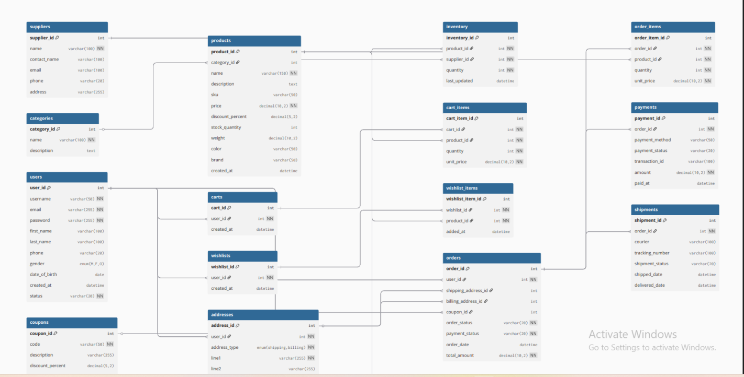
Figure 1: Entity-Relationship design of the Online Shopping Management System (pre-implementation diagram).

6.3 phpMyAdmin Designer View (Implemented Schema)
The screenshot below is taken from the phpMyAdmin Designer tab, showing all 16 tables of the implemented database with their live foreign key connections.
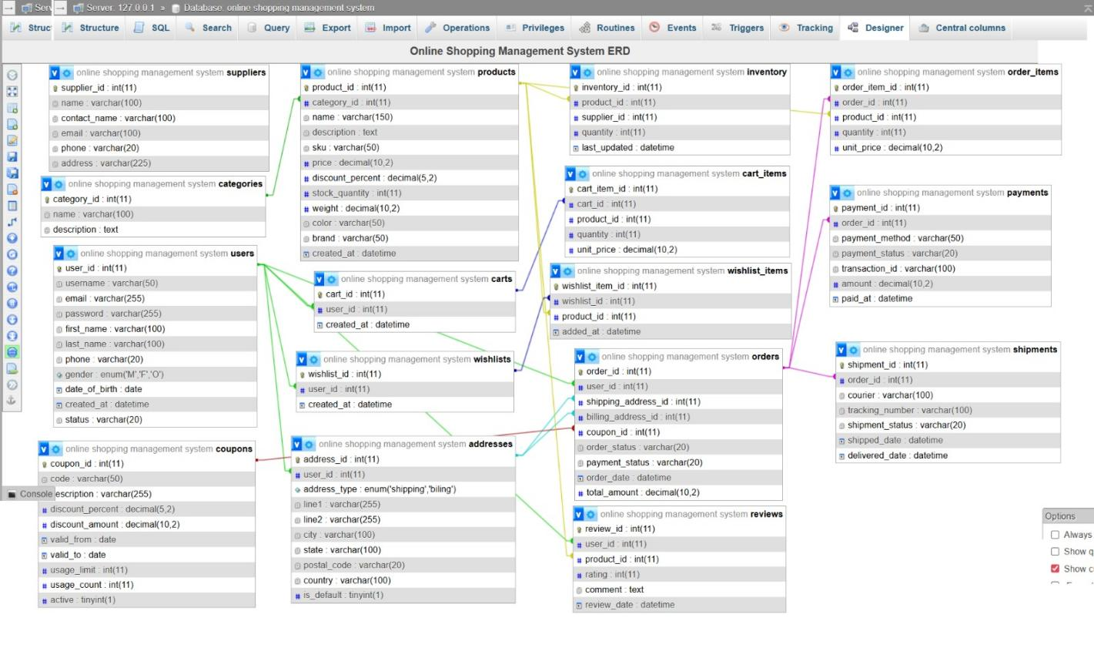
Figure 2: phpMyAdmin Designer view of the online shopping management system database, showing all foreign key relationships.

7. SQL Implementation
The database was implemented entirely in SQL. Representative examples of each statement type, taken directly from the Project.sql dump, are shown below.

7.1 CREATE DATABASE / Database Context
The SQL dump does not include an explicit CREATE DATABASE statement (phpMyAdmin exports typically assume the database already exists); the dump header confirms the target database name as follows:
-- Database: `online shopping management system`

7.2 CREATE TABLE
Example: creation of the products table, showing column definitions and data types.
CREATE TABLE `products` (
`product_id` int(11) NOT NULL,
`category_id` int(11) NOT NULL,
`name` varchar(150) NOT NULL,
`description` text NOT NULL,
`sku` varchar(50) NOT NULL,
`price` decimal(10,2) NOT NULL,
`discount_percent` decimal(5,2) NOT NULL,
`stock_quantity` int(11) NOT NULL,
`weight` decimal(10,2) NOT NULL,
`color` varchar(50) NOT NULL,
`brand` varchar(50) NOT NULL,
`created_at` datetime NOT NULL
) ENGINE=InnoDB DEFAULT CHARSET=utf8mb4 COLLATE=utf8mb4_general_ci;

7.3 INSERT
Example: inserting sample records into the categories table.
INSERT INTO `categories` (`category_id`, `name`, `description`) VALUES
(1, 'Women', 'Womens clothing and accessories'),
(2, 'Men', 'Mens clothing and accessories'),
(3, 'Kids', 'Childrens clothing'),
(4, 'Sale', 'Discounted items'),
(5, 'Accessories', 'Bags, belts, scarves and more');

7.4 SELECT and JOIN
Example (from the project presentation, Slide 9, Q1): retrieving all orders together with the customer's name.
SELECT o.order_id, u.first_name, u.last_name,
o.total_amount, o.payement_status
FROM orders o JOIN users u ON o.user_id = u.user_id;
Note: this query is reproduced exactly as it appears in the project presentation. The column referenced as payement_status does not match the actual column name in the orders table, which is payment_status — this discrepancy exists in the original source material and has not been corrected here, per the instruction to avoid altering the actual project details.
Example (Slide 9, Q2): retrieving products together with their category name.
SELECT p.name, p.price, c.name AS category
FROM products p
JOIN categories c ON p.category_id = c.category_id;

7.5 GROUP BY and Aggregate Functions
Example (Slide 9, Q3): finding the top-rated products by average customer rating, using the AVG() aggregate function with GROUP BY.
SELECT p.name, AVG(r.rating) AS avg_rating
FROM reviews r JOIN products p ON r.product_id = p.product_id
GROUP BY p.name ORDER BY avg_rating DESC;

8. Sample Queries and Results
The following queries were presented as sample SQL demonstrations in the project presentation (Slide 9: "Sample SQL Queries"). No screenshots of actual query result sets were included in the provided project files, so expected results are described based on the sample data present in Project.sql rather than shown as captured output.

Query 1: Get all orders with user names
SELECT o.order_id, u.first_name, u.last_name,
o.total_amount, o.payement_status
FROM orders o JOIN users u ON o.user_id = u.user_id;
Purpose: Joins the orders table with the users table on user_id to display each order alongside the customer's first and last name, order total, and status.
Expected result (based on sample data): a 10-row result set (one row per order in the orders table), for example order_id 1 paired with user Nadia Khan, total amount 5670.00.

Query 2: Products with category names
SELECT p.name, p.price, c.name AS category
FROM products p
JOIN categories c ON p.category_id = c.category_id;
Purpose: Joins products with categories to display each product's name and price alongside its readable category name, instead of the raw category_id.
Expected result (based on sample data): a 16-row result set, for example "Floral Maxi Dress", price 3500.00, category "Women".

Query 3: Top rated products by average rating
SELECT p.name, AVG(r.rating) AS avg_rating
FROM reviews r JOIN products p ON r.product_id = p.product_id
GROUP BY p.name ORDER BY avg_rating DESC;
Purpose: Joins reviews with products and groups by product name to calculate each product's average rating using AVG(), ordering results from highest to lowest rated.
Expected result (based on sample data): products with a single 5-star review, such as "Floral Maxi Dress", "Silk Kurta", "Embroidered Shawl", and "Waistcoat", would appear at the top with an average rating of 5.0.

9. Screenshots
The provided project files included the following database-related screenshots, embedded in the project presentation:

database.png / structure screenshot
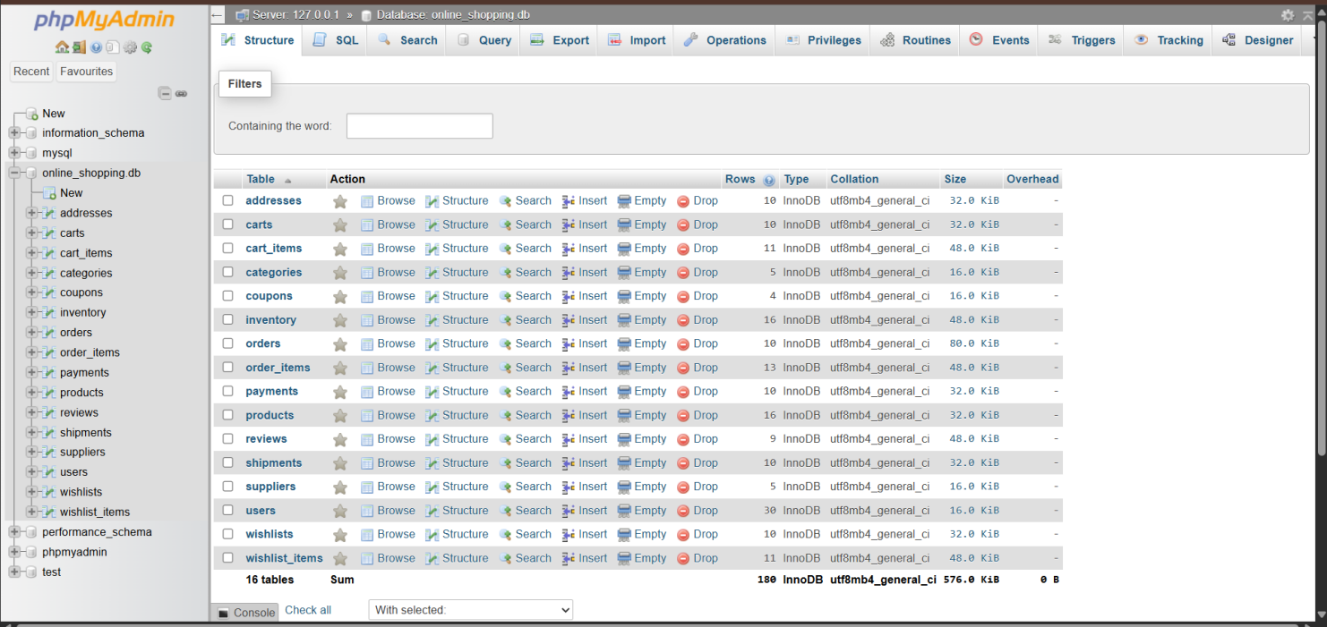

tables.png (table list screenshot)
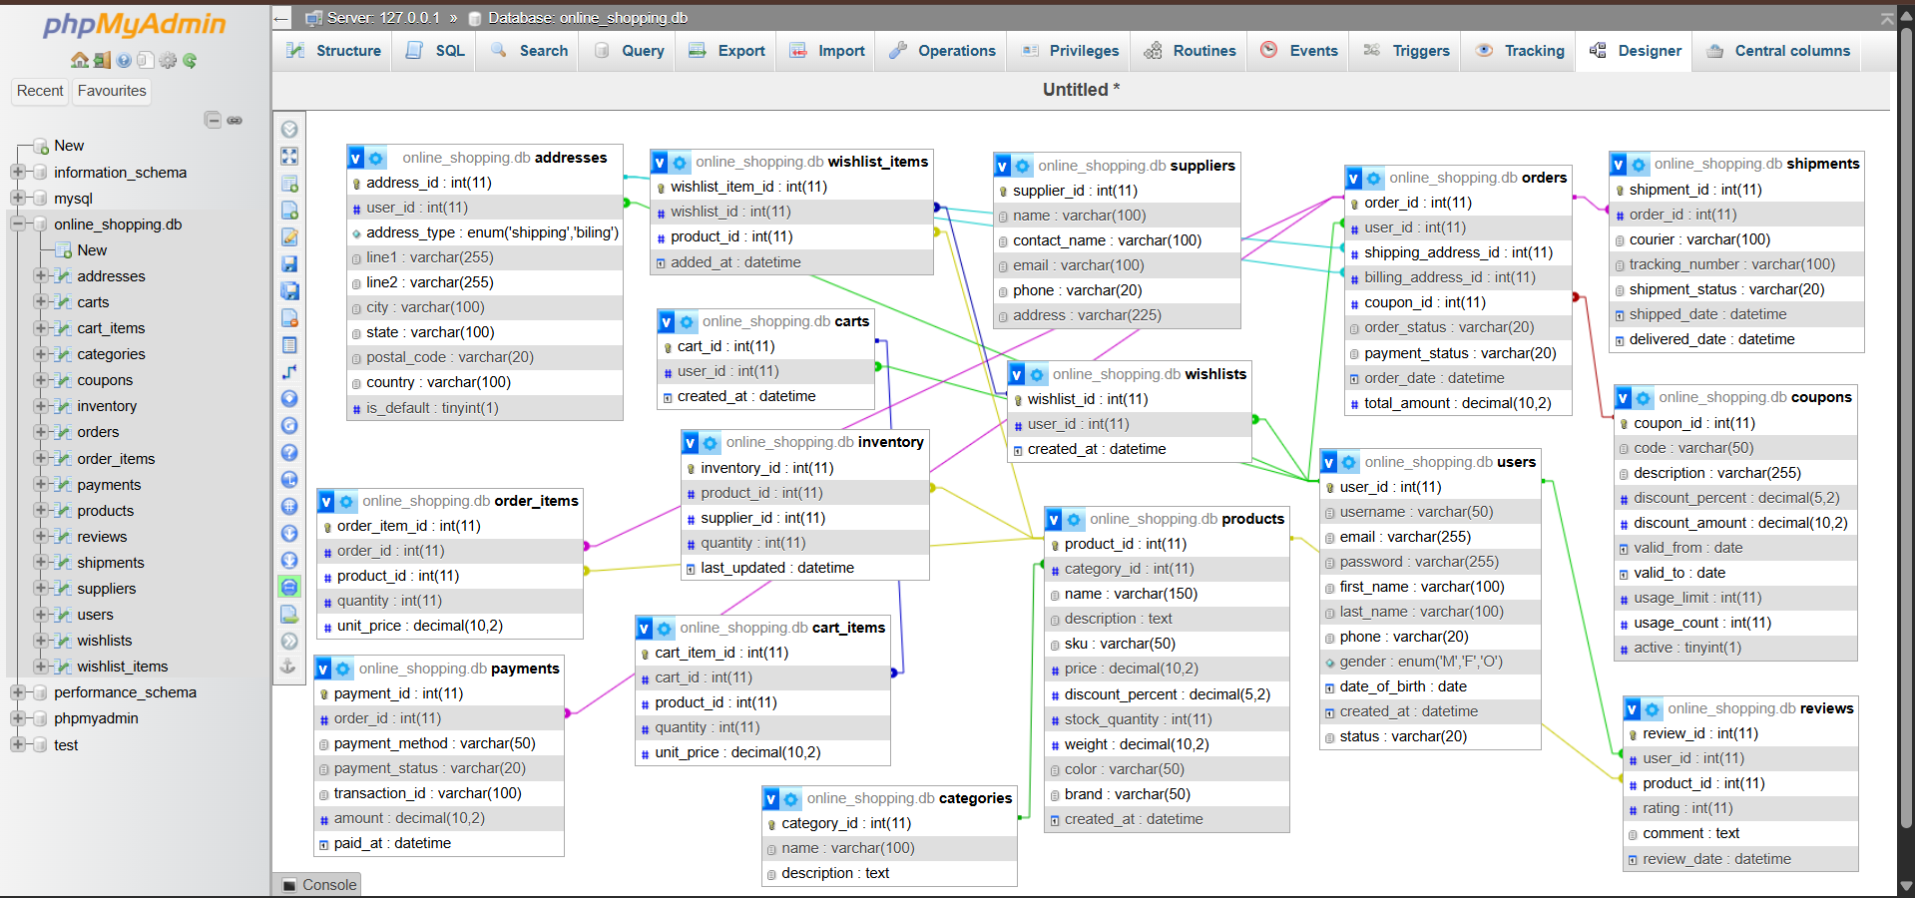

ER Diagram / Designer screenshots
Two ER diagram screenshots were provided and are included in full in Section 6 (ER Diagram / Database Relationships):
- Figure 1 — the pre-implementation ER design diagram (Section 6.2).
- Figure 2 — the phpMyAdmin Designer tab screenshot of the implemented schema (Section 6.3).

queries.png (query result screenshot)
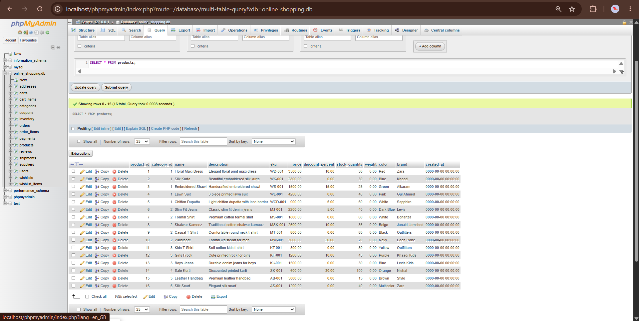

10. Normalization
Normalization was assessed strictly against the structure of the tables as declared in Project.sql.

10.1 First Normal Form (1NF)
All tables in the schema satisfy 1NF. Every column holds a single, atomic value (for example, price is a single decimal value, not a list), each table has a defined primary key (a single-column surrogate id in every case), and there are no repeating groups of columns. For instance, in order_items, each row represents exactly one product line for one order, rather than storing multiple products in a single row.

10.2 Second Normal Form (2NF)
All tables also satisfy 2NF. Since every table uses a single-column primary key (e.g., product_id, order_id, user_id), there is no possibility of a partial dependency on part of a composite key — a requirement that only applies to tables with composite primary keys, none of which exist in this schema.

10.3 Third Normal Form (3NF)
Based on the declared schema, the tables largely satisfy 3NF, as non-key attributes generally depend only on the primary key. For example, in the products table, name, price, and brand all describe the product itself and depend only on product_id, while the category name is correctly kept separate in the categories table and referenced via category_id (avoiding transitive dependency). Similarly, order_items stores unit_price at the time of order rather than deriving it from products — this is a deliberate historical-pricing design choice common in order-management systems, not a normalization violation, since the price of an item at the time of purchase may differ from its current catalogue price.

11. Advantages of the System
- Centralizes product, customer, order, payment, and shipment data in a single, consistent relational database.
- Enforces data integrity through primary and foreign key constraints, preventing orphaned or inconsistent records across related tables.
- Separates concerns cleanly — e.g., products, categories, and inventory are modeled as distinct tables — reducing data duplication.
- Supports flexible reporting and analysis through SQL joins, grouping, and aggregate functions (e.g., average product ratings, order summaries).
- Provides a scalable schema that can support additional features (search, filtering, admin reporting) without redesigning the core structure.

12. Limitations
- The project currently consists of the database layer only; no front-end or admin application was included in the provided files.
- A small number of relationships (cart_items.product_id and inventory.supplier_id) are indexed but not enforced with an explicit foreign key constraint in the current schema.
- Several datetime fields in the sample data use placeholder values (0000-00-00 00:00:00), indicating that timestamp population was not fully completed during testing.
- Passwords in the users table are stored as plain text sample values (e.g., "pass123") rather than hashed values, which would not be acceptable in a production system.
- The addresses table contains a minor spelling inconsistency in its address_type enum value ("biling" instead of "billing"), carried over from the original schema.

13. Future Enhancements
Based on the future improvements outlined in the project presentation (Slide 10: "Conclusion"), the following enhancements are planned:
- Build a PHP front-end application on top of the existing database.
- Add an admin panel for managing products, orders, and users.
- Implement search and filter functionality for browsing the product catalogue.

14. Conclusion
This project successfully designed and implemented a complete 16-table relational database for an online fashion store, covering user management, product and inventory management, shopping cart and wishlist functionality, order processing, payments, shipments, and product reviews. All foreign key relationships were implemented with the correct cardinality (1:1 and 1:M) between related entities, and the database was populated with realistic sample data — including 30 users and full sample records across all 16 tables — to demonstrate its functionality. Through this project, key database concepts including ER modeling, normalization, and SQL querying (joins, grouping, and aggregate functions) were applied in a practical, real-world-style scenario. The resulting schema provides a solid foundation for the planned future enhancements, including a PHP front-end, admin panel, and search/filter features.

