DATABASE MANAGEMENT SYSTEMS
ACADEMIC PROJECT REPORT
Student Course Registration System
A Complete Database Design Project
Project Title | Student Course Registration System
Subject | Database Management Systems (DBMS)
Submitted By | Arshman (24108107), Anzal (24108106),  Zakia (24108131), Nadia (24108120)
Academic Level | Undergraduate / University
Date | May 6, 2026
Supervisor | Sir Javed Dahri
Department | Department of Artificial Intelligence

. Table of Contents

- Entity-Relationship (ER) Diagram Page 3
- Relational Schema Page 5
- Normalization — UNF to BCNF Page 6
- Sample Data Tables Page 12

1. Entity-Relationship (ER) Diagram

  - Database Overview

The Student Course Registration System involves four core entities that interact to model real-world academic enrollment. The central design challenge is resolving the many-to-many (M:N) relationship between Students and Courses, achieved through the Enrollment junction entity.
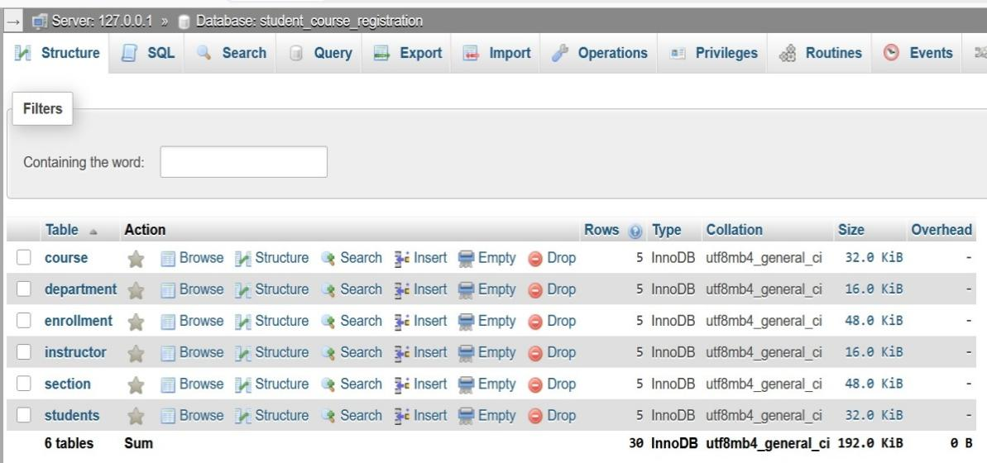
  - Entities & Attributes

- student
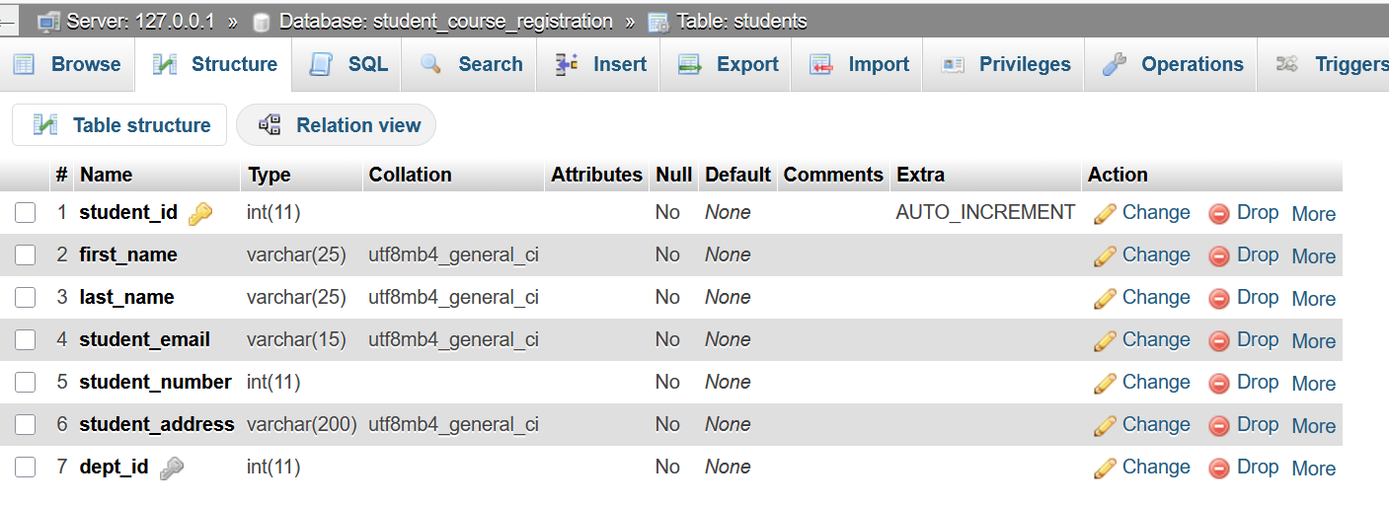
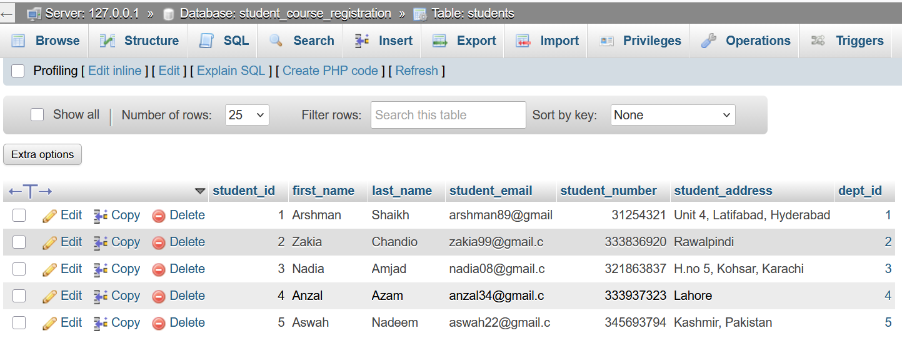
- section
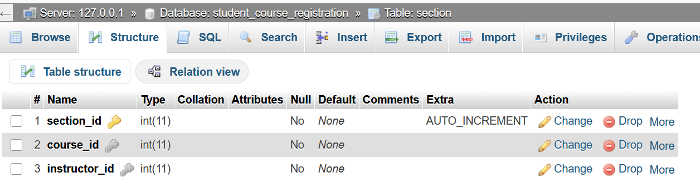
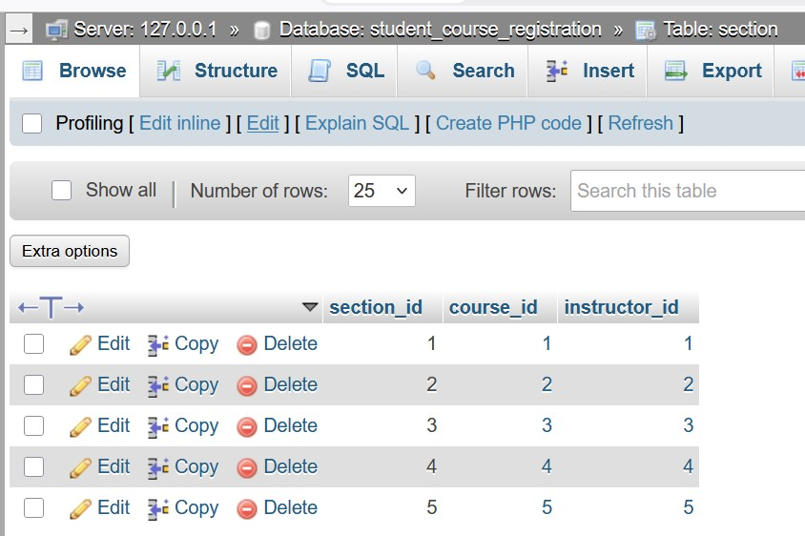

- instructor
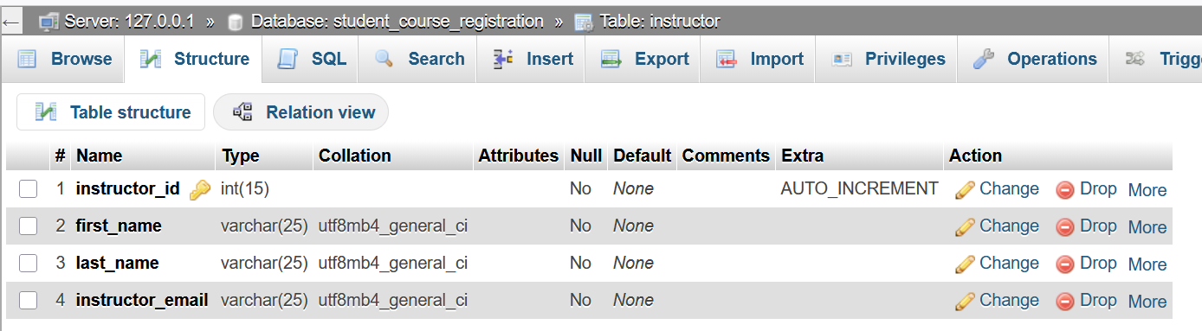
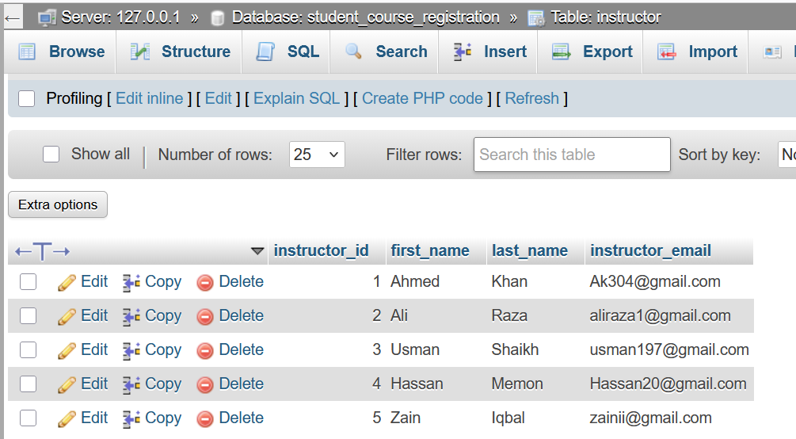

- enrollment
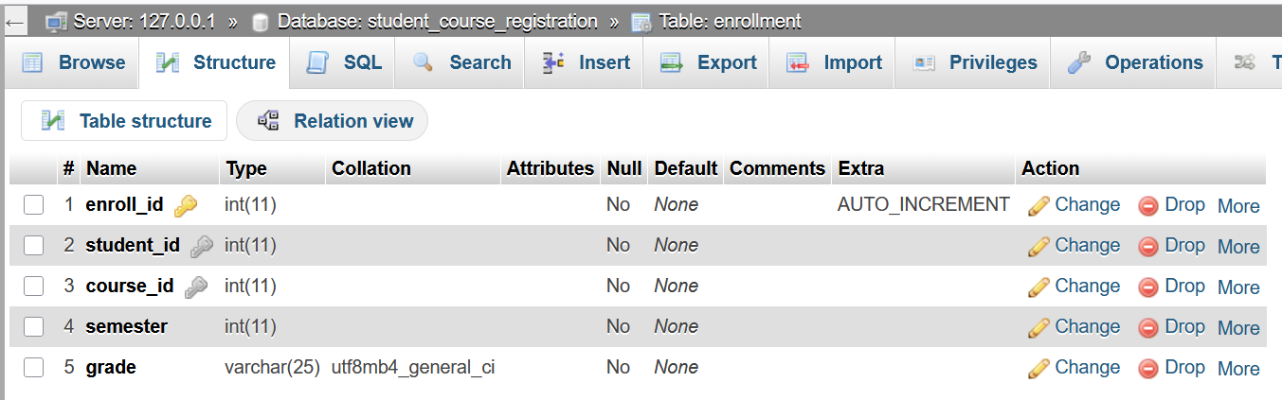
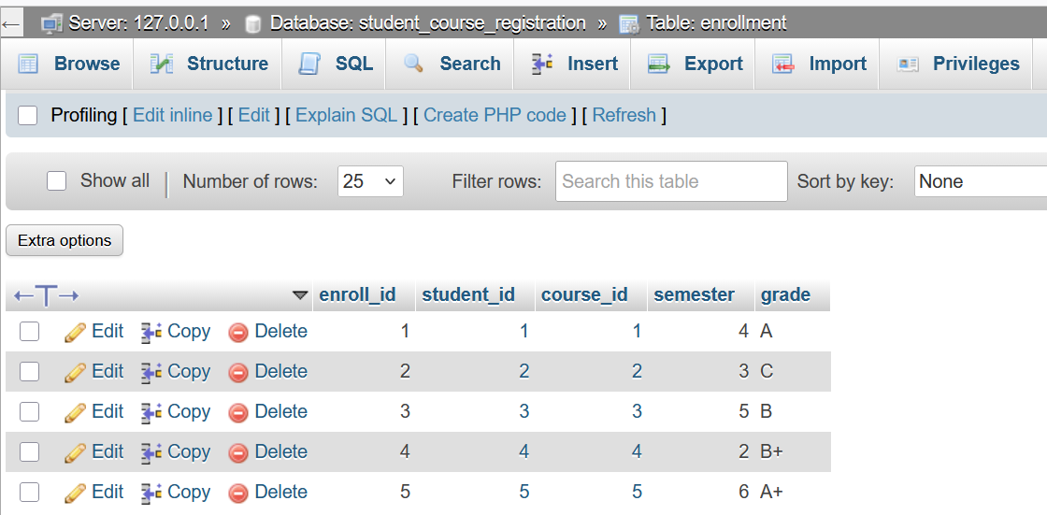
- department
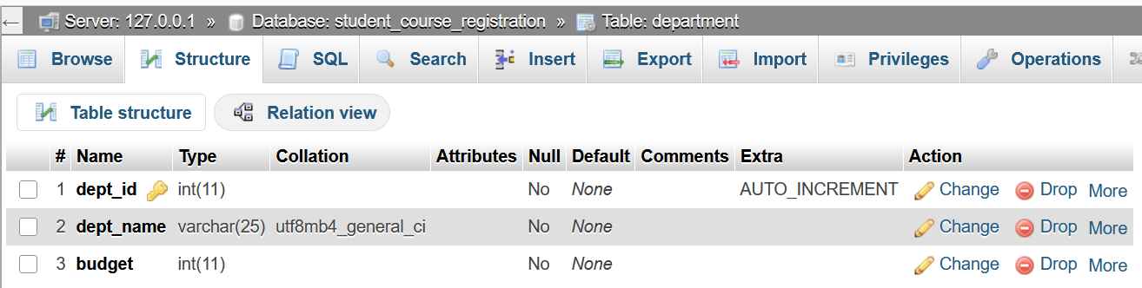
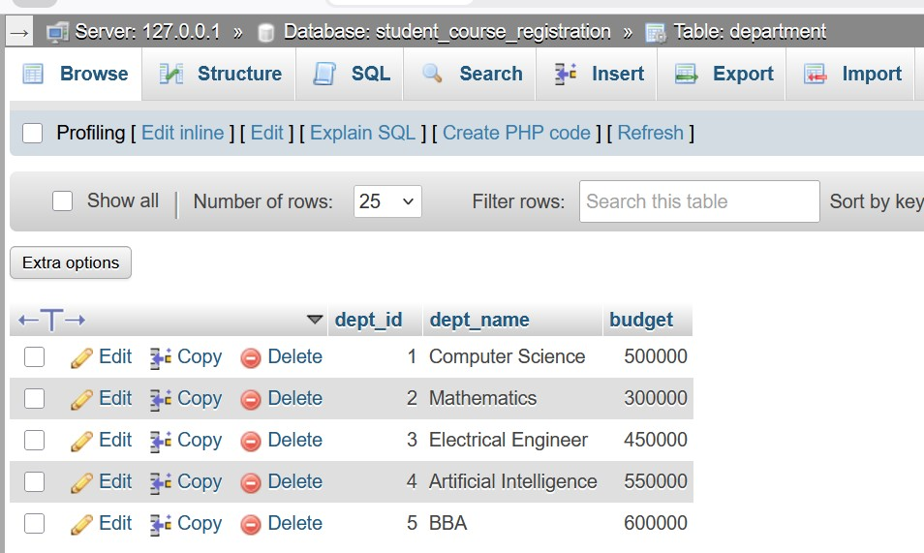

- course
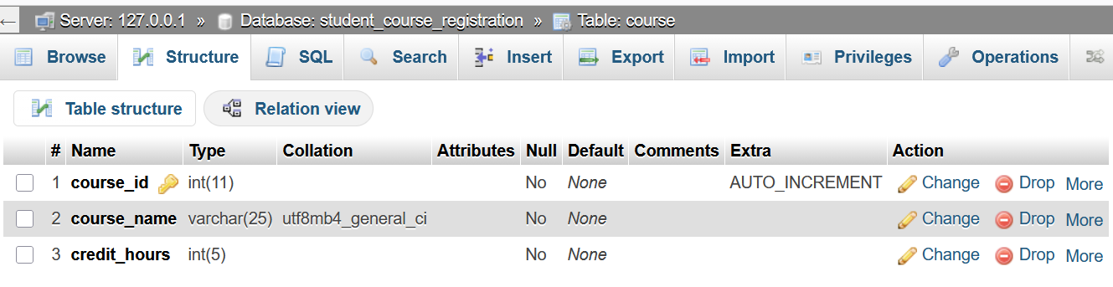
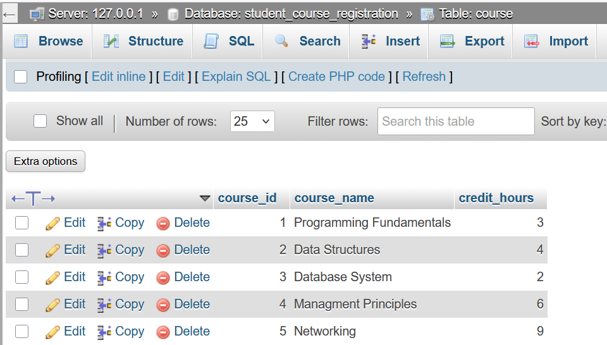

1.3 Relationships & Cardinality

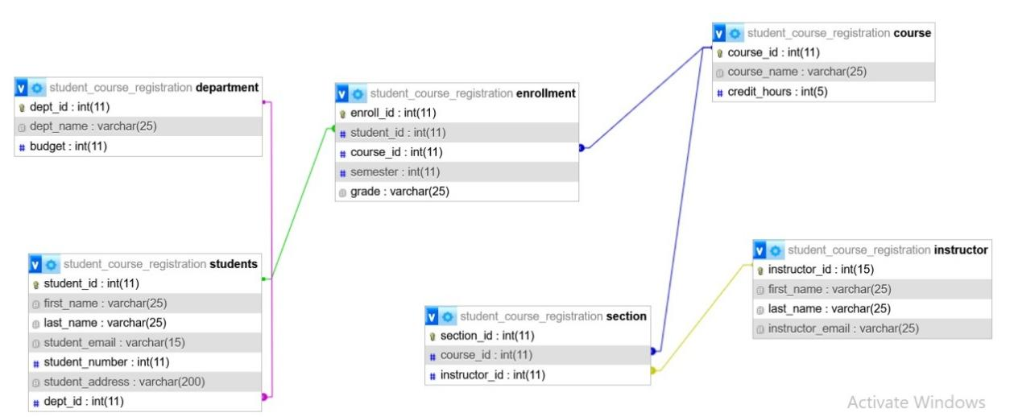
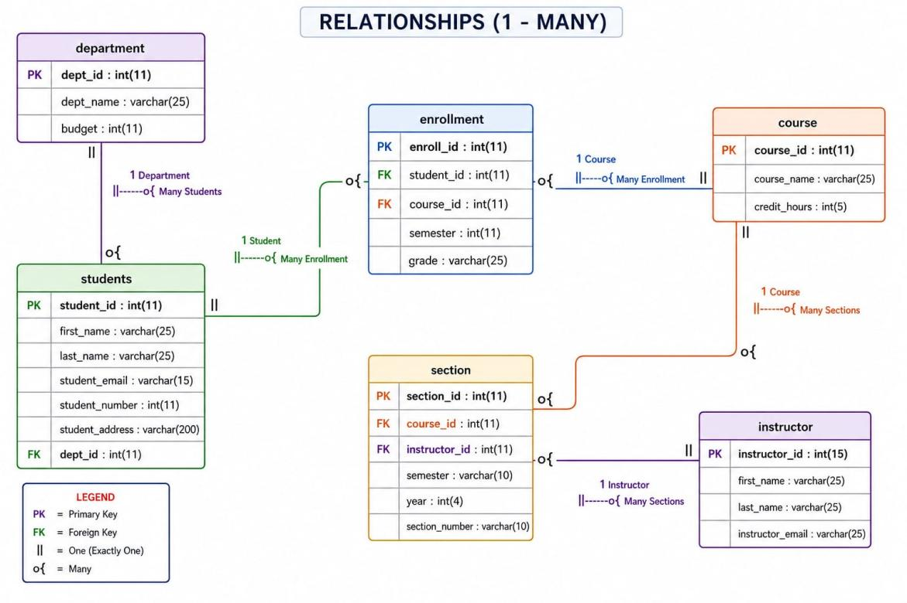

  - ER Diagram
ER Notation Guide
- Rectangle = Entity
- Oval = Attribute
- Underlined = Primary Key attribute
- Double Oval = same person having multiple values
- Doted- Underline= Foreign Key attribute
- Diamond = Relationship

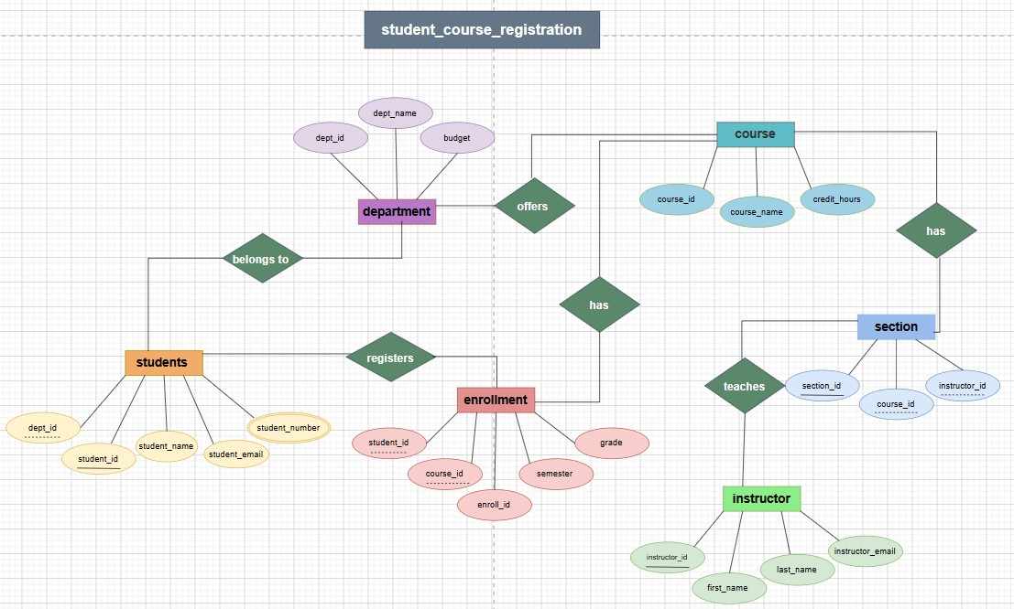
1.5 Normalization — UNF to BCNF

Why Normalize?
- Normalization eliminates data redundancy — storing the same data in multiple places.
- It prevents update anomalies (changing data in one place but not another).
- It prevents insert anomalies (inability to add data without unrelated data).
- It prevents delete anomalies (losing data accidentally when deleting a row).
- Each normal form builds on the previous, progressively cleaning the structure.

1.6 First Normal Form (1NF)

Definition: A table is in 1NF if every column contains only atomic (indivisible) values, each column has a unique name, the order of rows does not matter, and there are no repeating groups or arrays.

1.7 Rules of 1NF

- Each table has a primary key that uniquely identifies each row.
- Each column contains only atomic (single) values — no lists or sets.
- No repeating groups of columns exist.
- All entries in a column are of the same data type.

1.8 1NF Analysis — All Tables

Table | Primary Key | All Atomic? | No Repeating Groups? | 1NF Status
students | student_id | Yes | Yes | ✓ Satisfied
department | dept_id | Yes | Yes | ✓ Satisfied
course | course_id | Yes | Yes | ✓ Satisfied
instructor | instructor_id | Yes | Yes | ✓ Satisfied
enrollment | enroll_id | Yes | Yes | ✓ Satisfied
section | section_id | Yes | Yes | ✓ Satisfied

Detailed Verification:

students: student_id (PK) is unique. All fields — first_name, last_name, student_email, student_number, student_address, dept_id — are single atomic values. No multi-valued attributes exist.
enrollment: enroll_id (PK) is unique. student_id, course_id, semester are stored as single integer values (not arrays). grade is a single VARCHAR value.
section: section_id (PK) is unique. course_id and instructor_id are single FK references — not lists of courses or instructors.

✓ CONCLUSION: All six tables fully satisfy 1NF. Every attribute is atomic, every table has a defined primary key, and no repeating groups exist.

1.9 Second Normal Form (2NF)

Definition: A table is in 2NF if it is in 1NF AND every non-key attribute is fully functionally dependent on the entire primary key (not just part of it). This rule applies only when the primary key is a composite key.

2.1 Rules of 2NF

- Table must already be in 1NF.
- No partial dependency: non-key attributes must depend on the whole primary key.
- If the PK is a single column, the table is automatically free of partial dependencies.

2.2 Functional Dependencies Analysis

Table | Primary Key Type | Non-Key Attributes | Partial Dependency? | 2NF Status
students | Single (student_id) | first_name, last_name, email, number, address, dept_id | None | ✓ Satisfied
department | Single (dept_id) | dept_name, budget | None | ✓ Satisfied
course | Single (course_id) | course_name, credit_hours | None | ✓ Satisfied
instructor | Single (instructor_id) | first_name, last_name, instructor_email | None | ✓ Satisfied
enrollment | Single (enroll_id) | student_id, course_id, semester, grade | None | ✓ Satisfied
section | Single (section_id) | course_id, instructor_id | None | ✓ Satisfied

Why 2NF is Automatically Satisfied?

All six tables use a single-column surrogate primary key (student_id, dept_id, course_id, instructor_id, enroll_id, section_id). When the PK is a single attribute, partial dependency is mathematically impossible — every non-key attribute must depend on that one key. Therefore, all tables satisfy 2NF without any restructuring.
✓ CONCLUSION: All six tables fully satisfy 2NF. Since all primary keys are single-column, there are no partial dependencies possible. Every non-key attribute depends on the complete primary key.

2.3 Third Normal Form (3NF)

Definition: A table is in 3NF if it is in 2NF AND no non-key attribute is transitively dependent on the primary key through another non-key attribute. In other words, non-key attributes must depend only on the primary key, not on other non-key attributes.

2.4 Rules of 3NF

- Table must already be in 2NF.
- No transitive dependency: non-key attribute A should not depend on non-key attribute B which depends on the PK.
- Every non-key attribute must be directly determined by the primary key only.

2.3 Transitive Dependency Analysis

Table | Transitive Dependency Check | 3NF Status
students | student_id -> dept_id -> dept_name? No — dept_name is NOT stored in students table. dept_id is just a FK reference. | ✓ Satisfied
department | dept_id -> dept_name, budget. Both depend directly on PK. No transitive chain. | ✓ Satisfied
course | course_id -> course_name, credit_hours. Both depend directly on PK. No transitive chain. | ✓ Satisfied
instructor | instructor_id -> first_name, last_name, instructor_email. All depend directly on PK. | ✓ Satisfied
enrollment | enroll_id -> student_id, course_id, semester, grade. All depend directly on PK. No derived attributes. | ✓ Satisfied
section | section_id -> course_id, instructor_id. Both are FK references, depend directly on PK. | ✓ Satisfied

Key Design Decision — Separation of Concerns:

The schema avoids transitive dependencies by properly separating data into distinct tables. For example, dept_name and budget are stored in the department table (not in students), and course_name is stored in the course table (not in enrollment). This ensures that all attributes depend directly on their table's primary key.
✓ CONCLUSION: All six tables fully satisfy 3NF. No transitive dependencies exist because the schema correctly separates all entity attributes into their respective tables using foreign key references.

2.4 Boyce-Codd Normal Form (BCNF)

Definition: A table is in BCNF (also called 3.5NF) if it is in 3NF AND for every functional dependency X → Y, X must be a super key (i.e., X must be the primary key or a candidate key). BCNF is stricter than 3NF — it handles anomalies that 3NF sometimes misses.

2.5 Difference Between 3NF and BCNF

Property | 3NF | BCNF
Basis | In 2NF, no transitive dependency | In 3NF, every determinant is a superkey
Strictness | Less strict | More strict (stronger version of 3NF)
Anomalies handled | Most update/insert/delete anomalies | All anomalies including 3NF edge cases
When they differ | When there are multiple overlapping candidate keys | When a non-key determines part of a candidate key
Lossless decomposition | Always possible | Not always possible without losing FDs

2.6 BCNF Analysis — All Tables

Table | Functional Dependencies | Determinants Are Superkeys? | BCNF Status
students | student_id -> first_name, last_name, student_email, student_number, student_address, dept_id | Yes — student_id is PK (superkey) | ✓ Satisfied
department | dept_id -> dept_name, budget | Yes — dept_id is PK (superkey) | ✓ Satisfied
course | course_id -> course_name, credit_hours | Yes — course_id is PK (superkey) | ✓ Satisfied
instructor | instructor_id -> first_name, last_name, instructor_email | Yes — instructor_id is PK (superkey) | ✓ Satisfied
enrollment | enroll_id -> student_id, course_id, semester, grade | Yes — enroll_id is PK (superkey) | ✓ Satisfied
section | section_id -> course_id, instructor_id | Yes — section_id is PK (superkey) | ✓ Satisfied

BCNF Verification Logic:

For BCNF, we must check every functional dependency X → Y and confirm that X is a superkey. In all six tables, the only functional dependencies that exist are those where the primary key determines all other attributes. There are no non-trivial functional dependencies where a non-key attribute determines another attribute. Therefore, all determinants are superkeys.
✓ CONCLUSION: All six tables fully satisfy BCNF. In every functional dependency, the left-hand side (determinant) is the table's primary key, which is a superkey. No anomalies remain.

