**SOFTWARE TESTING ASSINGMENT**

**Module 1**

**1.What is SDLC ?**

**ANS. SDLC stand for Software Development Life CYCLE. It Define the entire process of software development step-by-step.**

**It has 6 stages :-**

* **Planning.**
* **Analysis.**
* **Design.**
* **Implementation.**
* **Testing.**
* **Maintenance.**

**The Goal of SDLC Life Cycle is to provide high-quality, maintainable software that meets the User's requirement.**

**2. What is Software Testing ?**

**Ans. Software Testing is a process of checking functionality, performance, quality of a software before launching it. Tester interact with software find bugs and error , ensuring that software works as expected.**

**3. What is Agile Meth ology?**

**Ans. Agile Model is a combination of iterative and incremental process models focus on process of adaptability, customer satisfaction, rapid delivery of a working software.**

**Agile model works on principle.**

**It has 4 Principle :-**

1. **Individual interaction with customer.**
2. **Working software.**
3. **Customer Collaboration.**
4. **Accept the change.**

**4.What is SRS ?**

**Ans. SRS stands for Software Requirement Specification . Its intend purpose and environment for software under development. The SRS fully describes what the software will do and how it will be expected to perform.**

**5.What is OOPS ?**

**Ans. OOPS stand for Object Oriented Programing Language. OOP is based on the idea of classes and objects. It organizes a computer program into basic, reusable blueprints of code or “classes.”**

**6. Write Basic Concept of OOP ?**

**Basic Concept of OOP :-**

1. **Class.**
2. **Object.**
3. **Inheritance.**
4. **Polymorphism.**
5. **Abstraction.**
6. **Encapsulation.**

**7. What is Object ?**

**Ans. An object can be defined as a data field that has unique attributes and behavior. An object is an instance of a Class. It contains properties and functions. They are like real-world objects.**

**8. What is class ?**

**Ans. It is a user-defined data type, which holds its own data members and member functions, which can be accessed and used by creating an instance of that class. A class is like a blueprint for an object.**

**For example, the animal type Dog is a class while a particular dog named Tommy is an object of the Dog class.**

**9. What is encapsulation ?**

**Ans. Encapsulation is the wrapping up of data and information in a single unit. In Encapsulation is defined as binding together the data and the functions that manipulate them.**

**10. What is Inheritance ?**

**Ans. Inheritance is that enables a new class to inherit the properties and methods of an existing class. This feature promotes code reusability and creates a parent-child relationship between classes.**

**For example , the base class is 'Vehicle' and the derived classes are 'Car', 'Bus', and 'Maruti'.**

**11. What is Polymorphism ?**

**Ans. Polymorphism as the ability of a message to be displayed in more than one form. Polymorphism allows us to perform a single action in different ways.**

**For example, A person at the same time can have different characteristic. Like a man at the same time is a father, a husband, an employee.**

**12. Write SDLC phases with basic introduction.**

**Ans. There are 6 phases in SDLC life cycle :-**

**i) Requirement / Planning :- This Phase gathering the information about the software from customer, Business analyst.**

**ii) Analysis :- This phase analysis the requirement of customer. and make document about requirement and software.**

**iii) Designing :- In this phase, The whole architecture of software created.**

**iv) Implementation :- After designing it implement in coding.**

**v) Testing :- In this phase software tested thoroughly and ensure that it work correctly as per requirement.**

**vi) Maintenance :- In this phase, it include Bug fixed, software Update .**

**13) Explain Phases of the waterfall model.**

**Ans. The Waterfall Model is a classical software development methodology. It is a linear and sequential approach to software development**

**The Waterfall Model has six phases which are:**

1. **Requirements : The first phase involves gathering requirements from client and analyzing them .**
2. **Analysis :- This phase analysis the requirement of customer. and make document about requirement and software.**

**3. Design : Once the requirements are understood, the design phase begins. This involves creating a detailed design document that outlines the software architecture, user interface, and system components.**

**4. Development : The Development phase include implementation involves coding the software based on the design specifications**

**5. Testing : In the testing phase, the software is tested as a whole to ensure that it meets the requirements and is free from defects.**

**6. Maintenance : It fixing any issues that arise after the software has been deployed and ensuring that it continues to meet the requirements in time.**

**14. Write phases of spiral model.**

**Ans. There are 4 phase in Spiral Model :-**

1. **Planning :- In this phase, according to requirement of customer developer plan the software.**
2. **Risk analysis :- In spiral model there is separate phase for risk analyze . if in planning it seem like risk in software then it analyze earlier. So chance of failure decrease.**
3. **Engineering :- In this phase, developer develop the software on basis of requirement of customer. In this phase first prototype product is prepare.**
4. **Customer Evaluation :- In this phase, Testing and maintenance done.**

15. **Write agile manifesto principles**

Ans. **There are 4 agile manifesto principles :-**

1. Individuals and interactions over processes and tools
2. Working software over comprehensive documentation
3. Customer collaboration over contract negotiation
4. Responding to change over following a plan.

16**. Explain working methodology of agile model and also write pros and cons.**

Ans. “Agile SDLC model is a combination of iterative and incremental process models with focus on process adaptability and customer satisfaction by rapid delivery of working software product.”

Pros:

1. Very realistic approach

2. Rapid delivery.

3. Functionality can be developed rapidly

4. Resource requirements are minimum.

5. Little or no planning required

6. Promotes teamwork and cross training.

7. Suitable for fixed or changing requirements

8. Gives flexibility to developer.

**Cons**:

1. More risk of sustainability, maintainability and extensibility.

2. Depends heavily on customer interactions.

3. Very high individual dependency.

4. Minimum documentation generated.

5. Not useful for small projects.

6. Not suitable for handling complex dependencies.

**17. Use Case on Cash On Delivery.**

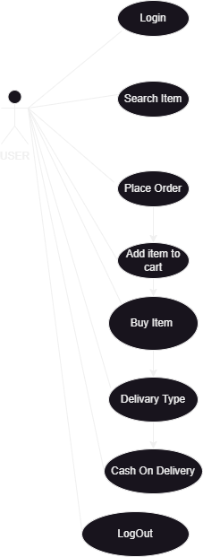

**18. Use Case On Online Book Shopping.**

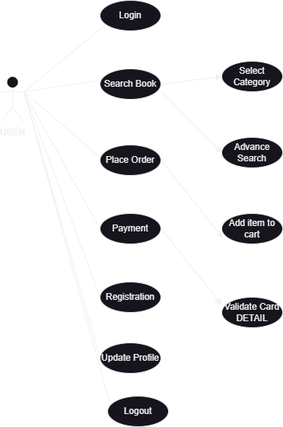

**19. Use Case On Pytm.**

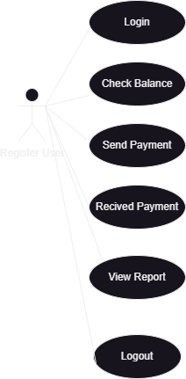

**20.. Use case On Online Shopping.**

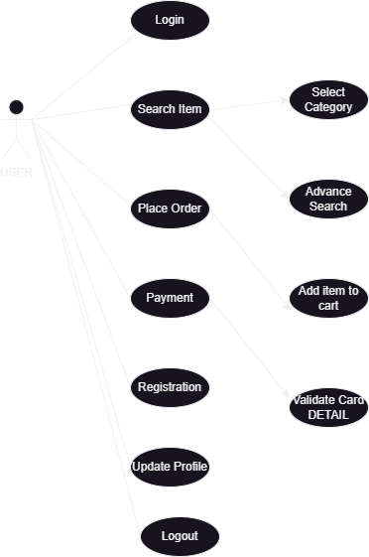

Created by : Aqsa Shaikh.