**A RESEARCH ON AIRBNB - FOUNDERS AND THE COMPANY.**

**-**BY ARSHAN SHAIKH VNIT, Nagpur

From a failing start-up to a **$108 Billion** company (as per 2024) is not what one will here often and that is the case of the San Francisco-based home rental service giant ‘Airbnb’.

Airbnb (AirBedandBreakfast.com) started in **2008** with humble beginnings, but the innovative company quickly grew into a multi-billion dollar company in the hotel industry.

Founded by **Joe Gebbia, Brian Chesky, and Nathan Blecharczyk,** Airbnb is a community marketplace that gives anyone a platform to list and book accommodations around the world. Over 60 million people in 190 countries have found apartments, houses, or even castles to stay in.

**Brian Joseph Chesky** is an American businessman and industrial designer and the co-founder and CEO of Airbnb. As of January 2024, Chesky is the **232nd richest person** in the world according to Forbes, with a net worth of $9.4 billion.

**Brian Chesky** went to the **Rhode Island School of Design in 2005**, where **he met Joe Gebbia** and eventually became his roommate.

Chesky took a very hands-on role when it came to hiring talent, interviewing every new applicant up until the company had around 200 employees.

**Joseph Gebbia Jr.** is an American billionaire designer and a co-founder of Airbnb. Gebbia is the **286th richest person** in the world according to Forbes, with a net worth of $8.5 billion.

While studying at the Rhode Island School of Design in 2005, **Gebbia** let a **stranger stay the night in his apartment on an air mattress**. This incident caused him to spark an idea couple of years later when he brought up the idea again in San Francisco. A design conference was coming to the city, and the nearby hotels were fully booked. **People needed a place to stay, and Gebbia saw an opportunity.**

**Nathan Blecharczyk** is Chief Technical Officer (CTO), leading the team of engineers and guiding the technical strategy of Airbnb.

He **met the other founders** when he moved to **San Francisco in 2007**, finding an ad for Joe Gebbia's apartment **on Craigslist**. They noticed that their skills seemed to fit well together, and they teamed up later on to build the first Airbnb website.

**Blecharczyk** was originally responsible for the **technical work, like coding**, but now he manages teams of software engineers who do most of the heavy lifting. He's focused on some of the harder problems that Airbnb faces, like personal privacy, trust, and payment systems.

 He is also the co-founder and chief strategy officer of Airbnb, and chairman of Airbnb China.

**ABOUT THE COMPANY:**

In October 2007, when **Joe Gebbia** sent an email to his roommate **Brian Chesky**, he was not aware that he was roping in seeds for a billion dollar company.

So, they began with a simple website (airbedandbreakfast.com), bought three air mattresses and gave their apartment on rent. Their first clients were two men and a woman, each paying out $80 rent. With $240 in hand the very first day, both realised that there is something big in here.

With this thought in mind, they approached their former roommate **Nathan Blecharczyk** to develop a more professional website. He finally ended up becoming the third co-founder.

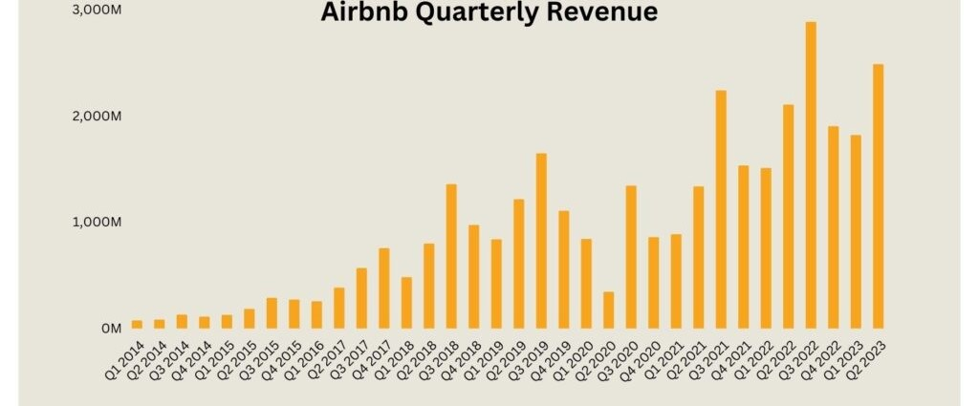

**Above figure shows Airbnb’s quarterly revenue from Q1 - 2014 to Q2 - 2023.**

**We can see that company`s revenue has increased almost exponentially over the years.**

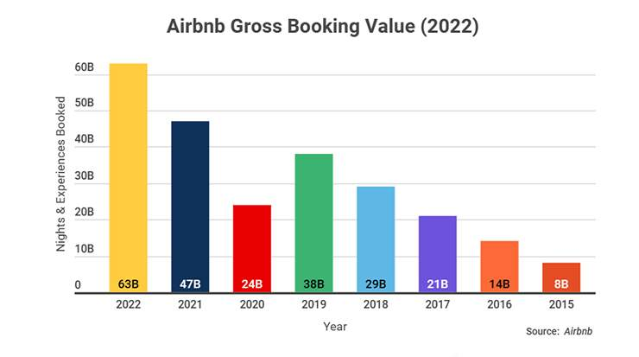

**Above figure shows Airbnb’s Gross booking value.**

**We can see that bookings reduced significantly (24 Billion) during COVID-19 pandemic and later scaled up (63 Billion) at the year 2022.**

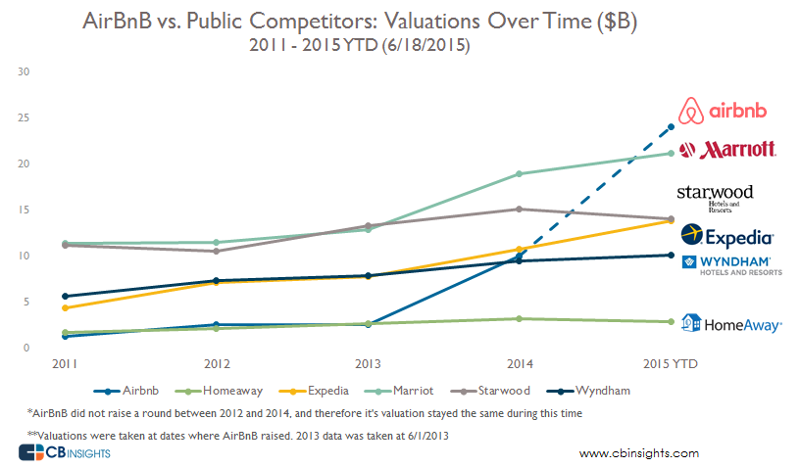

**Above figure shows Airbnb’s Growth over it’s competitors.**

**Thus, I can conclude that the company beat it’s competitors, has managed to significantly make a comeback from the losses incurred during the pandemic and managed to remain a giant in the hotel industry.**