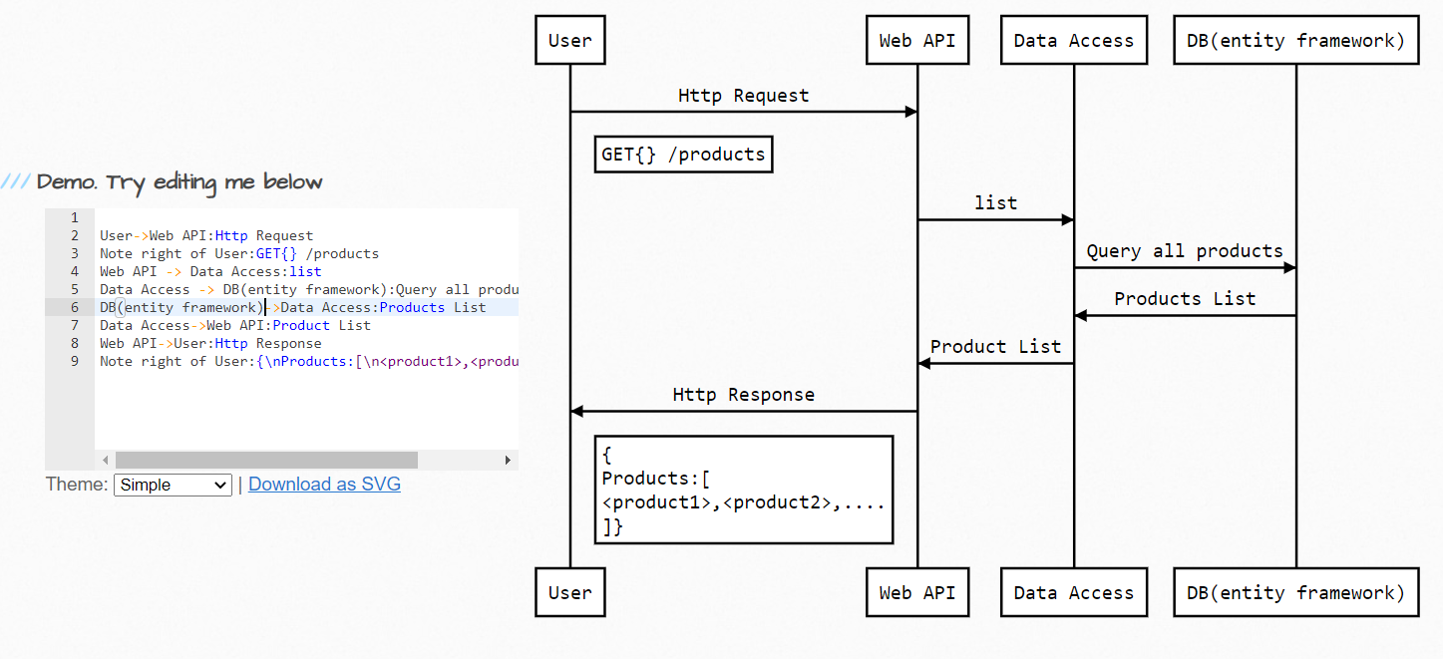

User->Web API:Http Request

Note right of User:GET{} /products

Web API -> Data Access:list

Data Access -> DB(entity framework):Query all products

DB(entity framework)->Data Access:Products List

Data Access->Web API:Product List

Web API->User:Http Response

Note right of User:{\nProducts:[\n<product1>,<product2>,....\n]}

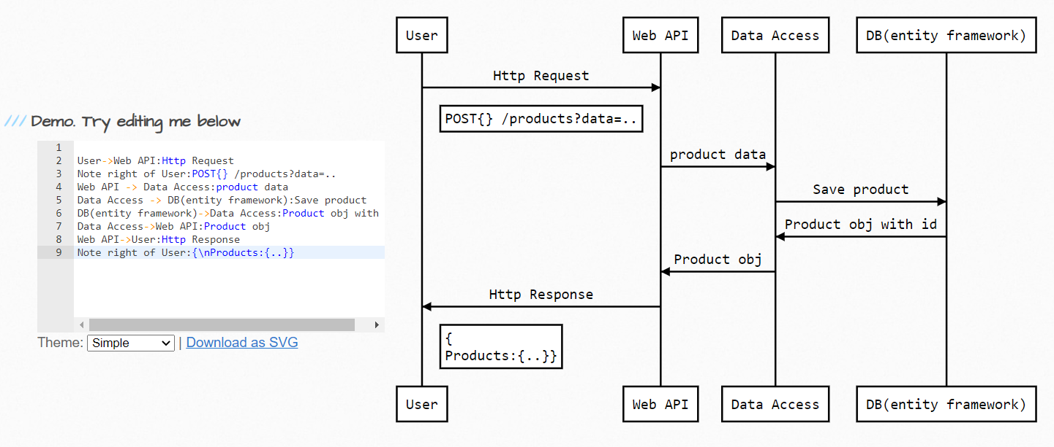

User->Web API:Http Request

Note right of User:POST{} /products?data=..

Web API -> Data Access:product data

Data Access -> DB(entity framework):Save product

DB(entity framework)->Data Access:Product obj with id

Data Access->Web API:Product obj

Web API->User:Http Response

Note right of User:{\nProducts:{..}}

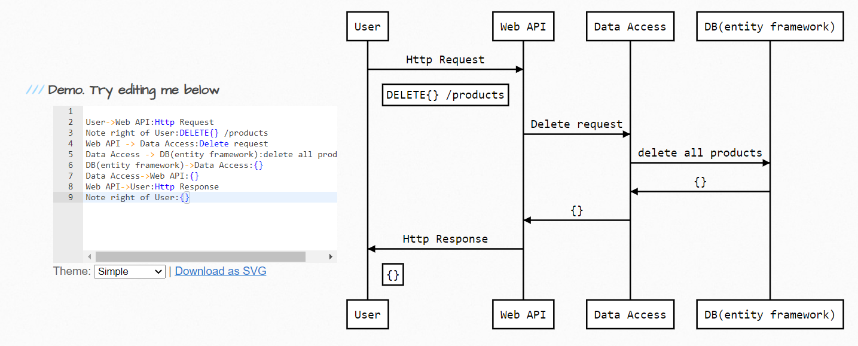

User->Web API:Http Request

Note right of User:DELETE{} /products

Web API -> Data Access:Delete request

Data Access -> DB(entity framework):delete all products

DB(entity framework)->Data Access:{}

Data Access->Web API:{}

Web API->User:Http Response

Note right of User:{}