Business Problem
Effective sales and pricing strategies are essential for driving profitability across global markets.
The company needs clarity on:
- Which territories, product lines, and customers contribute most to revenue
- Whether regional differences in sales performance exist
- How deal size, discounting, and product mix impact sales
- Which customer groups or products offer the greatest growth potential
- How to align marketing, inventory, and pricing decisions with seasonal demand patterns
This analysis aims to provide data driven insights to guide strategic decision making across pricing, customer targeting, and product strategy.

Exploratory Data Analysis Insights
- Summary Statistics
- Sales show a strong right skew, with a few high value orders driving much of the revenue
- Unit prices and MSRP are centered around $80 - $100, indicating standardized pricing across most lines
- Discounts vary widely, with some extreme negative values (refunds/returns), requiring cleaning
- Quantity sold is moderately spread, with occasional bulk purchases
- Seasonality is evident, with recurring sales peaks in Q1 and Q4 every year
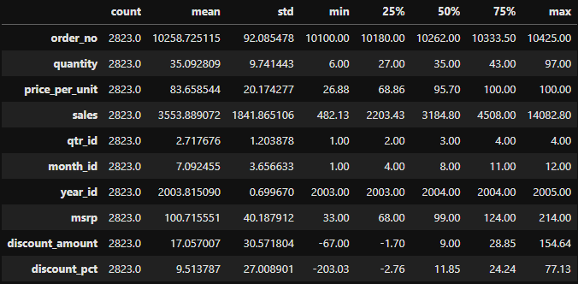
- Data Cleaning and Filtering
To ensure reliable analysis, the following steps were applied:
- Standardized column names and converted numeric fields
- Removed and created new columns for further analysis.
- Handled missing territories (e.g., UNKNOWN)
- Replaced Null values
- Created cleaned datasets and a database for SQL analysis

Correlation Insights
- Sales vs. Quantity: Moderate positive correlation. More units sold generally leads to higher sales
- Price vs. Sales: Stronger correlation. High priced items contribute significantly to revenue
- MSRP and Price Per Unit: Stronger positive correlation. Actual selling prices track closely with MSRP price
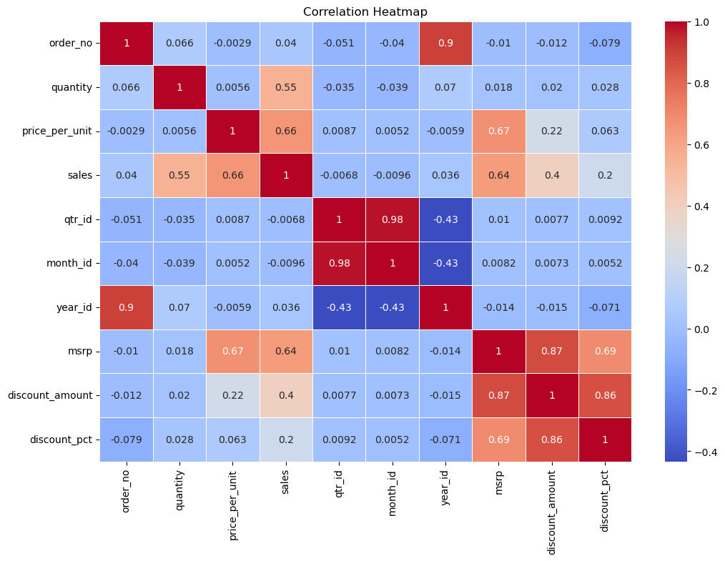
Implication:
Revenue is driven more by product value and volume rather than regional factors.

Research Questions and Key Findings

- Do average sales differ across territories?
- Territories compared: Japan, APAC, EMEA
- One-way ANOVA: F = 1.76, p = 0.17
Conclusion: No statistically significant difference in mean sales
Suggested Data Driven Action: Focus growth efforts on product assortment and deal strategy rather than territory.
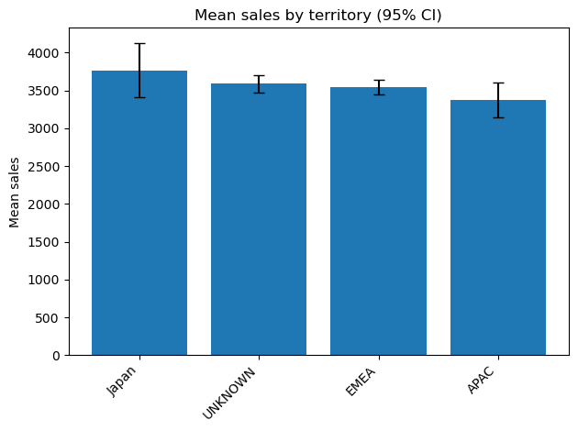
- Which product lines drive the most revenue?
- Classic Cars dominate revenue but depend heavily on 32% average discounts
- Trains and Ships have very low or negative discounts (selling at or above MSRP)
- Product revenue differences are driven more by sales volume than price
Suggested Data Driven Action: Review of discount strategy, especially for top-selling lines.

- Which deal sizes contribute most to sales?

Deal Size | Total Revenue | Avg Sale per Order
Medium | Highest | Moderate
Large | Moderate | Highest
Small | Lowest | Low
- Medium deals generate most of the revenue
- Large deals are rare but high value
Suggested Data Driven Action: Convert Medium to Large through bundles/incentives.

- Which customers contribute most to revenue? (Pareto Analysis)
- Top 10 customers contribute ~25% of total revenue
- Euro Shopping Channel (~9%) is the top buyer
- Long tail of customers contributes small increments
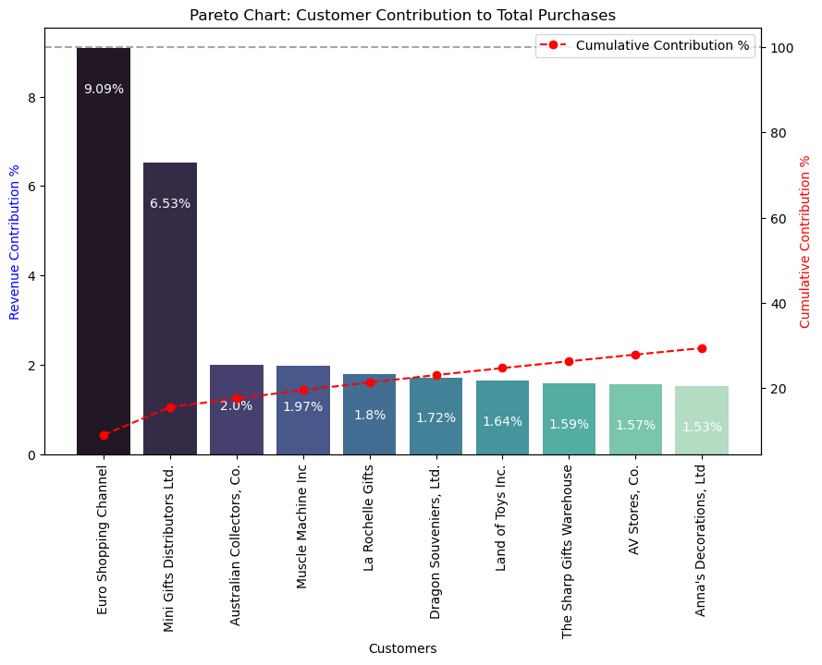
Suggested Data Driven Action: Strong dependency on a small customer base. Hence targeted account management is required.

- Seasonality and Revenue Trends Across Time

- Sales peak consistently in January-February and October-November
- Q2-Q3 shows lower revenue
- This pattern holds across all years analyzed
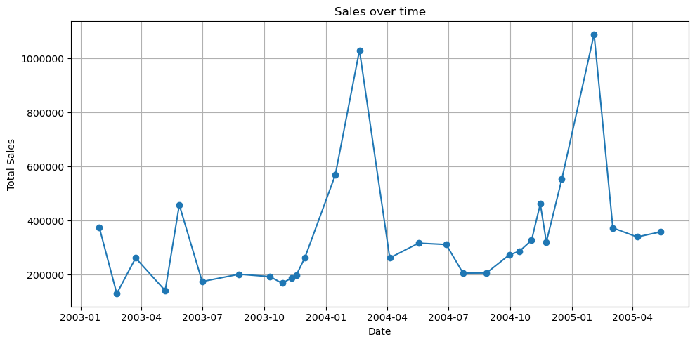
Suggested Data Driven Action: Use Q1 or Q4 for major promotions and introduce mid-year marketing boosts.

Final Recommendations

- Pricing and Discount Optimization
- Reduce heavy discounts on Classic Cars, and thus, test price elasticity
- Keep premium pricing for Trains and Ships where demand supports it
- Product Mix Strategy
- Prioritize high margin, low discount product lines
- Optimize stock and promotions for underperforming categories
- Deal Size Strategy
- Incentivize customers to move from Medium to Large deal sizes
- Automate small deals to save operational effort
- Customer Segmentation
- Strengthening relationships with top accounts
- Develop targeted upsell campaigns for mid-tier customers
- Simplify engagement for low value accounts
- Seasonal Planning
- Align marketing, staffing, and inventory to Q1 and Q4 revenue spikes
- Use Q2 and Q3 for product launches or retention campaigns
Conclusion
This analysis shows that regional differences are minimal, and performance is largely driven by product mix, deal size, and key customers.
By adjusting pricing strategies, optimizing product lines, and focusing on customer value, the company can unlock meaningful revenue and margin improvements.

