StreamingApp on AWS EKS
Deployment & Verification Walkthrough
App repo: https://github.com/shaikhniraj/MERNStreamingApp
Infra repo: https://github.com/shaikhniraj/streamingapp-infra

Part 1 — Provision AWS Infrastructure (Terraform / Terragrunt)
Repo: https://github.com/shaikhniraj/streamingapp-infra
Prerequisites: AWS CLI configured with credentials, Terraform ≥ 1.9, Terragrunt installed, and terraform login run once against the shaikhniraj Terraform Cloud org (state backend).

Step 1.1 — Confirm AWS credentials
aws sts get-caller-identity
- Check: the Account field matches your AWS account.
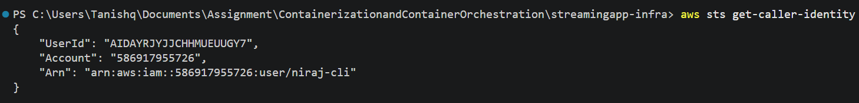
📸 SCREENSHOT: terminal output of the command above.

Step 1.2 — Provision ECR repositories
Creates one ECR repository per microservice, with scan-on-push enabled.
cd streamingapp-infra/live/dev/ecr
terragrunt init
terragrunt plan
terragrunt apply
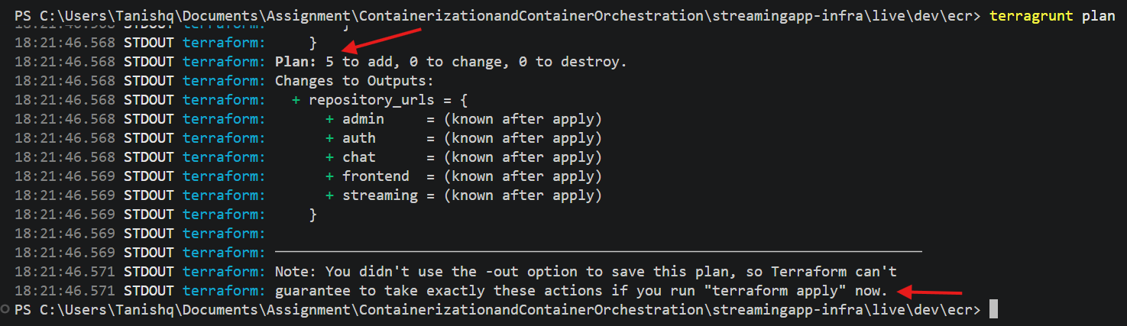
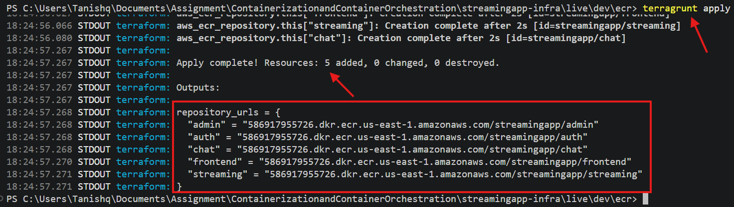
📸 SCREENSHOT: terragrunt plan → terragrunt apply.

- Check: 5 repositories exist — streamingapp/auth, streamingapp/streaming, streamingapp/admin, streamingapp/chat, streamingapp/frontend.
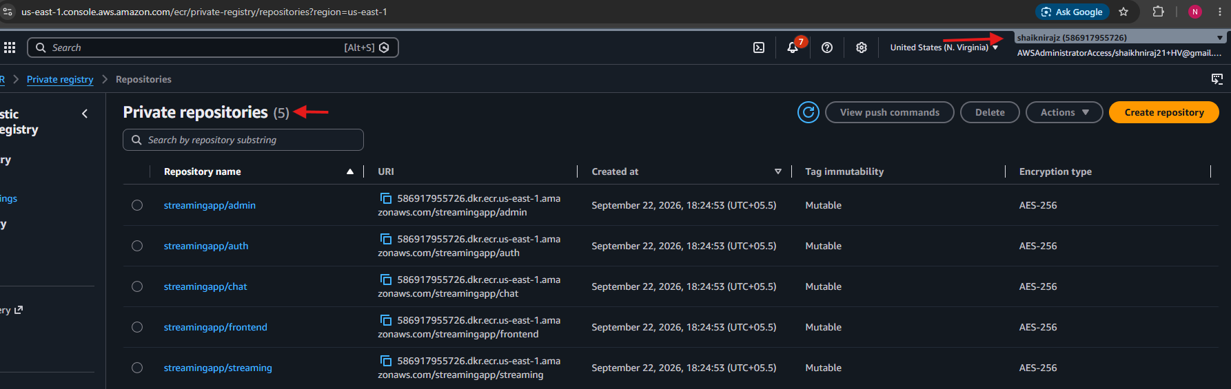📸 SCREENSHOT: AWS Console → ECR → Repositories, showing all 5 streamingapp/* repos.

Step 1.3 — Provision the S3 media bucket
cd ../s3
terragrunt apply
terragrunt output bucket_name
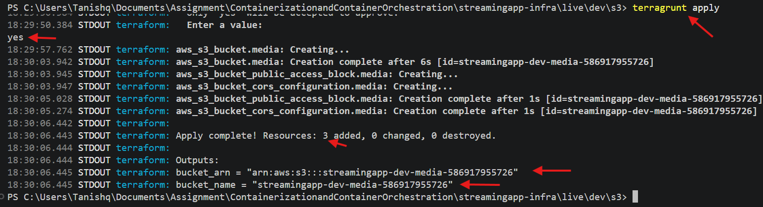
📸 SCREENSHOT: terragrunt apply.
Note: copy the bucket name printed above — it goes into values.yaml in Part 2 streamingapp-dev-media-586917955726.
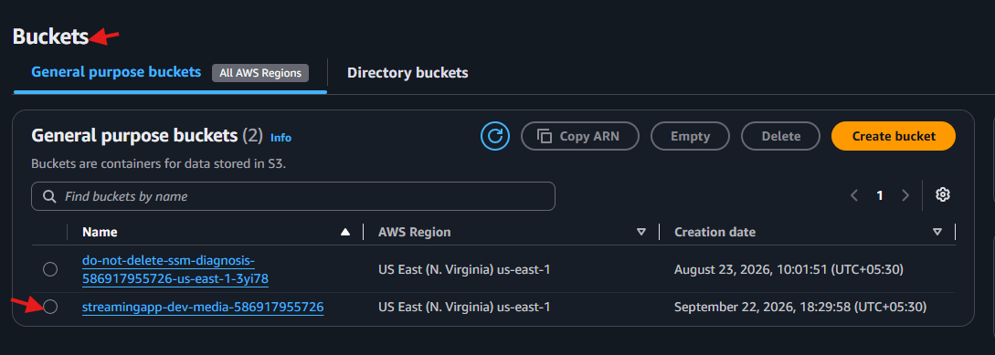📸 SCREENSHOT: AWS Console → S3 → the new bucket's page.

Step 1.4 — Provision the scoped IAM user for S3 access
Creates a dedicated IAM user + access key limited to read/write/delete/list on only the bucket from Step 1.3 — nothing else.
cd ../iam-s3-access
terragrunt apply
terragrunt output access_key_id
terragrunt output -raw secret_access_key
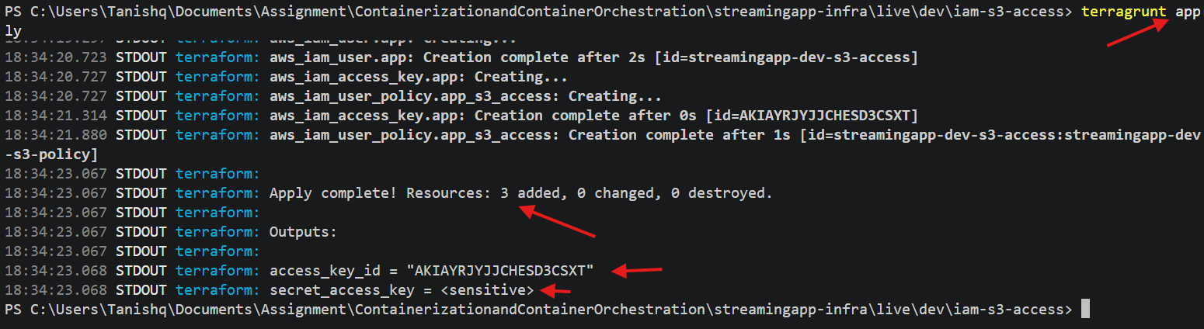📸 SCREENSHOT: terragrunt apply

Note: save both values somewhere safe — they go into values-secrets.yaml in Part 2. The secret is marked sensitive and won't print in plain plan/apply logs, only via this explicit output command.
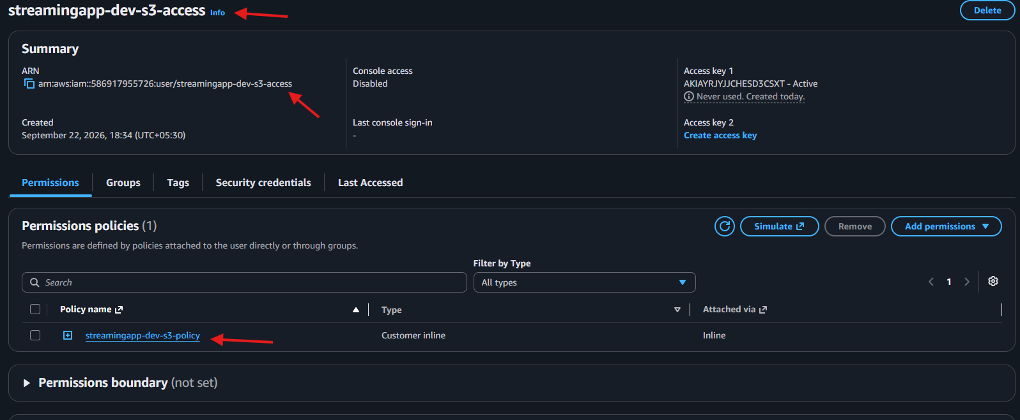📸 SCREENSHOT: AWS Console → IAM → Users, showing the new user and its attached inline policy (bucket-scoped, not AdministratorAccess).

Step 1.5 — Provision the EKS cluster
Creates the EKS control plane, a managed node group, an IAM OIDC provider (IRSA), and installs the EBS CSI driver and metrics-server as EKS add-ons. Takes roughly 15–20 minutes.
cd ../eks
terragrunt apply
📸 SCREENSHOT: AWS Console → EKS → Clusters → streamingapp-dev-cluster, status Active, showing the node group.

Step 1.6 — Point kubectl at the new cluster
aws eks update-kubeconfig --region us-east-1 --name streamingapp-dev-cluster
kubectl get nodes
- Check: every node shows STATUS Ready.
📸 SCREENSHOT: terminal output of kubectl get nodes.

Step 1.7 — Provision the ingress controller
Installs ingress-nginx via Terraform's helm provider, exposed as a LoadBalancer Service — AWS provisions a Classic ELB for it, which becomes the single public entry point for the whole app.
cd ../ingress-nginx
terragrunt apply
terragrunt output load_balancer_hostname
Note: this hostname is what you'll open in a browser for every step in Part 5 onward, and what goes into values.yaml's clientUrl in Part 2.
📸 SCREENSHOT: AWS Console → EC2 → Load Balancers, showing the new Classic ELB with State = active.

Step 1.8 — Provision monitoring (CloudWatch)
Installs the amazon-cloudwatch-observability EKS add-on (CloudWatch Agent + Fluent Bit via IRSA), an SNS topic, and 5 CloudWatch alarms (node CPU/memory, pod restarts, ingress ELB unhealthy hosts, ingress ELB 5xx rate).
cd ../monitoring
terragrunt apply
📸 SCREENSHOT: AWS Console → CloudWatch → Alarms, showing all 5 alarms (they'll read INSUFFICIENT_DATA for the first few minutes — that's expected).
📸 SCREENSHOT: kubectl get pods -n amazon-cloudwatch — the cloudwatch-agent and fluent-bit DaemonSet pods, one of each per node, all Running.

Part 2 — Wire Infra Outputs Into the App
Repo: https://github.com/shaikhniraj/MERNStreamingApp

Step 2.1 — Update charts/streamingapp/values.yaml
- image.registry → <your account id>.dkr.ecr.us-east-1.amazonaws.com (from Step 1.2)
- s3BucketName → the bucket name from Step 1.3
- clientUrl → http://<load balancer hostname from Step 1.7> (must match exactly — scheme + host, no trailing slash — it's what the browser sends as the CORS Origin header)
- awsRegion → us-east-1
📸 SCREENSHOT: the edited values.yaml open in your editor, with the 4 fields above visible.

Step 2.2 — Create values-secrets.yaml
cd charts/streamingapp
cp values-secrets.yaml-template values-secrets.yaml
- jwtSecret → any long random string
- awsAccessKeyId / awsSecretAccessKey → the two values from Step 1.4
Note: this file is gitignored — it must never be committed.

Part 3 — CI Pipeline: Build & Push Images (Jenkins)

Step 3.1 — Confirm Jenkins credentials & the GitHub webhook
The Jenkinsfile already defines triggers { githubPush() } and expects a credential named aws-ecr-creds bound to your AWS account.
📸 SCREENSHOT: Jenkins job configuration page, showing the GitHub webhook trigger and the aws-ecr-creds credential binding.

Step 3.2 — Trigger a build
Push any commit to main, or click “Build Now” in Jenkins directly.
📸 SCREENSHOT: Jenkins → the pipeline run, all 5 build/push stages green (Build & Push Images succeeded for auth, streaming, admin, chat, frontend).

Step 3.3 — Confirm the images landed in ECR
aws ecr describe-images --repository-name streamingapp/frontend --region us-east-1 \
--query 'sort_by(imageDetails,& imagePushedAt)[-1].imageTags' --output table
Note: note the new tag printed (e.g. 1.0.11) — you'll set it in Part 4.
📸 SCREENSHOT: AWS Console → ECR → streamingapp/frontend → Images, showing the new tag with a recent push time.

Part 4 — Deploy to EKS with Helm

Step 4.1 — Set the image tag
In values.yaml, set image.tag to the tag confirmed in Step 3.3. All 5 services share one tag — Jenkins builds and pushes them together on every run.

Step 4.2 — Install / upgrade the release
cd charts/streamingapp
helm upgrade --install streamingapp . \
-f values.yaml \
-f values-secrets.yaml \
--wait
📸 SCREENSHOT: terminal output ending in “Release ‘streamingapp’ has been installed/upgraded. Happy Helming!”

Step 4.3 — Confirm everything is running
kubectl get pods,svc,ingress -A
- Check: every Deployment at its desired replica count, all pods Running/Ready, both Ingress resources listed with the ELB address under ADDRESS.
📸 SCREENSHOT: full terminal output — this is one of the assignment's required deliverable screenshots.

Part 5 — Manual Verification (Smoke Tests)
Open http://<load balancer hostname from Step 1.7> in a browser for every step below.

Step 5.1 — Landing page loads
📸 SCREENSHOT: the homepage.

Step 5.2 — Register a new account
📸 SCREENSHOT: the successful-registration message.

Step 5.3 — Log in
📸 SCREENSHOT: the logged-in state (browse page, your name/avatar visible in the nav).

Step 5.4 — Promote your account to admin (one-time)
Registration always creates role: "user" — there's no UI for granting admin, so this is done once directly against Mongo.
kubectl exec mongo-0 -- mongosh streamingapp --quiet --eval "db.users.updateOne({email:'YOUR_EMAIL'}, {$set:{role:'admin'}})"
Note: log out and log back in afterward — the JWT bakes in role at login time, so a token issued before this update will still show as a regular user.
📸 SCREENSHOT: command output showing modifiedCount: 1.

Step 5.5 — Upload a video via /admin
Go to /admin → Upload Video → fill in the details, select a small video file and a thumbnail image → Upload.
📸 SCREENSHOT: the success message, and the new entry listed under Manage Videos.

Step 5.6 — Play it back from Browse
Go to /browse, open the uploaded video, confirm it plays.
📸 SCREENSHOT: the video actively playing (progress bar advancing, not stuck at 0:00).

Step 5.7 — Live chat across two tabs
Open the same video in two browser tabs (or a normal + an incognito window, logged in as two different accounts). Send a message from one tab.
📸 SCREENSHOT: both tabs side by side, showing the same message appearing in real time in each.
Note: Steps 5.3, 5.5, and 5.7 together satisfy the assignment's required “screenshot of the running app: successful login, one upload, and chat working across two tabs.”

Part 6 — Scaling, Rolling Update & Self-Heal (live demo)

Step 6.1 — Manual scale
kubectl scale deploy/streamingapp-streaming --replicas=4
kubectl get pods -l app=streaming
📸 SCREENSHOT: 4 streaming pods Running.

Step 6.2 — Zero-downtime rolling update
helm upgrade streamingapp . -f values.yaml -f values-secrets.yaml \
--set image.tag=<a tag>
kubectl rollout status deploy/streamingapp-auth
- Check: rollout finishes with “successfully rolled out” — every Deployment is configured with maxUnavailable: 0 / maxSurge: 1, so this never drops below full capacity.
📸 SCREENSHOT: the rollout status output.

Step 6.3 — HPA autoscaling under load
frontend (target 30% CPU) and streaming (target 70% CPU) both have a HorizontalPodAutoscaler, min 2 / max 6 replicas, reading from the cluster's metrics-server add-on.
kubectl get hpa -w
# in a second terminal, generate load against the ELB, e.g.:
for i in $(seq 1 500); do curl -s -o /dev/null http://<elb-hostname>/; done
- Check: REPLICAS climbs above the minimum while load runs, then settles back to 2 a few minutes after the load stops.
📸 SCREENSHOT: kubectl get hpa output while load is running, showing REPLICAS above minimum and a non-trivial CPU% under TARGETS.
📸 SCREENSHOT: the same command a few minutes after stopping the load, back at the minimum replica count.

Step 6.4 — Pod self-heal
While the pod is being recreated, refresh the app in a browser a few times to confirm no user-facing errors.
kubectl get pods -l app=auth
kubectl delete pod <one-of-the-two-pod-names>
kubectl get pods -l app=auth
📸 SCREENSHOT: “before” output (2 pods, both established), and “after” output (still 2 pods, one with a fresh AGE) — the assignment's required pod self-heal demonstration.

Part 7 — Monitoring & Logging Verification

Step 7.1 — Container Insights metrics
AWS Console → CloudWatch → Container Insights → Resources → select the cluster.
📸 SCREENSHOT: pod/node CPU and memory graphs showing real, non-flat data.

Step 7.2 — Alarms
AWS Console → CloudWatch → Alarms.
📸 SCREENSHOT: all 5 alarms listed, ideally all in OK state (they need a few minutes of real data after Part 1 before settling out of INSUFFICIENT_DATA).

Step 7.3 — Logs
AWS Console → CloudWatch → Log groups → /aws/containerinsights/streamingapp-dev-cluster/application.
📸 SCREENSHOT: a log stream containing real application log lines (e.g. an Express/morgan request log from one of the 5 services).

Part 8 — Final Submission Checklist
- Both GitHub repos pushed and accessible to the instructor — App: see link on page 1; Infra: see link on page 1
- This document, filled in with every screenshot above, added to one of the repos (e.g. as docs/DEPLOYMENT_WALKTHROUGH.docx or exported to PDF)
- README in the app repo documents architecture, install steps, and a production-changes paragraph (already done — see MERNStreamingApp/README.md)
- A short text/Word/PDF file containing the repo link(s), uploaded to Vlearn per the assignment's submission instructions

