**Introduction:**

Spatial Analysis techniques and tools are used to investigate and study the penetration of domestic broadband service provider. Purpose of this report is to highlight the distribution of broadband or any other Internet service usage across the county of the Ireland. The detailed analysis of broadband coverage is studied at electoral division level and county level. Also, the broadband networking in houses with personal computer and without personal computer will be analyzed. Pattern or reason behind the distribution will be discussed considering spatial position and factor involved.

**Data Source:**

Shape file with associated attribute is downloaded from link “<http://www.cso.ie/en/census/>”. Data for County and Electoral division is used for analysis at county and ED level respectively.

Information such as number of houses with broadband and personal computer is recorded in .csv file from the survey taken in 2016. The .csv file with these details of survey for county and ED is downloaded from the link “<http://www.cso.ie/en/census/>”.

**Data Manipulation:**

The csv file contained large amount of columns giving information about number of houses, person living in house, members, no. of cars etc. All the details of survey was recorded in the different columns. This unnecessary columns from county and ED file are trimmed from the csv file using simple delete function in excel. Column containing the relevant information about the personal computer and broadband are used for analysis.

The columns in the csv file has large numeric values with place value separated by comma (e.g. 12, 10,100). Field with comma value in numeric field was not imported correctly in QGIS. These comma was removed and handled in excel by using format function available in excel. The fields were converted to numeric value without comma and then imported in QGIS.

New columns were added which contained the computed value from the available information. Proportion of houses with personal computers and broadband is calculated and converted to percentage. These information is filled in the new columns. The computed value is converted to percentage because the number total household in ED is different from county. So that the distribution can be discussed on same scale i.e. in terms of percentage.

Only the houses who answered the survey question are used for calculation. Houses who did not stated anything are exempted from the calculation. As this will give incorrect proportion. New column is introduced with total count of the houses with Personal Computer and Broadband who stated either yes/no.

**QGIS:**

QGIS features are is used to make map which will aids to draw inference based on analysis. The downloaded shape file for county and electoral division is added as a vector layer in QGIS. Also, the open street map is used as background as shown in figure below.

Step: Layer > Add vector Layer > “shape file”

Step: Web > openlayer plugin> openstreet map > open street map

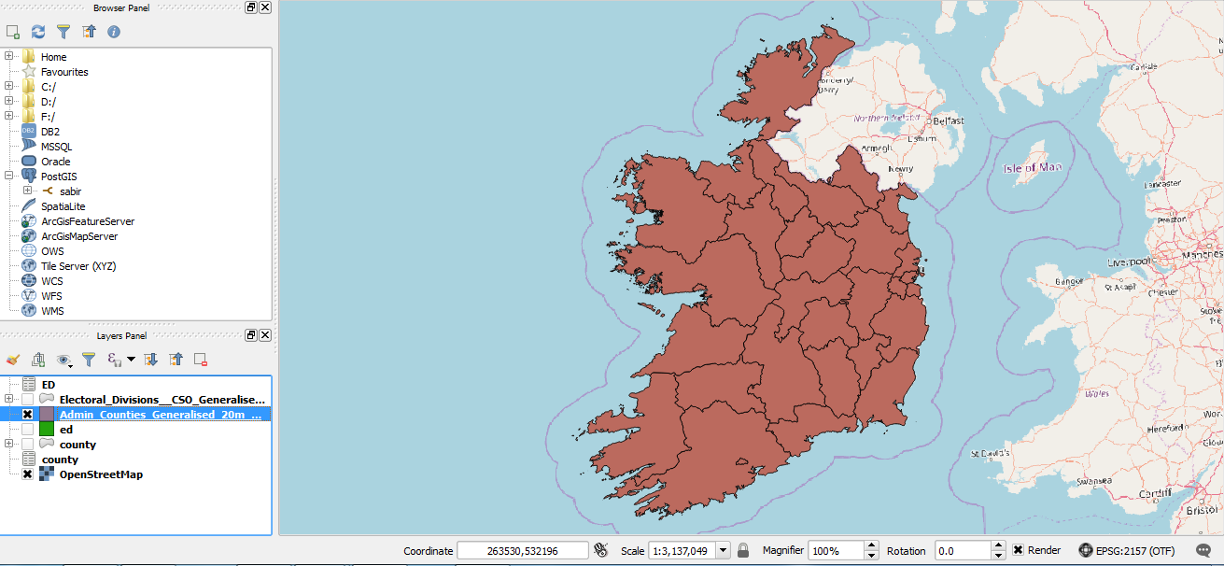

Fig: Vector layer of County.

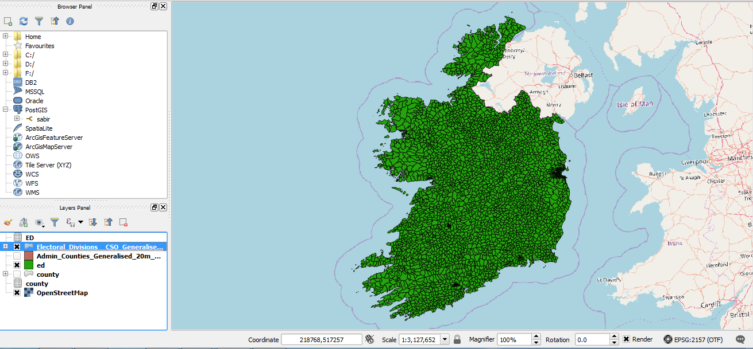

Fig: Vector layer of electoral division

The csv data of county and ED is imported in QGIS using the “add delimiter file” feature in QGIS. The shape file and csv survey data is joined together for further analysis. Data is joined using QGIS join feature. The data is joined on the basis of the GUID available in both the file.

Step: Layer > Add Delimited file > “csv file”

Step: Right Click on the layer in layer panel > Properties > joins > + > select file and common columns

The projection of the maps of ED and county are transformed to local i.e. Irish Transverse Mercator (EPSG 2157). This is done in order to comprise the error that can be made from converting globe to 2D plane.

Step: Right Click on the layer in layer panel > Save as > change the Coordinate Reference system

The percentage distribution of houses with Personal Computer and Broadband is shown using the Graduated feature in QGIS which helps to identify the density of problem/interest with the use of color. Also, the comparison of houses with Broadband but no PC is made.

Step: Right Click on the layer in layer panel > Properties > style > Graduated

The Distribution is classified using quantile and natural breaks. By default QGIS breaks the data and classify equally into 5 classes which does not give the true picture. More number of classes gives more detail story. Also manual detail classification is done using histogram in some map below.

Step: Right Click on the layer in layer panel > Properties > style > Graduated > Classify > Quantile break/Natural Break

Step: Right Click on the layer in layer panel > Properties > style > Graduated > Classify > Histogram tab > load value > manually drag the bar for classes

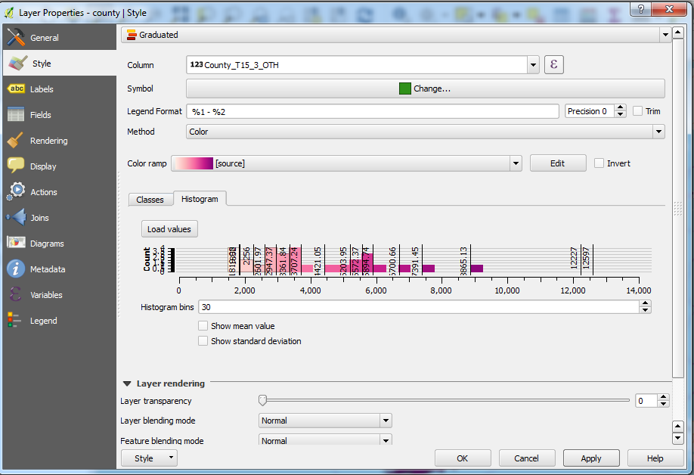

**Analysis:**

***Penetration of PCs at County level***

Below Choropleth map tells the story about the distribution of number of households in Ireland with Personal Computers at county level. Darker regions says that intensity of number of Computer are higher. The darkest and lightest shade shows the counties with maximum and minimum number of personal computers respectively. The proportion of number of personal computers reduces with the intensity of shade.

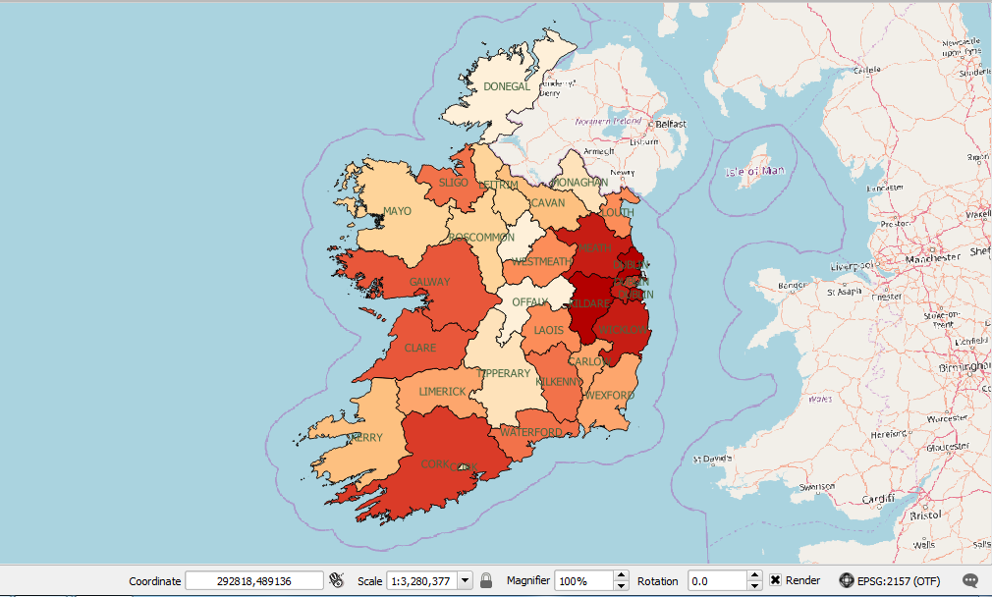

Fig : Choropleth map – household with Personal Computers at county level

It can be observed that the Dublin city has got more household with personal computers. This is obvious because the population of Dublin is largest among all the counties. Also, the number of industries, institutes and companies are more in Dublin. It can be seen that the Dublin city has more proportion than Dublin County. This due to the population and presence of companies. Similar observation can be made for Galway and Cork County and city. The reason will be studied later by considering the minute areas. The County such as Donegal, Mayo and Monaghan etc. is scarcely populated and thus the percentage of personal computers are less with light shade.

*Note: Proportion of household with PC over total population who answered the survey is considered and people who did not stated anything is exempted from total population. (T15_2_Y/ T15_2_Y + T15_2_N) * 100 %*

***Penetration of PCs at Electoral division level***

The analysis above gives good idea about the distribution of pcs but the areas are much bigger than it appear on the map. Therefore detailed analysis is required for accuracy. It can be possible that only cork city has got more number of personal computer and other areas of cork is scarcely populated but analysis at county level says that cork complete county has greater number of personal computer user. Which may not the true story. Therefore, it will be a good idea to divide the area at minute level such as electoral division level and then do analysis.

The map below shows the distribution of proportion of houses with personal computers. The divisions highlighted in dark blue shows areas with more than 75% houses have personal computers out of total population of that area. Now it can be observed that although the County Donegal had very less houses with computers but there are areas in Donegal where the computer users are more. Also, it is clear that the Dublin city has the more computers than Dublin County. And this is obvious for all the cities due to number of population, no. of institutes, schools and colleges, Companies etc.

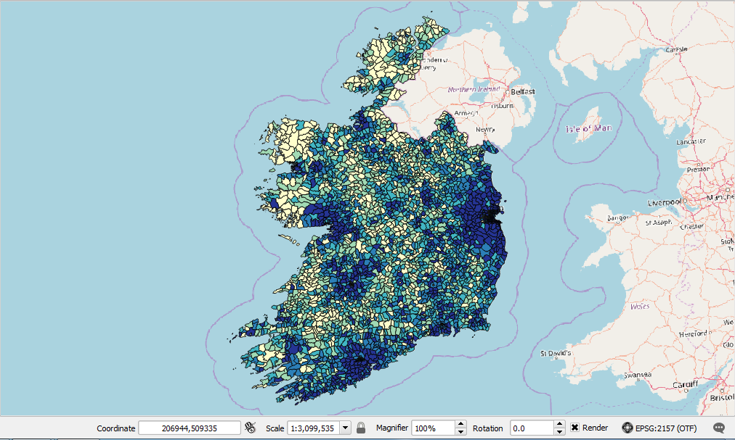

Fig : Choropleth map – household with Personal Computers at electoral level

***Penetration of broadband and other internet services at County level***

Map given below shows the distribution of broadband network and other internet services in Ireland at county level. It is clear from the map that there are more number of broadband connection in urban counties like Dublin, Galway and Cork. It can observed that the remote rural counties has less broadband penetration. It is because these counties are densely populated and have more number of education institutes and companies. Also, as per the above analysis on computers it is clear that more number of people with computers will definitely have more broadband connection. Also, the internet is required for mobile device, laptops, payment machines etc. In today’s world no device either laptop or smartphones are smart without internet. Therefore, it is expected that the houses with no computers can have broadband connections for other purpose like using smartphone etc.

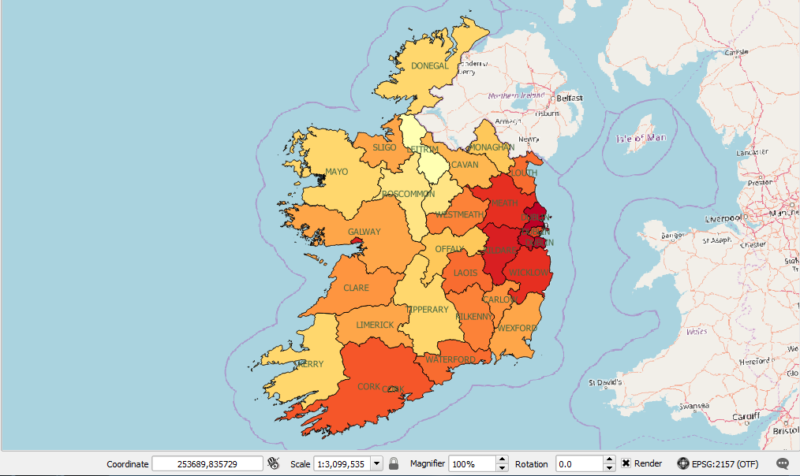

Fig : Choropleth map – household with broadband connections at county level

***Penetration of broadband and other internet services at ED level***

It will be good practice to analyze the distribution at smaller level before drawing any inferences. This will show more detail picture about the regions at detail level with internet connection. This will benefit more for internet service provider to improve their service. Map given below shows that the city regions has more broadband connection than the rural remote areas. The darkest divisions shows the highest internet connection and color intensity reduces with the decreases in broadband connection. The reason here could be same, as these places are densely populated, more companies etc.

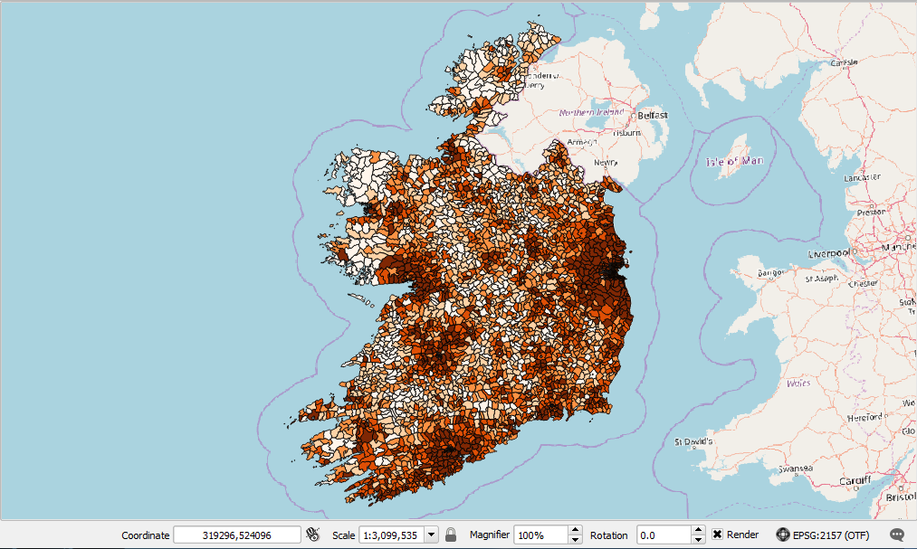

***Study of regions with internet but no PCs***

It would be interesting to study the areas which has got broadband connection but no personal computers. The map below show the difference between the broadband connection and the personal computers. It can be seen that the people who did not have computers has got broadband. This difference is more in city region due to the large population. But people can possibly use broadband connection other purpose. That could be possibly for mobile or other internet driven device. But it is surprising to notice that Galway has very less difference because cities have mostly broadband network via cables as the users are more. And County Donegal has more difference that is houses in Donegal has broadband network but less computers.

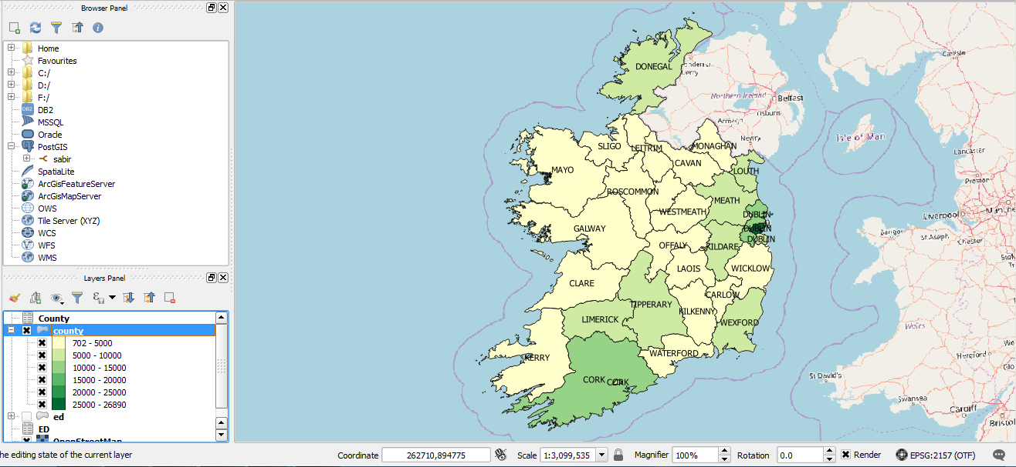

Fig : Choropleth map of houses with internet service but no PCs

***Analysis of services other than Broadband***

The above analysis rise the interesting question that How the cable for broadband is provided for remote rural areas? The survey report also gives the data about the houses which uses other service for internet like wimax etc. As laying broadband cable to such rural may be expensive. It is definite from the map below that cities such as Dublin, Cork and Galway has no other services and are light shaded. This is because the broadband connectivity is good. Light shaded regions shows that the network of broadband is good. Whereas rural areas which is in dark color states that they uses other services for internet like rural area of county Galway, Cork and Donegal etc.

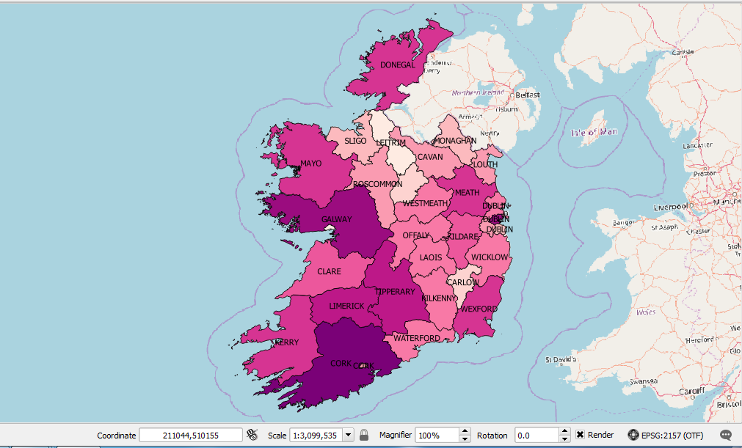

Fig : Choropleth map of distribution of internet service other than Broadband

**Conclusion:**

With the help of spatial analysis techniques and tools such as QGIS it is analyzed that the most of the houses in the Cities or area near to the city has more personal computers. Same is analyzed for Broadband i.e. urban areas has more broadband connection compared to rural areas. Major reason for this pattern can be that these regions are densely populated, number of education institutes are more, and Software and other industries are more. As rural areas are scarcely populated therefore laying cable for ISP (Internet service provider) is expensive. Therefore, these regions uses other internet services such as wimax etc. Also, the internet service is used for many purpose other than PCs. Such as mobile etc.