PERSONAL AGENT
UI, UX, AG-UI &
SYSTEM ARCHITECTURE
A comparative research report across OpenMuse, OpenBot, OpenDots, Coworkers, Rakazo and Twenty
THE EXECUTIVE TAKE
Build the experience around OpenMuse, make work reviewable like OpenDots, enforce permissions like OpenBot, use Twenty to learn product structure and Nx discipline, and use Rakazo as the practical self-hosted reference. Do not combine six codebases or copy their entire stacks.

Prepared from public repositories and documentation available on 3 November 2026. This is a source-based architecture and product-design review, not a line-by-line code audit or a security certification.

What this report answers
- What AG-UI is, how it differs from UX, UI kits, MCP and A2A.
- Which repository is strongest for personal-agent UX, agent workspaces, governance, self-hosting and scalable application structure.
- What screens, reusable components, states and user journeys a great personal-agent product needs.
- How to shape the frontend, backend, data model, event stream, worker system and infrastructure.
- What to borrow, what not to copy, and what to build first as a small team.
Reading map: Sections 1–3 explain AG-UI and the repositories; Sections 4–8 design the product experience, journeys, backend and infrastructure; Sections 9–13 cover Nx, validation, repository study and sources.

Executive summary
You are not choosing one “best UI” from six repositories. Each repo solves a different layer of the problem. The winning approach is a carefully selected set of patterns, backed by one coherent product architecture.
Need | Best reference | Why | Caution
Great personal-agent experience | OpenMuse | Outcome-first chat, visible work, interruption, retained drafts, activity, task recovery and inline artifacts. | Alpha template; verify every external integration and hosted dependency.
Work becomes a usable artifact | OpenDots | Chat + live computer + human review + editable Space page is a strong end-to-end workflow. | Template; conversations depend on CopilotKit Intelligence.
Trust, permissions and audit | OpenBot | Policy gateway, per-agent computer isolation, per-tool grants, audit and takeover patterns. | Beta template; Intelligence is an external dependency unless self-hosted/licensed.
Self-hosted product stack | Rakazo | React/Vite, Hono/oRPC, Postgres/Prisma, worker, desktop/mobile and sandbox adapters. | Beta; many providers and clients increase integration surface.
Cloudflare-native agent model | Coworkers | Durable Object boundaries, per-bot state, browser handoff, routines and cost tracking. | Explicitly experimental; Cloudflare preview/beta dependencies.
Mature application architecture | Twenty | Nx monorepo, domain-rich product shell, shared UI, data views, workflows and extension model. | CRM product, not an agent UX blueprint; overall repo licensing is AGPL-3.0.

MY RECOMMENDATION
Use OpenMuse as the main interaction reference, OpenDots for artifact/review patterns, OpenBot for safety boundaries, and Twenty for the ordinary application shell and design-system discipline. Run Rakazo locally to experience a complete self-hosted system. Treat Coworkers as an architecture study, not a foundation for a production commitment today.

A simple mental model
UI is what people see and manipulate. UX is the sequence of decisions and feelings as they get a job done. AG-UI is the protocol that carries structured agent events between the agent backend and the interface. The agent runtime does the reasoning and tool orchestration. The policy layer decides what is allowed. Durable backend state makes long-running work survive refreshes, restarts and failures.

1. AG-UI explained without confusion
AG-UI (Agent-User Interaction Protocol) is an open, event-based communication contract between an agent backend and a frontend application. It is designed to expose more than a final text answer: the UI can observe a run starting, text arriving, tools being called, state changing, and a run completing. The protocol does not dictate your visual design or product information architecture. [1][2]
Term | Simple meaning | What it is not
AG-UI | The event language and connection between an agent and the user-facing app. | Not a component library, agent framework or full product.
UI | The visible controls and displays: chat, task cards, browser view, tables, approvals. | Not the business journey by itself.
UX | How a person discovers, understands, controls and completes work. | Not merely visual polish or animation.
A2UI | A declarative approach for describing UI elements an agent may ask an app to render. | Not the same as AG-UI; one concerns UI descriptions, the other agent-UI events.
MCP | A way for an agent to connect to tools and data sources. | Not a user interface protocol.
A2A | A protocol family for communication between agents. | Not the main agent-to-human UI channel.

How the interaction works
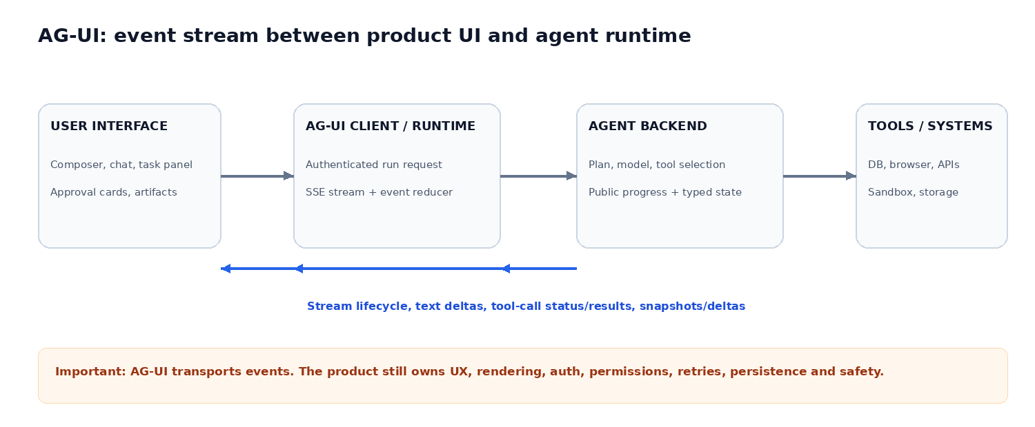
A typical run: the user sends a prompt; the frontend starts an authenticated run; the backend emits run and message events; tool-call events expose activity; the tool executes through a permission-controlled path; results and state updates return; the UI renders progress and the final artifact. The AG-UI repository documents lifecycle, text, tool, state, activity and other event families. [1][2]

Event families worth designing for
Event family | UX interpretation | Frontend response
Run lifecycle | The task started, is progressing, or ended. | Show running/complete/error state; keep controls accurate.
Text message | Assistant is streaming a response. | Append streamed text; preserve markdown and message identity.
Tool call | The agent is using a browser, API, database or file tool. | Show the tool, purpose, status and safe public summary.
Tool result | The tool returned data or an error. | Render structured output, citations or a recoverable failure.
State snapshot/delta | The agent’s structured public state changed. | Update task plan, current step, progress, artifact reference.
Human approval / input | The agent needs a user decision. | Pause the risky action and render an explicit approval/input card.

IMPLEMENTATION RULE
Do not stream private chain-of-thought. Stream concise status (“Searching three sources”), structured plans, tool names, user-visible outputs, citations and explicit requests for input. The backend—not the browser—must authorize every side effect.

AG-UI design and engineering checklist
- Use run_id, thread_id, tenant_id and actor identity as explicit server-validated context. Never trust tenant or permission values supplied only by the client.
- Use ordered events with IDs/sequence numbers; handle duplicate, out-of-order and reconnect cases. Persist enough run state to send a fresh snapshot after a lost connection.
- Define typed schemas for public state and tool arguments; validate at the boundary. Do not let the model invent arbitrary frontend components or execute arbitrary browser-side code.
- Separate UI message history from authoritative task/run state. A chat can close while a background task continues.
- Make tool events intelligible: “Read CRM account”, “Searched public pricing”, “Prepared draft” is better than dumping raw JSON or hidden prompts.
- Provide visible controls for stop, pause, resume, retry and human takeover; map each control to a server-side state transition.

2. Repository comparison: what to learn from each

2.1 OpenMuse — strongest personal-agent UX reference
OpenMuse is a personal-agent template for web and mobile, built with CopilotKit React Native and AG-UI. It is explicitly described as alpha and intended for self-hosting/building on. Its core promise is outcome-first: ask for a result, follow a plan, review actions and return to completed work. [3]

UI and UX patterns
- One primary conversation by default, with separate chats when needed. The composer remains available during a response; send becomes stop; the draft is retained when stopping.
- A visible follow-up queue distinguishes “next prompts waiting” from a durable delegated task. Interrupting a response need not cancel a separate background task.
- Inline artifacts turn chat from a text transcript into a workspace: email, browser results, PDF, plan and finance cards can appear beside the conversation.
- Activity is a first-class surface: task plan, progress, input requests, pause/resume/cancel/retry, approvals and receipts.
- The agent computer is inspectable: persistent browser profile, takeover console, optional isolated Linux terminal and workspace files.
- Ideas and goals add proactive work: evidence-backed suggestions, milestones, recurring checks and deduplicated alerts.

Architecture and boundaries
The public architecture shows an Expo/React Native/web client talking to an authenticated Hono + CopilotKit runtime using AG-UI. A durable task worker coordinates tasks, review records, Google adapters, a browser worker with persistent profiles, optional Docker Linux computer, files and PGlite/PostgreSQL storage. Direct rich threads require CopilotKit Intelligence; this is not an entirely self-contained local chat stack. [3]

What to borrow / what not to copy
Borrow | Do not copy blindly
Conversation + durable Activity split; visible queue; draft retention; human review receipts; inline artifacts; recovery after interruption. | Alpha assumptions; every external integration; dependency on hosted Intelligence without a fallback plan; broad product surface before one workflow is validated.

Best use: prototype the exact user experience and learn how a personal agent should feel while doing work. OpenMuse is the best starting point for interaction design, not a guarantee of production readiness.

2.2 OpenDots — strongest artifact and specialist-coworker workflow
OpenDots is an open-source template for persistent AI coworkers (“Dots”) with web/mobile clients, individual computers, Spaces and Slack channel integration. Its defining journey is Ask → browse → approve → save: the live computer and review card appear in chat; the approved work becomes an editable Space page. [4]

UI / UX elements
- Spaces act as a document-oriented workspace: searchable pages, list/grid, nested pages, editor, formatting, slash commands, autosave, revision checks and links to related chats.
- A Dot is a specialist with a defined role, instructions and permitted tools. Users should be able to inspect what it is for and what it can access.
- A side panel makes computer activity visible without losing the conversation; browser, files, terminal and activity can be inspected.
- Human review is attached to the proposed artifact/action. Approve & save writes into an authorized Space; decline leaves the user in control.
- Connections include MCP tools and third-party integrations; read-only tools can be enabled separately from write tools.

Architecture and caveats
The documented path is web app → AG-UI → CopilotKit runtime → specialist agents/model provider. TanStack AI handles model streaming and server-tool execution; CopilotKit Intelligence stores durable Threads; Pages, Spaces, agent metadata and background-work state are stored separately. Slack uses a managed channel connection. Conversations require CopilotKit Intelligence (hosted, local evaluation or licensed self-hosting), so the template has an important service dependency. [4]
BEST LESSON
Do not stop at “the agent answered”. Turn useful answers into editable, traceable objects: a report page, a ticket, a plan, a generated test suite or a reviewed email draft.

2.3 OpenBot — strongest governance and computer-control reference
OpenBot is a template, not a hosted SaaS product. It accepts agents that speak AG-UI, gives each coworker its own computer/browser/files, routes tool calls through a policy gateway, and records decisions in an audit trail. The current repository describes itself as beta and requires Docker plus a CopilotKit Intelligence project/licence for the documented setup. [5][6]

Surfaces worth studying
Surface | What it should help a user do
Channels / bot chat | Start work with one coworker or a group, follow responses and watch execution.
Agent directory / profile | Create, duplicate, configure, start, hide and inspect bots.
Computer view | Watch browser activity, take over the browser when a login or judgment is needed, then return control.
Connections / plugins | Connect MCP or external apps and grant only the required tool scopes.
Skills / routines / memory | Give a coworker repeatable procedures, standing jobs and bounded context.
Boundaries / approvals | Set allow, ask-first or block rules for browser, files and tools.
Audit / admin | Inspect permitted, refused and failed actions, identities, grants and computer lifecycle.

Backend and security lesson
OpenBot’s documented service model includes a React/Vite app, Hono API/runtime, PostgreSQL (with pgvector in the architecture), per-agent browser/computer service, supervisor, bot agents and a routine worker. The gateway resolves each tool target, checks policy, writes an audit row, then executes or refuses. Computer containers are per-person/per-bot and have separate Chromium profiles, logins and workspace. Threads/memory use CopilotKit Intelligence. [5][6]
NON-NEGOTIABLE SECURITY PRINCIPLE
Never let an agent talk directly to a powerful computer or external API and trust that the prompt will behave. Route every action through an authenticated server-side policy gateway. The tool sandbox is not the policy engine.

2.4 Coworkers — interesting Cloudflare-native agent model
Coworkers describes a Cloudflare-first architecture: a Worker routes WebSocket traffic to three Durable Object types—UserHub (one per user), BotAgent (one per bot) and AppLive (one per bot-built app). Each bot keeps SQLite state. The frontend uses TanStack Start, React 19, Tailwind v4, Kumo and Hugeicons; the stack includes Cloudflare Workers, Durable Objects, Workers AI/AI Gateway, Browser Run and Dynamic Workers. [7]
- Good ideas: state partitioned per user and bot; browser takeover for user login; per-action allow/ask/block policies; routines/check-ins; shared and bot-specific memory; cost visibility; teaching a bot through browser demonstrations.
- The repository explicitly warns that it is under heavy development and uses preview/beta Cloudflare packages. Browser Run and Dynamic Workers also require a Cloudflare paid plan in the documented deploy path.
- Study this repo for an architecture pattern when you have decided to build deeply on Cloudflare. Do not let a changing preview platform determine your first product architecture.

2.5 Rakazo — practical self-hosted multi-platform reference
Rakazo is a beta self-hosted AI teammate product for web, Electron desktop, iOS and Android. The published README lists persistent bots, chat history/memory/routines, voice, shared and isolated computers, browser/terminal/files/desktop, peer-bot delegation, model choice, MCP/OpenAPI and integration providers. Its stack is React 19 + Vite + Tailwind, Electron + Expo, Hono + oRPC, PostgreSQL + Prisma, Better Auth, Graphile Worker and sandbox-provider adapters. [8]

Architecture lessons
- The repo separates apps (web, API, worker, desktop, mobile) from packages (domain, contracts, persistence, adapters, UI and tests). This is a useful way to keep frontends thin and provider-specific code behind adapters.
- Its stated design principle is that frontends express intent and render state; backend owns orchestration, authorization, validation, retries, recovery and provider translation. This is exactly the boundary a serious agent product needs.
- The quick start is Docker-based and avoids requiring a local Node development environment for first use; the repository currently publishes an installer script. [8]
- Many client platforms and sandbox providers are powerful but create maintenance cost. A solo builder should first ship one web client and one reliable computer/tool path.

3. Twenty — learn how to build a complete application, not just a chat UI
Twenty is an open-source CRM and application platform. Its public README lists TypeScript, Nx, NestJS, BullMQ, PostgreSQL, Redis, React, Jotai, Linaria and Lingui. The repository is a Yarn 4/Nx monorepo with multiple first-party packages. The product provides objects, views, workflows, agents and app extensions—not simply a CRM screen. [9][10]

3.1 Product UI and information architecture
Study Twenty for the “ordinary application” around the AI. It has durable navigation, search, workspace settings, records, list/table/kanban/calendar views, saved filters, relationships, custom fields, workflow management, permission-aware settings and application extension surfaces. Its product guide emphasises configurable objects, views, workflows and app-building building blocks. [9]
Pattern | Why it works | How to adapt it to an agent product
Persistent left navigation | User can predict where features live. | Home/Inbox, Chat, Tasks, Agents, Workspace, Connections, Activity, Settings.
Search / command palette | Fast access without forcing deep navigation. | Search chats, tasks, artifacts, agents and connections; commands such as “New task”.
Saved views and filters | Users can reuse a useful way of seeing records. | Task views: Mine, Needs approval, Running, Failed, Completed, Scheduled.
Record detail page | A row opens into an understandable entity, not a modal maze. | Task detail shows goal, owner, run history, steps, evidence, artifact, permissions and receipts.
Object and relation model | Product data has explicit types and relationships. | Model agents, tasks, runs, approvals, files and connections as linked records.
Settings and governance | Powerful controls have a predictable home. | Centralize agent access, tool grants, network boundaries, credentials and audit.
Extension surface | Product can grow without rewriting the core. | Add specialist agent types and typed tools through documented manifests/contracts.

3.2 Nx monorepo: what it does and what it does not do
Nx is a workspace/task orchestration system. It discovers projects and their import/dependency relationships, builds a project graph, runs task graphs, and can cache work based on declared inputs. It helps answer “which projects depend on this change?” and “which build/test tasks can run?” It does not create your product architecture, turn a modular monolith into microservices, or decide how your backend should be split. [10][11]
The Twenty repository currently uses Nx and Yarn 4. Its package/workspace list includes front, server, UI, shared utilities, SDK, CLI, client SDK, website, docs, tests and other first-party packages. Its root start script orchestrates frontend/server and a server worker. Exact package contents and versions can change; inspect the current branch before copying commands or code. [10][12]

Representative workspace map
packages/
twenty-front/ React application
twenty-server/ NestJS API and worker code
twenty-ui/ Shared design system and components
twenty-shared/ Shared types and utilities
twenty-sdk/ App declarations and runtime support
twenty-cli/ Developer command-line tools
twenty-e2e-testing/ Browser-level tests
twenty-docs/ Developer/user documentation

Nx commands to understand the repo
yarn install
npx nx show projects
npx nx graph
npx nx show project twenty-server --web
npx nx run-many -t build -p twenty-front twenty-server
npx nx affected -t lint test build --base=main

Use the graph before reading files. Trace a UI action to its hook/service/API, then trace the resolver/service to persistence and background jobs. In a large codebase, following one vertical feature slice is more efficient than browsing every folder.

3.3 Backend architecture and runtime shape
Twenty documents NestJS with TypeORM, PostgreSQL, Redis, GraphQL and BullMQ. Its server package has separate production app, command, database migration and queue-worker entry points. This is a strong example of keeping HTTP/API handling distinct from background work while sharing domain and persistence code. [9][13]
Concern | Typical Twenty layer | Design lesson
User-facing API | NestJS modules / GraphQL | Make API contracts explicit; avoid UI reaching directly into database.
Data persistence | PostgreSQL + TypeORM | Use migrations, typed domain models and clear relation boundaries.
Background work | BullMQ + Redis worker | Long-running or retryable work should leave the request thread.
Shared frontend primitives | twenty-ui | Build a single design system with documented, reused patterns.
Shared code | twenty-shared / SDK | Share contracts/utilities deliberately; avoid dumping all logic into a giant shared package.
Testing | Playwright E2E plus package tests | Test user-visible behavior and critical cross-service journeys.

3.4 App extension model
Twenty’s app platform is a notable design lesson: apps can declare objects, fields, relations, logic functions, skills, agents, workflows, connection providers, views, navigation items and front components. The SDK reads declarations and builds a manifest; runtime components execute under scoped capabilities rather than receiving unrestricted access. This separates product extension points from internal implementation. [14]
For your own agent platform, start with a narrower version: a typed AgentDefinition (role, instructions, model policy, tool grants, UI capabilities) plus ToolDefinition (input/output schema, risk class, scopes, approval policy). Add a plugin marketplace only after users need it.
IMPORTANT LICENSING NOTE
The Twenty repository is AGPL-3.0 (the public package metadata also shows AGPL-3.0 for the server). Do not copy or embed its code into a closed-source commercial product without understanding AGPL obligations and obtaining appropriate legal advice. You can study architectural ideas and independently implement similar patterns. [13]

4. Design the personal-agent product: information architecture
A personal agent is not “a chatbot with a sidebar”. It is a workspace where the user can assign work, watch work, interrupt work, review side effects, and keep the outputs. Keep the navigation small enough to understand, but make long-running tasks visible.
Primary area | What lives there | Primary success question
Home / Inbox | Recent tasks, pending approvals, completed work, reminders and suggested next actions. | What needs my attention now?
Chat | Persistent conversations, prompt composer, tool status, source links and inline artifacts. | Can I describe the outcome and steer the agent?
Tasks | Running, scheduled, paused, failed and completed tasks; plans, run timeline and receipts. | What is the agent doing, and can I control it?
Agents | Specialists, role, model, instructions, tools, memory, schedules and status. | Who should do this work and with what access?
Workspace | Documents, files, reports, generated code, saved artifacts and versions. | Where is the useful work product?
Connections | OAuth accounts, MCP servers, API connections, granted scopes and health. | What can the agent access?
Activity & Audit | Actions, decisions, approvals, failures, tool traces and usage. | What happened, who/what did it, and why?
Settings | Profile, workspace, users, security, notifications, budgets and billing. | How is the workspace governed?

Recommended desktop layout
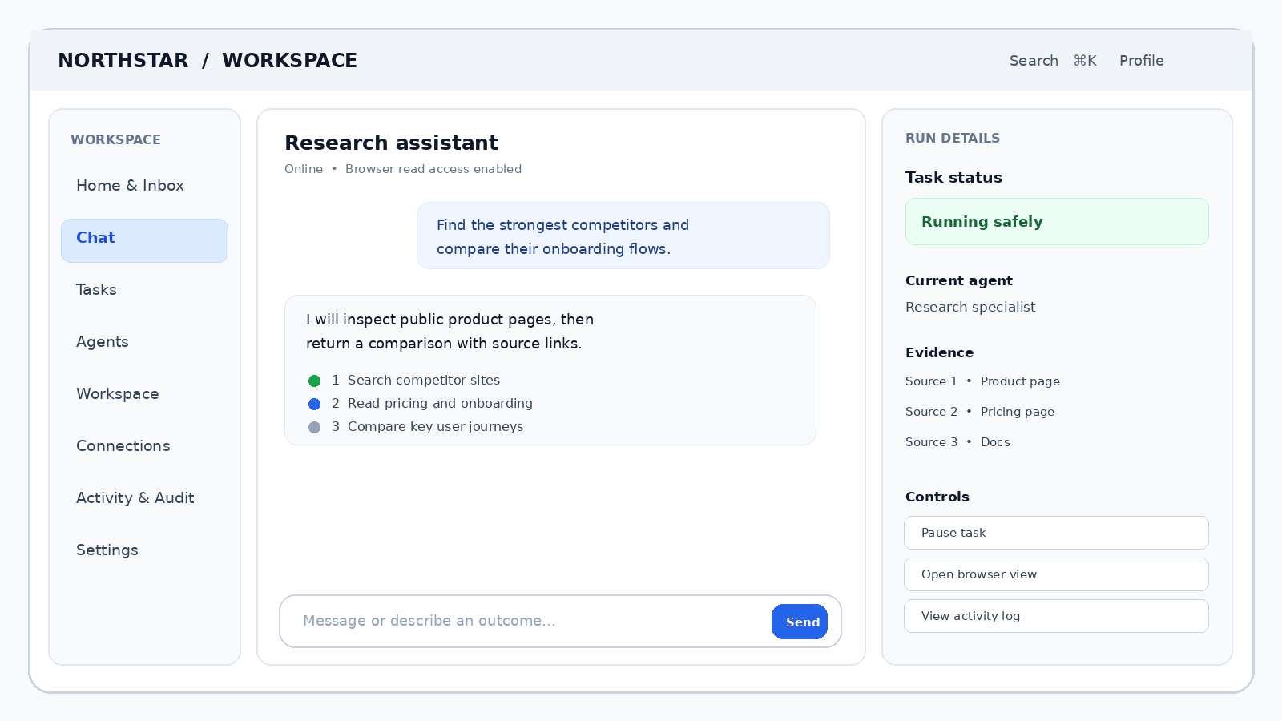
Use a three-region layout: left navigation, central conversation/work surface, and a contextual right panel. The right panel should be closed or compact by default and open only when useful (task details, sources, live browser, approval preview, file/artifact). On mobile, convert it into a bottom sheet or dedicated route. The wireframe is a design proposal inspired by the repositories, not a screenshot from any of them.

Navigation and information hierarchy
- Keep Chat and Tasks distinct. A chat is a conversation; a task is durable work that can outlive the conversation. Link them, but do not collapse them into one record.
- Make pending approval a first-class inbox item. Do not bury it in a transcript or send it only as a notification.
- Make artifacts durable and searchable. A generated report should have a stable URL, owner, created-from task, version, and evidence links.
- Show the agent’s current permission state where the user chooses an agent or starts a task. Do not hide access rules behind an admin-only screen.
- Use tables for sorting/filtering many tasks and records; use cards for summaries and decisions; use a document editor for content. Avoid using cards for every data shape.

5. Component inventory: build a reusable system, not one-off screens
Component group | Core components | States and behavior to define
App shell | Workspace switcher, sidebar, breadcrumbs, command palette, global search, profile menu. | Collapsed/expanded nav, keyboard focus, active route, loading permissions.
Conversation | Thread list, message row, assistant/user bubble, markdown renderer, streaming cursor, composer, attachment tray. | Streaming, stop, retry, queued prompt, draft saved, offline, failed, empty.
Agent activity | Run timeline, step row, tool-call card, plan/progress panel, status chip, event details. | Queued, running, waiting, succeeded, failed, cancelled, paused, needs input.
Human control | Approval card, diff preview, permission scope selector, takeover banner, confirmation modal. | Pending, approved, rejected, expired, superseded, execution uncertain.
Artifacts | Report/document preview, code block, table/chart preview, file tile, source/citation list, version history. | Draft, saved, stale, version conflict, download/export, permission denied.
Computer view | Browser live view/snapshot, terminal output, file explorer, session health, hand-back control. | Connecting, active, human takeover, blocked, expired, crashed, reconnecting.
Agent management | Agent card, role editor, model selector, tool picker, memory inspector, routine editor. | Draft/published, disabled, no model, permission missing, budget limit.
Connections | Provider card, OAuth connect, scope summary, MCP tool list, credential health. | Not connected, connecting, connected, expired, revoked, limited scope.
Data views | Task table, agent table, filter builder, saved view, pagination, sort/group controls. | Empty, filtered-empty, loading, partial data, access denied, bulk selection.
Governance | Audit log, policy rule editor, tool risk label, usage/cost panel, workspace member table. | Allowed, ask, denied, anomalous, quota reached, policy changed.

Design-system rules
- Define tokens first: color roles, spacing scale, radius, typography, elevations, focus rings, breakpoints and motion duration. Use semantic roles (success/warning/danger) rather than hard-coded component colors.
- Every component needs loading, empty, error, disabled, permission-denied and keyboard-accessible states—not only its ideal screenshot.
- Use one icon set and consistent labels. “Needs your approval” is more useful than a vague “Action required”.
- Use calm hierarchy: one primary action per card, secondary actions in a menu, destructive actions separated and confirmed. Avoid visual noise and too many gradients or badges.
- Make streaming stable: do not remount the message list on each event; preserve scroll position when reading older messages; auto-scroll only when the user is already near the bottom.
- Treat generated UI components as an optional advanced capability with an allowlisted schema. Never eval arbitrary model-generated JSX or HTML.

6. End-to-end user flows

6.1 First-time onboarding
Landing page
-> Create workspace / sign in
-> Choose a starter outcome (research, email, coding, operations)
-> Choose a model/provider (explain cost and data handling)
-> Connect one app with minimum OAuth scopes
-> Test a read-only action
-> Create one agent with a clear role
-> Choose allow / ask / block permissions
-> Run a guided sample task
-> Show where tasks, approvals and saved artifacts live

Do not ask a new user to configure ten agents, twenty tools and every policy before they see value. Use a guided first success with safe sample data, then reveal advanced settings at the moment they matter.

6.2 Standard task execution
1. User describes an outcome, not an implementation recipe: “Compare our top five competitors and prepare a report.”
2. Agent checks missing constraints. It asks one focused question only when the missing detail changes the result materially.
3. For multi-step work, show a short plan: intended outputs, tools, expected time class and any access required. Let the user edit or start.
4. Start a durable task. Show current step and concise tool activity in the conversation; the task record persists independently.
5. Read-only permitted work runs. Evidence/source cards appear as results arrive. Risky writes pause for human approval.
6. User approves/rejects or takes over a browser. Show exactly what will happen, to which target, using which account/scope.
7. Agent returns an artifact with a summary, links/evidence, status and receipt. User can edit, save, export or continue.

6.3 Approval flow (most important trust interaction)
Approval card field | Required content
Action | Plain-language verb: send, delete, update, publish, purchase, change access.
Target | Exact account, record, recipient, URL or resource.
Preview | Message content, diff, affected rows/items, amount or other irreversible impact.
Scope | This action once, this tool for this task, or ongoing grant (where appropriate). Default to once.
Risk / reason | Why approval is needed; what permission/policy triggered the pause.
Controls | Approve, reject, edit first, or take over. Destructive actions require clearer confirmation.
Receipt | After execution, show provider result, timestamp, record ID and whether retry is safe.

DO NOT DO THIS
Do not ask “May I use Gmail?” once and then silently allow every future email. Permission should be scoped by tool, action class, account, and sometimes target. Read access and write access are different risk levels.

6.4 Long-running task and failure recovery
- Store task status and checkpoints in the database. Browser/agent process memory is not durable state.
- Expose pause, resume, cancel and retry. Explain whether cancel means “stop now” or “request cancellation after current safe step”.
- Retry only idempotent steps automatically. For uncertain external writes, verify provider state before resending.
- On restart, show last completed step, current checkpoint and what is safe to repeat.
- Make failures actionable: what failed, what data may have changed, what is needed from the user, and a safe next step.

7. Proposed backend architecture
Do not reproduce the full complexity of the reference repos. Start with a modular backend and clear boundaries. Since your existing direction includes Python/FastAPI/Postgres, a React/TypeScript frontend plus FastAPI backend is a sensible small-team choice. Use AG-UI at the agent-to-UI boundary; keep your business API and task persistence independent of a particular model vendor.
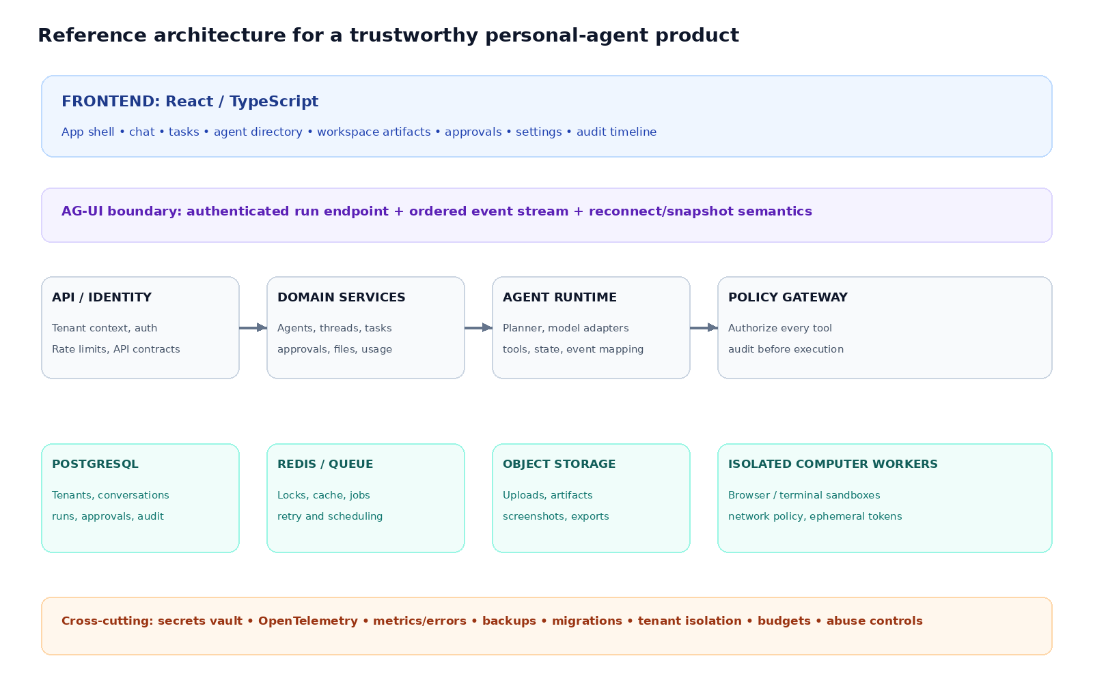

7.1 Logical backend modules
Module | Responsibilities | Owns / must enforce
Identity & workspace | Users, sessions, tenants, memberships, roles. | Authenticated actor, tenant boundaries, session lifecycle.
Agent registry | Agent definition, version, model policy, prompts, tools. | Published version and capability manifest.
Conversation | Threads, messages, attachments, summaries. | User-visible chat history; no hidden reasoning exposure.
Task orchestration | Create runs, plans, steps, checkpoint, pause/cancel/retry. | Durable task state and state transitions.
Tool gateway | Resolve tools, validate schemas, authorize, execute adapters. | Final permission decision, rate limit, audit before action.
Approvals | Pending requests, decision, expiry, approved scope. | Human decision record and one-time/limited grant.
Connections | OAuth grants, MCP/API credentials, scopes and health. | Encrypted credentials and least privilege.
Artifacts | Files, generated documents, code, reports and versions. | Ownership, access policy, checksums and storage references.
Memory | User/project facts, retrieval index, source and expiry. | Consent, retention, provenance and deletion.
Usage & audit | Model/token/tool usage, cost, decisions, run traces. | Attribution, budgets, audit immutability/retention.

7.2 Suggested technology choices
Layer | Recommended starting choice | Why / trade-off
Web UI | React + TypeScript + Vite or Next.js; component library of your choice. | Fast iteration; choose one routing/data strategy and keep it consistent.
Agent API | FastAPI + Pydantic schemas. | Matches your Python strengths; typed request/response validation.
AG-UI transport | Use a compatible AG-UI implementation/adapter or implement a narrowly scoped event endpoint to the official contract. | Avoid inventing incompatible event shapes; keep UI agnostic to model vendor.
Primary database | PostgreSQL. | Users, tasks, permissions, runs, audit and artifacts metadata fit relational data.
Vector search | Postgres pgvector only when retrieval needs justify it. | Avoid adding a separate vector DB before there is real retrieval traffic.
Background jobs | One worker process + Redis queue, or a Python-native queue if that fits deployment. | Separate long-running work from HTTP requests; keep retries/checkpoints durable.
File storage | S3-compatible object storage (R2/S3/MinIO in dev). | Avoid storing large PDFs/screenshots in relational rows.
Computer runtime | Docker isolated browser/terminal worker, later remote sandbox adapter. | Do not give agent tools direct access to your host machine.
Observability | Structured logs + OpenTelemetry traces + error tracking. | Correlate task, run, tool and approval IDs end-to-end.

7.3 Core tables / entities
workspaces(id, name, created_at)
users(id, email, auth_subject)
memberships(workspace_id, user_id, role)
agents(id, workspace_id, name, published_version_id)
agent_versions(id, agent_id, definition_json, status)
conversations(id, workspace_id, created_by)
messages(id, conversation_id, role, content_json, created_at)
tasks(id, workspace_id, conversation_id, agent_version_id, status)
runs(id, task_id, sequence, status, started_at, finished_at)
run_steps(id, run_id, ordinal, kind, status, input_ref, output_ref)
tool_calls(id, run_id, tool_id, args_json, status, risk_class)
approvals(id, tool_call_id, status, scope, decided_by, decided_at)
connections(id, workspace_id, provider, encrypted_secret_ref, scopes)
artifacts(id, task_id, storage_key, mime_type, version, checksum)
policies(id, workspace_id, subject, tool, action, decision)
audit_events(id, workspace_id, actor, action, target, decision, created_at)
usage_events(id, workspace_id, run_id, provider, units, estimated_cost)

Add tenant_id/workspace_id to every tenant-owned record; enforce access in service layer and, where appropriate, PostgreSQL Row-Level Security. Index operational fields (workspace_id, status, created_at, task_id). Keep secrets out of normal application rows; store encrypted references in a dedicated secret mechanism.

7.4 AG-UI event contract design
A single run may emit events such as RUN_STARTED, STEP_STARTED, TEXT_MESSAGE_CONTENT, TOOL_CALL_START/ARGS/END/RESULT, STATE_SNAPSHOT/DELTA, STEP_FINISHED and RUN_FINISHED. Exact event names and payload shapes must follow the AG-UI version and integration you adopt; treat the following as a conceptual mapping, not copy-paste protocol code. [1][2][15]
Public state field | Example content | Why the UI needs it
run_status | queued / running / waiting_approval / succeeded / failed / cancelled | Stable task badge and controls.
current_step | “Reading public pricing pages” | Human-readable progress.
plan[] | Step title, status, optional output reference | Makes multi-step work legible.
pending_approval | Action, target, preview, expiry | Renders a safe decision card.
artifact_refs[] | ID, title, type, version | Links durable outputs.
public_activity[] | Tool label, summary, timestamp, status | Explains what happened without exposing hidden reasoning.

7.5 Authorization sequence for every tool call
Agent proposes typed tool call
-> Server authenticates actor + tenant
-> Resolve tool + connection + exact target
-> Validate schema and resource ownership
-> Evaluate policy (allow / ask / block)
-> If ask: persist approval request and pause run
-> If allow: write audit intent, then execute adapter
-> Persist result / receipt / error
-> Emit sanitized AG-UI tool result and updated state

8. Infrastructure, deployment and security

8.1 Local development and MVP deployment
Start with Docker Compose locally: web, API, Postgres, Redis/queue worker, and one isolated computer/browser service. Keep the API, database and worker on a private network. Put uploaded files in a local S3-compatible service for development or object storage in production.
Component | MVP deployment | Scale later when a real bottleneck appears
Frontend | Static web app / single frontend container behind HTTPS. | CDN, preview deployments and separate mobile client.
API | One FastAPI service with modular routers/services. | Horizontal replicas behind a load balancer.
Worker | One separate worker process reading durable jobs. | Queue partitions, concurrency pools and priority lanes.
Database | Managed Postgres or a persistent volume with automated backup. | Read replicas, connection pooling, PITR and partitioning.
Redis | Managed Redis or private container for queue/cache/locks. | HA Redis and separate cache/queue if required.
Computer | One isolated Docker worker per active task/session. | Sandbox pool, per-tenant quotas and remote providers.
Files | S3/R2 bucket with private objects and signed downloads. | Lifecycle rules, virus scanning and CDN for approved public files.

8.2 Security controls
- Treat prompts, documents, webpages and emails as untrusted input. Defend against prompt injection by separating data from instructions and restricting tool capabilities.
- Never mount the host filesystem or Docker socket into an agent computer. Run non-root; apply CPU/memory/disk limits, read-only base filesystems where possible, short-lived tokens and network egress allowlists.
- Keep OAuth refresh tokens and API keys encrypted server-side. Never place secrets in model context, frontend bundles, logs or generated artifacts.
- Require approval for consequential writes (send, publish, delete, payment, permission change, external database mutation). Apply least privilege and target-level scoping.
- Record action intent, policy decision, actor, target, result and timestamps. Avoid capturing sensitive payloads in audit logs unless essential and protected.
- Use tenant isolation in every query and storage path. Test cross-tenant access explicitly. Add rate limits, per-agent budget caps and runaway-loop detection.
- Build cancellation and idempotency into tool adapters. When the external provider may have accepted an action but the response was lost, reconcile state before retrying.

8.3 Operational readiness
Operational area | Minimum baseline
Backups | Automated Postgres backups, tested restore, object-storage lifecycle and versioning where valuable.
Migrations | Versioned DB migrations in CI; no ad-hoc production schema edits.
Monitoring | API latency/error, queue depth/age, task age, worker crashes, approval wait time, sandbox count and model spend.
Tracing | Correlation IDs across HTTP request → run → tool call → external provider. Redact secrets and private prompt data.
Abuse / cost | Per-user and per-agent token/tool budgets, max steps, concurrency limits and daily spend alerts.
Incident response | Kill switch for a tool/provider, revoke credentials, terminate sandbox, inspect audit trail and replay safe tasks.
Privacy | Retention policy for chats, files, browser profiles and memories; user export and deletion path.

9. How to apply Nx architecture to your own repo
Use Nx if you have several JavaScript/TypeScript applications and shared libraries. It is useful for a web app, admin app, UI library, contracts, SDK and docs. It is not compulsory for a single frontend + Python API. If you keep FastAPI, Nx can orchestrate Python commands with run-commands targets, but do not force Python code into a TypeScript workspace abstraction.
apps/
web/ React personal-agent app
admin/ Optional governance console
api-python/ FastAPI domain API + AG-UI endpoint
worker-python/ Durable task worker
computer-manager/ Sandbox lifecycle service (later)
packages/
ui/ Design tokens + shared React components
contracts/ OpenAPI + AG-UI public state schemas
api-client/ Generated typed frontend client
domain/ Shared TS domain types where useful
agent-definitions/ Declarative agent and tool manifests
test-fixtures/ Mock events, providers and test workspaces
infra/
compose/ Local stack
migrations/ Database migrations
terraform/ Only when cloud infra needs repeatable IaC

Repository hygiene and dependency rules
- Keep app-specific code in apps; reusable code in packages. Do not create a package for every component or every database table.
- Define dependency direction: UI → contracts/client; API → domain/adapters; worker → domain/adapters; domain must not import UI or vendor SDKs.
- Use Nx tags or module-boundary rules to prevent circular and forbidden dependencies. Keep adapters at the edges.
- Set explicit build/test/lint targets and inputs/outputs. Use affected builds in CI only after the graph is accurate.
- Generate API clients from OpenAPI rather than maintaining two drifting copies of request types.
- Keep vendor-specific model, browser, OAuth and queue code behind small interfaces.

10. Practical build plan: prove one complete loop first
BRUTALLY HONEST PRIORITY
Do not build multi-agent collaboration, voice, mobile, custom app marketplaces, autonomous background research and a universal plugin system at once. Your first validation target is whether users will trust one agent to complete one recurring, valuable task—and return for it.

Phase | Build | Exit criterion
1. UX prototype | Three-panel app shell, one chat, one task list, static approval card and artifact preview. | Five target users understand where to start, what is happening and where results live.
2. One complete agent | One backend agent, one read-only tool, AG-UI streaming, durable run/task persistence. | A task survives page refresh; progress and final result are correct.
3. Safe write | One consequential tool (e.g., create/update one record) behind approval and audit. | User can inspect target/preview, approve, reject and see a receipt.
4. Background work | Worker queue, checkpoint, pause, cancellation, retry and notifications. | Worker restart does not lose the task; retries do not duplicate side effects.
5. Real workspace | Save outputs as artifacts with source links, versions and search. | Users reopen and reuse the output without repeating the prompt.
6. Expand only from demand | One more integration or specialist agent based on observed user requests. | Measured repeat usage or paid commitment justifies the addition.

Validation metrics that matter
- Activation: percent of invited users who complete a first real task without founder intervention.
- Time-to-first-value: minutes from sign-up to a useful saved output.
- Task completion rate: successful tasks / started tasks, segmented by integration and failure type.
- Approval friction: approval acceptance, rejection and timeout rates; investigate confusing or over-broad requests.
- Repeat use: weekly users who run the same job again; stronger signal than “the demo was impressive”.
- Trust: percentage of users who allow the agent to perform a defined write after inspecting the preview.
- Willingness to pay: paid pilot, purchase order or committed budget—not compliments or waitlist signups.

A focused first workflow
Choose a narrow job where the result is visible and mistakes are reversible: research → evidence-backed report, internal ticket triage → suggested updates, or code/schema inspection → tests and proposed patch. Start read-only. Add one approval-protected write only after people value the read-only result. If your wedge is production Postgres/Python safety, keep the database integration read-only first, show the schema/data evidence, and make generated code/tests reviewable artifacts rather than auto-deploying changes.

11. Exact study sequence and repository navigation
Order | Repo / action | Inspect first | What to extract
1 | OpenMuse — run demo/local stack if dependencies permit. | README, EXPERIENCE.md, architecture, apps/mobile, apps/server, apps/worker. | Composer behavior, activity/task states, artifact cards, stop/resume and approval flow.
2 | OpenDots — map the workflow. | README, architecture, features, Spaces/page editor, human review and computer panel. | Chat-to-document conversion, specialist definition, page versioning and approval UI.
3 | OpenBot — trace one tool call. | README, docs/architecture, policy gateway, agent-computer, supervisor, audit UI. | How policy is evaluated before computer execution and how actions are recorded.
4 | Rakazo — run Docker installer; trace one action. | README, docs/architecture, apps/web, apps/api, apps/worker, packages/contracts/adapters. | Frontend/backend ownership, provider adapters, job worker and sandbox interface.
5 | Coworkers — study only the state model. | README, AGENTS.md, user-hub.ts, bot-agent.ts, apps-runtime.ts, guards.ts. | Durable Object boundary, per-bot state, routines and browser takeover.
6 | Twenty — learn product architecture. | README, CLAUDE.md, root package.json, nx graph, twenty-front, twenty-server, twenty-ui, twenty-sdk. | Project graph, component system, domain model, worker entry point and app manifest.

How to trace a feature in code
1. Pick a visible action: “Approve a draft”, “Pause task”, “Connect Gmail” or “Create agent”.
2. Find the route/component and identify the state source. Is this local UI state, server state or a protocol event?
3. Trace the API request or AG-UI event to the server handler/runtime. Note identity and tenant context.
4. Trace domain logic to persistence and any queue. Find where authorization occurs—not only where a button is disabled.
5. Find tests for the user-visible behavior, failure mode and permission boundary. Record what is not tested.

12. Local setup: which projects are easiest to try?
This is a setup-readiness map, not a claim that every integration works with a free account. Use a current stable release/tag where possible, inspect each project’s .env.example, and never paste API keys into source files. On Windows, WSL2 + Docker Desktop is usually the least painful route for Docker-based repositories.
Repo | Local prerequisites / start path | Dependencies and cautions
Rakazo | Docker Engine + Compose plugin, curl and OpenSSL. Run the published install-images.sh script from the README; open http://127.0.0.1:5173. | Best first “run a whole self-hosted agent app” experiment. Connect a supported model provider; optional remote computer providers need their own credentials.
OpenMuse | Node 24, pnpm 11.19 and the repo .env setup; install with pnpm install --frozen-lockfile; use its documented dev commands for API/web. | Alpha. Rich chat threads require CopilotKit Intelligence configuration; Google OAuth and other integrations need credentials.
OpenDots | Node 24 and npm; clone, npm ci, configure .env and run npm run dev; open http://127.0.0.1:5173. | Page editing can be explored before chat is configured; conversations need CopilotKit Intelligence and a model-provider key.
OpenBot | Bun 1.3+ and Docker; configure .env and CopilotKit Intelligence; use the documented scripts/start.sh / development commands. | Beta template. Do not enable the single-user local-admin mode on a public deployment. Keep browser/computer endpoints private behind the gateway.
Coworkers | Install the Cloudflare cf CLI, pnpm dependencies, authenticate with Wrangler, then pnpm dev; local UI typically opens at http://localhost:3000. | Experimental Cloudflare packages. Some Workers AI / Browser Run features use your real Cloudflare account even in dev; deployment needs a paid plan for key services.
Twenty | Use Node 24.5+ and Yarn 4; follow the local setup guide for database, Redis and environment configuration. Nx graph commands help map the workspace. | Largest application to learn; setup is more involved. Do not start by trying to understand every package; trace one UI-to-database feature.

Quick start: Rakazo (recommended first local run)
mkdir -p rakazo && cd rakazo
curl -fsSLO https://raw.githubusercontent.com/elie222/rakazo/main/infra/compose/install-images.sh
bash install-images.sh
# Open http://127.0.0.1:5173 after the containers start

Run this only from the official repository instructions; the installer downloads published images and creates a local .env with generated secrets. Check the script before executing it, keep the app bound to localhost, and connect a model only after the local stack is healthy.

Suggested hands-on sequence
1. Run Rakazo first to experience a complete self-hosted agent workflow and learn the difference between a chat, a persistent bot, a computer session and a background task.
2. Study OpenMuse’s EXPERIENCE.md while using the UI. Write down each visible state: response streaming, stop, queued follow-up, background task, approval, completed receipt.
3. Run OpenDots next only when you want to study its Space/document workflow. Check what remains available without Intelligence and what requires the hosted/local service.
4. Use OpenBot to trace one browser or file action through policy evaluation, audit and computer execution. Do not start by changing its tenant/security code.
5. Open Twenty last; run nx graph and trace one feature through front-end component, API, domain service, database and queue worker.
INSTALLATION ORDER VS STUDY ORDER
Rakazo is the practical first run. OpenMuse is the best first UX study. OpenBot is the security study. Twenty is the deeper architecture study. These are different rankings because “easy to run” and “best design reference” are not the same thing.

13. Final architecture decision
THE STACK I WOULD CHOOSE FOR A SMALL TEAM
React + TypeScript web UI • FastAPI + Pydantic backend • AG-UI event boundary • PostgreSQL • Redis-backed durable worker • S3-compatible artifact storage • one isolated Docker browser/terminal worker • OpenTelemetry. Add Nx only when the TypeScript workspace has enough apps/libraries to benefit from project graphs and task caching.

The important product architecture is not the number of agents. It is the separation between (1) conversation, (2) durable task execution, (3) tool permissions, (4) artifacts, and (5) audit. Keep those concepts explicit in the database and UI. One reliable agent using those boundaries is more valuable than a visual “team of agents” that cannot recover, explain actions or prove what it did.

Decision summary
Question | Decision
Best personal-agent UI to study? | OpenMuse.
Best chat-to-work-product journey? | OpenDots.
Best permission and audit architecture? | OpenBot.
Best self-hosted stack to run and inspect? | Rakazo.
Best Cloudflare state-partitioning lesson? | Coworkers, with experimental-status caution.
Best reference for Nx, reusable UI and full app architecture? | Twenty.
What should be built first? | A single reliable task flow with progress, one safe tool, approval, durable result and audit receipt.

14. Sources and verification notes
Repository facts in this report were checked against public GitHub READMEs and project documentation on 3 November 2026. Source citations are listed below by topic. Repository state changes frequently; re-check branch, setup requirements, dependencies, license and maturity before installing or adopting code.
[1] AG-UI introduction — Protocol purpose, positioning and adjacent protocols. https://github.com/ag-ui-protocol/ag-ui/blob/main/docs/introduction.mdx
[2] AG-UI events concepts — Event groups and event-driven architecture. https://github.com/ag-ui-protocol/ag-ui/blob/main/docs/concepts/events.mdx
[3] OpenMuse README and UX docs — Alpha status, features, architecture, dependencies and setup. https://github.com/CopilotKit/openmuse
[4] OpenDots README — Spaces, Dots, approval flow, AG-UI architecture and Intelligence dependency. https://github.com/CopilotKit/OpenDots
[5] OpenBot README — Template/beta status, surfaces, AG-UI support and security model. https://github.com/CopilotKit/OpenBot
[6] OpenBot architecture docs — Services, policy gateway, computer, deployment and operations. https://github.com/CopilotKit/OpenBot/tree/main/docs
[7] Coworkers README — Cloudflare architecture, components, experimental status and stack. https://github.com/fayazara/coworkers
[8] Rakazo README — Beta status, feature set, stack, quick start and repository layout. https://github.com/elie222/rakazo
[9] Twenty README — Product capabilities and top-level stack. https://github.com/twentyhq/twenty
[10] Twenty CLAUDE.md — Main packages and code conventions. https://github.com/twentyhq/twenty/blob/main/CLAUDE.md
[11] Nx project graph — Project graph, task graph and workspace model. https://nx.dev/concepts/mental-model
[12] Twenty root package.json — Workspace list, scripts and Nx orchestration. https://github.com/twentyhq/twenty/blob/main/package.json
[13] Twenty server package — NestJS server scripts, worker, dependencies and license metadata. https://github.com/twentyhq/twenty/blob/main/packages/twenty-server/package.json
[14] Twenty developer documentation — Developer references for app extensions, objects, views, logic functions and workflows. https://docs.twenty.com
[15] CopilotKit architecture — Runtime and frontend protocol integration overview. https://github.com/CopilotKit/CopilotKit/blob/main/dev-docs/architecture/ARCHITECTURE.md

Scope and limitations
This report is based on public source documentation and repository metadata. It does not claim to have installed every repo, run every service, audited source code line by line, benchmarked responsiveness, verified all integrations, or penetration-tested sandbox isolation. The UI wireframe and proposed architecture are recommendations, not screenshots or claims about any repository. AG-UI payload names and semantics must be checked against the exact protocol version and library integration you adopt.

