Project Report: DNA Sequence Analyzer

1. Project Overview
The DNA Sequence Analyzer is a Python-based bioinformatics tool designed to perform basic analysis on raw deoxyribonucleic acid (DNA) sequence data. The tool cleans and validates the input sequence, counts the nucleotide composition, calculates GC content, generates the complementary DNA strand, and performs in-silico transcription from DNA to messenger RNA (mRNA).
---

2. Objectives
- Check and clean input nucleotide sequences by removing unwanted spaces and identifying non-standard characters.
- Calculate the length of the DNA sequence and count how many times each nucleotide appears: Adenine (A), Thymine (T), Guanine (G), and Cytosine (C).
- Calculate the Guanine-Cytosine (GC) percentage of the DNA sequence.
- Generate the complementary DNA strand according to Watson-Crick base-pairing rules.
- Demonstrate basic transcription by converting DNA into an RNA sequence by replacing Thymine (T) with Uracil (U).
---

3. System Specifications & Technologies
- Programming Language: Python 3.x
- Libraries Used: Built-in Python string methods such as strip(), upper(), count(), and len()
- Interface: Command Line Interface (CLI)
- Dependencies: None (Pure Python implementation)
---

4. System Methodology
The overall workflow of the DNA Sequence Analyzer is:
`text
[User Input: Raw DNA String]
|
v
[Sanitization: strip() & upper()]
|
v
[Validation: Check A, T, G, C]
/ \
/ \
(Invalid) (Valid)
| |
v +--> Sequence Length & Base Counts
[Print Error] |
+--> GC Content Calculation (%)
|
+--> Complementary Strand Synthesis
| (A↔T, G↔C)
|
+--> RNA Transcription
(T → U)
### Module Descriptions
#### 1. Input Sanitization and Normalization
The input is processed using `strip()` and `upper()`. The `strip()` method removes unnecessary spaces from the beginning and end of the input, while `upper()` converts all letters to uppercase. This allows the program to handle input such as `atgcgcta` and `ATGCGCTA` in the same way.
#### 2. Sequence Validation
The program checks every character in the sequence to make sure it is one of the four standard DNA bases: `A`, `T`, `G`, or `C`. If an invalid character is found, the program displays an error message instead of continuing the analysis.
#### 3. Nucleotide Composition Analysis
The `len()` function is used to determine the length of the DNA sequence. The `count()` method is then used to calculate how many times each nucleotide (`A`, `T`, `G`, and `C`) appears.
#### 4. GC Content Metric
The GC percentage is calculated by adding the number of Guanine (`G`) and Cytosine (`C`) bases and dividing the result by the total sequence length.
$$
\text{GC Percentage} =
\left(
\frac{\text{Count}(G) + \text{Count}(C)}
{\text{Length}}
\right)
\times 100
$$
#### 5. Complement Generation
The complementary DNA strand is generated using the Watson-Crick base-pairing rules:
- A ↔ T
- G ↔ C
The program checks each nucleotide and adds its corresponding complementary base to the new strand.
#### 6. In-Silico Transcription
In basic transcription, the DNA sequence is converted into an RNA sequence. For this simple implementation, each Thymine (`T`) is replaced with Uracil (`U`).
---
## 5. Test Cases and Results
### Test Case 1: Standard Canonical DNA Sequence
**Input:**
```text
atgcgcta

Code Implementation Screenshots
The following screenshots show the main Python components used to implement the DNA Sequence Analyzer.
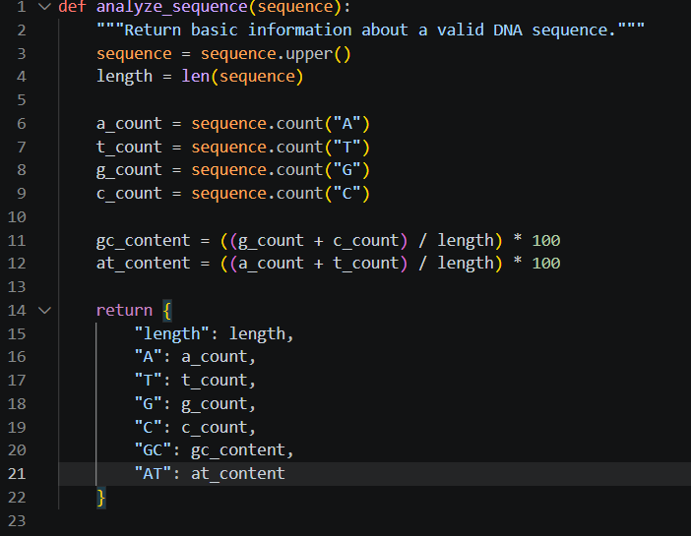
Figure 1: DNA sequence analysis function (analyze_sequence).

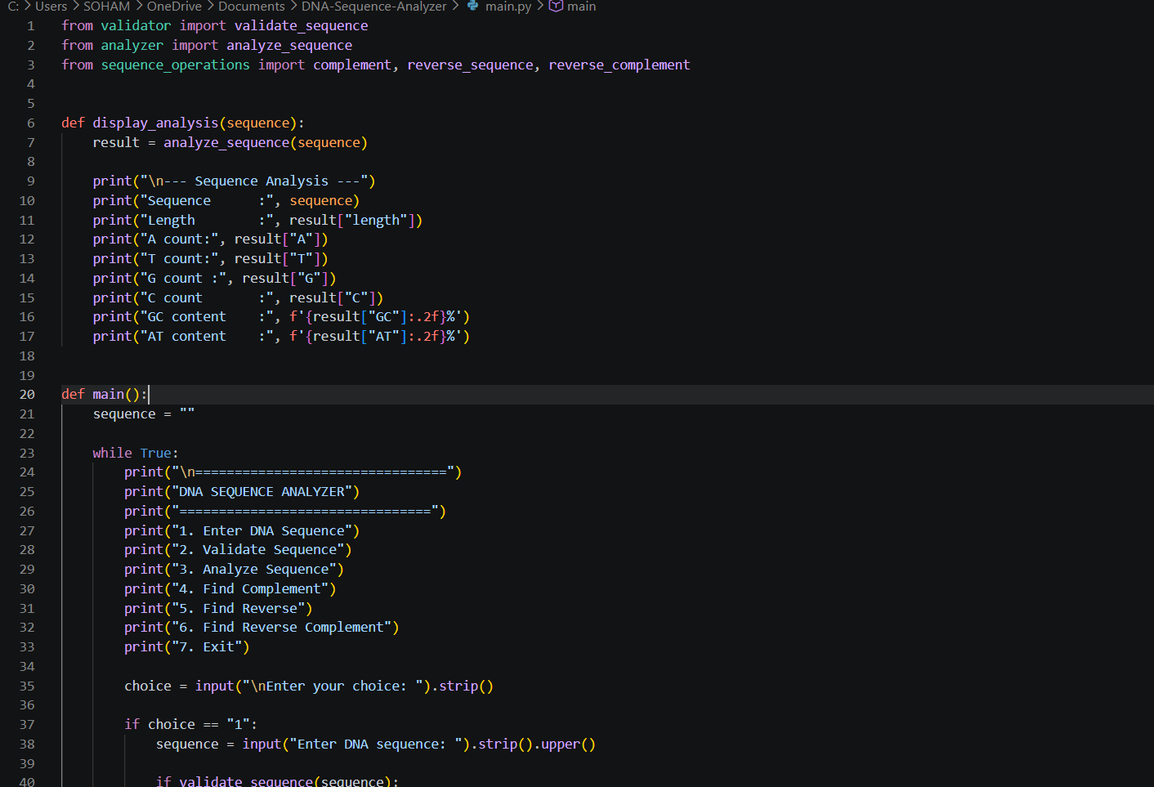
Figure 2: Main program menu and sequence input handling.

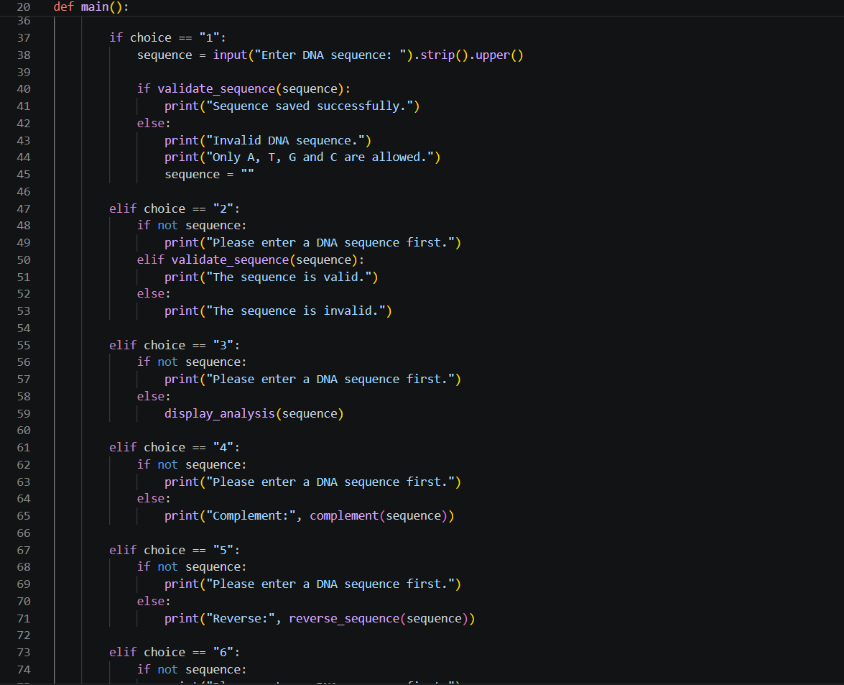
Figure 3: Main program validation, analysis, complement, and reverse operations.
Output:
`text
DNA SEQUENCE ANALYZER
---------------------
Enter DNA sequence: atgcgcta
The DNA sequence is
Length: 8
A = 2
T = 2
G = 2
C = 2
GC percentage: 50.00%
Complementary DNA: TACGCGAT
RNA: AUGCGCUA
Program finished.
### Test Case 2: Sequence with Non-Canonical Characters
**Input:**
```text
ATGCX99
Output:
`text
DNA SEQUENCE ANALYZER
---------------------
Enter DNA sequence: ATGCX99
This is not a valid DNA sequence
Program finished.

