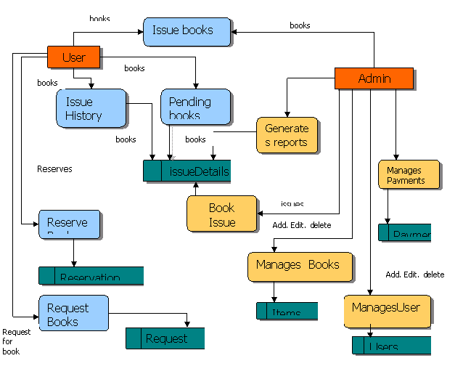

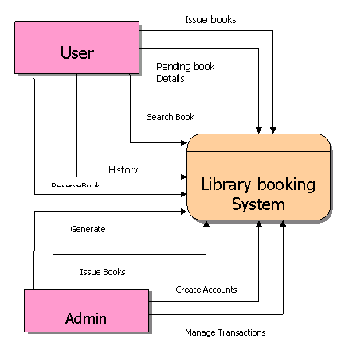

* Module - Login(Admin and Reader). When Login API call, need validate the user credentials, i/p will username and password. Once that is success return the login response with status code, token (use JWT) and admin or reader identifier. If failed return the error with proper validation.
* Admin Related API
  + Admin Profile update API 
    - Username
    - Email
    - Contact Number
  + Add Book API
    - Book name
    - Book id(auto generate)
    - Author
    - Number of books
    - Cost of each book------D
    - Available rack------D
    - Book Image
  + Update Existing Book
    - Book id
    - New/Remove books number
    - Reason for update
  + Users dropdown
    - Need to return the username and user id
  + Issue Book API
    - User id
    - Book id
    - Booking id ( Auto generated)
    - Issue date
    - Expiry date
  + Book Stock check API
    - Book name / Book ID
    - Need to return the how many books available with that name or id
  + Fines rates implement API
    - From day
    - To day
    - Cost
  + Add user
    - Email
    - Username
    - Contact number
    - Joining date
    - Profile
  + Book history track
    - Book id – optional( If no request return the all booking history in desc)
    - Need to return the response who taken the book previously. Response keys as follows
      * Username
      * Book taken date
      * Book return date - Return if not returned yet
      * Booking id
  + Fine calculate API
    - Booking ID
    - Returning date
  + Submit Book
    - Booking ID
    - Returning date
    - Fine amount if exists
* User related API
  + Search API
    - Book name or Book ID
    - Response need to return as
      * Count of available books,
      * Available rack--D
      * Cost per book
  + Fine related API
    - No Request
    - Response should to return as
      * From day
      * To day
      * Fine amount
  + User taken books history