Name : Shaikh Mohd Waliullah

Roll no : SCS2021084

Create a network with three routers with RIPv2 and each router associated network will have minimum three PC. Show connectivity.

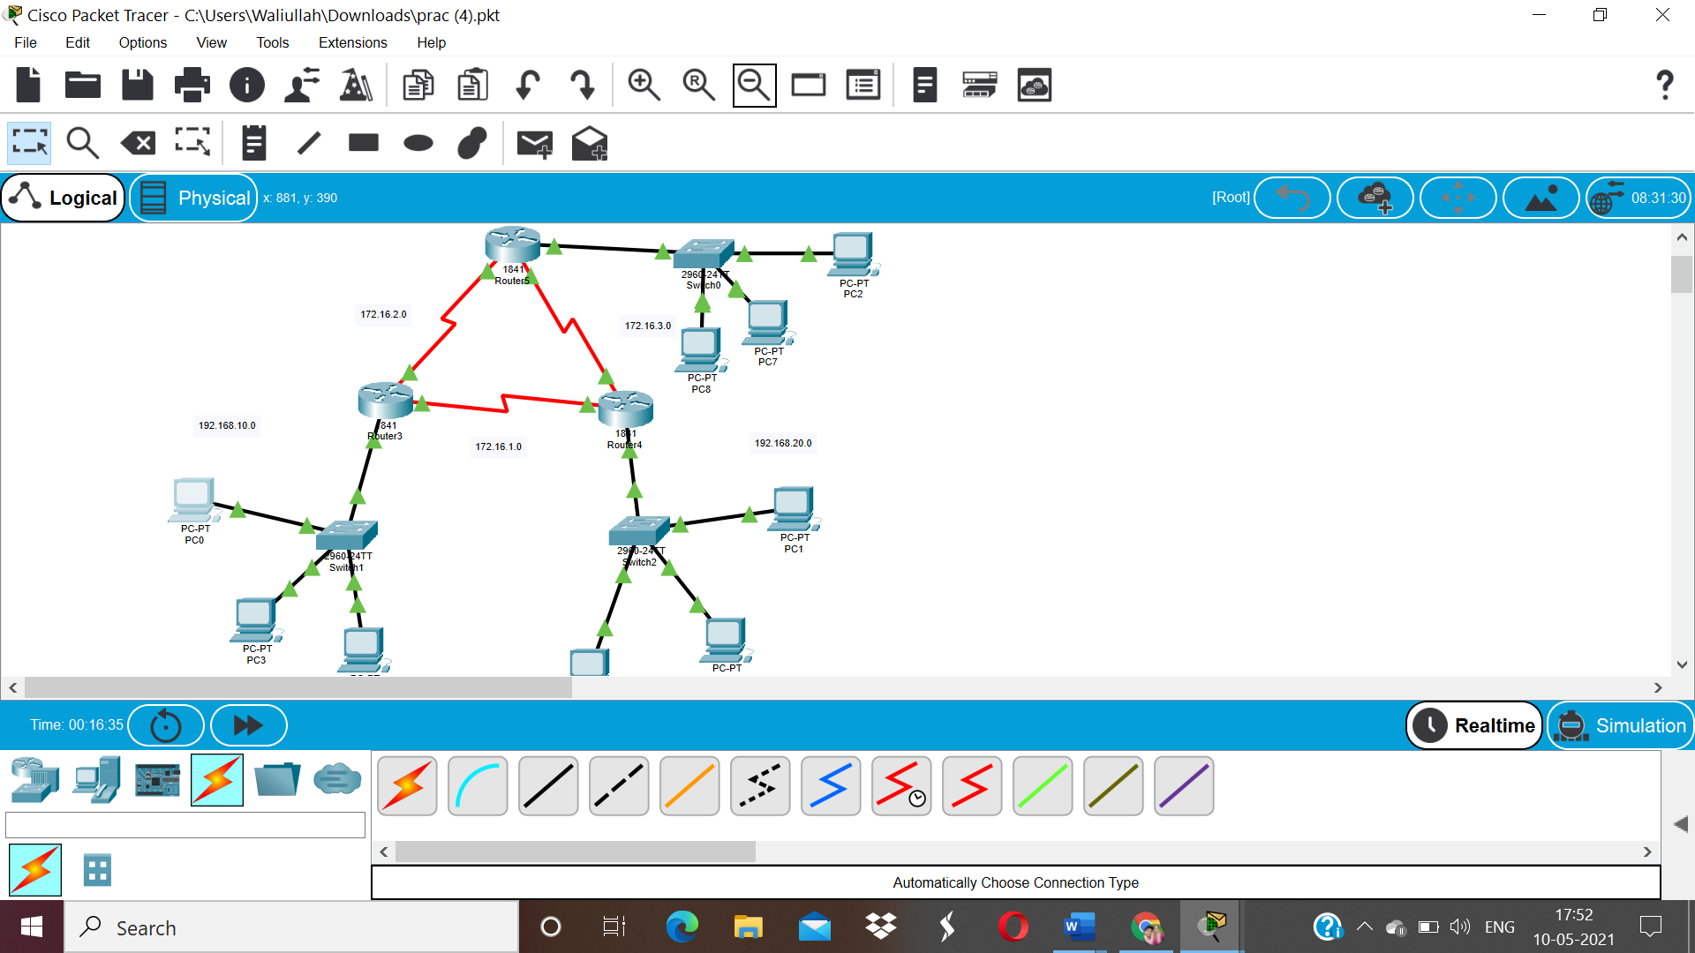

Output :

