1.Frist run this command: php artisan make:migration create_tablename_table. Then file will be create in the **:laravelpro\database\migrations\2025_07_22_104457_create_tablename_table.**

* **Example:**

**C:\xampp\htdocs\rphp\laravelpro\database\migrations\2025_07_22_104457_create_product_table:**

<?php

use Illuminate\Database\Migrations\Migration;

use Illuminate\Database\Schema\Blueprint;

use Illuminate\Support\Facades\Schema;

return new class extends Migration

{

    /**

     * Run the migrations.

     */

   // this class is a blueprint of the table.

    public function up(): void

    {

        Schema::connection('mysql2')->create('product', function (Blueprint $table) {

//we will add columns in the table

$table->id();

$table->string('name', 100);

            $table->float('price');

            $table->string('description');

            $table->timestamps();

        });

    }

    /**

     * Reverse the migrations.

     */

    public function down(): void

    {

        Schema::dropIfExists('product');

    }

};

**2.**  **After creating the migration file, run this command to execute the migration : php artisan migrate. So table will be create in the xampp.**

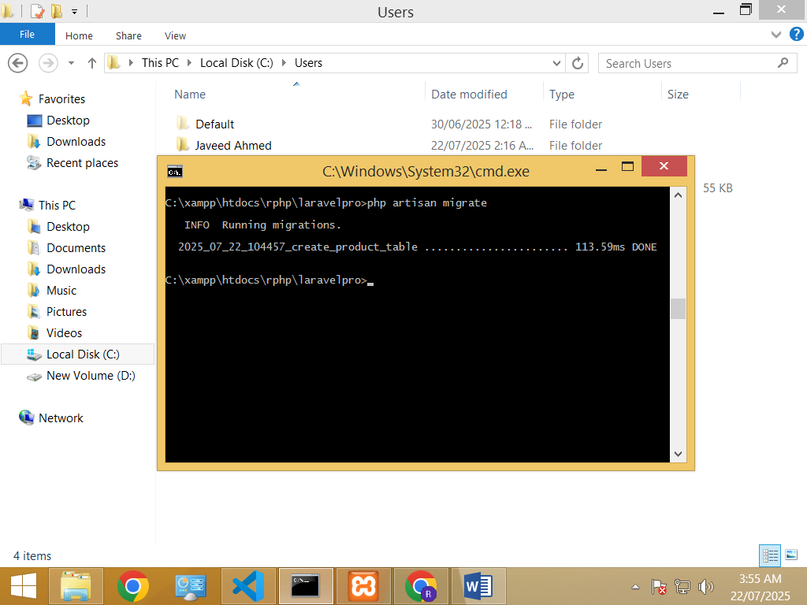

**You can see here:**

