HOUSEHUNT
ITRODUCTION:
" Welcome to HouseHunt Web App, your ultimate destination for finding the perfect place to call home! With our user-friendly interface and extensive listings of verified properties, we make your house-hunting journey simple, smooth, and stress-free. Whether you're searching for a cozy apartment, a spacious family home, or a modern villa, HouseHunt offers a wide range of options to suit your needs and budget. Browse through detailed property descriptions, view high-quality images, compare prices, and connect directly with property owners or agents—all in one place. Discover your dream home effortlessly with HouseHunt Web App today!"
DESCRIPTION:
Our HouseHunt Web App is more than just a platform for browsing properties—it’s a comprehensive solution designed to simplify and elevate every step of your home-search journey. Imagine having access to a dynamic real estate marketplace right at your fingertips, offering a wide range of verified properties tailored to your lifestyle, preferences, and budget.
From modern city apartments and cozy rental homes to luxurious villas and commercial spaces, HouseHunt provides detailed listings complete with high-quality images, property specifications, location insights, and pricing information. Our intuitive, user-friendly interface allows you to filter properties based on location, price range, amenities, and more—helping you find exactly what you’re looking for with just a few clicks.
But HouseHunt goes beyond simple property browsing. You can schedule site visits at your convenience, connect directly with property owners or trusted agents, and compare multiple listings to make confident, informed decisions. No more endless searching or unreliable information—everything you need is organized in one convenient platform.
We understand that finding the right home is a deeply personal experience. That’s why HouseHunt offers personalized recommendations based on your preferences, helping you discover properties that truly feel like home. Whether you’re a first-time buyer, a renter, or an investor, our app is designed to support your unique journey.
Our commitment doesn’t end with property listings. Our dedicated support team is always ready to assist you with any questions, ensuring a smooth and stress-free experience from search to settlement.
Experience the smarter way to find your dream home with HouseHunt Web App. Start your journey today and take the first step toward your perfect space.

SCENARIO BASED CASE STUDY:
Scenario: Renting an Apartment

User Registration: Alice, who is looking for a new apartment, downloads your house rent app and registers as a Renter. She provides her email and creates a password.
Browsing Properties: Upon logging in, Alice is greeted with a dashboard showcasing available rental properties. She can see listings with detailed descriptions, photos, and rental information.
She applies filters to narrow down her search, specifying her desired location, rent range, and the number of bedrooms.
Property Inquiry: Alice finds an apartment she likes and clicks on it to get more information. She sees the property details and owner's contact information.
Interested in renting, Alice fills out a small form with her details and sends it to the owner.
Booking Confirmation: The owner receives Alice's inquiry and reviews her details. Satisfied, the owner approves Alice's booking request.
Alice receives a notification that her booking is confirmed, and the status in her dashboard changes to "pending owner confirmation."
Admin Approval (Background Process): In the background, the admin reviews new owner registrations and approves legitimate users who want to add properties to the app.
Owner Management: Bob, a property owner, signs up for an Owner account on the app and submits a request for approval.
The admin verifies Bob's credentials and approves his Owner account.
Property Management: With his Owner account approved, Bob can now add, edit, or delete properties in his account.
He updates the status and availability of his properties based on their occupancy.
Platform Governance: Meanwhile, the admin ensures that all users adhere to the platform's policies, terms of service, and privacy regulations.
The admin monitors activities to maintain a safe and trustworthy environment for all users.
Transaction and Lease Agreement: Once Alice's booking is confirmed, she and the owner negotiate the terms of the lease agreement through the app's messaging system.
They finalize the rental contract and payment details within the app, ensuring transparency and security.
Move-in Process: Alice successfully moves into her new apartment, marking the completion of the rental process facilitated by the house rent app.
This scenario highlights the main functionalities of your MERN-based house rent app, including user registration, property browsing, inquiry and booking process, admin approval, owner management, platform governance, and the overall rental transaction.

TECHNICAL ARCHITECTURE

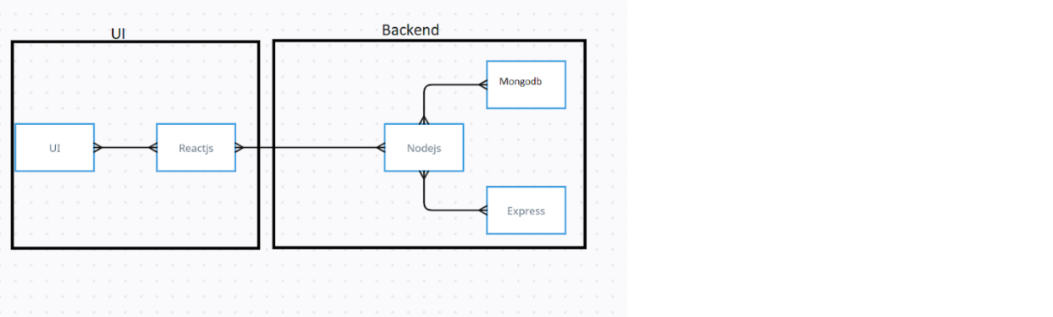
The technical architecture of our House rent app follows a client-server model, where the frontend serves as the client and the backend acts as the server. The frontend encompasses not only the user interface and presentation but also incorporates the axios library to connect with backend easily by using RESTful Apis.

The frontend utilizes the bootstrap and material UI library to establish real-time and better UI experience for any user whether it is admin, doctor and ordinary user working on it.

On the backend side, we employ Express.js frameworks to handle the server-side logic and communication.
For data storage and retrieval, our backend relies on MongoDB. MongoDB allows for efficient and scalable storage of user data, including user profiles, for booking room, and adding room, etc. It ensures reliable and quick access to the necessary information.

Together, the frontend and backend components, along with moment, Express.js, and MongoDB, form a comprehensive technical architecture for our House rent app. This architecture enables real-time communication, efficient data exchange, and seamless integration, ensuring a smooth and immersive booking an appointment and many more experience for all users.
.

ER-Diagram:

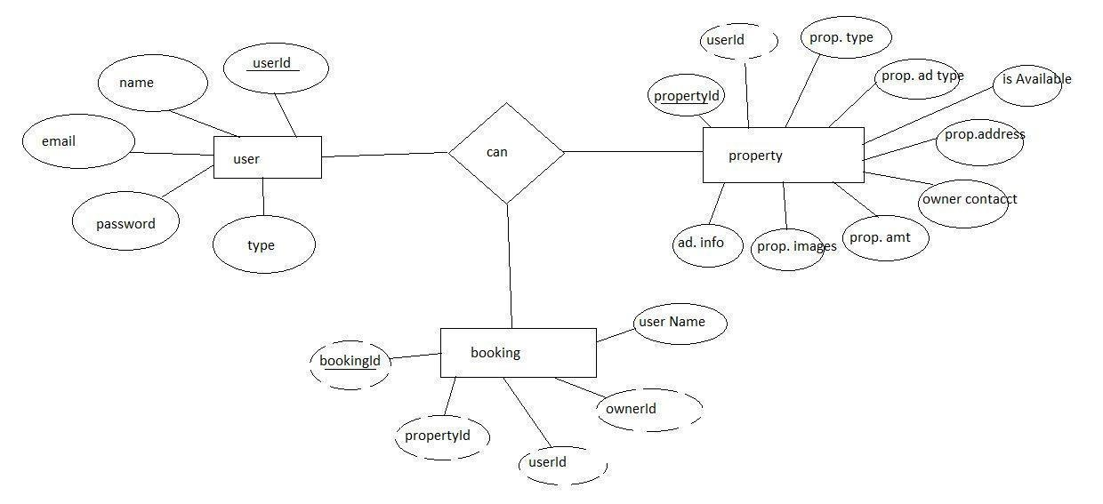

Here there is 3 collections namely users, property, and booking which have their own fields in
Users:
- _id: (MongoDB creates by unique default)
- name
- email
- password
- type
Property:
- userID: (can be act as foreign key )
- _id: (MongoDB creates by unique default)
- prop.Type
- prop.AdType
- isAvailable
- prop.Address
- owner contact
- prop.Amt
- prop.images
- add.Info
Booking
- _id: (MongoDB creates by unique default)
- propertId
- userId
- ownerId
- username

PRE REQUISITES:

- Here are the key prerequisites for developing a full-stack application using Node.js, Express.js, MongoDB, React.js:
Node.js and npm:
- Node.js is a powerful JavaScript runtime environment that allows you to run JavaScript code on the server-side. It provides a scalable and efficient platform for building network applications.
- Install Node.js and npm on your development machine, as they are required to run JavaScript on the server-side.
- Download: https://nodejs.org/en/download/
- Installation instructions: https://nodejs.org/en/download/package-manager/
- npm init

Express.js:
- Express.js is a fast and minimalist web application framework for Node.js. It simplifies the process of creating robust APIs and web applications, offering features like routing, middleware support, and modular architecture.
- Install Express.js, a web application framework for Node.js, which handles server-side routing, middleware, and API development.
- Installation: Open your command prompt or terminal and run the following command:
npm install express
- MongoDB:
- MongoDB is a flexible and scalable NoSQL database that stores data in a JSON-like format. It provides high performance, horizontal scalability, and seamless integration with Node.js, making it ideal for handling large amounts of structured and unstructured data.
- Set up a MongoDB database to store your application's data.
- Download: https://www.mongodb.com/try/download/community
- Installation instructions: https://docs.mongodb.com/manual/installation/
Moment.js:
- Momentjs is a JavaScript package that makes it simple to parse, validate, manipulate, and display date/time in JavaScript. Moment. js allows you to display dates in a human-readable format based on your location. Install React.js, a JavaScript library for building user interfaces.
- Follow the installation guide: https://momentjs.com/

React.js:
- React.js is a popular JavaScript library for building user interfaces. It enables developers to create interactive and reusable UI components, making it easier to build dynamic and responsive web applications.
- Install React.js, a JavaScript library for building user interfaces.
- Follow the installation guide: https://reactjs.org/docs/create-a-new-react-app.html
Antd:
- Ant Design is a React. js UI library that contains easy-to-use components that are useful for building interactive user interfaces. It is very easy to use as well as integrate. It is one of the smart options to design web applications using react.
- Follow the installation guide: https://ant.design/docs/react/introduce
HTML, CSS, and JavaScript: Basic knowledge of HTML for creating the structure of your app, CSS for styling, and JavaScript for client-side interactivity is essential.
- Database Connectivity: Use a MongoDB driver or an Object-Document Mapping (ODM) library like Mongoose to connect your Node.js server with the MongoDB database and perform CRUD (Create, Read, Update, Delete) operations. To Connect the Database with Node JS go through the below provided link:
- https://www.section.io/engineering-education/nodejs- mongoosejs-mongodb/
- Front-end Framework: Utilize Reactjs to build the user-facing part of the application, including entering booking room, status of the booking, and user interfaces for the admin dashboard.
- For making better UI we have also used some libraries like material UI and bootstrap.
Install Dependencies:
- Navigate into the cloned repository directory:
- cd house-rent
- Install the required dependencies by running the following commands:
- cd frontend
- npm install
- cd ../backend
- npm install
- Start the Development Server:
- To start the development server, execute the following command:
- npm start
- The house rent app will be accessible at http://localhost:3000
- You have successfully installed and set up the online complaint registration and management app on your local machine. You can now proceed with further customization, development, and testing as needed.

ROLE BASED ACCESS:
The project has 2 type of user – Renter and Owner and other will be Admin which takes care to all the user. The roles and responsibilities of these two types of users can be inferred from the API endpoints defined in the code. Here is a summary:

Renter/Tenent:
- Create an account and log in to the system using their email and password.
- They will be shown automatically all the properties in their dashboard.
- After clicking on the Get Info, all the information of the property and owner will come and small form will generate in which the renter needs to send his\her details.
- After that they can see their booking in booking section where the status of booking will be showing “pending”. It will be change by owner of the property.

Admin:
- He/she can approve the user as “owner” for the legit user to add properties in his app
6. He monitors the applicant of all doctors and approve them and then doctors are registered in the app.
7. Implement and enforce platform policies, terms of service, and privacy regulations.

Owner:
- lets the approval from the admin for his Owner account.
- After approval, he/she can do all CRUD operation of the property in his/her account
- He/she can change the status and availability of the property.

PROJECT FLOW
- Frontend Development
- Backend Development
- Integration
DEMO LINK:- https://drive.google.com/file/d/1WKvHJYQJpXpoIURI4T0GkkvK_DH1arQ8/view?usp=sharing
USE THE CODE IN:-
https://github.com/shaikibrahim8014/HouseHunt.git
or follow the videos below for better understanding.
MILESTONE 1: PROJECT SETUP AND CONFIGURATION: reference Link:- Folder setup:
- Create frontend and
- Backend folders

2. Open the backend folder to install necessary tools
For backend, we use:
- cors
- bcryptjs
- express
- dotenv
- mongoose
- Moment
- Multer
- Nodemon
- jsonwebtoken

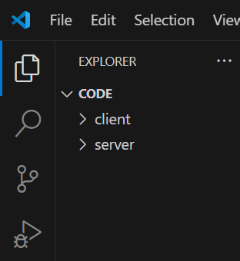

MILESTONE 2: BACKEND DEVELOPMENT:
- Setup express server
- Create index.js file in the server (backend folder).
- define port number, MongoDB connection string and JWT key in env file to access it.
- Configure the server by adding cors, body-parser.

- Add authentication: for this,
- You need to make middleware folder and in that make authMiddleware.js file for the authentication of the projects and can use in.

MILESTONE 3: DATABASE:
- Configure MongoDB
- Import mongoose.
- Add database connection from config.js file present in config folder
- Create a model folder to store all the DB schemas like renter, owner and booking, and properties schemas.

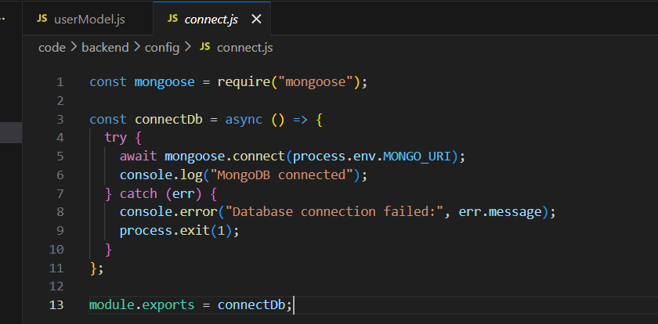

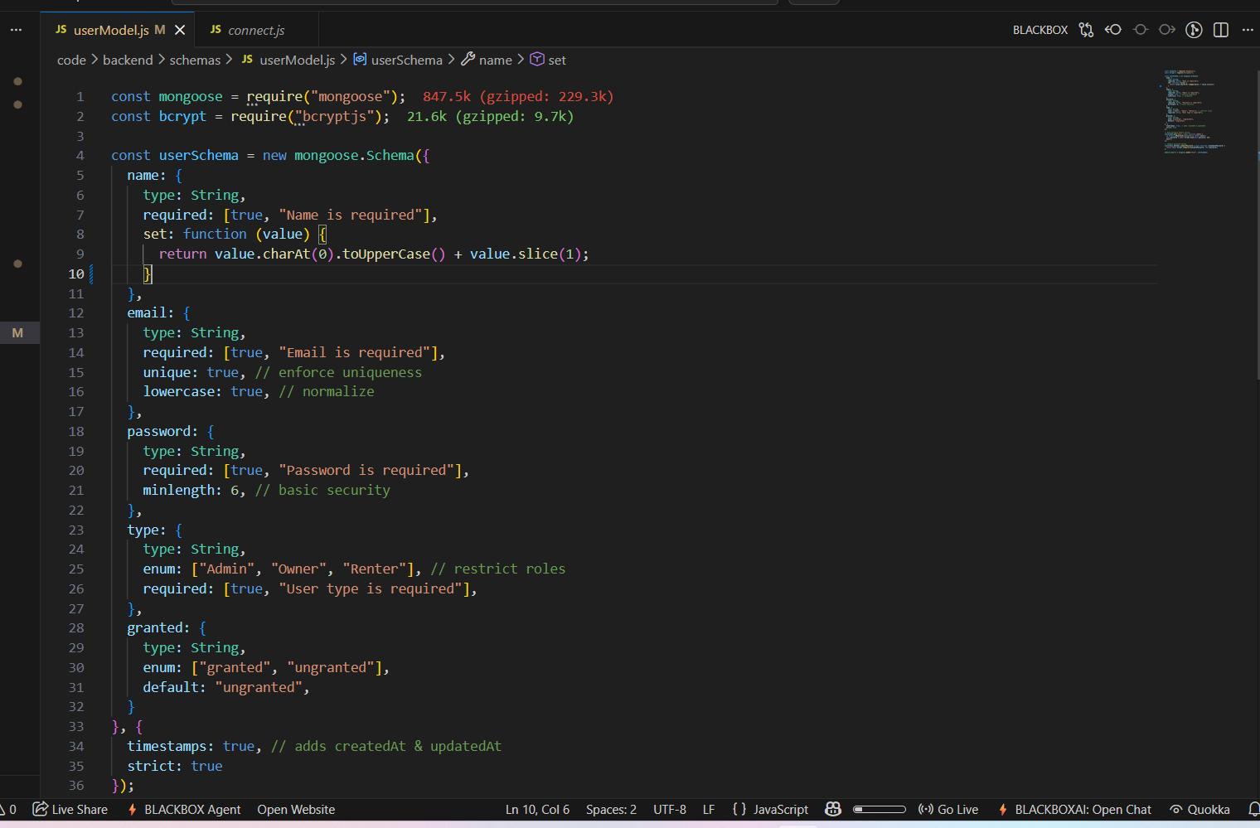

MILESTONE 4: FRONTEND DEVELOPMENT
Installation of required tools:
For frontend, we use:
- React
- Bootstrap
- Material UI
- Axios
- Moment
- Antd
- mdb-react-ui-kit
- react-bootstrap
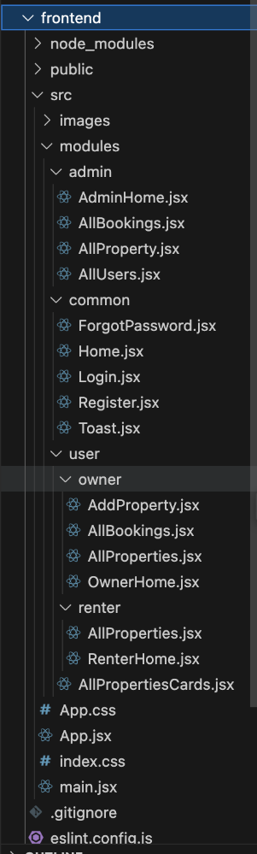

MILESTONE 5: PROJECT IMPLEMENTATION
- On completing the development part, we then run the application one last time to verify all the functionalities and look for any bugs in it. The user interface of the application looks a bit like the one’s provided belo

Homepage:
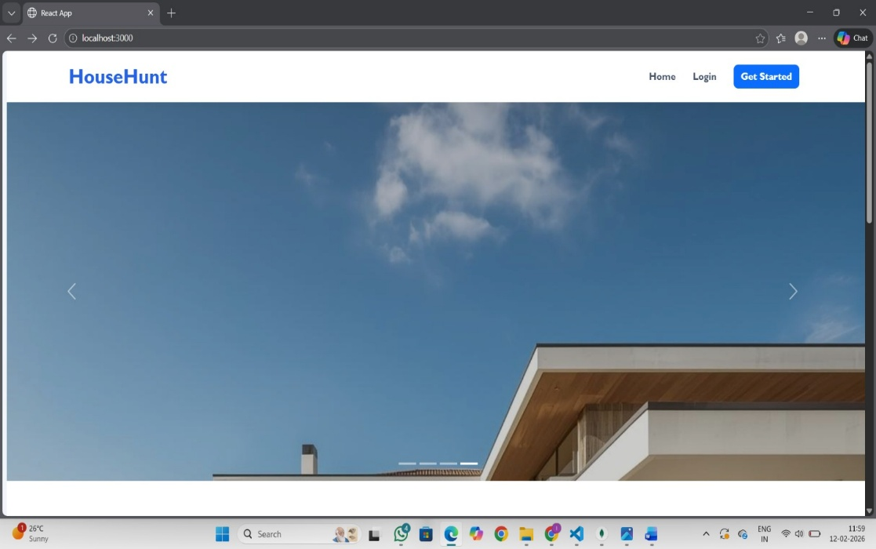

Register page:

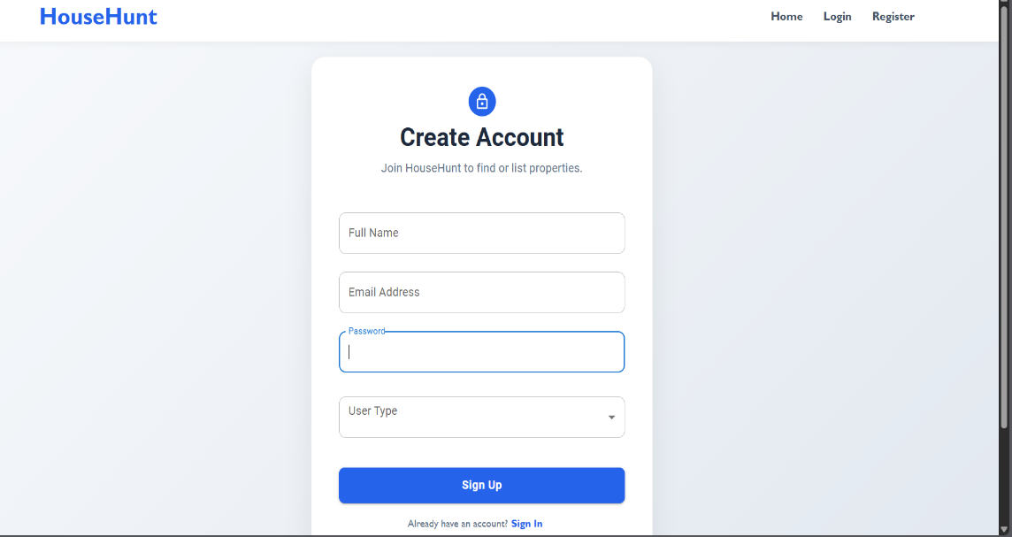

Login
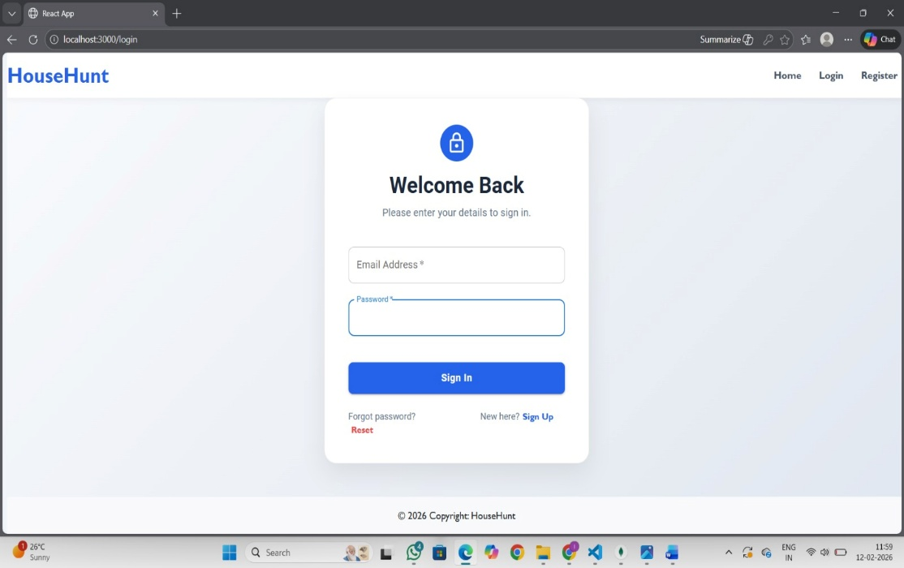

Tenant panel:
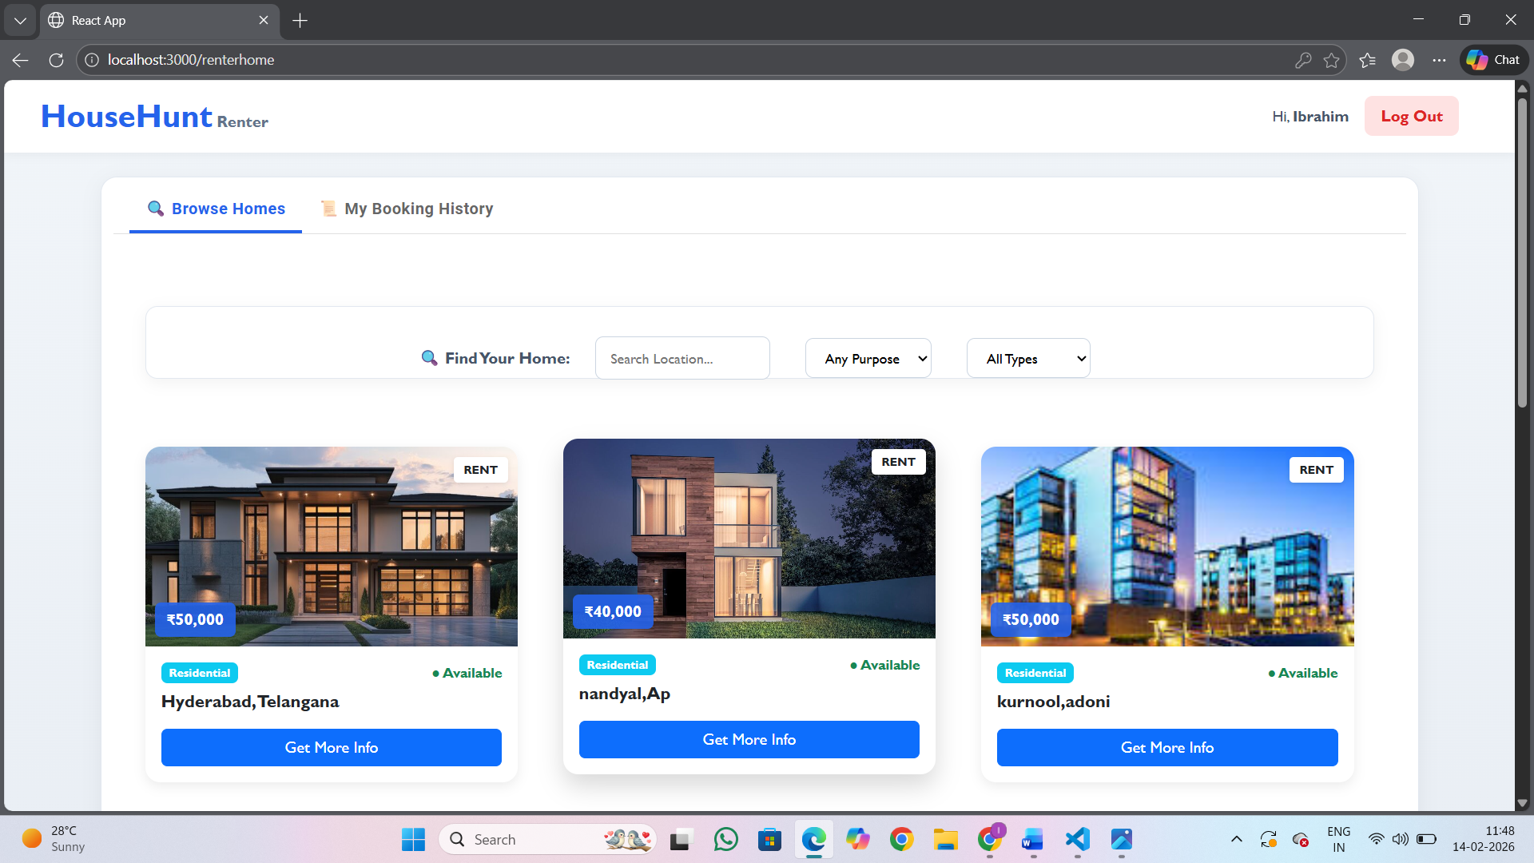

Ownerpage: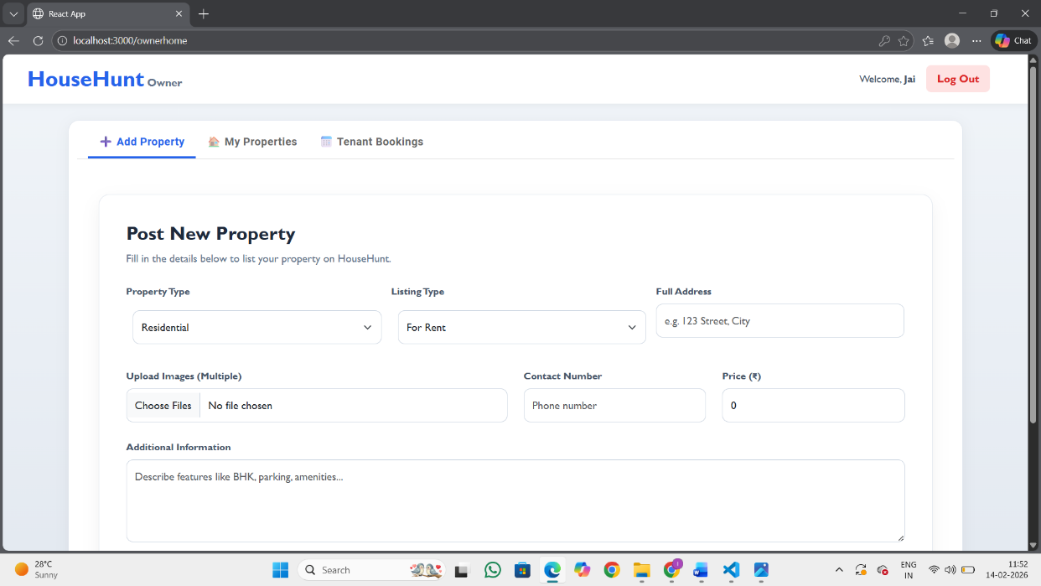

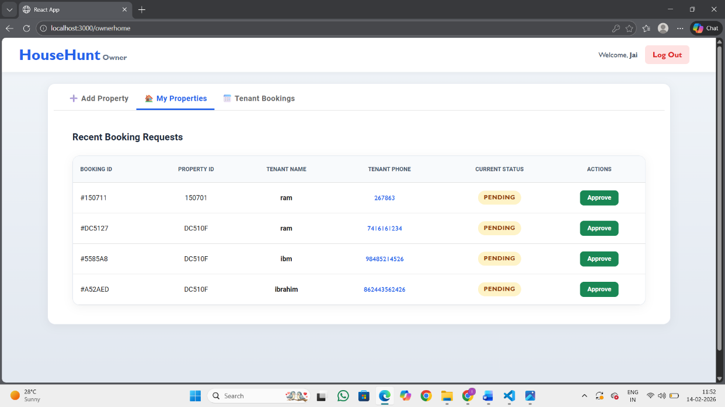
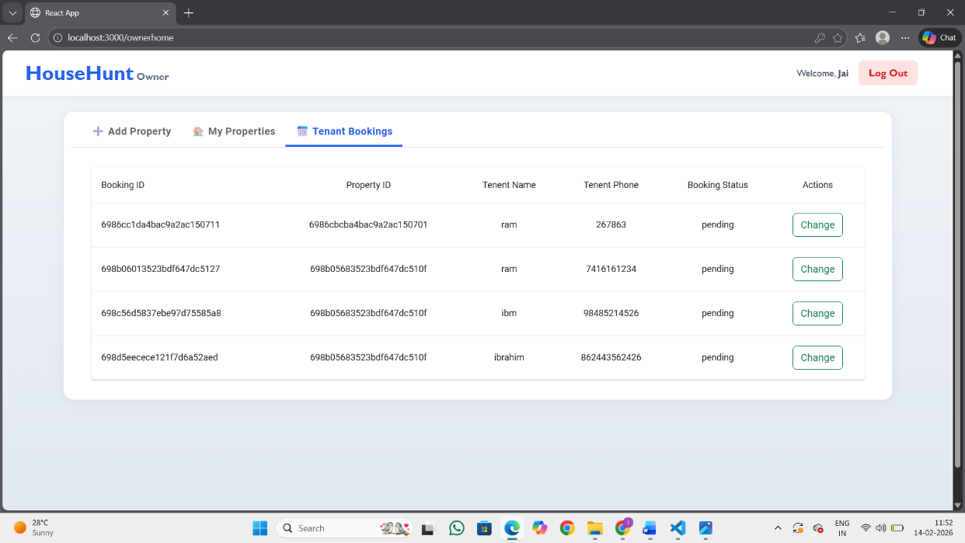

Admin page
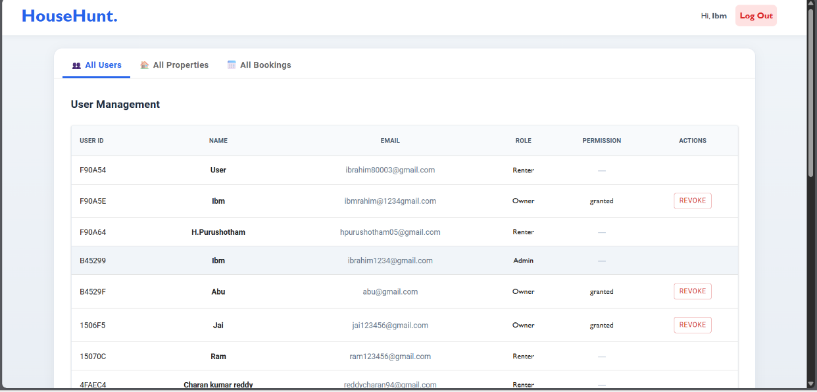

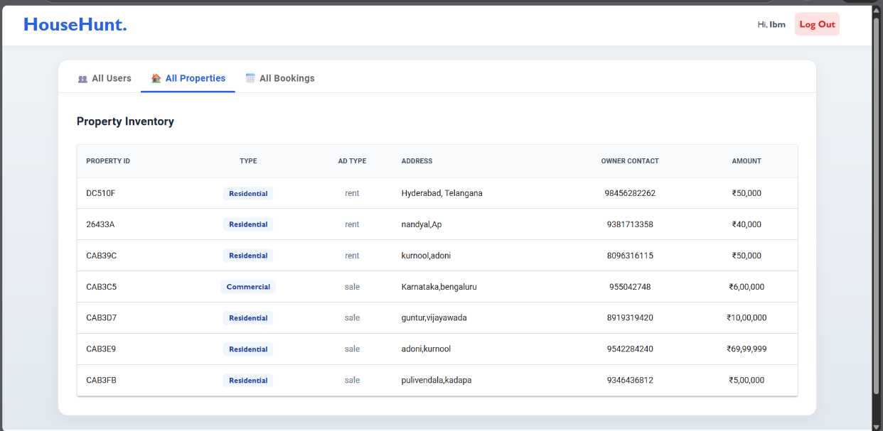
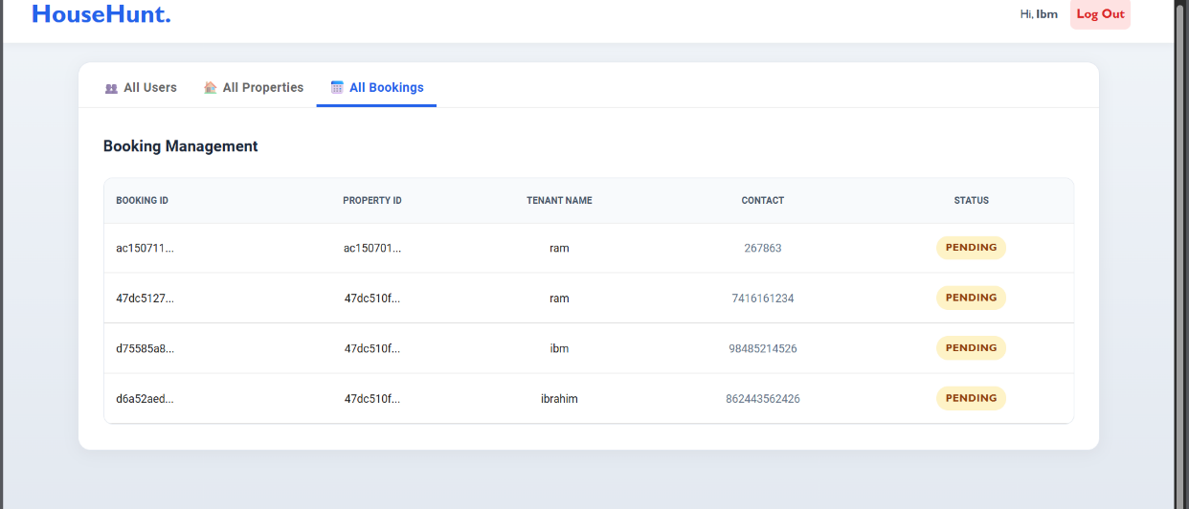
SEARCH PAGE :

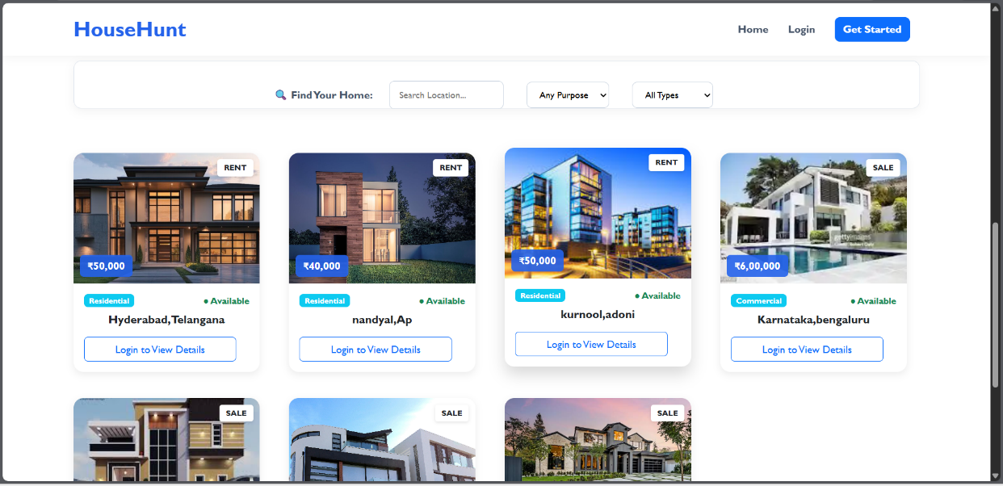
Conclusion:
The HouseHunt Rental Application was successfully designed and developed to simplify the process of finding and listing rental properties. The system provides a user-friendly platform where Renters can search and view available properties, Owners can post and manage property listings, and the Admin can monitor and control overall system activities.
This project demonstrates the practical implementation of full-stack web development using React.js for the frontend and Node.js, Express.js, and MongoDB for the backend. Through this project, essential concepts such as user authentication, role-based access control, RESTful APIs, database integration, and responsive UI design were effectively applied.
The application ensures secure login and registration, smooth property management, and structured data handling. It also highlights the importance of proper backend routing, error handling, and deployment processes.
Overall, the HouseHunt project enhances the rental experience by providing a centralized digital solution that reduces manual effort, increases transparency, and improves efficiency in property management. This project serves as a strong foundation for further improvements such as payment integration, advanced filtering, chat systems, and mobile application support.

Future Scope:
The HouseHunt Rental Application has strong potential for further enhancement and expansion. While the current system successfully manages property listings, user authentication, and role-based access, several advanced features can be added to improve functionality and user experience.

1. Online Payment Integration:
Future versions can integrate secure online payment gateways such as Razorpay or Stripe to allow tenants to pay rent directly through the platform.
2. Advanced Search & Filtering:
Adding smart filters like price range, location radius, amenities, property type, and availability date can enhance the user experience and help tenants find suitable properties more efficiently.
3. Real-Time Chat System:
Implementing a real-time messaging feature between owners and tenants would improve communication and reduce dependency on external contact methods.
4. Mobile Application Development:
Developing an Android and iOS mobile application would increase accessibility and allow users to manage properties conveniently from their smartphones.
5. AI-Based Property Recommendations:
Using machine learning algorithms to recommend properties based on user preferences and browsing history can make the platform smarter and more personalized.
6. Rating & Review System:
Adding a review and rating system for properties and owners can increase transparency and help users make better decisions.
7. Location Integration with M aps:
Integrating Google Maps API can allow users to view property locations visually and explore nearby facilities such as schools, hospitals, and markets.

8. Admin Analytics Dashboard:
A detailed analytics dashboard for the admin can provide insights such as user growth, property statistics, and revenue reports.

The demo of the app is available at:
https://drive.google.com/file/d/1WKvHJYQJpXpoIURI4T0GkkvK_DH1arQ8/view?usp=sharing
The reference code is available at:
https://github.com/shaikibrahim8014/HouseHunt.git

** THANK YOU**

