Object Classification Using CNN-Based Fusion of Vision and LIDAR in Autonomous Vehicle Environment

In this paper Alexnet algorithm is training with LIDAR (Light detection and ranging) RGB images to detect and classify objects in Autonomous Vehicle environment. This algorithm is based on CNN model which extract and fed depth RGB values from images. This proposed algorithm helps autonomous (self-driving) vehicles in accurate detection and classification of objects found at road side. In propose paper author training Alexnet CNN with two different datasets such as KITTI and RGB LIDAR dataset.

Propose algorithm can up-sample images to increase image clarity for better detection and classification.

To implement this project we have used KITTI dataset and then designed following modules

1. Upload Kitti Dataset: using this module we will upload dataset to application
2. Load Alexnet LIDAR CNN Model: this module will read all images and then applying up-sampling to increase image intensity and then extract RGB value to train ALEXNET CNN model
3. Run LIDAR Object Detection & Classification: In this module we we will upload test image and then Alexnet model will detect and classify objects from that test image
4. LIDAR Accuracy & Loss Graph: using this module we will plot LIDAR Alexnet accuracy and loss graph and we train this algorithm for 10 EPOCH and in graph we will get accuracy plot for each epoch

Note: Alexnet model trained on Light Detection and Ranging images so it will called as LIDAR Alexnet CNN model

SCREEN SHOTS

To run project double click on ‘run.bat’ file to get below screen

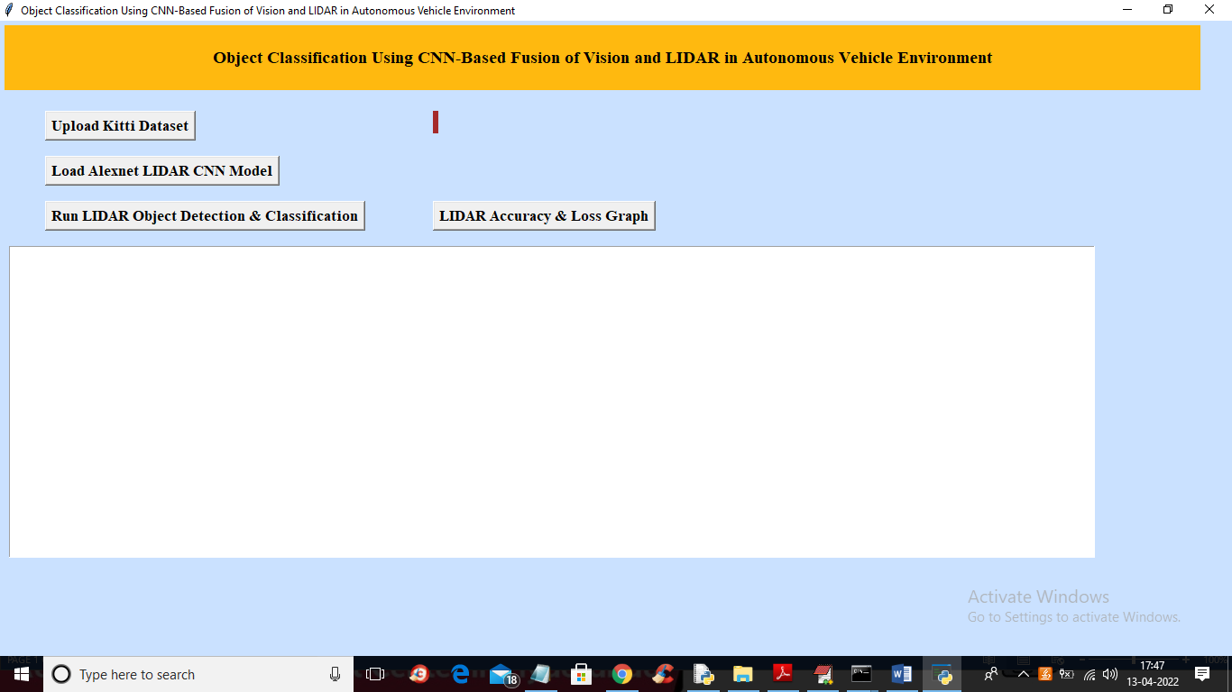

In above screen click on ‘Upload Kitti Dataset’ button to upload dataset to application

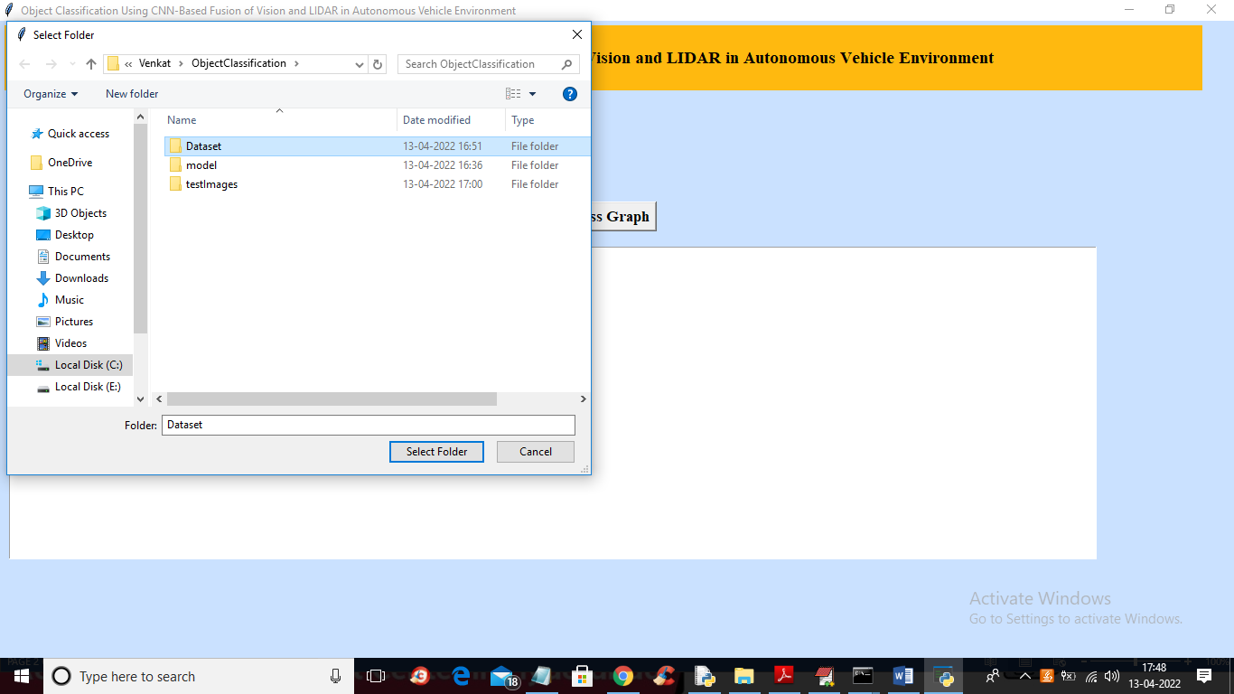

In above screen selecting and uploading dataset folder and this folder contains different types of objects which you can see in below screen

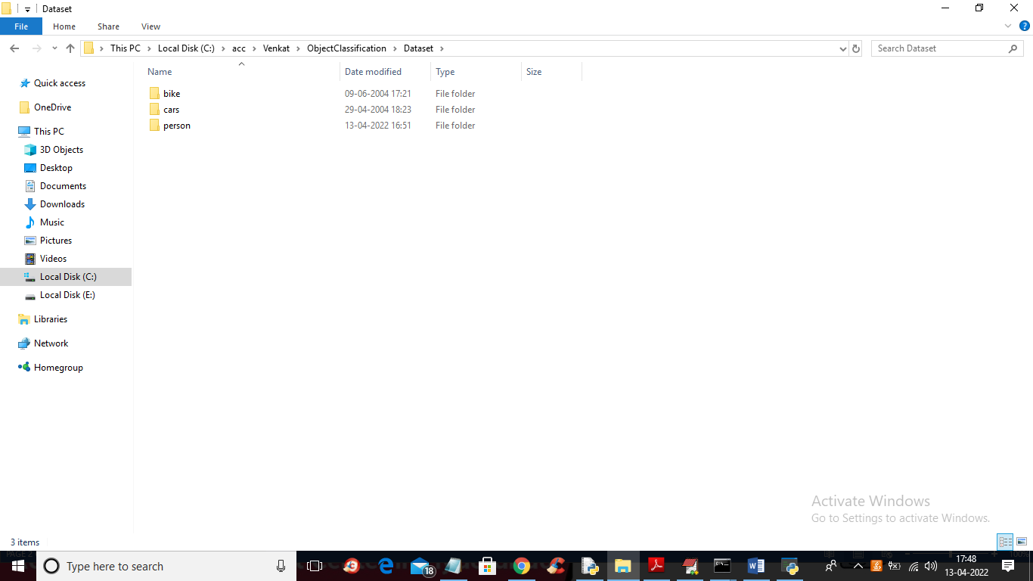

In above screen dataset has 3 different types of classes and just go inside any folder to view those type of images

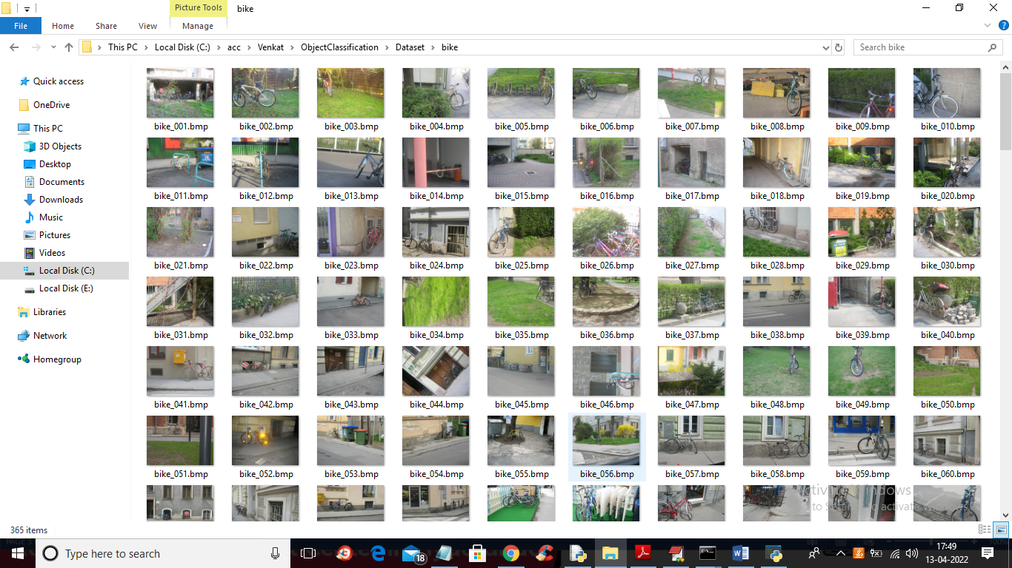

In above screen we can see cycle classes from cycle folder and Alexnet will get trained on above image and now in application screen click on ‘Load Alexnet LIDAR CNN Model’ button to build Alexnet model and get below output

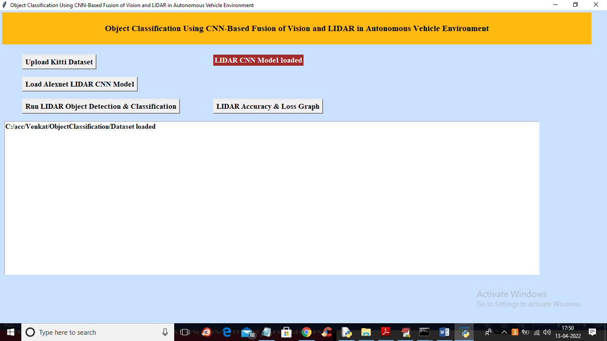

In above screen in red colour text we can see CNN model loaded and now click on ‘Run LIDAR Object Detection & Classification’ button to upload test image and get below output

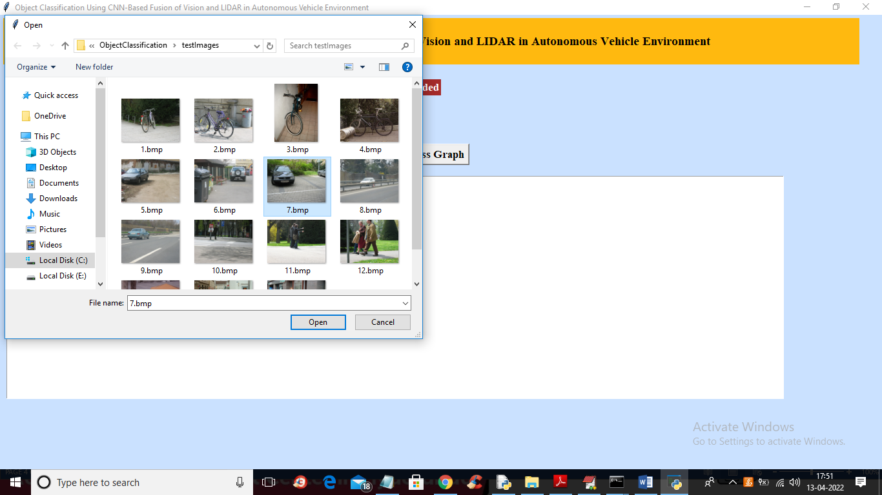

In above screen selecting and uploading 7.bmp image and then click on ‘Open’ button to get below output

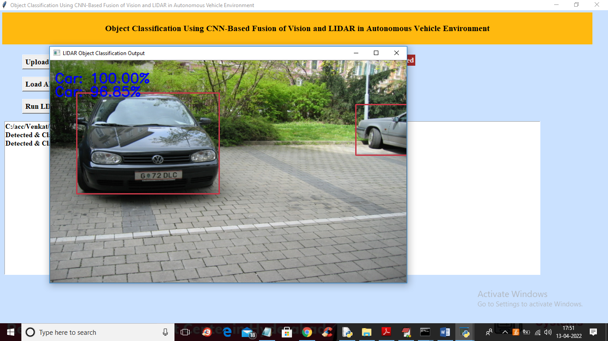

In above screen two objects are detected and classified as CAR and similarly you can upload and test other images

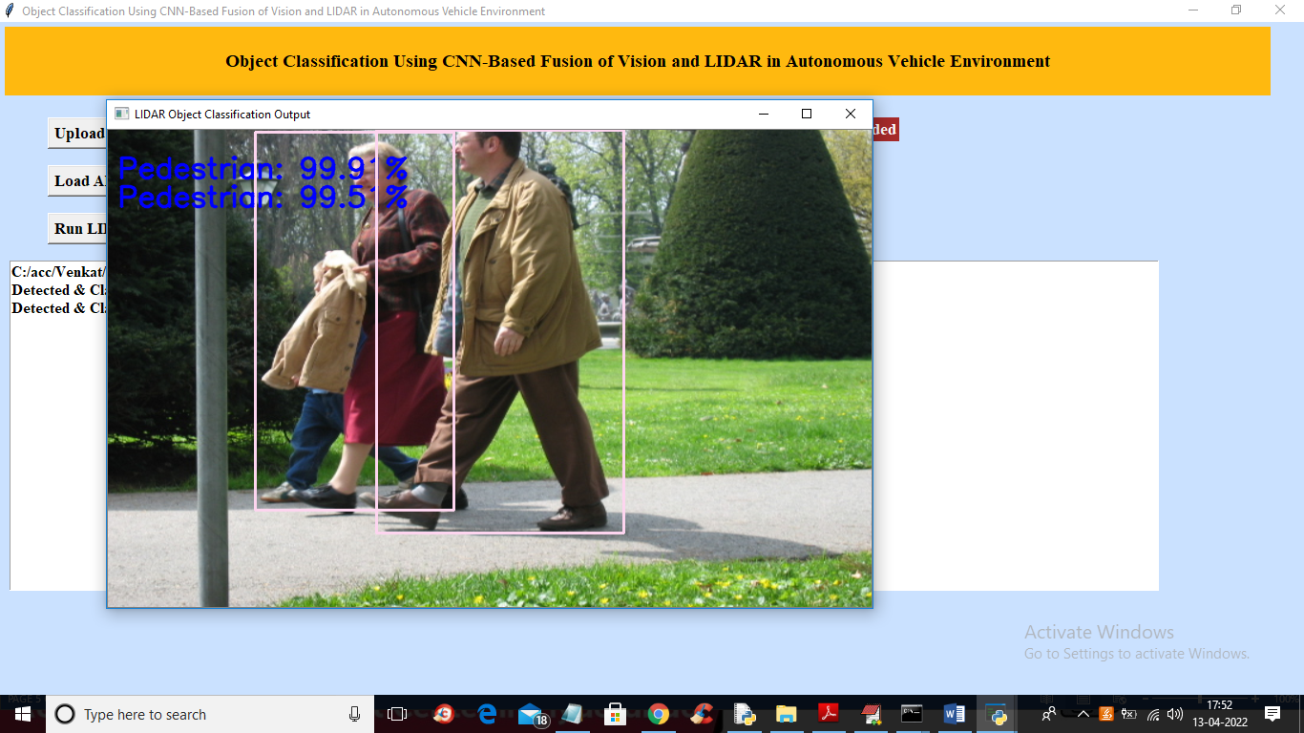

In above screen pedestrian detected

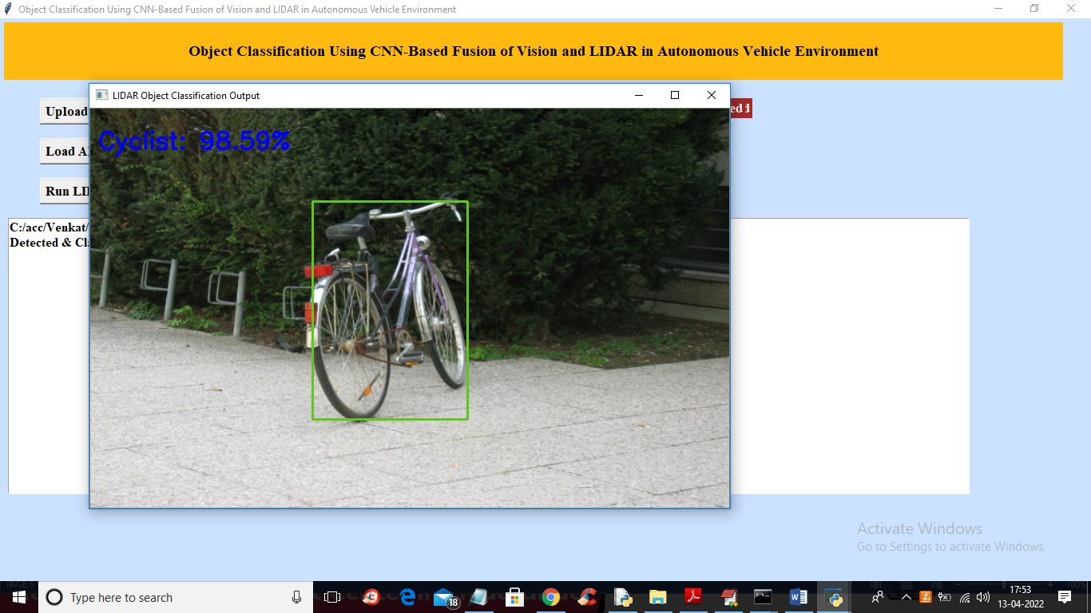

In above screen cyclist is detected and now click on ‘LIDAR Accuracy & Loss Graph’ button to get below graph

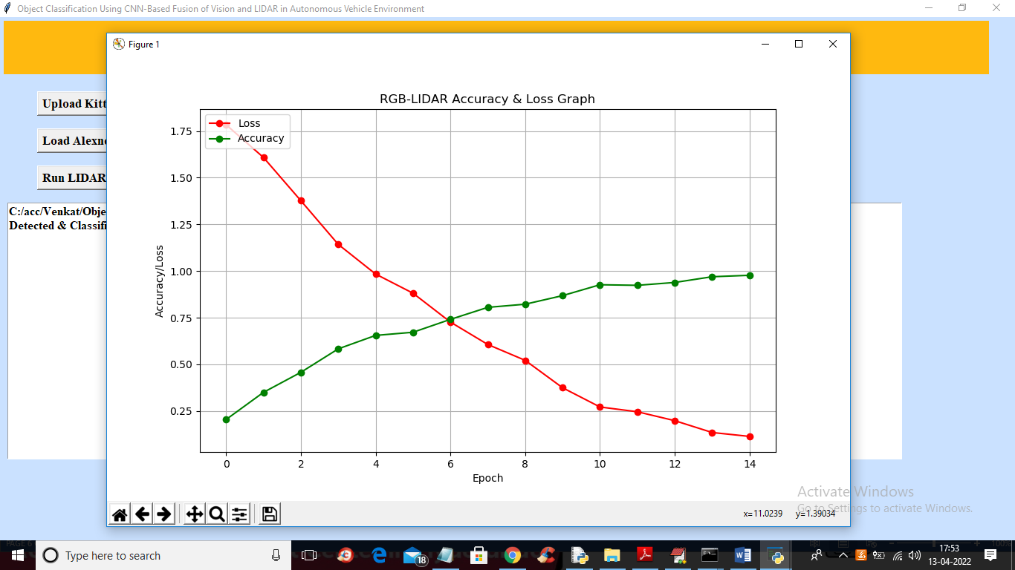

In above graph x-axis represents EPOCH and y-axis represents accuracy and loss values and red line represents LOSS and green line represents accuracy and in above graph we can see with each increasing epoch accuracy get increased and loss get decreased