EMOTION DETECTION USING SPEECH RECOGNITION AND FACIAL EXPRESSION

In this project we are detecting emotion using speech data and facial expression images and to implement this project we have trained CNN algorithm with RAVDESS Audio Dataset for speech emotion recognition and for face expression we have used Emotion Facial Expression images dataset. Below screen shots code with red colour comments showing extraction of MFCC features from audio dataset.

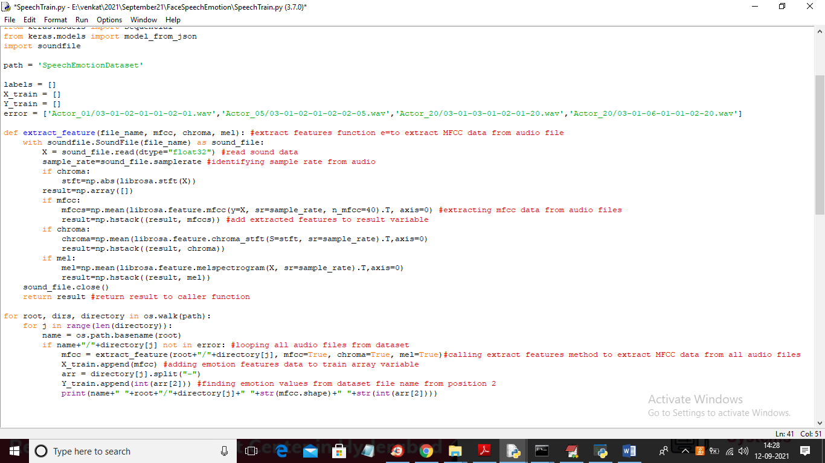

In above screen you can read red colour comments to know about features extraction from audio and in below screen you can see X and Y data training with CNN

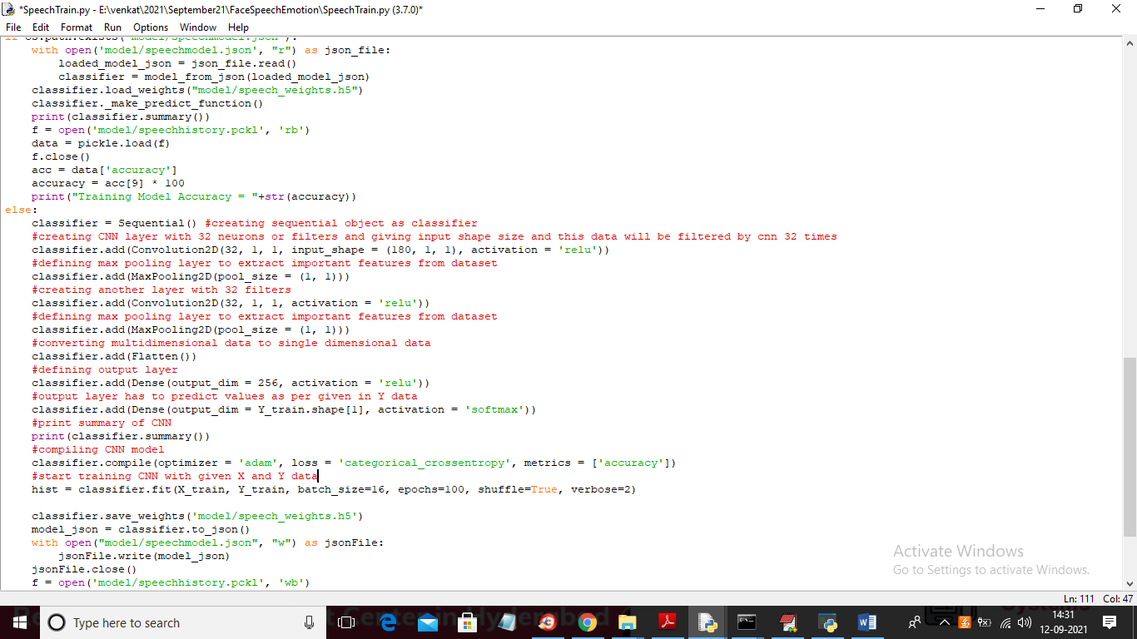

In above screen we have used CNN model to train speech dataset and by using same code we have trained face images also. Below screen showing images from face dataset and this dataset is available inside ‘Dataset’ folder

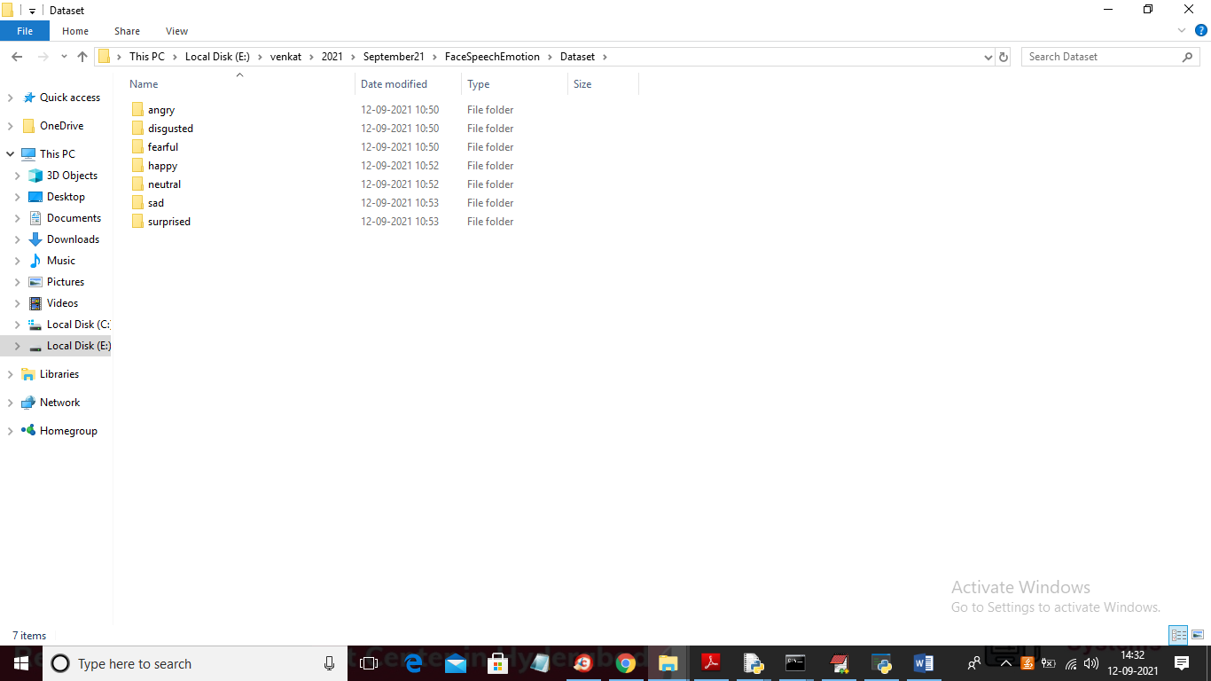

In above screen for facial expression we took 7 different emotions and go inside any folder to see images

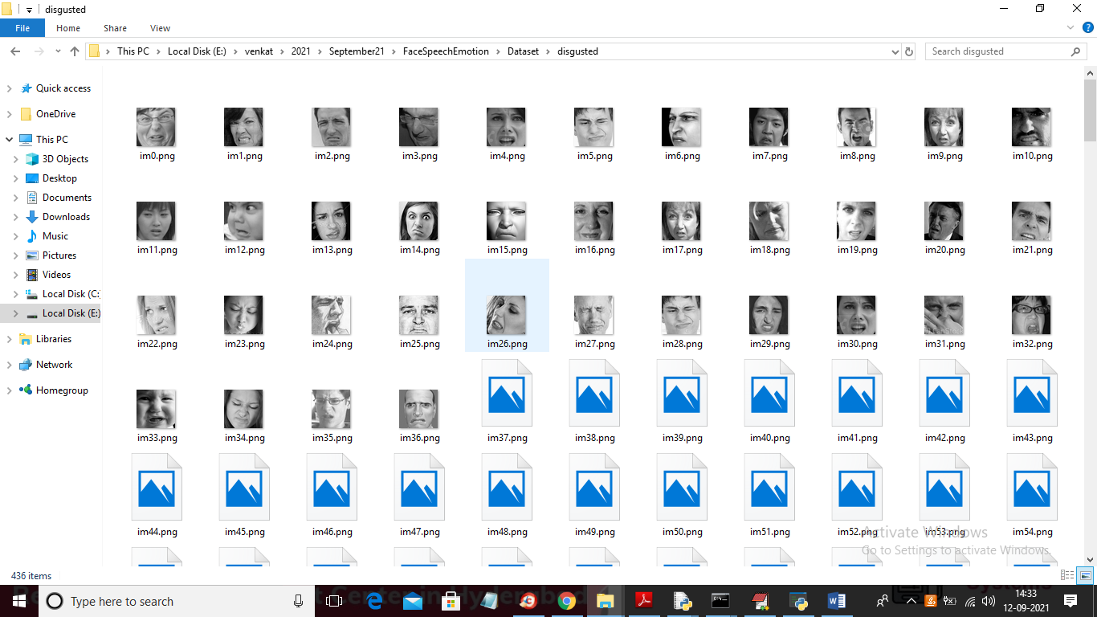

In below screen I am showing dataset of speech audio files and this dataset saved inside ‘SpeechEmotionDataset’ folder

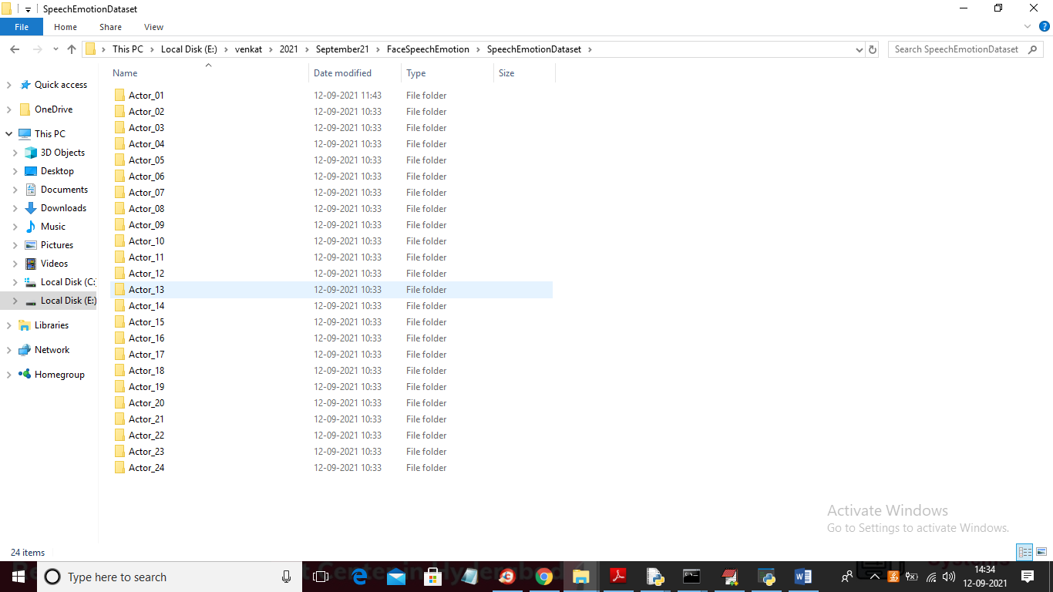

In above screen we can see we have speech recording from 24 different actors which record voice in 8 different emotions such as ['neutral', 'calm', 'happy', 'sad', 'angry', 'fearful', 'disgust', 'surprised']. Just go inside any folder in above screen to see audio data

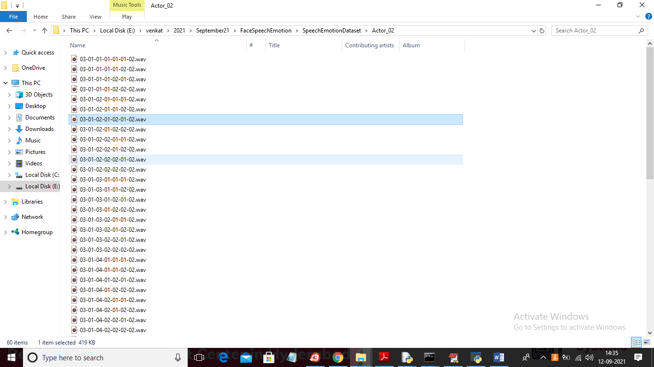

In above screen each wav file is associated with number separated with ‘-‘ symbol where 03 is the id and then 01 is the gender and then the 3rd position value is the emotion from 1 to 8.

To run project double click on ‘run.bat’ file to get below screen

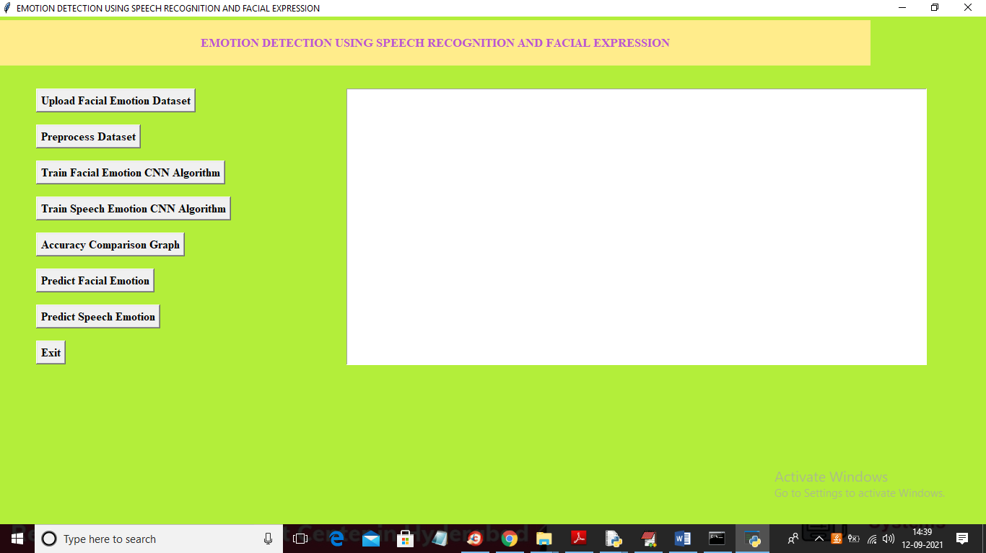

In above screen click on ‘Upload Facial Emotion Dataset’ button to upload dataset and to get below screen

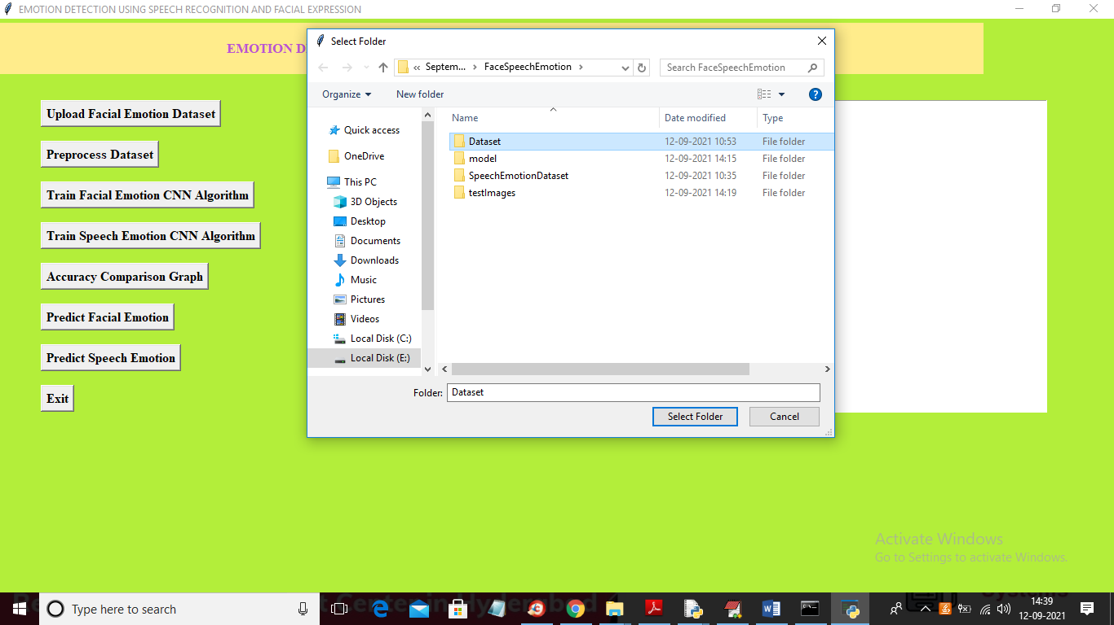

In above screen selecting and uploading ‘Dataset’ folder and then click on ‘Select Folder’ button to upload dataset and to get below screen

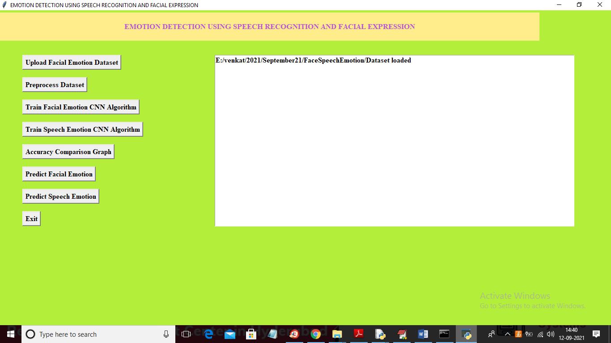

In above screen dataset loaded and now click on ‘Preprocess Dataset’ button to read all images and then resize them to equal size and then extract MFCC features from dataset and then build trained model.

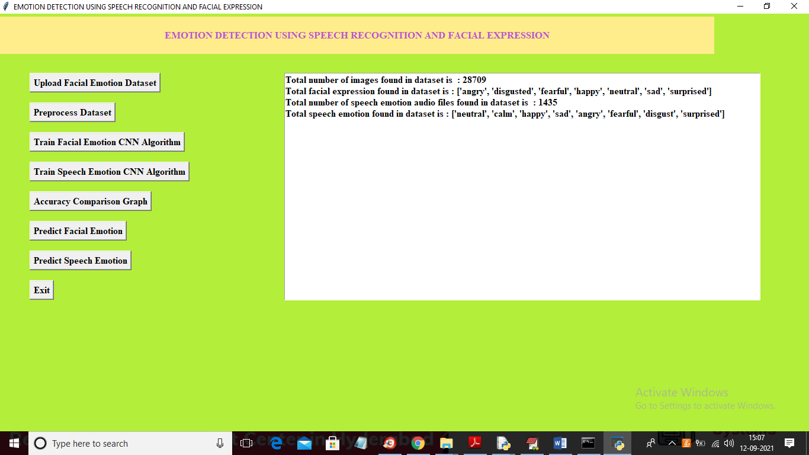

In above screen both datasets are processed and we can see total number of images and audio files available in both datasets and now dataset is ready and now click on ‘Train Facial Emotion CNN Algorithm’ button to train Facial dataset with CNN and to get below screen

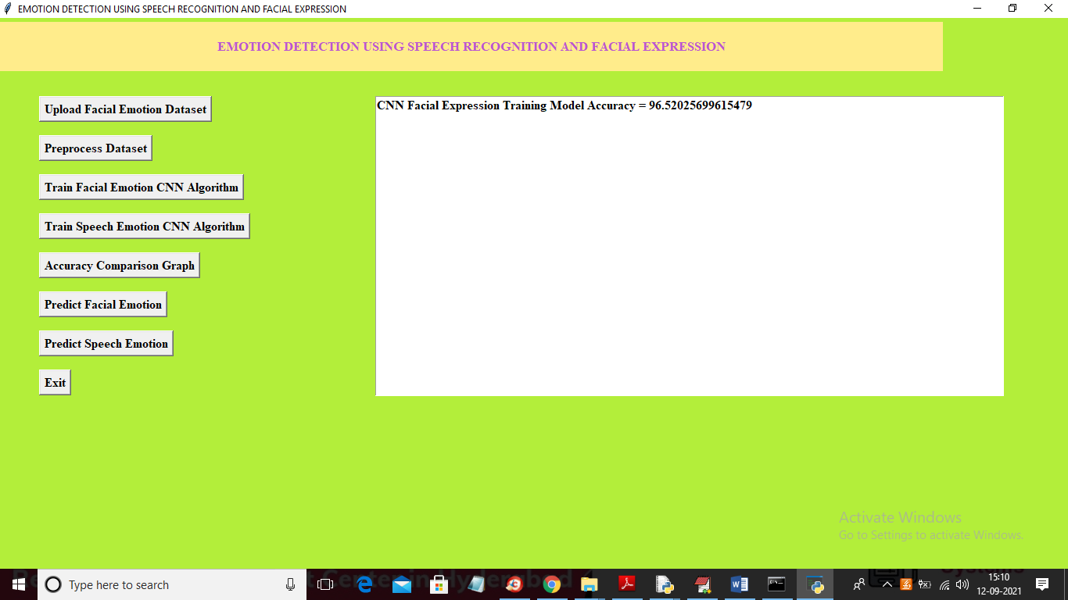

In above screen training CNN with Facial images got 96.52% accuracy and now click on ‘Train Speech Emotion CNN Algorithm’ button to train CNN with audio features and to get below output

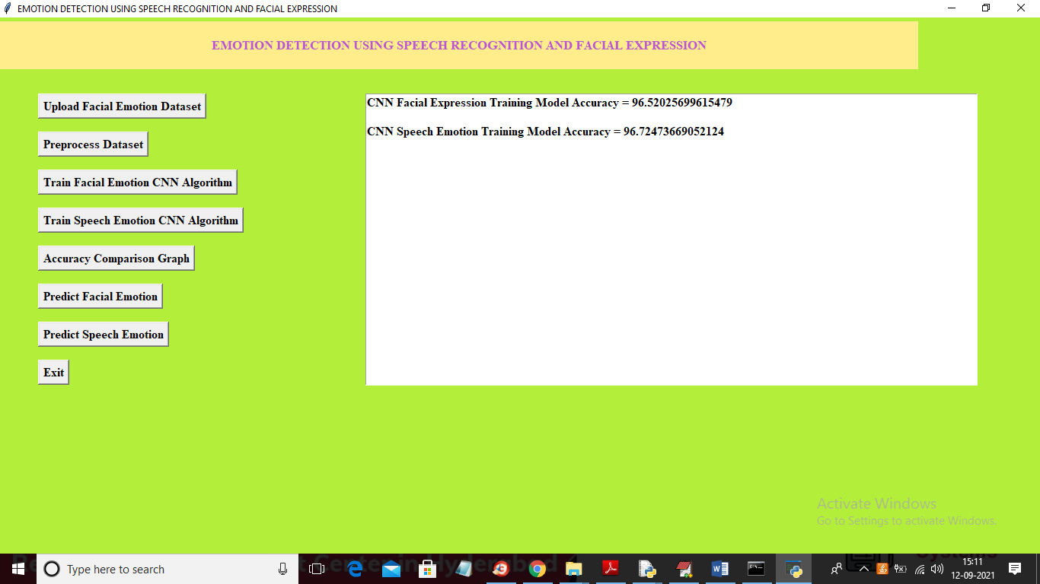

In above screen with CNN speech Emotion we got 96.72% accuracy. Now click on ‘Accuracy Comparison Graph’ button to get below graph

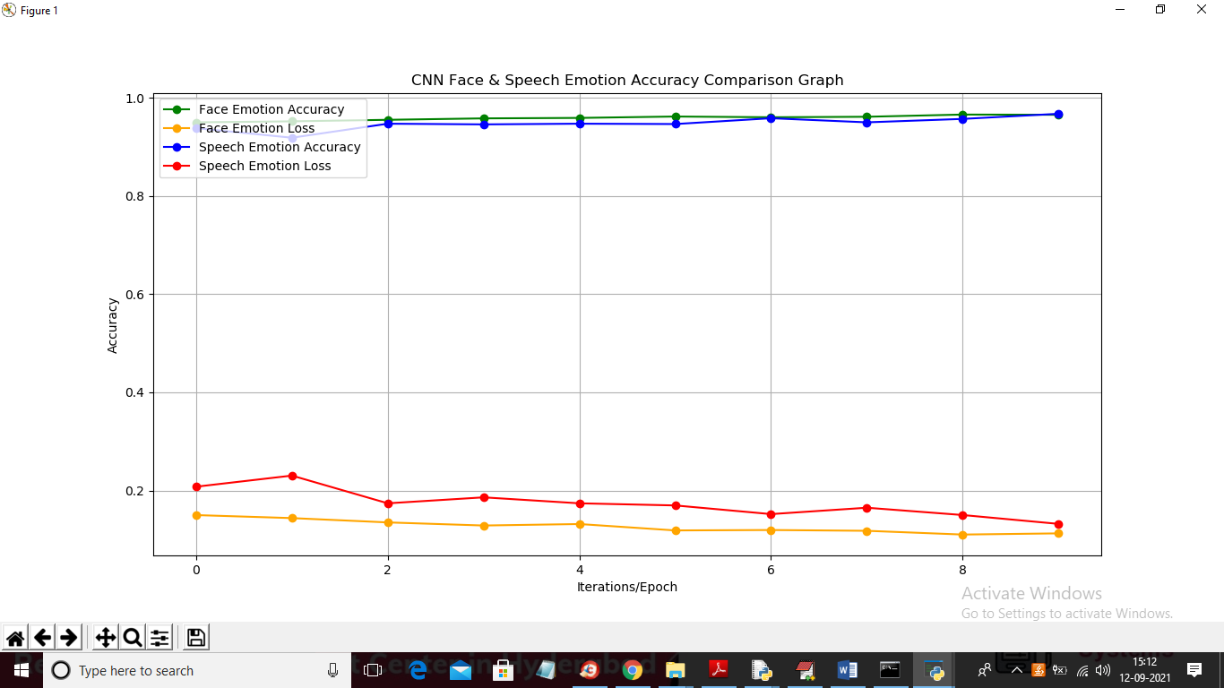

In above graph x-axis represents EPOCH and y-axis represents accuracy and loss values and we can see both algorithms accuracy reached to 1 and both algorithms loss values reached to 0. In above graph green line represents face emotion accuracy and blue line represents speech accuracy. Now click on “Predict Facial Emotion” button to upload face image and will get below result

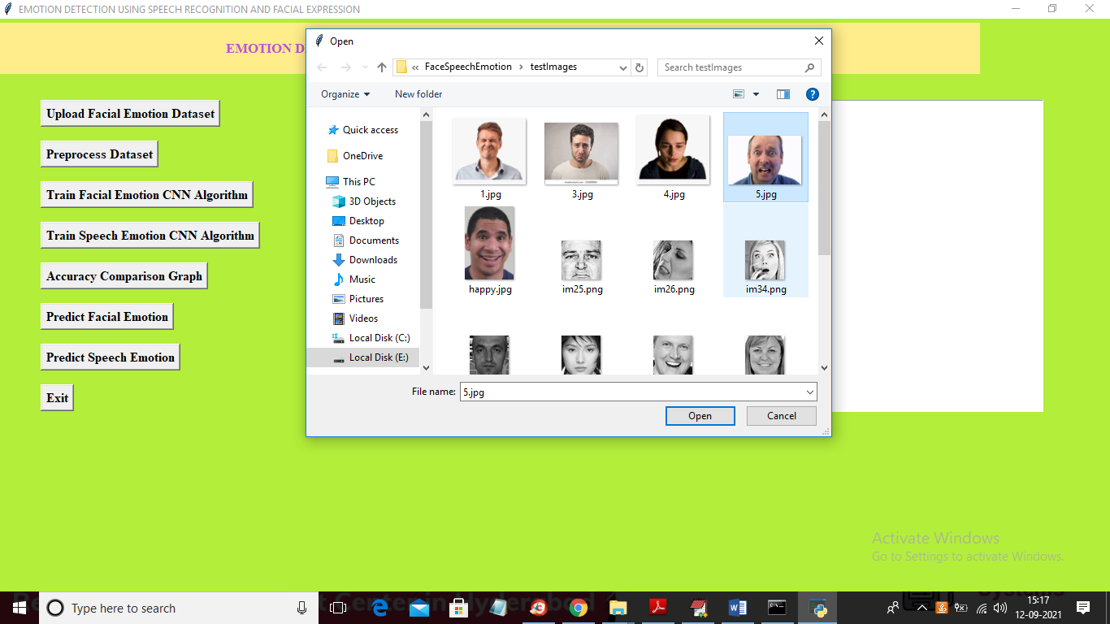

In above screen selecting and uploading ‘5.jpg’ image and then click on ‘Open’ button to get below result

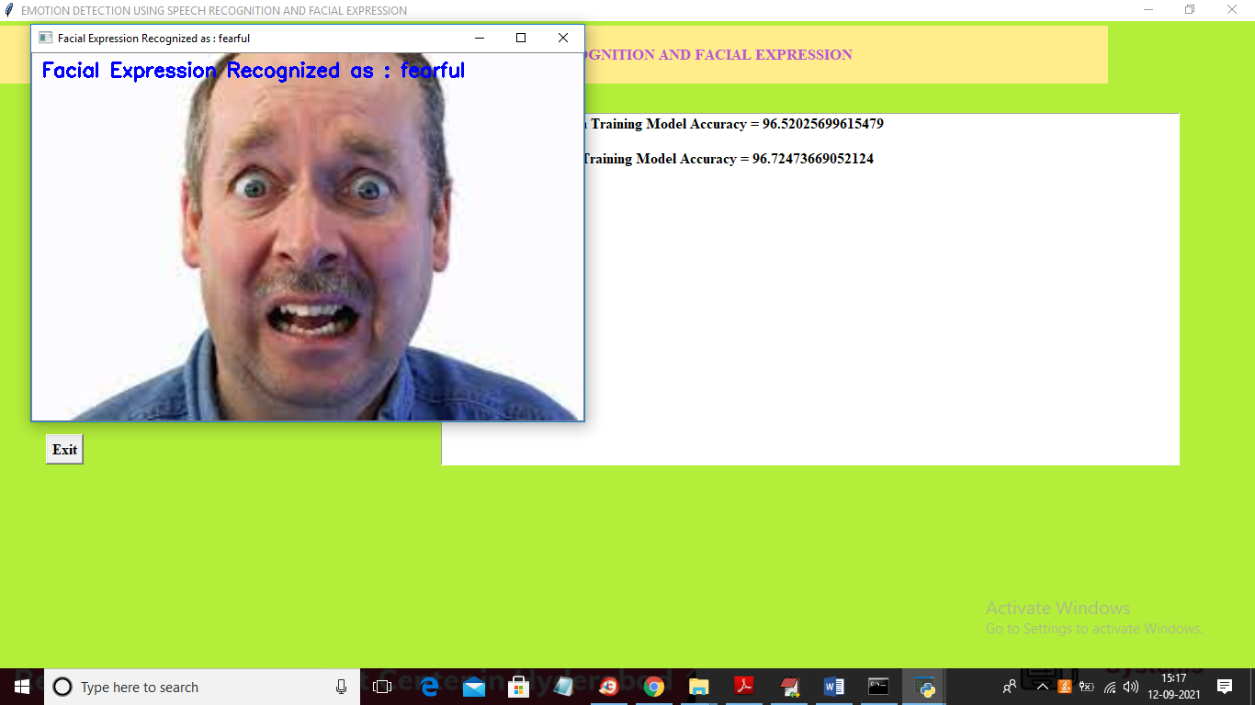

In above screen facial emotion or expression predicted as ‘Fearful’ and now test other image

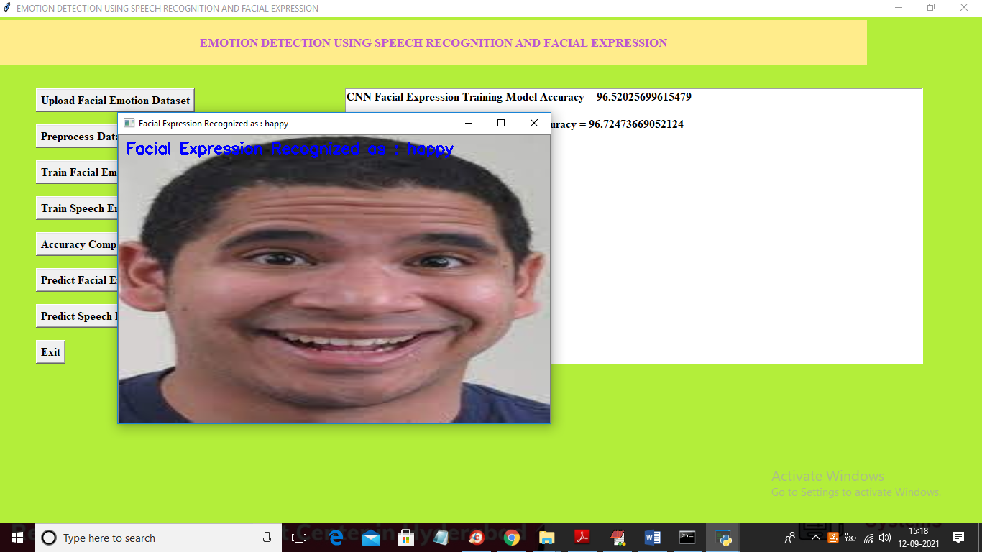

In above screen facial expression predicted as ‘happy’ and similarly you can upload other images and test. Now click on ‘Predict Speech Emotion’ button to upload audio file and get below result

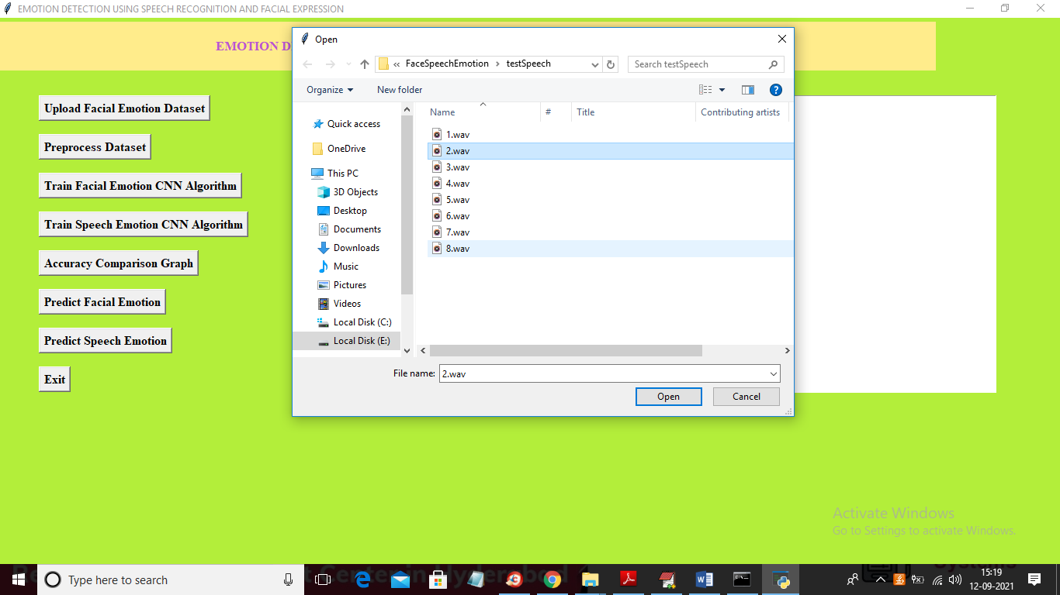

In above screen selecting and uploading ‘2.wav’ file and below is the result

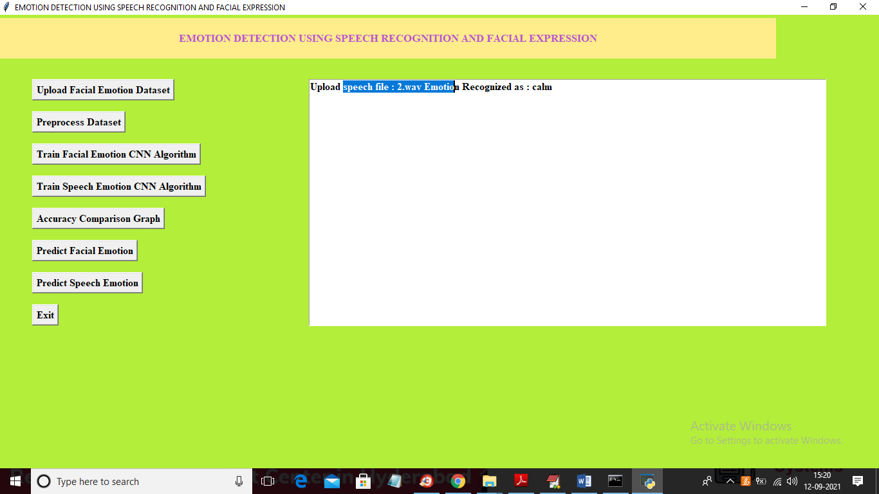

In above screen uploaded audio file emotion predicted as ‘calm’ and now test other file

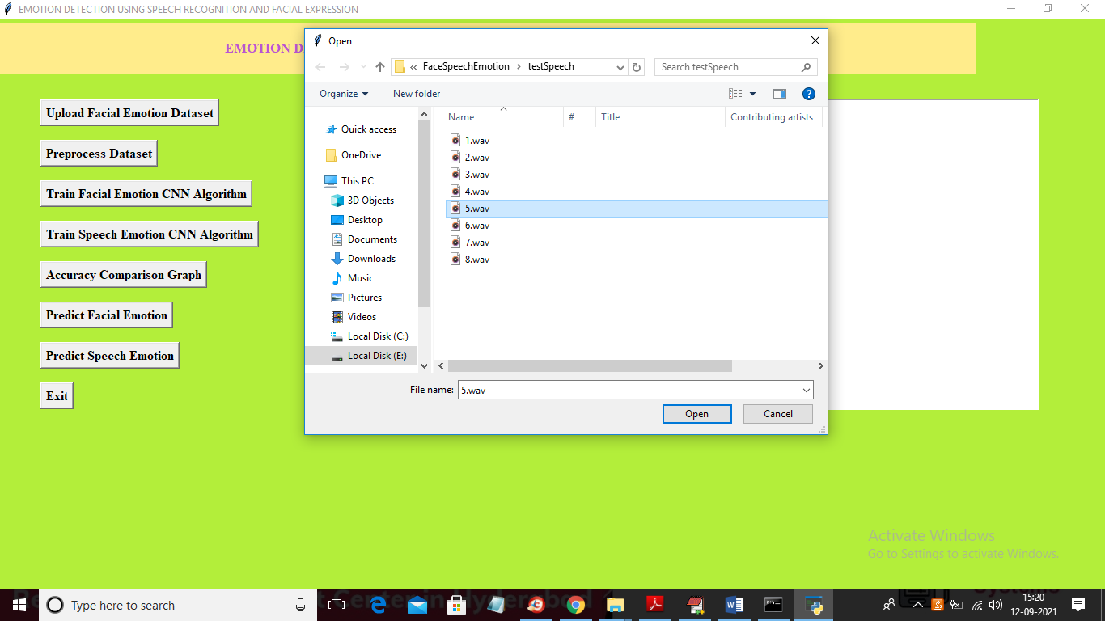

In above screen uploading ‘5.wav’ file and below is the prediction result

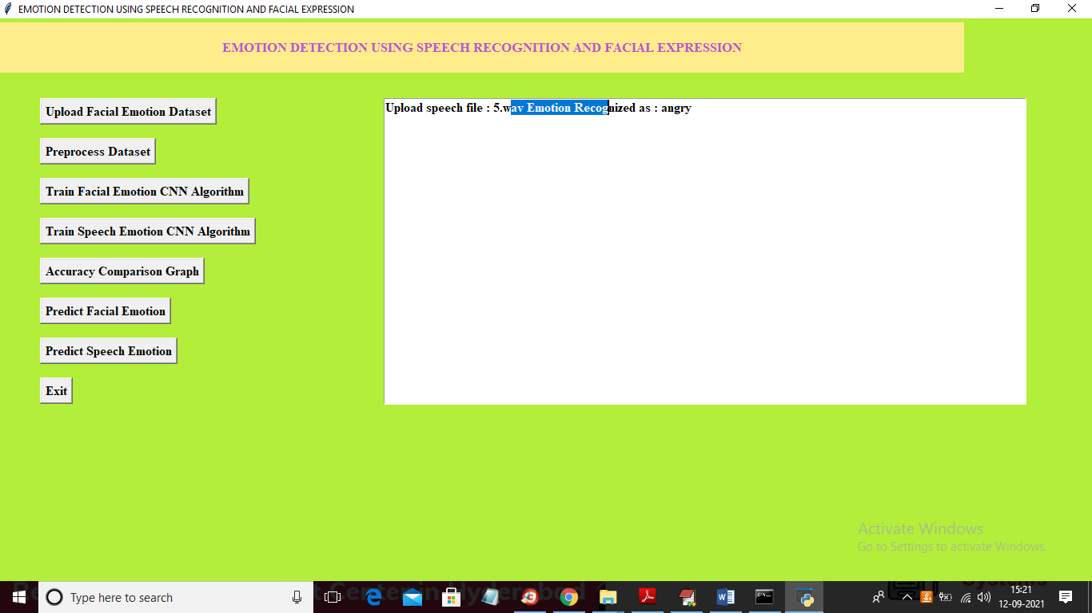

In above screen uploaded file emotion predicted as ‘angry’ and similarly you can upload other files and test