**1. USECASE DIAGRAM**

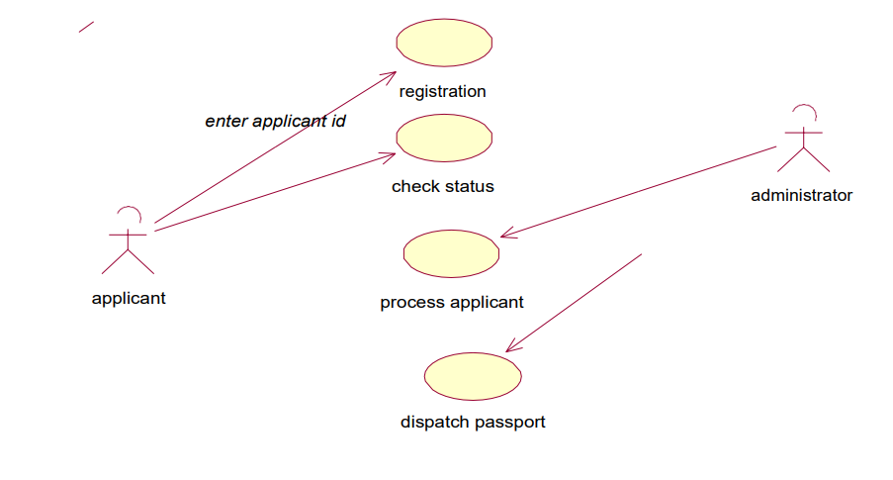

**2. ACTIVITY DIAGRAM**



**3. CLASS DIAGRAM**

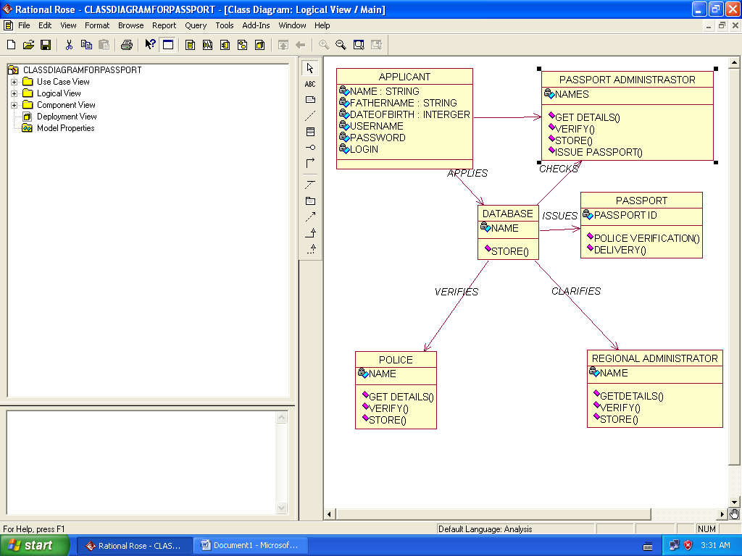

**4. SEQUENCE DIAGRAM**



**5. STATE CHART DIAGRAM**



**6. PACKAGE DIAGRAM**

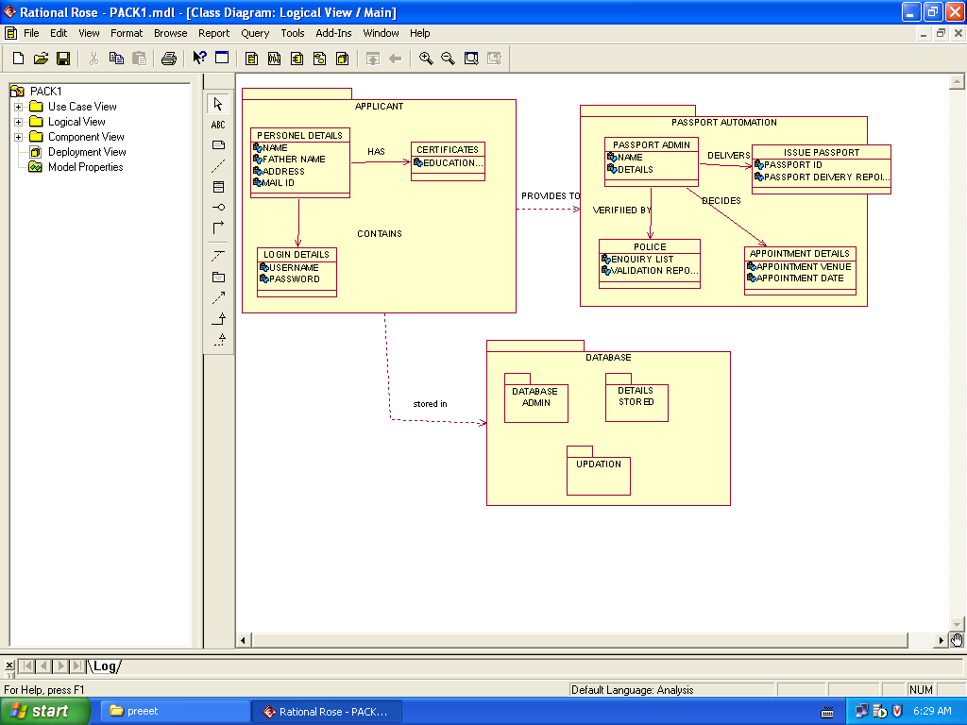

**7. COLLABORATION DIAGRAM**



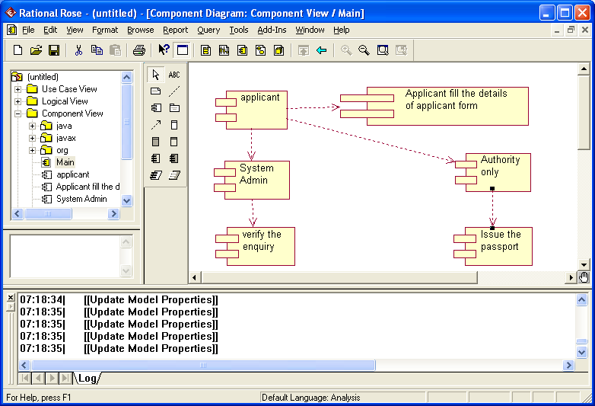**8. COMPONENT DIAGRAM**

**9. DEPLOYMENT DIAGRAM**

