**1. SEQUENCE DIAGRAM**

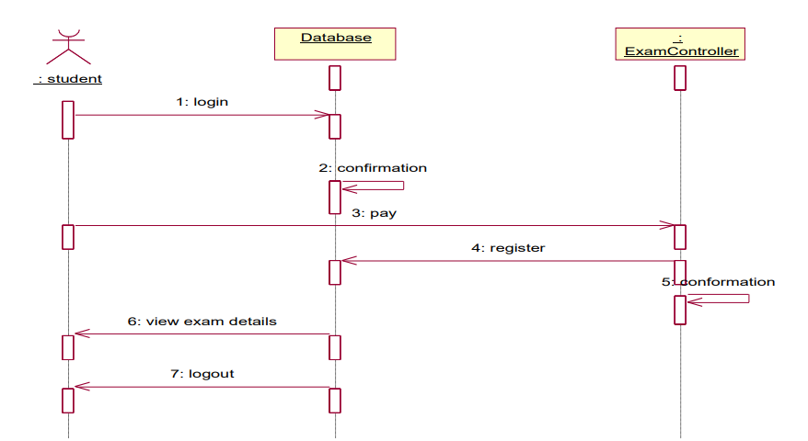

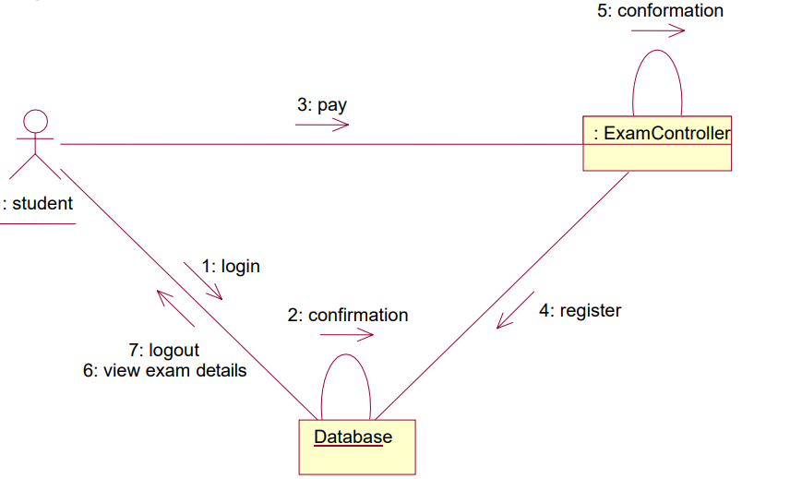**2. COLLABORATION DIAGRAM**

**3. COMPONENT DIAGRAM**

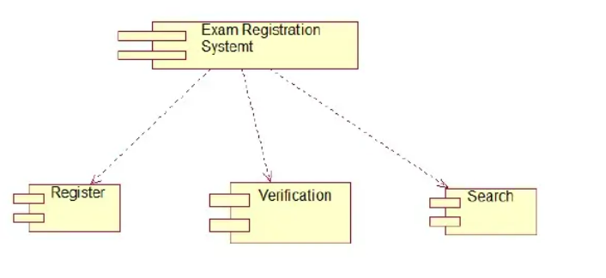

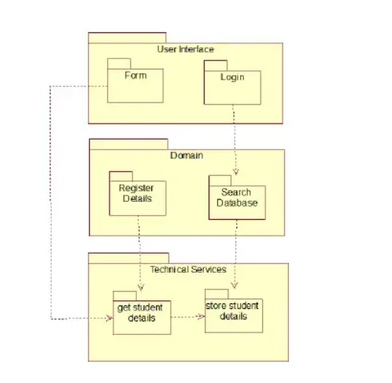**4. PACKAGE DIAGRAM**