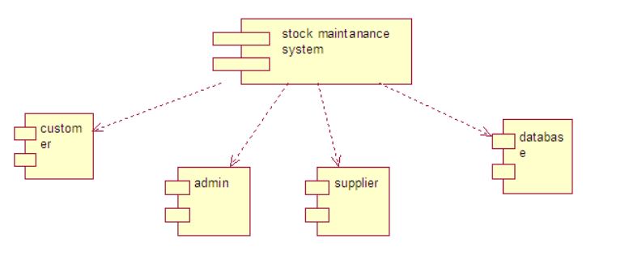**1. COMPONENT DIAGRAM**

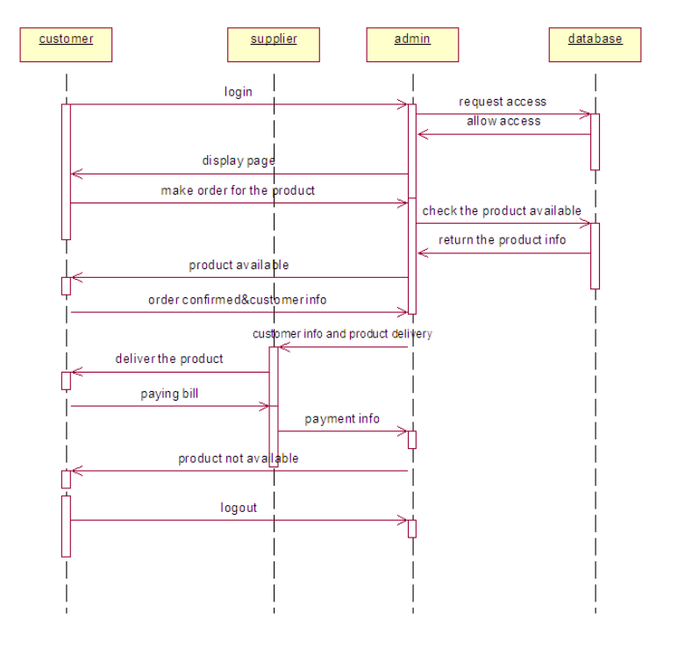**2. SEQUENCE DIAGRAM**

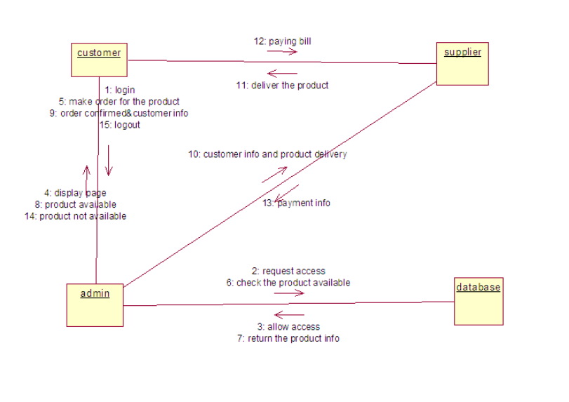**3. COLLABORATION DIAGRAM**