**1. ACTIVITY DIAGRAM**

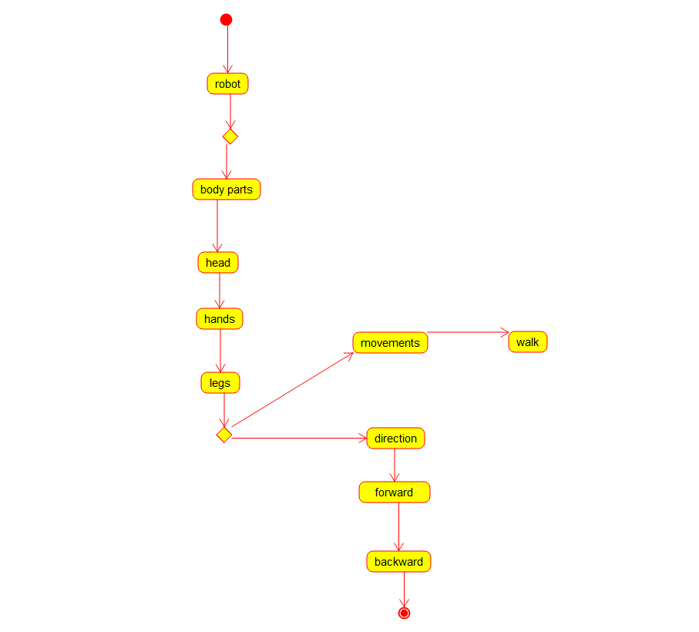

**2. SEQUENCE DIAGRAM**

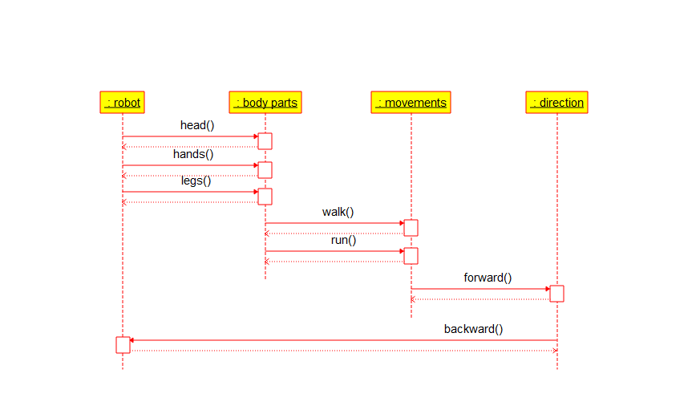

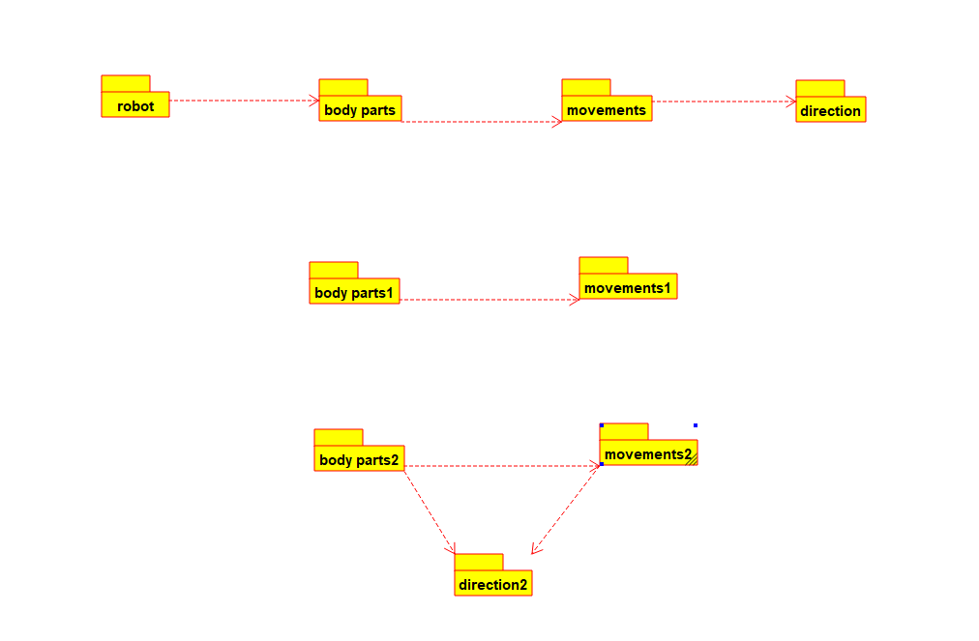**3. PACKAGE DIAGRAM**