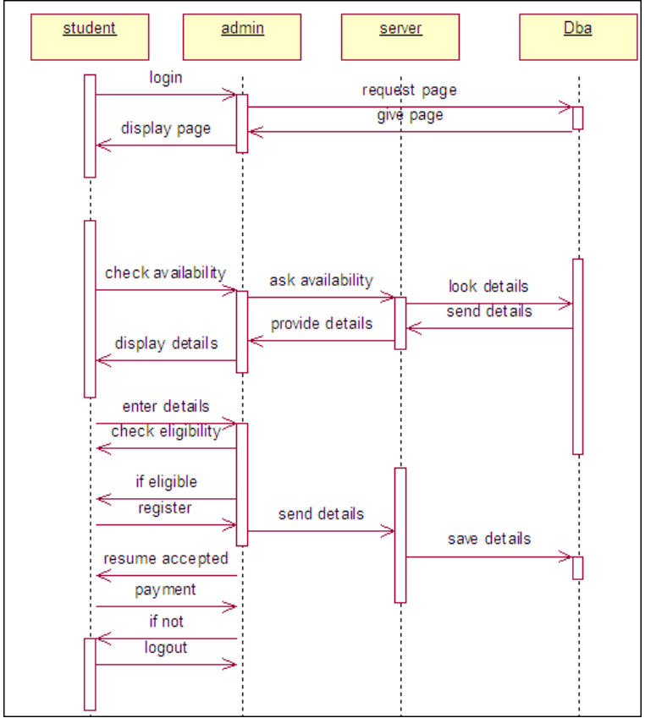**1. SEQUENCE DIAGRAM**

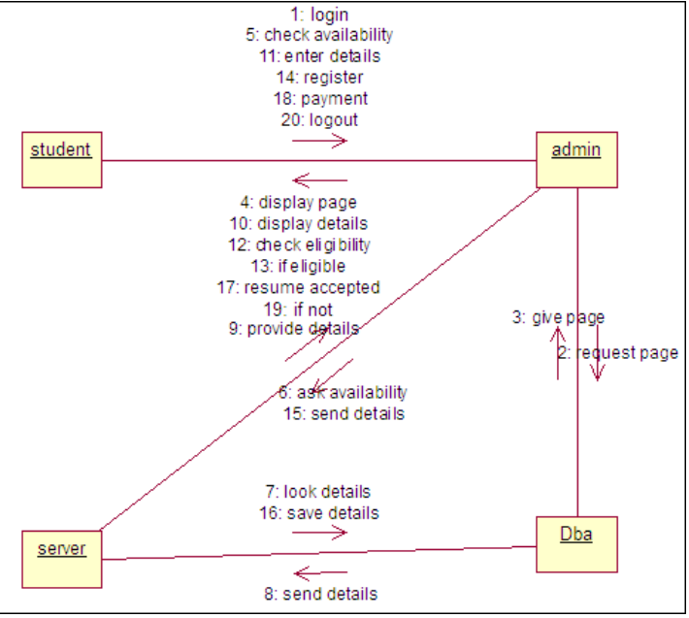**2. COLLABORATION DIAGRAM**

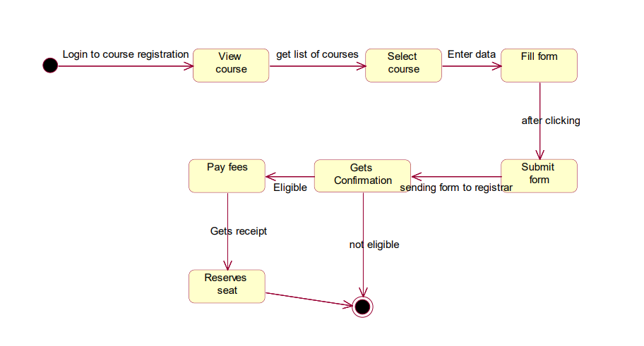**3. STATECHART DIAGRAM**

**4. COMPONENT DIAGRAM**