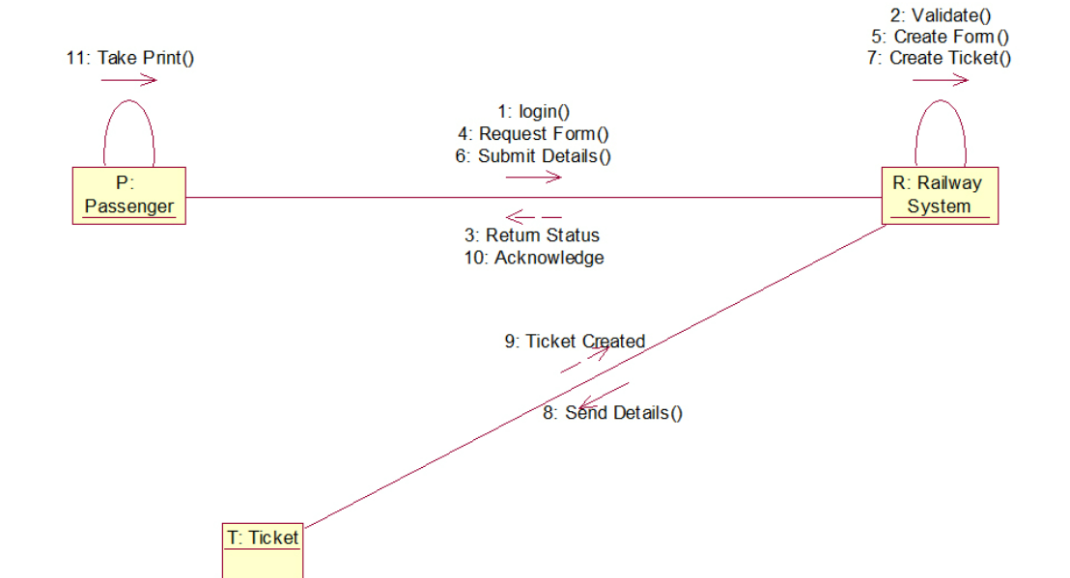**1. COLLABORATION DIAGRAM**

**2. COMPONENT DIAGRAM**

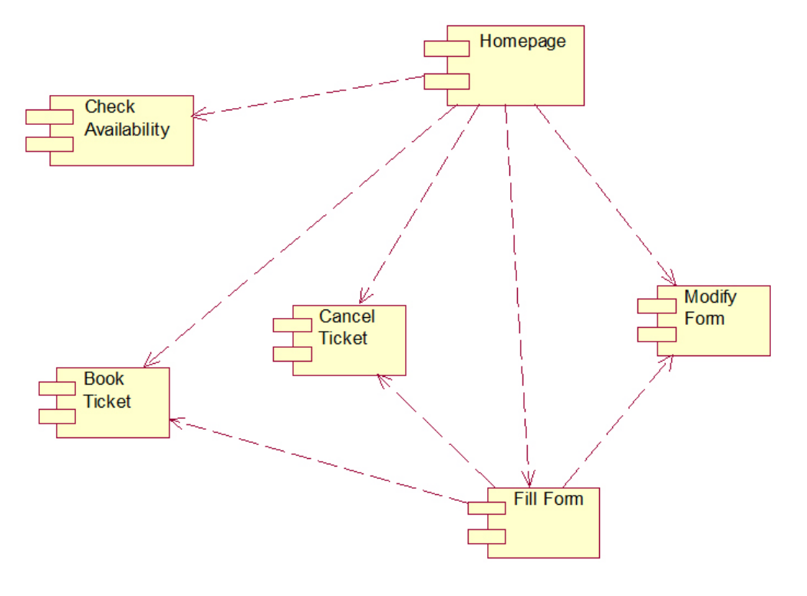

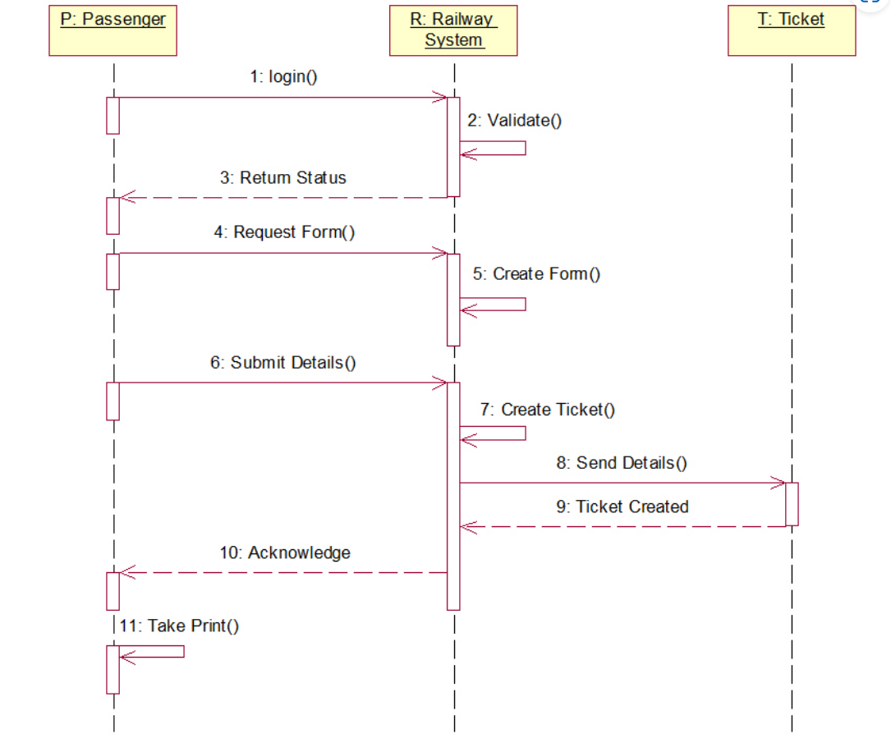**3. SEQUENCE DIAGRAM**