Navigating Your Workspace and Core Modules in Recruit CRM This article will guide you on navigating the main dashboard and core modules to streamline your recruitment workflow.
Written by Shaik Kabeeruddin Updated this week The Workspace dashboard helps you in managing, tracking, and organizing your daily recruitment tasks directly inside Recruit CRM. It allows you to monitor team performance, track schedules, and access candidate records in one centralized location.
📍 Exploring the Customized Dashboard
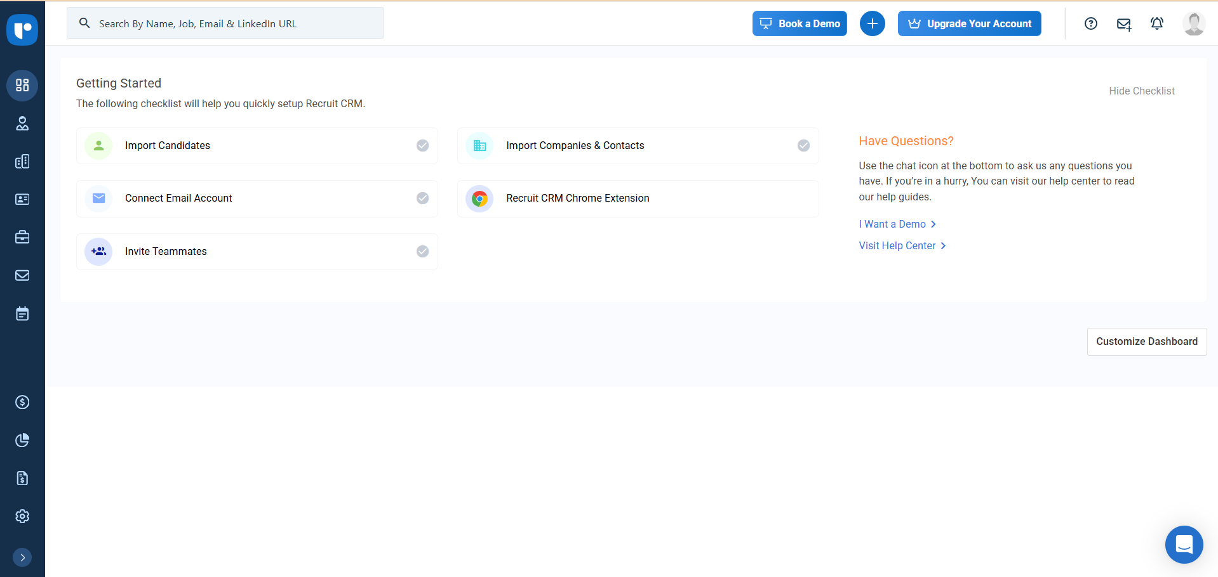
When you log in, you will start at the main dashboard overview. You can utilize the "Getting Started" checklist to easily import candidates, connect your email account, or invite your teammates. ​ Scroll down the page to monitor real-time visual analytics, including your candidate lifecycle report and team performance charts. These metrics give you a quick snapshot of your recruitment performance. ​
📋 Managing Tasks and Meetings
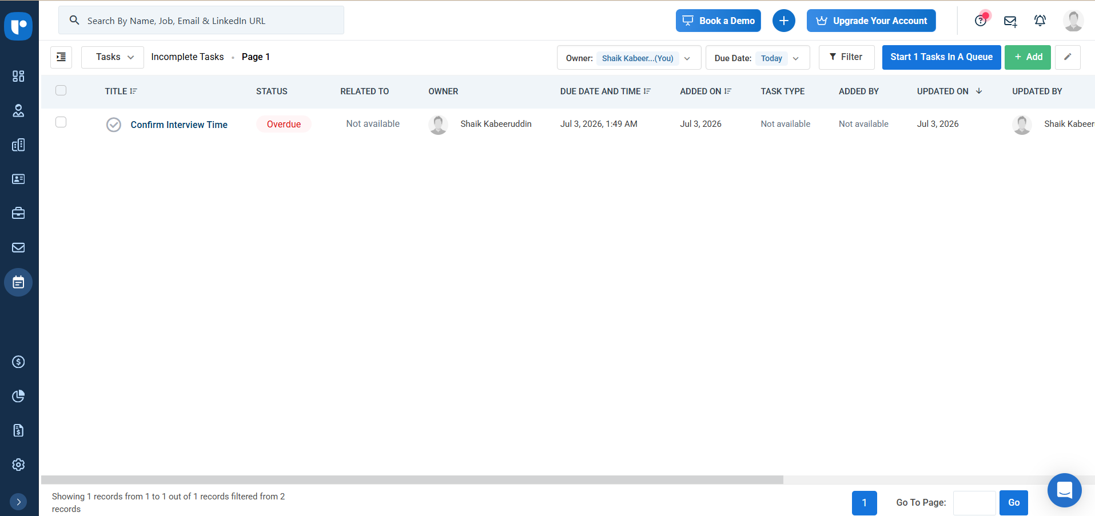
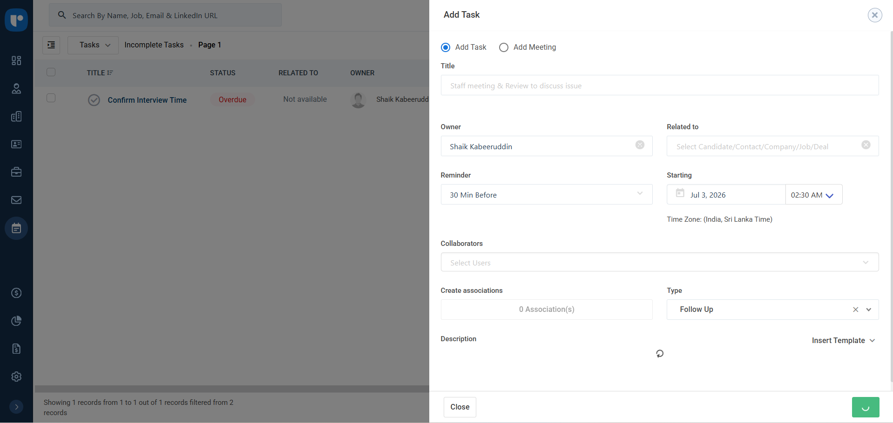
Right from the dashboard, you can review your pending meetings and tasks to stay on top of your schedule. ​ Steps to manage your schedule:
Check the statuses and detailed descriptions of your daily action items. Click on the "Export Spreadsheet" button on the top right. This will download your schedule directly into an Excel file, allowing you to easily track everything offline. ​
​ 🔍 Accessing Core Modules via the Sidebar
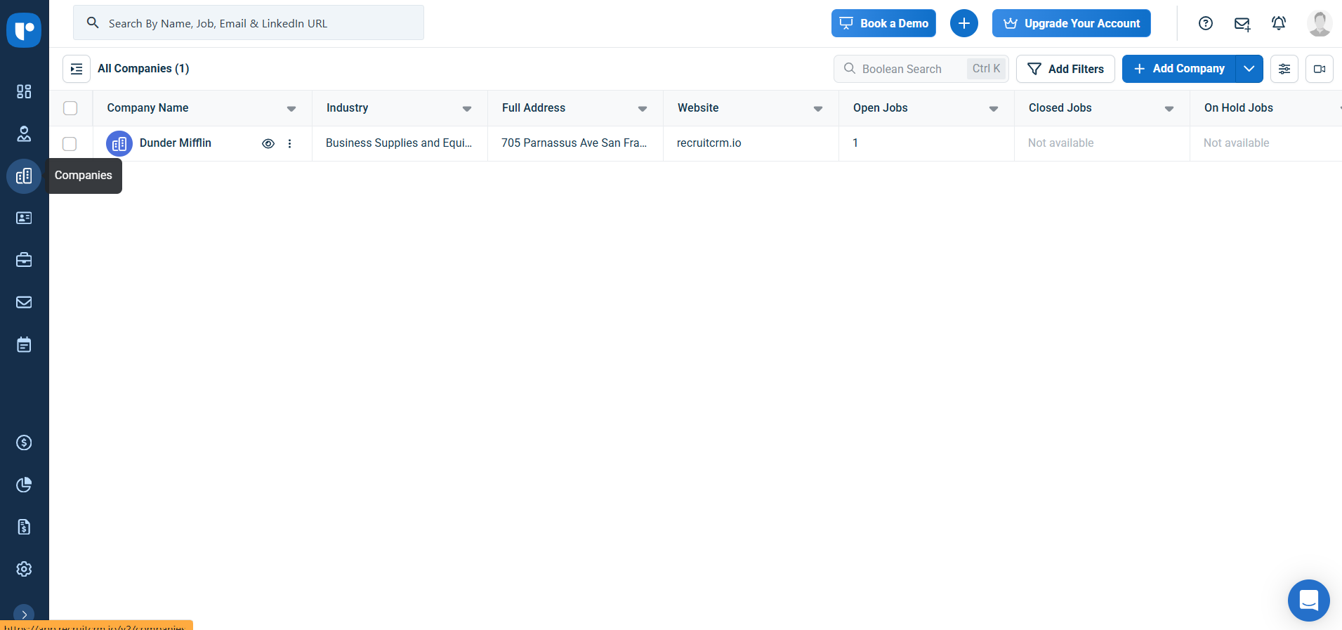

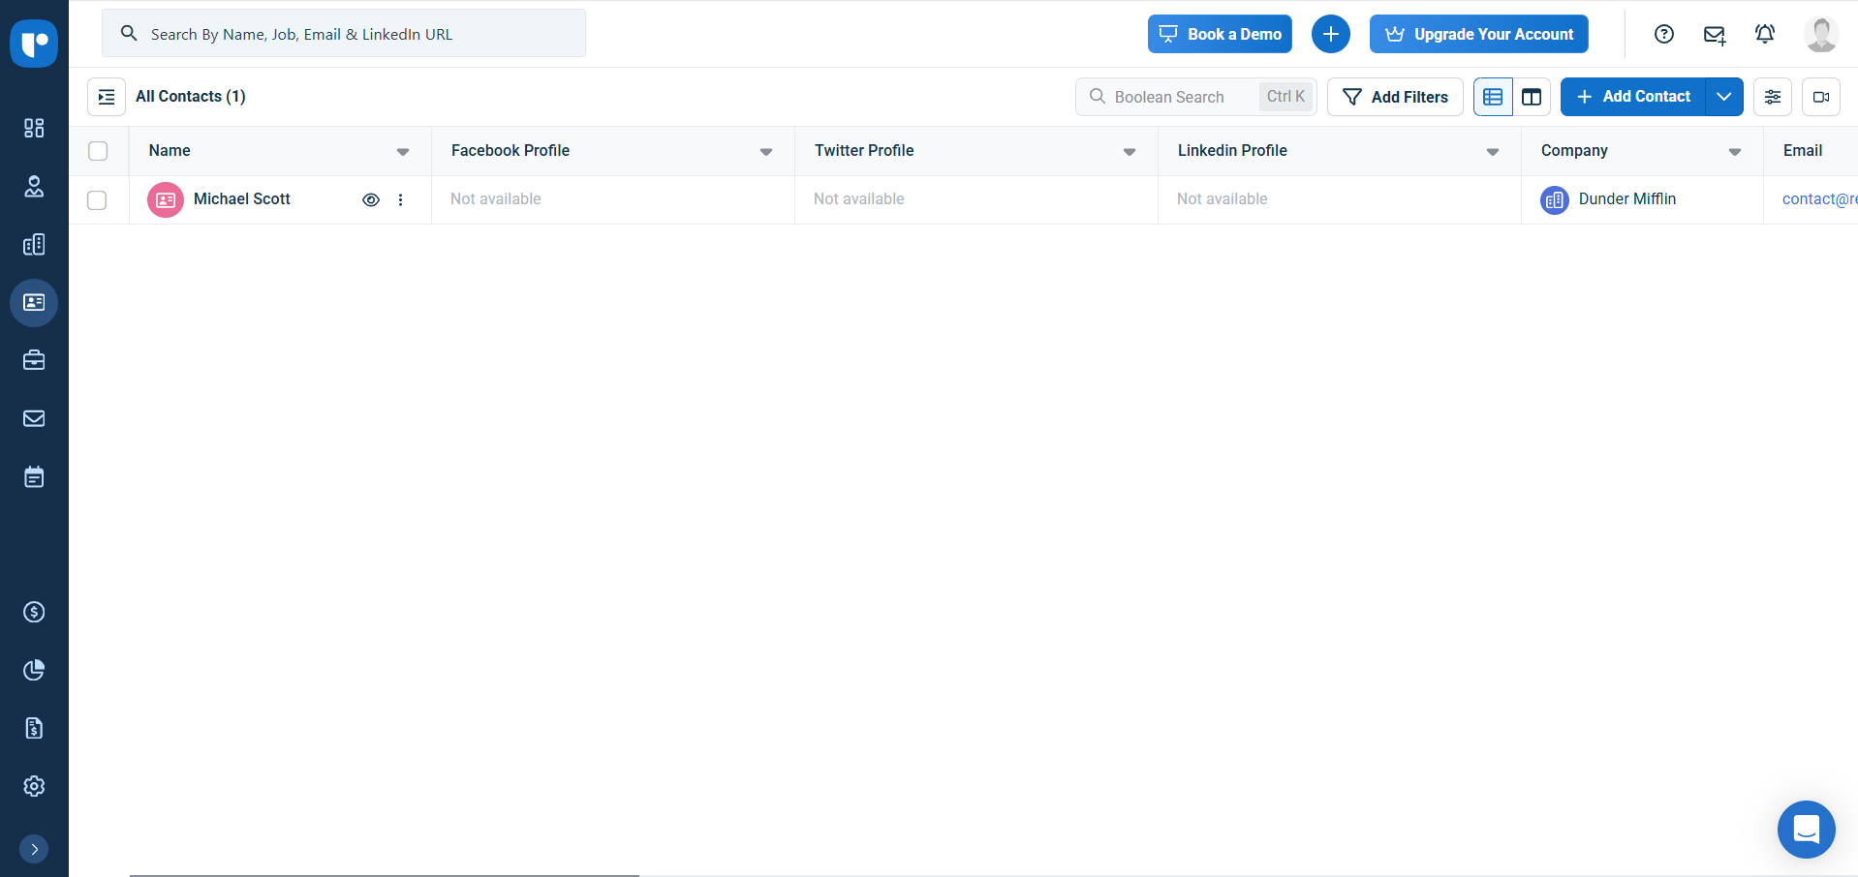

Use the left-hand menu panel to seamlessly jump between your main operational tabs. ​
You can access:
Candidates & Companies: View your entire talent database and actively manage your client accounts. Contacts & Jobs: Look up specific hiring managers and check out live job openings, including details like salary ranges and experience requirements.
​📧 Using the Integrated Mailbox
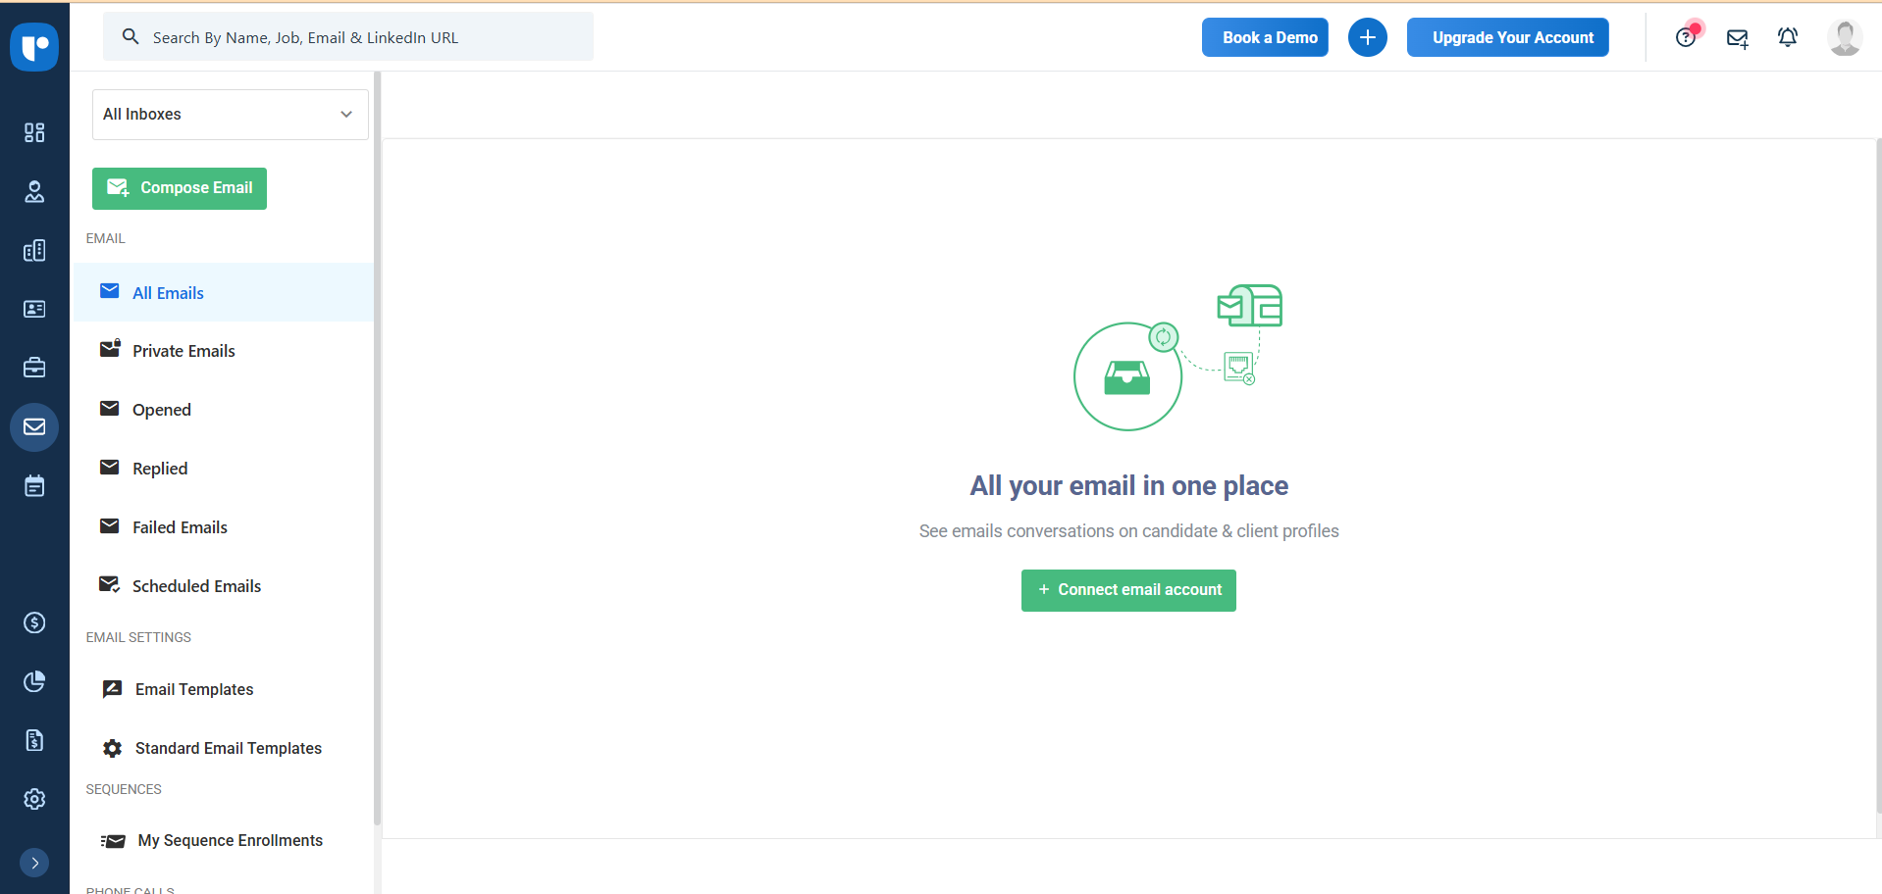

Click the Mailbox icon from the sidebar to handle all your communication in one place.
Once your account is linked, you can compose emails directly within the CRM. The system neatly organizes your messages into helpful subfolders, such as:
Opened Replied Scheduled emails
✅ Monitoring the Task & Appointments Queue
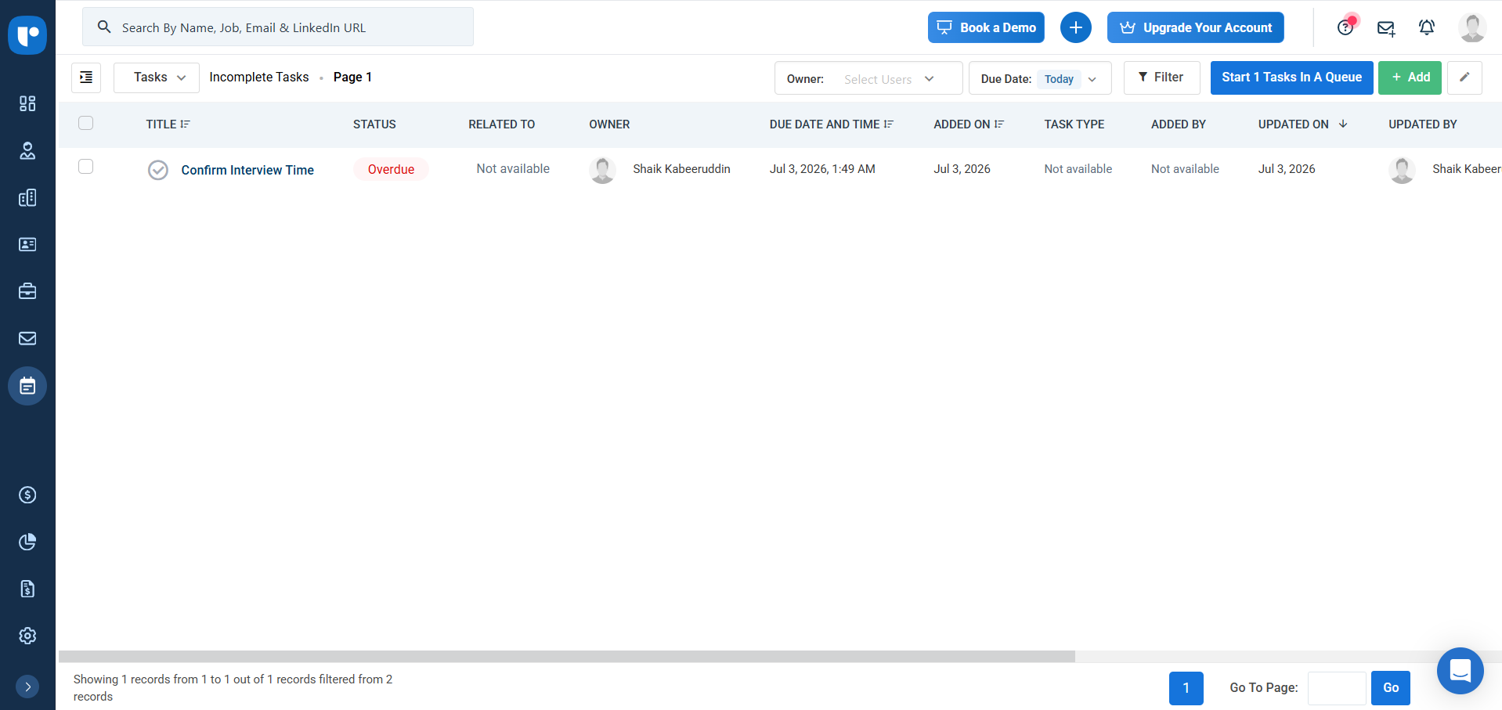
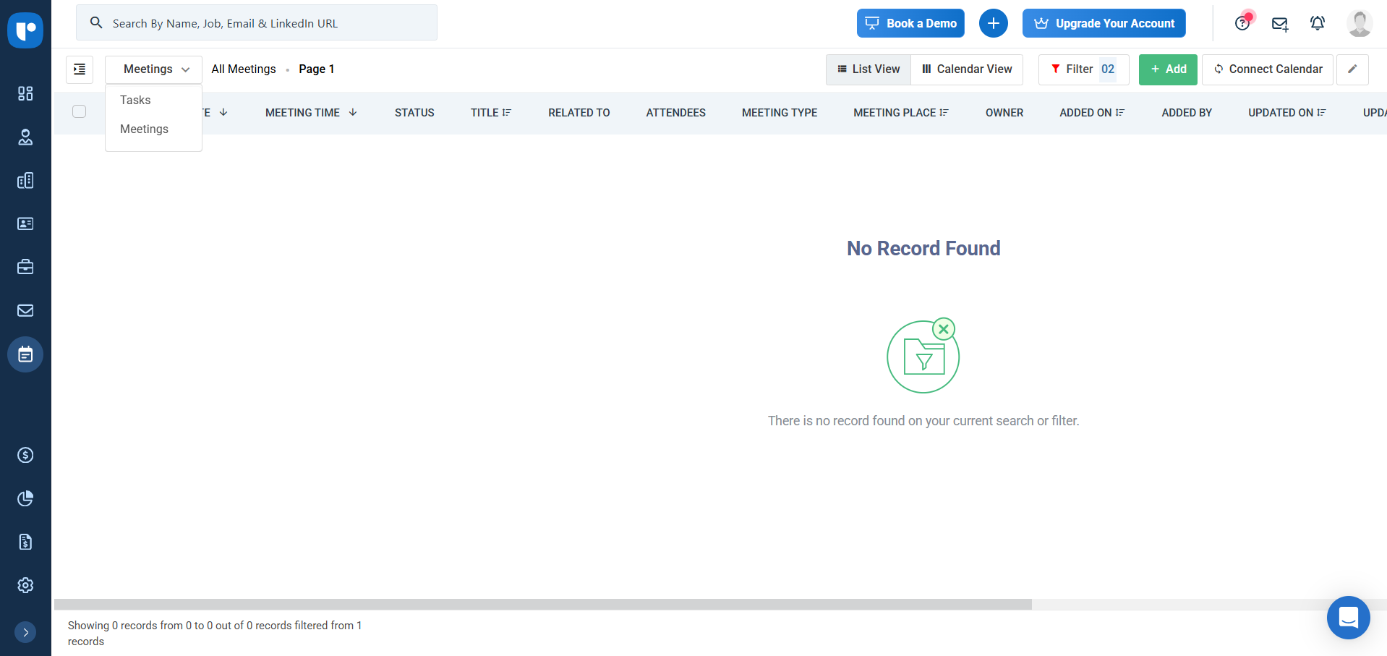
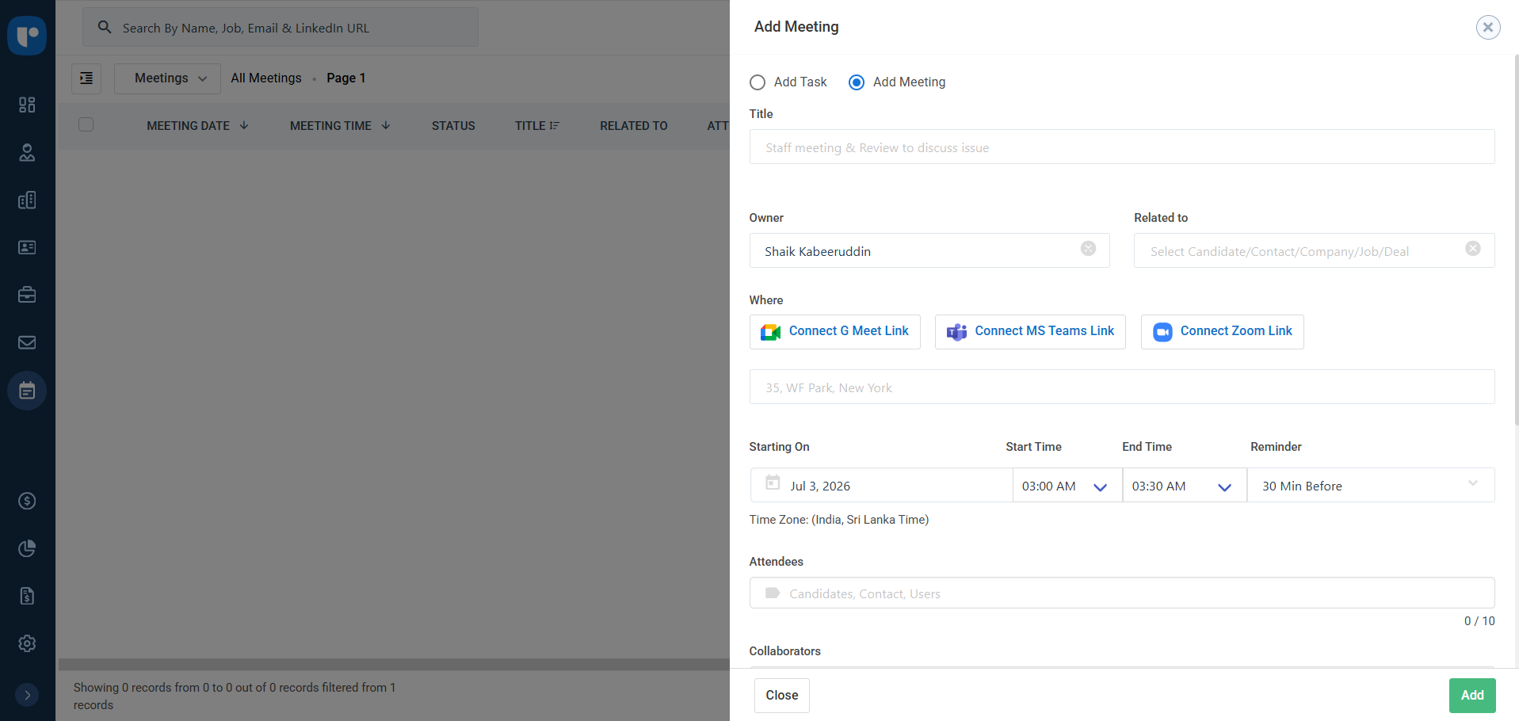
Head over to the dedicated Tasks section to view your full action queue. ​
You can filter this list by owner or due date to instantly see your pending milestones, like confirming interview times, ensuring you stay completely aligned with your schedule.

