I MCA II Semester Regular Examinations – June, 2023

COMPUTER NETWORKS

Time: 150 Min (MCA) Max. Marks:80M

SECTION – A
Answer all Four questions 4×10M=40M
- a) Host A needs to send four data items Ox3456, OxABCC, Ox02BC, and OxEEEE to host B. What is the checksum computed at host A? Suppose that the second data item has been changed to OxABCE during transmission. What would be the checksum computed by host B? Would it be possible for B to detect which data item has been corrupted?
b) Frames arrive randomly at a 50 Mbps channel for transmission. If the channel is busy when a frame arrives, it waits for its turn in a queue. Frame length is exponentially distributed with a mean of 5,000 bits/frame. For each of the following frame arrival rates, give the delay experienced by the average frame, including both queueing time and transmission time:
i. 90 frames/sec ii. 900 frames/sec

- Assume that a frame ends with a CRC computed using the divisor polynomial x⁵+1. Explain whether this CRC detects.
  - All “odd number” of bit-errors that occur in the frame.
  - All “even number” of bit-errors
  - All “bursts of error” of burst-length 4 of bit-errors

- Consider an instance of TCP’s Congestion control algorithm where the initial window size is set as 2MSS and the threshold at the start of first transmission is 8MSS. Assume that a time out occurs during the fifth transmission. What would be the congestion window size at the end of tenth transmission? Show all intermediate steps.

What is communication protocol? Why is it used in computer networks? Write a note on following communication protocols.

a. HTTP

SSH

SMS

SECTION - B
Answer all Two questions 2×20M=40M

- Consider the following undirected, weighted graph: Step through Dijkstra’s algorithm to calculate the single-source shortest paths from A to every other vertex.
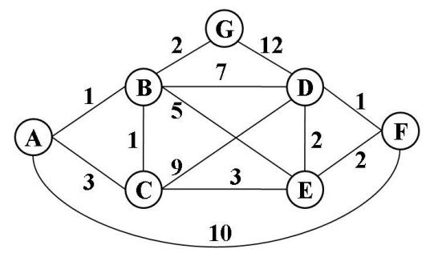
- Consider the network shown below, where the numbers on the edges indicate the cost of using that edge.
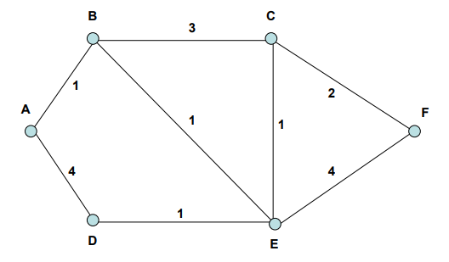
Suppose node A wants to send a message to node F, Use the distance vector routing to find the shortest path

