I MCA II Semester Regular Examinations – May, 2025
COMPUTER NETWORKS
Time: 150 Min (MCA) Max. Marks:60M

SECTION – A
Answer all Four questions 4×8M=32M

1. a) A university wants to connect all its departments across a campus. Which type of network is suitable and why? [2M]
b) Compare OSI and TCP/IP models focusing on their layer functionalities. [3M]
c) Suppose a fibre-optic cable is used for long-distance transmission. Discuss its advantages and limitations over coaxial and twisted-pair cables. [3M]

2. a) List any two framing methods used in the data link layer. [2M]
b) Given the data word 10011101 and generator 1001, compute the CRC code and final frame to be transmitted. [4M]
c) Analyze the efficiency of the Stop-and-Wait protocol when the transmission time is 10ms and round-trip delay is 50ms. [2M]

3. a) Discuss the role of Quality of Service (QoS) in supporting performance requirements of multimedia applications such as video conferencing. [2M]
b) A router receives the following routing table. Given a destination IP of 192.168.1.45, determine the output interface. Provide justification. [3M]

Destination | Subnet Mask | Interface
192.168.1.0 | 255.255.255.0 | Eth0
192.168.0.0 | 255.255.0.0 | Eth1
0.0.0.0 | 0.0.0.0 | Eth2
- Compare distance vector and link state routing in terms of convergence and scalability.
[3M]
4. a) Why is flow control essential in the transport layer? [2M]
b) Compare the header fields of UDP and TCP. In what cases is UDP preferred? [3M]
c) A DNS resolver receives a query for www.vignan.ac.in Describe how the name resolution process proceeds with each DNS server involved. [3M]

SECTION – B
Answer all Two questions 2×14M=28M

5. a) Draw and explain a protocol stack diagram for Bluetooth, highlighting key layers. [3M]
b) Vignan’s University plans to upgrade its LAN to a metropolitan network. What physical media and protocol architecture would you recommend? Justify. [3M]
- A bit stream 011010101 is to be transmitted. Apply bit stuffing and show the result.
[2M]
- Discuss how CSMA/CD handles collisions and why it is less effective in wireless media. [4M]
- Explain the advantages and disadvantages of using parity, CRC, and checksum for error detection. [2M]

6. a) A network has routers A-B-C-D-E-F-G with the following link costs. Apply Dijkstra’s algorithm to find the shortest path from A to F.
[5M]
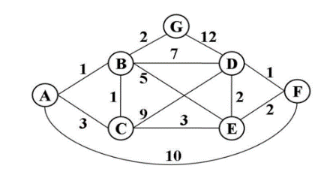

- Explain the need for sub netting and calculate the number of subnets and hosts possible for the address 192.168.10.0/26. [3M]
- Compare TCP's congestion control phases with appropriate diagrams. [3M]
- Explain how email is delivered using SMTP, POP3, and IMAP protocols.
[3M]

