25MC409-OBJECT ORIENTED PROGRAMMING
Hours Per Week:5
L | T | P | C
3 | 0 | 2 | 4
PREREQUISITE KNOWLEDGE: Computer Programming.

COURSE DESCRIPTION AND OBJECTIVES:
This course is about the fundamentals of Object-Oriented Programming (OOP) Concept and OOP- based software development methodology. Java as a class-based and pure OOP language is used to demonstrate and implement appropriate concepts and techniques. The students are exposed to the concepts, fundamental syntax, and the thought processes behind object-oriented programming. By end of the course, students will acquire the basic knowledge and skills necessary to implement object - oriented programming techniques in software development using Java.

MODULE – 1

UNIT – 1 18L+0T+12P=30 Hours
INTRODUCTION TO OOP: Introduction to JDK, JRE, JVM, Byte code, Java buzzwords, OOP principles, Data types, Operators, Control statements, Type conversion and casting, Arrays, String class, String Tokenizer.

UNIT – 2
CLASSES AND METHODS: Introduction to classes and methods, objects, Constructors, Overloading Methods and Constructors, Usage of static, Access control, this key word, Garbage Collection.
INHERITANCE: Basics of Inheritance, Types of inheritance, Abstract classes, Interfaces, Usage of
final, Usage of super key word, implementing interface, extending interfaces.

PRACTICES:
- Reading different types of data from the user and display that data using Scanner class.
- Illustrating type conversions.
- Implementing different operators.
- Generating electricity bill
- Implementing different patterns.
- Implementing logical programs.
- Implementing Arrays.
- Implementing String class.
- Implementing String Tokenizer class.
- Implementing constructor overloading using this keyword
- Implementing method overloading and overriding
- Implementing forms of Inheritance and super keyword.
- Create an abstract class Media (id, description). Derive classes Book (page count) and CD(play time). Define parameterized constructors. Create one object of Book and CD each and display the details.
- Define an interface, operations which has method area (), volume (). Define a constant PI having value 3.14. Create class a Cylinder which implements this interface (memberid, height). Create one object and calculate area and volume.

MODULE – 2 27L+0T+18P=45 Hours

UNIT – 1
PACKAGES: Creating, defining and accessing packages, importing packages.
EXCEPTION HANDLING: Concepts of exception handling, Types of exceptions, Built- in exceptions, Usage of try, catch, throw, throws and finally keywords, Custom Exception.

UNIT – 2
MULTITHREADING: Thread, Thread life cycle, Thread creation, Thread priorities, multithreading, Thread Synchronization, Daemon Thread.

UNIT - 3
AWT, APPLETS AND GUI PROGRAMMING WITH SWING: Applet life cycle,
AWT, AWT Hierarchy, AWT Controls, Delegation Event Model.
EXPLORING SWING CONTROLS: JLabel, JText Field, JButton,JCheckBox, JRadioButton, JTabbed Pane, JList, JCombo Box.

PRACTICES:
- Create a package college.details with a class Student containing fields: name, roll, branch, email, and a method to display all details.
Create another package college.main with a MainClass that imports Student, reads details from user using Scanner, stores them in a Student object, and prints them.
- Create a package math.operations containing two classes:
Addition with method add(int,int) and
Multiplication with method mul(int,int).
In another class, import the package and perform addition and multiplication of two numbers entered by the user.
- Implementing Exception handling.
- Write a program that reads two numbers from the user and performs division. Handle ArithmeticException, InputMismatchException, and a general Exception using multi-catch. Print a message in finally that says "Execution Completed".
- Implement java program which accepts withdraw amount from the user and throws an exception “In Sufficient Funds” when withdraw amount more than available amount.
- Creating Thread and Implementing multithreading.
- Write a program with a shared BankAccount class where multiple threads attempt to deposit and withdraw money at the same time. Use synchronized methods to prevent race conditions. Print balance updates after every operation.
- Create three threads and that displays “good morning”, for every one second,” hello” for every2 seconds and “welcome” for every 3 seconds by using extending Thread class.
- Develop an Applet program to accept two numbers from user and output the sum, difference in the respective text boxes.
- Design a Swing registration form with fields: Name, Roll No, Email, Mobile, Gender, Branch, Address. Validate all fields and show error messages using JOptionPane. Display all entered data in a separate confirmation dialog.
- Design student registration form using Swing Controls. The form which having the following fields and button SAVE a. Form Fields are: Name, RNO, Mail id, Gender, Branch, Address.
- Create a Swing program with: A JList of 5 subjects, A JComboBox of 3 branches On clicking submit, show a dialog displaying the selected branch and chosen subject.

COURSE OUTCOMES:
Upon completion of the course, student will able to achieve the following outcomes:

CO  No | Course Outcome | Bloom’s Level | Mapping with PO’s
1 | Utilize Java fundamentals including data types, operators,  control statements, arrays, and strings to develop structured programs. | Apply | 1,2,4
2 | Examine and implement classes, objects, constructors, method overloading, method overriding, inheritance, and  packages for modular and reusable code. | Analyze | 2,3,5
3 | Evaluate abstraction concepts, interfaces, access control, and exception handling to create secure and robust Java  applications. | Evaluate | 2,3,4,6
4 | Develop multithreaded Java applicationsand GUI-based  programs using AWT, Applets, and Swing to enhance interactivity and efficiency. | Create | 3,4,7
5 | Implement Collection Framework operations and JDBC  connectivityincluding CRUD operationsand transaction management for efficient data handling. | Apply | 2,3,4,7

MAPPING OF SUSTAINABLE DEVELOPMENT GOALS (SDG’S) AND INDIAN KNOWLEDGE SYSTEM (IKS):
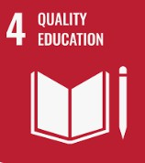


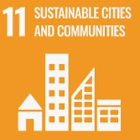
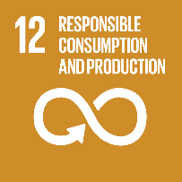


TEXT BOOKS:

- Herbert Scheldt, “Java the complete reference”, 12th Edition, McGraw Hill, Education, 2022.
- Cay S Horstmann, Core Java Volume 1 Fundamentals, Prentice Hall, 13th Edition, 2025.

REFERENCE BOOKS:

- J. Nino and F.A. Hosch, “An Introduction to programming and OO design using Java”, 3rd Edition, John Wiley & sons, 2008.
- P. Radha Krishna, “Object Oriented Programming through Java”, 1st Edition, Universities Press, 2007.
- R. A. Johnson, “Java Programming and Object-Oriented Application Development”, 1st Edition, Cengage Learning, 2006.
- T. Budd, “Understanding Object-Oriented Programming with Java”, Updated Edition, Pearson Education, 2000.

SKILLS:

- Design modular, reusable, and scalable software using classes and objects.
- Proficiency in applying OOP principles like encapsulation, inheritance, polymorphism, and abstraction.
- Structuring real-world problems into efficient program architectures.
- Improved debugging, code organization, and maintainability through OOP design patterns.

IMAGES:

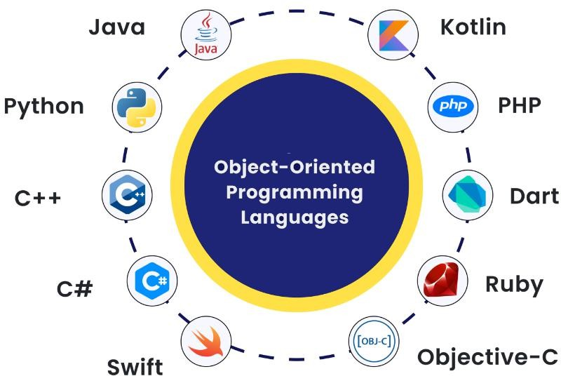
https://www.icoderzsolutions.com/blog/object-oriented-programming-languages/

