1. Downloaded the dataset from <https://github.com/shaikksameer/mongodb-sample-dataset>
2. Connected to localhost MongoDB

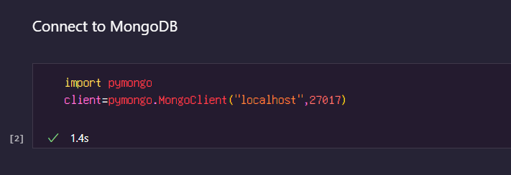

1. Created database called projectMovie

