SIMATS ENGINEERING
ASSESSMENT TOOL 2: Concept Mapping

COURSE NAME: | Cloud Computing and Big Data Analytics | COURSE CODE: | CSA1519

COURSE OUTCOME COVERED
CO1: Apply cloud computing technologies including hardware-software evolution, virtualization, web services, and service models to develop cloud-based solutions. (BL2)
Assessment Tool Weightage: 20%

Dave's Taxonomy: Imitation (Level 1)  Question Count: 4 | Total Marks: 20

Code of Conduct
I Shaik Mahummad - 192325031 (Name / Reg No) certify that this submission is my original work and that I have adhered to the guidelines specified for this assessment.
I understand that any violation of academic integrity rules will result in disciplinary action.
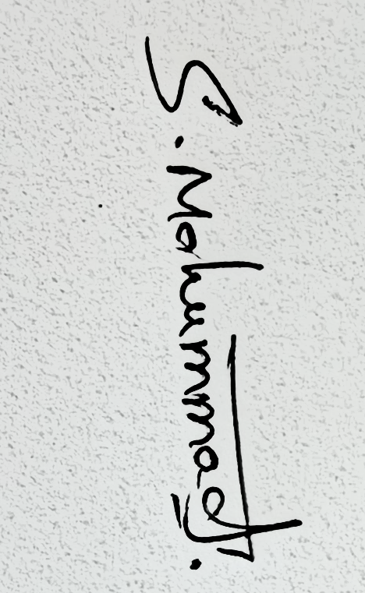

Signature of the student:

Assessment Tasks
Concept Mapping Tasks
Create concept maps for the following tasks. Each map must show key nodes, link labels, and a logical hierarchy.
- Concept Map 1: Cloud Computing Fundamentals. Include definition, characteristics, benefits, and limitations.
- Concept Map 2: Evolution of Cloud Computing. Connect hardware evolution, internet software evolution, distributed systems, and service delivery.
- Concept Map 3: Service Models. Map IaaS, PaaS, SaaS, and XaaS with provider responsibilities and user responsibilities.
- Concept Map 4: Virtualization and Web Services as Enablers of Cloud. Show how these two concepts support cloud deployment and scalability.
Expected concept nodes:
- Elasticity, scalability, resource pooling, on-demand access, measured service
- Virtual machine, hypervisor, abstraction, API, SOAP, REST, provider, consumer
- Infrastructure layer, platform layer, application layer, shared responsibility

Concept Mapping Rubric
Criteria | Weightage | Level 4 - Exemplary | Level 3 - Proficient | Level 2 - Developing | Level 1 - Beginning
Concept Identification | 25% | All major concepts are accurately identified | Most concepts are identified correctly | Limited concepts are identified | Essential concepts are missing
Relationship Mapping | 25% | Links between concepts are accurate and meaningful | Most links are correct | Some links are weak or unclear | Relationships are mostly incorrect
Hierarchy and Organization | 20% | Excellent structure with clear hierarchy | Mostly organized with minor issues | Basic structure with weak hierarchy | No logical organization
Technical Relevance | 20% | Map strongly reflects cloud course content | Mostly aligned to topic | Partially aligned to topic | Weak alignment to topic
Visual Clarity | 10% | Neat, readable, and easy to interpret | Generally readable | Somewhat cluttered | Poorly presented

Concept Map 1: Cloud Computing Fundamentals
CONCEPT MAP
CLOUD COMPUTING
│
"provides computing resources"
│
▼
Over the Internet
│
┌────────────────────┼────────────────────┐
│ │ │
▼ ▼ ▼
CHARACTERISTICS BENEFITS LIMITATIONS
│ │ │
┌─────┼─────┐ ┌─────┼─────┐ ┌─────┼─────┐
▼ ▼ ▼ ▼ ▼ ▼ ▼ ▼ ▼
On-demand Resource Elasticity Cost Flexibility Security Internet
access pooling efficiency risks dependency
│ │ │
└───────┼───────┘
▼
Measured Service
│
"tracks resource
usage"
▼
Pay-as-you-use

Concepts and Explanation
- Cloud Computing — Delivery of computing resources such as servers, storage, databases, networking, and applications through the Internet.
- On-demand access — Resources can be provisioned whenever users need them without requiring physical infrastructure.
- Resource pooling — A provider combines computing resources and dynamically allocates them among multiple users.
- Elasticity — Resources can automatically increase or decrease according to workload demand.
- Scalability — The ability of a cloud system to handle increasing or decreasing workloads by adding or removing resources.
- Measured service — Cloud usage is monitored and measured, allowing users to be charged according to consumption.
- Benefits — Cloud computing provides cost efficiency, flexibility, rapid deployment, accessibility, and reduced infrastructure requirements.
- Limitations — Major limitations include security risks, privacy concerns, Internet dependency, compliance issues, and vendor lock-in.

Concept Map 2: Evolution of Cloud Computing
CONCEPT MAP

EVOLUTION OF CLOUD COMPUTING
│
"developed through"
│
┌───────────────────────┼────────────────────────┐
│ │ │
▼ ▼ ▼
HARDWARE EVOLUTION INTERNET & SOFTWARE DISTRIBUTED SYSTEMS
│ EVOLUTION │
▼ ▼ ▼
Mainframes Internet Growth Network Computing
│ │ │
▼ ▼ ▼
Client-Server Web Applications Cluster Computing
│ │ │
▼ ▼ ▼
Virtualization Web Services Grid Computing
│ │ │
└───────────────┬───────┴───────────┬────────────┘
│ │
▼ ▼
Resource Abstraction Distributed Resources
│ │
└─────────┬─────────┘
▼
CLOUD COMPUTING
│
"delivers services"
│
┌──────────────┼──────────────┐
▼ ▼ ▼
IaaS PaaS SaaS
│ │ │
▼ ▼ ▼
Infrastructure Platform Application
Layer Layer Layer

Concepts and Explanation
- Hardware evolution — Computing developed from large mainframe systems to client-server systems and eventually to virtualized infrastructure.
- Mainframes — Large centralized computers that provided shared computing resources to multiple users.
- Client-Server computing — Applications and resources were divided between client machines and centralized servers.
- Virtualization — Physical computing resources were abstracted into virtual machines, allowing multiple workloads to run on one physical server.
- Internet evolution — Increasing Internet connectivity enabled users to access applications and resources remotely.
- Web applications — Software began moving from locally installed applications toward browser-based applications.
- Web services — Standardized interfaces allowed different software systems to communicate over networks.
- Distributed systems — Computing tasks and resources were distributed across multiple connected machines.
- Cluster computing — Multiple computers worked together as a unified computing system.
- Grid computing — Computing resources from different locations were combined to solve large computational tasks.
- Cloud computing — These developments combined to create a model where scalable computing resources are delivered as services.
- Service delivery — Cloud computing delivers infrastructure, platforms, and applications through models such as IaaS, PaaS, and SaaS.

Concept Map 3: Cloud Service Models
CONCEPT MAP

CLOUD SERVICE MODELS
│
"include"
│
┌────────────────────┼────────────────────┐
▼ ▼ ▼
IaaS PaaS SaaS
│ │ │
"provides" "provides" "provides"
│ │ │
▼ ▼ ▼
Infrastructure Layer Platform Layer Application Layer
│ │ │
┌─────┼─────┐ ┌─────┼─────┐ Complete
▼ ▼ ▼ ▼ ▼ ▼ Software
VM Storage Network Runtime Database Application
│ │ │
└────────────────────┼────────────────────┘
▼
SHARED RESPONSIBILITY
│
┌────────┴────────┐
▼ ▼
PROVIDER USER
│ │
"manages" "manages"
│ │
Hardware Applications
Networking Data
Virtualization Configuration
Infrastructure Access

Concepts and Explanation
- IaaS — Infrastructure as a Service — Provides virtualized infrastructure such as virtual machines, storage, networking, and computing resources.
- Provider responsibility in IaaS — The provider manages physical hardware, networking, data centers, and virtualization.
- User responsibility in IaaS — The user generally manages the operating system, applications, configurations, and data.
- PaaS — Platform as a Service — Provides a ready-made platform for developing, testing, and deploying applications.
- Provider responsibility in PaaS — The provider manages infrastructure, operating systems, runtime environments, middleware, and supporting platform components.
- User responsibility in PaaS — The user primarily manages application code, application configuration, and data.
- SaaS — Software as a Service — Provides complete software applications through the Internet.
- Provider responsibility in SaaS — The provider manages infrastructure, platform, application software, maintenance, and updates.
- User responsibility in SaaS — Users mainly manage their data, configurations, accounts, and how they use the application.
- XaaS — Everything as a Service — A broader model in which different IT capabilities are delivered as cloud-based services.
- DBaaS — Database as a Service.
- FaaS — Function as a Service.
- STaaS — Storage as a Service.
- Shared responsibility — Cloud security and management responsibilities are divided between the provider and the user depending on the service model.

Concept Map 4: Virtualization and Web Services as Enablers of Cloud
CONCEPT MAP
CLOUD COMPUTING
│
"enabled by"
│
┌─────────────┴─────────────┐
▼ ▼
VIRTUALIZATION WEB SERVICES
│ │
"provides" "provides"
│ │
▼ ▼
ABSTRACTION API
│ │
"creates" "enables communication"
│ │
▼ ┌──────┴──────┐
VIRTUAL MACHINE ▼ ▼
│ SOAP REST
"managed by" │ │
│ └──────┬──────┘
▼ │
HYPERVISOR ▼
│ PROVIDER ↔ CONSUMER
"manages multiple
virtual machines"
│
▼
PHYSICAL HARDWARE
│
"supports resource"
▼
RESOURCE POOLING
│
"enables"
│
┌─────┴─────┐
▼ ▼
SCALABILITY ELASTICITY
│ │
"handles "adjusts
growth" resources"
│ │
└─────┬─────┘
▼
SCALABLE CLOUD
DEPLOYMENT

Concepts and Explanation
- Virtualization — Technology that abstracts physical computing resources and creates virtual versions of servers, storage, networks, or operating environments.
- Abstraction — Hides the complexity of physical hardware and presents computing resources in a manageable virtual form.
- Virtual Machine (VM) — A software-based computer that operates independently within a physical machine.
- Hypervisor — Software or firmware that creates, manages, and isolates virtual machines on physical hardware.
- Resource pooling — Virtualization allows resources from physical infrastructure to be combined and allocated to different workloads.
- Scalability — Virtualized resources can be added or allocated when additional computing capacity is required.
- Elasticity — Cloud resources can dynamically expand or contract according to workload demand.
- Web services — Software-based services that allow applications and systems to communicate over a network.
- API — Application Programming Interface — Defines how a consumer or application can communicate with a service.
- SOAP — A protocol for exchanging structured information between distributed applications, commonly using XML.
- REST — An architectural style commonly used for web APIs, typically using HTTP methods such as GET, POST, PUT, and DELETE.
- Provider — The entity that offers and manages cloud services or resources.
- Consumer — The user or application that accesses and uses those cloud services.
- Cloud deployment — Virtualization provides the underlying resource flexibility, while web services provide interfaces through which cloud resources and applications can be accessed.

