SIMATS ENGINEERING
ASSESSMENT TOOL 2

COURSE NAME: Database Management Systems COURSE CODE: CSA05

COURSE OUTCOME COVERED

CO3: Analyze relational databases using functional dependencies, normalization (1NF to 5NF), and key constraints to identify redundancy and ensure data integrity. (BL2, BL3)

Activity Tool : Case Study (Medium) Assessment Tool Weightage: 30%

QUESTIONS Total Marks: 50
Q.No | Question | Bloom's Level | Marks
1 | Analyze the case: An online shopping platform stores Order(OrderID, CustID, CustName, ProdID, ProdName, Qty, Price). Identify FDs and normalize to 3NF. | BL2 – Understand | 5
2 | A hospital maintains Patient(PID, PName, DocID, DocName, Specialization, WardNo, WardName). Identify anomalies and normalize to BCNF. | BL3 – Apply | 5
3 | Case study: A university stores Enrollment(SID, SName, CourseID, CourseName, Faculty, Grade). Analyze FDs and apply 2NF decomposition. | BL3 – Apply | 5
4 | Given the airline booking case: Booking(FlightNo, PassID, PassName, Seat, DeptCity, ArrCity, Date). Normalize up to BCNF. | BL3 – Apply | 5
5 | Analyze an HR system schema for a multinational company. Identify  all functional and transitive dependencies and normalize to 3NF. | BL2 – Understand | 5
6 | Case: Library(MemberID, MemberName, BookID, Title, Author, Genre, BorrowDate). Identify MVDs and decompose to 4NF. | BL3 – Apply | 5

7 | Analyze a telecom billing schema and identify all candidate keys, primary keys, and functional dependencies before normalization. | BL2 – Understand | 5
8 | A retail inventory system has Product(PID, PName, SupplierID,  SupplierName, Category, Price, Warehouse). Apply complete normalization. | BL3 – Apply | 5
9 | Study the given poorly normalized schema for a School ERP and  propose a fully normalized design up to BCNF with justification. | BL3 – Apply | 5
10 | Given a movie streaming platform schema, identify join dependencies and decompose to 5NF with lossless-join verification. | BL3 – Apply | 5

Code of Conduct:

I Shaik Mansoor(192525010) certify that this submission is my original work and that I have adhered to the guidelines specified for this assessment.
I understand that any violation of academic integrity rules will result in disciplinary action.

Signature of the student: 

RUBRICS FOR CALCULATION:

Criteria | Level 4 – Exemplary | Level 3 – Proficient | Level 2 – Developing | Level 1 – Beginning
Understanding of Case | Thorough understanding; clearly  identifies all key issues | Good understanding with most  issues identified | Basic understanding; some issues missed | Poor understanding; problem not  identified correctly
Application of Concepts | Effectively applies relevant concepts to  analyze the case deeply | Applies appropriate concepts with minor gaps | Limited application of concepts | Fails to apply relevant concepts
Analysis | In-depth analysis with strong reasoning and  insights | Good analysis with logical reasoning | Basic analysis with limited depth | Weak or no analysis; lacks reasoning

Solution Design | Innovative, feasible solutions with strong justification | Logical solutions with adequate justification | Basic solutions with weak justification | Incorrect or no solution provided
Clarity | Clear, well-structured, and  easy to understand | Organized and understandable presentation | Limited clarity and structure | Poor clarity; difficult to understand

- Analyze the case: An online shopping platform stores Order(OrderID, CustID, CustName, ProdID, ProdName, Qty, Price). Identify FDs and normalize to 3NF.

Given Relation

ORDER(OrderID, CustID, CustName, ProdID, ProdName, Qty, Price) Assume:
  - OrderID → Order number
  - CustID → Customer ID

  - CustName → Customer name
  - ProdID → Product ID
  - ProdName → Product name

  - Qty → Quantity ordered

  - Price → Product price Functional Dependencies
  - CustID → CustName

  - ProdID → ProdName, Price
  - (OrderID, ProdID) → Qty The candidate key is:
(OrderID,ProdID)

because one order can contain multiple products.

Identify Dependencies

There is a partial dependency:

OrderID, ProdID → Qty ProdID → ProdName, Price

Since ProdName and Price depend only on ProdID, they depend on part of the composite key.

There are also dependencies involving customer information:

CustID → CustName
So we decompose the relation to remove redundancy and achieve 3NF.

3NF Decomposition

CUSTOMER
CUSTOMER(CustID, CustName)

PRODUCT
PRODUCT(ProdID, ProdName, Price)

ORDER
ORDER(OrderID, CustID)

- ORDER_ITEM
ORDER_ITEM(OrderID, ProdID, Qty)

CREATE TABLE AND INSERT DATA
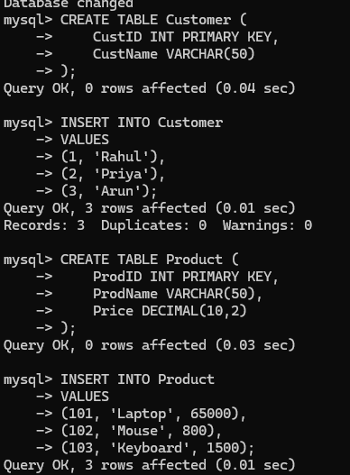

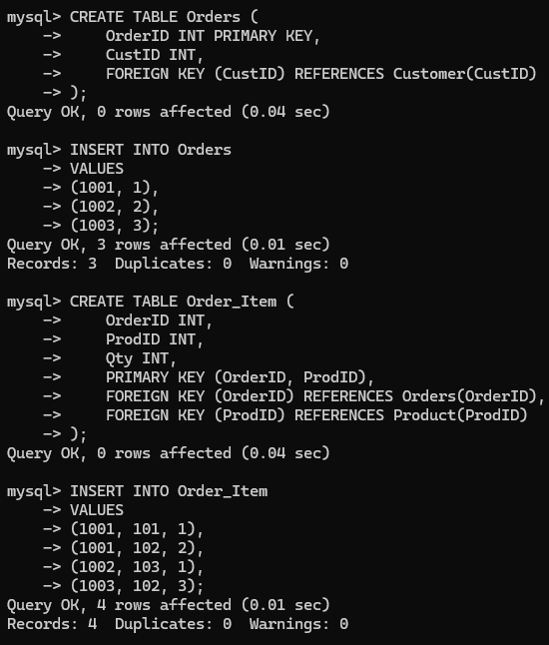

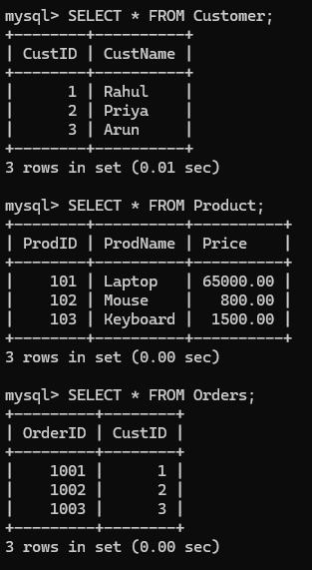

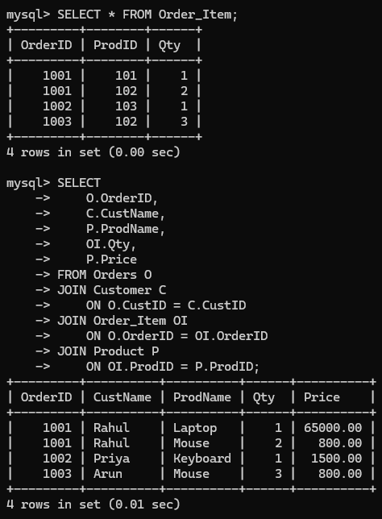

Justification

The original relation contains redundant customer and product information because the same customer and product details can appear in many orders. Decomposing it into Customer, Product, Orders, and Order_Item removes partial and transitive dependencies while preserving the relationships. Hence, the resulting schema satisfies 3NF.

- A hospital maintains Patient(PID, PName, DocID, DocName, Specialization, WardNo, WardName). Identify anomalies and normalize to BCNF.

Given Relation

PATIENT(PID, PName, DocID, DocName, Specialization, WardNo, WardName)
Assume the following functional dependencies:

PID → PName, DocID, WardNo DocID → DocName, Specialization WardNo → WardName
Therefore, there are transitive dependencies:

PID → DocID → DocName, Specialization
And

PID → WardNo → WardName

Identify Anomalies

- Update Anomaly

If a doctor's name changes, it must be updated in multiple patient records.

For example, if DocID = D01 appears for 20 patients, the doctor's name is repeated 20 times.

- Insertion Anomaly

A new doctor cannot easily be added unless a patient is assigned to that doctor.

- Deletion Anomaly

If the last patient assigned to a doctor is deleted, the doctor's information may also be lost.

BCNF Analysis

A relation is in BCNF when every determinant in a non-trivial functional dependency is a superkey.

In the original relation:

DocID → DocName, Specialization

But DocID is not a superkey of the complete Patient relation. Similarly:
WardNo → WardName
but WardNo is not a superkey of the complete relation. Therefore:
Patient is not in BCNF

BCNF DECOMPOSITION

Separate the determinants into their own relations.

PATIENT

PATIENT(PID, PName, DocID, WardNo)

DOCTOR
DOCTOR(DocID, DocName, Specialization)

WARD

WARD(WardNo, WardName)

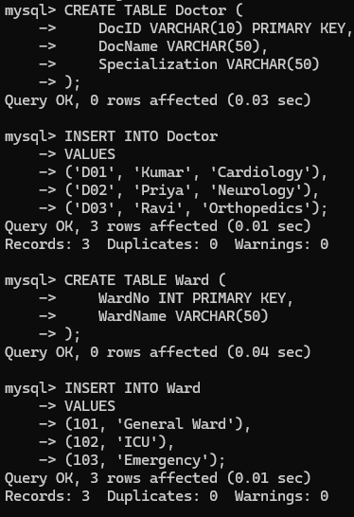
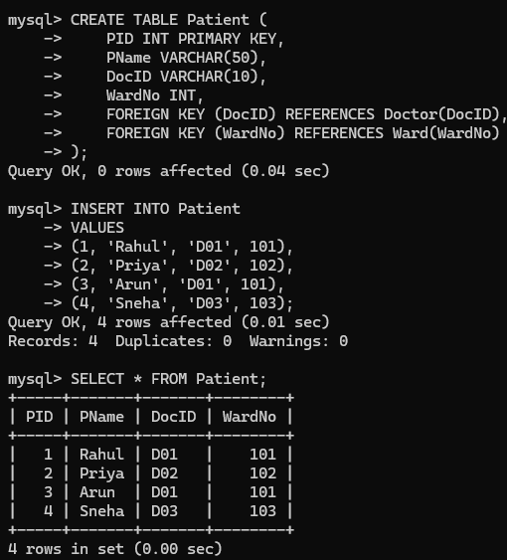

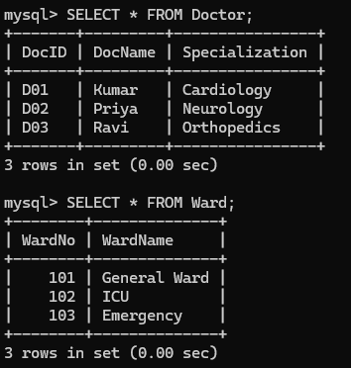
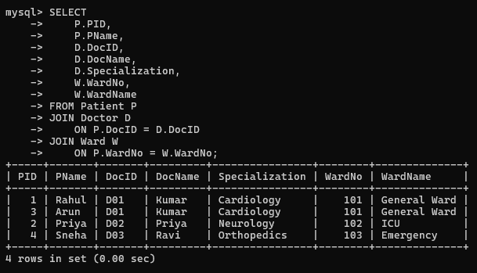

Justification

The original relation has redundancy because doctor and ward information is repeated for multiple patients. DocID and WardNo determine non-key attributes but are not superkeys of the original relation, causing BCNF violations. Separating Doctor and Ward into independent relations removes these dependencies and produces a BCNF design.

- Case study: A university stores Enrollment(SID, SName, CourseID, CourseName, Faculty, Grade). Analyze FDs and apply 2NF decomposition.

Given Relation

ENROLLMENT(SID, SName, CourseID, CourseName, Faculty, Grade)

Functional Dependencies
SID → SName

CourseID → CourseName, Faculty
(SID, CourseID) → Grade
Candidate Key

- A student can enroll in multiple courses, so SID alone is not enough.
- A course can have multiple students, so CourseID alone is not enough.

Therefore:

(SID,CourseID)

is the candidate key. Partial Dependencies We have:
SID → SName
CourseID → CourseName, Faculty
Both depend on parts of the composite key, so the relation is not in 2NF.

2NF DECOMPOSITION
Separate the attributes that depend only on part of the key. STUDENT
STUDENT(SID, SName)

COURSE

COURSE(CourseID, CourseName, Faculty)

ENROLLMENT

ENROLLMENT(SID, CourseID, Grade)

CREATE TABLE AND INSERT DATA
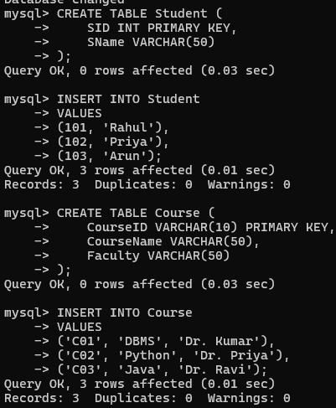

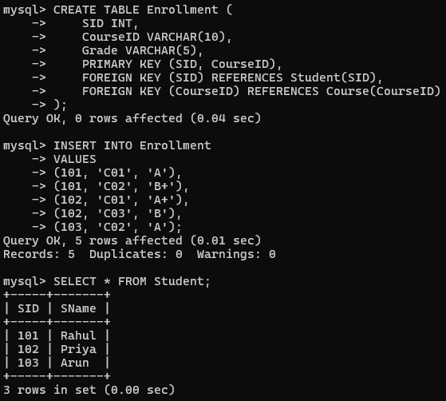
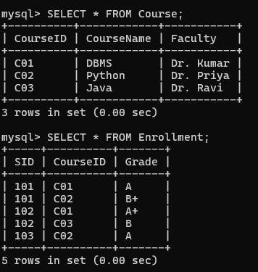

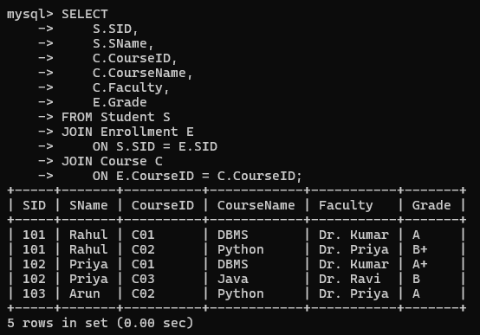

Justification

The decomposition stores student and course details only once, reducing redundancy and avoiding update anomalies. The ENROLLMENT table retains the relationship between students and courses along with their grades, giving a proper 2NF structure.

- Given the airline booking case: Booking(FlightNo, PassID, PassName, Seat, DeptCity, ArrCity, Date). Normalize up to BCNF.

Given Relation

BOOKING(FlightNo, PassID, PassName, Seat, DeptCity, ArrCity, Date) Assume these functional dependencies:

PassID → PassName

FlightNo → DeptCity, ArrCity, Date (FlightNo, PassID) → Seat
The candidate key is:

(FlightNo,PassID)

because a passenger can book multiple flights and a flight can have multiple passengers.

Dependencies We have:

PassID → PassName
and:

FlightNo → DeptCity, ArrCity, Date Both depend on part of the composite key.
Therefore, the original relation is not even in 2NF. Decompose it into:

PASSENGER

PASSENGER(PassID, PassName)

FLIGHT

FLIGHT(FlightNo, DeptCity, ArrCity, Date)

BOOKING

BOOKING(FlightNo, PassID, Seat)

Now each determinant is a key in its respective relation, so the resulting relations satisfy BCNF.

CREATE TABLE AND INSERT
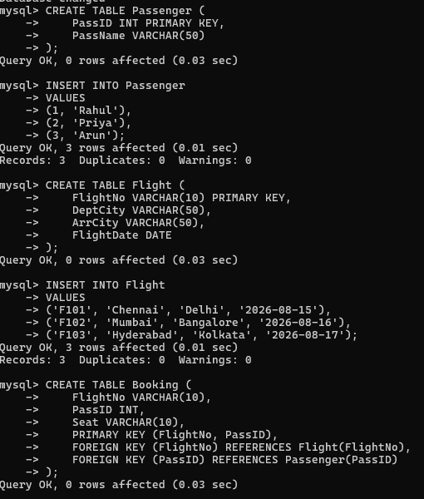

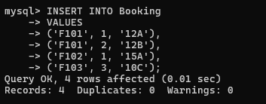

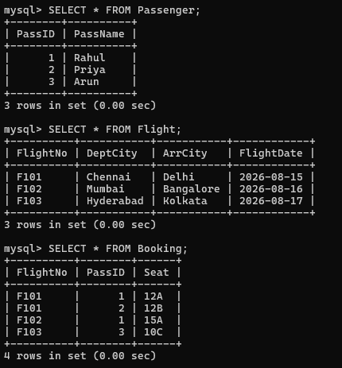
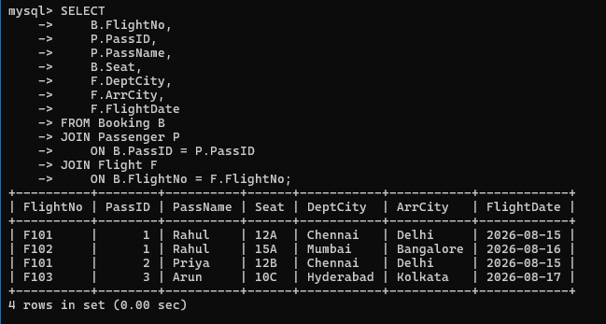

Justification
In each decomposed relation, the determinant is a candidate key: PassID determines passenger details and FlightNo determines flight details. The composite key (FlightNo, PassID) determines the seat in Booking, so there are no non-key determinants violating BCNF.

- Analyze an HR system schema for a multinational company. Identify all functional and transitive dependencies and normalize it to 3NF.

Consider the HR relation:

EMPLOYEE(EmpID, EmpName, DeptID, DeptName, ManagerID, ManagerName) Functional Dependencies
EmpID → EmpName, DeptID, ManagerID

DeptID → DeptName

ManagerID → ManagerName Therefore, the transitive dependencies are:

EmpID → DeptID → DeptName
and

EmpID → ManagerID → ManagerName
Candidate Key

EmpID

3NF DECOMPOSITION

EMPLOYEE

EMPLOYEE(EmpID, EmpName, DeptID, ManagerID)

DEPARTMENT
DEPARTMENT(DeptID, DeptName)

MANAGER

MANAGER(ManagerID, ManagerName) This removes the transitive dependencies.

CREATE TABLE AND INSERT DATA
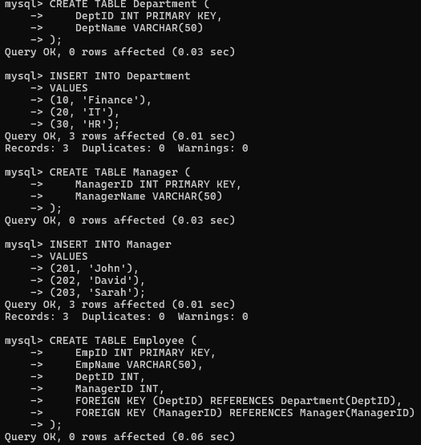

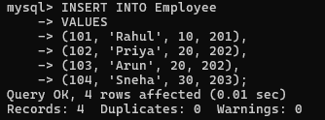

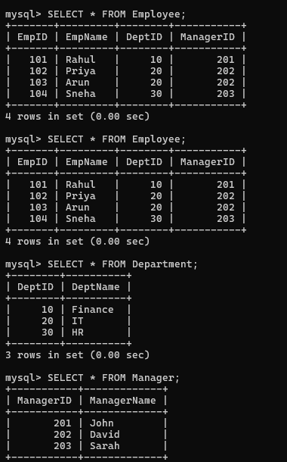
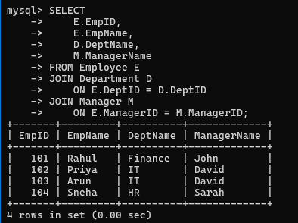

Justification
Each non-key attribute in the decomposed relations depends directly on its respective key. This prevents repeated department and manager information and avoids insertion, deletion, and update anomalies.

- Case: Library(MemberID, MemberName, BookID, Title, Author, Genre, BorrowDate). Identify MVDs and decompose to 4NF.

Given Relation

LIBRARY(MemberID, MemberName, BookID, Title, Author, Genre, BorrowDate)

Assume a member can borrow multiple books and the library can have multiple independent authors/genres associated with books.

The important dependency is:

MemberID → MemberName

For the 4NF case, assume each member can have multiple books, independently of another multi-valued fact such as multiple genres of interest.

A cleaner practical relation for demonstrating the MVD is:

MEMBER_LIBRARY(MemberID, BookID, Genre)
with:

MemberID →→ BookID MemberID →→ Genre

These are multi-valued dependencies.

Example of Redundancy Suppose Member 101 has:
- Books: B01, B02

- Genres: Fiction, Science

The relation may contain:

MemberID | BookID | Genre
101 | B01 | Fiction
101 | B01 | Science
101 | B02 | Fiction
101 | B02 | Science

The combinations create unnecessary redundancy. 4NF DECOMPOSITION
Separate the independent multi-valued facts.

MEMBER_BOOK

MEMBER_BOOK(MemberID, BookID)
MEMBER_GENRE

MEMBER_GENRE(MemberID, Genre)

CREATE TABLE AND INSERT DATA
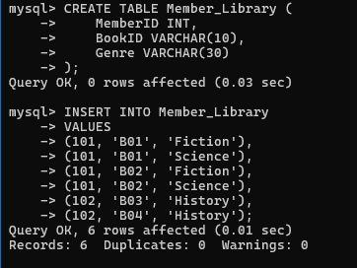

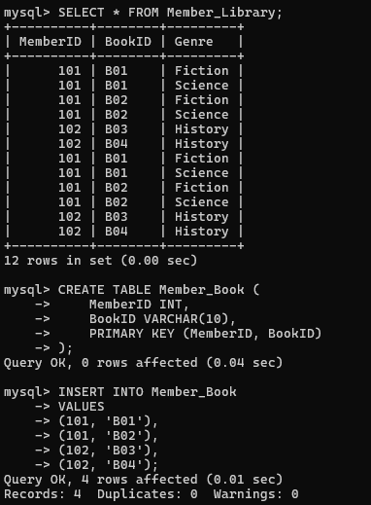

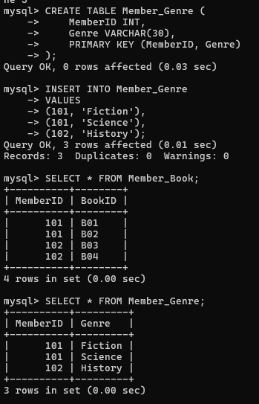

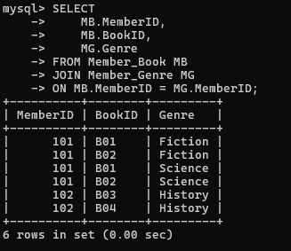

Justification

4NF requires every non-trivial multi-valued dependency to have a superkey as its determinant. By separating the independent multi-valued attributes into two relations, the MVDs are removed and unnecessary combinations are avoided.

- Analyze a telecom billing schema and identify all candidate keys, primary keys, and functional dependencies before normalization.

Consider the telecom billing relation:

BILLING(BillID, CustomerID, CustomerName, PlanID, PlanName, Amount, BillDate)

Functional Dependencies

BillID → CustomerID, PlanID, Amount, BillDate

CustomerID → CustomerName

PlanID → PlanName
Therefore:

BillID → CustomerID → CustomerName
And

BillID → PlanID → PlanName

are transitive dependencies.

Candidate Key
BillID uniquely identifies each bill.

Candidate Key=BillID

Primary Key

BillID

CREATE TABLE AND INSERT DATA
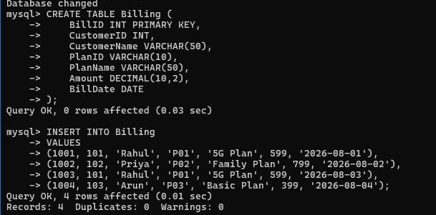

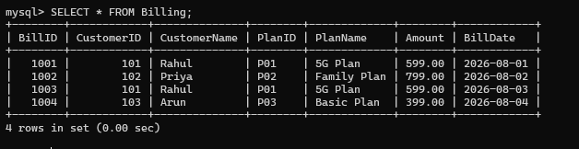

Justification

BillID uniquely identifies every billing record, so it is the candidate key and can be selected as the primary key. CustomerID determines customer information and PlanID determines plan information, creating transitive dependencies from BillID. These dependencies should be considered during normalization to remove redundancy.

- A retail inventory system has Product(PID, PName, SupplierID, SupplierName, Category, Price, Warehouse). Apply complete normalization.

Given Relation

PRODUCT(PID, PName, SupplierID, SupplierName, Category, Price, Warehouse)
Assume:

PID → PName, SupplierID, Category, Price, Warehouse
and:

SupplierID → SupplierName
Therefore:

PID → SupplierID → SupplierName is a transitive dependency.
Candidate Key

PID

NORMALIZATION
Separate supplier information:

PRODUCT

PRODUCT(PID, PName, SupplierID, Category, Price, Warehouse) SUPPLIER
SUPPLIER(SupplierID, SupplierName)

Now SupplierID is the primary key of SUPPLIER and a foreign key in PRODUCT. This gives a normalized 3NF/BCNF design under the stated dependencies.

CREATE AND INSERT DATA

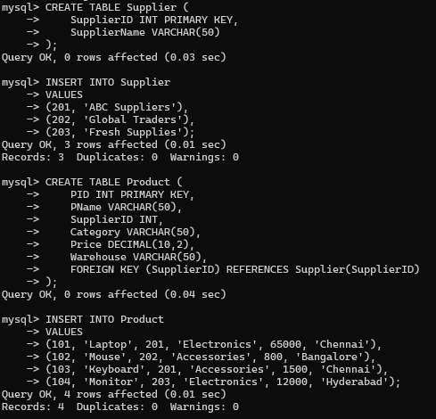

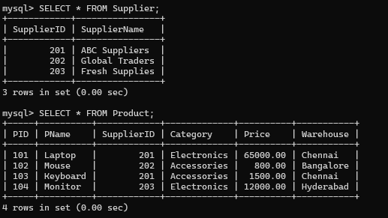

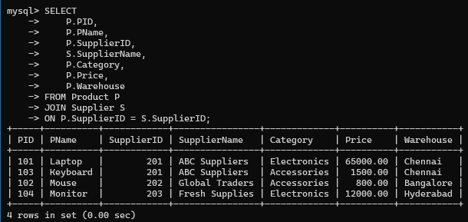

Justification
The original relation stores supplier information repeatedly for every product supplied by the same supplier. Since SupplierID → SupplierName, SupplierName has a transitive dependency through SupplierID. Separating the Supplier relation removes this redundancy and gives a normalized 3NF/BCNF design under the stated functional dependencies.

- Study the given poorly normalized schema for a School ERP and propose a fully normalized design up to BCNF with justification.

Consider:

Functional Dependencies

SCHOOL(
StudentID, StudentName, ClassID, ClassName, TeacherID, TeacherName, SubjectID, SubjectName
)

StudentID → StudentName, ClassID ClassID → ClassName, TeacherID TeacherID → TeacherName SubjectID → SubjectName
Thus, transitive dependencies include:

StudentID → ClassID → ClassName, TeacherID → TeacherName Candidate Key
Assume a student can study multiple subjects:

(StudentID,SubjectID)

BCNF DECOMPOSITION STUDENT

STUDENT(StudentID, StudentName, ClassID)

CLASS

CLASS(ClassID, ClassName, TeacherID)

TEACHER

TEACHER(TeacherID, TeacherName)

SUBJECT

SUBJECT(SubjectID, SubjectName)

ENROLLMENT

ENROLLMENT(StudentID, SubjectID)

Each determinant is a key in its respective relation, satisfying BCNF. CREATE TABLE AND INSERT DATA
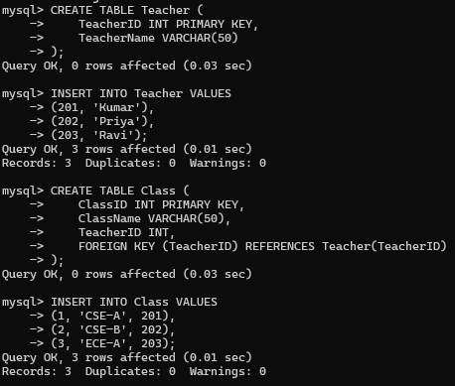

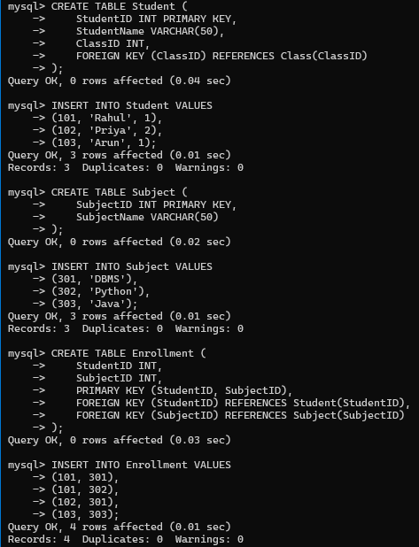

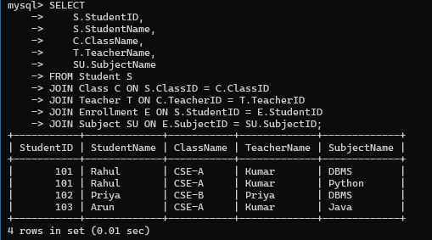

Justification

The original School ERP relation contains repeated student, class, teacher, and subject information. Decomposing it into separate entities removes the transitive dependencies and stores each fact only once. The resulting relations have determinants that are keys, giving a BCNF design.

- Given a movie streaming platform schema, identify join dependencies and decompose to 5NF with lossless-join verification.

Consider:

STREAMING(MovieID, ActorID, PlatformID)

Assume a movie can independently have:

  - multiple actors
  - multiple streaming platforms

For a 5NF example, assume the valid relationship is represented through three independent pairwise relationships.

Join Dependency

∗(Movie,Actor),(Movie,Platform),(Actor,Platform)

So decompose into:

MOVIE_ACTOR(MovieID, ActorID) MOVIE_PLATFORM(MovieID, PlatformID) ACTOR_PLATFORM(ActorID, PlatformID)

CREATE TABLES AND INSERT DATA
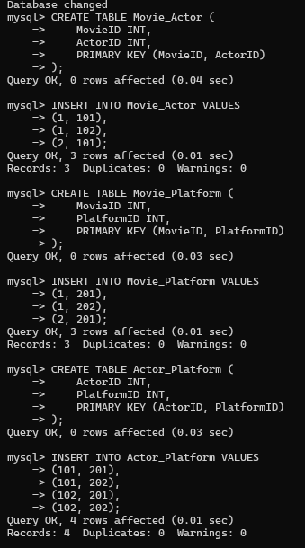
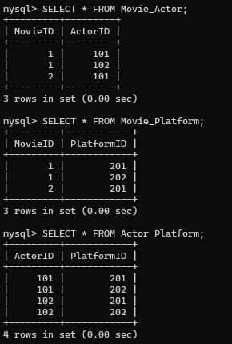

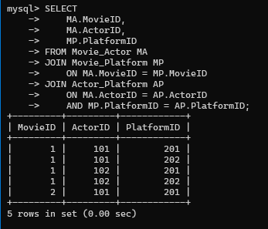

Justification

The original movie-streaming relation can contain redundancy when movie, actor, and platform relationships are stored together. Decomposing it into pairwise relations removes the join dependency redundancy. The successful JOIN reconstructs the required tuples, demonstrating a lossless-join decomposition into 5NF

