Stakeholder Requirements Document

Irrigation Using Wireless Sensor Network

Author: Shaikmeera

Version: 0.2

Date: 22 July 2020

Document ID: SRQ 001

Table of Contents

1 Executive Summary 3

2 Project Description 3

3 Current Process 3

4 Proposed Process 4

5 Functional Requirement 4

5.1 Temperature Sensor 4

5.2 Soil Moisture Sensor 5

5.3 Motion Detection Sensor 5

5.4 NODE MCU 5

5.5 MASTER NODE MCU 5

5.6 AWS 5

5.7 Mobile App 5

5.8 Electrical Specification 5

6 Effort Estimation 6

# Executive Summary

This Stakeholder requirement document outlines the requirements for the Irrigation using wireless sensor network. It contains both functional requirements, an overview of the current process, as well as the proposed process once the solution is implemented. It is used to determine what needs to be done, and as a starting point for solution design.

# Project Description

Irrigation using wireless sensor network, this system will collect sensor data from sensor nodes available within the network and report the same to the Master node. Master node will connect to AWS with help of internet from the router.

# Current Process

No current system available

# Proposed Process

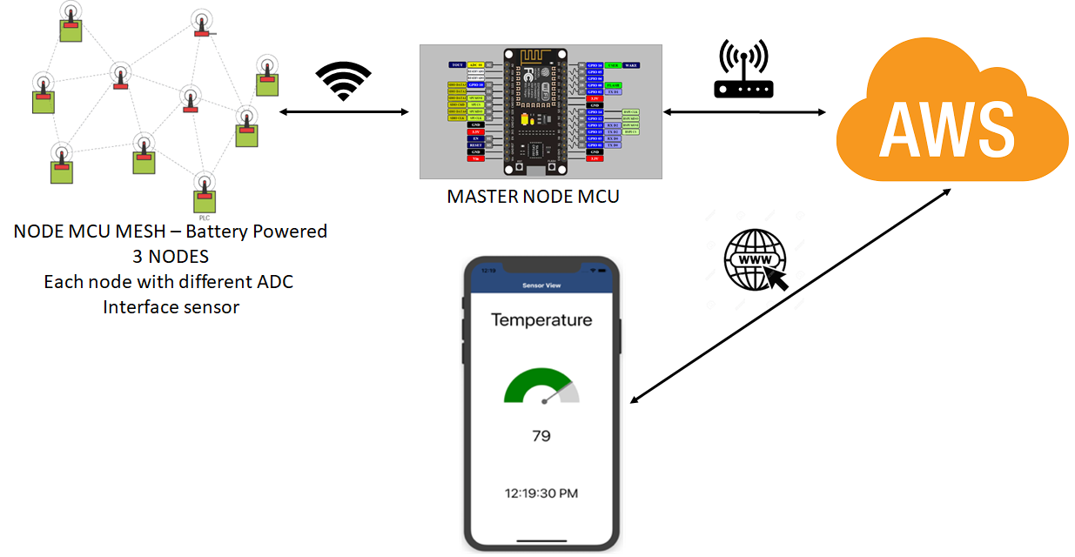

# Functional Requirement

This section is to the describe the functional specification of each components in the system

Components involved in the system

|  |  |  |
| --- | --- | --- |
| Sl. No | Item | Description |
|  | Temperature Sensor | Measures environmental temperature - ADC |
|  | Soil Moisture Sensor | Measure soil moisture level - ADC |
|  | Motion detection Sensor | Detect motion in the field – ADC |
|  | Node MCU | Sensor node |
|  | Master Node MCU | Master node to transmit data to AWS |
|  | Wi-Fi router | Network to which sensor and master node connected |
|  | AWS | Amazon Web Service |
|  | Mobile App | User interface and decision |

## Temperature Sensor

1. Detects temperature of the surrounding and sends value to Node MCU

## Soil Moisture Sensor

1. Detects moisture of the soil and sends value to Node MCU

## Motion Detection Sensor

1. Detects motion within the proximity and sends value to the MCU

## NODE MCU

1. Their total 3 MCU in the network
2. Node 1 is connected to temperature sensor
3. Node 2 is connected to soil moisture sensor
4. Node 3 is connected to motion detection sensor
5. All these individual nodes are connected the same network as Internet router is connected
6. These nodes form a mesh network through which it pushes sensor data to master node
7. These sensor nodes are battery powered

## MASTER NODE MCU

1. Master Node MCU pushes data to the AWS.
2. This node is notified every time when data changes in the network
3. All the AWS relevant certification and policy credential are preloaded(hard-coded) in this node ROM memory.

## AWS

1. Central Cloud storage for sensor data
2. Should be accessible from authentication devices

## Mobile App

1. This will provide the temperature, soil moisture and field condition (Wind or Person movements)
2. Also suggest user decision based on the sensor data

## Electrical Specification

1. List of components

|  |  |  |  |
| --- | --- | --- | --- |
| Sl. No | Components | Part Number | Qty |
|  | Temperature Sensor | LM35 MQTT with BeagleBone and ESP8266 – MQTT on ESP8266 with ... | 3 |
|  | Soil Moisture Sensor | <https://www.amazon.in/Absolute-Electronics-Soil-Moisture-Testing/dp/B00AYCNEKW> | 3 |
|  | Motion detection Sensor | [555-28027](https://www.digikey.com/products/en?mpart=555-28027&v=149) PIR ADC Sensor | 3 |
|  | Node MCU – ESP8266 | Mcu Esp8266 | 6 |
|  | Arudino | Arduino Uno R3 | 1 |
|  | Wi-Fi router | Not required – assumed available in the testing vicinity and its accessible | 1 |
|  | AWS | Purchased login | 1 |
|  | 9v Battery |  | 10 |
|  | Connecting Wires | Male to Male  Male to Female | 20nos each |
|  | 9v battery to 12mm dc adaptor | C:\Users\uid42649\AppData\Local\Microsoft\Windows\INetCache\Content.MSO\8DC4B87.tmp | 10 |
|  | 9v to 5v DC-DC convertor board |  | 7 |
|  | Micro USB cable |  | 5 |

# Effort Estimation

One Man Hour in INR – 150 INR

Effort Distribution (Developer)

|  |  |  |  |  |
| --- | --- | --- | --- | --- |
| Sl. No | Item | Effort estimated | Man hour | INR |
|  | Documentation | 15 | 1 x 15 x 150 | 2250 |
|  | SW Creation | 50 | 1 x 50 x 150 | 7500 |
|  | HW Interface and testing | 35 | 1 x 35 x 150 | 5250 |
|  | Incremental SW change | 10 | 1 x 10 x 150 | 1500 |
| Total | | |  | 16500 INR |

Effort Distribution (Company)

|  |  |  |  |  |
| --- | --- | --- | --- | --- |
| Sl. No | Item | Effort estimated | Man hour | INR |
|  |  |  |  |  |
|  |  |  |  |  |
|  |  |  |  |  |
|  |  |  |  |  |
| Total | | |  |  |