EXPERIMENT-18
Demonstrate Storage as a Service (SaaS) create and configure a new VM Image in any Public Cloud Service Provider

AIM: TO Demonstrate Storage as a Service (SaaS) create and configure a new VM Image in any Public Cloud Service Provider

PROCEDURE:
STEP1: GOTO AZURE AND GOTO SQLDATABASE.
STEP 02: Now Create a Sql Databse
STEP3: SELECT THE RESOURCE GROUP AND ENTER THE SERVERNAME THAT APPLICABLE.
STEP4: IN NETWORKING SELECT ALLOW AZURE SERVICES AND
RESOURCES TO ACCESS THIS SERVER.
STEP5: IN ADDITIONAL SETTINGS SELECT SAMPLE.
STEP6:AND THE SQL DATABASE IS DEPLOYED
TEP7: NOW GOTO QUERY EDITOR.
STEP8:NOW AGAIN LOGIN TO THE SQLDATADATABASE
STEP9: OUR TABLES WILL SHOWN AND TYPE THE QUERY TO EXCUTED.

IMPLEMENTATION:
STEP1: GOTO AZURE AND GOTO SQLDATABASE.

STEP 02:- Now Create a Sql Databse
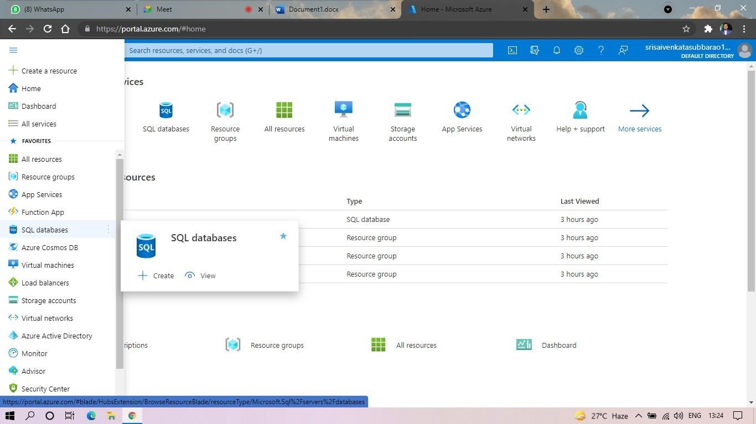
STEP3: SELECT THE RESOURCE GROUP AND ENTER THE SERVERNAME THAT APPLICABLE

STEP4: IN NETWORKING SELECT ALLOW AZURE SERVICES AND RESOURCES TO ACCESS THIS SERVER.

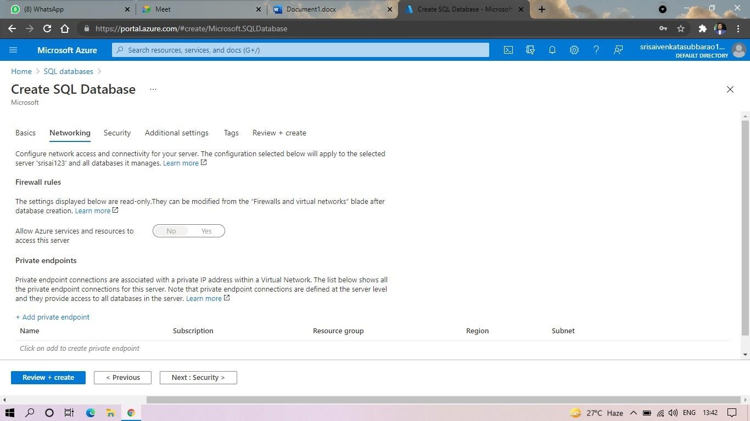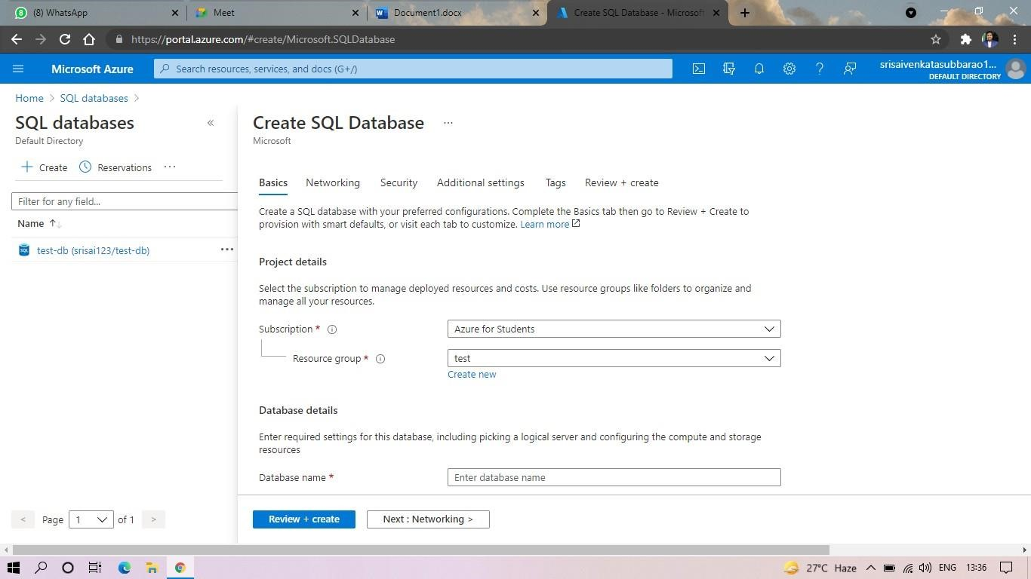
STEP5: IN ADDITIONAL SETTINGS SELECT SAMPLE.
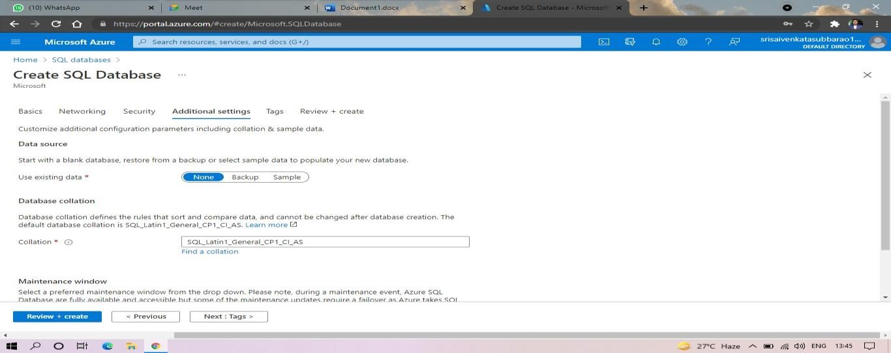
STEP6:AND THE SQL DATABASE IS DEPLOYED.
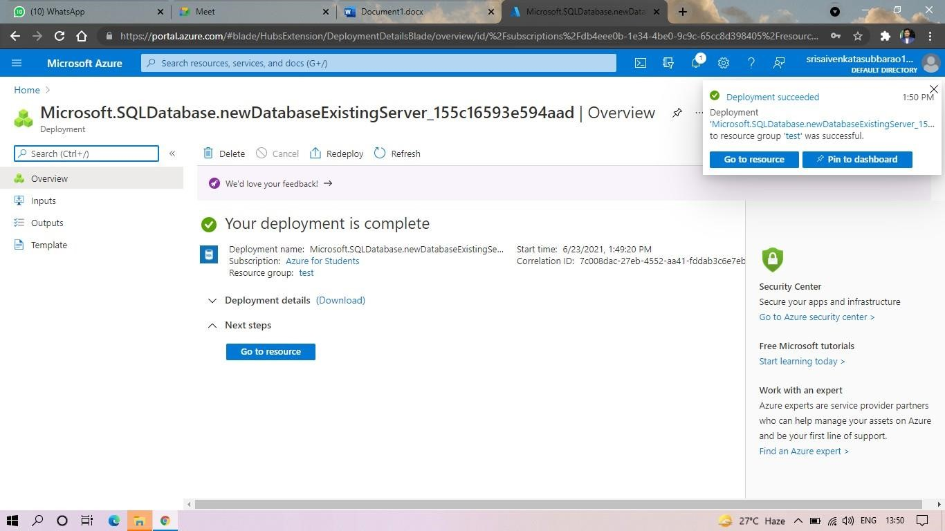
STEP7:AND NOW GOTO QUERY EDITOR.

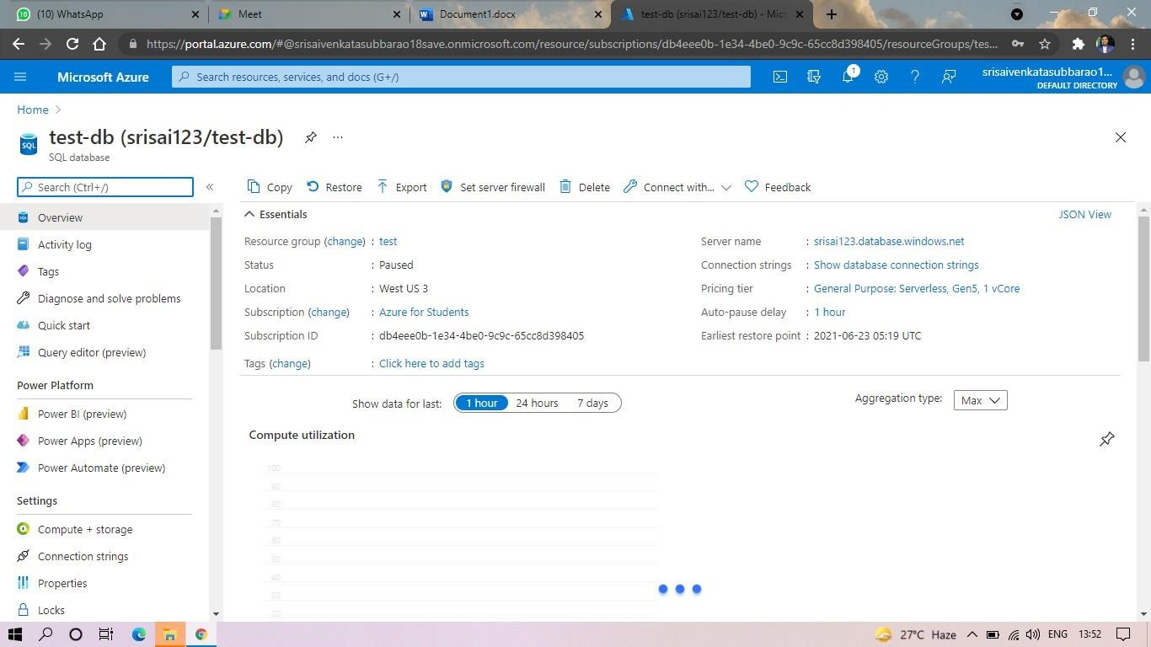
STEP8:AND NOW AGAIN LOGIN TO THE SQLDATADATABASE

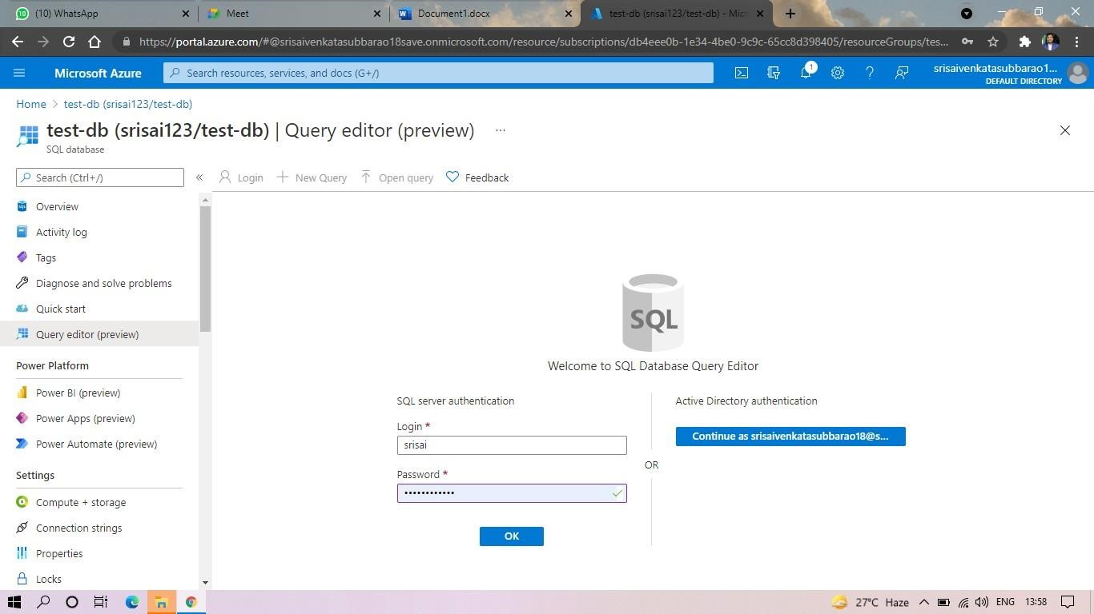
STEP9: AND OUR TABLES WILL SHOWN AND TYPE THE QUERY TO EXCUTED
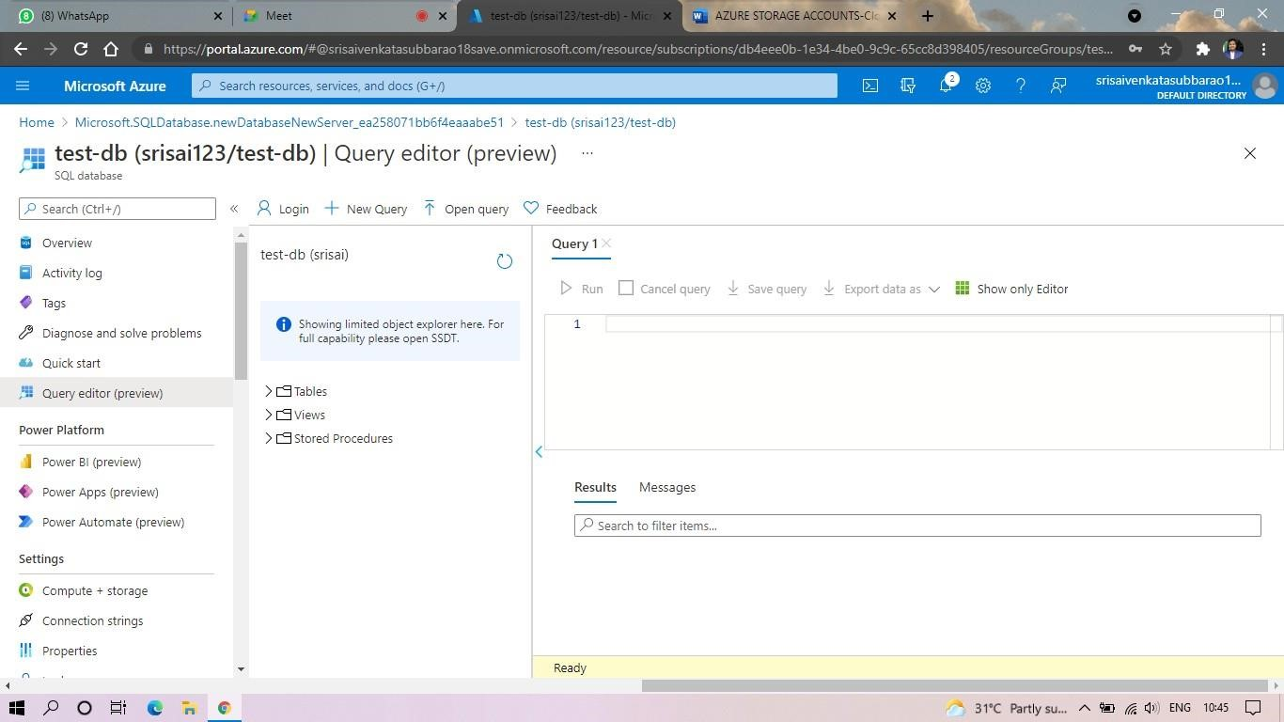
STEP10: AND OUR OUTPUT IS READY.
