EXPERIMENT- 24
LAUNCH THE HADOOP 2.X AND PERFORM MAPREDUCE PROGRAM FOR A WORD
COUNT PROBLEM

AIM: LAUNCH THE HADOOP 2.X AND PERFORM MAPREDUCE PROGRAM FOR A WORD COUNT PROBLEM

PROCEDURE:
Step 1 - Open Terminal
$ su
hduser
Password:
Step 2 - Start dfs and mapreduce services
$ cd /usr/local/hadoop/hadoop-2.7.2/sbin
$ start-dfs.sh
$ start-yarn.sh
$ jps

Step 3 - Check Hadoop through web UI

// Go to browser type http://localhost:8088 – All Applications Hadoop Cluster

// Go to browser type http://localhost:50070 – Hadoop Namenode

Step 4 – Open New Terminal
$ cd Desktop/
$ mkdir inputdata
$ cd inputdata/
$ echo “Hai, Hello, How are you? How is your health?” >> hello.txt
$ cat >> hello.txt
Step 5 – Go back to old Terminal
$ hadoop fs –copyFromLocal /home/hduser/Desktop/inputdata/hello.txt /folder/hduser
// Check in hello.txt in Namenode using Web UI
Step 6 – Download and open eclipse by creating workspace
Create a new java project.
Step 7 – Add jar to the project
You need to remove dependencies by adding jar files in the hadoop source folder. Now Click on
Project tab and go to Properties.Under Libraries tab, click Add External JARs and select all the
jars in the folder (click on 1st jar, and Press Shift and Click on last jat to select all jars in between and click ok)
/usr/local/hadoop/hadoop-2.7.2/share/hadoop/commonand
/usr/local/hadoop/hadoop-2.7.2/share/hadoop/mapreduce folders.
Step -8 – WordCount Program
Create 3 java files named
- WordCount.java
- WordCountMapper.java
- WordCountReducer.java
WordCount.java
import org.apache.hadoop.conf.Configured; import org.apache.hadoop.fs.Path; import org.apache.hadoop.io.IntWritable;
import org.apache.hadoop.mapred.FileInputFormat; import
org.apache.hadoop.mapred.FileOutputFormat; import org.apache.hadoop.mapred.JobClient; import org.apache.hadoop.mapred.JobConf;

import org.apache.hadoop.util.Tool;
import org.apache.hadoop.util.ToolRunner; import org.apache.hadoop.io.Text;
public class WordCount extends Configured implements Tool { @Override
public int run(String[] arg0) throws Exception {
// TODO Auto-generated method stub if(arg0.length<2)
{
System.out.println("check the command line arguments");
}
JobConf conf=new JobConf(WordCount.class);
FileInputFormat.setInputPaths(conf, new Path(arg0[0]));
FileOutputFormat.setOutputPath(conf, new Path(arg0[1])); conf.setMapperClass(WordMapper.class); conf.setReducerClass(WordReducer.class); conf.setOutputKeyClass(Text.class); conf.setOutputValueClass(IntWritable.class);
conf.setOutputKeyClass(Text.class);
}
}

WordCountMapper.java

import java.io.IOException;

import org.apache.hadoop.io.IntWritable; import org.apache.hadoop.io.LongWritable;
import
org.apache.hadoop.mapred.MapReduceBase; import
org.apache.hadoop.mapred.OutputCollector; import org.apache.hadoop.mapred.Reporter; import org.apache.hadoop.io.Text; import org.apache.hadoop.mapred.Mapper;

public class WordCountMapper extends MapReduceBase implements Mapper<LongWritable,Text,Text,IntWritable>
{
@Override
public void map(LongWritable arg0, Text arg1, OutputCollector<Text, IntWritable> arg2,
Reporter arg3)

WordCountReducer.java

import java.io.IOException; import java.util.Iterator;
import org.apache.hadoop.io.IntWritable; import org.apache.hadoop.mapred.JobConf;
import org.apache.hadoop.mapred.OutputCollector; import org.apache.hadoop.mapred.Reducer;
import org.apache.hadoop.mapred.Reporter; import org.apache.hadoop.io.Text;

public class WordCountReducer implements Reducer<Text,IntWritable,Text,IntWritable> {
@Override
public void configure(JobConf arg0) {
}
@Override
public void reduce(Text arg0, Iterator<IntWritable> arg1, OutputCollector<Text, IntWritable>
arg2, Reporter arg3)
throws IOException {
// TODO Auto-generated method stub int count=0; while(arg1.hasNext())
{
IntWritable i=arg1.next(); count+=i.get();

Step 9 - Creatr JAR file
Now Click on the Run tab and click Run-Configurations. Click on New Configuration button on the left-top side and Apply after filling the following properties.
Step 10 - Export JAR file

Now click on File tab and select Export. under Java, select Runnable Jar.

In Launch Config – select the config fie you created in Step 9 (WordCountConfig).

Select an export destination (lets say desktop.)
Under Library handling, select Extract Required Libraries into generated JAR and click Finish.
Right-Click the jar file, go to Properties and under Permissionstab, Check Allow executing file as a program. and give Read and Write access to all the users

Step 11 – Go back to old Terminal for Execution of WordCount Program

$hadoop jar wordcount.jar/usr/local/hadoop/input/usr/local/hadoop/output

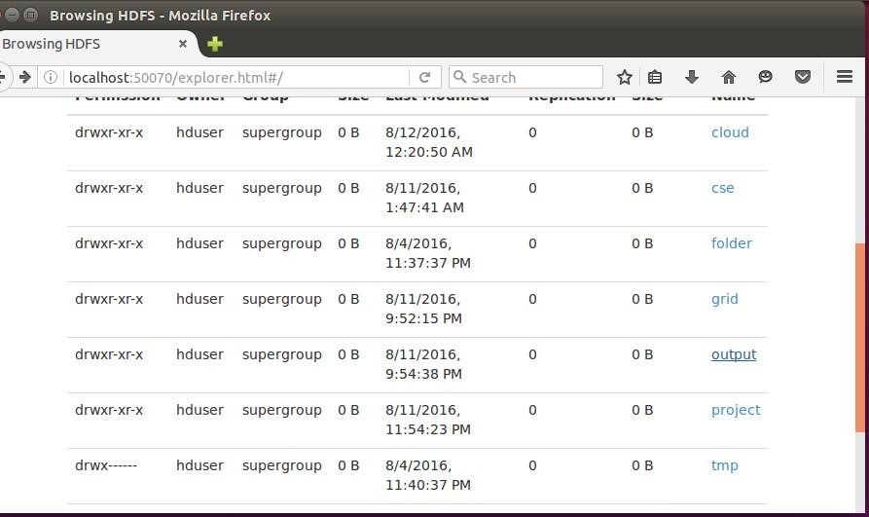

Step 12 – To view results in old Terminal
$hdfs dfs -cat /usr/local/hadoop/output/part-r-00000
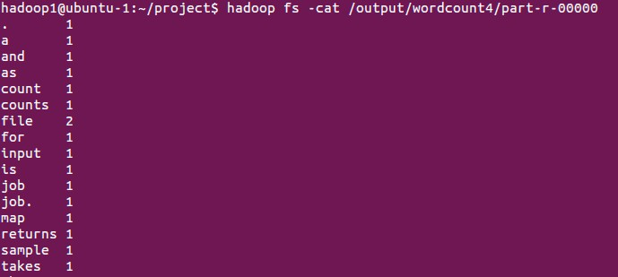
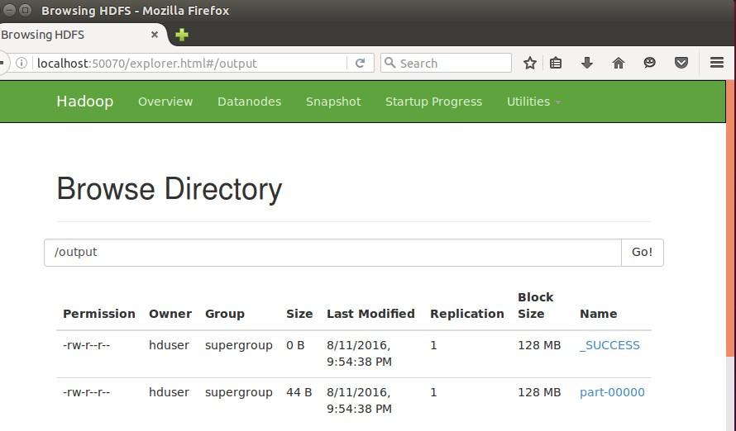

Step 13 - To Remove folders created using hdfs

$ hdfs dfs -rm -R /usr/local/hadoop/output

