EXPERIMENT-20
CREATE A SQL STORAGE SERVICE AND PERFORM A BASIC QUERY USING ANY PUBLIC
CLOUD SERVICE PROVIDER (AZURE/GCP/AWS) TO DEMONSTRATE DATABASE AS A SERVICE (DAAS)
AIM: CREATE A SQL STORAGE SERVICE AND PERFORM A BASIC QUERY USING ANY PUBLIC CLOUD
SERVICE PROVIDER (AZURE/GCP/AWS) TO DEMONSTRATE DATABASE AS A SERVICE (DAAS)

PROCEDURE:
STEP1: GOTO AZURE AND GOTO SQLDATABASE.
STEP 02: Now Create a Sql Databse
STEP3: SELECT THE RESOURCE GROUP AND ENTER THE SERVERNAME THAT APPLICABLE.
STEP4: IN NETWORKING SELECT ALLOW AZURE SERVICES AND
RESOURCES TO ACCESS THIS SERVER.
STEP5: IN ADDITIONAL SETTINGS SELECT SAMPLE.
STEP6:AND THE SQL DATABASE IS DEPLOYED
TEP7: NOW GOTO QUERY EDITOR.
STEP8:NOW AGAIN LOGIN TO THE SQLDATADATABASE
STEP9: OUR TABLES WILL SHOWN AND TYPE THE QUERY TO EXCUTED.

IMPLEMENTATION:

STEP1: GOTO AZURE AND GOTO SQLDATABASE.

STEP 02:- Now Create a Sql Databse .
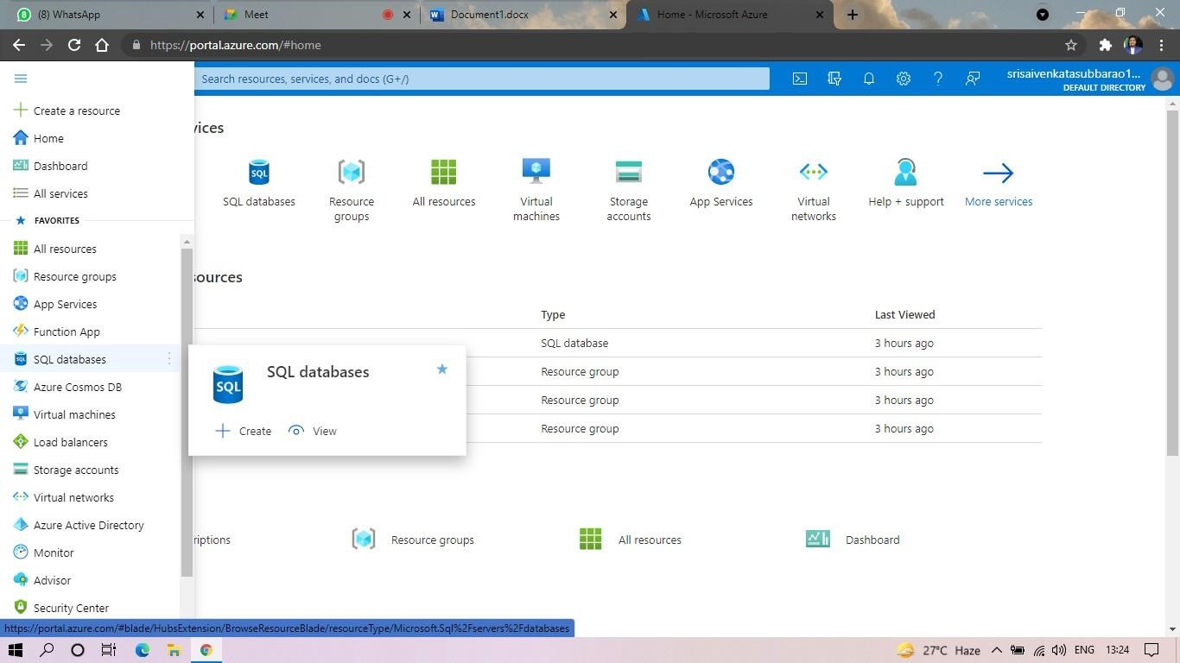

STEP3: SELECT THE RESOURCE GROUP AND ENTER THE SERVERNAME THAT APPLICABLE.

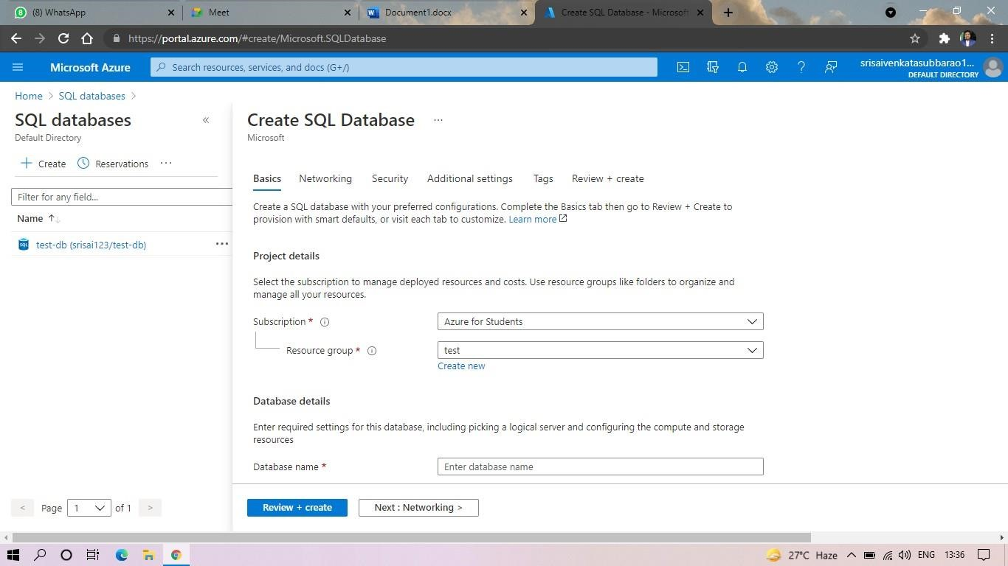
STEP4: IN NETWORKING SELECT ALLOW AZURE SERVICES AND RESOURCES TO ACCESS THIS SERVER.
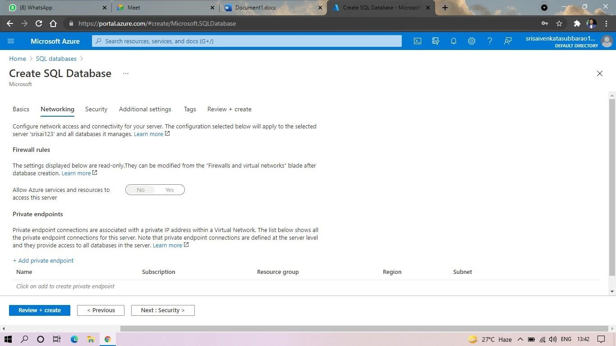
STEP5: IN ADDITIONAL SETTINGS SELECT SAMPLE.
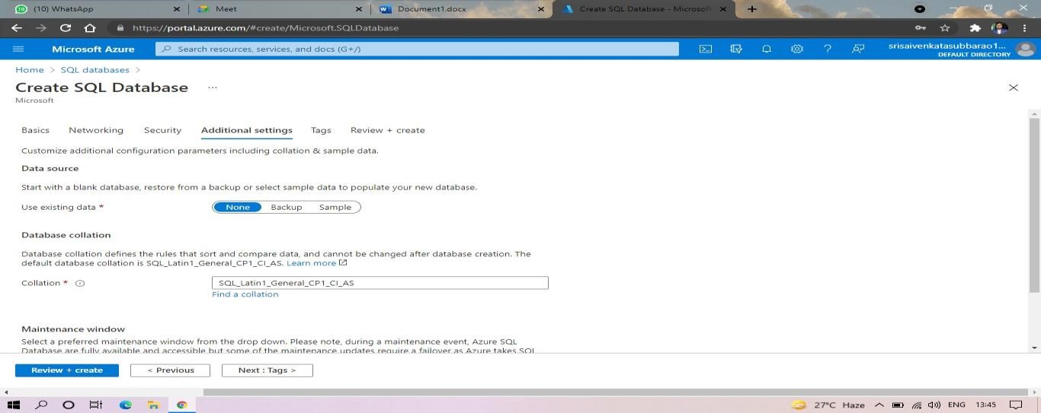
STEP6:AND THE SQL DATABASE IS DEPLOYED.

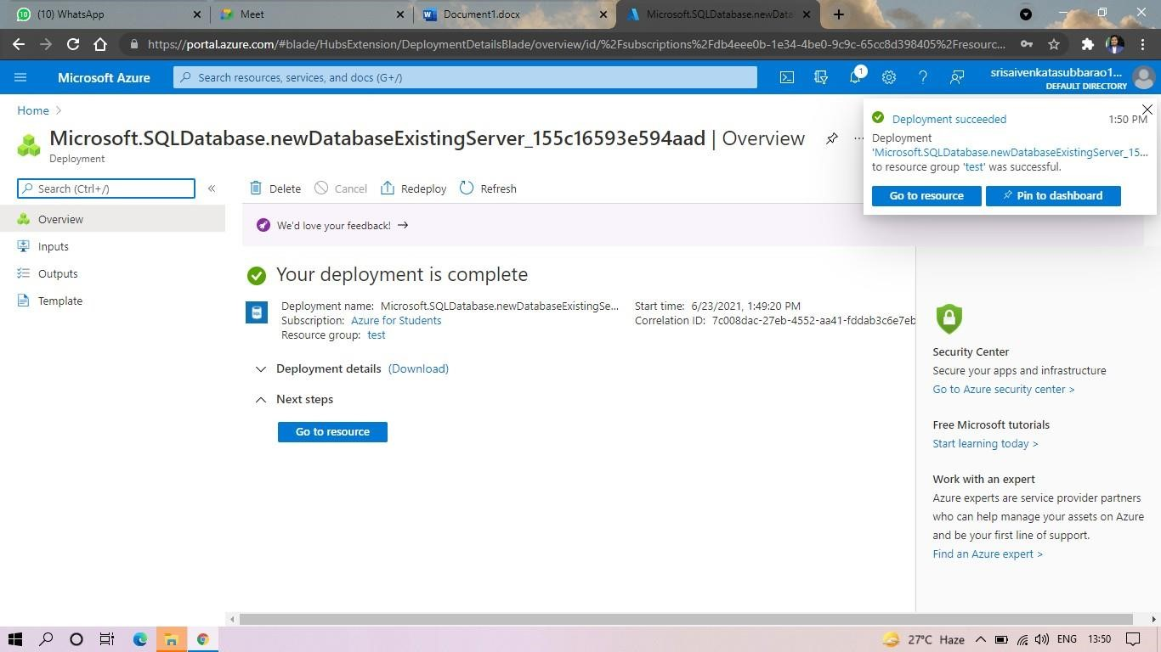
STEP7:AND NOW GOTO QUERY EDITOR.
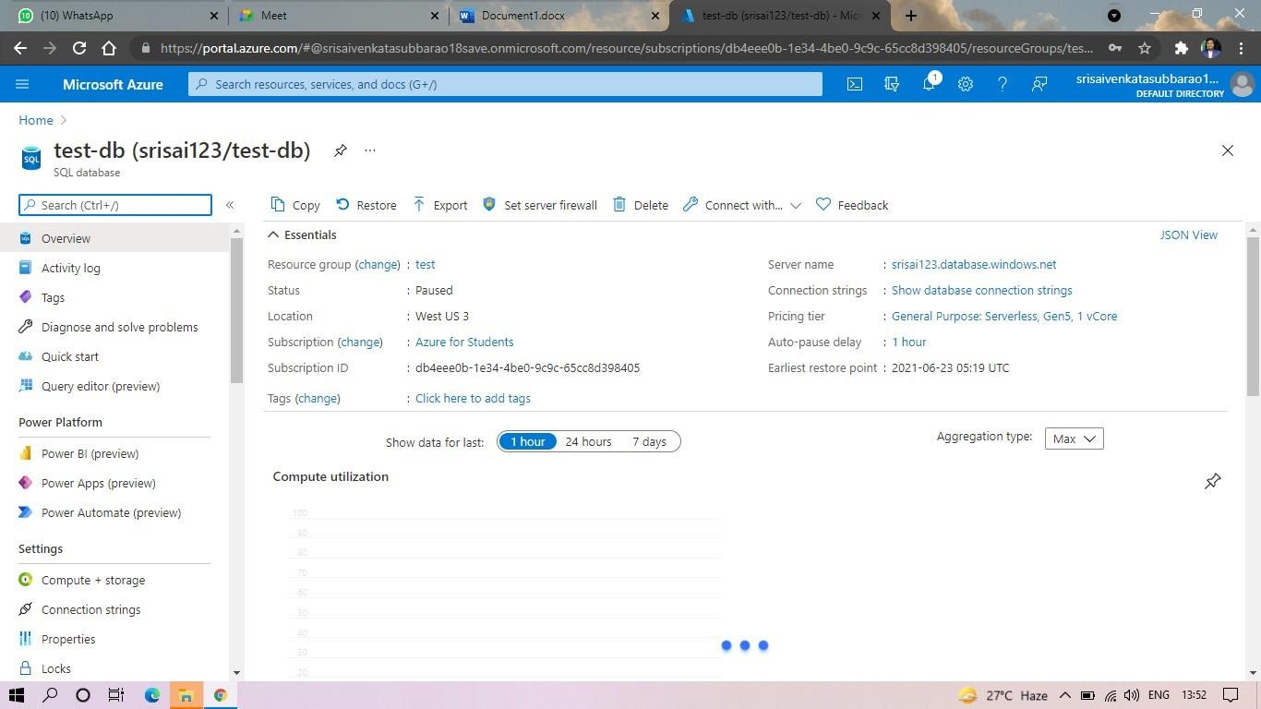

STEP8:AND NOW AGAIN LOGIN TO THE SQLDATADATABASE

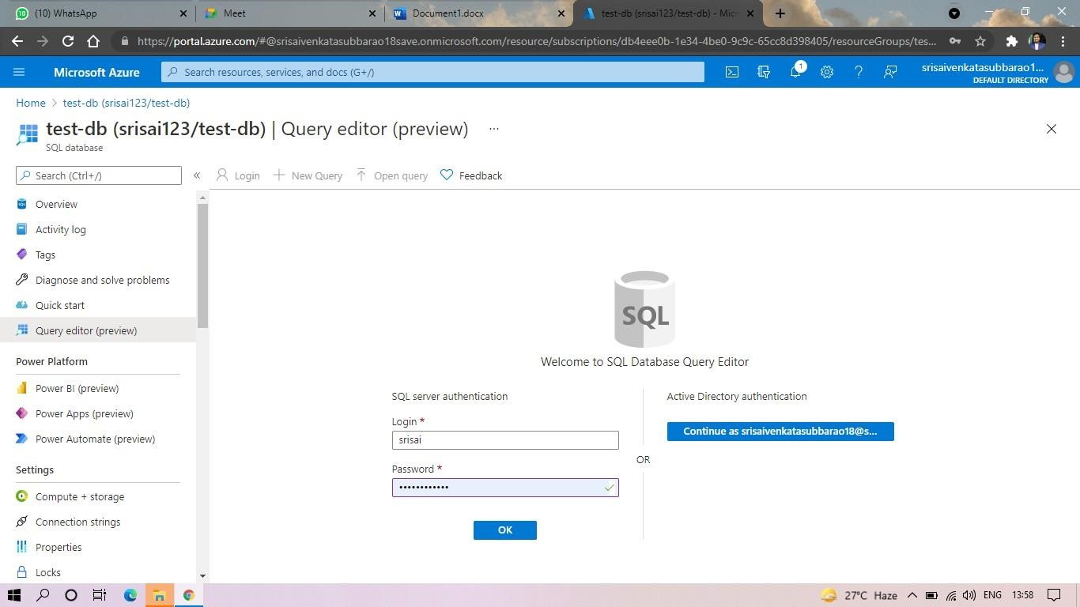
STEP9: AND OUR TABLES WILL SHOWN AND TYPE THE QUERY TO EXCUTED.
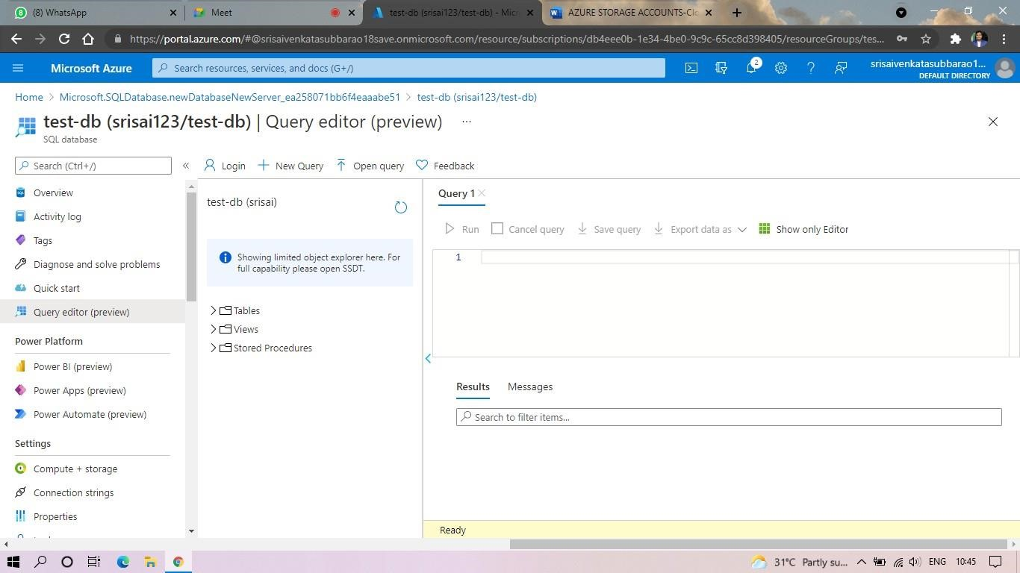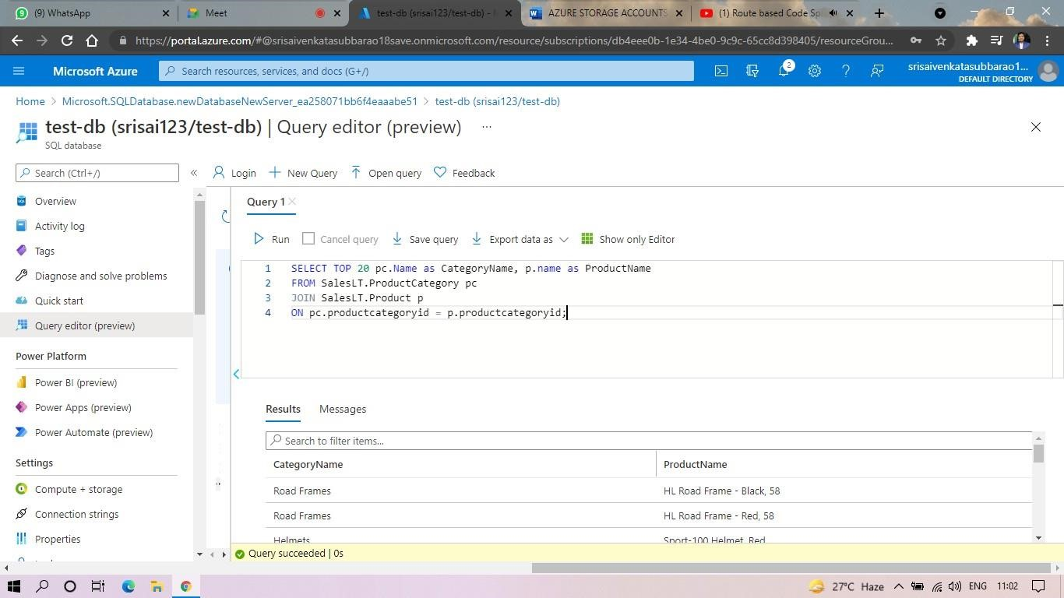
STEP10: AND OUR OUTPUT IS READY.

