EXPERIMENT-19

CREATE A STORAGE SERVICE USING ANY PUBLIC CLOUD SERVICE PROVIDER (AZURE/GCP/AWS)
AND CHECK THE PUBLIC ACCESSIBILITY OF THE STORED FILE TO DEMONSTRATE STORAGE AS A SERVICE.
AIM:
To CREATE A STORAGE SERVICE USING ANY PUBLIC CLOUD SERVICE PROVIDER (AZURE/GCP/AWS)
AND CHECK THE PUBLIC ACCESSIBILITY OF THE STORED FILE TO DEMONSTRATE STORAGE AS A SERVICE.

PROCEDURE:
STEP1: OPEN AZURE AND GOTO STORAGE ACCOUNTS AND CREATE STOROAGE ACCOUNT
STEP2: ENTER THE RESOURC GROUP AND AND STORAGE ACCOUNT NAME AND REVIEW AND CREATE AND CLICK TH CREATE AND YOUR STORAGE ACCOUNT WILL BE DEPLOYED SUCESSFULLY.
STEP3: OUR STORAGE ACCOUNT IS CREATED.
STEP4: GOTO STATIC WEBSITE
STEP5: AND ENABLE AND ENTER YOUR INDEX AND ERROR HTML FILES NAMES.
STEP6: AND GOTO STORAGE EXPLORR(REVIEW) AND AND GOTO BLOB CONTAINERS AND WEB AND UPLOAD THE TWO HTML FILES INIT
STEP7: AND AGAIN RETURN TO STATIC WEBSITE AND OPEN THE PRIMARY LINK AND YOUR WEB PAGE IS CREATED

IMPLEMENTATION:

STEP1: OPEN AZURE AND GOTO STORAGE ACCOUNTS AND CREATE STOROAGE ACCOUNT 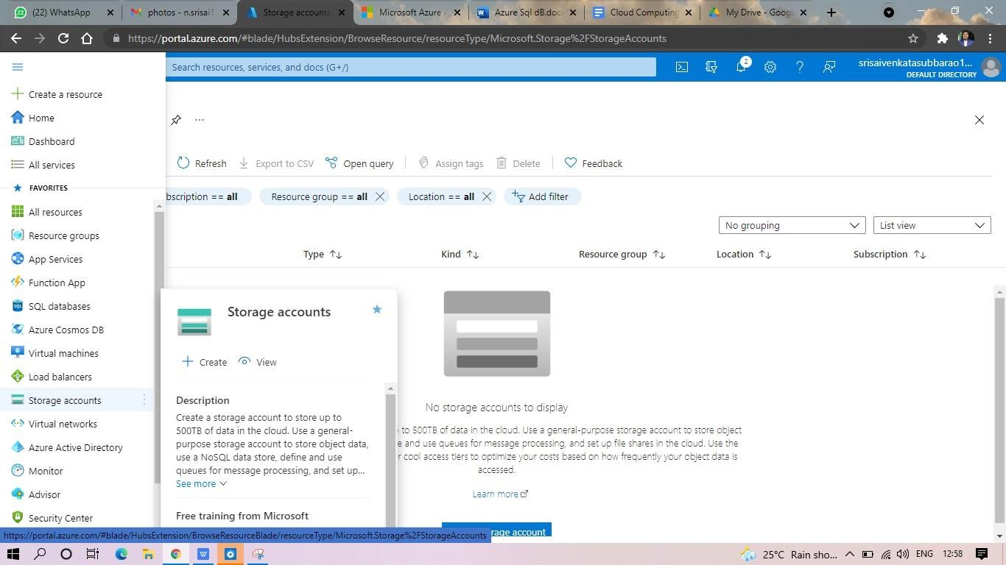

STEP2: ENTER THE RESOURC GROUP AND AND STORAGE ACCOUNT NAME AND REVIEW AND CREATE AND CLICK TH CREATE AND YOUR STORAGE ACCOUNT WILL BE DEPLOYED SUCESSFULLY.

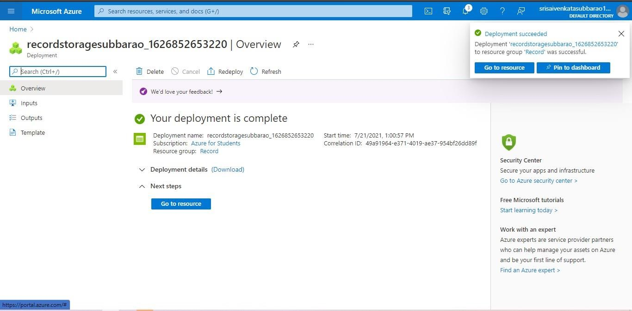

STP3: AND OUR STORAGE ACCOUNT IS CREATED.
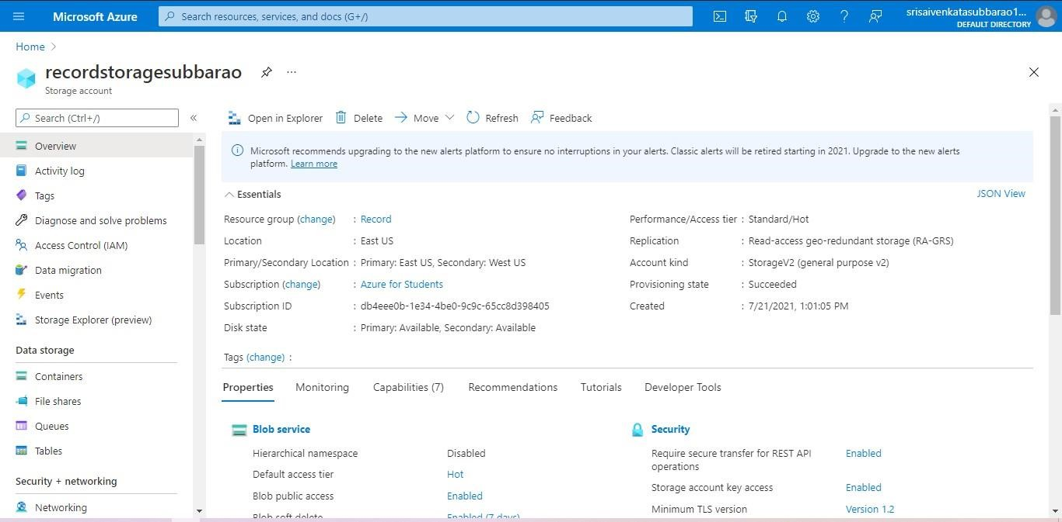

STEP4: GOTO STATIC WEBSITE

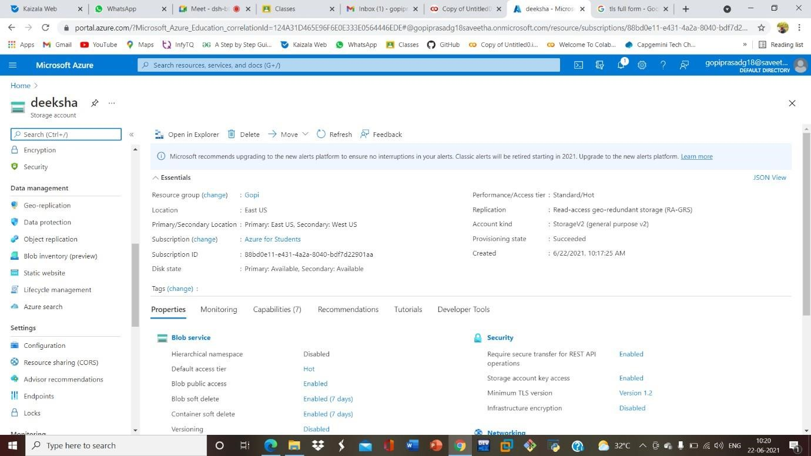
STEP5: AND ENABLE AND ENTER YOUR INDEX AND ERROR HTML FILESNAMES.
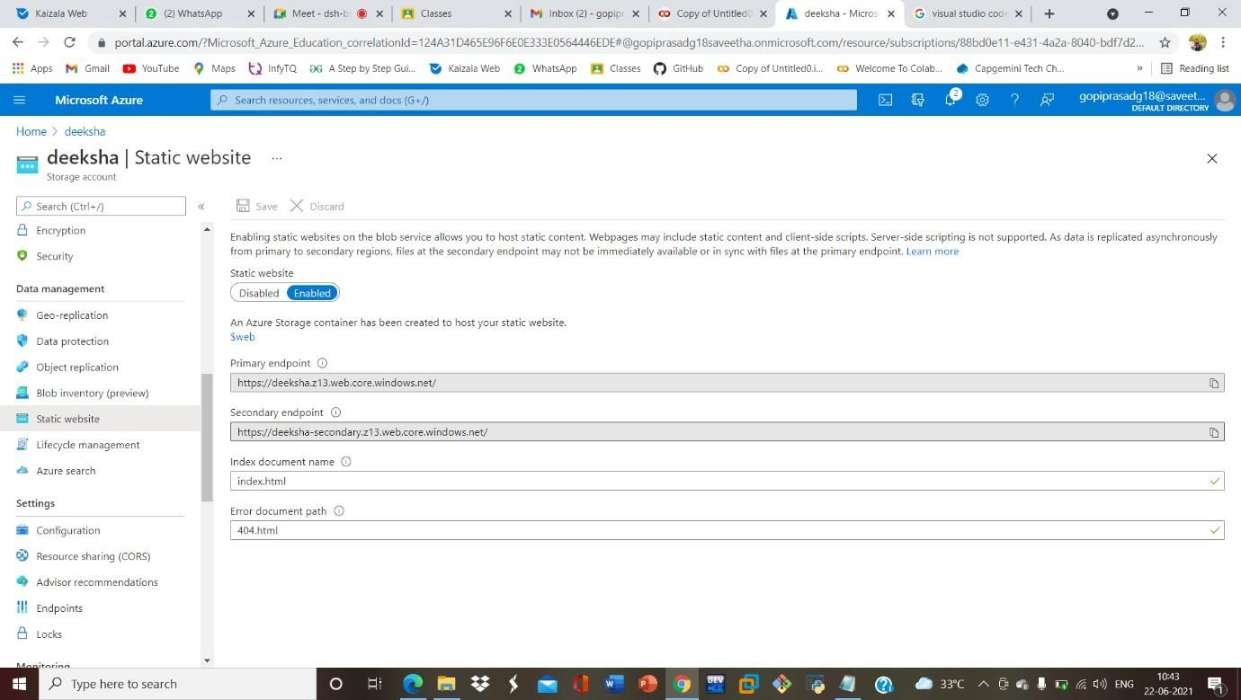
STEP6: AND GOTO STORAGE EXPLORR(REVIEW) AND AND GOTO BLOB CONTAINERS AND WEB AND UPLOAD THE TWO HTML FILES INIT

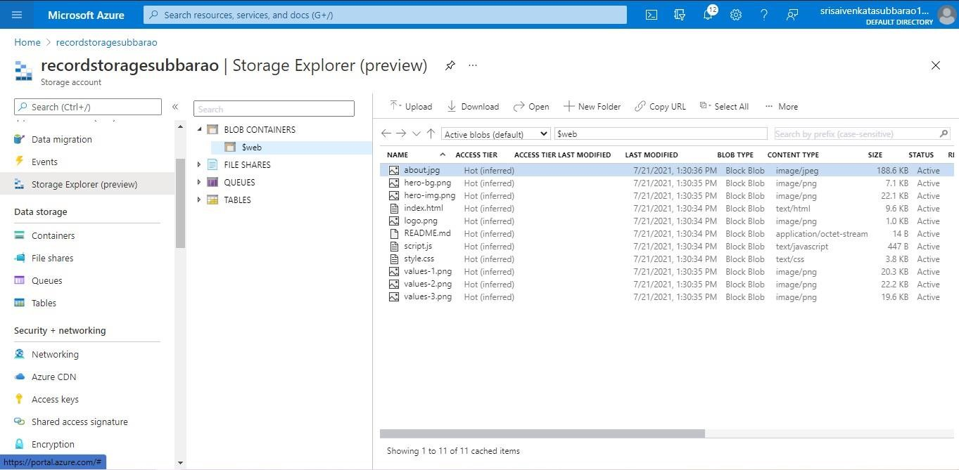
STEP7: AND AGAIN RETURN TO STATIC WEBSITE AND OPEN THE PRIMARY LINK AND YOUR WEB PAGE IS CREATED
