Learning Sessions - .NET Team

Topic: How to perform pull and push operations in GitHub through the terminal

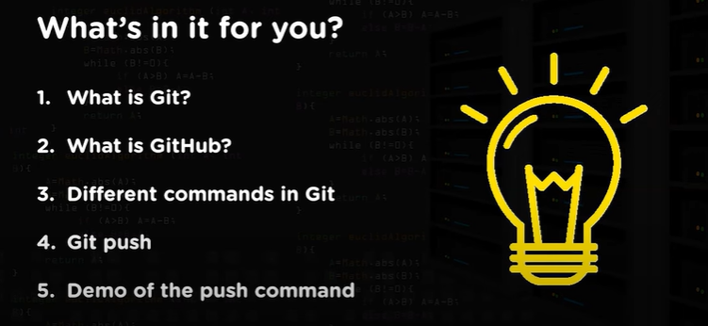

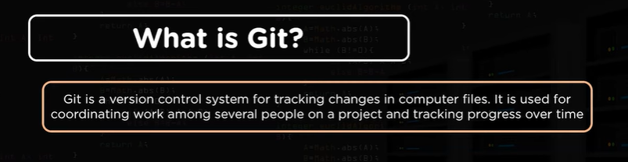

Version Control Systems (VCS): Version control systems are software tools that help manage changes to source code, documents, or any set of files over time. They allow multiple people to work on a project simultaneously without interfering with each other's work. Key features of VCS include:

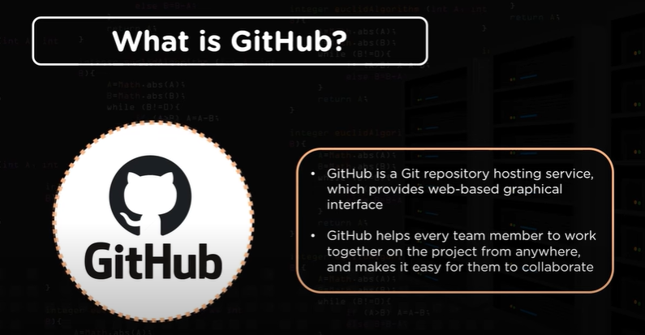

Git Push and Pull:

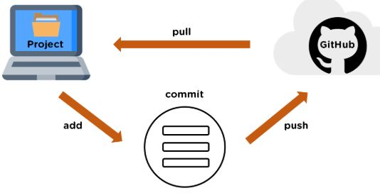

Commands:

PUSH:

- git init
- git add .
- git commit -m “msg”
- git remote add origin URL
- git remote -v
- git push -u origin master

PULL:
- git pull URL

Addition comments:

git config --global user.name "Your Name"
git config --global user.email "your.email@example.com"
git status

