YUVA INTERN

DATA SCIENCE WITH PYTHON ANALYST INTERNSHIP

Week1 Task: Data Cleaning and Preprocessing Pipeline Development
Aim: Develop a robust data cleaning and preprocessing pipeline for data to prepare the dataset for accurate analysis and modeling in a typical beauty & wellness context.
Internship Domain: Data Science – Beauty & Wellness’
Dataset: Most Used Beauty and Cosmetic Products 2024
Dataset Source: https://drive.google.com/file/d/1e4rU20K2eFoU-DM3is88R0LMq4Chz1km/view?usp=sharing
Submitted By: SHAIK NIHASUHANI
Submission Date: 30/10/2026
Github link: https://github.com/shaikniha11/Data-Science-Orientation-Problem-Definition-in-Beauty-Wellness.git

Introduction
Data cleaning and preprocessing are essential stages in the data science lifecycle. Raw datasets may contain missing values, duplicate records, inconsistent data formats, incorrect data types and unusual observations. These issues can affect the reliability of data analysis and machine learning models.
This project focuses on developing a data cleaning and preprocessing pipeline using a Beauty and Cosmetics Products dataset. The objective is to inspect the dataset, evaluate its data quality, identify potential inconsistencies, apply suitable preprocessing techniques and transform numerical and categorical features into appropriate formats for further analysis.
Python libraries such as Pandas, NumPy, Matplotlib, Seaborn and Scikit-learn were used throughout the implementation.

Project Objectives
The main objectives of this project are:
- To understand the structure and characteristics of the raw dataset.
- To identify missing values and duplicate records.
- To implement appropriate missing-value handling techniques.
- To detect outliers using statistical and visualization methods.
- To identify invalid numerical values and inconsistencies.
- To perform categorical encoding and numerical scaling.
- To develop a systematic and reproducible preprocessing workflow.
- To prepare the dataset for further statistical analysis and machine learning.

Dataset Description
The project uses the Most Used Beauty and Cosmetic Products dataset, containing information about cosmetic and personal-care products.
The dataset consists of 15,000 records and 14 columns.
Dataset attributes
Column | Description
Product_Name | Name of the cosmetic product
Brand | Product manufacturing brand
Category | Product category
Usage_Frequency | Frequency of product usage
Price_USD | Product price in USD
Rating | Customer rating
Number_of_Reviews | Total number of product reviews
Product_Size | Product quantity or size
Skin_Type | Skin type suitability
Gender_Target | Intended gender category
Packaging_Type | Product packaging
Main_Ingredient | Primary product ingredient
Cruelty_Free | Whether the product is cruelty-free
Country_of_Origin | Country where the product originates
The dataset contains three numerical features and multiple categorical features, making it suitable for demonstrating different preprocessing techniques.
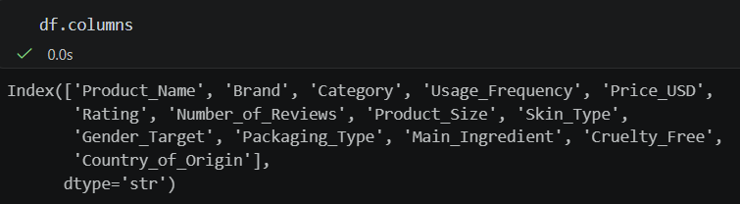

Tools and Technologies Used
The following Python libraries were used:
Pandas: Used for loading the CSV file, inspecting the dataset, identifying missing values, detecting duplicates and manipulating data.
NumPy: Used for numerical operations and handling numerical data.
Matplotlib: Used to create visualizations for understanding numerical distributions.
Seaborn: Used for statistical visualization, particularly boxplots for identifying potential outliers.
Scikit-learn: Used for categorical encoding and numerical feature scaling through preprocessing utilities.

Initial Dataset Inspection
The dataset was loaded into a Pandas DataFrame using read_csv().
Initial inspection was performed using:
- head() to view the first five records.
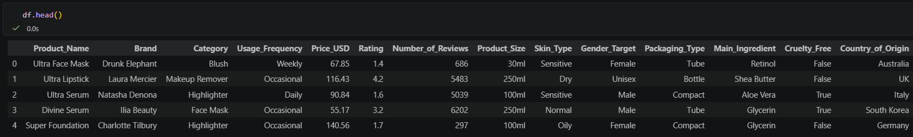
- tail() to inspect the last five records.
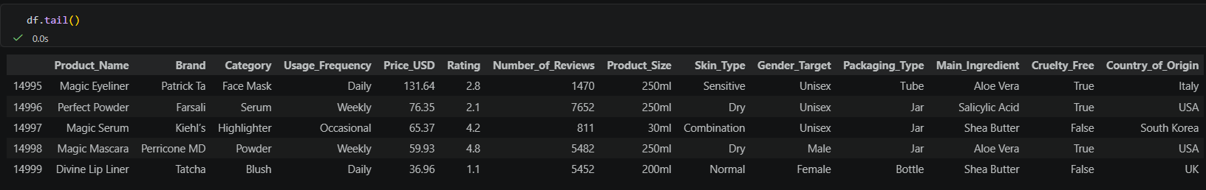
- shape to identify the number of rows and columns.
- info() to understand data types and non-null counts.
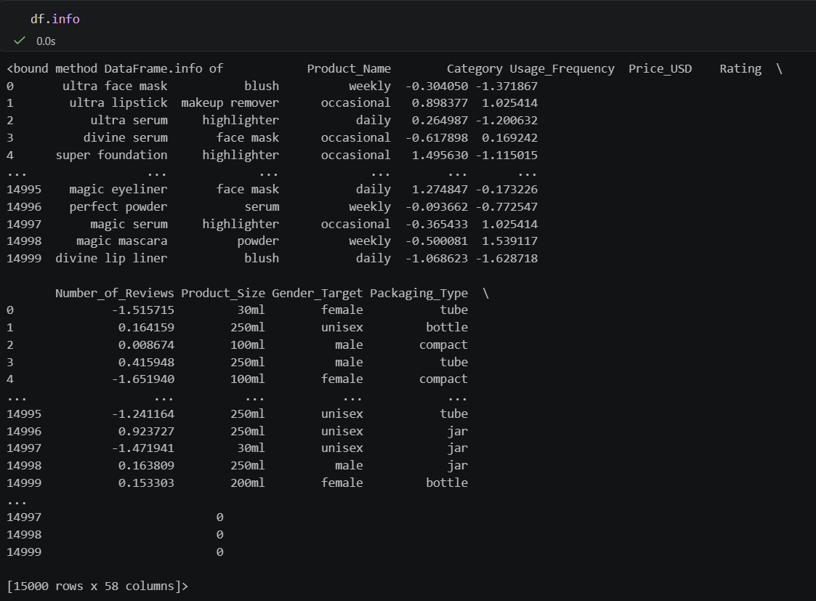
- describe() to obtain statistical summaries.
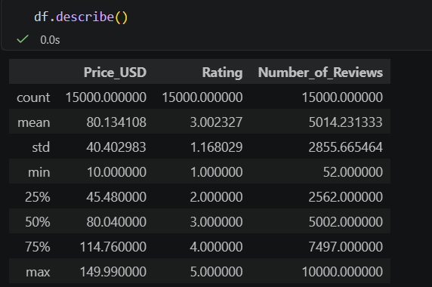
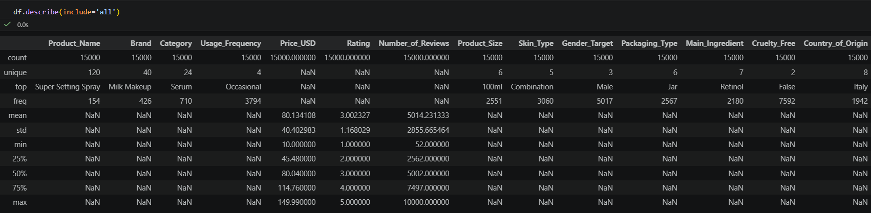
- nunique() to identify the number of unique values in each column.
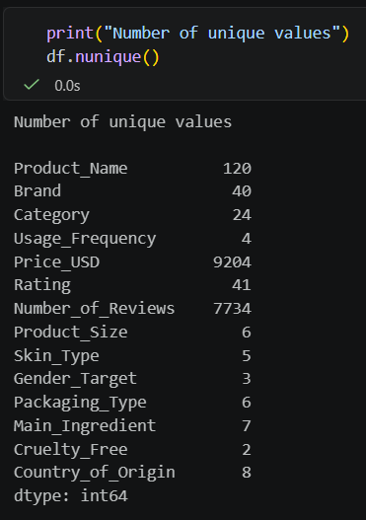
Initial observations-
The dataset contained 15,000 records and 14 columns.
The numerical attributes included Price_USD, Rating and Number_of_Reviews. Other attributes represented categorical product information, including brand, category, skin type, packaging type and country of origin.
The inspection confirmed that the dataset contained a mixture of numerical, categorical and Boolean data types.

Data Quality Assessment
A systematic data-quality assessment was performed to identify potential problems before applying preprocessing techniques.
The following checks were implemented:
- Missing-value identification.
- Duplicate-record detection.
- Unique-value analysis.
- Numerical range validation.
- Categorical-value inspection.
- Outlier visualization.
These checks helped determine which cleaning operations were necessary.

Missing Value Detection and Handling
Missing values can affect statistical calculations and machine learning performance. Therefore, missing-value detection was performed using the isnull() and sum() functions.
The inspection revealed that the original dataset contained zero missing values across all 14 columns.
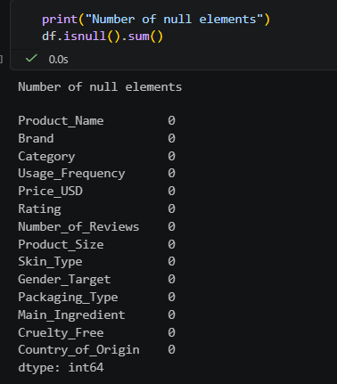

Although no missing values were present, a missing-value handling procedure was implemented to make the preprocessing pipeline reusable for datasets containing incomplete records.
Handling strategy
Numerical columns: Median imputation was selected because the median is less sensitive to extreme values than the mean.
Categorical columns: Mode imputation was selected to replace missing entries with the most frequently occurring category.
The missing-value counts were recorded before and after applying these methods.
The final result showed zero missing values before and after preprocessing. Therefore, the total number of values imputed was zero.
This confirms that the imputation procedure was implemented successfully without unnecessarily modifying the original data.
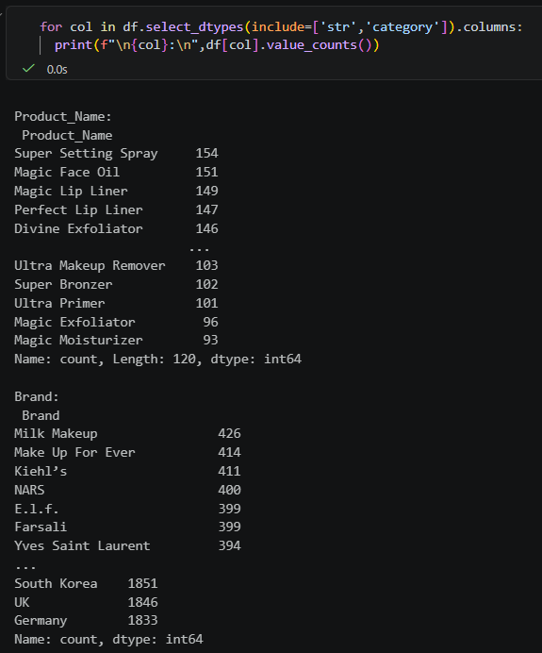

Duplicate Detection and Removal
Duplicate records can create biased results and affect statistical analysis.
Duplicate detection was performed using the Pandas duplicated() function.
The inspection identified zero duplicate records in the original dataset.
Therefore, no records were removed during this stage. Duplicate removal using drop_duplicates() was considered as the appropriate treatment if duplicate records were identified.
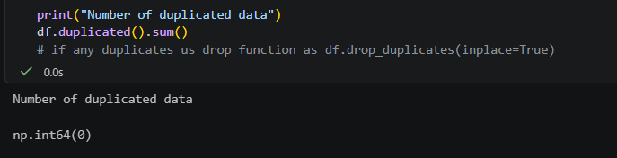

Outlier Detection
Outliers are observations that differ considerably from the general distribution of a variable.
In this project, boxplots were created using Seaborn to inspect numerical attributes.
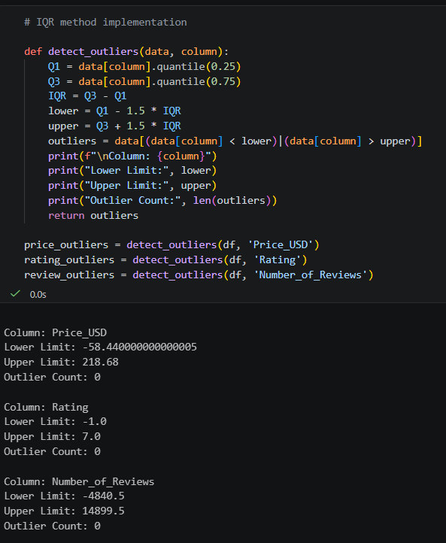
The following columns were selected for visualization:
- Price_USD
- Number_of_Reviews
Boxplots helped visualize the distribution, median, interquartile range and potential extreme observations.
The Interquartile Range (IQR) method can be used to identify potential outliers.
Q1 represents the first quartile, while Q3 represents the third quartile.
IQR = Q3 - Q1
Lower Bound = Q1 - 1.5 × IQR
Upper Bound = Q3 + 1.5 × IQR
Observations outside these boundaries are flagged for further investigation.
Outliers were treated as potential unusual observations rather than automatically removed, since unusually expensive products or products with many reviews may represent genuine records.
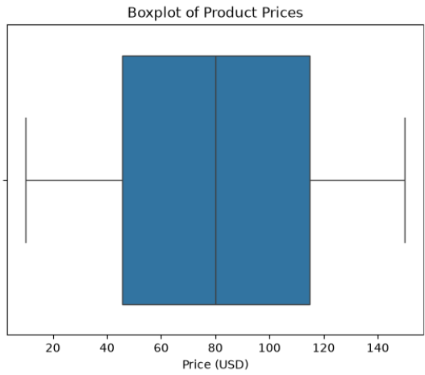
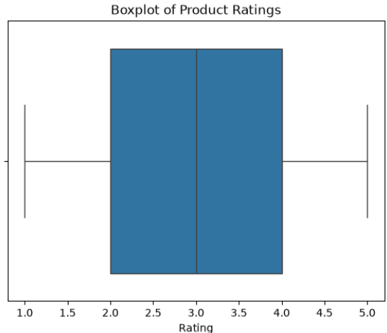
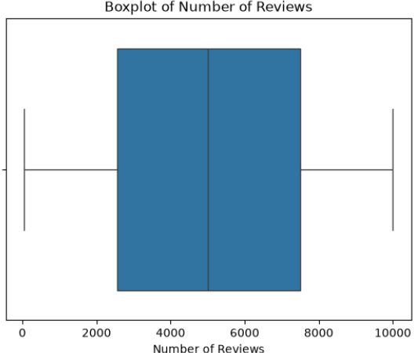

Identification of Invalid Values
Validation checks were performed on important numerical attributes.
The following conditions were examined:
- Product prices less than zero.
- Ratings below 1.
- Ratings above 5.
The validation results showed:
- Invalid prices: 0
- Invalid ratings: 0
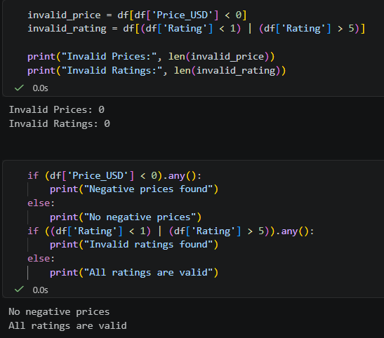
Therefore, no invalid price or rating records were identified using these conditions.
This validation helped confirm that the numerical values were within the expected business constraints.

Categorical Data Processing and Encoding
Machine learning algorithms generally require categorical variables to be converted into numerical representations.
In this project, categorical features were inspected using unique() and value_counts().
The Skin_Type column was selected for One-Hot Encoding.
The original skin-type categories were transformed into separate binary columns:
- Skin_Type_combination
- Skin_Type_dry
- Skin_Type_normal
- Skin_Type_oily
- Skin_Type_sensitive
Each new column represents whether a product is associated with a particular skin type.
This transformation allows categorical information to be represented numerically without introducing an artificial ranking between skin-type categories.
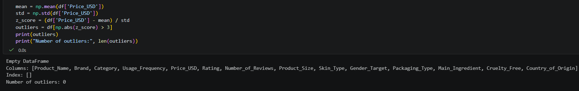

Numerical Feature Scaling
Numerical features often have different ranges and units. Feature scaling helps bring numerical variables onto comparable scales.
The following numerical columns were selected:
- Price_USD
- Rating
- Number_of_Reviews
Two scaling techniques were explored.

Min-Max Scaling
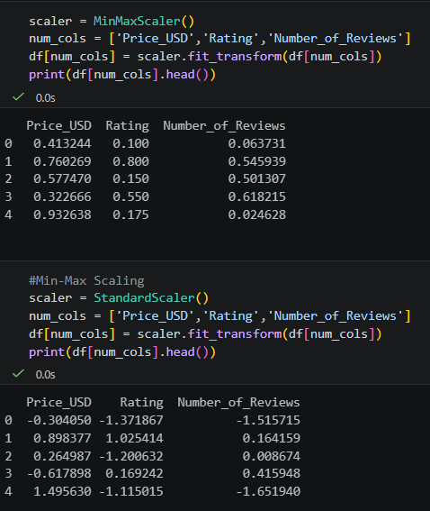
Min-Max Scaling transforms numerical values into a specified range, generally between 0 and 1.
Formula:
X_scaled = (X - X_min) / (X_max - X_min)
Scikit-learn's MinMaxScaler was used to demonstrate this technique.
Standardization
Standardization transforms numerical data so that it has approximately zero mean and unit standard deviation.
Formula:
Z = (X - μ) / σ
Where:
- X represents the original value.
- μ represents the mean.
- σ represents the standard deviation.
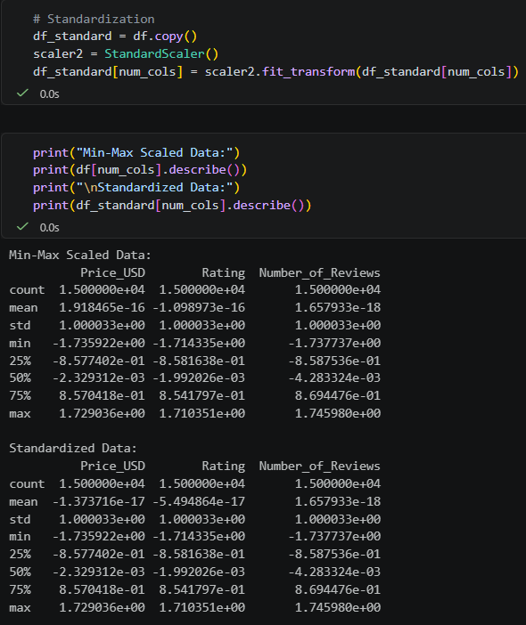
Scikit-learn's StandardScaler was used to implement this technique.
Both methods were explored to understand how feature scaling influences numerical distributions and prepares features for machine learning algorithms.

Python Libraries and Their Applications
The following functions and methods were important in the implementation:
Function / Method | Application
pd.read_csv() | Loading the dataset
df.head() | Initial data inspection
df.info() | Checking data types
df.describe() | Statistical summary
df.isnull().sum() | Missing-value detection
df.duplicated().sum() | Duplicate detection
df.nunique() | Unique-value analysis
df.value_counts() | Category frequency analysis
df.fillna() | Missing-value treatment
sns.boxplot() | Outlier visualization
OneHotEncoder | Categorical encoding
MinMaxScaler | Numerical scaling
StandardScaler | Numerical standardization

Overall Preprocessing Workflow
The preprocessing pipeline followed a systematic sequence:
- Load the raw Beauty and Cosmetics dataset.
- Inspect the dataset structure and data types.
- Identify numerical and categorical attributes.
- Check for missing values.
- Apply suitable imputation strategies where required.
- Detect duplicate records.
- Investigate potential outliers using boxplots.
- Validate numerical values against expected ranges.
- Perform categorical encoding.
- Apply numerical feature scaling and standardization.
- Validate the processed data.
Preprocessing Flowchart
Raw Dataset
↓
Dataset Loading and Inspection
↓
Data Quality Assessment
↓
Missing Value Detection and Handling
↓
Duplicate Detection
↓
Outlier Detection and Validation
↓
Categorical Encoding
↓
Numerical Feature Scaling
↓
Final Data Validation
↓
Preprocessed Dataset Ready for Further Analysis and Modeling

Results and Observations
The preprocessing implementation provided the following observations:
- A dataset containing 15,000 records and 14 columns was successfully loaded.
- The dataset contained three numerical features and multiple categorical features.
- No missing values were identified in the original dataset.
- No duplicate records were identified.
- No invalid negative prices were detected.
- No ratings outside the expected range of 1 to 5 were detected.
- Boxplots were generated to examine the distributions of product prices and review counts.
- One-Hot Encoding was demonstrated on the Skin_Type attribute.
- Min-Max Scaling and Standardization techniques were explored on numerical features.
The analysis demonstrated that preprocessing is not limited to correcting errors. It also involves validating existing data, transforming features and preparing datasets for subsequent analytical tasks.

Importance of Documentation and Reproducibility
Documenting each preprocessing operation is important for maintaining transparency and reproducibility.
The workflow was organized into separate steps so that each operation could be inspected and repeated.
Recording missing-value counts, duplicate counts, validation results and transformation methods helps ensure that the preprocessing process can be understood and reproduced.
The same workflow can also be adapted to other beauty, cosmetics and wellness datasets containing more complex data-quality issues.

Limitations
The project has a few limitations:
- The original dataset did not contain missing values or duplicate records, so actual imputation and duplicate removal were not required.
- The dataset may not represent every beauty and cosmetics market.
- Outlier detection using statistical boundaries does not always indicate incorrect data.
- Further validation of categorical consistency and product attributes may improve data quality.
- Additional preprocessing may be required before applying specific machine learning algorithms.

Conclusion
This project successfully demonstrated a structured data cleaning and preprocessing workflow using a Beauty and Cosmetics Products dataset containing 15,000 records.
The implementation covered dataset inspection, data-quality assessment, missing-value detection, duplicate detection, outlier visualization, numerical validation, categorical encoding and numerical feature scaling.
Although the original dataset did not contain missing values or duplicate records, suitable handling procedures were implemented to make the workflow adaptable to other datasets.
The project provided practical experience with Python data preprocessing libraries and demonstrated the importance of preparing reliable data before performing statistical analysis or developing machine learning models.
The resulting preprocessing workflow establishes a foundation for future beauty and cosmetics analytics, including product-rating analysis, customer preference analysis and predictive modeling.

References
- Kaggle – Most Used Beauty and Cosmetic Products 2024 dataset.
- Pandas Documentation – https://pandas.pydata.org/docs/
- NumPy Documentation – https://numpy.org/doc/
- Matplotlib Documentation – https://matplotlib.org/
- Seaborn Documentation – https://seaborn.pydata.org/
- Scikit-learn Preprocessing Documentation – https://scikit-learn.org/stable/modules/preprocessing.html

