YUVA INTERN

DATA SCIENCE WITH PYTHON ANALYST INTERNSHIP

WEEK 2 - Data Identification, Sourcing Strategy & Initial Analysis Planning
Project Title: Beauty Product Performance Analysis – Exploring Product Attributes, Ratings and Consumer Engagement
Internship Domain: Data Science – Beauty & Wellness
Submitted By: Shaik Nihasuhani
Internship Program: Data Science with Python Analyst Internship
Submission Date: 25/10/2026

Abstract
The beauty and wellness industry offers a wide variety of skincare, haircare, makeup, and personal care products. Understanding product attributes, ratings, pricing, and customer engagement indicators can help businesses make informed decisions regarding product positioning, marketing, and portfolio management.
This report presents a data sourcing strategy and initial analysis plan for the project titled Beauty Product Performance Analysis – Exploring Product Attributes, Ratings and Consumer Engagement. The project uses the Most Used Beauty and Cosmetic Products 2024 dataset selected during Week 1.
The report identifies potential public data sources, establishes criteria for evaluating dataset quality and relevance, and outlines a structured approach to data collection. It also defines the key variables, exploratory data analysis techniques, statistical methods, visualization strategies, and preprocessing activities required for the investigation.
The selected dataset contains product-level information, including brand, category, price, rating, number of reviews, skin type, main ingredient, packaging type, cruelty-free status, and country of origin. The planned analysis will investigate associations between these attributes and product ratings while considering the limitations of the available data.
The outcome of this work will be a documented and reproducible data collection and analysis plan that supports the next stages of the project.
Introduction
1.1 Background
The beauty and wellness industry is characterized by a wide range of products, brands, price levels, ingredients, and product categories. Customers may consider product ratings, reviews, price, ingredients, and intended skin type when evaluating beauty products.
Data science techniques can help analyze these product characteristics and identify patterns in available product-level data. Such analysis can support businesses in understanding product positioning and identifying areas for further investigation.
However, meaningful analysis requires suitable data sources, reliable variables, appropriate preprocessing, and a clear understanding of dataset limitations.
1.2 Purpose of Week 2
The purpose of Week 2 is to develop a systematic strategy for identifying, evaluating, and collecting data relevant to the business problem defined during Week 1.
The work focuses on selecting appropriate data sources, evaluating data quality and accessibility, identifying important variables, and planning exploratory analysis and statistical investigation.
1.3 Project Overview
The project investigates relationships between beauty-product characteristics and product ratings.
The primary dataset selected during Week 1 is Most Used Beauty and Cosmetic Products 2024. It contains product-level attributes that can be examined using Python-based data analysis techniques.
The project will focus on descriptive and exploratory analysis rather than assuming that any particular product attribute causes higher ratings.

Business Problem Statement
Beauty brands operate in a competitive market where products differ in price, category, ingredients, intended skin type, packaging, and other characteristics. Understanding how these attributes relate to product ratings can help businesses investigate product positioning and portfolio performance.

The business problem addressed by this project is:
How can data science be used to analyze beauty-product attributes and investigate their relationships with product ratings, helping businesses make more informed decisions about product positioning, pricing, and portfolio management?
The analysis will examine available product-level information to identify patterns and associations. It will also evaluate whether the selected attributes may provide useful information for predicting product ratings, provided the dataset supports a meaningful predictive task.

Objectives
The objectives of this Week 2 task are:
- Identify potential public data sources relevant to beauty-product performance analysis.
- Evaluate candidate sources according to accessibility, reliability, completeness, relevance, and availability.
- Justify the selection of the primary dataset.
- Define a structured strategy for collecting and documenting data.
- Identify the variables required to answer the research questions.
- Assess the quality and limitations of the selected dataset.
- Plan exploratory data analysis using descriptive statistics and visualizations.
- Identify appropriate statistical techniques for investigating relationships between variables.
- Plan initial data cleaning and preprocessing.
10. Establish a reproducible workflow for subsequent analysis.
Research Questions
The following research questions were established during Week 1 and will guide the data collection and analysis process.
- How do average product ratings vary across beauty-product categories?
- How do product ratings differ across brands?
- Is product price associated with product ratings?
- Is the number of product reviews associated with product ratings?
- Do rating distributions differ across product-target skin types?
- Are there differences in ratings across main-ingredient groups?
- Do cruelty-free and non-cruelty-free products differ in their price and rating distributions?
These questions determine which variables must be available in the selected dataset and guide the choice of statistical methods and visualizations.

Data Requirements
Required Data
The project requires structured product-level data containing numerical and categorical variables.
The important data requirements are:
- Product identification and brand information.
- Product category and classification.
- Product price and rating.
- Number of reviews as an available engagement indicator.
- Intended skin type and target audience.
- Main ingredient and packaging type.
- Cruelty-free status and country of origin.
The data should have clearly defined fields, usable data types, sufficient observations for meaningful comparisons, and accessible documentation.
Primary Dataset
Dataset Name: Most Used Beauty and Cosmetic Products 2024
Dataset Source: Kaggle
Dataset Link:
https://www.kaggle.com/datasets/aashitanoah/most-used-beauty-and-cosmetic-products-2024
Local File Name: most_used_beauty_cosmetics_products_extended.csv
According to the initial inspection documented in Week 1, the dataset contains 15,000 records and 14 columns. These values will be revalidated during the Week 2 quality assessment.
The dataset includes product names, brands, categories, usage frequency, prices, ratings, review counts, product sizes, skin types, gender targets, packaging types, main ingredients, cruelty-free status, and country of origin.
The dataset is suitable for the planned exploratory investigation because it contains several variables directly related to the project's research questions. However, its collection methodology, provenance, license, and representativeness must be verified before treating its contents as reliable evidence about the wider beauty market.

Potential Data Sources
To develop a reliable sourcing strategy, multiple public data discovery platforms and potential supplementary sources will be considered.
Kaggle Datasets
Website: https://www.kaggle.com/datasets
Kaggle provides datasets covering different industries, including cosmetics, skincare, product reviews, and consumer behavior.
The existing Kaggle dataset will be the primary candidate because it was selected during Week 1 and contains the attributes needed for the planned analysis.
Advantages:
- Downloadable datasets may be available in CSV format.
- Data can be loaded easily using Pandas.
- Dataset descriptions and metadata may support evaluation.
- Alternative datasets may be available for comparison.

Limitations:
- Dataset quality and collection methods vary.
- Some datasets may have incomplete documentation.
- Licenses and usage permissions must be checked.
- A dataset's presence on Kaggle does not guarantee that it represents actual market conditions.

Hugging Face Datasets
Website: https://huggingface.co/datasets
Hugging Face provides a platform for discovering datasets used in machine learning and data analysis.
Potentially relevant datasets may include cosmetic product reviews, skincare information, product descriptions, and text-based customer feedback.
Advantages:
- Some datasets include detailed text and structured variables.
- Data may be available in formats suitable for Python processing.
- Alternative data can support future extensions of the project.
Limitations:
- Relevant datasets may not contain the same fields as the primary dataset.
- Review text may require substantial preprocessing.
- Dataset licenses, provenance, and completeness must be evaluated individually.

Google Dataset Search
Website: https://datasetsearch.research.google.com/
Google Dataset Search can be used to discover datasets published by different organizations and repositories.
Search terms will include:
- Beauty product ratings dataset.
- Skincare product reviews dataset.
- Cosmetics prices and ratings.
- Beauty product ingredients dataset.
- Cosmetic consumer review data.
Advantages:
- Supports discovery across multiple data repositories.
- Helps identify alternative sources.
- Can provide access to datasets not hosted on Kaggle.
Limitations:
- It is a dataset discovery service rather than the original data provider.
- Search results may contain inaccessible or outdated resources.
- Each dataset must be inspected at its original source.

Government Open Data Platforms
Website: https://www.data.gov.in/
The Open Government Data Platform India may be explored for supplementary information relevant to the broader industry or market context.
Advantages:
- Government datasets may provide useful contextual information.
- Some resources include documentation and publication details.
- Public data may be available for download.
Limitations:
- Direct product-level ratings and review counts may not be available.
- Data may cover a different geographic area or subject.
- Supplementary data may not be directly comparable with the primary dataset.
The availability of a suitable beauty-product dataset on this platform has not been confirmed and must be checked.

Public Product-Review Datasets and APIs
Publicly documented product-review datasets or APIs may provide supplementary product information, customer ratings, review text, or product identifiers.
Potential advantages:
- Additional review information may support deeper analysis.
- Some sources may provide product-level information not present in the existing dataset.
- Supplementary data could help validate selected patterns.
Limitations:
- Access may require an API key or account.
- Rate limits or usage restrictions may apply.
- Product identifiers and field definitions may differ.
- Data collection and privacy requirements must be respected.
No particular API is assumed to be available until its documentation, access requirements, and relevance have been verified.
Data Source Evaluation Strategy
The candidate sources will be assessed using a consistent set of criteria.
Evaluation criterion | Assessment approach
Relevance | Determine whether the source contains variables needed for the research questions.
Accessibility | Check whether the data can be downloaded or accessed through a documented API.
Completeness | Inspect missing values in essential fields.
Reliability | Examine the publisher, collection methodology, documentation, and provenance.
Freshness | Record the publication date, collection period, or last update where available.
Size | Check the number of records and whether the sample is adequate for the planned analysis.
Consistency | Verify field definitions, data types, units, and category labels.
Licensing | Check permitted uses, redistribution conditions, and attribution requirements.
Limitations | Identify possible sampling bias, synthetic data, restricted access, and other weaknesses.
Preliminary Comparison
The following is a preliminary assessment of the source types. It is not a substitute for inspecting individual datasets.
Source | Potential suitability | Main limitation
Existing Kaggle dataset | High potential because it contains the planned product attributes | Provenance and representativeness require verification
Alternative Kaggle datasets | Potentially useful for supplementary analysis | Field definitions may differ
Hugging Face datasets | Potentially useful for review text and product information | Additional processing may be required
Google Dataset Search | Useful for discovering alternatives | The underlying dataset must be evaluated separately
Government open data | Potentially useful for contextual information | Directly comparable product-level data may not exist
Public review datasets or APIs | Potentially useful for supplementary variables | Access and compatibility must be confirmed
The current Kaggle dataset will remain the primary candidate unless the evaluation reveals significant limitations that make it unsuitable. A supplementary source will only be selected if it adds relevant information and can be used responsibly.

Data Collection Strategy
Collection Procedure
The following procedure will be used to collect and document the data.
Step 1: Access the original source.
Open the Kaggle dataset page and review the description, available files, documentation, and licensing information.
Step 2: Download the dataset.
Download the appropriate CSV file and save it in the project directory.
Step 3: Preserve the original data.
Keep the original file unchanged and perform any transformations on a separate working copy.
Step 4: Record metadata.
Document the source URL, access date, filename, file format, record count, column count, and available version information.
Step 5: Inspect the dataset.
Use Pandas to inspect the structure, data types, numerical ranges, missing values, and duplicate records.
Step 6: Evaluate the data quality.
Check whether the dataset meets the requirements of the seven research questions.
Step 7: Document limitations.
Record any uncertainty about collection methods, representativeness, definitions, or permitted uses.
Data Collection Tools
The following tools will support the process:
- Python: Main programming language.
- Pandas: Loading, inspecting, and transforming tabular data.
- NumPy: Numerical calculations.
- Jupyter Notebook / VS Code: Reproducible analysis and documentation.
- Microsoft Word: Preparation of the final report.
- GitHub: Optional version control and project sharing.
The primary dataset is already available locally, so the initial work will focus on verifying and documenting it rather than unnecessarily collecting the same data again.
Quality and Relevance Assessment
Initial Quality Assessment
The Week 1 report documents an initial inspection of the primary dataset. The reported structure contains 15,000 rows and 14 columns, and the initial missing-value check indicated no missing values.
These observations provide an initial indication of structural completeness, but further checks are required.
The Week 2 assessment will examine:
- Whether the row and column counts match the documented values.
- Whether exact duplicate rows exist.
- Whether product prices are valid and positive.
- Whether ratings fall within the expected scale of 1 to 5.
- Whether review counts are non-negative.
- Whether categorical values are consistent.
- Whether numerical variables contain unusual or extreme observations.
- Whether the dataset documentation explains the source and collection process.
The results will be recorded using actual notebook outputs.
Relevance to the Business Problem
The dataset is potentially relevant because it contains product attributes that can be compared with product ratings.
For example, price and rating can be used to investigate whether more expensive products tend to receive different ratings. Brand and category information can support comparisons of rating distributions. Main ingredients and intended skin types can be examined for differences in the available ratings.
The number of reviews can serve as an available indicator of product engagement, but it does not directly measure sales or purchase intention.
Reliability and Representativeness
A complete dataset is not necessarily a representative dataset.
The original collection process, sampling method, source coverage, and meaning of each variable must be reviewed. It is also necessary to determine whether the records represent actual products and observations or include generated or simulated data.
If these details cannot be established, the findings will be described as patterns within the supplied dataset rather than conclusions about the entire beauty industry.
Key Variables for Analysis
The variables will be grouped according to their roles in the investigation.
Variable | Type | Purpose
Product_Name | Categorical/text | Product identification
Brand | Categorical | Brand-level comparisons
Category | Categorical | Category-level comparisons
Usage_Frequency | Categorical/text | Supplementary product information
Price_USD | Numerical | Pricing analysis
Rating | Numerical | Main outcome variable
Number_of_Reviews | Numerical | Review-count analysis
Product_Size | Categorical/text | Product characteristic
Skin_Type | Categorical | Intended skin-type comparisons
Gender_Target | Categorical | Target-audience information
Packaging_Type | Categorical | Product characteristic
Main_Ingredient | Categorical | Ingredient-group comparisons
Cruelty_Free | Boolean | Product attribute comparisons
Country_of_Origin | Categorical | Geographic product information
The variable definitions and data types will be verified against the actual CSV and source documentation.
For the main investigation, product rating will be the principal outcome variable. Price, review count, category, brand, skin type, main ingredient, and cruelty-free status will be examined as potential explanatory variables.
The intended skin type of a product must not be confused with the actual skin type of the customer who rated it.
Initial Exploratory Data Analysis Plan
Exploratory data analysis will be performed to understand the distribution of variables, compare product groups, and identify relationships relevant to the research questions.
Descriptive Statistics
The analysis will calculate appropriate descriptive statistics, including:
- Mean and median.
- Minimum and maximum.
- Standard deviation and quartiles.
- Frequency and percentage distributions for categorical variables.
- Product counts for each category and group.
These statistics will help summarize the dataset and identify unusual values or uneven representation.
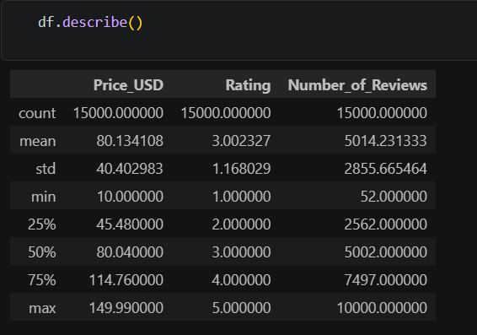
Category-Wise Rating Analysis
Average and median ratings will be calculated for each product category. The number of products represented in each category will also be examined.
Proposed visualization: Bar chart showing average ratings by category, accompanied by sample counts or uncertainty estimates where appropriate.
Purpose: To identify category-level differences in the supplied dataset.
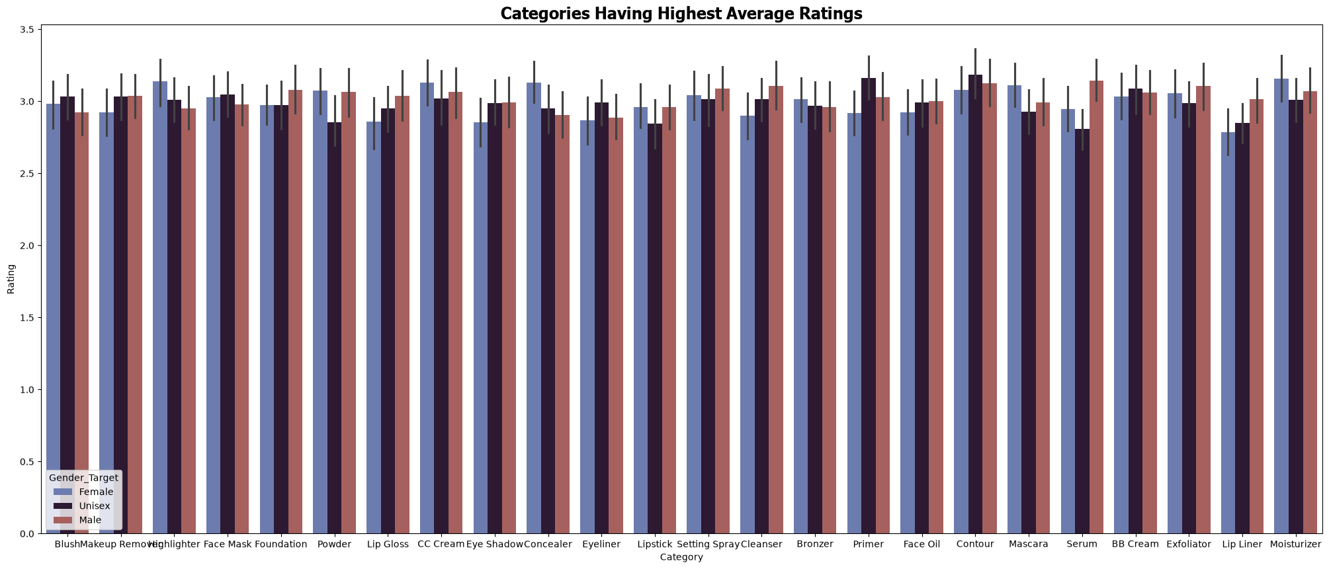
Brand-Wise Rating Analysis
Ratings will be summarized across brands. Brands with very few product records will be treated cautiously because their average ratings may be unstable.
Proposed visualization: Ranked bar chart of average ratings for selected brands with sufficient observations.
Purpose: To compare observed rating patterns across brands without assuming that ratings alone measure overall business performance.
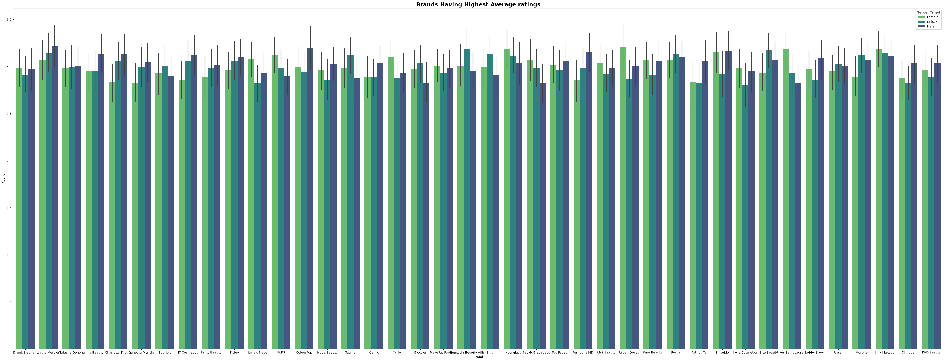
Price and Rating Analysis
The relationship between product price and rating will be examined.
Proposed visualizations:
- Scatter plot of price against rating.
- Additional price-group summaries if useful.
Proposed statistical methods: Pearson and Spearman correlation.
Pearson correlation measures linear association, while Spearman correlation assesses monotonic association using ranks. The results will be interpreted in the context of the data distribution and possible outliers.
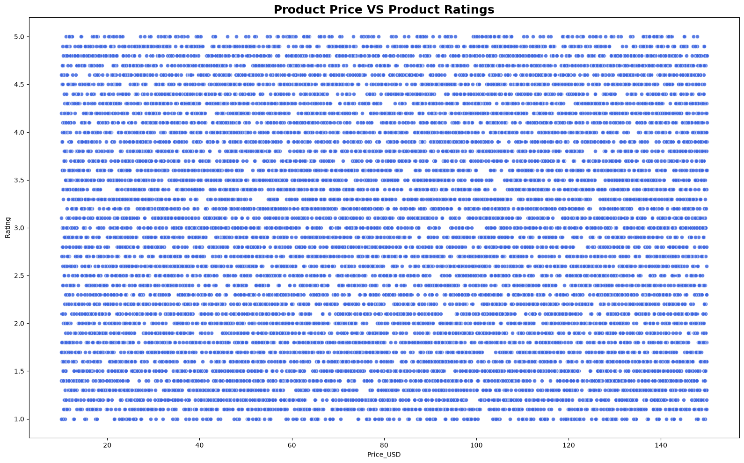
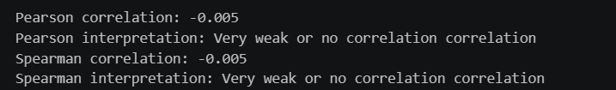
Review Count and Rating Analysis
The number of reviews will be compared with product ratings.
Proposed visualizations:
- Scatter plot of review counts against ratings.
- A logarithmic scale for review counts if the distribution is strongly skewed.
Proposed statistical method: Spearman correlation, with Pearson correlation considered where appropriate.
The analysis will investigate association, not assume that a larger review count necessarily indicates a higher rating or better product quality.
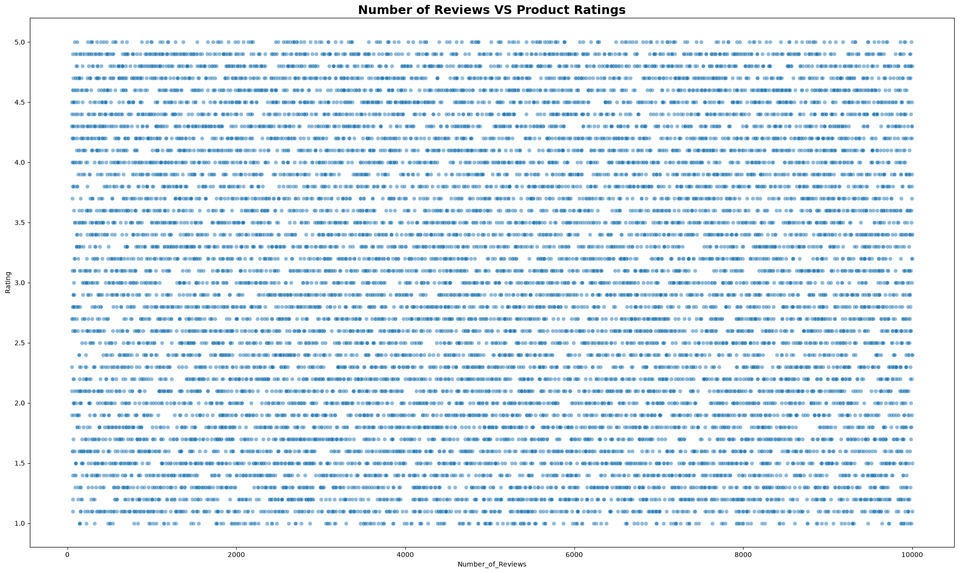
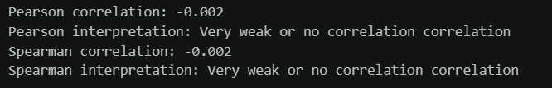
Skin Type and Rating Analysis
Ratings will be grouped by the intended skin type associated with each product.
Proposed visualization: Box plot of ratings across skin-type categories.
Proposed statistical methods: Descriptive group comparisons, followed by ANOVA or Kruskal–Wallis testing if suitable for the data and assumptions.
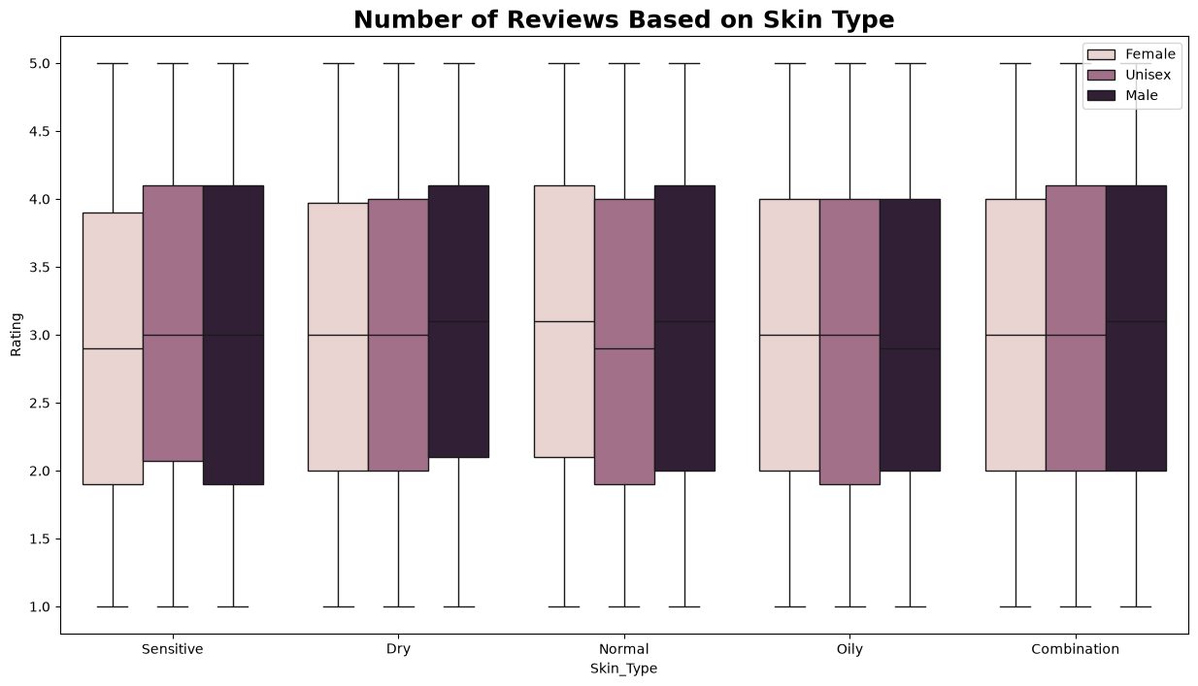

Main Ingredients and Ratings
Rating distributions will be examined across main-ingredient groups.
Proposed visualizations:
- Horizontal bar chart of group-level average ratings.
- Box plot showing the distribution of ratings by ingredient.
The number of products in each group will be considered to avoid drawing conclusions from groups with insufficient observations.
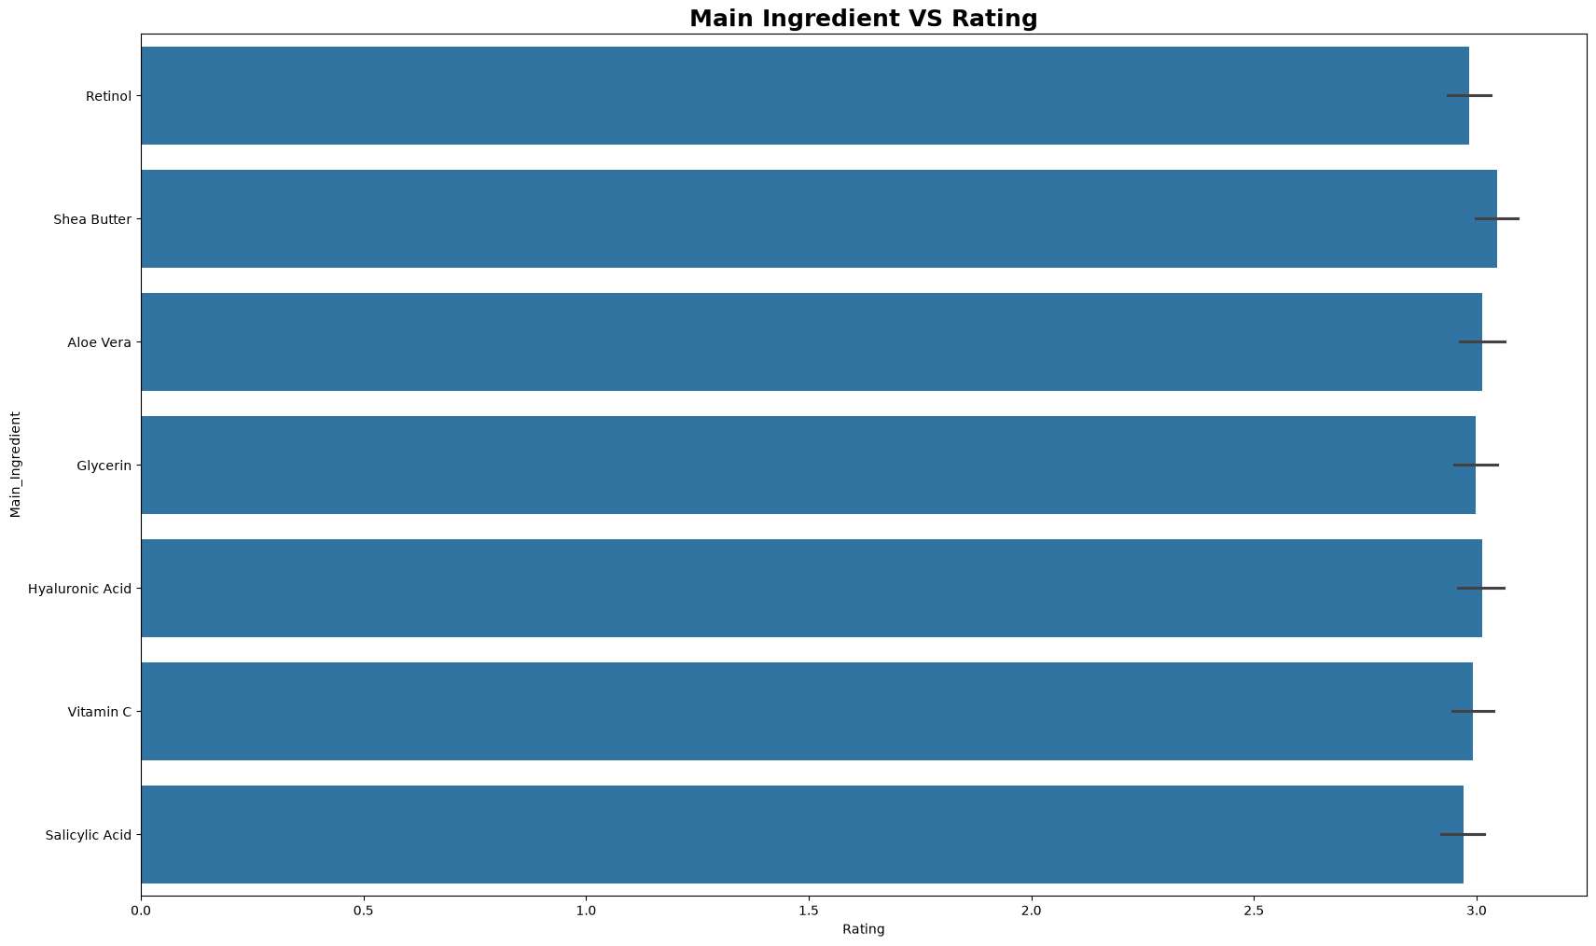
Cruelty-Free Status, Price, and Ratings
Price and rating distributions will be compared between products marked as cruelty-free and those not marked as cruelty-free.
Proposed visualizations:
- Box plot comparing prices by cruelty-free status.
- Box plot comparing ratings by cruelty-free status.
Appropriate two-group statistical tests may be considered after checking sample sizes, distributions, and assumptions.
The analysis will examine associations with the recorded status and will not assume that cruelty-free status causes differences in ratings or prices. 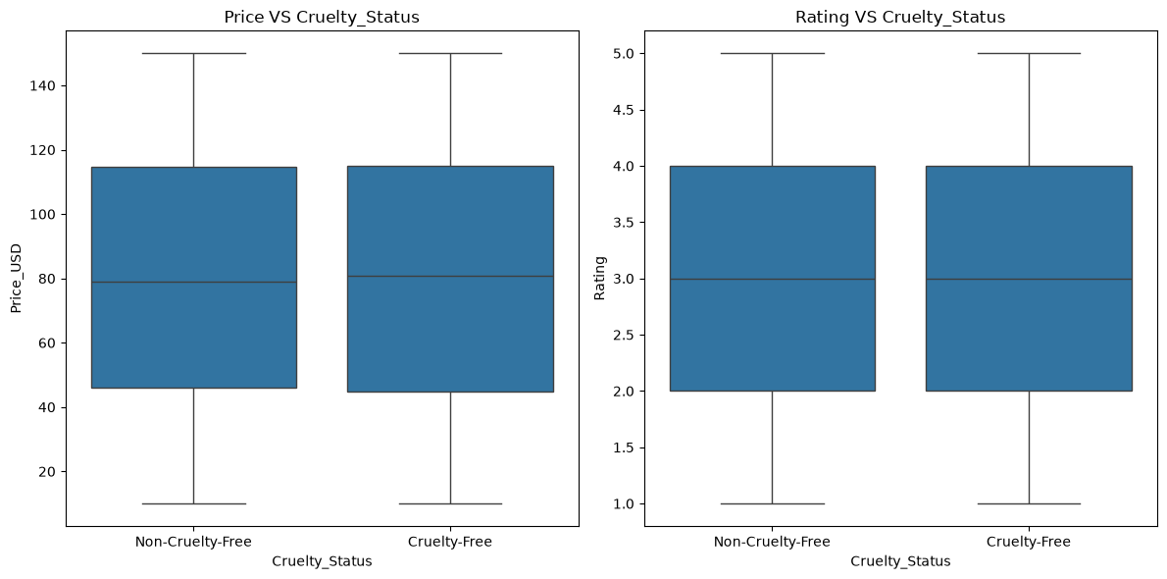
Data Cleaning and Preprocessing Plan
The dataset will be checked and cleaned only when the inspection results justify an intervention.
Missing Values
The presence and distribution of missing values will be checked using Pandas.
If missing values are found, the appropriate handling method will depend on the variable, the amount of missing data, and the reason the values are missing.
If no missing values are found, this will be reported as an observed result rather than introducing artificial missing values.
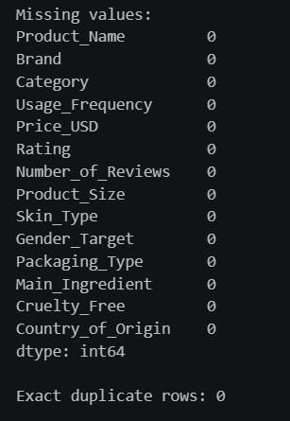
Duplicate Records
Exact duplicates will be identified using Pandas. Potential duplicate products will also be investigated using product names, brands, and other relevant identifiers.
Records will not be removed automatically because different products or legitimate observations may share similar attributes.
Data Type Validation
Numerical variables, including price, rating, and number of reviews, will be checked for appropriate data types.
Categorical and Boolean fields will be standardized where necessary.
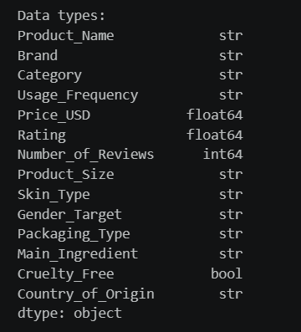
Range Validation
The analysis will verify that ratings follow the documented scale and that prices and review counts contain plausible values.
Unexpected values will be investigated before being corrected or excluded.
Categorical Standardization
Inconsistent spelling, capitalization, whitespace, or category labels will be identified and standardized where the intended meaning is clear.
Outlier Investigation
Box plots, quartiles, and other descriptive techniques will be used to identify unusual observations.
Outliers will not be removed solely because they are extreme. Their validity and influence on the analysis will be investigated.
Feature Preparation
If predictive modeling is appropriate, categorical variables may be encoded and numerical variables prepared for model training.
Any preprocessing required for predictive modeling will be fitted using training data only when necessary to prevent data leakage.
Tools and Technologies
The project will use the following tools:
Python: Main programming language for analysis.
Pandas: Data loading, cleaning, grouping, and descriptive statistics.
NumPy: Numerical operations and calculations.
Matplotlib: Customizable visualizations.
Seaborn: Statistical charts and exploratory data analysis.
Jupyter Notebook: Execution and documentation of the analysis workflow.
VS Code: Project development and file management.
Microsoft Word: Preparation of the formal report.
GitHub: Optional version control and sharing of project files.
These tools are sufficient for the planned data inspection, statistical analysis, visualization, and documentation.
Risks and Limitations
The project may face several data-related limitations.
- The dataset's collection methodology and representativeness may be unclear.
- Ratings may not be directly comparable across different sources or product categories.
- Product-level records may not reflect individual customer behavior.
- Review counts do not necessarily represent sales or unique customers.
- Missing documentation may limit interpretation of certain variables.
- Some categories or brands may have insufficient observations for reliable comparisons.
- Extreme values and inconsistencies may affect statistical results.
- Supplementary datasets may use incompatible formats, definitions, or measurement scales.
- The data may not support causal conclusions about product attributes and ratings.
These limitations will be documented and considered when interpreting the results. Recommendations will be based on the available evidence rather than unsupported assumptions about the wider market.
Conclusion
This report establishes a structured data sourcing and initial analysis plan for the Beauty Product Performance Analysis project.
The Most Used Beauty and Cosmetic Products 2024 dataset remains the primary candidate because its documented fields align with the research questions established during Week 1. Potential alternative sources have also been identified for further evaluation.
The planned work includes source verification, data-quality assessment, variable identification, descriptive analysis, statistical association testing, visualization, and preprocessing. These activities will help ensure that subsequent findings are based on an appropriate understanding of the available data.
The project will emphasize reproducibility, transparent reporting, and careful interpretation of relationships between product attributes and ratings. The resulting analysis may support further investigation into product positioning and pricing, while acknowledging that product ratings alone cannot establish overall commercial success or causal effects.
References
- Kaggle. Most Used Beauty and Cosmetic Products 2024.
https://www.kaggle.com/datasets/aashitanoah/most-used-beauty-and-cosmetic-products-2024
- Hugging Face. Datasets.
https://huggingface.co/datasets
- Google. Google Dataset Search.
https://datasetsearch.research.google.com/
- Government of India. Open Government Data Platform India.
https://www.data.gov.in/
- Pandas Documentation.
https://pandas.pydata.org/docs/
- NumPy Documentation.
https://numpy.org/doc/
- Matplotlib Documentation.
https://matplotlib.org/stable/
- Seaborn Documentation.
https://seaborn.pydata.org/
Note: Dataset-specific metadata, licenses, collection methodology, and the availability of alternative sources should be verified and documented before final submission.

