YUVA INTERN

DATA SCIENCE WITH PYTHON ANALYST INTERNSHIP
Week 6 Task: Model Evaluation, Reporting & Business Impact Communication
Aim: Designing a comprehensive validation plan, describing different stages of model testing and performance measurement.
Internship Domain: Data Science – Beauty & Wellness’
Dataset: Most Used Beauty and Cosmetic Products 2024
Dataset Source: https://drive.google.com/drive/folders/1TxC0YHGMjbCFTOGJCHI9N_wISlSMYxvK?usp=sharing
Submitted By: SHAIK NIHASUHANI
Submission Date: 03/10/2026
Github link: https://github.com/shaikniha11/Data-Science-Orientation-Problem-Definition-in-Beauty-Wellness.git
Introduction
The final phase of this project focuses on evaluating Machine Learning models, measuring their predictive performance, and communicating the results in a meaningful business context. The project uses a Beauty and Cosmetics Products dataset to explore whether product characteristics can help predict customer rating categories.
The primary objective is to apply classification algorithms, evaluate their performance using appropriate metrics, compare different models, and identify useful insights that can support business decision-making in the beauty and wellness industry.
Python libraries such as Pandas, NumPy, Matplotlib, Seaborn and Scikit-learn were used for data processing, model development, evaluation and visualization.
Project Objective
The main objectives of this phase are:
- To develop predictive classification models using product-related features.
- To evaluate model performance using multiple evaluation metrics.
- To compare different Machine Learning algorithms.
- To visualize model performance using charts and confusion matrices.
- To identify important product characteristics influencing predictions.
- To translate technical findings into practical business recommendations.
Dataset Description
The project uses the Most Used Beauty and Cosmetics Products Extended dataset.
The dataset contains 15,000 product records and 14 columns representing different product characteristics.
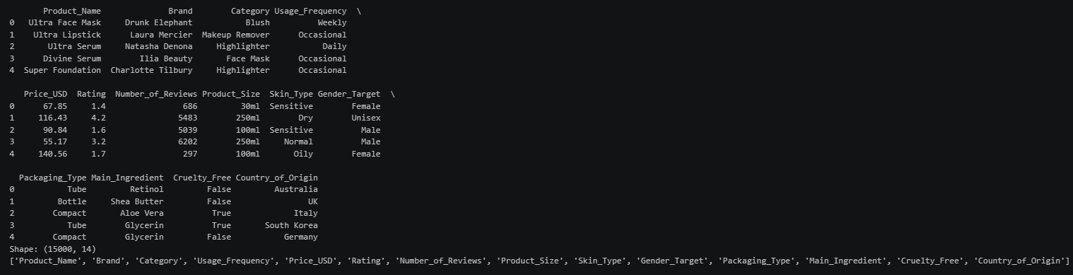
The major attributes include:
- Product Name
- Brand
- Category
- Usage Frequency
- Price (USD)
- Rating
- Number of Reviews
- Product Size
- Skin Type
- Gender Target
- Packaging Type
- Main Ingredient
- Cruelty-Free Status
- Country of Origin
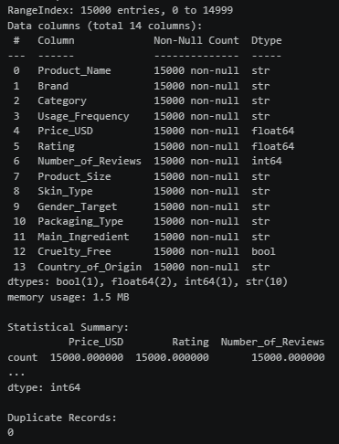
These attributes provide information about product pricing, customer ratings, product categories, ingredients and other characteristics that can be used for predictive analysis.
Problem Definition
The predictive problem selected for this phase is the classification of beauty products into high-rating and low-rating categories.
The target variable was created using the existing product rating.
The classification criteria were:
- Rating greater than or equal to 4.0: High Rating (1).
- Rating below 4.0: Low Rating (0).
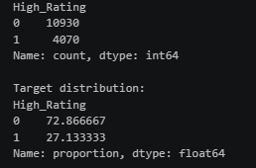
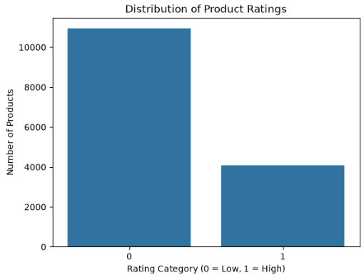
This converts the original numerical rating into a binary classification problem.
The purpose is to investigate whether available product characteristics can help identify products that are likely to receive high customer ratings.
Data Preparation and Preprocessing
Before training the models, the dataset was loaded using Pandas and examined to understand its structure, data types and statistical characteristics.
The following activities were performed:
- Loaded the dataset using Pandas.
- Examined the first few records using the head() function.
- Checked the dataset dimensions and column names.
- Examined numerical attributes using descriptive statistics.
- Checked missing values and duplicate records.
- Created the binary target variable named High_Rating.
- Separated input features and the target variable.
- Removed the original Rating column from the input features to prevent target leakage.
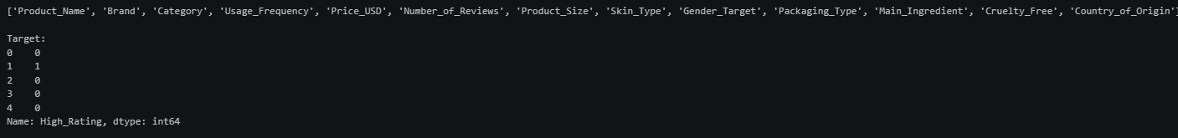
The numerical features included Price_USD and Number_of_Reviews, while categorical features included product category, brand, skin type, usage frequency, packaging type and other product characteristics.
StandardScaler was used to scale numerical features, while OneHotEncoder was applied to convert categorical variables into numerical representations.
A ColumnTransformer was implemented to combine both preprocessing operations.
Training and Testing Data Split
The dataset was divided into training and testing subsets to evaluate the predictive performance of the models on unseen records.
The train_test_split() function from Scikit-learn was used.

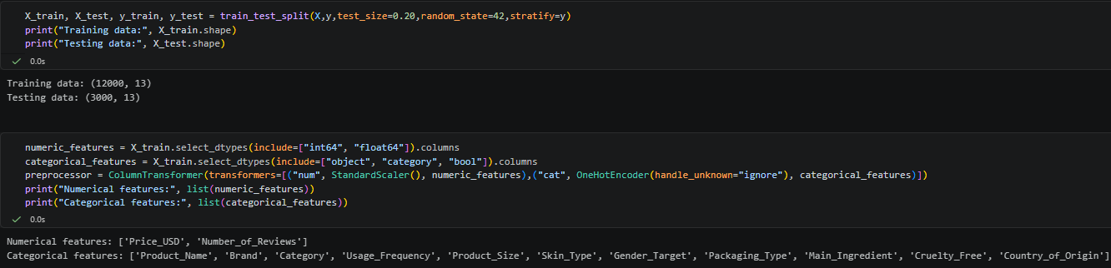
The selected configuration was:
Dataset | Records | Percentage
Training Data | 12,000 | 80%
Testing Data | 3,000 | 20%
Total | 15,000 | 100%
A random_state value of 42 was used to ensure reproducibility. Stratified sampling was applied to maintain the target class proportions across both subsets.
Machine Learning Models Implemented
Three classification algorithms were selected and implemented.
Logistic Regression
Logistic Regression was used as a baseline classification algorithm. It estimates the probability of a product belonging to a particular rating category based on the available input features.
It provides a simple approach for understanding the relationship between input characteristics and the predicted class.
Decision Tree Classifier
The Decision Tree algorithm was implemented to identify patterns and decision rules within the dataset.
It divides the data into smaller groups based on feature conditions and generates predictions through a tree-like structure.
A maximum tree depth of 5 was selected to control model complexity.
Random Forest Classifier
Random Forest is an ensemble learning algorithm that combines multiple decision trees to generate predictions.
It was selected to examine whether combining multiple trees could improve predictive performance.
The model was configured with 200 estimators and a maximum depth of 10.
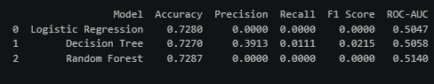
All three models were trained using Scikit-learn pipelines that integrated preprocessing and classification.
Model Evaluation Metrics
The performance of the three classification models was evaluated using the following metrics.
Accuracy
Accuracy measures the proportion of correctly classified observations among all predictions.
Precision
Precision measures how many observations predicted as high-rated products actually belong to the high-rating category.
Recall
Recall measures the proportion of actual high-rating products correctly identified by the model.
F1-Score
The F1-score represents the harmonic mean of precision and recall. It provides a balanced measure of classification performance.
ROC-AUC
The Area Under the Receiver Operating Characteristic Curve measures the model's ability to distinguish between the two rating categories across different classification thresholds.
These metrics provide a more complete understanding of model performance than accuracy alone.
Model Performance Comparison
The evaluation results obtained from the testing dataset are presented below.
Evaluation Metric | Logistic Regression | Decision Tree | Random Forest
Accuracy | 0.7280 | 0.7270 | 0.7287
Precision | 0.0000 | 0.3913 | 0.0000
Recall | 0.0000 | 0.0111 | 0.0000
F1-Score | 0.0000 | 0.0215 | 0.0000
ROC-AUC | 0.5047 | 0.5058 | 0.5140

Interpretation of Results
The Random Forest model achieved the highest accuracy of approximately 72.87%, followed by Logistic Regression at 72.80%.
However, the precision, recall and F1-score values indicate that the models struggled to identify the high-rating class.
Logistic Regression and Random Forest produced almost no positive predictions, while the Decision Tree identified a small number of positive cases.
The ROC-AUC values were also close to 0.50, indicating that the models had limited ability to distinguish between the two rating categories.
Therefore, the accuracy values alone should not be considered evidence of strong predictive performance.
Model Performance Visualization
A grouped bar chart was created to compare the accuracy, precision, recall, F1-score and ROC-AUC values of the three models.
The visualization makes it easier to identify differences in performance across the evaluation metrics.
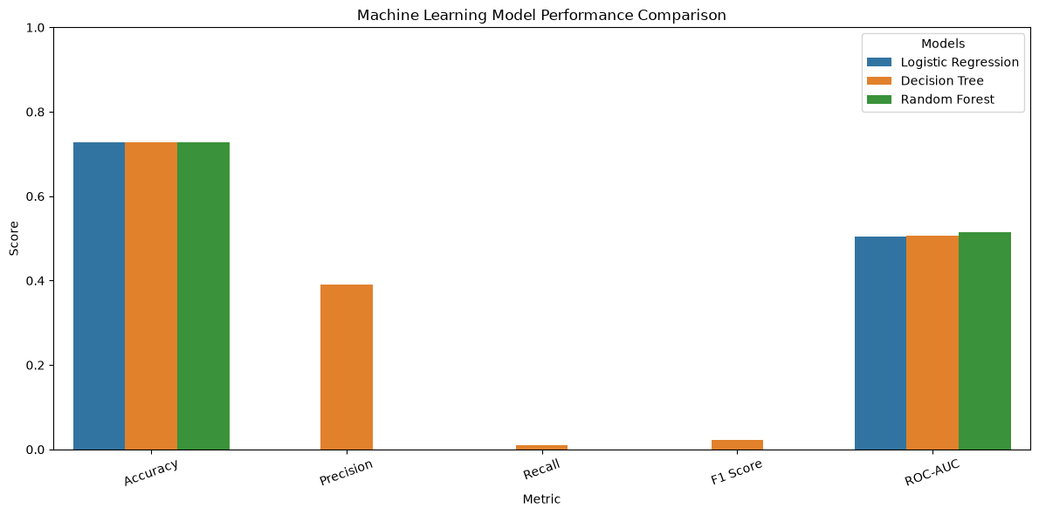
The comparison indicates that although the models achieved similar accuracy values, their performance in identifying high-rated products was weak.
This highlights the importance of considering multiple evaluation metrics while selecting a predictive model.
Confusion Matrix Analysis
Confusion matrices were generated for the trained models to examine their classification results.
The confusion matrix for Logistic Regression showed the following results:
Actual / Predicted | Low Rating (0) | High Rating (1)
Low Rating (0) | 2184 | 2
High Rating (1) | 814 | 0
The model correctly classified most low-rating products but failed to identify the actual high-rating products in the testing dataset.
This explains why the model achieved reasonable accuracy but a zero F1-score.
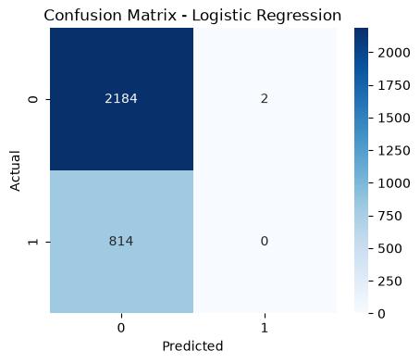
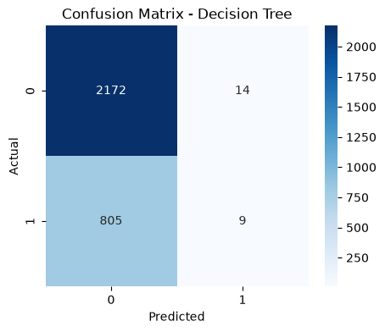
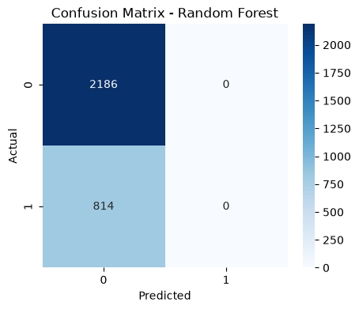
The confusion matrix demonstrates that the classification model requires further improvement before it can be considered suitable for practical business use.
ROC Curve Analysis
ROC curves were generated for all three models using their predicted probabilities.
The ROC curve compares the True Positive Rate against the False Positive Rate at different classification thresholds.
The ROC-AUC values were:
- Logistic Regression: 0.5047
- Decision Tree: 0.5058
- Random Forest: 0.5140
The results indicate that all three models performed close to random classification.
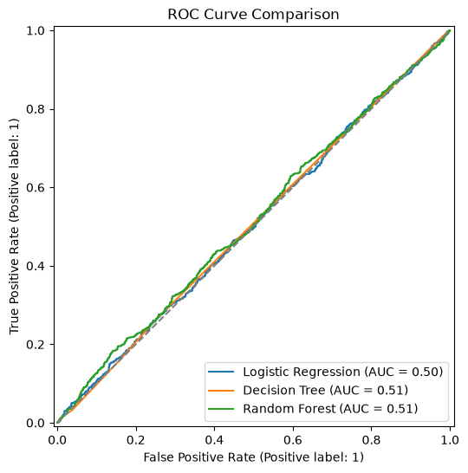
Random Forest achieved a slightly higher ROC-AUC value than the other models, but the improvement was limited.
Therefore, additional model optimization and feature investigation are necessary.
Feature Importance Analysis
Feature importance analysis was performed using the trained Random Forest classifier.
The feature_importances_ attribute was used to estimate the relative predictive contribution of individual features.
The results were visualized using a horizontal bar chart displaying the top 15 features.
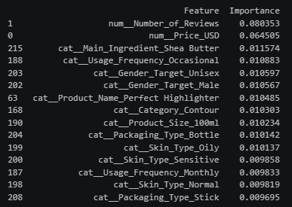
The analysis considered product characteristics such as:
- Usage Frequency
- Gender Target
- Skin Type
- Product Name
- Main Ingredient
- Other encoded product attributes
Feature importance helps identify which variables contribute to the model's predictions.
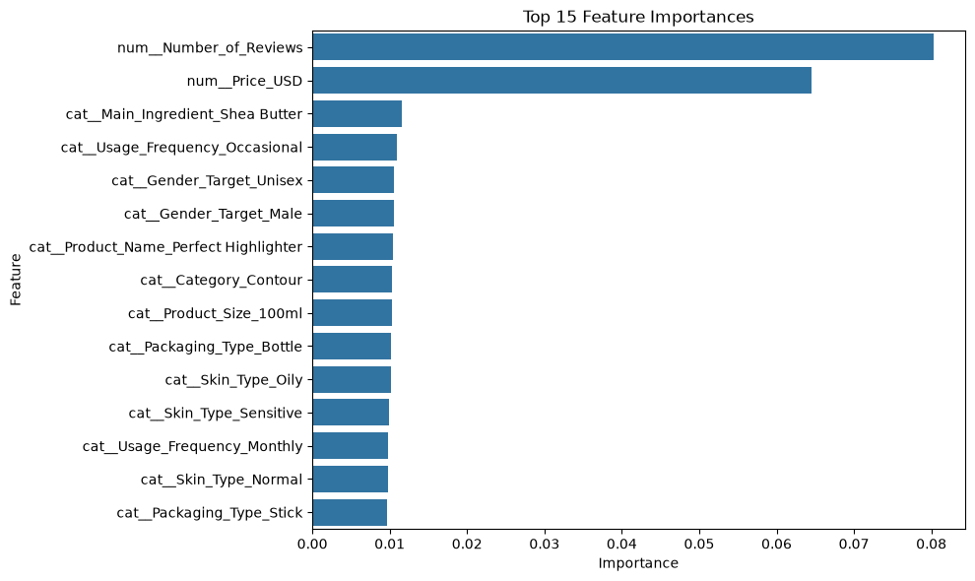
However, these values represent predictive importance within the trained model and do not establish a causal relationship between product characteristics and customer ratings.
Model Validation Strategy
A reliable predictive model should perform consistently on data that was not used during training.
The project used a separate testing dataset containing 3,000 records to measure performance on unseen observations.
The following validation considerations were identified:
- Training and testing separation was maintained.
- Stratified splitting was used to preserve class proportions.
- Multiple evaluation metrics were considered.
- Confusion matrices were examined to understand classification errors.
- ROC curves were used to examine classification ability.
- Cross-validation can be performed to further assess model stability across multiple data splits.
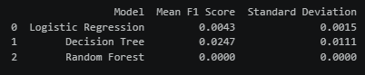
The low recall and F1-score indicate that additional validation and model improvement are required before deployment.
Business Impact Analysis
The project demonstrates how Machine Learning can be applied to product-related data in the beauty and wellness industry.
Product ratings are important indicators of customer satisfaction and can influence purchasing decisions, product visibility and brand reputation.
Predictive models may help businesses explore patterns in customer feedback and product characteristics.
However, the current models have not demonstrated sufficient predictive capability to support automated business decisions.
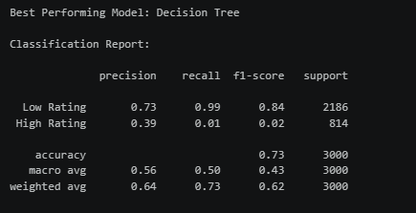
The findings provide several useful directions for future business analysis:
- Brands can examine product categories and customer rating distributions to understand product performance.
- Businesses can study the relationship between product pricing and customer ratings.
- Product teams can investigate how ingredients, skin types and usage patterns relate to customer preferences.
- Marketing teams can use customer review information to identify areas requiring product improvement.
- Businesses can improve future predictive systems by incorporating richer and more informative customer feedback data.
The current model results should be treated as exploratory findings rather than reliable product-rating predictions.
Actionable Business Recommendations
Based on the analysis, the following recommendations are proposed:
- Improve Data Quality: Collect more detailed and reliable customer feedback and product information.
- Investigate Class Imbalance: Examine the distribution of high-rating and low-rating products and consider suitable class-balancing techniques.
- Improve Feature Selection: Identify the most relevant product characteristics and investigate whether high-cardinality variables such as product names are useful.
- Optimize Machine Learning Models: Experiment with hyperparameter tuning and alternative classification algorithms.
- Evaluate Multiple Metrics: Prioritize precision, recall, F1-score and ROC-AUC rather than relying only on accuracy.
- Understand Customer Preferences: Analyze customer ratings, review counts, product categories and ingredients to identify possible business opportunities.
- Conduct Further Validation: Test improved models on additional unseen data before considering real-world implementation.
Limitations of the Project
Although the project demonstrates the implementation of Machine Learning evaluation techniques, certain limitations were identified.
- The current models showed weak classification performance.
- The models struggled to identify high-rating products.
- Accuracy was influenced by the distribution of the target classes.
- Some categorical features contained many unique values, increasing model complexity.
- The available dataset may not capture all factors influencing customer satisfaction.
- Feature importance does not establish causation.
- Further hyperparameter tuning and validation are necessary.
These limitations provide opportunities for improving the project in future work.
Future Scope
The project can be extended through several improvements.
- Apply class-balancing methods such as SMOTE when appropriate.
- Experiment with advanced classification algorithms.
- Perform systematic hyperparameter optimization using GridSearchCV or RandomizedSearchCV.
- Explore feature selection and dimensionality reduction.
- Incorporate customer review text using Natural Language Processing techniques.
- Develop an interactive dashboard to present product insights.
- Deploy an improved predictive model through a web application.
- Evaluate the final model using additional real-world product data.
These improvements can help transform the analytical project into a more practical decision-support system for the beauty and wellness industry.
Conclusion
This project successfully demonstrated the implementation of a Machine Learning model evaluation workflow using a Beauty and Cosmetics Products dataset.
Three classification algorithms, namely Logistic Regression, Decision Tree and Random Forest, were trained and evaluated using a training dataset of 12,000 records and a testing dataset of 3,000 records.
The models were compared using accuracy, precision, recall, F1-score and ROC-AUC. Performance visualizations, confusion matrices, ROC curves and feature importance analysis were also generated to understand their predictive behaviour.
Although Random Forest achieved the highest accuracy of approximately 72.87%, the low recall, F1-score and ROC-AUC values revealed that the models were not sufficiently effective at identifying high-rating products.
The project highlights an important lesson in Data Science: a model should not be judged by accuracy alone. Proper evaluation, validation, interpretation and business understanding are essential for developing reliable predictive systems.
Overall, this final phase brought together data preparation, Machine Learning, model evaluation, visualization and business communication, demonstrating the practical application of Data Science techniques to the beauty and wellness industry.

