YUVA INTERN

DATA SCIENCE WITH PYTHON ANALYST INTERNSHIP

Week4 Task: Exploratory Data Analysis and Feature Engineering on Beauty and Cosmetics Products
Aim: This task focuses on performing an Exploratory Data Analysis (EDA) on the preprocessed data and creating new features that could improve further data modeling.
Internship Domain: Data Science – Beauty & Wellness’
Dataset: Most Used Beauty and Cosmetic Products 2024
Dataset Source: https://drive.google.com/drive/folders/1IA9g18kJmKzUVAmdoX2raFNUwYiinrtx?usp=sharing
Submitted By: SHAIK NIHASUHANI
Submission Date: 01/11/2026
Github link: https://github.com/shaikniha11/Data-Science-Orientation-Problem-Definition-in-Beauty-Wellness.git
Introduction
Exploratory Data Analysis (EDA) and Feature Engineering are important stages in the Data Science and Machine Learning workflow. EDA helps understand the structure, distribution, relationships, and patterns present in a dataset, while Feature Engineering focuses on creating meaningful variables and transforming existing features to improve the performance of future analytical and predictive models.
This project focuses on analyzing beauty and cosmetic products using Python. The analysis explores product characteristics such as price, customer ratings, number of reviews, product categories, brands, skin types, ingredients, and cruelty-free status.
The primary objective is to identify meaningful patterns in product information and customer feedback that can help businesses understand product performance, customer preferences, and market trends.

Project Objectives
The main objectives of this project are:
- To perform Exploratory Data Analysis on the preprocessed beauty and cosmetics dataset.
- To understand the distribution of numerical and categorical variables.
- To identify relationships between product price, customer ratings, and review counts.
- To analyze product performance across different categories, brands, and skin types.
- To apply statistical techniques to investigate relationships between variables.
- To create new meaningful features using Feature Engineering techniques.
- To perform categorical encoding, normalization, and standardization.
- To prepare an improved dataset for future Machine Learning applications.
Dataset Description
The project uses the Most Used Beauty and Cosmetic Products 2024 dataset obtained from Kaggle.
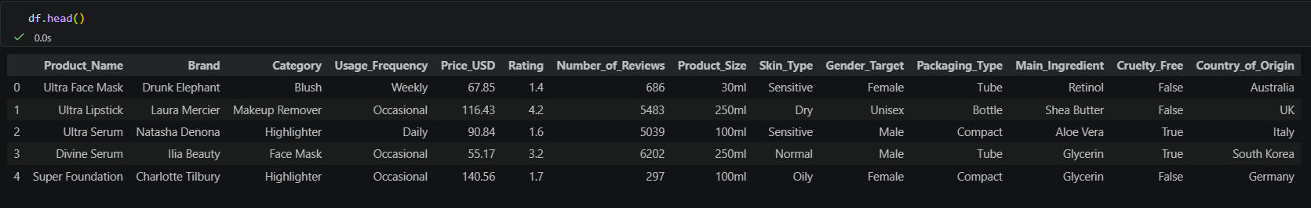
The dataset contains 15,000 records and 14 original features describing different beauty and cosmetic products.
The important variables used in this analysis include:
Feature | Description
Product_Name | Name of the beauty product
Brand | Product manufacturing brand
Category | Product category
Usage_Frequency | Frequency of product usage
Price_USD | Product price in USD
Rating | Customer rating
Number_of_Reviews | Total number of customer reviews
Main_Ingredient | Main ingredient used in the product
Skin_Type | Suitable skin type
Gender_Target | Target customer gender
Packaging_Type | Product packaging information
Country_of_Origin | Product manufacturing country
Cruelty_Free | Indicates whether the product is cruelty-free
Other product attributes | Additional product information
The preprocessed dataset obtained from the previous data cleaning stage was used for further analysis.
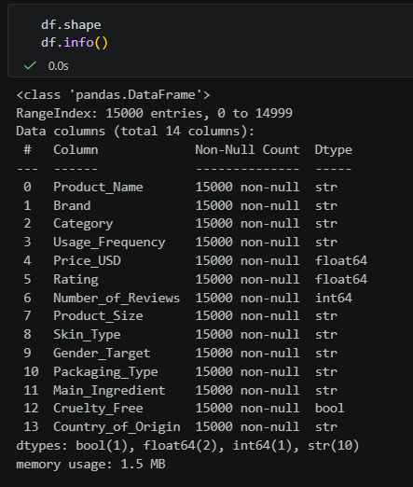
Tools and Technologies Used
The project was implemented using Python and Jupyter Notebook in Visual Studio Code.
The following libraries were used:
Pandas: Used for loading datasets, inspecting data, grouping variables, calculating statistical summaries, and performing data manipulation.
NumPy: Used for numerical calculations and logarithmic transformations.
Matplotlib: Used for creating customized charts and visualizations.
Seaborn: Used for statistical visualizations such as histograms, boxplots, scatterplots, and correlation heatmaps.
SciPy: Used for statistical tests, including Pearson correlation, Spearman correlation, independent t-tests, and ANOVA.
Scikit-learn: Used for feature transformation techniques such as Min-Max Scaling and Standardization.
Exploratory Data Analysis (EDA)
Exploratory Data Analysis was performed to understand the characteristics of the dataset and discover patterns that could provide useful business insights.
The analysis was divided into three major categories: Univariate Analysis, Bivariate Analysis, and Multivariate Analysis.
Univariate Analysis
Univariate Analysis involves examining one variable at a time to understand its distribution, frequency, and statistical characteristics.
A. Numerical Feature Analysis
The numerical variables selected for analysis were:
- Price_USD
- Rating
- Number_of_Reviews
Histograms with Kernel Density Estimation (KDE) were generated to understand the distribution of these variables.
Boxplots were also created to examine the spread of numerical values and identify potential outliers.
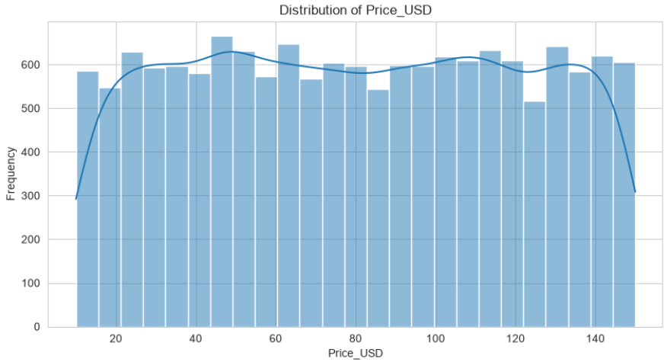
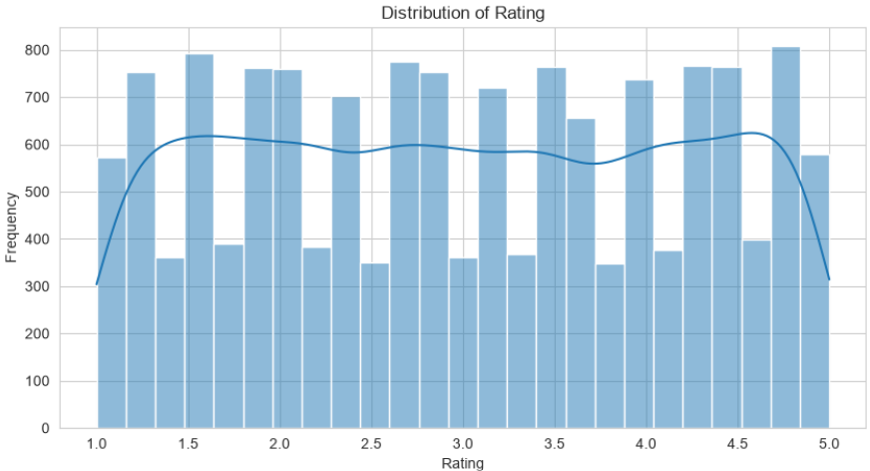
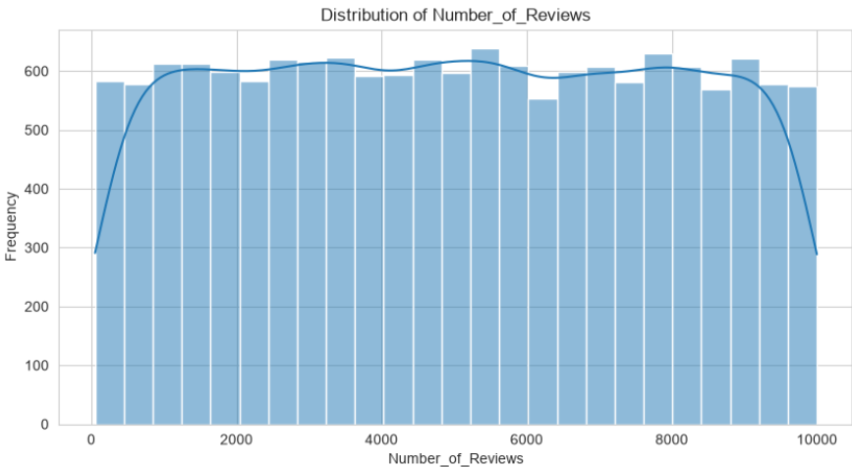
The analysis helps understand product pricing patterns, customer rating distributions, and variations in review counts.
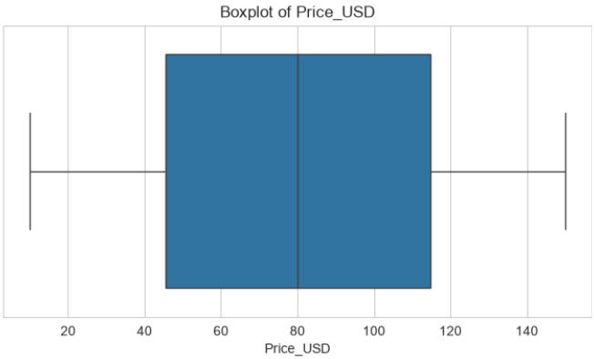
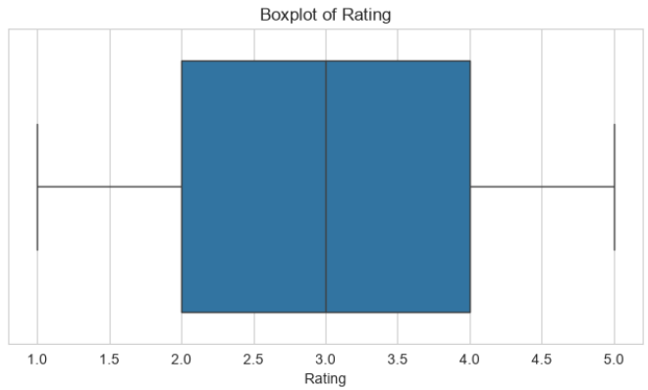
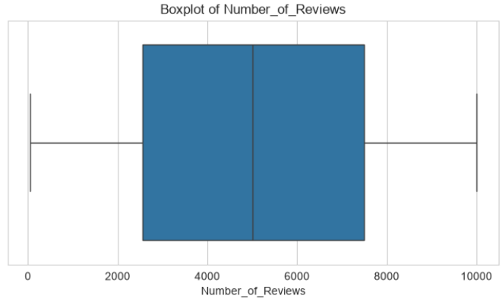
B. Categorical Feature Analysis
Categorical variables were analyzed using frequency distributions and bar charts.

The following features were examined:
- Category
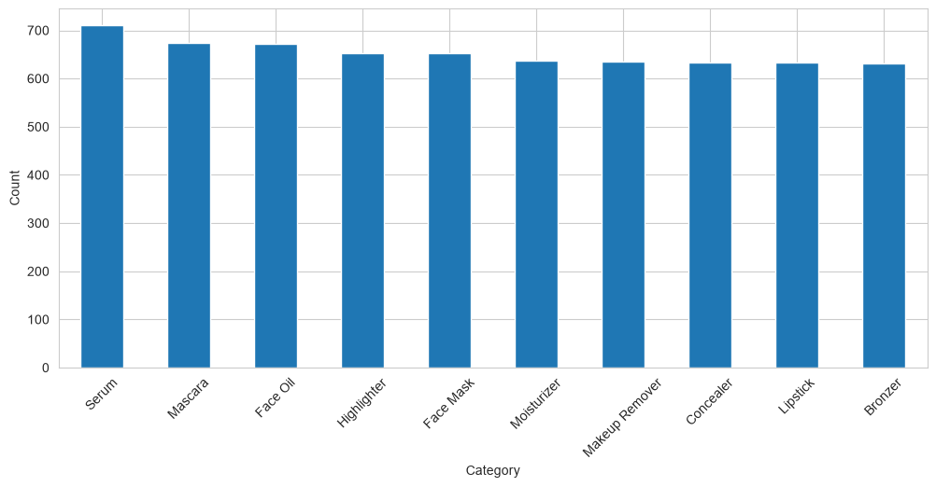
- Brand
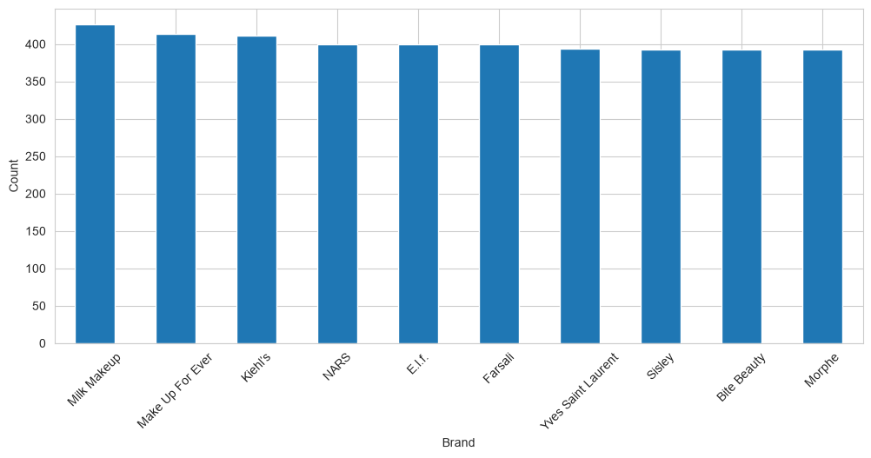
- Skin_Type
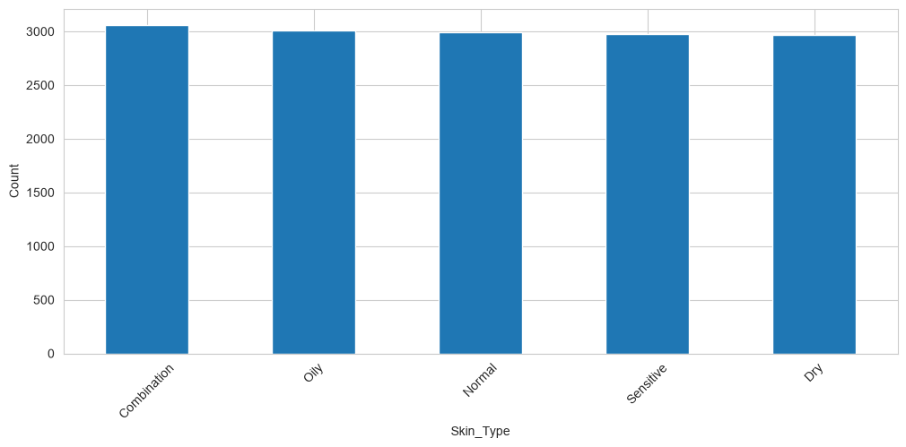
- Gender_Target
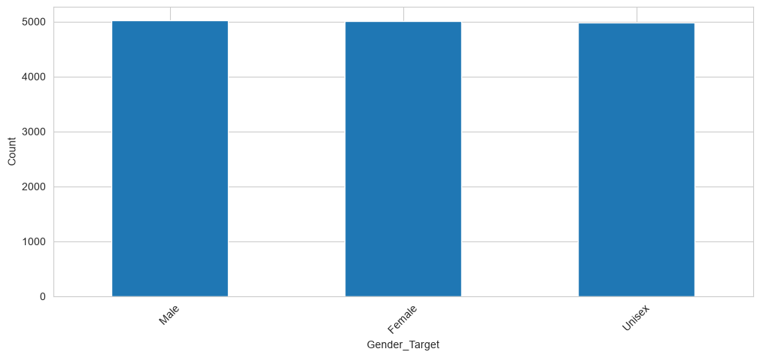
- Packaging_Type
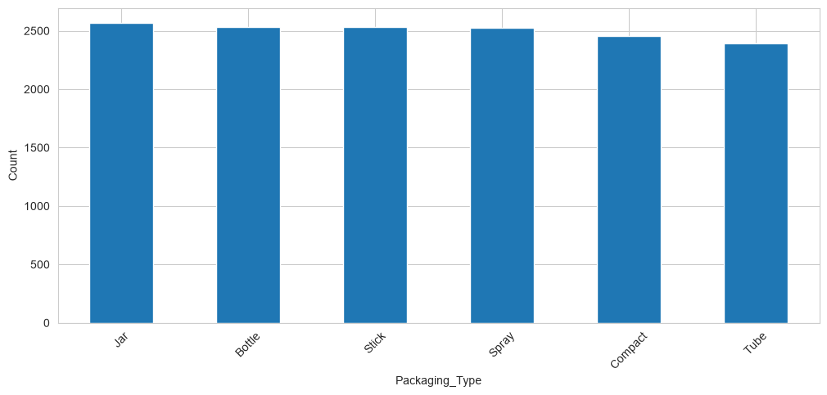
- Main_Ingredient
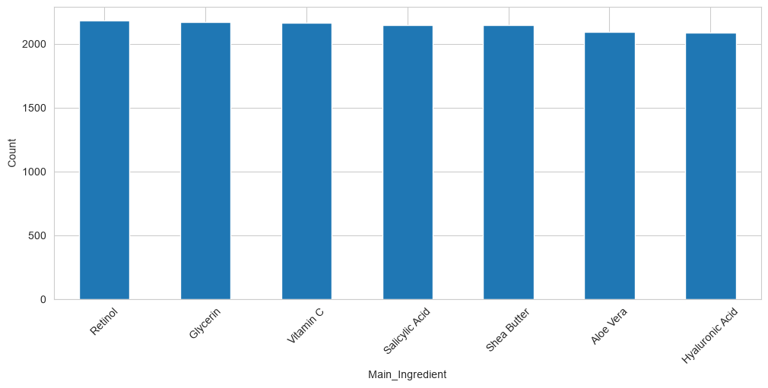
- Usage_Frequency
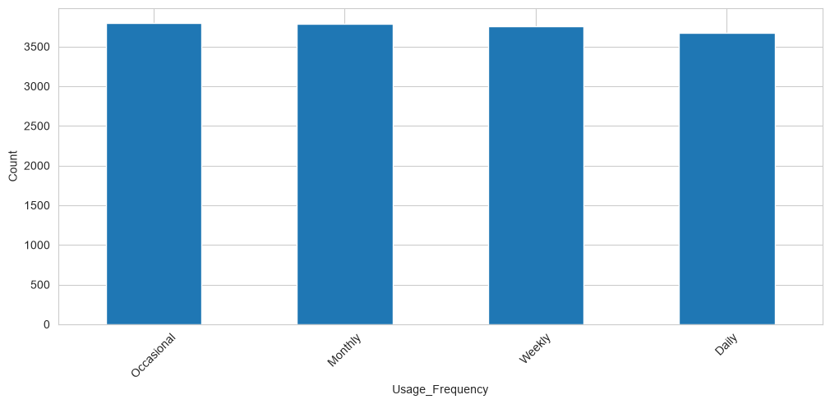
- Cruelty_Free
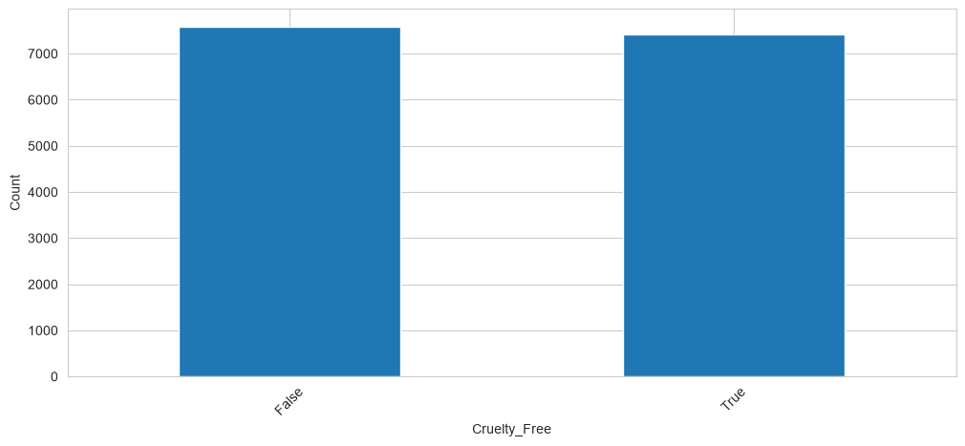
- Country_of_Origin
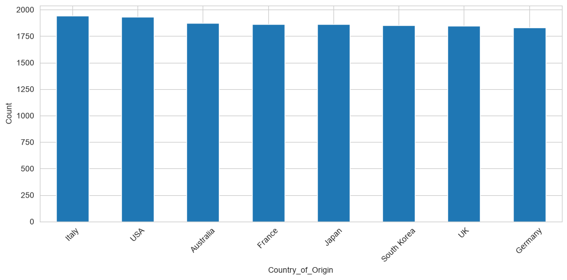
The top ten most frequently occurring categories were visualized for suitable categorical variables.
This analysis helps identify frequently represented product categories, commonly occurring brands, popular ingredients, and the distribution of products across different customer groups.
Bivariate Analysis
Bivariate Analysis examines the relationship between two variables to understand how one variable changes in relation to another.
The following comparisons were performed:
A. Price vs Product Rating
A scatterplot was created to investigate whether product price is associated with customer ratings.
This analysis helps understand whether expensive products necessarily receive higher customer ratings or whether ratings vary independently of price.
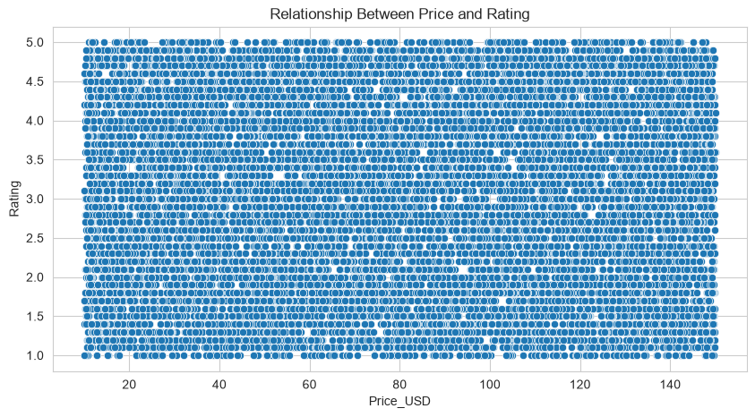
B. Number of Reviews vs Product Rating
A scatterplot was used to examine the relationship between the number of customer reviews and product ratings.
This helps investigate whether products receiving more customer reviews also tend to have higher ratings.
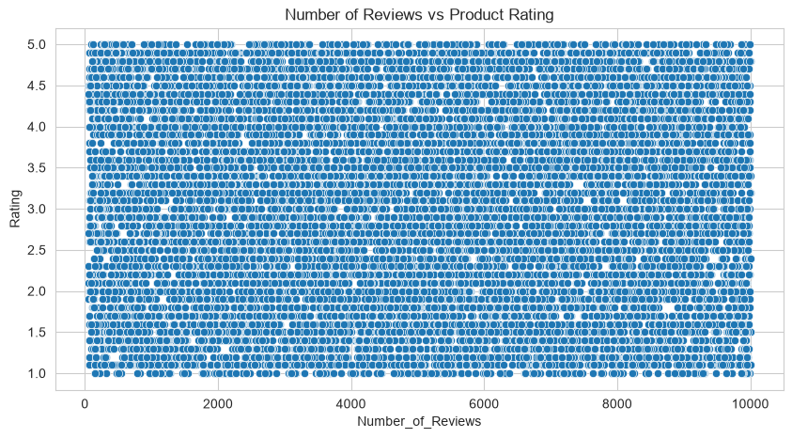
C. Product Category vs Average Rating
The average rating of products was calculated for each category using the groupby() function.
A bar chart was created to compare the average ratings across different product categories.
This helps identify categories with relatively higher or lower customer satisfaction.
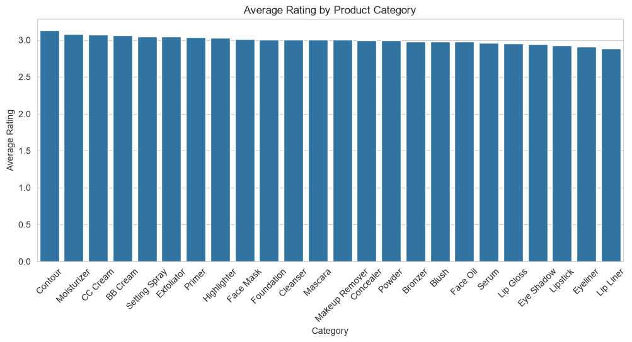

D. Skin Type vs Product Rating
A boxplot was created to compare the distribution of product ratings across different skin types.
This analysis helps understand variations in product ratings for different skin-type categories.
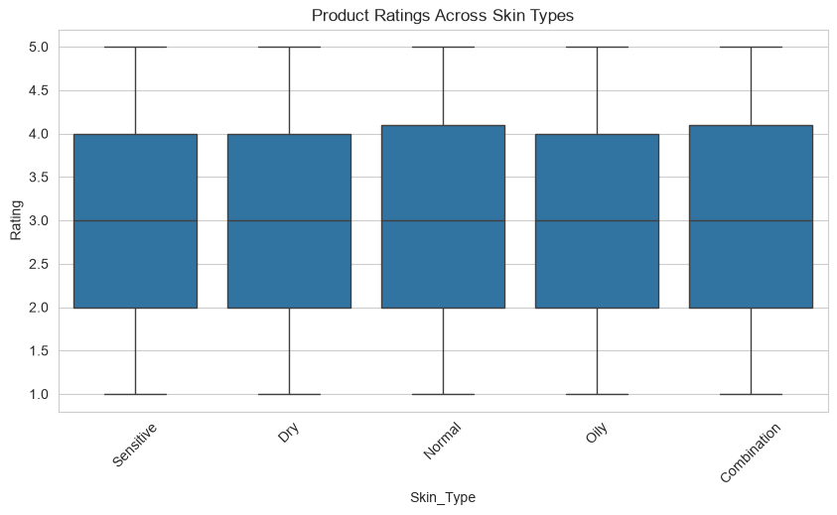
E. Cruelty-Free Status vs Product Rating
A boxplot was used to compare ratings of cruelty-free and non-cruelty-free products.
This analysis helps investigate whether product ratings differ according to cruelty-free status.
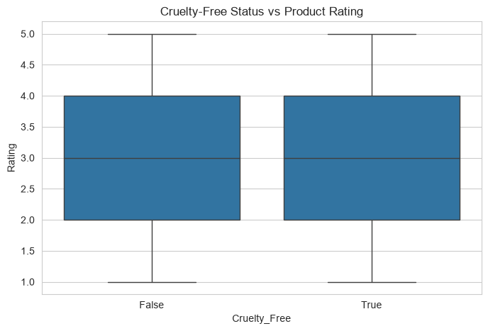
F. Brand vs Average Rating
The average rating for each brand was calculated and the top ten brands were visualized using a bar chart.
This helps compare brand-level product ratings and understand differences in customer feedback.
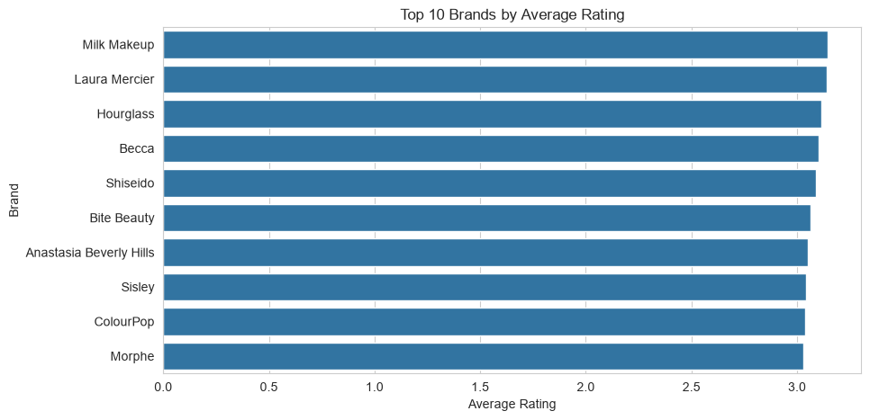
Correlation Analysis
Correlation analysis was performed to measure the strength and direction of relationships between numerical variables.
Two correlation methods were implemented:
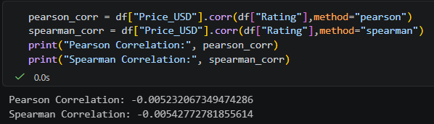
Pearson Correlation:
Pearson correlation measures the strength and direction of a linear relationship between two numerical variables.
It was used to examine the relationship between product price and customer ratings.
Spearman Correlation:
Spearman correlation measures the strength and direction of a monotonic relationship based on ranked values.
It was also used to investigate the relationship between product price and ratings.
The correlation coefficients were interpreted using their absolute values:
- Below 0.3: Weak relationship
- Between 0.3 and 0.7: Moderate relationship
- Above 0.7: Strong relationship
These are approximate interpretation guidelines.
The correlation analysis helps determine whether price and customer ratings show meaningful associations.
Multivariate Analysis
Multivariate Analysis was performed to understand relationships involving multiple variables simultaneously.
The following techniques were implemented:
A. Correlation Heatmap
A correlation matrix was calculated for numerical variables and visualized using a Seaborn heatmap.
The heatmap provides a visual representation of relationships between numerical features and helps identify potential correlations.
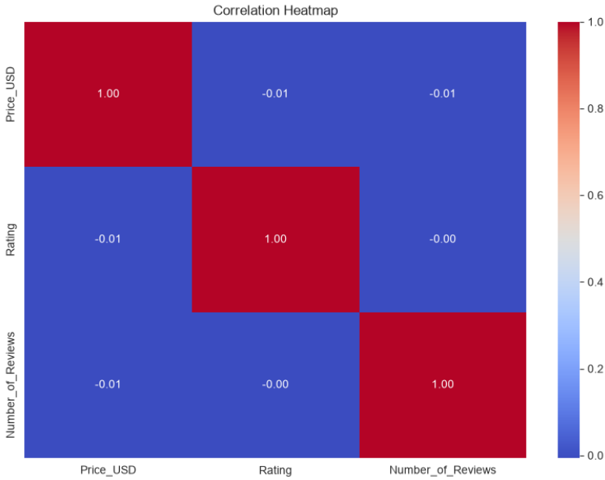
B. Category, Cruelty-Free Status, and Rating
A grouped barplot was created to compare average ratings across product categories based on cruelty-free status.
This analysis helps investigate whether the relationship between product category and ratings differs according to cruelty-free status.
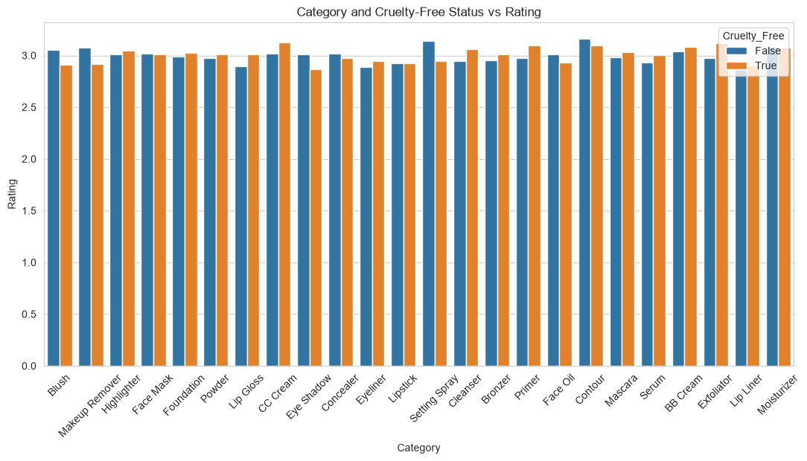
C. Price, Rating, and Category
A scatterplot was created with product price on the X-axis, customer rating on the Y-axis, and product category represented using different colors.
This visualization helps examine price-rating patterns across multiple product categories.
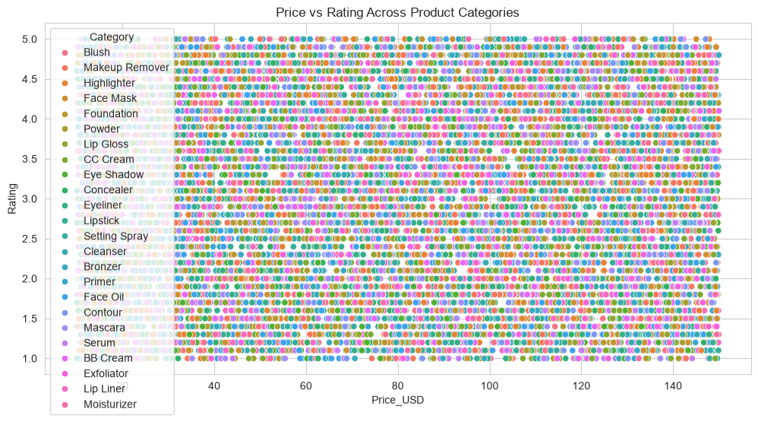
Statistical Analysis
Statistical methods were applied to support the visual observations and investigate whether the relationships found in the dataset were statistically significant.
Pearson Correlation Test
The Pearson correlation test was performed using SciPy to calculate the correlation coefficient and corresponding p-value.
The p-value helps determine whether the observed linear correlation is statistically significant.
Spearman Correlation Test
The Spearman correlation test was performed to identify monotonic relationships between product prices and ratings.
It is useful when the relationship may not be strictly linear or when ranked associations are more appropriate.
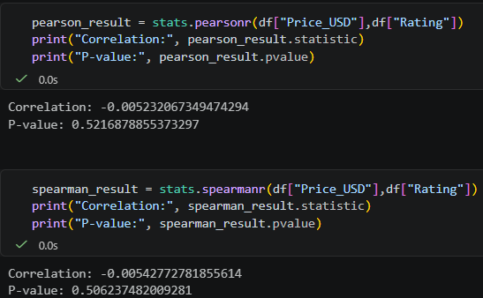
Independent T-Test
An independent two-sample t-test was conducted to compare the average ratings of cruelty-free and non-cruelty-free products.
The test was performed using unequal variance assumptions (Welch's t-test).
The purpose was to investigate whether the difference in average product ratings between the two groups was statistically significant.
Analysis of Variance (ANOVA)
One-way ANOVA was performed to compare average product ratings across different product categories.
The test helps determine whether there are statistically significant differences in average ratings among the categories.
A significance level of 0.05 was considered.
- If the p-value is below 0.05, the result is considered statistically significant.
- If the p-value is greater than or equal to 0.05, there is insufficient evidence of a statistically significant difference.
ANOVA identifies whether at least one group differs; additional post-hoc testing would be required to identify the specific groups responsible for a significant result.
Feature Engineering
Feature Engineering was performed to create new meaningful variables from existing dataset columns.
The objective was to represent product characteristics in a more useful format and prepare the dataset for future Machine Learning applications.
The following new features were created.
Price Category
A new feature named Price_Category was created using the original Price_USD column.
Products were divided into three groups:
- Budget
- Mid-Range
- Premium
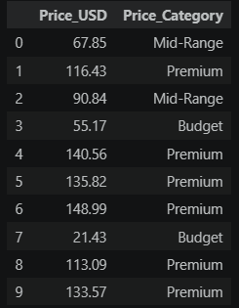
The pandas qcut() function was used to divide the products into three approximately equal-sized groups based on their price distribution.
This feature helps compare customer ratings and product characteristics across different price segments.
Product Popularity
A new feature named Product_Popularity was created using Number_of_Reviews.
Products were categorized into three popularity levels:
- Low
- Medium
- High
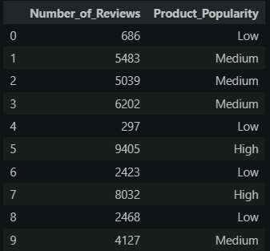
The qcut() function was used to create approximately equal-sized groups based on review counts.
This feature provides a simplified representation of product popularity based on customer review volume.
Log Transformation of Reviews
A new feature named Log_Reviews was created using a logarithmic transformation of Number_of_Reviews.
The NumPy log1p() function was used.
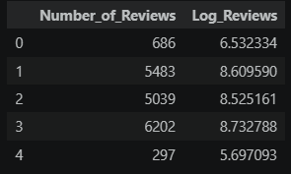
The transformation helps reduce the impact of large review counts and can make a highly skewed distribution more manageable for certain analytical and predictive models.
Brand Frequency
A new feature named Brand_Frequency was created by calculating the number of times each brand appears in the dataset.
The value_counts() and map() functions were used.
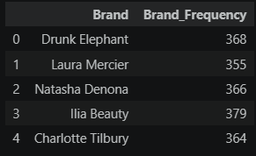
This feature represents how frequently a brand occurs in the dataset and can help investigate relationships between brand representation and product characteristics.
Price and Review Interaction Feature
A new feature named Price_Review_Interaction was created by multiplying Price_USD with Log_Reviews.
This interaction feature represents a combined measure of product price and transformed review volume.
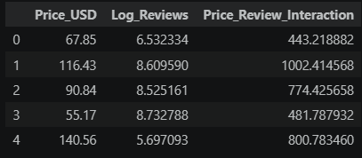
It can be explored to determine whether combining these two variables provides additional information for future analytical and predictive models.
Feature Transformation
Feature Transformation was performed to convert existing variables into formats suitable for analytical and Machine Learning algorithms.
One-Hot Encoding
One-Hot Encoding was applied to selected categorical variables.
The following columns were encoded:
- Category
- Skin_Type
- Gender_Target
- Packaging_Type
- Cruelty_Free
- Usage_Frequency
The pandas get_dummies() function was used with drop_first=True.
This technique converts categorical values into separate binary numerical columns.
The transformation allows algorithms that require numerical input to process categorical information.
Min-Max Normalization
Min-Max Scaling was applied to the Price_USD feature using the MinMaxScaler class from Scikit-learn.
Normalization transforms numerical values into a range between 0 and 1.
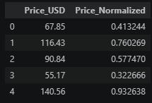
It helps ensure that numerical features measured on different scales can be represented within a common range.
A new feature named Price_Normalized was created.
Standardization
Standardization was performed using the StandardScaler class from Scikit-learn.
It transforms numerical values based on their mean and standard deviation.
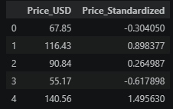
The resulting feature has approximately zero mean and unit variance.
A new feature named Price_Standardized was created.
Comparison of Transformations
Histograms were generated to compare:
- Original product prices
- Normalized product prices
- Standardized product prices
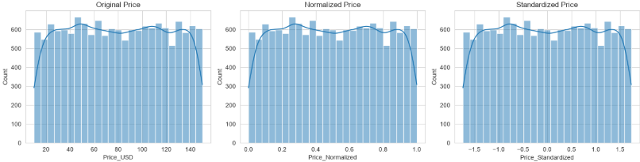
Another comparison was performed between the original number of reviews and the logarithmically transformed review counts.
These visualizations help understand how the transformations change the scale and distribution of the original variables.
Evaluation of Engineered Features
After creating the new features and applying transformations, the engineered variables were examined to verify their values and structure.
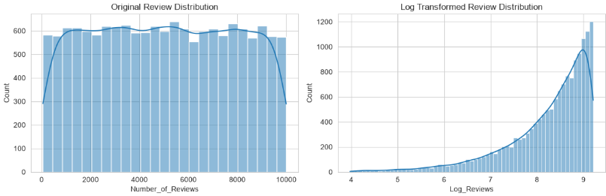
The following features were reviewed:
- Price_Category
- Product_Popularity
- Log_Reviews
- Brand_Frequency
- Price_Review_Interaction
- Price_Normalized
- Price_Standardized
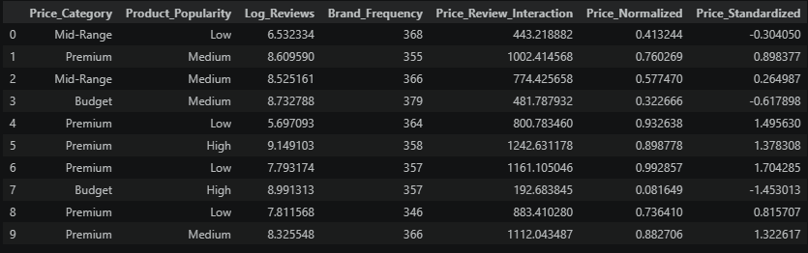
The original and transformed datasets were also compared to understand the changes in the number of features.
Feature Engineering provides additional representations of existing product information. However, the usefulness of each feature must be evaluated through further statistical analysis and Machine Learning experiments.
Key Observations and Business Relevance
The EDA and Feature Engineering process provides a structured understanding of the beauty and cosmetics product market.
The analysis focuses on several important business questions:
- Whether product pricing is associated with customer ratings.
- Whether products with higher review counts receive different ratings.
- Which product categories have relatively higher average ratings.
- Whether customer ratings vary across different skin types.
- Whether cruelty-free status is associated with differences in product ratings.
- How product ratings vary across different brands.
- Whether numerical variables show meaningful correlations.
- Whether product price segments and popularity groups provide useful analytical information.
These insights can help beauty and wellness businesses understand product performance, identify customer preferences, compare product segments, and support data-driven business decisions.
The analysis also provides a foundation for developing recommendation systems, product performance analysis, and customer-focused predictive models.
Expected Impact on Machine Learning Models
The features created during this project can support future Machine Learning applications.
For example:
- Price_Category can help models understand different product price segments.
- Product_Popularity can represent review-based popularity groups.
- Log_Reviews can reduce the effect of highly skewed review counts.
- Brand_Frequency can provide information about brand representation.
- Price_Review_Interaction can help investigate combined feature relationships.
- One-Hot Encoding makes selected categorical features suitable for numerical model inputs.
- Normalization and Standardization help numerical features use comparable scales.
These transformations may improve model training, depending on the algorithm and the dataset.
Their actual contribution must be evaluated by comparing model performance using appropriate training and testing datasets.
Conclusion
This project successfully demonstrates the application of Exploratory Data Analysis and Feature Engineering to a beauty and cosmetics dataset.
Different EDA techniques were implemented to understand numerical distributions, categorical frequencies, relationships between variables, and patterns across multiple product characteristics.
Statistical techniques such as Pearson correlation, Spearman correlation, independent t-tests, and ANOVA were used to investigate relationships and differences between product groups.
Feature Engineering techniques were also implemented to create new variables such as Price_Category, Product_Popularity, Log_Reviews, Brand_Frequency, and Price_Review_Interaction.
Furthermore, One-Hot Encoding, Min-Max Normalization, and Standardization were applied to transform the dataset into formats suitable for future analytical and predictive applications.
Overall, this project strengthened the understanding of data exploration, statistical analysis, visualization, and feature preparation. The resulting engineered dataset provides a foundation for future Machine Learning experiments and data-driven decision-making in the beauty and wellness industry.
Future Scope
The project can be extended through the following activities:
- Develop Machine Learning models to predict product ratings.
- Build a product recommendation system based on product characteristics.
- Analyze customer preferences across product categories and skin types.
- Perform feature selection to identify the most relevant predictive variables.
- Compare different Machine Learning algorithms.
- Develop interactive dashboards to communicate business insights.
- Explore customer sentiment analysis using product reviews, if review text data becomes available.
These extensions can help transform the current analytical project into a more comprehensive Beauty and Cosmetics Product Intelligence system.

