YUVA INTERN

DATA SCIENCE WITH PYTHON ANALYST INTERNSHIP

Week 5 Task: Predictive Modeling And Algorithm Selection
Aim: The task necessitates an analytical approach in weaving business insights with technical methods, tailoring model selection to the specific characteristics of the data and the problem defined
Internship Domain: Data Science – Beauty & Wellness’
Dataset: Most Used Beauty and Cosmetic Products 2024
Dataset Source: https://drive.google.com/drive/folders/1yEx2JvuuGvn4JC-jEMWWQCilc-fxK990?usp=sharing
Submitted By: SHAIK NIHASUHANI
Submission Date: 02/10/2026
Github link: https://github.com/shaikniha11/Data-Science-Orientation-Problem-Definition-in-Beauty-Wellness.git
Introduction
Predictive modeling is an important phase of Data Science that uses historical data, statistical techniques, and Machine Learning algorithms to predict future outcomes or estimate unknown values. This project focuses on applying predictive modeling techniques to the Beauty and Wellness industry using a beauty and cosmetics products dataset.
The main objective of this phase is to identify suitable Machine Learning algorithms, train predictive models, evaluate their performance, and compare their effectiveness in predicting beauty product ratings.
Business Problem Definition
The Beauty and Wellness industry offers a wide range of cosmetic and skincare products with different prices, brands, categories, and customer ratings. Understanding the factors associated with product ratings can help businesses evaluate product performance and customer preferences.

The business problem selected for this project is:
Can customer ratings of beauty and cosmetic products be predicted using product-related characteristics such as price, brand, category, product size, skin type, and number of reviews?
Predicting product ratings can help businesses understand customer satisfaction patterns and identify product characteristics associated with higher or lower ratings.
Dataset Description
The analysis uses the most_used_beauty_cosmetics_products_extended.csv dataset.
The dataset contains information about beauty and cosmetic products, including:
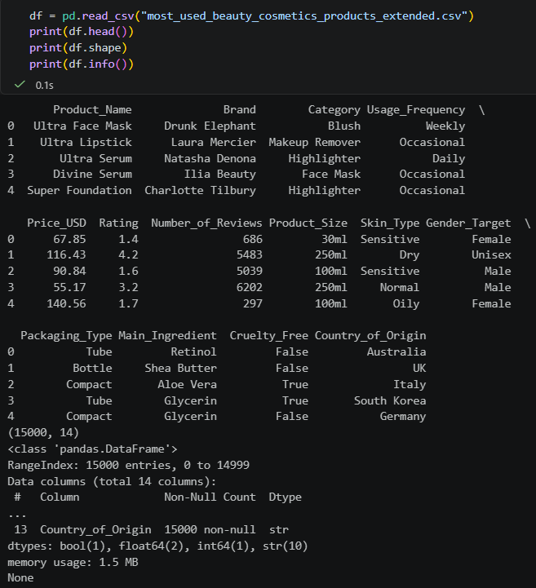
- Product Name
- Brand
- Category
- Usage Frequency
- Price (USD)
- Rating
- Number of Reviews
- Product Size
- Skin Type
- Gender Target
The dataset provides both numerical and categorical variables, making it suitable for experimenting with different regression algorithms.
Predictive Modeling Objective
The primary objective is to develop Machine Learning models that can estimate the rating of a beauty product based on its available characteristics.
The predictive modeling task is classified as:
- Machine Learning Type: Supervised Learning
- Learning Task: Regression
- Target Variable: Rating
- Input Features: Price, number of reviews, brand, category, product size, skin type, and other relevant product characteristics.
Regression is selected because product ratings are numerical values and the objective is to predict a continuous numerical outcome.
Data Preparation and Feature Selection
The dataset was loaded using the Pandas library and examined to understand its structure, dimensions, column names, and data types.
Relevant input features were selected based on their potential relationship with product ratings.
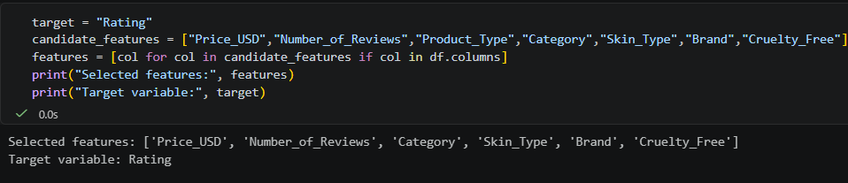
The Rating column was selected as the target variable, while other relevant product attributes were considered input features.
The feature selection process helps remove irrelevant information and focuses the model on variables that may contribute to predicting product ratings.
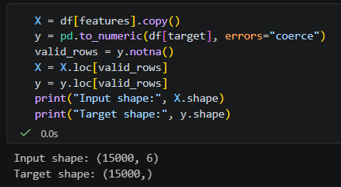
Data Preprocessing
Data preprocessing was performed to prepare the dataset for Machine Learning algorithms.
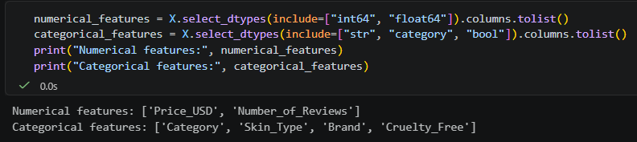
The following techniques were considered and implemented:
Handling Missing Values: Numerical missing values were handled using median imputation, while categorical missing values were handled using the most frequent value.
Categorical Encoding: Categorical variables such as brand, category, and skin type were converted into numerical representations using One-Hot Encoding.
Feature Scaling: StandardScaler was applied to numerical features to standardize their values and improve the training process, particularly for Linear Regression.
These preprocessing operations were incorporated into a Scikit-learn pipeline to maintain consistency during model training and evaluation and prevent data leakage.
Train-Test Splitting
The prepared dataset was divided into training and testing subsets using the train_test_split() function from Scikit-learn.
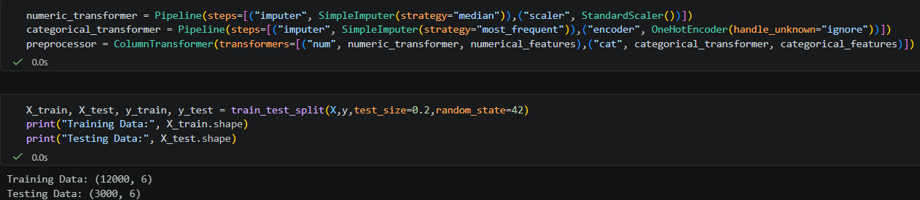
The dataset was divided using the following proportions:
- Training Data: 80%
- Testing Data: 20%
The training dataset was used to train the Machine Learning models, while the testing dataset was used to evaluate their performance on unseen observations.
A random state of 42 was used to ensure reproducibility.
Algorithm Selection
Three regression algorithms were selected for the predictive modeling process.
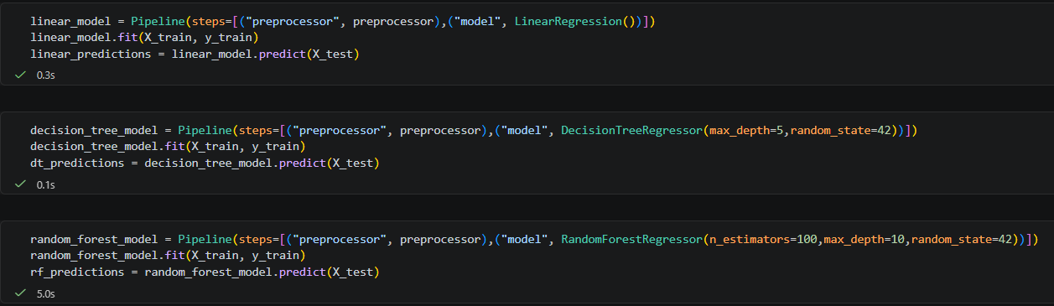
Linear Regression
Linear Regression is a supervised Machine Learning algorithm used to predict continuous numerical values by identifying a linear relationship between independent variables and a dependent variable.
In this project, Linear Regression was used to estimate product ratings based on selected product characteristics.
Advantages:
- Simple and easy to implement.
- Computationally efficient.
- Provides an understandable baseline model.
Limitations:
- Assumes a linear relationship between features and target.
- May not capture complex nonlinear patterns.
Decision Tree Regressor
Decision Tree Regression is a supervised learning algorithm that makes predictions using a sequence of decision rules. It divides the dataset into smaller groups based on feature values and generates predictions from the resulting groups.
In this project, the Decision Tree Regressor was used to identify possible nonlinear relationships between product characteristics and customer ratings.
Advantages:
- Can capture nonlinear relationships.
- Easy to understand and interpret.
- Requires relatively little feature scaling.
Limitations:
- Can overfit the training dataset.
- Small changes in data may produce different tree structures.
Random Forest Regressor
Random Forest Regression is an ensemble learning algorithm that combines multiple decision trees to generate predictions. It averages the predictions from individual trees to produce the final result.
In this project, Random Forest Regression was implemented to evaluate whether combining multiple decision trees could improve prediction accuracy and model stability.
Advantages:
- Captures complex relationships.
- Generally more stable than an individual decision tree.
- Can provide feature importance information.
Limitations:
- Requires more computational resources.
- Less interpretable than a single decision tree.
- Performance depends on suitable parameter selection.

Model Training and Implementation
The three selected algorithms were implemented using the Scikit-learn library.
Each model was trained using the training dataset and subsequently used to generate predictions for the testing dataset.
The models implemented were:
- Linear Regression
- Decision Tree Regressor
- Random Forest Regressor
A Pipeline was used to combine preprocessing operations with the respective Machine Learning algorithms. This ensured that the same preprocessing steps were consistently applied during training and prediction.
Model Evaluation Metrics
To evaluate the performance of the predictive models, the following evaluation metrics were selected.
Mean Absolute Error (MAE)
MAE measures the average absolute difference between actual and predicted values. A lower MAE indicates smaller prediction errors.
Mean Squared Error (MSE)
MSE calculates the average of squared differences between actual and predicted values. It gives greater importance to larger prediction errors.
Root Mean Squared Error (RMSE)
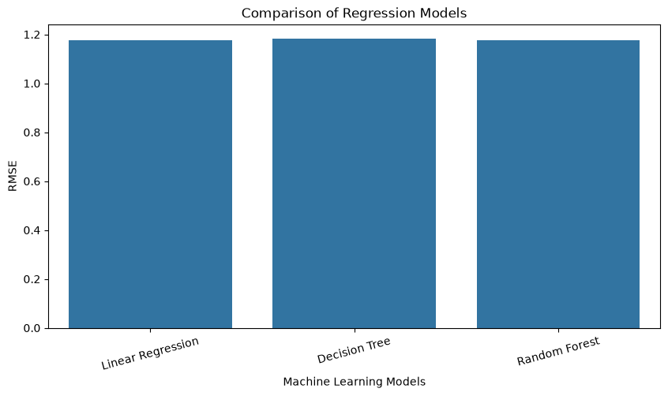
RMSE is the square root of Mean Squared Error. It measures prediction errors in the same unit as the target variable. A lower RMSE indicates better predictive performance.
R-Squared Score (R²)
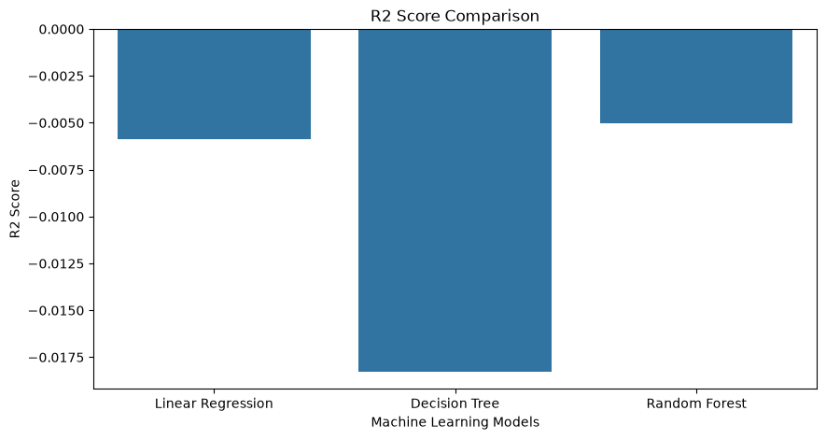
R² measures how much of the variation in the target variable is explained by the model. A higher R² generally indicates a better fit, although a negative score indicates performance worse than predicting the test-set mean.
Model Performance Comparison
After training the three regression models, their predictions were evaluated using MAE, MSE, RMSE, and R² Score.
A comparison table was generated to examine the performance of each algorithm.
The RMSE comparison visualization showed that the three models produced relatively similar error values, approximately around 1.17 based on the plotted results.
This indicates that none of the three algorithms demonstrated a clearly substantial improvement in RMSE in the current experiment.
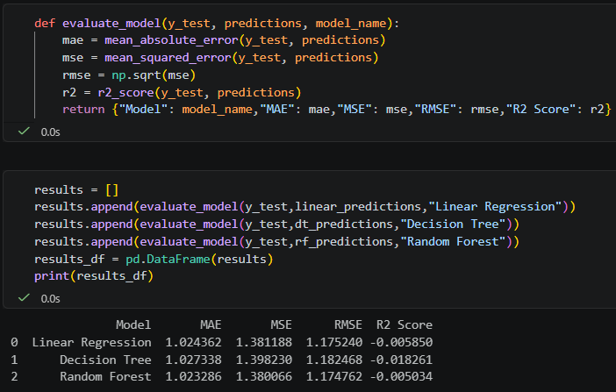
The final model selection should consider all evaluation metrics and cross-validation results rather than relying on RMSE alone.
Actual vs Predicted Ratings
An Actual vs Predicted visualization was generated to compare the actual product ratings with the ratings estimated by the Random Forest model.
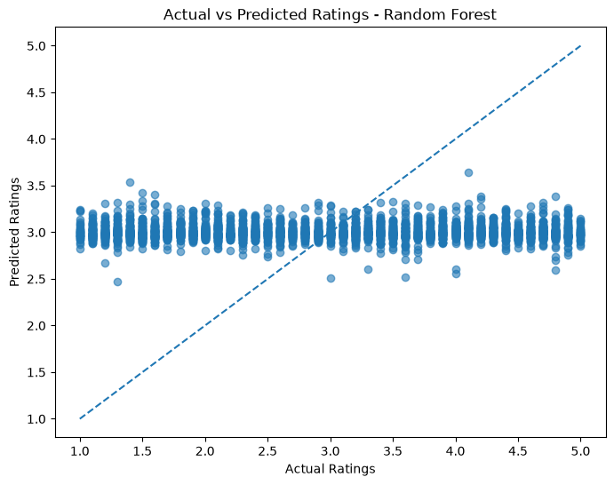
A diagonal reference line was included to help evaluate prediction accuracy.
Points closer to the diagonal line represent more accurate predictions, while points farther away indicate larger prediction errors.
This visualization provides a graphical understanding of how effectively the model estimates product ratings.
Feature Importance Analysis
Feature importance analysis was performed using the Random Forest Regressor.
The purpose was to identify which input features contributed most to the model's predictions.
The feature importance values were extracted from the trained Random Forest model and visualized using a horizontal bar chart.
This analysis helps understand the relative contribution of product characteristics such as price, number of reviews, category, and other available attributes to the model's predictions.
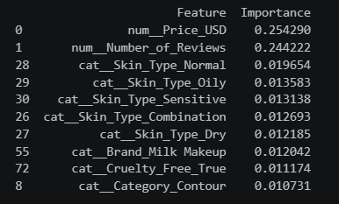
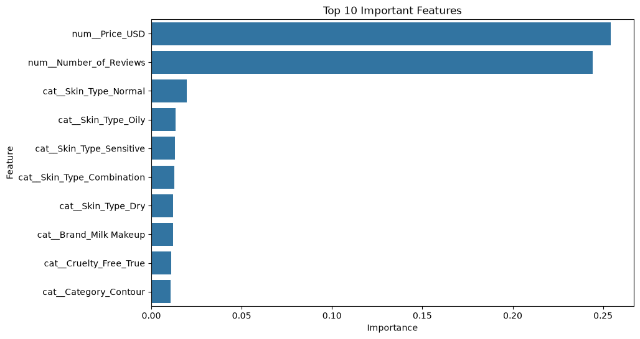
Feature importance represents the model's predictive usage of features and does not establish a causal relationship.
Overfitting and Underfitting Analysis
Overfitting and underfitting are important challenges in Machine Learning.
Overfitting occurs when a model performs very well on training data but performs poorly on unseen testing data.
Underfitting occurs when a model fails to learn important patterns from both training and testing data.
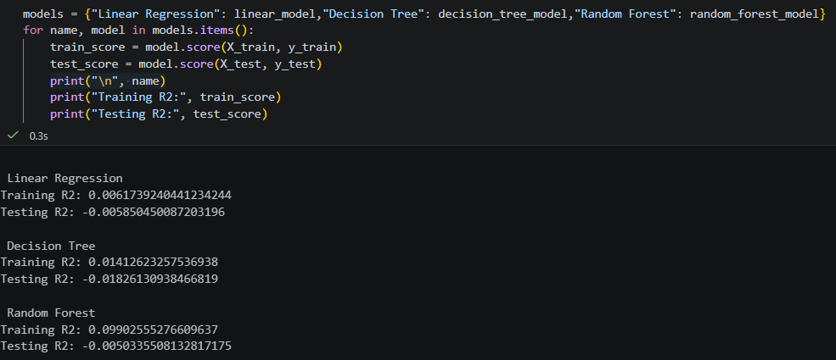
To examine these issues, training and testing R² scores were compared for all three models.
The comparison helps identify differences in model generalization and determine whether further parameter tuning is necessary.
Cross-Validation
Five-fold cross-validation was used to assess the stability of the selected Machine Learning models.
In this technique, the dataset is divided into five subsets. The model is trained and evaluated across different combinations of these subsets.
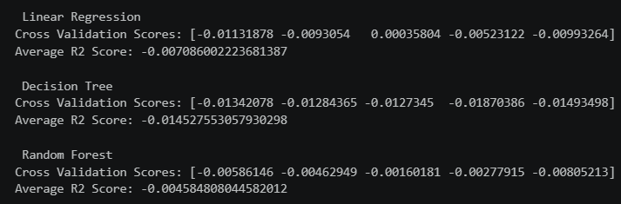
The average cross-validation R² score was calculated for each algorithm.
Cross-validation provides a more reliable assessment of model performance than depending on a single train-test split.
Predicting Ratings for New Products
After training the Random Forest model, a new product input was created using representative values from the available dataset.
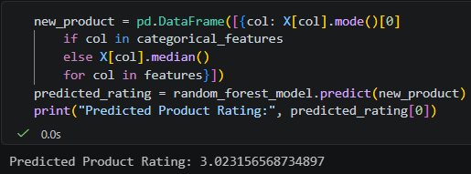
The trained model was used to generate a predicted rating for the new input.
This demonstrates how a trained Machine Learning model can be used to estimate product ratings for previously unseen combinations of product characteristics.
Business Applications and Insights
The predictive modeling approach can provide useful insights for businesses operating in the Beauty and Wellness industry.
Potential applications include:
- Understanding the relationship between product characteristics and customer ratings.
- Identifying product features that contribute to rating predictions.
- Supporting product performance analysis.
- Understanding customer satisfaction patterns.
- Assisting businesses in product evaluation and decision-making.
The results can help businesses explore how data-driven techniques can support better understanding of product performance.
However, predicted ratings should be treated as estimates rather than guaranteed customer feedback.
Challenges and Limitations
The predictive modeling process may involve several limitations:
- Limited dataset size may affect model generalization.
- Product ratings may depend on subjective customer preferences.
- Some important factors influencing ratings may not be available in the dataset.
- Similar evaluation results across models may indicate that the selected features provide limited predictive information.
- Regression models may produce predicted values outside the original rating range.
- The relationship between product price and customer ratings does not necessarily indicate causation.
These limitations should be considered when interpreting the model results.
Conclusion
This project explored the application of predictive modeling techniques in the Beauty and Wellness industry using a beauty and cosmetics products dataset.
Three supervised Machine Learning algorithms, namely Linear Regression, Decision Tree Regressor, and Random Forest Regressor, were implemented to predict product ratings.
The models were trained using an 80:20 train-test split and evaluated using MAE, MSE, RMSE, and R² Score. Additional analysis included Actual vs Predicted visualization, feature importance analysis, overfitting and underfitting assessment, and five-fold cross-validation.
The RMSE comparison indicated relatively similar performance among the three models in the current experiment. This highlights the importance of comparing multiple algorithms and evaluating their generalization before selecting a final model.
Overall, this phase provided practical experience in predictive modeling, algorithm selection, model training, evaluation, and interpreting Machine Learning outcomes in a real-world business context.
Future Scope: Further improvements can be explored through hyperparameter tuning, additional feature engineering, more relevant customer-related data, and experimentation with other Machine Learning algorithms to improve prediction performance.

