FUNCTIONS (Scenarios)

1. You are writing a billing system where tax and discount are optional. How would you design a function so that it works even if tax or discount is not passed?
Use default arguments so the function works even if values are not passed.
Default parameters allow optional inputs without breaking the function.

2. A function should return sum, average, and maximum of given numbers. How will you return multiple values from a function and receive them?
Python returns multiple values as a tuple.
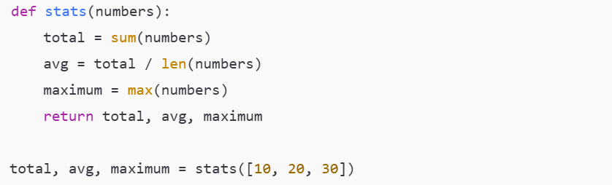
Tuple unpacking makes multiple return values clean and readable.

3. You want to restrict users from passing positional arguments for age and city. Which function design will you use and why?
Arguments after * must be passed as keywords, preventing positional misuse.

4. You have a function that modifies a list passed to it. How does Python handle mutable arguments inside functions?
Python passes references to mutable objects.
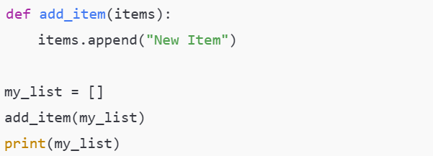
Changes inside the function affect the original list because lists are mutable.

5. You want to count how many times a function is called during program execution. Which type of variable scope will you use?
Use a global variable (or a function attribute).
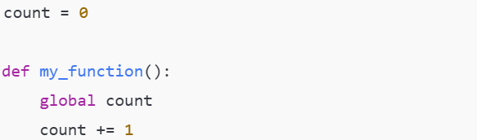
The value must persist across function calls.

6. A restaurant app receives any number of food items in an order. How would you design a function to accept unlimited food prices?
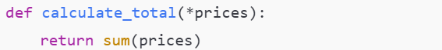
*args accepts any number of positional arguments.

7. You already have a list of prices but the function expects separate arguments. How will you pass the list correctly?
Use the unpacking operator.
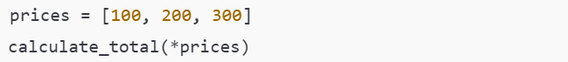
* expands the list into individual arguments.

8. What happens if you pass a list as a single argument to a function using *args?
The list becomes one element inside args.
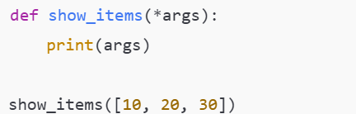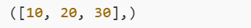

9. You want to print the first item separately and remaining items dynamically. How will you design the function using *args?
Combine normal parameters with *args.
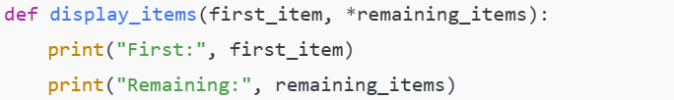

**kwargs SCENARIOS
10. A user profile system stores optional fields like age, city, phone. How will you design a function to accept any optional details?
Use **kwargs.
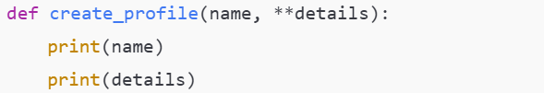
Allows flexible keyword-based data.

11. You want to provide default values if some keyword arguments are missing. How will you handle this safely?
Use .get() on kwargs.
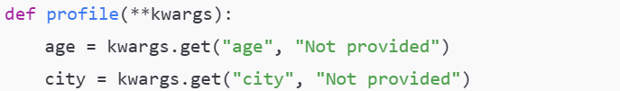
Prevents KeyError if keys are missing.

12. How will you pass a dictionary to a function that expects **kwargs?
Use dictionary unpacking.
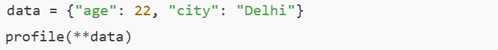
LAMBDA EXPRESSIONS (Scenarios)
13. You have a list of students and want to sort them by marks quickly without defining a full function. What will you use and why?
Use a lambda expression with sorted() or list.sort().
- Lambda provides a short, inline anonymous function
- Ideal for one-time logic like sorting
- Avoids unnecessary function definitions

14. You need to filter all even numbers from a list and then square them in one flow. Which combination of functions will you use?
Use filter() + map() with lambda (or a list comprehension, which is often clearer)
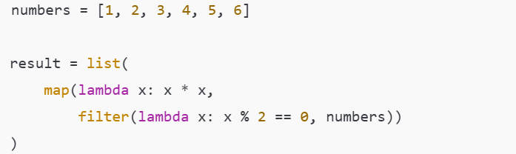
- filter() keeps only even numbers
- map() transforms each even number by squaring it
- Lambdas keep logic compact
LISTS & TUPLES (Scenarios)
15. Your program crashes with: TypeError: 'tuple' object is not callable What is the most common cause of this error when working with lists of tuples?
The most common cause of this error when working with lists of tuples is using parentheses () instead of square brackets [] to access tuple elements.
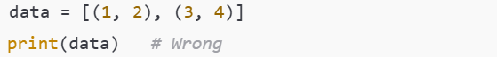
Here, Python thinks data[0] (which is a tuple) is being called like a function, which is not allowed.
Correct way:
Other frequent causes to double-check:
- Overwriting a function name with a tuple
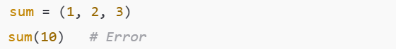
- Trying to access tuple elements using function-call syntax
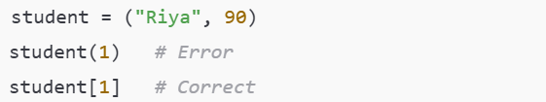
- Parentheses () are used for function calls
- Square brackets [] are used for indexing lists and tuples

- Mohit Gadhvi (VWGDS107295)

