# A PROJECT REPORT ON

“SMART TRAFFIC DETECTION”

Submitted in partial fulfilment of the requirements for the award of the degree of

# MASTER OF COMPUTER APPLICATIONS

**Submitted**

**BY**

**Nadukuru Sai santoshi**

**Regd. No:2251926019**

Under the esteemed guidance of

**Dr. G. Rama Krishna, M. Tech, Ph. D**

**Assistant Professor**



# DEPARTMENT OF COMPUTER SCIENCE AND ENGINEERING

**COLLEGE OF ENGINEERING**

# Dr. B. R. AMBEDKAR UNIVERSITY, SRIKAKULAM

**2023-2024**

DEPARTMENT OF COMPUTER SCIENCE AND ENGINEERING COLLEGE OF ENGINEERING

Dr. B.R. AMBEDKAR UNIVERSITY, SRIKAKULAM



CERTIFICATE

This is to certify that the project entitled “**SMART TRAFFIC DETECTION”** that is being submitted by **NADUKURU SAI SANTOSHI (2251926019)** in partial fulfilment of requirements for the award of the degree in **MASTER OF COMPUTERAPPLICATIONS** during 2022 - 2024, in **Dr. B. R. AMBEDKAR UNIVERSITY, SRIKAKULAM, COLLEGE OF ENGINEERING** is a record of bonafide work carried out by him under our guidance and supervision. The results embodied in this work have not being submitted to any other university or institute for the award of any degree or diploma.

|  |  |
| --- | --- |
| **SUPERVISOR** | **HEAD OF THE DEPARTMENT** |
| Dr. G. RAMAKRISHNA M. Tech., Ph .D. | Sri. R.SRIDHAR M. Tech., Ph .D |

Assistant Professor Assistant professor

## External examiner

**DECLARATION**

I hereby declare that the project work entitled **“SMART TRAFFIC DETECTION”** submitted by me for the award of the degree of **MASTER OF COMPUTER APPLICATIONS, under the guidance of Dr. G.RAMAKRISHNA M. Tech, Ph.D., Assistant Professor.** Dr.B.R. AMBEDKAR UNIVERSITY, SRIKAKULAM. Is original and it has not been submitted earlier.

Place: Srikakulam NADUKURU SAI SANTOSHI

Date: Regd.No:2251926019

**AKNOWLEDGEMENT**

A Project is a golden opportunity for learning and self-development. Iconsider myself lucky and privileged to express my gratefulness and deep sense of gratitude and to our guide **Dr. G. RAMAKRISHNA M. Tech, Ph.D.., Assistant professor, Department of COMPUTER SCIENCE ANDENGINEERING,** for stimulating suggestions and encouragement that helped me at every stage of our project work, which made this project successful.

I also express my gratefulness gratitude to our **Dr. R.SRIDHAR M.Tech., Ph, D.,** Head of the Department of Computer Science and Engineering**, Dr. B.R. AMBEDKAR UNIVERSITY, SRIKAKULAM for** his support and encouragement throughout the project. I also express my gratefulness gratitude to our **Prof. Dr. Ch. RAJSEKHARA RAO M. Tech. Ph. D., Principal , College of engineering, Dr. B.R. AMBEDKAR UNIVERSITY, SRIKAKULAM for** his support and encouragement throughout the project. Further-more, I would also like to acknowledge my thankfulness with much appreciation the crucial role of our **TEACHING STAFF, NONTEACHING STAFF, PARENTS AND FRIENDS** for their love, support, encouragement and cooperation.

Place: Srikakulam NADUKURU SAI SANTOSHI

Date: Regd.No:2251926019

**ABSTRACT**

|  |  |  |
| --- | --- | --- |
|  |  |  |

The current methods used such as timers or human control are proved to be inferior to alleviate this crisis. In this project, a system to control the traffic by measuring the real-time vehicle density using canny edge detection with digital image processing is proposed. This imposing traffic control system offers significant improvement in response time, vehicle management, automation, reliability and overall efficiency over the existing systems. As the problem of urban traffic congestion intensifies, there is a pressing need for the introduction of advanced technology and equipment to improve the state-of-the-art of traffic control. Besides that, the complete technique from image acquisition to edge detection and finally green signal allotment using four sample images of different traffic conditions is illustrated with proper schematics and the final results are verified by hardware implementation.

KEYWORDS : Inferior to alleviate this crisis, Image processing ,Canny edge detection

|  |  |  |
| --- | --- | --- |
| **S. No** | **TABLE OF CONTENTS** | **PAGE-NO** |
|  |  |  |
| 1 | **DECLARATION** |  |
| 2 | **ACKNOWLEDGEMENT** |  |
| 3 | **ABSTRACT** |  |
| 4 | **List of Figures** |  |
| 5 | **Chapter 1. INTRODUCTION** | **1-5** |
|  | 1.1. Overview | 1 |
|  | 1.2. Survey | 3 |
| 6 | **Chapter 2. LITERATURE SURVEY** | **6-7** |
| 7 | **Chapter 3. SYSTEM ANALYSIS** | **8-12**  8  9  10  12 |
|  | 3.1.Existing systems  3.1.1 Proposed systems |
|  | 3.2. System Requirements  3.2.1 Hardware requirements  3.2.2 Software requirements |
| 8 | **Chapter 4. SYSTEM STUDY** | **13-35** |
|  | 4.1 Feasibility Study  4.1.1 Economic Feasibility  4.1.2 Technical Feasibility  4.1.3 Social Feasibility |  |

|  |  |  |
| --- | --- | --- |
| 9 | **Chapter 5. SYSTEM DESIGNING**   * 1. System Architecture   2. UML diagram   5.2.1 Class Diagram  5.2.2 Use case Diagram  5.2.3 Sequence Diagram  5.2.4 Activity Diagram | **51-56**  52-53  53-56 |
| 10 | **Chapter 6. IMPLEMENTATION**  6.1 Module  6.1.1 Image Pre Processing  6.1.2 Canny Edge Algorithm  6.1.3 White Pixel Count  6.1.4 Green Signal Time Allocation |  |

|  |  |  |
| --- | --- | --- |
| 11  12  13  14  15  16 | **Chapter 7. SOFTWARE ENVIRONMENT**  7.1 What is Python  7.2 Advantages of Python Over Other Languages  7.3 History of Python  7.4 Modules Used in Project  7.5 How to install Python on Windows and MAC  7.6 Background  7.7 What is IMAGE PROCESSING  7.8 What is an Image  **Chapter 8. SYSTEM TESTING**  8.1 Types of Testing  8.2 Acceptance Testing    **Chapter 9. SAMPLE CODE**  **Chapter 10. OUTPUT SCREENS**  **Chapter 11. CONCLUSIONS**  11.1 Scope and future work  **Chapter 12. References** | 58 |

|  |  |  |
| --- | --- | --- |
| **Figure No.** | **List Of Figures**  **Description** | **Page-No** |
| 1.1.1 | **Comparative analysis of distinct edge detection techniques** | 24 |
| 5.1.1 | **Block diagram of proposed density based smart traffic control system.** | 26 |
| 6.2.1 | **Drawing of a car** | 28 |
| 6.2.2 | **Edge detected output of (a) Image A and(b) reference image** | 10 |
| 6.2.3 | **Original image (left) — Blurred image with a Gaussian filter** | 12 |
| 6.2.4 | **Blurred image (left) — Gradient intensity (right)** | 30 |
| 6.2.5 | **Double Threshold** | 34 |
| 6.2.6 | **Non-Max Suppression image (left) — Threshold result (right): weak pixels in gray and strong ones in white.** | 38 |
| 6.2.7 | **Results of hysteresis process** | 39 |
|  |  |  |

## INTRODUCTION

#### Overview

Traffic congestion is one of the major modern-day crisis in every big city in the world. Recent study of World Bank has shown that average vehicle speed has been reduced from 21 km to 7 kmper hour in the last 10 years in Dhaka [1]. Inter metropolitan area studies suggest that traffic congestion reduces regional competitiveness and redistributes economic activity by slowinggrowth in county gross output or slowing metropolitan area employment growth [2].As more and more vehicles are commissioning in an already congested traffic system, there is an urgent need for a whole new traffic control system using advanced technologies to utilize the already existent infrastructures to its full extent. Since building new roads, flyovers, elevated expressway etc. needsextensive planning, huge capital and lots of time; focus should be directed upon availing existing infrastructures more efficiently and diligently. Previously different techniques had been proposed,such as infra-red light sensor, induction loop etc. to acquire traffic date which had their fair share of demerits. In recent years, image processing has shown promising outcomes in acquiring real time traffic information using CCTV footage installed along the traffic light. Different approaches have been proposed to glean traffic data. Some of them count total number of pixels [3], some of the work calculate number of vehicles [4- 6].These methods have shown promising results in collecting traffic data. However, calculating the number of vehicles may give false results if the intravehicular spacing is very small (two vehicles close to each other may be counted as one) and it may not count rickshaw or auto- rickshaw as vehicles which are the quotidian means of traffic especially in South- Asian countries. And counting number of pixels has disadvantage of counting insubstantial materials as vehicles such as footpath or pedestrians. Some of the work have proposed to allocate time based solely on the density of traffic. But this may be disadvantageous for those who are in lanes that have less frequency of traffic. Edge detection technique is imperative to extract the required traffic

information from the CCTV footage. It can be used to isolate the required information from rest of the image. There are several edge detection techniques available. They have distinct characteristics in terms of noise reduction, detection sensitivity, accuracy etc. Among them, Prewitt [7], canny [8],Sobel [9], Roberts and LOG are most accredited operators. It has been observed that the Canny edge detector depicts higher accuracy in detection of object with higher entropy, PSNR(Peak Signal to Noise Ratio), MSE(Mean Square Error) and execution time

compared with Sobel, Roberts, Prewitt, Zero crossing and LOG [10-12].Here is a comparison between distinct edge detection techniques.

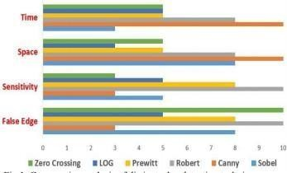

Fig 1.1 Comparative analysis of distinct edge detection techniques

**I**NDIA is the second most populous Country in the World and is a fast growing economy. It is seeing terrible road congestion problems in its cities. Infrastructure growth is slow as compared to the growth in number of vehicles, due to space and cost constraints [1]. Also, Indian traffic is non lane based and chaotic. It needs a traffic control solutions , which are different from the developed Countries. Intelligent management of traffic flows can reduce the negative impact of congestion. In recent years, wireless networks are widely used in the road transport as they provide more cost effective options [2]. Technologies like ZigBee, RFID and GSM can be used in traffic control to provide cost effective solutions. RFID is a wireless technology that uses radio frequency electromagnetic energy to carry information between the RFID tag and RFID reader. Some RFID systems will only work within the range inches or centimeters, while others may work for 100 meters (300 feet) or more. A GSM

modem is a specialized type of modem, which accepts a SIM card and operates over a subscription to a mobile operator, just like a mobile phone. AT commands are used to control modems. These commands come from Hayes commands that were used by the Hayes smart modems. The ZigBee operates at low-power and can be used at all the levels of work configurations to perform predefined tasks. It operates in ISM bands (868 MHz in Europe, 915 MHz in USA and Australia, 2.4 GHz in rest of the world). Data transmission rates vary from 20 Kilobits/second in the 868 MHz frequency band to 250 Kilobits/second in the 2.4 GHz frequency band [3], [4]. The ZigBee uses 11 channels in case of 868/915 MHz radio frequency and 16 channels in case of 2*.*4 GHz radio frequency. It also uses 2 channel configurations, CSMA/CA and slotted CSMA/CA [5].

#### Survey

Traffic congestion is a major problem in cities of developing Countries like India. Growth in urban population and the middle-class segment contribute significantly to the rising number of vehicles in the cities [6]. Congestion on roads eventually results in slow moving traffic, which increases the time of travel, thus stands-out as one of the major issues in metropolitan cities. In [7], green wave system was discussed, which was used to provide clearance to any emergency vehicle by turning all the red lights to green on the path of the emergency vehicle, hence providing a complete green wave to the desired vehicle. A ‘green wave’ is the synchronization of the green phase of traffic signals. With a ‘green wave’ setup, a vehicle passing through a green signal will continue to receive green signals as it travels down the road. In addition to the green wave path, the systemwill track a stolen vehicle when it passes through a traffic light. Advantage of the system is that GPS inside the vehicle does not require additional power. The biggest disadvantage of green wavesis that, when the wave is disturbed, the disturbance can cause traffic problems that can be exacerbated by the synchronization. In such cases, the queue of vehicles in a green wave grows insize until it becomes too large and some of the vehicles cannot reach the green lights in time and must stop. This is called over-saturation [12], [13]. In [8], the use of RFID traffic control to avoidproblems that usually arise with standard traffic control systems, especially those related to imageprocessing and beam interruption techniques are discussed. This RFID technique deals with multivehicle, multilane, multi road junction areas. It provides an efficient time management scheme, in which, a dynamic time schedule is worked out in real time for the passage of each traffic column. The real-time operation of the system emulates the judgment of a traffic policeman on duty. The number of vehicles in each column and the routing are proprieties, upon which the calculations and the judgments are done. The disadvantage of this work is that it does not discuss what methods are used for communication between the emergency vehicle and the traffic signal controller. In [9], it proposed a RFID and GPS based automatic lane clearance system for ambulance. The focus of this work is to reduce the delay in arrival of the

ambulance to the hospital by automatically clearing the lane, in which, ambulance is travelling, before it reaches the traffic signal. This can be achieved by turning the traffic signal, in the path of the ambulance, to green when the ambulance is at a certain distance from the traffic junction. The use of RFID distinguishes between the emergency and non-emergency cases, thus preventing unnecessary traffic congestion. The communication between the ambulance and traffic signal post is done through the transceivers and GPS. The system is fully automated and requires no human intervention at the traffic junctions. The disadvantage of this system is it needs all the information about the starting point, end point of the travel. It may not work, if the ambulance needs to take another route for some reasons or if the starting point is not known in advance. Traffic is a critical issue of transportation system in most of all the cities of Countries. This is especially true for Countries like India and China, where the population is increasing at higher rate as show in figure 1. For example, Bangalore city, has witnessed a phenomenal growth in vehicle population in recent years. As a result, many of the arterial roads and intersections are operating over the capacity (i.e., v/c is more than 1) and average journey speeds on some of the key roads in the central areas are lower than 10 Km/h at the peak hour. In [10], some of the main challenges are management of more than 36,00,000 vehicles, annual growthof 7– 10% in traffic, roads operating at higher capacity ranging from 1 to 4, travel speed less than 10 Km/h at some central areas in peak hours, insufficient or no parking space for vehicles, limited number of policemen. In [11], currently a video traffic surveillance and monitoring system commissioned in Bangalore city. It involves a manual analysis of data by the traffic management team to determine the traffic light duration in each of the junction. It will communicate the same to the local police officers for the necessary actions.

## LITERATURE SURVEY

**In “Violation detection method for vehicular ad hoc networking,”** Every hour, nearly 40 people under the age of 25 die in road accidents around the world. According to the World Health Organization, this is the second most important cause of death for 5- to 29-year-olds. In India, drunk driving and inefficient law enforcements are major contributing factors. The current system of visual identification of traffic violation, conducted by the traffic authorities, cannot work everywhere and every time. There is a great demand for simple and cost-

effect violat

|  |  |
| --- | --- |
| ive solutions to | traffic safety problem |
| ion detection technique for vehicular | |

. In this paper, we propose a traffic ad hoc networks to detect crossing

speed limits and analyzing the behavior of driver. In this work, we used a sensor device, a digital map and GPS-based system for area of 1000 m × 1000 m. We analyzed the behavior of each vehicle in the network. Here, we have divided a network into a number of clusters, and each cluster has an infrastructure node (base station); the infrastructure node will be the point of contact for all the vehicles in that area. All infrastructure nodes communicate with a control center (master control room). If the driver violates traffic rule(s), thenthe infrastructure node will send an alert message to the control center. We have simulated our proposed model on a graphics package, and the simulation result suggests that drunken drivers can no longer escape from the law enforcers, which is the foundation for traffic safety.

**In “Traffic light control in non-stationary environments based on multi agent Q-learning,”** In many urban areas where traffic congestion does not have the peak pattern, conventional trafficsignal timing methods does not result in an efficient control. One alternative is to let traffic signal controllers learn how to adjust the lights based on the traffic situation. However this creates a classical non-stationary environment since each controller is adapting to the changes caused by other controllers. In multi-agent learning this is likely to be inefficient and computationally challenging, i.e., the efficiency decreases with the increase in the number of agents (controllers). In this paper, we model a relatively large

traffic network as a multi-agent system and use techniques from multi-agent reinforcement learning. In particular, Q-learning is employed, wherethe average queue length in approaching links is used to estimate states. A parametric representation of the action space has made the method extendable to different types of intersection. The simulation results demonstrate that the proposed Q- learning outperformed the fixed time method under different traffic demands.

**In “A novel approach to implement green wave system and detection of stolen vehicles”** In today's world, traffic jams during rush hours is one of the major concerns. During rush hours, emergency vehicles like Ambulances, Police cars and Fire Brigade trucks get stuck in jams. Due to this, these emergency vehicles are not able to reach their destinations in time, resulting into a loss of human lives. We have developed a system which is used to provide clearance to any emergency vehicle by turning all the red lights to green on the path of the emergency vehicle, hence providing a complete green wave to the desired vehicle. A `green wave' is the synchronization of the green phase of traffic signals. With a `green wave' setup, a vehicle passingthrough a green signal will continue to receive green signals as it travels down the road. Around the world, green waves are used to great effect. Often criminal or terrorist vehicles have to be identified. In addition to the green wave path, the system will track a stolen vehicle when it passesthrough a traffic light. In contrast to any traditional vehicle tracking system, in which the Global Positioning System (GPS) module requires battery power, our tracking system, installed inside the vehicle, does not require any power. The information regarding the vehicle has to be updated in the system database. So, it is an autonomous 2-tier system which will help in the identification of emergency vehicles or any other desired vehicle. It is a novel system which can be used to implement the concept of the green wave.

**In “Traffic light priority control for emergency vehicle using RFID,”** The proposed RFID traffic control avoids problems that usually arise with standard traffic control systems, especially those related to image processing and beam interruption techniques. This RFID technique deals with a multivehicle, multilane, multi road junction area. It provides an efficient time management scheme, in which a dynamic time schedule is worked out in real time for the passage of each trafficcolumn. The real time operation of the system emulates the judgment of a traffic policeman on duty. The number of vehicles in each column and the routing are proprieties, upon which the calculations and the judgments are based. Keywords-EV (Emergency vehicle),PIC (Priority Intersection Control),RFID TAGS, VTL (Virtual traffic light).

**In “RFID and GPS based automatic lane clearance system for ambulance,”** The exponential growth of the metropolitan cities of the country has generated and magnified urban sprawl into problematic proportions. Lack of efficient traffic control and management has many a times lead to loss of lives due to ambulances getting stuck in traffic jams. To overcome this problem, we propose a RFID and GPS based Automatic Lane Clearance System for Ambulance. The focus of this paper is to reduce the delay in arrival of the ambulance to the hospital by automatically clearingthe lane in which ambulance is travelling, before it reaches the traffic signal. This can be achievedby turning the traffic signal, in the path of the ambulance, to green when the ambulance is at a certain distance from the traffic junction. The use of RFID distinguishes between the emergency and non-emergency cases, thus preventing unnecessary traffic congestion. The communication between the ambulance and the traffic signal post is done through transceivers and GPS. The system is fully automated and thus, requires no human intervention at the traffic junctions Bangalore has grown exponentially in the past two decades. Improvement in the quality of life along with substandard public transportation has resulted in spiralling growth of private automobiles. The resultant offshoot of such a high automobile growth is that now Bangalore is oneof the most accident-prone cities in India [1].

Moreover, the ambulances often get stuck at the traffic signals where all other vehicles try to squeeze in to all the available space so as to move ahead as soon as the signal turns green. Unlike western countries, Indian cities cannot think of having separate lanes for emergency purpose due to lack of road planning and infrastructure. Withthe lives of the patients depending on the speedy arrival of the ambulances to hospital, an alternative solution to the above problem is the need of the hour. The problem of ambulance gettingstuck in a traffic jam can be addressed by ensuring that the lane in which the ambulance is travelling is cleared. That is, the arrival of the ambulance is to be communicated to the nearest traffic signal, so that it can turn the light to green and hence clear the traffic. However, all the ambulances will not be carrying emergency cases. Hence, the traffic clearing system, if done for all the ambulances, will certainly pose a traffic problem. To overcome this difficulty, we propose to make a system combining RFID (Radio Frequency Identification) and GPS.

###### IN “M. SWEET, “TRAFFIC CONGESTION’S ECONOMIC IMPACTS: EVIDENCE FROM US METROPOLITAN REGIONS,” URBAN STUDIES, VOL. 51, NO. 10, PP. 2088–

**2110, OCT. 2013.”** Traffic congestion alleviation has long been a common core transport policy objective, but it remains unclear under which conditions this universal byproduct of urban life alsoimpedes the economy. Using panel data for 88 US metropolitan statistical areas, this study estimates congestion’s drag on employment growth (1993 to 2008) and productivity growth per worker (2001 to 2007). Using instrumental variables, results suggest that congestion slows job growth above thresholds of approximately 4.5 minutes of delay per one-way auto commute and11,000 average daily traffic (ADT) per lane on average across the regional freeway network. While higher ADT per freeway lane appears to slow productivity growth, there is no evidence of congestion-induced travel delay impeding productivity growth. Results suggest that the strict policy focus on travel time savings may be misplaced and, instead, better outlooks for managing congestion’s economic drag lie in prioritising the economically most important trips (perhaps through road pricing) or in providing alternative travel capacity to

enable access despite congestion. Planners and policy-makers use both congestion alleviation and mitigating congestion’s economic drag as core justifications for publicly desired and politically favoured transport programmes. Yet while congestion and its potential costs serve as powerful discourses to frame transport policy debates, the precise relationship between road gridlock and economic outcomes is unclear. This research contributes empirically to this gap. Does congestion impede the prospects of a regional economy? Economic and travel behaviour theories reason that congestion is a diseconomy and is inconvenient, but little research explores the more extensive impact of congestion (and congestion alleviation policy) on second-order outcomes, including the economy. This study uses panel data models to estimate congestion’s drag on economic growth in comparison with other explanations of economic outcomes. Understanding the link between congestion and the economy is critical to improving the leveraging of transport and land use policy to support more fundamental social objectives. US federal legislation explicitly identifies congestion reduction and economic support as primary surface transport policy objectives. Yet research on the link between congestion and economic growth is conflicted. The largest urban economies are also among the most congested. Many suggest that traffic congestion reduces city competitiveness and that only peak-period pricing, a highly unpopular tool, can reduce congestion to increase economic function (Boarnet, 1997; Hymel, 2009; Winston and Langer, 2006). Others question the assumption that congestion is an indicator of unsuccessful places and poor social outcomes (Mondschein et al., 2009; Taylor, 2002) or whether long-term congestion alleviation is feasible (Downs, 1992). Instead, the extent and conditions under which congestion impedes social outcomes remain unclear and effective politically acceptable solutions to this murky problem remain even more elusive. There are many important causes of economic growth, of which this study focuses on traffic congestion’s potential drag on regional employment growth and productivity growth per worker. Each of these two metrics of economic activity contributes to total productivity (the sum of employment and productivity per worker), thereby focusing on how

congestion might influence regional economic growth by either impeding worker productivity or slowing the hiring of new workers. Existing literature on congestion’s diseconomy focuses on different scales at which congestion can potentially slow economic growth (within or between regions). Road congestion is an external byproduct of other common causes of economic growth, including big-city agglomeration benefits, social preferences and affluence, urban spatial structure, and municipal governance and therefore separating ‘good’ from ‘bad’ congestion is challenging Research on congestion’s economic consequences explores differences in regional or firm productivity, city growth and relocation responses by individuals and firms. The relationship between metropolitan economic activity and traffic congestion is complex and unclear (Taylor, 2002). Large regional economies lead to more congestion, while congestion may impede economic activities by degrading mobility services. Travel is a direct economic input which also leads to thecongestion externality. In econometrics, this issue is called endogeneity and captures the methodological challenges of separating the competing benefits of big-city access and dense travelpatterns from the drag of big-city road gridlock which raises travel costs or increases unreliability. Congestion reduces national (Fernald, 1999) and regional (Boarnet, 1997; Hymel, 2009) economic competitiveness across regions, but firms and workers adapt within regions through location decisions and bearing commuting burdens (Cervero, 1996; Gordon et al., 1989). Thus, while congestion can potentially lead to travel and economic inefficiencies, it is unclear under what circumstances urbanisation benefits and adaptations by individuals, firms or through policy can no longer outweigh congestion’s potential drag (Sweet, 2011). Intrametropolitan studies of traffic congestion’s economic consequences suggest that it shapes regional geographies, but that it is unclear whether resident and firm adjustments can overcome the impact of congestion on urban function. According to the co- location hypothesis, congestion simply induces employer-employeesuburban co- location (Crane and Chatman, 2003; Gordon et al., 1989; Levinson and Kumar, 1994). In contrast, empirical research on job–housing imbalance (Cervero, 1996; Cervero and Wu, 1998; Schwanen et al., 2004) suggests significant commuting

burdens while theoretical urban economic models likewise imply congestion- induced urban economic inefficiencies (Arnott, 2007; Anas and Xu, 1999; Fujita and Thisse, 2002; Weisbrod, Vary, and Treyz, 2001), most notably by reducing agglomeration benefits (Graham, 2007). Moreover, research suggests industry- variant sensitivity to congestion’s potential drag—most notably, service industries are least sensitive while manufacturing industries are most sensitive, indicating that industry mix is important.

Intermetropolitan area studies suggest that traffic congestion reduces regional competitiveness andredistributes economic activity by slowing growth in county gross output (Boarnet, 1997) or slowing metropolitan area employment growth (Hartgen and Fields, 2009; Hymel, 2009). Boarnet (1997) finds that congestion reduces productivity in California counties. Similarly, using panel data for major American metropolitan areas, Hymel (2009) finds that higher congestion leads to slower employment growth, but that its short-term job growth impacts are stronger than those over the longer term—implying regional adaptation. Thus, while intrametropolitan studies suggest that firms and residents adapt to congestion, intermetropolitan studies suggest that such adaptations may not overcome congestion’s regionally scaled drag.

**IN “MD. MUNIR HASAN, GOBINDA SAHA, AMINUL HOQUE AND MD. BADRUDDOJA MAJUMDER, “SMART TRAFFIC CONTROL SYSTEM WITH APPLICATION OF IMAGE PROCESSING TECHNIQUES,”IN 3RD INTERNATIONAL CONFERENCE INFORMATICS, ELECTRONICS & VISION, DHAKA, MAY 2014.”** In this paper we propose a method for determining traffic congestion on roads using image processing techniques and a modelfor controlling traffic signals based on information received from images of roads taken by video camera. We extract traffic density which corresponds to total area occupied by vehicles on the roadin terms of total amount of pixels in a video frame instead of calculating number of vehicles. We set two parameters as output, variable traffic cycle and weighted time for each road based on traffic density and control traffic lights in a sequential manner.Traffic congestion has become a major problem in every large city of the

world. To ensure a reliable transportation system it is important to have an intelligent traffic control system. The very first step to do that is to acquire traffic data. Traffic data may come from different sensors. Some examples are use of induction loop, infra-red light sensor, optical flow etc. However in recent days image processing techniques [1] has been very important and promising topic to deal with traffic related problems because of its ease of maintenance and being more intelligent system. Different techniques [2]– [5] have been proposed to acquire traffic information. Most of the work detects edge of the vehicles and counts the numberof traffic on the road. However the disadvantage of the method is that counting the number of vehicles may give faulty results when space between the vehicles on the road are very small (i.e. two cars very close to each other may be counted as one vehicle). Moreover most of the methods treat only cars as traffic but in many part of the world rickshaws, autorickshaws, bikes are major part of everyday traffic such as in south asian countries. In this paper we propose a method that finds out total amount of pixels in a video frame which corresponds to the amount of area of occupied by vehicles on the road rather than finding number of vehicles. The greater the amount of area occupied by vehicles on the road the greater the amount of traffic congestion. This way every kind of vehicles can be accounted for traffic density. Using this traffic data we propose a model for traffic signal control depending on the amount of traffic on the road. Time allocated for each road is made variable by weighing its time allocation depending on the traffic density In thissection we present a process of extracting traffic information from image. We assume that a video camera, placed at appropriate position, is employed for image accusation. From the camera video stream data is processed frame by frame. Our goal is to determine how much traffic is on the road.The amount of traffic will be termed Traffic Density in this paper. To accomplish this task we will use background subtraction method [6]. The background subtraction method is particularly suitable for detecting a foreground objects on fixed background. Here the empty road will be the background image and subsequent frames from the video camera will be the foreground image. By subtracting background image from the foreground image

we can find out traffic density present in a frame. We present two methods to find traffic density and both methods will be used simultaneously. One is using gradient magnitude and other using direct subtraction.

**IN “VISMAY PANDIT, JINESH DOSHI, DHRUV MEHTA, ASHAY MHATRE AND ABHILASH JANARDHAN, “SMART TRAFFIC CONTROL SYSTEM USING IMAGE PROCESSING,”INTERNATIONAL JOURNAL OF EMERGING TRENDS & TECHNOLOGY IN COMPUTER SCIENCE (IJETTCS), VOL. 3,**

**ISSUE 1, JANUARY – FEBRUARY 2014”** –The fact

is that, the population of city and numbers of vehicles on the road are increasing day by day. Withincreasing urban population and hence the number of vehicles, need of controlling streets, highways and roads is major issue. The main reason behind today’s traffic problem is the techniques that are used for traffic management. Today’s traffic management system has no emphasis on live traffic scenario, which leads to inefficient traffic management systems. This project has been implemented by using the Mat lab software and it aims to prevent heavy traffic congestion. Moreover, for implementing this project Image processing technique is used. At first, film of a lane is captured by a camera. A web camera is placed in a traffic lane that will capture images of the road on which we want to control traffic. Then these images are efficiently processed to know the traffic density. According to the processed data from mat lab, the controller will sendthe command to the traffic LEDs to show particular time on the signal to manage traffic. Fast transportation systems and rapid transit systems are nerves of economic developments for any nation. Mismanagement and traffic congestion results in long waiting times, loss of fuel and money. It is therefore utmost necessary to have a fast, economical and efficient traffic control system for national development. The monitoring and control of city traffic is becoming a major problem in many countries. With the ever increasing number of vehicles on the road, the Traffic Monitoring Authority has to find new methods of overcoming such a problem. One way to improve traffic flow and Safety of the current transportation system is to apply automation and Intelligent control methods. As the Number of road users constantly increases, and resources

provided by current infrastructures are limited, intelligent control of traffic will become a very important issuein the future [1]. Traffic congestion may result due to heavy traffic at a junction. To avoid congestion there are so many traffic management techniques available. But no technique is perfectby itself as the real time situations are generally continuously changing and the system has to adapt itself to change in the continuously changing circumstances. We have made an attempt to provide some traffic management strategy which is self-changing in nature, so as to fit into continuously changing real time traffic scenarios. In this system time is assigned to traffic light of particular lane according to the traffic density on the road with priority given to ambulance. Also we can indicate signal break in a particular lane. If there is an obstacle LCD is used to display the message of obstacle detection to avoid inconvenience. Objective of proposed system is to improve efficiency of existing automatic traffic signalling system. The system will be image processing based adaptive signal controlling. The timing will be calculated each time change automatically depending upon the traffic load. Proposed system will be functioning based on traditional system along with automated signalling. System will have artificial vision with the help of digital camera mounted on motor for its rotation to face lanes and sense the traffic on the road. The camera is controlled by PC through microcontroller to change its direction in steps of 90 degree to face eachlane and capture image. This single image of lane will be processed using image processing techniques to estimate traffic load. Estimated traffic load on particular road will be used to calculate the required time duration for controlling of signal lights based on in comparison with experimental results. System will be intelligent and will calculate the time every time and operate in a cyclic clockwise signal lights control. Maximum and minimum time limit will be maintained to prevent over waiting of vehicle in queue of other lanes which would be found out experimentally. Controls of the signal will be routed through the microcontroller. MATLAB programming will be used for simulating and developing the proposed system. The signal will becontrolled by interrupting the normal functioning.The emergency will set the priority and the requested lane

will be open closing all others. After emergency is removed the system starts normal functioning. The main aim in designing and developing of the Smart Traffic Signal Simulator is to reduce the waiting time of each lane of the cars and also to maximize the total number of cars that can cross an intersection given the mathematical function to calculate the waiting time. The traffic signal system consists of three important parts. The first part is the controller which represents the brain of the traffic system.

###### IN “PALLAVI CHOUDEKAR, SAYANTI BANERJEE AND M. K. MUJU, “IMPLEMENTATION OF IMAGE PROCESSING IN REAL TIME TRAFFIC LIGHT CONTROL,” IN3RD INTERNATIONAL CONFERENCE ON ELECTRONICS COMPUTER TECHNOLOGY,

**APRIL, 2011.” —** As the problem of urban traffic congestion spreads, there is a pressing need for the introduction of advanced technology and equipment to improve the state-of-the-art of traffic control. Traffic problems nowadays are increasing because of the growing number of vehicles and the limited resources provided by current infrastructures. The simplest way for controlling a traffic light uses timer for each phase. Another way is to use electronic sensors in order to detect vehicles, and produce signal that cycles. We propose a system for controlling the traffic light by image processing. The system will detect vehicles through images instead of using electronic sensors embedded in the pavement. A camera will be installed alongside the traffic light. It will capture image sequences. Setting image of an empty road as reference image, the captured images are sequentially matched using image matching. For this purpose edge detection has been carried out using Prewitt edge detection operator and according to percentage of matching traffic light durations can be controlled. Automatic traffic monitoring and surveillance are important for road usage and management. Traffic parameter estimation has been an active research area for the development of intelligent Transportation systems (ITS). For ITS applications traffic- information needs to be collected and distributed. Various sensors have been employed to estimate traffic parameters for updating traffic information. Magnetic loop detectors have been the most used technologies, but

their installation and maintenance are inconvenient and might become incompatible with future ITS infrastructure. It is well recognized that vision- based camera system are more versatile for traffic parameter estimation [l,4]. In addition to qualitative description of road congestion, image measurement can provide quantitative analysis.

## SYSTEM ANALYSIS

#### Existing System

Edge detection technique is imperative to extract the required traffic information from the CCTV footage. It can be used to isolate the required information from rest of the image. There are several edge detection techniques available. They have distinct characteristics in terms of noise reduction, detection sensitivity, accuracy etc. Among them, Prewitt [7], canny [8],Sobel [9], Roberts and LOG are most accredited operators. It has been observed that the Canny edge detector depicts higher accuracy in detection of object with higher entropy, PSNR(Peak Signal to Noise Ratio), MSE(Mean Square Error) and execution time compared with Sobel, Roberts, Prewitt, Zero crossing and LOG [10- 12].Here is a comparison between distinct edge detection techniques [13].

To implement this technique we are uploading current traffic image to the application and application will extract edges from images and if there is more traffic then there will be more number of edges with white colour and if uploaded image contains less traffic then it will have less number of white colour edges.

#### Proposed System

In this paper, a system in which density of traffic is measured by comparing captured image withreal time traffic information against the image of the empty road as reference image is proposed. Here, in figure 1, the block diagram for proposed traffic control technique is illustrated.

Each lane will have a minimum amount of green signal duration allocated. According to the percentage of matching allocated traffic light duration can be controlled. The matching is achieved by comparing the number of white points between two images. The entire image processing beforeedge detection i.e. image acquisition, image resizing, RGB to gray conversion and noise reduction is explained in section II. At section III, canny edge detection operation and white point count aredepicted. Canny edge detector operator is selected because of its greater overall performance.

#### Advantages :-

It is advantageous to convert RGB images into grayscale for further processing. When convertingan RGB image to grayscale, it is pertinent to consider the RGB values for each pixel and make asoutput a single value reflecting the brightness of that pixel. One of the approaches is to take the average of the contribution from each channel:(R+B+C)/3.

Advantages of proposed traffic control system have been demonstrated. for this purpose, four sample images of different traffic scenario have been attained. upon completion of edge detection, the similarity between sample images with the reference image has been calculated.

Reduces noise in an image. noise reduction is one of the main use cases of gaussian smoothing. Easy to implement. no complicated algorithms with multiple nested for loops needed. ...

Lose fine image detail and contrast

## SYSTEM REQUIREMENTS

##### HARDWARE REQUIREMENTS:

* + - * System : Pentium dual core
      * PROCESSOR : I3.
      * Hard Disk : 40 GB.
      * Ram : 4GB.

##### SOFTWARE REQUIREMENTS:

* + - * Operating system : Windows.
      * Coding Language : python
      * Front end : Html ,CSS
      * Data Base : MYSQL

# SYSTEM STUDY

### FEASIBILITY STUDY

The feasibility of the project is analyzed in this phase and business proposal is put forth with a very general plan for the project and some cost estimates. During system analysis the feasibility study of the proposed system is to be carried out. This is to ensure that the proposed system is not a burden to the company. For feasibility analysis, some understanding of the major requirements for the system is essential.

Three key considerations involved in the feasibility analysis

* ECONOMICAL FEASIBILITY
* TECHNICAL FEASIBILITY
* SOCIAL FEASIBILITY

### ECONOMICAL FEASIBILITY

This study is carried out to check the economic impact that the system will have on the organization. The amount of fund that the company can pour into the research and development ofthe system is limited. The expenditures must be justified. Thus the developed system as well within the budget and this was achieved because most of the technologies used are freely available. Only the customized products had to be purchased.

### TECHNICAL FEASIBILITY

This study is carried out to check the technical feasibility, that is, the technical requirements of the system. Any system developed must not have a high demand on the availabletechnical resources. This will lead to high demands on the available technical resources. This willlead to high demands being placed on the client. The developed system must have a modest requirement, as only minimal or null changes are required for implementing this system

### SOCIAL FEASIBILITY

The aspect of study is to check the level of acceptance of the system by the user. This includes the process of training the user to use the system efficiently. The user must not feel threatened by the system, instead must accept it as a necessity. The level of acceptance by the userssolely depends on the methods that are employed to educate the user about the system and to makehim familiar with it. His level of confidence must be raised so that he is also able to make some constructive criticism, which is welcomed, as he is the final user of the system.

## SYSTEM DESIGN

### SYSTEM ARCHITECTURE

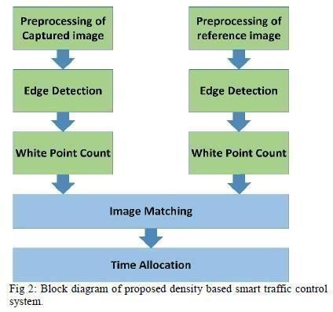

Fig 5.1 Block diagram of proposed density based smart traffic control system

* 1. **UML DIAGRAMS**

UML stands for Unified Modeling Language. UML is a standardized general-purpose modeling language in the field of object-oriented software engineering. The standard is managed, and was created by, the Object Management Group. The goal is for UML to become a common language for creating models of object orientedcomputer software. In its current form UML is comprised of two major components: a Meta-modeland a notation. In the future, some form of method or process may also be added to; or associatedwith, UML.

The Unified Modeling Language is a standard language for specifying, Visualization, Constructing and documenting the artifacts of software system, as well as for business modeling and other non-software systems.The UML represents a collection of best engineering practices that have proven successfulin the modeling of large and complex systems.

The UML is a very important part of developing objects oriented software and the softwaredevelopment process. The UML uses mostly graphical notations to express the design of softwareprojects.

GOALS:

The Primary goals in the design of the UML are as follows:

1. Provide users a ready-to-use, expressive visual modeling Language so thatthey can developand exchange meaningful models.
2. Provide extendibility and specialization mechanisms to extend the coreconcepts.
3. Be independent of particular programming languages and developmentprocess.
4. Provide a formal basis for understanding the modeling language.
5. Encourage the growth of OO tools market.
6. Support higherlevel development concepts such ascollaborations, frameworks, patternsand components.
7. Integrate best practices.

### CLASS DIAGRAM:

A Unified Modeling Langue (UML) class diagram is a sort of static structure diagram forsoftware engineering which describes the structure of a system by showing system classes , attributes , operations (or methods) and class relationships. This defines which class contains knowledge.

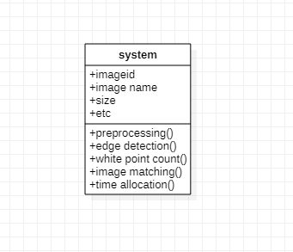

Fig 5.2.1 class diagram for image processing

### USE CASE DIAGRAM:

A use case diagram in the Unified Modeling Language (UML) is a type of behavioural diagram defined by and created from a Use-case analysis. Its purpose is to present a graphical overview of the functionality provided by a system in terms of actors, their goals (represented as use cases), and any dependencies between those use cases. The main purpose of a use case diagramis to show what system functions

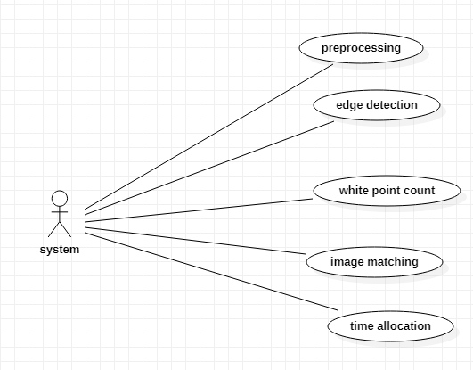

Fig 5.2.2 use case diagram for image processing

### SEQUENCE DIAGRAM:

A sequence diagram in Unified Modeling Language (UML) is a kind of interaction diagram that shows how processes operate with one another and in what order. It is a construct of a Message Sequence Chart. Sequence diagrams are sometimes called event diagrams, event scenarios, and timing diagrams

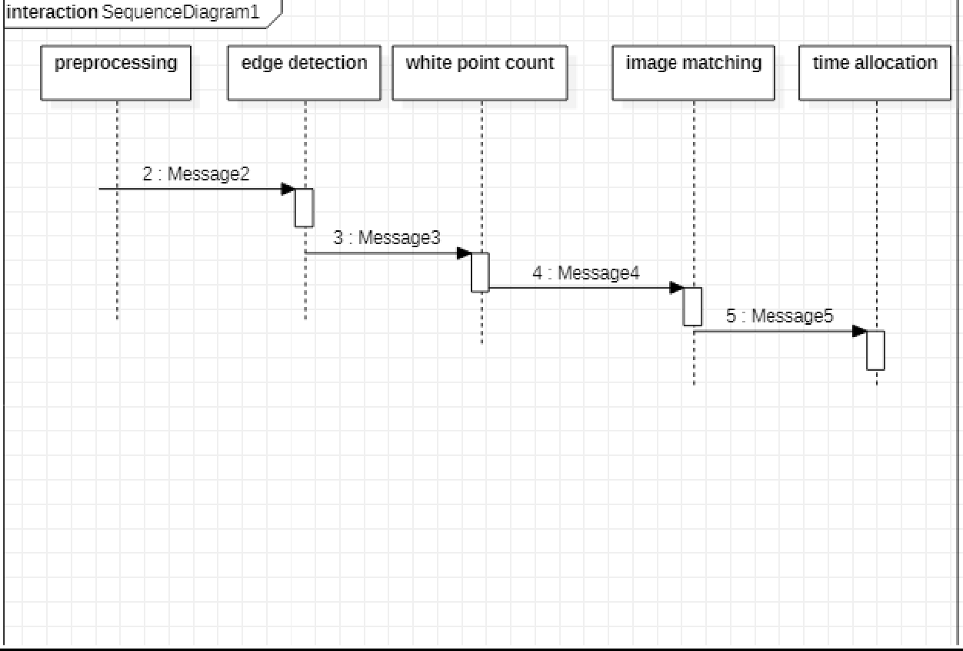

Fig 5.2.3 sequence diagram for image processing

### ACTIVITY DIAGRAM:

Activity diagrams are graphical representations of workflows of stepwise activities and actionswith support for choice, iteration and concurrency. In the Unified Modeling Language, activity diagrams can be used to describe the business and operational step-by-step workflows of components in a system. An activity diagram shows the overall flow of control.

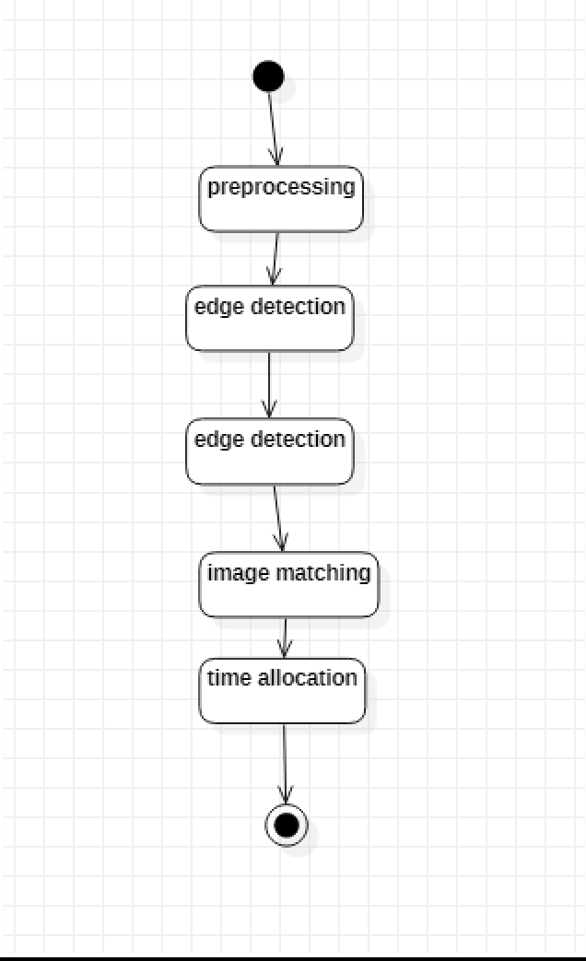

Fig 5.2.4 activity diagram for image processing

## 6. IMPLEMENTATION

* 1. **MODULES**

### 6.1.1 IMAGE PRE PROCESSING

Image preprocessing is performed to convert the raw images into more accessible form for edge detection purpose. At first, four images of different traffic scenario are selected and image of the empty road is chosen as reference image. All the images are then resized into 400*400 pixel using the following formula for constant spatial resolution and greater computational efficiency.

### 6.1.2 CANNY EDGE ALGORITHM

Edge detection our project we use “canny edge detection technique” because of its: low error rate single edge point response the canny edge detection algorithm consist of the following basic steps;

1. Smooth the input image with gaussian filter.
2. Compute the gradient magnitude and angle images.
3. Apply non-maxima suppression to the gradient magnitude image.
4. Use double thresholding and connectivity analysis to detect and link edges

### 6.1.3 WHITE PIXEL COUNT

Numpy provides a function sum() that returns the sum of all array elements in the numpy array. Thissum() function can be used to count the number of pixels on the basis of the required criteria.

Now, a bit of knowledge of the pixel patterns comes into the picture. as we know that each pixel in a coloured image ranges from [0-255] all-inclusive, The pixel value for the black color being 0 and that for the white color is 255. This gives us a certain fixed condition of differentiation for the blackand white pixels respectively from the other color pixels respectively.

### 6.1.4 GREEN SIGNAL TIME ALLOCATION

Avg = (sample_pixels/refrence_pixels) *100 //in this step we are getting average white pixels if avg

>= 90: //

if avg pixels > 90 percent then signal time will be 60 secs. similarly apply for all messagebox.showinfo("green signal allocation time","traffic is very high allocation green signaltime : 60 secs")

if avg > 85 and avg < 90: messagebox.showinfo("green signal allocation time","traffic is highallocation green signal time : 50 secs")

if avg > 75 and avg <= 85: messagebox.showinfo("green signal allocation time","traffic ismoderate green signal time : 40 secs")

if avg > 50 and avg <= 75: messagebox.showinfo("green signal allocation time","traffic is lowallocation green signal time : 30 secs")

if avg <= 50: messagebox.showinfo("green signal allocation time","traffic is very low allocationgreen signal time : 20 secs")

### ALGORITHM

###### CANNY EDGE DETECTION

When it comes to image classification, the human eye has the incredible ability to process an imagein a couple of milliseconds, and to determine what it is about (label). It is so amazing that it can do itwhether it is a drawing or a picture.

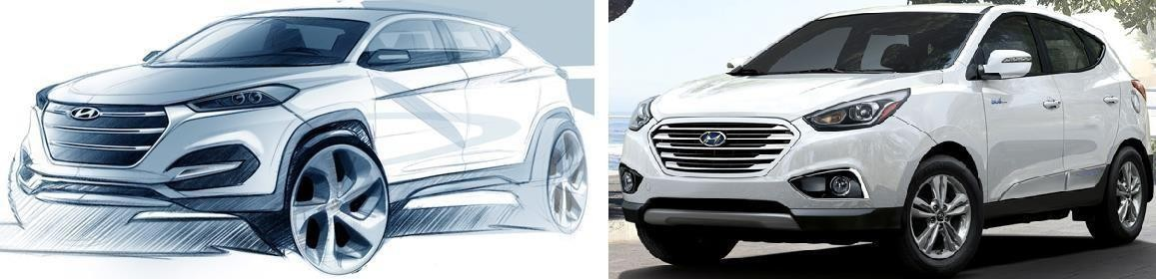

Fig 6.2.1:Drawing of a car (Left) — Real car picture (Right): The human eye is able to classify both.

The idea today is to build an algorithm that can sketch the edges of any object present on a picture,using the Canny edge detection algorithm.

First of all, let’s describe what is the Canny Edge Detector:

*The* ***Canny edge detector*** *is an* [*edge detection*](https://en.wikipedia.org/wiki/Edge_detection) *operator that uses a multi-stage* [*algorithm*](https://en.wikipedia.org/wiki/Algorithm) *to detect awide range of edges in images.* [*It was develope*](https://en.wikipedia.org/wiki/Edge_detection)*d by* [*John F. Canny*](https://en.wikipedia.org/wiki/John_F._Canny) *in 1986. Ca*[*nny also p*](https://en.wikipedia.org/wiki/Algorithm)*roduced*

*a* computational theory of edge detection *explaining why the technique works. (Wikipedia)*

The Canny edge detection algorithm is composed of 5 steps:

1. Noise reduction;
2. Gradient calculation;
3. Non-maximum suppression;
4. Double threshold;
5. Edge Tracking by Hysteresis.

After applying these steps, you will be able to get the following result:

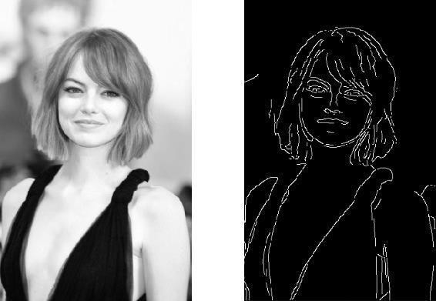

Fig 6.2.2: Edge detected output of (a) Image A and(b) reference image Original image on the left

— Processed image on the right

One last important thing to mention, is that the algorithm is based on grayscale pictures. Therefore,the pre-requisite is to convert the image to grayscale before following the above-mentioned steps.

Noise Reduction

Since the mathematics involved behind the scene are mainly based on derivatives (cf. Step 2:Gradient calculation), edge detection results are highly sensitive to image noise.

One way to get rid of the noise on the image, is by applying Gaussian blur to smooth it. To do so, image convolution technique is applied with a Gaussian Kernel (3x3, 5x5, 7x7 etc…). The kernel size depends on the expected blurring effect. Basically, the smallest the kernel, the less visible is theblur. In our example, we will use a 5 by 5 Gaussian kernel. The equation for a Gaussian filter kernel of size (2*k*+1)×(2*k*+1) is given by:



Gaussian filter kernel equation

Python code to generate the Gaussian 5x5 kernel:Gaussian Kernel function

After applying the Gaussian blur, we get the following result:

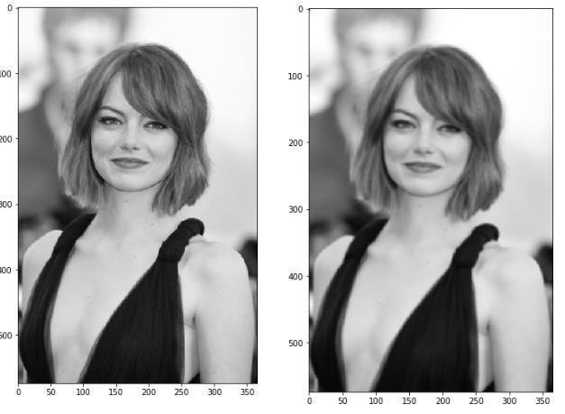

Fig 6.2.3: Original image (left) — Blurred image with a Gaussian filter (sigma=1.4 and kernel size of 5x5)

Gradient Calculation

The Gradient calculation step detects the edge intensity and direction by calculating the gradient ofthe image using edge detection operators.

Edges correspond to a change of pixels’ intensity. To detect it, the easiest way is to apply filters thathighlight this intensity change in both directions: horizontal (x) and vertical (y)

When the image is smoothed, the derivatives ***Ix*** and ***Iy*** w.r.t. ***x*** and ***y*** are calculated. It can beimplemented by convolving ***I*** with Sobel kernels ***Kx*** and ***Ky***, respectively:

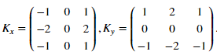

Sobel filters for both direction (horizontal and vertical)

Then, the magnitude ***G*** and the slope ***θ*** of the gradient are calculated as follow:

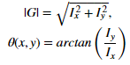

Gradient intensity and Edge direction

Below is how the Sobel filters are applied to the image, and how to get both intensity and edgedirection matrices:

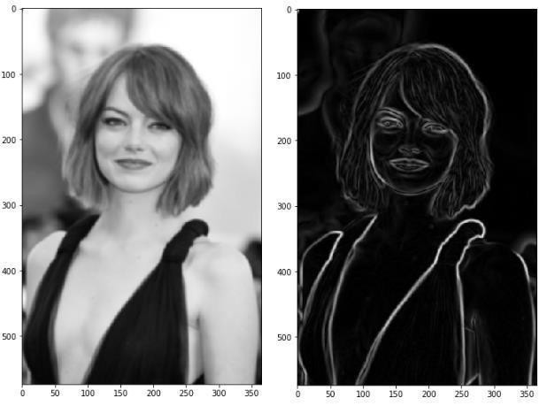

Fig 6.2.4: Blurred image (left) — Gradient intensity (right)

The result is almost the expected one, but we can see that some of the edges are thick and others arethin. Non-Max Suppression step will help us mitigate the thick ones.

Moreover, the gradient intensity level is between 0 and 255 which is not uniform. The edges on thefinal result should have the same intensity (i-e. white pixel =255).

Non-Maximum Suppression

Ideally, the final image should have thin edges. Thus, we must perform non- maximum suppressionto thin out the edges.

The principle is simple: the algorithm goes through all the points on the gradient intensity matrixand finds the pixels with the maximum value in the edge directions.

Let’s take an easy example:

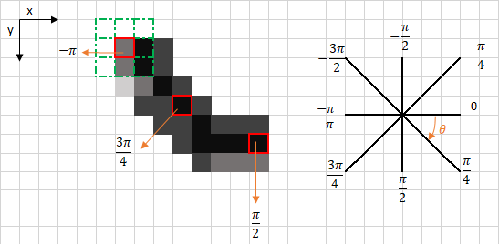

fig 6.2.5 : represent an intensity pixel

degrees).

The upper left corner red box present on the above image, represents an intensity pixel of the Gradient Intensity matrix being processed. The corresponding edge direction is represented by theorange arrow with an angle of -pi radians (+/-180

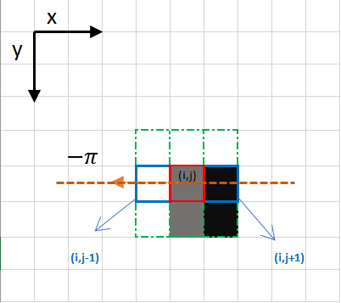

Fig 6.2.6 : represent the Focus on the upper left corner red box pixel

The edge direction is the orange dotted line (horizontal from left to right). The purpose of the algorithm is to check if the pixels on the same direction are more or less intense than the ones being processed. In the example above, the pixel ***(i, j)*** is being processed, and the pixels on the same direction are highlighted in blue ***(i, j-1)*** and ***(i, j+1).*** If one those two pixels are more intense than theone being processed, then only the more intense one is kept. Pixel ***(i, j-1)*** seems to be more intense, because it is white (value of 255). Hence, the intensity value of the current pixel ***(i, j)*** is set to 0. If there are no pixels in the edge direction having more intense values, then the value of the current pixel is kept.

Let’s now focus on another example:

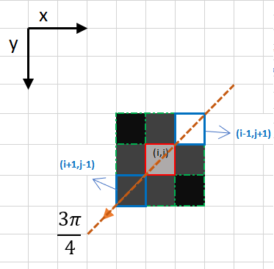

Fig 6.2.7 represent for edge detection

In this case the direction is the orange dotted diagonal line. Therefore, the most intense pixel in thisdirection is the pixel ***(i-1, j+1).***

Let’s sum this up. Each pixel has 2 main criteria (edge direction in radians, and pixel intensity(between 0–255)). Based on these inputs the non-max-suppression steps are:

* Create a matrix initialized to 0 of the same size of the original gradient intensity matrix;
* Identify the edge direction based on the angle value from the angle matrix;
* Check if the pixel in the same direction has a higher intensity than the pixel that iscurrently processed;
* Return the image processed with the non-max suppression algorithm.

The result is the same image with thinner edges. We can however still notice some variation regarding the edges’ intensity: some pixels seem to be brighter than others, and we will try to coverthis shortcoming with the two final steps.

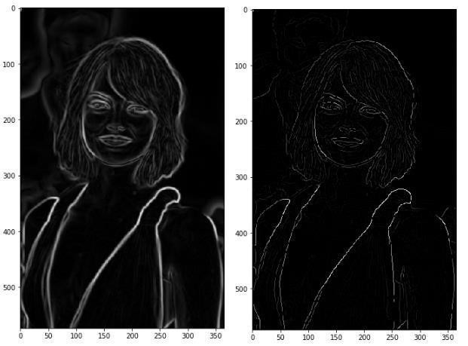

Result of the non-max suppression.

Fig 6.2.8: Double Threshold

Double threshold

The double threshold step aims at identifying 3 kinds of pixels: strong, weak, and non- relevant:

* Strong pixels are pixels that have an intensity so high that we are sure they contribute to the final edge.

* High threshold is used to identify the strong pixels (intensity higher than the highthreshold) Weak pixels are pixels that have an intensity value that is not enough to be considered as strong ones, but yet not small enough to be considered as non-relevant for the edgedetection.
* Other pixels are considered as non-relevant for the edge.

Now you can see what the double thresholds holds for:

* Low threshold is used to identify the non-relevant pixels (intensity lower than the lowthreshold)
* All pixels having intensity between both thresholds are flagged as weak and the Hysteresis mechanism (next step) will help us identify the ones that could be consideredas strong and the ones that are considered as non-relevant.

The result of this step is an image with only 2 pixel intensity values (strong and weak):

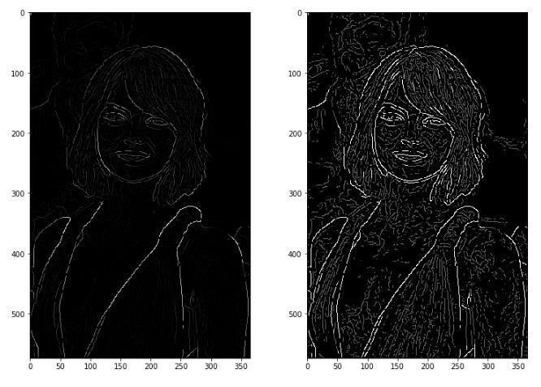

Fig 6.2.9:Non-Max Suppression image (left) — Threshold result (right): weak pixels in gray and strong onesin white.

Edge Tracking by Hysteresis

Based on the threshold results, the hysteresis consists of transforming weak pixels into strong ones, if and only if at least one of the pixels around the one being processed is a strong one, as described below:

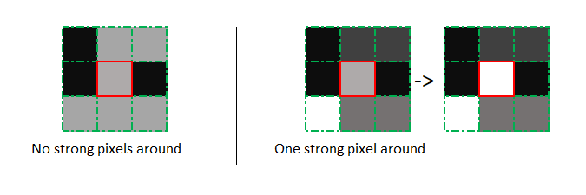

Hysteresis function

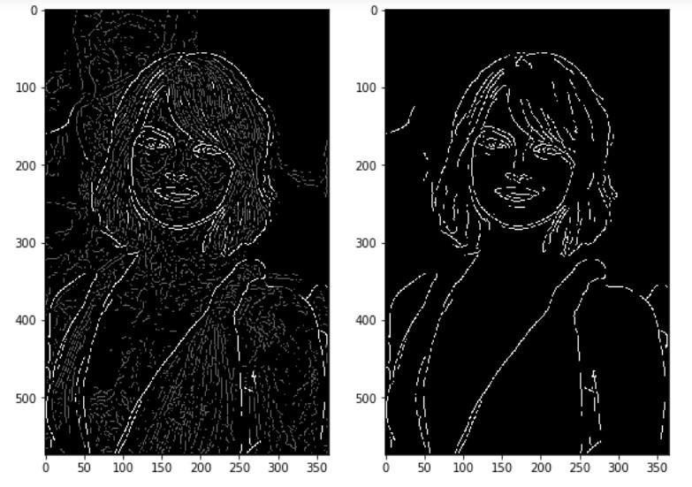

Fig 6.2.10: Results of hysteresis process

## SOFTWARE ENVIRONMENT

#### What is Python :-

Below are some facts about Python.

Python is currently the most widely used multi-purpose, high-level programming language.

Python allows programming in Object-Oriented and Procedural paradigms. Python programsgenerally are smaller than other programming languages like Java.

Programmers have to type relatively less and indentation requirement of the language,makes them readable all the time.

Python language is being used by almost all tech-giant companies like – Google, Amazon,Facebook, Instagram, Dropbox, Uber… etc.

The biggest strength of Python is huge collection of standard library which can be usedfor the following –

* [Machine Learning](https://www.geeksforgeeks.org/machine-learning/)
* GUI Applications (like Kivy, Tkinter, PyQt etc. )
* Web frameworks like Django (used by YouTube, Instagram, Dropbox)
* Image processing (like Opencv, Pillow)
* Web scraping (like Scrapy, BeautifulSoup, Selenium)
* Test frameworks
* Multimedia

##### Advantages of Python :-

Let’s see how Python dominates over other languages.

* 1. *Extensive Libraries*

Python downloads with an extensive library and it *contain code for various purposes like regularexpressions, documentation-generation, unit-testing, web browsers, threading, databases, CGI,*

*email, image manipulation, and more.* So, we don’t have to write the complete code for that manually.

* 1. *Extensible*

As we have seen earlier, Python can be **extended to other languages**. You can write some of your code in languages like C++ or C. This comes in handy, especially in projects.

* 1. *Embeddable*

Complimentary to extensibility, Python is embeddable as well. You can put your Python code inyour source code of a different language, like C++. This lets us add **scripting capabilities** to ourcode in the other language.

* 1. *Improved Productivity*

The language’s simplicity and extensive libraries render programmers **more productive** than languages like Java and C++ do. Also, the fact that you need to write less and get more things done.

* 1. *IOT Opportunities*

Since Python forms the basis of new platforms like Raspberry Pi, it finds the future bright for the Internet Of Things. This is a way to connect the language with the real world.

* 1. *Simple and Easy*

When working with Java, you may have to create a class to print **‘Hello World’**. But in Python, just a print statement will do. It is also quite **easy to learn, understand,** and **code.** This is whywhen people pick up Python, they have a hard time adjusting to other more verbose languages like Java.

* 1. *Readable*

Because it is not such a verbose language, reading Python is much like reading English. This isthe reason why it is so easy to learn, understand, and code. It also does not need curly braces to define blocks, and **indentation is mandatory.** This further aids the readability of the code.

* 1. *Object-Oriented*

This language supports both the **procedural and object-oriented** programming paradigms. While functions help us with code reusability, classes and objects let us model the real world. A class allows the **encapsulation of data** and functions into one.

* 1. *Free and Open-Source*

Like we said earlier, Python is **freely available.** But not only can you [**download Python**](https://data-flair.training/blogs/install-python-windows/)for free, but you can also download its source code, make changes to it, and even distribute it. It downloads with an extensive collection of libraries to help you with your tasks.

* 1. *Portable*

When you code your project in a language like C++, you may need to make some changes to it if you want to run it on another platform. But it isn’t the same with Python. Here, you need to **code only once**, and you can run it anywhere. This is called **Write Once Run Anywhere (WORA)**. However, you need to be careful enough not to include any system-dependent features.

* 1. *Interpreted*

Lastly, we will say that it is an interpreted language. Since statements are executed one byone, **debugging is easier** than in compiled languages.

*Any doubts till now in the advantages of Python? Mention in the comment section.*

#### Advantages of Python Over Other Languages

1. *Less Coding*

Almost all of the tasks done in Python requires less coding when the same task is done in other languages. Python also has an awesome standard library support, so you don’t have to search for any third-party libraries to get your job done. This is the reason that many people suggest learning Python to beginners.

1. *Affordable*

Python is free therefore individuals, small companies or big organizations can leverage the free available resources to build applications. Python is popular and widely used so it gives you better community support.

###### The 2019 Github annual survey showed us that Python has overtaken Java in the most popular programming language category.

1. *Python is for Everyone*

Python code can run on any machine whether it is Linux, Mac or Windows. Programmers need to learn different languages for different jobs but with Python, you can professionally build web apps, perform data analysis and [**machine learning**,](https://data-flair.training/blogs/machine-learning-tutorials-home/) automate things, do web scraping and also build games and powerful visualizations. It is an all-rounder programming language.

##### Disadvantages of Python

So far, we’ve seen why Python is a great choice for your project. But if you choose it, you should be aware of its consequences as well. Let’s now see the downsides of choosing Python over another language.

1. *Speed Limitations*

We have seen that Python code is executed line by line. But since [Python](https://www.python.org/) is interpreted, it often results in **slow execution**. This, however, isn’t a problem unless speed is a focal point for the project. In other words, unless high speed is a requirement, the benefits offered by Python are enough to distract us from its speed limitations.

1. *Weak in Mobile Computing and Browsers*

While it serves as an excellent server-side language, Python is much rarely seen on the **client- side**. Besides that, it is rarely ever used to implement smartphone- based applications. One such application is called **Carbonnelle**.

The reason it is not so famous despite the existence of Brython is that it isn’t that secure.

1. *Design Restrictions*

As you know, Python is **dynamically-typed**. This means that you don’t need to declare the typeof variable while writing the code. It uses **duck-typing**. But wait, what’s that? Well, it just means that if it looks like a duck, it must be a duck. While this is easy on the programmers during coding, it can **raise run-time errors**.

1. *Underdeveloped Database Access Layers*

Compared to more widely used technologies like **JDBC (Java DataBase Connectivity)** and **ODBC (Open DataBase Connectivity)**, Python’s database access layers are a bit underdeveloped. Consequently, it is less often applied in huge enterprises.

1. *Simple*

No, we’re not kidding. Python’s simplicity can indeed be a problem. Take my example. I don’t do Java, I’m more of a Python person. To me, its syntax is so simple that the verbosity of Java code seems unnecessary.

This was all about the Advantages and Disadvantages of Python Programming Language.

#### History of Python : -

What do the alphabet and the programming language Python have in common? Right, both start with ABC. If we are talking about ABC in the Python context, it's clear that the programming language ABC is meant. ABC is a general-purpose programming language and programming environment, which had been developed in the Netherlands, Amsterdam, at the CWI (Centrum Wiskunde &Informatica). The greatest achievement of ABC was to influence the design of Python.Python was conceptualized in the late 1980s. Guido van Rossum worked that time in a project at the CWI, called Amoeba, a distributed operating system. In an interview with Bill Venners1, Guido van Rossum said:

"In the early 1980s, I worked as an implementer on a team building a language called ABC at Centrum voor Wiskunde en Informatica (CWI). I don't knowhow well people know ABC's influence on Python. I try to mention ABC's influence because I'mindebted to everything I learned during that project and to the people who worked on it."Later on in the same Interview, Guido van Rossum continued: "I remembered all my experience and some of my frustration with ABC. I decided to try to design a simple scripting language that possessed some of ABC's better properties, but without its problems. So I started typing. I createda simple virtual machine, a simple parser, and a simple runtime. I made my own version of the various ABC parts that I liked. I created a basic syntax, used indentation for statement groupinginstead of curly braces or begin- end blocks, and developed a small number of powerful data types: a hash table (or dictionary, as we call it), a list, strings, and numbers."

#### 7.3.1 Python Development Steps : -

Guido Van Rossum published the first version of Python code (version 0.9.0) at alt.sources in February 1991. This release included already exception handling, functions, and the core data types of list, dict, str and others. It was also object oriented and had a module system. Python version 1.0 was released in January 1994. The major new features included in this release were the functional programming tools lambda, map, filter and reduce, which Guido Van Rossum never liked.Six and a half years later in October 2000, Python 2.0 was introduced. This release included list comprehensions, a full garbage collector and it was supporting unicode.Python flourished for another 8 years in the versions 2.x before the next major release as Python 3.0 (also known as "Python 3000" and "Py3K") was released. Python 3 is not backwards compatible with Python 2.x. The emphasis in Python 3 had been on the removal of duplicate programming constructs and modules, thus fulfilling or coming close to fulfilling the 13th law of the Zen of Python: "There should be one -- and preferably only one -- obvious way to do it."Some changes inPython 7.3:

* Print is now a function
* Views and iterators instead of lists
* The rules for ordering comparisons have been simplified. E.g. a heterogeneous list cannot besorted, because all the elements of a list must be comparable to each other.
* There is only one integer type left, i.e. int. long is int as well.
* The division of two integers returns a float instead of an integer. "//" can be used to have the"old" behaviour.
* Text Vs. Data Instead Of Unicode Vs. 8-bit

#### 7.3.2 Purpose:-

We demonstrated that our approach enables successful segmentation of intra- retinal layers— even with low-quality images containing speckle noise, low contrast, and different intensity ranges throughout—with the assistance of the ANIS feature.

#### 7.3.3 Python

Python is an interpreted high-level programming language for general-purpose programming. Created by Guido van Rossum and first released in 1991, Python has a design philosophy that emphasizes code readability, notably using significant whitespace.

Python features a dynamic type system and automatic memory management. It supports multiple programming paradigms, including object-oriented, imperative, functional and procedural, and has a large and comprehensive standard library.

* Python is Interpreted − Python is processed at runtime by the interpreter. You do not need to compile your program before executing it. This is similar to PERL and PHP.
* Python is Interactive − you can actually sit at a Python prompt and interact with the interpreter directly to write your programs.

Python also acknowledges that speed of development is important. Readable and terse code is part of this, and so is access to powerful constructs that avoid tedious repetition of code. Maintainability also ties into this may be an all but useless metric, but it does say something about how much code you have to scan, read and/or understand to troubleshoot problems or tweak behaviors. This speed of development, the ease with which a programmer of other languages can pick up basic Python skills and the huge standard library is key to another area where Python excels. All its tools have been quick to implement, saved a lot of time, and severalof them have later been patched and updated by people with no Python background - without breaking.

## Modules Used in Project :-

#### 7.4.1 Tensorflow

TensorFlow is a [free](https://en.wikipedia.org/wiki/Free_software) and [open-sourc](https://en.wikipedia.org/wiki/Open-source_software)e [software library for dataflow and](https://en.wikipedia.org/wiki/Open-source_software) [differentiable](https://en.wikipedia.org/wiki/Library_(computing)) [programmin](https://en.wikipedia.org/wiki/Library_(computing))g across a range of tasks. It is a symbolic math library, and is also used for [machine](https://en.wikipedia.org/wiki/Machine_learning) [learning](https://en.wikipedia.org/wiki/Machine_learning) applications such as [neural](https://en.wikipedia.org/wiki/Neural_networks) [networks.](https://en.wikipedia.org/wiki/Neural_networks) It is used for both research and production at [Google.](https://en.wikipedia.org/wiki/Google)

TensorFlow was developed by the [Google Brain](https://en.wikipedia.org/wiki/Google_Brain) team for internal Google use. It was releasedunder the [Apache 2.0](https://en.wikipedia.org/wiki/Apache_License) [open-source license](https://en.wikipedia.org/wiki/Apache_License) on November 9, 2015.

#### 7.4.2 Numpy

Numpy is a general-purpose array-processing package. It provides a high- performancemultidimensional array object, and tools for working with these arrays.

It is the fundamental package for scientific computing with Python. It contains various featuresincluding these important ones:

* A powerful N-dimensional array object
* Sophisticated (broadcasting) functions
* Tools for integrating C/C++ and Fortran code
* Useful linear algebra, Fourier transform, and random number capabilities Besides its obvious scientific uses, Numpy can also be used as an efficient multi-dimensional container of generic data. Arbitrary data-types can be defined using Numpy which allows Numpyto seamlessly and speedily integrate with a wide variety of databases.

#### 7.4.3 Pandas

Pandas is an open-source Python Library providing high-performance data manipulation and analysis tool using its powerful data structures. Python was majorly used for data munging and preparation. It had very little contribution towards data analysis. Pandas solved this problem. Using Pandas, we can

accomplish five typical steps in the processing and analysis of data, regardless of the origin of data load, prepare, manipulate, model, and analyze. Python with Pandas is used in a wide range of fields including academic and commercial domains includingfinance, economics, Statistics, analytics, etc.

#### 7.4.4 Matplotlib

Matplotlib is a Python 2D plotting library which produces publication quality figures in a variety of hardcopy formats and interactive environments across platforms. Matplotlib can be used in Python scripts, the Python and [IPython](http://ipython.org/) shells, the [Jupyter](http://jupyter.org/) Notebook, web application servers, and four graphical user interface toolkits. Matplotlib tries to make easy things easy and hard things possible. You can generate plots, histograms, power spectra, bar charts, error charts, scatter plots, etc., with just a few lines of code. For examples, see the [sample plots](https://matplotlib.org/tutorials/introductory/sample_plots.html) and [thumbnailgallery.](https://matplotlib.org/gallery/index.html)

For simple plotting the pyplot module provides a MATLAB-like interface, particularly when combined with IPython. For the power user, you have full control of line styles, font properties, axes properties, etc, via an object oriented interface or via a set of functions familiar to MATLABusers.

#### 7.4.5 Scikit – learn

Scikit-learn provides a range of supervised and unsupervised learning algorithms via a consistent interface in Python. It is licensed under a permissive simplified BSD license and is distributed under many Linux distributions, encouraging academic and commercial use.

###### Python

Python is an interpreted high-level programming language for general-purpose programming. Created by Guido van Rossum and first released in 1991, Python has a design philosophy that emphasizes code readability, notably using significant whitespace.

Python features a dynamic type system and automatic memory management. It supports multiple programming paradigms, including object-oriented, imperative, functional and procedural, and has a large and comprehensive standard library.

* Python is Interpreted − Python is processed at runtime by the interpreter. You do not need to compile your program before executing it. This is similar to PERL and PHP.
* Python is Interactive − you can actually sit at a Python prompt and interact with the interpreter directly to write your programs.

Python also acknowledges that speed of development is important. Readable and terse code is part of this, and so is access to powerful constructs that avoid tedious repetition of code. Maintainability also ties into this may be an all but useless metric, but it does say something about how much code you have to scan, read and/or understand to troubleshoot problems or tweak behaviors. This speed of development, the ease with which a programmer of other languages can pick up basic Python skills and the huge standard library is key to another area where Python excels. All its tools have been quick to implement, saved a lot of time, and severalof them have later been patched and updated by people with no Python background-without breaking.

**Install Python Step-by-Step in Windows and Mac :**

Python a versatile programming language doesn’t come pre-installed on your computer devices.Python was first released in the year 1991 and until today it is a very popular high-level programming language. Its style philosophy emphasizes code readability with its notable use of great whitespace.

The object-oriented approach and language construct provided by Python enables programmers to write both clear and logical code for projects. This software does not come pre-packaged withWindows.

# How to Install Python on Windows and Mac :

There have been several updates in the Python version over the years. The question is how to installPython? It might be confusing for the beginner who is willing to start learning Python but this tutorial will solve your query. The latest or the newest version of Python is version 3.7.4 or in otherwords, it is Python 3.

**Note:** The python version 3.7.4 cannot be used on Windows XP or earlier devices.

Before you start with the installation process of Python. First, you need to know about your **System Requirements**. Based on your system type i.e. operating system and based processor, you must download the python version. My system type is a **Windows 64-bit operating system**. So the steps below are to install python version 3.7.4 on Windows 7 device or to install Python 3. [Download the](https://myelearninghub.com/python-cheat-sheet/) [Python Cheatsheet here.](https://myelearninghub.com/python-cheat-sheet/)The steps on how to install Python on Windows 10, 8 and 7 are **dividedinto 4 parts** to help understand better.

##### Download the Correct version into the system

**Step 1:** Go to the official site to download and install python using Google Chrome or any otherweb browser. OR Click on the following link: [**https://www.python.org**](https://www.python.org/)

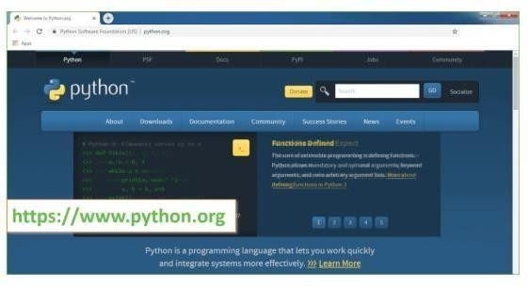 **Fig 7.5.1: install the python**

Now, check for the latest and the correct version for your operating system.

**Step 2:** Click onthe Download Tab.

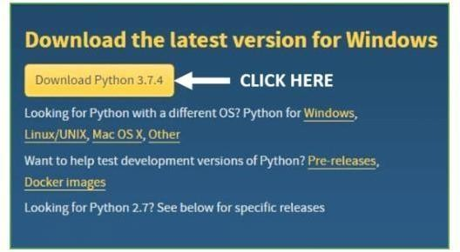

Fig 7.5.2 : download the python

**Step 3:** You can either select the Download Python for windows 3.7.4 button in Yellow Color or you can scroll further down and click on download with respective to their version. Here, we are downloading the most recent python

version for windows 3.7.4

**Step 4:** Scroll downthe page until you find the Files option.

**Step 5:** Here you see a different version of python along with the operating system.

* To download Windows 32-bit python, you can select any one from the three options: Windowsx86 embeddable zip file, Windows x86 executable installer or Windows x86 web-based installer.
* To download Windows 64-bit python, you can select any one from the three options: Windowsx86-64 embeddable zip file, Windows x86-64 executable installer or Windows x86-64 web-basedinstaller.

Here we will install Windows x86-64 web-based installer. Here your first part regarding which version of python is to be downloaded is completed. Now we move ahead with the second part ininstalling python i.e. Installation

**Note:** To know the changes or updates that are made in the version you can click on the ReleaseNote Option.

##### Installation of Python

**Step 1:** Go to Download and Open the downloaded python version to carry out the installation process.

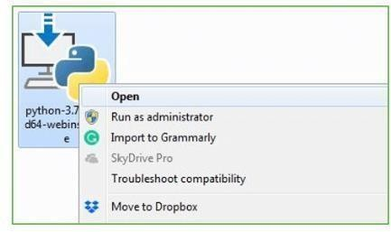

**Step 2:** Before you click on Install Now, Make sure to put a tick on Add Python 3.7 to PATH.

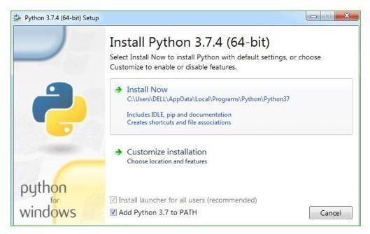

**Step 3:** Click on Install NOW After the installation is successful. Click on Close.

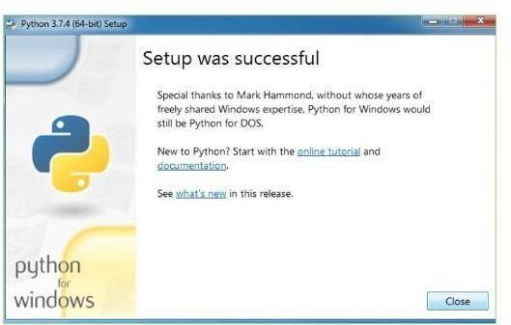

With these above three steps on python installation, you have successfully and correctly installedPython. Now is the time to verify the installation.

**Note:** The installation process might take a couple of minutes.

##### Verify the Python Installation

**Step 1:** Click on Start

**Step 2:** In the Windows Run Command, type “cmd”.

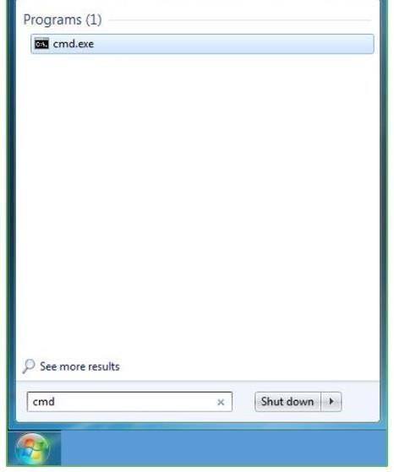

**Step 3:** Open the Command prompt option.

**Step 4:** Let us test whether the python is correctly installed. Type **python –V** and press Enter.

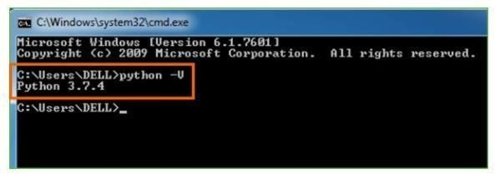

**Step 5:** You will get the answer as 3.7.4

**Note:** If you have any of the earlier versions of Python already installed. You must first uninstallthe earlier version and then install the new one.

##### Check how the Python IDLE works

**Step 1:** Click on Start

**Step 2:** In the Windows Run command, type “python idle”.

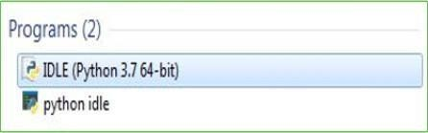

**Step 3:** Click on IDLE (Python 3.7 64-bit) and launch the program

**Step 4:** To go ahead with working in IDLE you must first save the file. **Click on File > Click on Save**

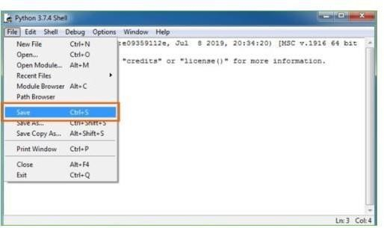

**Step 5:** Name the file and save as type should be Python files. Click on SAVE. Here I have namedthe files as Hey World.

**Step 6:** Now for e.g. **enter print**

### BACKGROUND:

Digital image processing is an area characterized by the need for extensive experimental work to establish the viability of proposed solutions to a given problem. An important characteristic underlying the design of image processing systems is the significant level of testing & experimentation that normally is required before arriving at an acceptable solution. This characteristic implies that the ability to formulate approaches &quickly prototype candidate solutions generally plays a major role in reducing the cost & time required to arrive at a viable system implementation.

#### What is IMAGE PROCESSING?

An image may be defined as a two-dimensional function f(x, y), where x & y are spatial coordinates, & the amplitude of f at any pair of coordinates (x, y) is called the intensity or gray level of the image at that point. When x, y & the amplitude values of f are all finite discrete quantities, we call the image a digital image. The field of DIP refers to processing digital image by means of digital computer. Digitalimage is composed of a finite number of elements, each of which has a particular location & value. The elements are called pixels.

Vision is the most advanced of our sensor, so it is not surprising that image play the single most important role in human perception. However, unlike humans, who are limited to the visual band of the EM spectrum imaging machines cover almost the entire EM spectrum, ranging from gamma to radio waves. They can operate also on images generated by sources that humans are not accustomed to associating with image.

There is no general agreement among authors regarding where image processing stops & other related areas such as image analysis& computer vision start. Sometimes a distinction is made by defining image processing as a discipline in which both the input & output at a process are images. This is limiting & somewhat artificial boundary. The area of image analysis (image understanding) is

in between image processing & computer vision

There are no clear-cut boundaries in the continuum from image processing at one end to complete visionat the other. However, one useful paradigm is to consider three types of computerized processes in this continuum: low-, mid-, & high-level processes. Low-level process involves primitive operations such as imageprocessing to reduce noise, contrast enhancement & image sharpening. A low- level process is characterized by the fact that both its inputs & outputs are images. Mid-level process on images involves tasks such as segmentation, description of that object to reduce them to a form suitable for computer processing & classification of individual objects. A mid-level process is characterized by the fact that its inputs generally are images but its outputs are attributes extracted from those images.

Finally higher- level processing involves

“Making sense” of an ensemble of recognized objects, as in image analysis & at the far end of the continuumperforming the cognitive functions normally associated with human vision

Digital image processing, as already defined is used successfully in a broad range of areas of exceptionalsocial & economic value.

### WHAT IS AN IMAGE?

An image is represented as a two dimensional function f(x, y) where x and y are spatial co-ordinates andthe amplitude of ‘f’ at any pair of coordinates (x, y) is called the intensity of the image at that point.

###### Gray scale image:

A grayscale image is a function I (xylem) of the two spatial coordinates of the image plane.

I(x, y) is the intensity of the image at the point (x, y) on the image plane.

I (xylem) takes non-negative values assume the image is bounded by a rectangle [0, a]  [0, b]I: [0, a]  [0, b]

 [0, info)

###### Color image:

**It** can be represented by three functions, R (xylem) for red, G (xylem) for green

*and* B (xylem) for blue.

An image may be continuous with respect to the x and y coordinates and also in amplitude. Converting such an image to digital form requires that the coordinates as well as the amplitude to be digitized.Digitizing the coordinate’s values is called sampling. Digitizing the amplitude values is called quantization.

#### Coordinate convention:

The result of sampling and quantization is a matrix of real numbers. We use two principal ways to represent digital images. Assume that an image f(x, y) is sampled so that the resulting image has M rows and N columns. We say that the image is of size M X N. The values of the coordinates (xylem) are discrete quantities. For notational clarity and convenience, we use integer values for these discrete coordinates. In many image processing books, the image origin is defined to be at (xylem)=(0,0).The next coordinate valuesalong the first row of the image are (xylem)=(0,1).It is important to keep in mind that the notation (0,1) is usedto signify the second sample along the first row. It does not mean that these are the actual values of physical coordinates when the image was sampled. Following figure shows the coordinate convention. Note that x ranges from 0 to M-1 and y from 0 to N-1 in integer increments.

#### The coordinate convention used in the toolbox to denote arrays is different from the preceding paragraph in two minor ways. First, instead of using (xylem) the toolbox uses the notation (race) to indicate rows and columns. Note, however, that the order of coordinates is the same as the order discussed in the previous paragraph, in the sense that the first element of a coordinate topples, (alb), refers to a row and the second to a column. The other difference is that the origin of the coordinate system is at (r, c) = (1, 1); thus, r ranges from1 to M and c from 1 to N in integer increments. IPT documentation refers to the coordinates. Less frequentlythe toolbox also employs another coordinate convention called spatial coordinates which uses x to refer to columns and y to refers to rows. This is the opposite of our use of variables x and y. Image as Matrices:

The preceding discussion leads to the following representation for a digitized image function:

|  |  |  |  |
| --- | --- | --- | --- |
| f (0,0) | f(0,1) | ……….. | f(0,N- 1) |
| f(1,0) | f(1,1) | ………… | f(1,N-1) |
| f(xylem)= . | . |  | . |

. .

f(M-1,0) f(M-1,1) f(M-1,N-1)

The right side of this equation is a digital image by definition. Each element of this array is called an image element, picture element, pixel or pel. The terms image and pixel are used throughout the restof our discussions to denote a digital image and its elements. A digital image can be represented naturally as a MATLAB matrix:f(1,1) f(1,2) f(1,N)

f(2,1) f(2,2) f(2,N)

. . .

f = . . . f(M,1) f(M,2) f(M,N)

Where f(1,1) = f(0,0) (note the use of a monoscope font to denote MATLAB quantities). Clearly the two representations are identical, except for the shift in origin. The notation f (p ,q) denotes the element located in row p and the column q. For example f (6, 2) is the element in the sixth row and second column of the matrix f. Typically we use the letters M and N respectively to denote the number of rows and columns in a matrix. A 1xN matrix is called a row vector whereas an Mx1 matrix is called a column vector. A 1x1 matrix is a scalar.

Matrices in MATLAB are stored in variables with names such as A, a, RGB, real array and so on. Variables must begin with a letter and contain only letters, numerals and underscores. As noted in the previous paragraph, all MATLAB quantities are written using mono-scope characters. We use conventional Roman, italic notation such as f(x ,y), for mathematical expressions

#### Reading Images:

Images are read into the MATLAB environment using function imread whose syntax isimread(‘filename’)

|  |  |  |
| --- | --- | --- |
| **Format name** | **Description** | **recognized extension** |
| TIFF | Tagged Image File Format | .tif, .tiff |
| JPEG | Joint Photograph Experts  Group | .jpg, .jpeg |
| GIF | Graphics Interchange Format | .gif |
| BMP | Windows Bitmap | .bmp |
| PNG | Portable Network Graphics | .png |
| XWD | X Window Dump | .xwd |

* 1. **What is Image Segmentation?**

Let’s understand image segmentation using a simple example. Consider the below image:

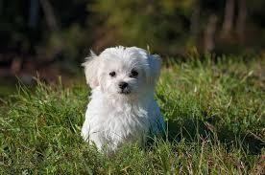

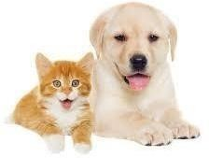

Fig 7.9.1 represent for image segmentation

There’s only one object here – a dog. We can build a straightforward cat-dog classifier model and predict that there’s a dog in the given image. But what if we

have both a cat and a dog in a single image?

We can train a multi-label classifier, in that instance. Now, there’s another caveat – we won’t knowthe location of either animal/object in the image.

That’s where image localization comes into the picture (no pun intended!). It helps us to identify the location of a single object in the given image. In case we have multiple objects present, we then relyon the concept of [object detection](https://www.analyticsvidhya.com/blog/2018/10/a-step-by-step-introduction-to-the-basic-object-detection-algorithms-part-1/?utm_source=blog&utm_medium=introduction-image-segmentation-techniques-python) (OD). We can predict the location along with the class for each object using OD.

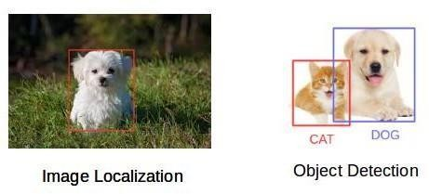

fig 7.9.2 represent for image localization and object detection

Before detecting the objects and even before classifying the image, we need to understand what the image consists of. Enter – Image Segmentation.

###### So how does image segmentation work?

We can divide or partition the image into various parts called segments. It’s not a great idea to processthe entire image at the same time as there will be regions in the image which do not contain any information. By dividing the image into segments, we can make use of the important segments for processing the image. That, in a nutshell, is how image segmentation works.

An image is a collection or set of different pixels. We group together the pixels that have similar attributes using image segmentation. Take a moment to go through the below visual (it’ll give you apractical idea of image segmentation):

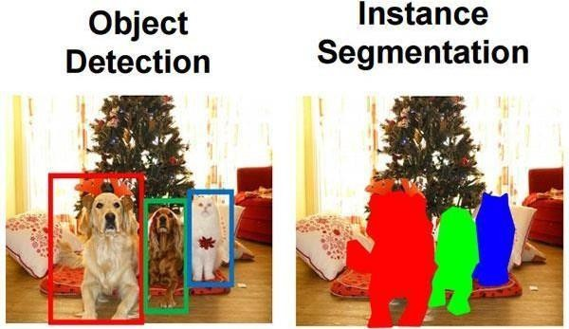

Fig 7.9.3: object detection and instance segmentation

Object detection builds a bounding box corresponding to each class in the image. But it tells us nothing about the shape of the object. We only get the set of bounding box coordinates. We want to get more information – this is too vague for our purposes.

Image segmentation creates a pixel-wise mask for each object in the image. This technique gives usa far more granular understanding of the object(s) in the image.

Why do we need to go this deep? Can’t all image processing tasks be solved using simple bounding box coordinates? Let’s take a real-world example to answer this pertinent question.

###### Why do we need Image Segmentation?

Cancer has long been a deadly illness. Even in today’s age of technological advancements, cancer can be fatal if we don’t identify it at an early stage. Detecting cancerous cell(s) as quickly as possiblecan potentially save millions of lives.

The shape of the cancerous cells plays a vital role in determining the severity of the cancer. You might have put the pieces together – object detection will not be very useful here. We will only generate bounding boxes which will not help us in identifying the shape of the cells.

Image Segmentation techniques make a MASSIVE impact here. They help us approach this problemin a more granular manner and get more meaningful results. A win-win for everyone in the healthcare

Here,

* Traffic Control Systems
* Self Driving Cars
* Locating objects in satellite images

There are even more applications where Image Segmentation is very useful. Feel free to share themwith me in the comments section below this article – let’s see if we can build something together.

###### The Different Types of Image Segmentation

We can broadly divide image segmentation techniques into two types. Consider the below images:Can you identify the difference between these two? Both the images are using image segmentation to identify and locate the people present.

* In image 1, every pixel belongs to a particular class (either background or person). Also, all the pixels belonging to a particular class are represented by the same color (background as black and person as pink). This is an example of semantic segmentation
* Image 2 has also assigned a particular class to each pixel of the image. However, different objects of the same class have different colors (Person 1 as red, Person 2 as green, background as black, etc.). This is an example of instance segmentation

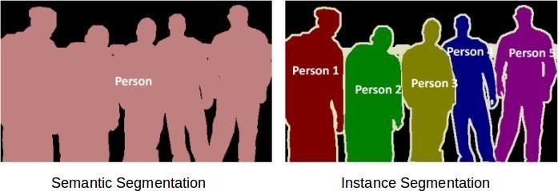

Fig 7.9.4: represent the semantic segmentation and instance segmentation

Let me quickly summarize what we’ve learned. If there are 5 people in an image, semantic segmentation will focus on classifying all the people as a single instance. Instance segmentation, on the other hand. will identify each of these people individually.

So far, we have delved into the theoretical concepts of image processing and segmentation. Let’s mix things up a bit – we’ll combine learning concepts with implementing them in Python. I strongly believe that’s the best way to learn and remember any topic.

###### Region-based Segmentation

One simple way to segment different objects could be to use their pixel values. An important point to note – the pixel values will be different for the objects and the image’s background if there’s a sharp contrast between them.

In this case, we can set a threshold value. The pixel values falling below or above that threshold canbe classified accordingly (as an object or the background). This technique is known as **Threshold Segmentation**.

*If we want to divide the image into two regions (object and background), we define a single thresholdvalue. This is known as the* ***global threshold****.*

*If we have multiple objects along with the background, we must define multiple thresholds. Thesethresholds are collectively known as the* ***local threshold****.*

Let’s implement what we’ve learned in this section. Download [**this image**](https://drive.google.com/open?id=1aM4otWKSsDz1Rof3LZkY055YkYXeO-vf)and run the below code.

It will give you a better understanding of how thresholding works (you can use any image of yourchoice if you feel like experimenting!).

First, we’ll import the required libraries.

|  |
| --- |
| from skimage.color import rgb2gray |
| import numpy as np |
| import cv2 |
| import matplotlib.pyplot as plt |
| %matplotlib inline |
| from scipy import ndimage |

[**view rawimport_library.py**](https://gist.github.com/PulkitS01/b92a41d29a6c496c87919479bffc33c3/raw/464dd408528ba094fa672e2cfd4a45e22e7d8840/import_library.py)hosted with by [**GitHub**](https://github.com/)

Let’s read the downloaded image and plot it:

|  |
| --- |
| image = plt.imread('1.jpeg') |
| image.shape |
| plt.imshow(image) |

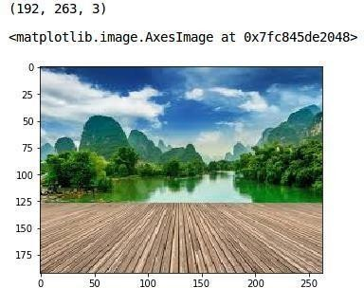

[**view rawread_image_1.py**](https://gist.github.com/PulkitS01/b92a41d29a6c496c87919479bffc33c3/raw/464dd408528ba094fa672e2cfd4a45e22e7d8840/read_image_1.py)hosted with by [**GitHub**](https://github.com/)

Fig 7.9.6: grayscale conversion

It is a three-channel image (RGB). We need to convert it into grayscale so that we only have a singlechannel. Doing this will also help us get a better understanding of how the algorithm works.

|  |
| --- |
| gray = rgb2gray(image) |
| plt.imshow(gray, cmap='gray') |

[**view rawgray_scale.py**](https://gist.github.com/PulkitS01/b92a41d29a6c496c87919479bffc33c3/raw/464dd408528ba094fa672e2cfd4a45e22e7d8840/gray_scale.py)hosted with by [**GitHub**](https://github.com/)

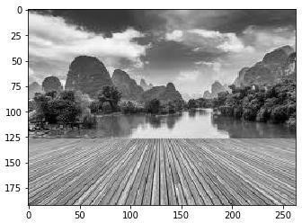

Now, we want to apply a certain threshold to this image. This threshold should separate the image into two parts – the foreground and the background. Before we do that, let’s quickly check the shapeof this image:

gray.shape

(192, 263)

The height and width of the image is 192 and 263 respectively. **We will take the mean of the pixelvalues and use that as a threshold.** If the pixel value is more than our threshold, we can say that it belongs to an object. If the pixel value is less than the threshold, it will be treated as the background.Let’s code this:

|  |
| --- |
| gray_r = gray.reshape(gray.shape[0]*gray.shape[1]) |
| for i in range(gray_r.shape[0]): |
| if gray_r[i] > gray_r.mean(): |
| gray_r[i] = 1 |
| else: |
| gray_r[i] = 0 |
| gray = gray_r.reshape(gray.shape[0],gray.shape[1]) |
| plt.imshow(gray, cmap='gray') |

[**view rawglobal_threshold.py**](https://gist.github.com/PulkitS01/b92a41d29a6c496c87919479bffc33c3/raw/464dd408528ba094fa672e2cfd4a45e22e7d8840/global_threshold.py)hosted with by [**GitHub**](https://github.com/)

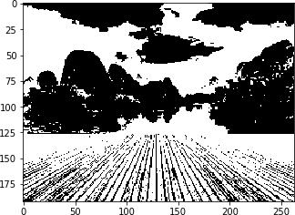

Fig 7.9.7:multiple thresholds

Nice! The darker region (black) represents the background and the brighter (white) region is theforeground. We can define multiple thresholds as well to detect multiple objects:

|  |
| --- |
| gray = rgb2gray(image) |
| gray_r = gray.reshape(gray.shape[0]*gray.shape[1]) |
| for i in range(gray_r.shape[0]): |
| if gray_r[i] > gray_r.mean(): |
| gray_r[i] = 3 |
| elif gray_r[i] > 0.5: |
| gray_r[i] = 2 |
| elif gray_r[i] > 0.25: |
| gray_r[i] = 1 |
| else: |
| gray_r[i] = 0 |
| gray = gray_r.reshape(gray.shape[0],gray.shape[1]) |
| plt.imshow(gray, cmap='gray') |

[**view rawlocal_threshold.py**](https://gist.github.com/PulkitS01/b92a41d29a6c496c87919479bffc33c3/raw/464dd408528ba094fa672e2cfd4a45e22e7d8840/local_threshold.py)hosted with by [**GitHub**](https://github.com/)

There are four different segments in the above image. You can set different threshold values and check how the segments are made. Some of the advantages of this method are:

* Calculations are simpler
* Fast operation speed
* When the object and background have high contrast, this method performs really well

But there are some limitations to this approach. When we don’t have significant grayscale difference,or there is an overlap of the grayscale pixel values, it becomes very difficult to get accurate segments.

###### Edge Detection Segmentation

What divides two objects in an image? There is always an edge between two adjacent regions with different grayscale values (pixel values). The edges can be considered as the discontinuous local features of an image.

We can make use of this discontinuity to detect edges and hence define a boundary of the object. This helps us in detecting the shapes of multiple objects present in a given image. Now the question

is how can we detect these edges? This is where we can make use of filters and convolutions. Referto [this article](https://www.analyticsvidhya.com/blog/2017/06/architecture-of-convolutional-neural-networks-simplified-demystified/?utm_source=blog&utm_medium=image-segmentation-article) if you need to learn about these concepts.

Here’s the step-by-step process of how this works:

* Take the weight matrix
* Put it on top of the image
* Perform element-wise multiplication and get the output
* Move the weight matrix as per the stride chosen
* Convolve until all the pixels of the input are used

The values of the weight matrix define the output of the convolution. My advice – it helps to extract features from the input. Researchers have found that choosing some specific values for these weight matrices helps us to detect horizontal or vertical edges (or even the combination of horizontal and vertical edges).

One such weight matrix is the sobel operator. It is typically used to detect edges. The sobel operatorhas two weight matrices – one for detecting horizontal edges and the other for detecting vertical edges. Let me show how these operators look and we will then implement them in Python.

|  |
| --- |
|  |
|  |
|  |
|  |
|  |

###### 7.10 Image Segmentation based on Clustering

This idea might have come to you while reading about image segmentation. Can’t we use clusteringtechniques to divide images into segments? We certainly can! In this section, we’ll get an an intuition of what clustering is (it’s always good to revise certain concepts!) and how we can use of it to segment images. Clustering is the task of dividing the population (data points) into a number of groups, such that data points in the same groups are more similar to other data points in that same group than those in othergroups. These groups are known as clusters.

One of the most commonly used clustering algorithms is [k-means.](https://www.analyticsvidhya.com/blog/2016/11/an-introduction-to-clustering-and-different-methods-of-clustering/) Here, the k represents the numberof clusters (not to be confused with k-nearest neighbor). Let’s understand how k-means works:

1. First, randomly select k initial clusters
2. Randomly assign each data point to any one of the k clusters
3. Calculate the centers of these clusters
4. Calculate the distance of all the points from the center of each cluster
5. Depending on this distance, the points are reassigned to the nearest cluster
6. Calculate the center of the newly formed clusters
7. Finally, repeat steps (4), (5) and (6) until either the center of the

We can see that the image has been converted to a 2-dimensional array. Next, fit the k- means algorithm on this reshaped array and obtain the clusters. The *cluster_centers_ function* of k-means will return the cluster centers and *labels_ function* will give us the label for each pixel (it will tell uswhich pixel of the image belongs to which cluster).

|  |
| --- |
| from sklearn.cluster import KMeans |
| kmeans = KMeans(n_clusters=5, random_state=0).fit(pic_n) |
| pic2show = kmeans.cluster_centers_[kmeans.labels_] |

[**view rawKmeans.py**](https://gist.github.com/PulkitS01/b92a41d29a6c496c87919479bffc33c3/raw/464dd408528ba094fa672e2cfd4a45e22e7d8840/Kmeans.py)hosted with by [**GitHub**](https://github.com/)

I have chosen 5 clusters for this article but you can play around with this number and check the results. Now, let’s bring back the clusters to their original shape, i.e. 3-dimensional image, and plot the results.

|  |
| --- |
| cluster_pic = pic2show.reshape(pic.shape[0], pic.shape[1], pic.shape[2]) |
| plt.imshow(cluster_pic) |

[**view rawclusters.py**](https://gist.github.com/PulkitS01/b92a41d29a6c496c87919479bffc33c3/raw/464dd408528ba094fa672e2cfd4a45e22e7d8840/clusters.py)hosted with by [**GitHub**](https://github.com/)

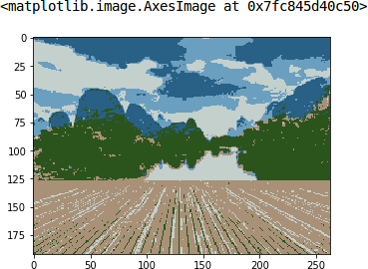

Fig 7.10.1: represent for improve the segmentation

Amazing, isn’t it? We are able to segment the image pretty well using just 5 clusters. I’m sure you’ll be able to improve the segmentation by increasing the number of clusters.

k-means works really well when we have a small dataset. It can segment the objects in the image andgive impressive results. But the algorithm hits a roadblock when applied on a large dataset (more number of images).

It looks at all the samples at every iteration, so the time taken is too high. Hence, it’s also too expensive to implement. And since k-means is a distance-based algorithm, it is only applicable to convex datasets and is not suitable for clustering [non-convex clusters.](https://en.wikipedia.org/wiki/Convex_set)

Finally, let’s look at a simple, flexible and general approach for image segmentation.

## SYSTEM TESTING

The purpose of testing is to discover errors. Testing is the process of trying to discover everyconceivable fault or weakness in a work product. It provides a way to check the functionalityof components, sub assemblies, assemblies and/or a finished product It is the process of exercising software with the intent of ensuring that the Software system meets its requirements and user expectations and does not fail in an unacceptable manner. There are various types of test. Each test type addresses a specific testing requirement.

## TYPES OF TESTING

#### 8.1.1 Unit testing

Unit testing involves the design of test cases that validate that the internal program logic is functioning properly, and that program inputs produce valid outputs. All decision branches and internal code flow should be validated. It is the testing of individual software units of the application

.it is done after the completion of an individual unit before integration. This is a structural testing, that relies on knowledge of its construction and is invasive. Unit tests perform basic tests at component level and test a specific business process, application, and/or system configuration. Unittests ensure that each unique path of a business process performs accurately tothe documented specifications and contains clearly defined inputs and expected results.

#### 8.1.2 Integration testing

Integration tests are designed to test integrated software components to determine if they actually run as one program. Testing is event driven and is more concerned with the basic outcomeofscreens or fields. Integration tests demonstrate that although the components were individually satisfaction, as shown by successfully unit testing, the combination of components is correct and consistent. Integration testing is specifically aimed at exposing the problems that arise from the combination of components.

#### 8.1.3 Functional test

Functional tests provide systematic demonstrations that functions tested are available asspecified by the business and technical requirements, system documentation, and user manuals.

Functional testing is centered on the following items: Valid Input : identified classes of valid input

Invalid Input : identified classes of invalid input Functions : identified functions

Output : identified classes of application outputs Systems/ Procedures : interfacing systems or procedures

Organization and preparation of functional tests is focused on requirements, key functions, or special test cases. In addition, systematic coverage pertaining to identify Business process flows; data fields, predefined processes, and successive processes must be considered for testing. Before functional testing is complete, additional tests are identified and the effective value of current testsisdetermined.

#### 8.1.4 system Test

System testing ensures that the entire integrated software system meets requirements. It tests a configuration to ensure known and predictable results. An example of system testing is the configuration oriented system integration test. System testing is based on process descriptions and flows, emphasizing pre-driven process links and integration points.

#### White Box Testing

White Box Testing is a testing in which in which the software tester has knowledge of the inner workings, structure and language of the software, or at least its purpose. It is purpose. It is used to test areas that cannot be reached from a black box level.

#### Black Box Testing

Black Box Testing is testing the software without any knowledge of the inner workings, structure or language of the module being tested. Black box tests, as most other kinds of tests, mustbe written from a definitive source document, such as specification or requirements document, such as specification or requirements document. It is a testing in which the software

under test is treated, as a black box .you cannot “see” into it. The test provides inputs and respondstooutputs without considering how the software works.

#### Unit Testing:

Unit testing is usually conducted as part of a combined code and unit test phase of the software lifecycle, although it is not uncommon for coding and unit testing to be conducted as two distinct phases.

***Test* strategy *and approach***

Field testing will be performed manually and functional tests will be written in detail.

#### Test objectives

* All field entries must work properly.
* Pages must be activated from the identified link.
* The entry screen, messages and responses must not be delayed.

#### Features to be tested

* Verify that the entries are of the correct format
* No duplicate entries should be allowed
* All links should take the user to the correct page.

#### Integration Testing

Software integration testing is the incremental integration testing of two or more integrated software components on a single platform to produce failures caused by interface defects.

The task of the integration test is to check that components or software applications, e.g. components in a software system or – one step up – software applications at the company level – interact without error.

**Test Results:** All the test cases mentioned above passed successfully. No defects encountered.

## Acceptance Testing

User Acceptance Testing is a critical phase of any project and requires significantparticipation bythe end user. It also ensures that the system meets the functional requirements.

**Test Results:** All the test cases mentioned above passed successfully. No defects encountered.

## SAMPLE CODE

from tkinter import messagebox from tkinter import *

from tkinter import simpledialog import tkinter

from tkinter import filedialog import numpy as np

from tkinter.filedialog import askopenfilename import cv2

import matplotlib.pyplot as plt

main = tkinter.Tk()

main.title("Density Based Smart Traffic Control System") main.geometry("800x600")

global image_filename global reference_pixels global sample_pixels

def rgb2gray(rgb):

r, g, b = rgb[:, :, 0], rgb[:, :, 1], rgb[:, :, 2] gray = 0.2989 * r + 0.5870 * g + 0.1140 * b return gray

def uploadImage():

global image_filename

image_filename = filedialog.askopenfilename(initialdir="images") pathlabel.config(text=image_filename)

def visualize(imgs, format=None, gray=False):

j = 0

plt.figure(figsize=(20, 40))

for i, img in enumerate(imgs): if img.shape[0] == 3:

img = img.transpose(1, 2, 0) plt_idx = i + 1

plt.subplot(2, 2, plt_idx) if j == 0:

plt.title('Sample Image (Canny Edges)') plt.imshow(img, format)

j = j + 1 elif j > 0:

plt.title('Reference Image (Canny Edges)') plt.imshow(img, format)

plt.show()

def applyCanny():

global image_filename

# Read the image as color (BGR)

img = cv2.imread(image_filename, cv2.IMREAD_COLOR)

# Resize the image to a smaller size

resized_img = cv2.resize(img, (0, 0), fx=0.5, fy=0.5)

# Convert the resized image to grayscale

img_gray = cv2.cvtColor(resized_img, cv2.COLOR_BGR2GRAY)

# Perform Canny edge detection on the image

edges = cv2.Canny(img_gray, threshold1=30, threshold2=100)

# Display the sample and reference images with Canny edges visualize([edges, edges], gray=True)

def pixelcount():

global image_filename global sample_pixels global reference_pixels

# Load the image and resize it

img = cv2.imread(image_filename, cv2.IMREAD_GRAYSCALE) resized_img = cv2.resize(img, (0, 0), fx=0.5, fy=0.5)

# Count the white pixels in the image sample_pixels = np.sum(resized_img == 255) reference_pixels = sample_pixels

messagebox.showinfo("Pixel Counts", "Total Reference White Pixels Count: " + str(reference_pixels) + "\nTotal Sample White Pixels Count: " + str(sample_pixels))

def timeAllocation():

avg = (sample_pixels / reference_pixels) * 100 if avg >= 90:

messagebox.showinfo("Green Signal Allocation Time", "Traffic is very high. Allocation green signal time: 60 secs")

elif 85 < avg < 90:

messagebox.showinfo("Green Signal Allocation Time", "Traffic is high. Allocation green signal time: 50 secs")

elif 75 < avg <= 85:

messagebox.showinfo("Green Signal Allocation Time", "Traffic is moderate. Allocation green signal time: 40 secs")

elif 50 < avg <= 75:

messagebox.showinfo("Green Signal Allocation Time", "Traffic is low. Allocation green signal time: 30 secs")

else:

messagebox.showinfo("Green Signal Allocation Time", "Traffic is very low. Allocation green signal time: 20 secs")

def exit():

main.destroy()

font = ('Arial', 14)

title = Label(main, text='Density Based Smart Traffic Control System', anchor=W, justify=CENTER)

title.config(bg='yellow4', fg='white') title.config(font=font) title.config(height=2) title.pack(fill=X)

upload_image = Button(main, text="Upload Image", command=uploadImage) upload_image.config(font=font)

upload_image.pack(pady=10)

pathlabel = Label(main) pathlabel.config(bg='white', fg='black') pathlabel.config(font=font) pathlabel.pack()

process = Button(main, text="Image Preprocessing Using Canny Edge Detection", command=applyCanny)

process.config(font=font) process.pack(pady=20)

count = Button(main, text="White Pixel Count", command=pixelcount) count.config(font=font)

count.pack(pady=20)

allocation = Button(main, text="Calculate Green Signal Time Allocation", command=timeAllocation)

allocation.config(font=font) allocation.pack(pady=20)

exitButton = Button(main, text="Exit", command=exit) exitButton.config(font=font) exitButton.pack(pady=20)

main.config(bg='magenta3') main.mainloop()

## OUTPUT SCREENS

To implement this project we are using 4 input images given in paper and on reference image.Below are the images screen shots saved inside images folder

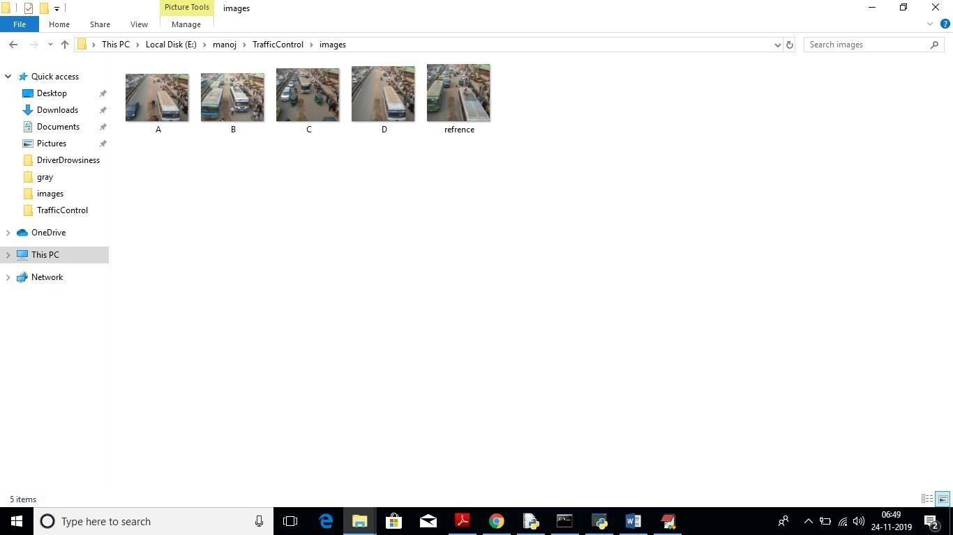

Fig 10.1:saved traffic images

We can upload above 4 images to application to calculate traffic signal time.Screen shots

To run this project double click on ‘run.bat’ file to get below screen

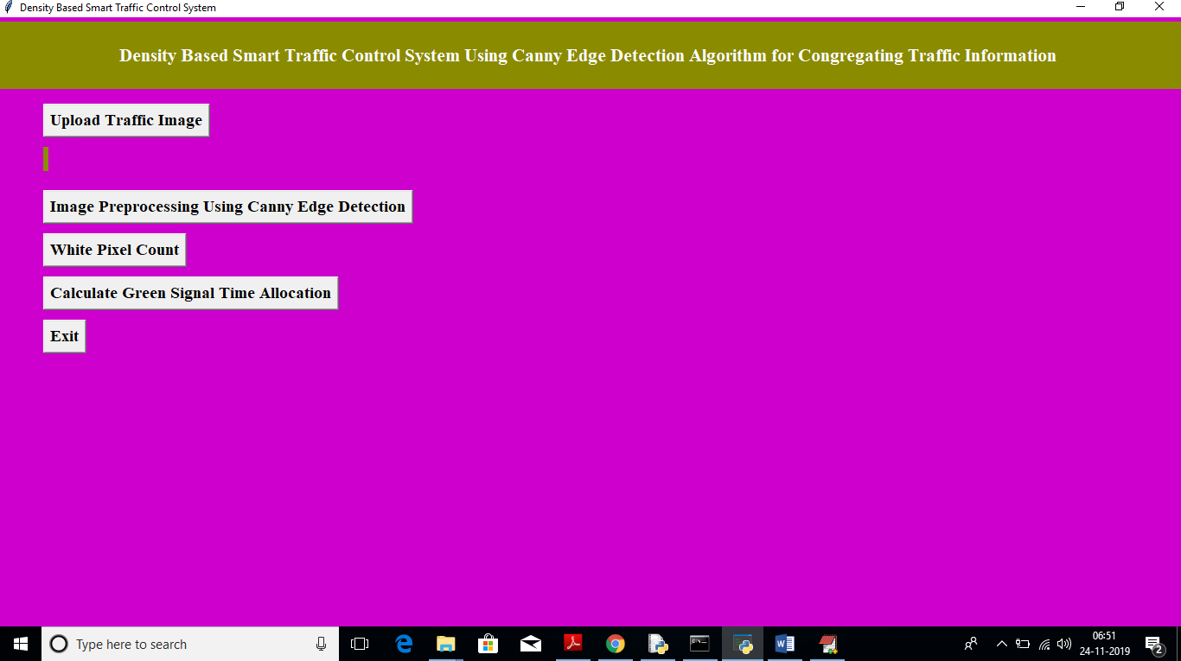 fig 10.2: uploading images

In above screen click on ‘Upload Traffic Image’ button to upload image.

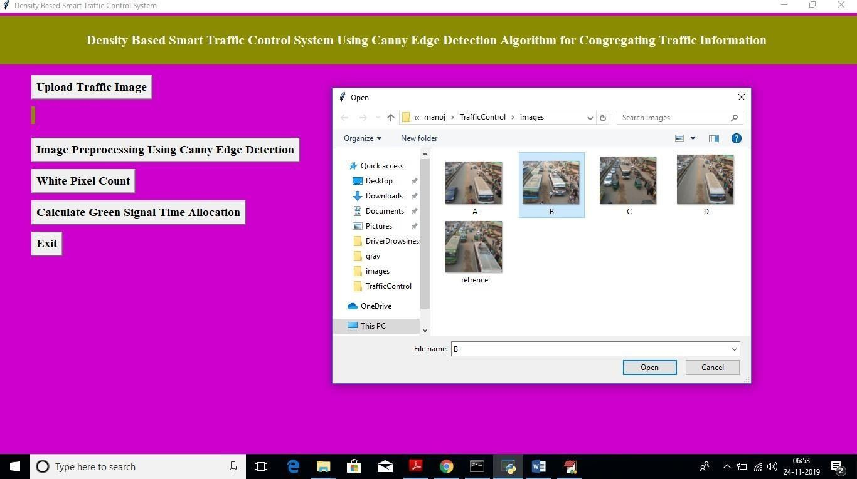

In above screen I am uploading image B and now click on ‘Open’ button to load image

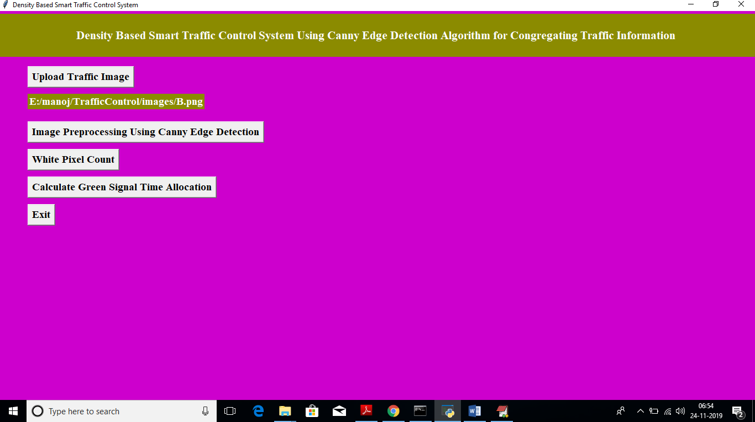

Fig 10.3:image preprocessing using canny edge detection

In above screen we got message as input image loaded. Now click on ‘Image Pre- processing Using Canny Edge Detection’ button to apply Gaussian filter and to get canny edges, after clicking button wait for few seconds till you get below screen with edges

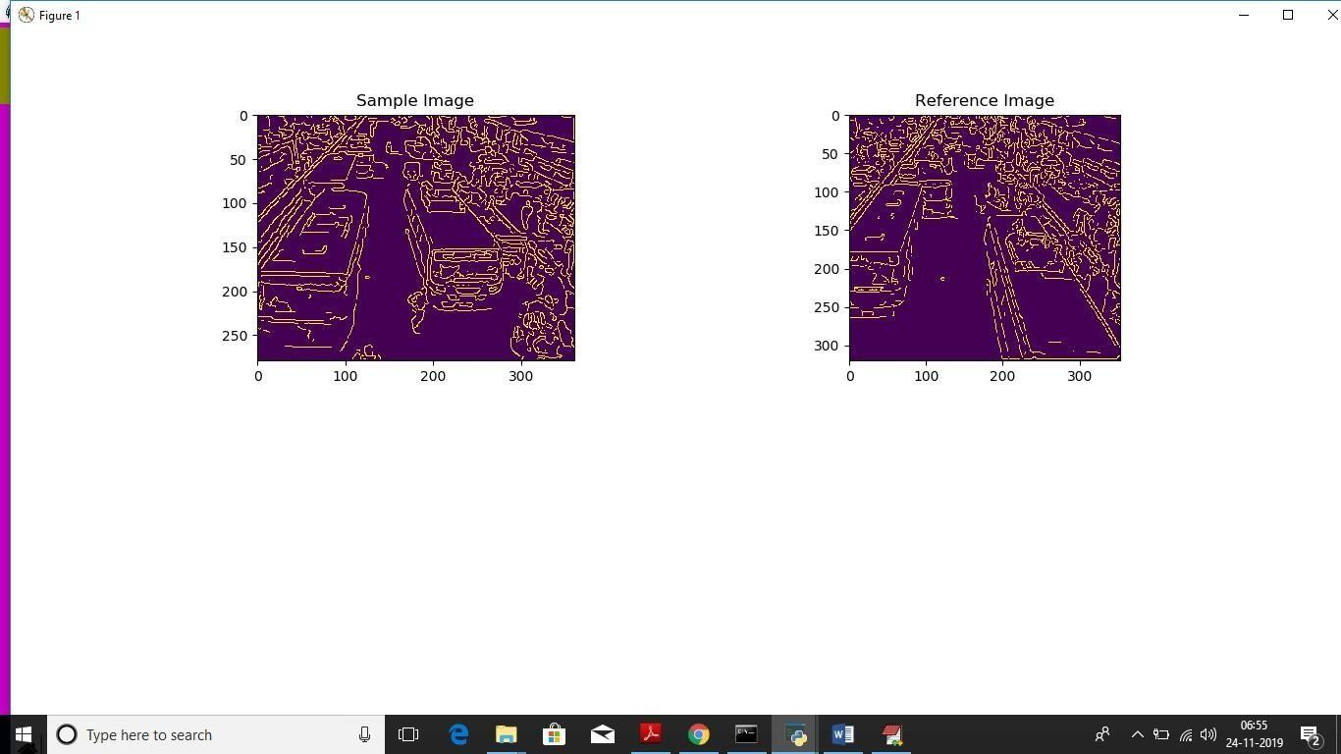

Fig 10.4: white pixel count

In above screen left side image is the uploaded image and right side is the ‘Reference Image’, Now close this above screen and click on ‘White Pixel count’ button to get white pixels from both images

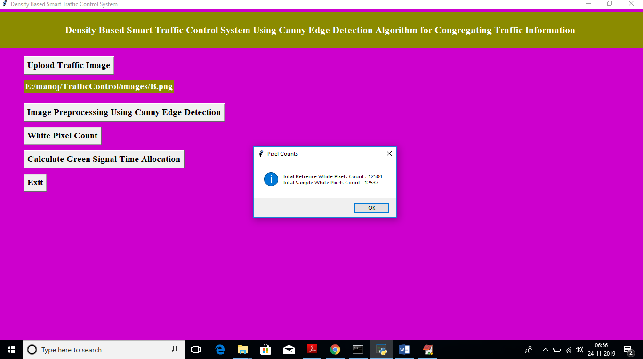

Fig 10.5: calculate green signal time allocation

In above screen dialog box we can see total white pixels found in both sample and reference image. Now click on ‘Calculate Green Signal Time Allocation’ button to get signal time

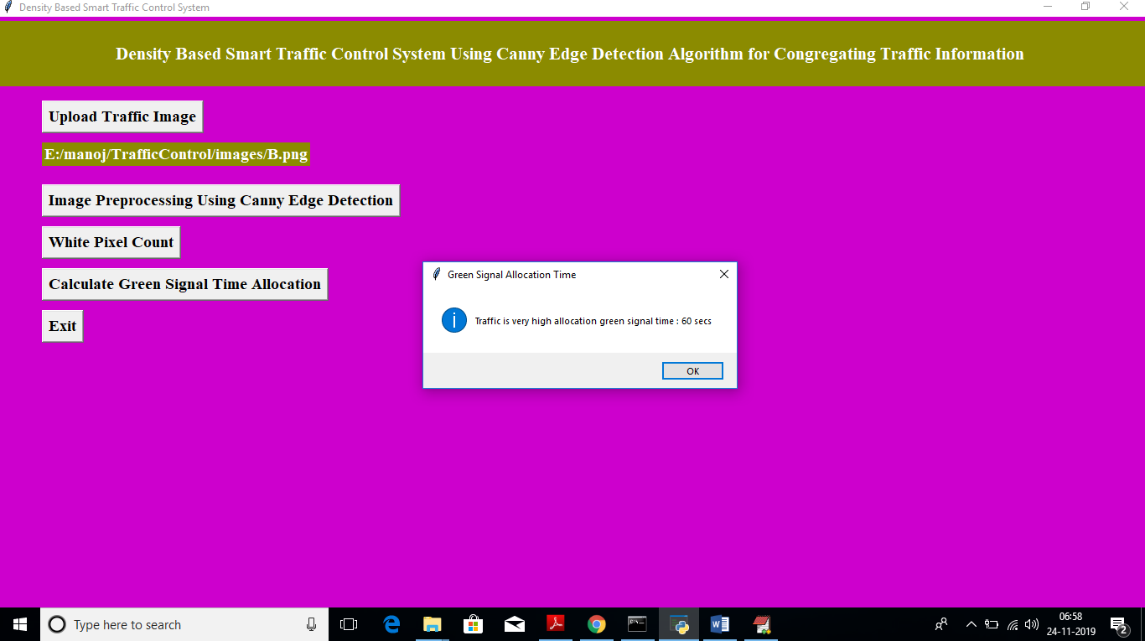

Fig 10.6: result of time allocation

For that uploaded image we got message as it contains high traffic and signal time must be 60seconds. Similarly you can upload any image and get output. Below is the output for image A

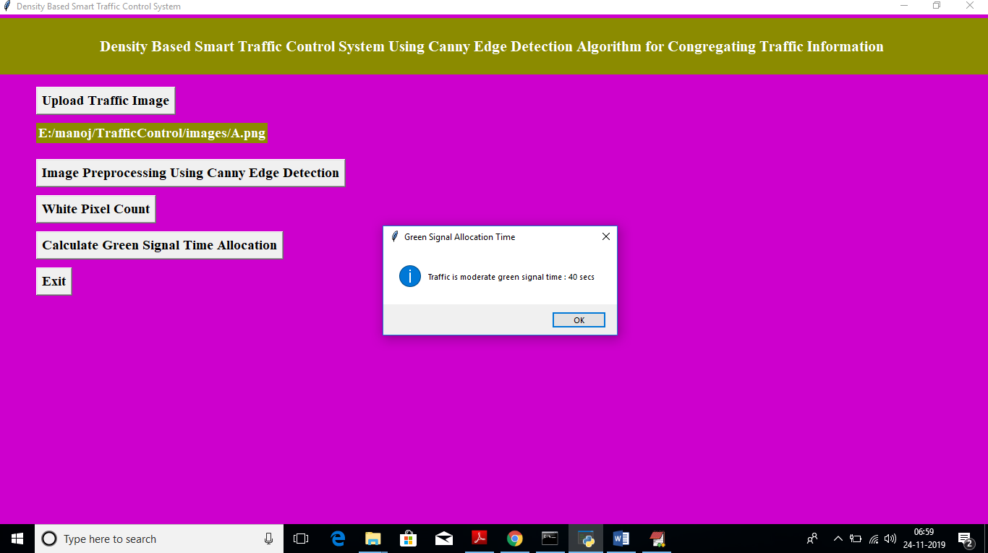

Above time for image A

Fig 10.7: output exit

## CONCLUSIONS

### CONCLUSION

In this paper, a smart traffic control system availing image processing as an instrument for measuring the density has been proposed. Besides explaining the limitations of current near obsolete traffic control system, the advantages of proposed traffic control system have been demonstrated. For this purpose, four sample images of different traffic scenario have been attained. Upon completion of edge detection, the similarity between sample images with the reference image has been calculated. Using this similarity, time allocation has been carried out for each individual image in accordance with the time allocation algorithm. In addition, similarityin percentage and time allocation have been illustrated for each of the four sample images using Python programming language. Besides presenting the schematics for the proposed smart traffic control system, all the necessary results have been verified by hardware implementation.

### SCOPE AND FUTURE WORK

The similarity between sample images with the reference image has been calculated. Using this similarity, time allocation has been carried out for each individual image in accordance with the time allocation algorithm. In addition, similarity in percentage and time allocation have been illustrated for each of the four sample images using Python programming language. Besides presenting the schematics for the proposed smart traffic control system, all the necessary results have been verified by hardware implementation.

## REFERENCES

1. Fei-Yue Wang et al. Parallel control and management for intelligent transportation systems: Concepts, architectures, and applications. IEEE Transactions on Intelligent Transportation Systems, 2010.
2. Yongchang Ma, Mashrur Chowdhury, Mansoureh Jeihani, and Ryan Fries. Accelerated incident detection across transportation networks using vehicle kinetics and support vector machines in cooperation with infrastructure agents. IET intelligent transport systems, 4(4):328– 337, 2010.Rutger Claes, Tom Holvoet, and Danny Weyns. A decentralized approach for anticipatory vehicle routing using delegate multiagent systems. IEEE Transactions on Intelligent Transportation Systems, 12(2):364–373, 2011.
3. Mehul Mahrishi and Sudha Morwal. Index point detection and semantic indexing of videos - a comparative review. Advances in Intelligent Systems and Computing, Springer, 2020.
4. Joseph D Crabtree and Nikiforos Stamatiadis. Dedicated short-range communications technology for freeway incident detection: Performance assessment based on traffic simulation data. Transportation Research Record, 2000(1):59–69, 2007.
5. H Qi, RL Cheu, and DH Lee. Freeway incident detection using kinematic data from probe vehicles. In 9th World Congress on Intelligent Transport SystemsITS America, ITS Japan, ERTICO (Intelligent Transport Systems and Services-Europe), 2002.
6. Z. Zhao, W. Chen, X. Wu, P. C. Y. Chen, and J. Liu. Lstm network: a deep learning approachfor short-term traffic forecast. IET Intelligent Transport Systems, 11(2):68–75, 2017.
7. C. Zhang, P. Patras, and H. Haddadi. Deep learning in mobile and wireless networking: A survey. IEEE Communications Surveys Tutorials, 21(3):2224–2287, third quarter 2019.
8. Chun-Hsin Wu, Jan-Ming Ho, and D. T. Lee. Travel-time prediction with support vector regression. IEEE Transactions on Intelligent Transportation Systems,

5(4):276–281, Dec 2004.

1. Yan-Yan Song and LU Ying. Decision tree methods: applications for classification and prediction. Shanghai archives of psychiatry, 27(2):130, 2015.
2. Yiming He, Mashrur Chowdhury, Yongchang Ma, and Pierluigi Pisu. Merging mobility and energy vision with hybrid electric vehicles and vehicle infrastructure integration. Energy Policy,

41:599–609, 2012.