



CE477: Digital system senior Project
EE402: Electrical Engineering Design Projects Project

Assessment 1 [15%]

ID | Student Name | Major
Date
Project Title: | Smart Agriculture
Supervisor

- [30 points] Finalized High-Level Design

Part One: Flowchart-1

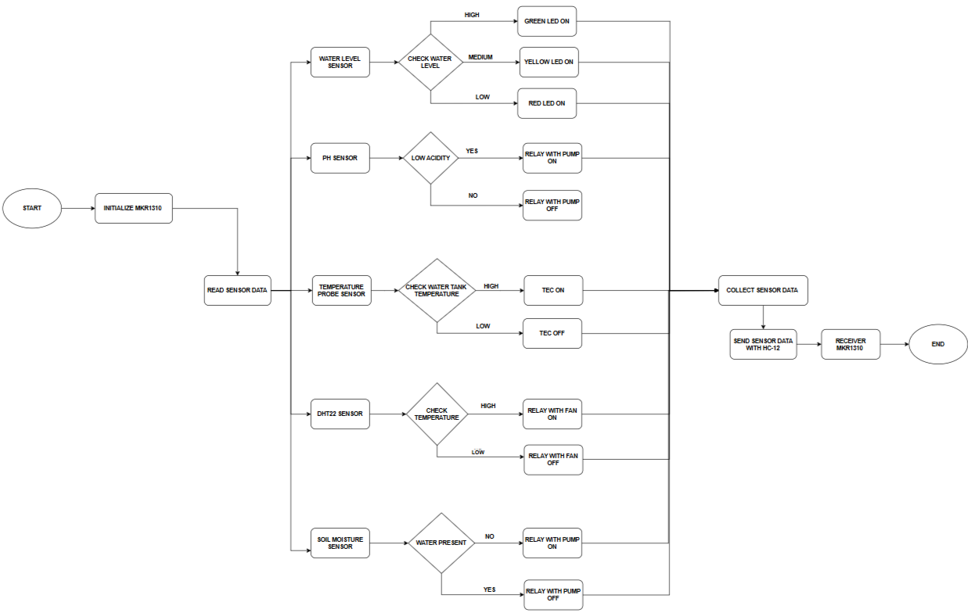

Figure 1 : Flowchart for Smart Agriculture Transmitter One

Above in fig-1 which shows a flowchart for our Smart Agriculture Transmitter one system. The process starts with system initialization where the MKR1310 microcontroller is powered on and configured. After initialization, the system begins reading all connected sensor data. First, the water level sensor checks the level of water in the tank. The controller compares the measured value with predefined thresholds. If the water level is high, the green LED is turned ON to indicate sufficient water. If the level is medium, the yellow LED is turned ON as a warning level. If the level is low, the red LED is turned ON to indicate critical shortage. Next, the pH sensor measures the acidity of the water or soil solution. The system checks whether the acidity is low (meaning pH imbalance). If low acidity is detected, the relay activates the pump to adjust nutrient or water supply. If the pH is normal, the relay keeps the pump OFF. Then, the temperature probe sensor measures the water tank temperature. The controller compares the temperature with a preset limit. If the temperature is high, the TEC (Thermoelectric Cooler) is turned ON to reduce water temperature. If the temperature is low or normal, the TEC remains OFF. After that, the DHT22 sensor measures ambient temperature and humidity. The system checks if the temperature is high. If high temperature is detected, the relay turns the cooling fan ON. If the temperature is low, the fan is turned OFF. Next, the soil moisture sensor checks whether sufficient water is present in the soil. If water is not present, the relay activates the irrigation pump. If adequate moisture is detected, the pump remains OFF. All sensor readings and device statuses are then collected together by the microcontroller. The transmitter prepares this data packet for communication. Using the HC-12 wireless module, the sensor data is transmitted wirelessly. The receiver MKR1310 collects the transmitted data on the other side. This data can be displayed and monitored remotely. Finally, the process continues in a loop for continuous real-time monitoring. This ensures automated control of irrigation, cooling, and nutrient management in smart agriculture.
Part One: Flowchart-2
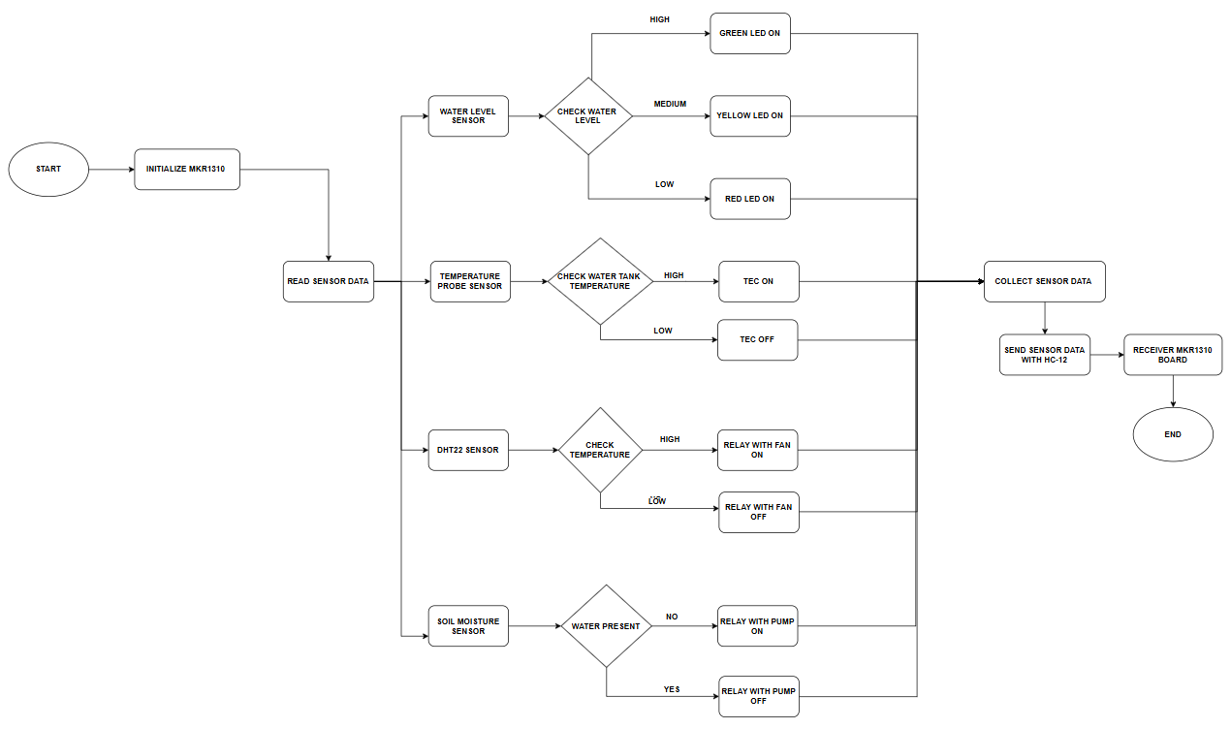
Figure 2: Flowchart for Smart Agriculture Transmitter Two
Above in fig-2 represents the working flowchart for our Smart Agriculture Transmitter Two system. The operation begins with the start condition, where the system is powered on. The MKR1310 microcontroller is initialized to configure input and output pins, sensors, relays, and communication modules. After successful initialization, the system moves to the sensor reading stage. The controller reads data from all connected environmental and soil sensors. First, the water level sensor measures the level of water available in the storage tank. The system checks whether the water level is high, medium, or low. If the level is high, the green LED is turned ON to indicate sufficient water availability. If the level is medium, the yellow LED is activated as a caution signal. If the level is low, the red LED is turned ON to warn about low water condition. Next, the temperature probe sensor measures the water tank temperature. The system compares the measured temperature with a predefined threshold value. If the water temperature is high, the Thermoelectric Cooler (TEC) is switched ON to reduce the temperature. If the temperature is low or within range, the TEC remains OFF. Then, the DHT22 sensor measures ambient temperature and humidity around the crops. The controller checks if the ambient temperature exceeds the set limit. If high temperature is detected, the relay activates the cooling fan. If the temperature is low, the fan relay remains OFF. After that, the soil moisture sensor measures the moisture content of the soil. The system checks whether water is present in sufficient quantity. If water is not present in the soil, the relay turns the irrigation pump ON to supply water. If moisture is adequate, the pump remains OFF to conserve water. Once all sensors are processed, the microcontroller collects and organizes the sensor data. The transmitter prepares a data packet containing water level, temperature, humidity, and soil moisture values. This data is transmitted wirelessly using the HC-12 communication module. The receiver MKR1310 board receives the transmitted sensor data. The received information can be monitored and displayed for analysis. The system completes one cycle and continues looping for real-time monitoring and automated agricultural control.

Part One: Flowchart-3
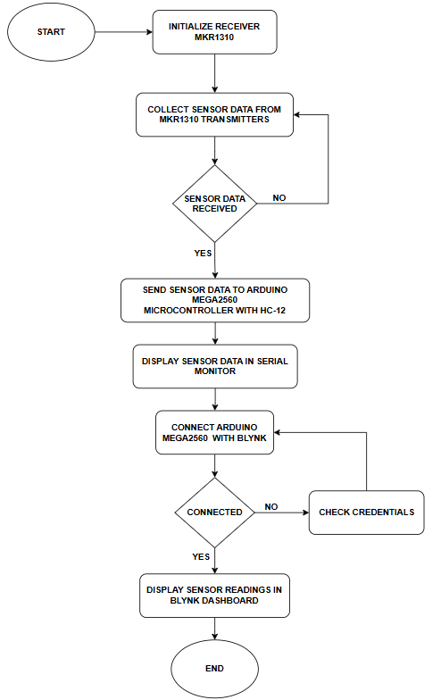
Figure 3: Flowchart for Smart Agriculture Receiver System
Above in Fig-3 represents the flowchart explaining the working of the Smart Agriculture Receiver System. The process begins when the receiver unit is powered ON, and the MKR1310 configured as the receiver is initialized by setting up serial communication, input–output pins, and the HC-12 wireless communication module. After initialization, the receiver continuously listens for incoming wireless sensor data transmitted from the MKR1310 transmitter nodes deployed in the agricultural field. A decision block checks whether valid sensor data has been received; if no data is detected, the system remains in a waiting loop and continues listening. When data is successfully received, the receiver processes and organizes the sensor values and forwards them to the ARDUINO MEGA 2560 Wi-Fi through serial communication. The received readings are also displayed on the serial monitor for local monitoring and debugging. The ARDUINO MEGA 2560 then initializes its Wi-Fi connection and attempts to connect to the Blynk Web Dashboard using predefined Wi-Fi credentials and authentication tokens. If the connection fails, the system retries until a stable connection is established. Once connected, the ARDUINO MEGA 2560 Wi-Fi uploads real-time sensor data such as temperature, humidity, soil moisture, pH, and water level to the Blynk dashboard, enabling remote monitoring through a smartphone or web interface. The entire process runs continuously in a loop to ensure real-time updates and reliable communication between transmitters and receiver. In this project, we used Blynk instead of ThingSpeak and Firebase because it provides a ready-made IoT dashboard with built-in widgets, simple ARDUINO MEGA 2560 integration, and real-time data visualization without requiring complex database configuration or backend development. ThingSpeak is mainly focused on data logging and analytics, while Firebase requires more advanced database setup and application development. Therefore, we chose Blynk for its simplicity, faster implementation, and suitability for real-time smart agriculture monitoring.

Part Two: Block Diagram
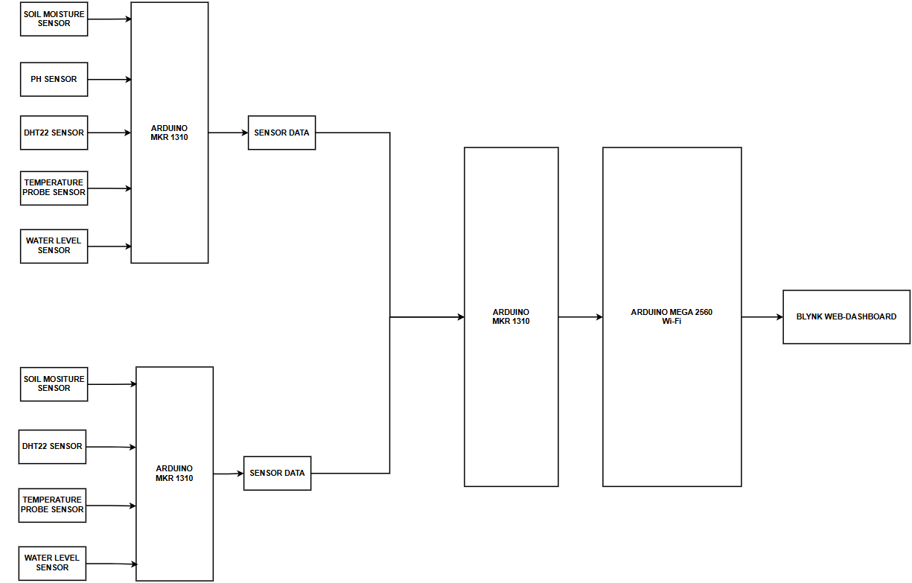
Figure 4 : Block Diagram

Above in fig-4 shows a block diagram explains our smart agriculture system clearly. In our project, we are using three boards in total. Two boards act as transmitters and one board acts as a receiver. The purpose of this design is to monitor different areas of the farm and send all the collected data to one central unit. In the first section of the farm, we connect sensors like the soil moisture sensor, pH sensor, DHT22 sensor, temperature probe sensor, and water level sensor to the first MKR 1310 board. This board collects the readings from all these sensors and processes them. Since it sends the collected data to another board, it works as a transmitter. Similarly, in another section of the farm, we use the second MKR 1310 board. This board is also connected to sensors such as soil moisture, DHT22, temperature probe, and water level sensors. It collects and processes the data from that particular area. Like the first board, this one also works as a transmitter and sends the sensor data wirelessly. The third board acts as the receiver. It receives the data from both transmitter boards and combines the information. This receiver board acts as the central control unit of our system. After organizing the data, it sends the final processed information to the ARDUINO MEGA 2560 Wi-Fi microcontroller. The ARDUINO MEGA 2560 provides Wi-Fi connectivity and uploads the data to the Blynk dashboard through the internet. On the dashboard, we can see real-time values of soil moisture, pH, temperature, humidity, and water level from different farm zones. If any parameter crosses the set limit, alerts can be generated. With this transmitter and receiver setup, we can monitor a large agricultural field efficiently. This system helps us reduce water wastage, improve crop growth, and control irrigation based on real-time data. Finally, we generate a power quality disturbance alert to notify users, ensuring that our system provides continuous monitoring and intelligent fault detection.

- [50 points] Finalized Low-Level Designs

Circuit Diagram - 1

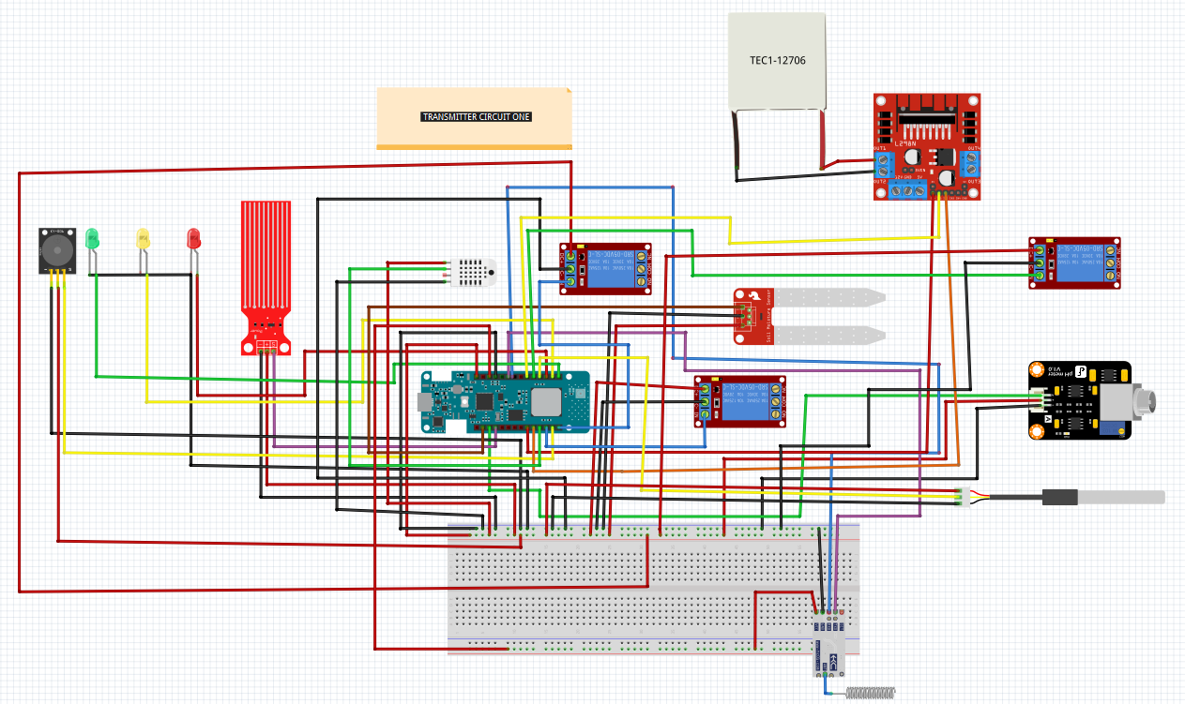

Figure 5: Circuit Diagram for Smart Agriculture Transmitter One

Above in fig-5 represents the Circuit Diagram for Smart Agriculture Transmitter One. We designed this circuit to collect and send sensor data to the receiver MKR 1310 board. The main controller used in this transmitter unit is the MKR 1310. All sensors and control components are connected to specific pins of this board. The DHT22 temperature and humidity sensor is connected to digital pin 2 of the MKR 1310. This sensor measures the surrounding air temperature and humidity, which helps us monitor environmental conditions affecting crop growth. The soil moisture sensor is connected to analog pin A1. It measures the water content in the soil and helps us determine when irrigation is required. The pH sensor is connected to analog pin A2 to measure the acidity or alkalinity of the soil, which is important for proper nutrient absorption. The water level sensor is connected to analog pin A3 to monitor the water level in the irrigation tank or reservoir. For controlling external devices, we connected relay modules to the MKR 1310. A relay is connected to digital pin 3 for soil-related control, such as switching a water pump when water is not detected. Another relay is connected to digital pin 10 for pH-related control, and one more relay is connected to digital pin 5 environmental control. These relays allow automatic switching of pumps based on sensor values. A buzzer is connected to digital pin 4 to provide an alert when water level is detected Low. For visual indication, three LEDs are used. The green LED is connected to digital pin 7 to show normal conditions. The yellow LED is connected to digital pin 8 to indicate water level is Medium. The red LED is connected to digital pin 6 to indicate water level is Low. Additionally, a DS18B20 soil temperature probe is connected to digital pin 9 of the MKR 1310. This sensor provides accurate soil temperature readings. To regulate temperature, a TEC (Peltier) module is connected through a motor driver. The control pins of the driver are connected to digital pins 11 and 12, and the enable pin is connected to pin 0. This setup allows us to control heating or cooling depending on temperature conditions. After collecting and processing all sensor readings, this transmitter circuit is designed to send the sensor data wirelessly to the receiver MKR 1310 board using HC-12 connected to RX-13, TX-14 pins. As a team, we designed this transmitter unit to monitor field conditions efficiently and ensure reliable data transmission to the central receiver system.

Circuit Diagram - 2
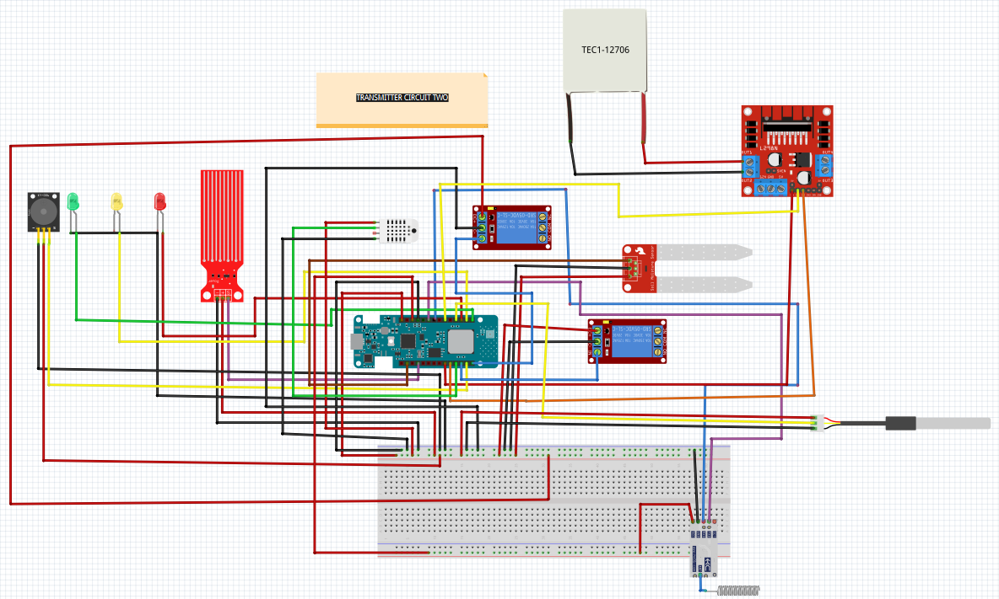
Figure 6: Circuit Diagram for Smart Agriculture Transmitter Two
Above in fig-6 represents the Circuit Diagram for Smart Agriculture Transmitter Two. We designed this circuit to collect and send sensor data to the receiver MKR 1310 board. The main controller used in this transmitter unit is the MKR 1310. All sensors and control components are connected to specific pins of this board. The DHT22 temperature and humidity sensor is connected to digital pin 2 of the MKR 1310. This sensor measures the surrounding air temperature and humidity, which helps us monitor environmental conditions affecting crop growth. The soil moisture sensor is connected to analog pin A1. It measures the water content in the soil and helps us determine when irrigation is required. The water level sensor is connected to analog pin A3 to monitor the water level in the irrigation tank or reservoir. For controlling external devices, we connected relay modules to the MKR 1310. A relay is connected to digital pin 3 for soil-related control, such as switching a water pump when water is not detected. one more relay is connected to digital pin 5 environmental control. These relays allow automatic switching of pumps based on sensor values. A buzzer is connected to digital pin 4 to provide an alert when water level is detected Low. For visual indication, three LEDs are used. The green LED is connected to digital pin 7 to show water level is High. The yellow LED is connected to digital pin 8 to indicate water level is Medium. The red LED is connected to digital pin 6 to indicate water level is Low. Additionally, a DS18B20 soil temperature probe is connected to digital pin 9 of the MKR 1310. This sensor provides accurate soil temperature readings. To regulate temperature, a TEC (Peltier) module is connected through a motor driver. The control pins of the driver are connected to digital pins 11 and 12, and the enable pin is connected to pin 0. This setup allows us to control heating or cooling depending on temperature conditions. After collecting and processing all sensor readings, this transmitter circuit is designed to send the sensor data wirelessly to the receiver MKR 1310 board using HC-12 connected to RX-13, TX-14 pins. As a team, we designed this transmitter unit to monitor field conditions efficiently and ensure reliable data transmission to the central receiver system.

Circuit Diagram – 3
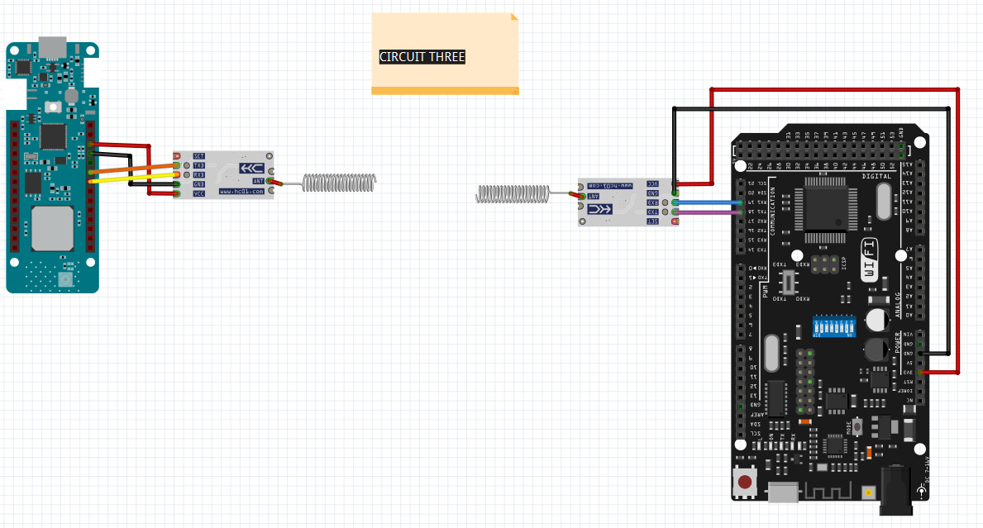
Figure 7: Circuit Diagram for Smart Agriculture Receiver System

Above in fig-6 represents the Circuit Diagram for Smart Agriculture Transmitter Receiver System of the smart agriculture project. In this setup, an Arduino MKR WAN 1310 acts as the central receiver. It uses an HC-12 wireless module to receive sensor data transmitted from the two separate MKR1310 transmitter circuits mentioned above. The transmitter boards send their collected environmental sensor data (such as soil moisture, pH, temperature, humidity, etc.) wirelessly over 433 MHz, and the receiver HC-12 captures this data and passes it to the MKR1310 through serial communication using pins 13 (RX) and 14 (TX). After collecting the incoming sensor data from both transmitters, the receiver MKR1310 forwards the processed or combined sensor information to an ARDUINO MEGA 2560 Wi-Fi serial communication (ARDUINO MEGA 2560 TX pin18 and RX pin 19). The ARDUINO MEGA 2560 then handles Wi-Fi connectivity and sends the received sensor data to the cloud platform for monitoring. In summary, this circuit functions as a wireless data gateway that gathers sensor data from multiple transmitter nodes and transfers it to the ARDUINO MEGA 2560 Wi-Fi for IoT-based monitoring.

- [20 points] Provide a table with your project performance specifications, showing all needed details.

Table 1: Smart Agriculture System Specifications
Parameter | Specification | Description
System Type | Wireless Smart Agriculture | Multi-node monitoring with central receiver
Number of Transmitter Nodes | 2 | MKR1310-based sensor nodes
Receiver Unit | 1 | MKR1310 acting as wireless gateway
Cloud Gateway | 1 | ARDUINO MEGA 2560 for Wi-Fi communication
Wireless Communication | HC-12 (433 MHz) | Serial RF communication between nodes
Wireless Range | Up to 1 km (open area) | Depends on antenna and environment
Data Transmission Method | UART Serial (9600 bps) | Between MKR and HC-12 / MKR to ARDUINO MEGA 2560
Wi-Fi Standard | 802.11 b/g/n | ARDUINO MEGA 2560 connectivity
Cloud Platform | Blynk Web Dashboard | Real-time monitoring and visualization
Soil Moisture Range | 0–100% | Based on analog sensor calibration
Temperature Range | -40°C to 80°C | Depends on DHT / probe sensor used
Humidity Range | 0–100% RH | From DHT sensor
pH Measurement Range | 0–14 pH | Soil acidity measurement
Water Level Detection | Low / Medium / High | Based on sensor threshold levels
Response Time | < 2 seconds | Sensor reading to dashboard update
Power Supply (MKR1310) | 5V and 3.3V Logic | Battery or regulated DC supply
Power Supply (ARDUINO MEGA 2560) | 5V via USB | Wi-Fi enabled operation
Actuator Control | Relay Modules | Pump / irrigation control
Alert System | Buzzer + LEDs | Visual and audio alerts
Data Update Interval | 5–10 seconds | Configurable in code
Operating Environment | Outdoor Agricultural Field | Designed for farm deployment
System Operation | Continuous Loop | Real-time monitoring

Table 2: Smart Agriculture System Sensor Pins Specifications

Sensor | Pin Type | Board | Pins | Function
DHT22 Temperature & Humidity Sensor | Digital | MKR1310 | D2 | Measures air temperature and humidity
Soil Moisture Sensor | Analog | MKR1310 | A1 | Measures soil moisture level
pH Sensor | Analog | MKR1310 | A2 | Measures soil pH value
Water Level Sensor | Analog | MKR1310 MKR1310 | A3 | Detects water level in tank
DS18B2 Temperature Sensor | Digital | MKR1310 | D9 | Measures water tank temperature
Soil Control Relay | Digital | MKR1310 | D3 | Controls irrigation pump
pH Control Relay | Digital | MKR1310 | D10 | Controls pH regulation
Environment Control Relay | Digital | MKR1310 | D5 | Controls environmental devices
Buzzer | Digital | MKR1310 | D4 | Low water level alert
Green LED | Digital | MKR1310 | D7 | Normal condition indicator
Yellow LED | Digital | MKR1310 | D8 | Medium water level indicator
Red LED | Digital | MKR1310 | D6 | Low water level indicator
Motor Driver IN1 | Digital | MKR1310 | D11 | TEC heating/cooling control
Motor Driver IN2 | Digital | MKR1310 | D12 | TEC heating/cooling control
Motor Driver EN | Digital | MKR1310 | D0 | Enable TEC module
HC-12 RX | Digital | MKR1310 | D13 | Wireless receive
HC-12 TX | Digital | MKR1310 | D14 | Wireless transmit
HC-12 RX | Digital | ARDUINO MEGA 2560 | RX-19 | Wireless receive
HC-12 TX | Digital | ARDUINO MEGA 2560 | TX-18 | Wireless transmit

Note:
- 10% of the grade of each question will be deducted for poor English writing and unorganized deliverable.

- Supervisors have the right to ask you questions about the deliverables submitted; grades can be affected according to your answers.

- AUM late submission policy will be applied for late submissions.

- The file submitted on Moodle should be named as follows: CE477-EE402_Sp26_A1_Group #

- Submitted File Format: DOCX

