Design and Synthetic Generation of a Relational Retail-Banking Database in SQLite
SQL Database Project | Tutor: David Lagattuta
Student: Saif Ali Student ID: 25045707 Github: https://github.com/shaiksaifalibaba/SQLProj
1. Introduction
This report explains how to design and create a simulated retail-banking database in SQLite. The choice of banking was made because it can naturally assume all four levels of measurement it has a many-to-many relationship between the tables (joint accounts), and it has realistic integrity rules like balances constrained by overdraft limits. There are 6 tables and 111,916 rows in total, including 60,077 rows in the largest table (transactions).
2. Data Generation Methodology
2.1 Approach and reproducibility. The generator is a Google Colab notebook, utilizing only the built-in Python libraries (sqlite3, random, math, datetime). The output is completely reproducible, using a fixed pseudo-random seed (42) and a fixed reference date (30 October 2026). The pipeline will create branches, customers, account specifications and holders, simulate the transactions for each account, create monthly statements, then aggregate them and finally bulk-insert the rows in dependency order with the foreign-key constraint ON (PRAGMA foreign_keys = ON) (Elmasri and Navathe, 2016).
2.2 Customers and branches. 15 branches (5 “Flagship”) are located in UK cities, each having a unique fiction sort code. Names are random combinations of hand-written first-name and surname lists; age has a truncated normal distribution (mean of 44, SD of 16, range of 19–92); employment status is conditional; annual income is taken from a log-normal distribution within employment groups (e.g. the median income of employed customers is £31,000, but the SD varies with age) to produce the right-skew of real income. The model of the credit score is 690 + 45·ln(income/30,000) + 1.2·(age − 40) + ε, with the result being clipped to the actual range of 300–850 for a credit score, but with variables having plausible correlations, such as between income and age, based on the nature of the underlying processes. Next, the ranking of the credit rating is calculated by applying the FICO-style score bands (Poor<Fair<Good<Very Good<Exceptional).
2.3 Accounts and transactions. One to three accounts per customer (60/30/10%). Most of the accounts are Savings, with the first one being a current-type account (Student for those of age ≤26, Premium for those of higher income). Approximately 10% of accounts are closed and 5% unused, overdraft limits are determined by credit rating and 12% of non-student accounts have a joint holder (50% of the time it is a joint surname). These accounts then are each simulated, in turn, starting from the initial deposit. Activity volume is related to account age and product type, transaction types are randomly selected from weighted distributions depending on product type and employment (i.e., only salary credits are used for employed accounts, pension credits for retired accounts), amounts are log normal, with size being scaled by income, ATM withdrawals are rounded, and 0.6% are flagged as potentially fraudulent for card and transfer payments. However, if a debit would cause the account to overspend the limit, the customer deposits funds into the account instead and closed accounts are reopened with a withdrawal that balances the account. As a result all balances are matched with their related transactions.
3. Database Schema
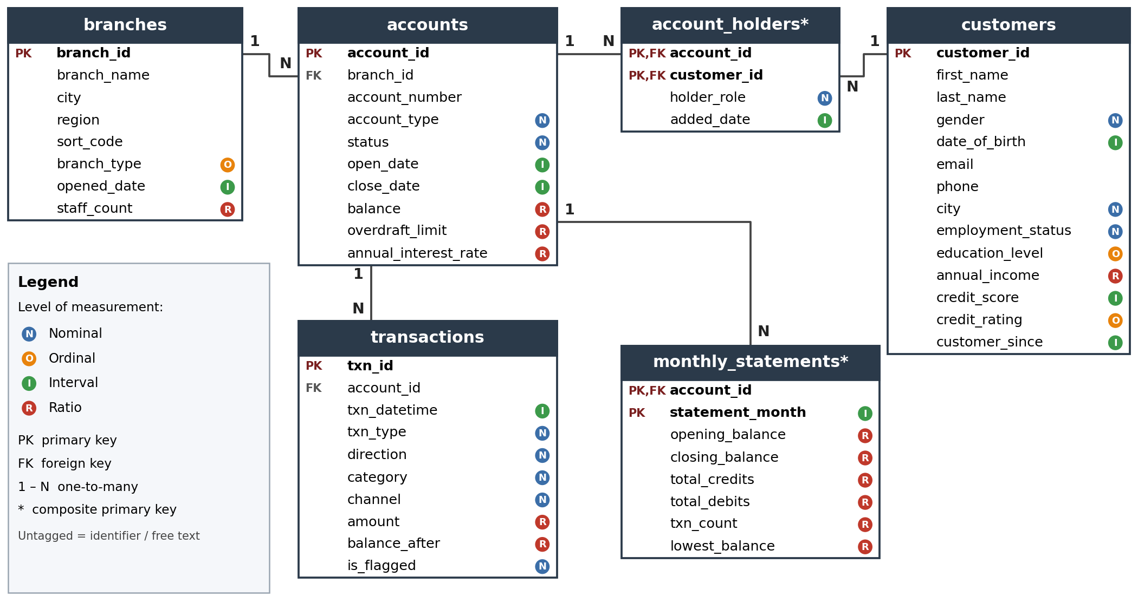
Figure 1. Entity-relationship diagram of the database, showing keys, one-to-many relationships and each column’s level of measurement.
Table 1. Summary of tables and keys.
Table | Primary key | Foreign key(s) | Cols | Rows
branches | branch_id | – | 8 | 15
customers | customer_id | – | 14 | 1200
accounts | account_id | branch_id → branches | 10 | 1810
account_holders | (account_id, customer_id) | account_id → accounts; customer_id → customers | 4 | 1988
transactions | txn_id | account_id → accounts | 10 | 60077
monthly_statements | (account_id, statement_month) | account_id → accounts | 8 | 46826
4. Justification of Tables and Constraints
Separate tables. They follow the relational model and normalisation principles (Codd, 1970), meaning that each entity is stored once to avoid data redundancy and data update anomalies: the customer's details are stored in one row, regardless of the number of accounts or transactions they have, and the branch's details are not stored in each of the account's rows. The transactions table is separated out because it's the most voluminous one-to-many child of accounts, and it's indexed by (account_id, txn_datetime) so that queries for the history of transactions are fast.
Compound keys. To model the many-to-many relationship between customers and accounts, a junction table, account_holders, is used. The primary key is composite (account_id, customer_id) so that the same person can't be added to one account twice, and the partial unique index ensures that the same person cannot have multiple “Primary” holders on one account. Monthly_statements has no unique key, account_id, or statement_month; instead, the composite key, (account_id, statement_month), is unique. This table is a deliberate controlled denormalisation (pre-aggregated monthly totals) which is designed to speed up the reporting and can be checked against transactions.
Attribute constraints. PRIMARY KEY and FOREIGN KEY constraints ensure referential integrity; NOT NULL and UNIQUE (email, account_number, sort_code) prevent missing or duplicate identifier(s); CHECK constraints enforce domain rules: nominal columns can only contain specific sets of values, ordinal columns can only contain specific values, credit_score is between 300 and 850, amount is greater than 0, balance is greater than or equal to −overdraft_limit, close_date can only be contained in a closed account, and it must be after open_date; direction must match txn_type. Since none of SQLite's types is DATE or DECIMAL, dates are stored as ISO-8601 text (sorted chronologically), and money is stored as REAL rounded to two decimals, using internal integer pence to prevent floating-point drift. Ordinal labels are stored as text and used in queries in an ordered way using CASE expressions.
Table 2. Levels of measurement represented in the database.
Level | Columns | Justification
Nominal | gender, city, employment_status, account_type, status, txn_type, direction, category, channel, is_flagged | Unordered categories; only equality is meaningful.
Ordinal | credit_rating, education_level, branch_type | Ordered categories whose spacing is undefined (e.g. Poor < Fair < Good).
Interval | All date/datetime columns; credit_score | Arbitrary zero (calendar origin; score floor of 300): differences, not ratios, are meaningful.
Ratio | annual_income, balance, balance_after, overdraft_limit, annual_interest_rate, amount, staff_count, txn_count, statement totals | True zero (no income, empty balance): ratios are meaningful.
5. Validation and Results
The database was also checked for errors using the following methods: (i) PRAGMA integrity_check and PRAGMA foreign_key_check, (ii) checking the balance of each account in the database with the signed sum of its transactions and (iii) ensuring that each account has only one primary holder.
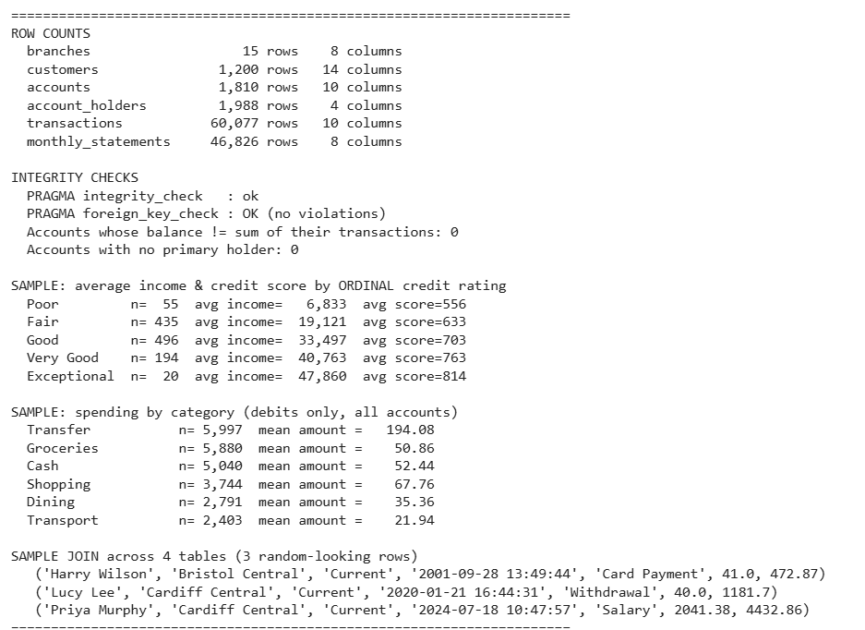
Figure 2. Output of the verification cells in the Colab notebook.
6. Ethical and Data Privacy Discussion
Synthetic data and re-identification. All records are generated and the database does not contain any information about an identifiable natural person and therefore is not intended to be associated with a natural person in any way and does not constitute personal data within the meaning of Article 4(1) GDPR (Regulation (EU) 2016/679). However, measures were put in place: e-mail addresses were based on the reserved domain example.com, telephone numbers on the 07700 900xxx domain reserved by Ofcom for fictional numbers, and names were combinations of common names – a coincidence of a name with an actual person was not expected and could not be verified(Lopez-Rojas, Elmir and Axelsson, 2016). The account numbers and sort codes are random and may be the same number as a real account, so it is always recommended to label the data set as synthetic(Jordon et al., 2022).
Validity, bias and fairness. Realism does not equal validity: all distributions reflect the author’s assumptions, so findings must not be generalised to real customers. Credit score is deliberately a function of income and age; in practice, age and sex are protected characteristics (Equality Act 2010), and any model trained on such data would require a fairness audit. The gender field includes a non-binary category for inclusiveness, and the fraud flag is random and carries no learnable signal.
If real data were used, the UK GDPR and Data Protection Act 2018 principles would apply: a lawful basis, data minimisation, purpose limitation, pseudonymisation, encryption, role-based access control and defined retention periods. Transparency is supported here by publishing the seed and the commented code.
References
Elmasri, R., 2008. Fundamentals of database systems. Pearson Education India.
Jordon, J., Szpruch, L., Houssiau, F., Bottarelli, M., Cherubin, G., Maple, C., Cohen, S.N. and Weller, A., 2022. Synthetic Data--what, why and how?. arXiv preprint arXiv:2205.03257.
Lopez-Rojas, E., Elmir, A. and Axelsson, S., 2016. PaySim: A financial mobile money simulator for fraud detection. In 28th European modeling and simulation symposium, EMSS, Larnaca (pp. 249-255). Dime University of Genoa.
Mehrabi, N., Morstatter, F., Saxena, N., Lerman, K. and Galstyan, A., 2021. A survey on bias and fairness in machine learning. ACM computing surveys (CSUR), 54(6), pp.1-35.
Voigt, P. and Von dem Bussche, A., 2017. The EU general data protection regulation (GDPR): a practical guide.

